Disabled People’s Organisations Grow Social Connectedness for People with Disabilities: Evidence from South Asia

James Montgomery¹, Andrew Sithling², Fairlene Soji³, Matthew Reeve⁴ and Nathan Grills⁵ 1The Leprosy Mission Australia^{i}, Melbourne, Australia
2Nepal Leprosy Fellowship, Dharan, Nepal
3CBM India Trust, Delhi, India,
4, 5 The Nossal Institute for Global Health, University of Melbourne, Australia

Abstract

Paper examines the social connections developed through two Disabled People’s Organisation programs in low-income, rural communities of Nepal and India. Mixed methods: network mapping surveys and Focus Group Discussions (FGDs) are used to compare between before joining group and time of study. Results clearly suggest positive impacts on social networks.

Keywords: social network analysis, low-income, DPOs

Social networks (collections of social connections) have been demonstrated to be important indicators of a person’s health and wellbeing, with a variety of studies across multiple settings demonstrating a direct correlation between fewer social connections and increased morbidity and mortality (Berkman, 1983; Holt-Lunstad et al., 2010; House et al., 1988; Perkins et al., 2015; Seeman et al., 1993). A myriad of health conditions including depression (Dalgard et al., 1995; Rosenquist et al., 2011), cardiovascular conditions (Knox & Uvnas-Moberg, 1998), cancer (Ell et al., 1992) and infectious diseases (Cohen, 2004; Patterson et al., 1996), have been found to correlate with having fewer social connections.
The positive health benefits of social connections have been acknowledged as related to the social support that a person receives through relationships (e.g., emotional support, practical assistance and health advice) (Schaefer et al., 1981) as well as the interconnectedness that comes from social participation, which promotes a sense of purpose and meaning in life (Cohen, 2004; Holt-Lunstad, 2015). Social networks have also been found to have a direct physiological effect on health, through complex interactions with immune, endocrine and cardiovascular processes (Uchino et al., 1996).
Studies from a variety of different contexts have shown that people with disabilities are more likely to have smaller and less diverse social networks compared to people without disabilities (Chen et al., 2017; Eisenman et al., 2013; Kreider et al., 2016; McCausland et al., 2016; Miles et al., 2012; Mithen et al., 2015). It has been theorised that the limited social networks of people with disabilities are a function of both physical and attitudinal barriers in society (Miles et al., 2012).
Disabled People’s Organisations (DPOs) are organisations that are established by and for people with disabilities, emerging as part of a social movement in response to disability related discrimination (Shakespeare, 1993). Formation of DPOs in low-income settings has become a key strategy in disability inclusive community development programs in low and

middle income countries (LMICs) (Cornielje, 2009; Henderson et al., 2017; Young, Reeve, Devine, et al., 2016). While the function of DPOs varies depending on the context in which they operate, generally DPOs have served to give people with disabilities a platform to share their priorities, as well providing opportunities for solidarity, accessing rights and advocating for change (Cornielje, 2009; Grills et al., 2020; Leung et al., 2019; Shakespeare, 1993; Young, Reeve, & Grills, 2016).
Very few studies directly investigate the effects of DPOs on social networks. Young et al.’s 2016 literature review into the function of DPOs in LMICs, however, suggested that participation in DPOs may play a role in providing a platform for people with disabilities to develop social connections, with the authors recommending further research into the impact that DPOs can have in developing social capital. This study investigated the impact of participation in two DPOs on the social networks of people with disabilities in a rural South Asian context.

Research Methods

This study used a mixed methods approach to investigate the impact of DPO participation on the social networks of people with disabilities. Firstly, descriptive Social Network Analysis (SNA) was used to map the results of surveys measuring the social connections of DPO members, comparing the social networks that existed before participants joined the DPOs with their social networks after several years of group participation.
Secondly, thematic analysis of Focus Group Discussions (FGDs) with DPO members and key staff of the two NGOs facilitating the DPO programs investigated qualitative changes in social networks. This use of mixed methods, as well as investigating DPOs in two different settings, serves to validate the study findings through data triangulation.

Ethics approval

Ethics approval for this research was obtained through the University of Melbourne’s

Medicine and Dentistry Human Ethics Sub-Committee, the Community Health Global Network (CHGN) Ethics Committee (Uttarakhand, India) and the Nepal Leprosy Fellowship (NLF) board (Nepal).

Study setting

Two different community level DPOs were selected for the study, one in the state of Uttarakhand in India and the other in the district of Sunsari in Nepal. Both locations are poor, rural, mountainous areas. In both settings, DPOs have been established with the support of local Non-Government Organisations (NGOs); Agnes Kunze Society (AKS) in India (part of the Uttarakhand Community Health Global Network (CHGN)) and Nepal Leprosy Fellowship (NLF). In both settings, the process that the NGOs used to establish the DPOs began with community consultation to identify people with disabilities at a village level.
Once people with disabilities were identified, they were invited to join the DPO in which they received education on their rights and available disability services (which included linking to healthcare and income generating opportunities). Though AKS/NLF staff are involved in the facilitation of group formation and capacity building of groups, it is the intention of both programs that DPOs will eventually be run and sustained independently by the people with disabilities who are members. The two groups selected for this study do not strictly meet some definitions of DPOs; they were not established solely by people with disabilities themselves. Much of the literature focussed on DPOs in LMICs include organisations that have external facilitation in their establishment as these are typical of DPOs in low-income, high discrimination settings where self-established DPOs are rare (Young, Reeve, & Grills, 2016). Therefore, the inclusion of the two groups selected for this study under the definition of DPO is in line with existing literature.

Study population

The primary study population was people with disabilities who are members of DPOs

which have been established with the support of AKS and NLF. DPO members were from ethnic groups based in the communities of Uttarakhand and Sunsari, speaking Hindi and Nepali respectively.
The population for the study also included staff members of AKS and NLF who have participated in the facilitation of the DPO programs of the NGOs. Both NGOs have established multiple village level DPOs, so some staff are directly involved with the two DPOs selected for the study, while others have supported similar groups.

Sampling

Purposive sampling was used for both the selection of DPOs (within the broader DPO programs of each of the NGOs) as well as for the selection of members within the DPOs. For the selection of DPOs, AKS and NLF staff were each asked to identify a DPO which had been relatively active in community engagement (to ensure that a broad as possible range of social connections could be analysed). Then for the sampling of members within each of the DPOs, staff were asked to select a representative sample of group members who were willing to voluntarily participate in the study. These were stratified according to age groups, gender and type of impairment prior to random selection; (final sample included men and women with physical disability, sensory disability, psychosocial disability and disability as a result of leprosy). Where people with psychosocial disability (cognitive impairment) were selected, carers acted as assistants for surveys/FGDs.
For study recruitment, participants were invited to participate by NLF/AKS staff and provided with a translated (Hindi/Nepali) Plain Language Statement which was explained by the Indian/Nepali research assistant in gaining consent. No incentives were provided for study participation as incentives can be coercive in this context, though snacks and tea were provided during FGDs.

A total of 16 individual DPO members with disabilities (eight representatives from the Indian DPO and eight from the Nepali DPO) were selected for the social network surveys and DPO FGDs. The inclusion criteria for the selection of this sample were: members of DPOs who identify themselves as having a disability (together with carers where required); including physical, sensory or psycho-social disability; who were at least 18 years old, had joined the DPO at least 12 months prior to the study, and were regular in attending DPO meetings (at least 50% of meetings in the last year).
For the staff FGDs, all AKS/NLF staff who were directly involved in facilitation of the DPO programs were approached to voluntarily participate in interviews and also completed the consent process outlined above. Nine staff attended the AKS staff FGD and seven staff attended the NLF staff FGD. These staff, despite not being people with disabilities themselves, were selected to participate in the study as it was felt that they would have unique perspectives on the changes in social networks for people with disabilities participating in the DPOs, as they had been involved in working together with people with disabilities to establish these DPOs.

Data collection

For the SNA aspect of the study, modified ‘position generator’ (Lin et al., 2001) surveys were developed (one for each setting) to gather data about the social connections of DPO members (surveys available on request). The lists of potential DPO social connections included in the surveys were developed through consultation with AKS and NLF staff as well as through reviewing project documentation. As well as basic demographic data, participants were asked to list contacts according to the pre-identified positions. Once a name was listed, the interviewer would ask the participant to determine whether the contact was an acquaintance, friend or family member (definitions included in surveys), then ask them to recall whether each contact was known before joining the DPO (as well as relationship type

at this time) to establish a baseline list of social connections to compare to the time of study list. In both settings, the SNA survey was piloted with two DPO members (from different DPOs to the ones selected for the study), and then refined following dummy-analysis and according to feedback from interviewers/interviewees.
For the FGD component of the study, questions (and theme-lists for prompts) were developed based on a literature review around social aspects of DPO involvement. Separate FGD question guides were developed for the DPO members and for NGO staff (available on request). The DPO member FGD question guides (for Nepal and India) were revised after analysis of the SNA results and staff FGDs.
Following a process of construct validation and localisation through consultation with key AKS/NLF staff, the SNA surveys and FGD guides were both translated into Hindi/Nepali and then independently back-translated to English for validation. Prior to survey interviews and FGDs, local research assistants (fluent in English as well as Hindi/Nepali) were trained in correct use of the tools.

Data analysis

SNA surveys

Results of the SNA surveys were collated and analysed using the open-source SNA tool NodeXL (an add-in for Microsoft Excel) (Smith et al., 2010). Data were cleaned for invalid results; for example, where participants listed ‘manager sir’ for financial institution staff rather than a name that could be matched with the results of other members. Using NodeXL, egocentric (Marin & Wellman, 2011) network maps were developed according to a Harel-Koren Fast Multiscale algorithm (Harel & Koren, 2002). The SNA survey analysis included a comparison of survey results for participants at baseline compared to time of study, both through looking at numbers and types of connections, and at the differences in network maps (e.g., degree of network centrality for people with disabilities).

FGDs

Audio was recorded from the four FGDs (NGO staff and DPO member FGDs for Nepal and India). The Nepal based and India based research assistants then completed verbatim transcription and translation of the results to English. Following multiple readings of the translated transcript, a thematic analysis approach was used to identify and analyze emerging themes. These emerging themes were used to develop a coding framework, which was used to manually code data from the transcripts, refining the emerging themes. Once coding was completed the themes were further refined through the development of sub- themes under each of the broad themes. Further analysis occurred through the write-up of themes, which included comparison of themes between the different FGDs as well as to existing literature related to the themes (continuing literature reviews).

Results

Social network survey results

Analysis of the social network surveys using NodeXL yielded the social network maps displayed below (Figures 1, 2, 3 and 4) which illustrate a comparison of the social networks of DPO members (in both settings) at baseline (before joining DPO) with the time of study. For each of the social network maps, nodes represent the social connections that DPO members have in their communities; color-coded according to the ‘position’ or role of the person. Positions were classified as DPO members, health service staff, NGO staff (AKS/NLF as well as other NGOs), government staff, community services staff (school teachers, religious leaders, financial institution staff) and community organisation members (women’s groups, youth clubs, ethnic groups and agricultural groups).
Comparing the baseline social network maps (Figures 1 and 3) to the time of study maps (Figures 2 and 4) for both Nepal and India, there was a marked difference not only in

the number of connections that each study participant had, but also in the interconnectedness of study participants. The Harel-Koren algorithm, which has been used to map the social networks, plots nodes that have a greater number of common social connections more centrally within a network (Harel & Koren, 2002). Thus the clustering towards the center of the maps by DPO members at time of study demonstrates a greater ‘degree centrality’ (Hanneman & Riddle, 2011) or connectedness of group members.
Tables 1 and 2 provide further insight into the changes in social networks of study participants, through showing a breakdown of the total numbers of connections reported for baseline compared to the time of study. Tables 1 and 2 also show the relative change in networks of members. For example, overall, there was a 225% increase in the number of connections for the Indian DPO members, and a 93% increase in the total number of connections for the Nepali DPO members. A common theme across both groups was a relatively high increase in number of connections with NGO workers, with a 2400% increase in India and a 275% increase in Nepal. It should be noted that most of these connections are with staff members of AKS and NLF.
Tables 1 and 2 also show that participants from both settings had a marked increase in the total number of connections between participants and other DPO members, with a 579% increase in India and a 294% increase in Nepal. Another common theme between the two settings is that both groups had a relatively low increase in the number of connections with ‘community services’ (7% increase for India, 22% increase for Nepal), suggesting that DPO participation had little impact on connections between DPO members and community services (financial institutions, religious leaders and school teachers). There was also commonality in the relatively similar level of increases in the connections between group members and ‘community organisations’ with relatively modest increases of 48% and 58% for India and Nepal respectively. Similarly, increases in connections with ‘health services’

were also modest for both settings, with a 20% increase for the India DPO and a 45% increase for the Nepal DPO.
Where the results for the total numbers of connections most markedly diverged between India and Nepal was in the total number of connections with government staff, with the Nepal DPO showing a 150% increase and the India group showing a modest 24% increase. However, this appears to be largely a function of the India DPO members having more connections to government staff before joining the DPO. Moreover, the increase in connections with government staff for the Nepal DPO was primarily due to connections of two participants (N #1 and N #7).

Within each of the DPOs, there was considerable variability between individuals in terms of increases in connections at time of study compared to baseline. For example, in Figure 3 for the India DPO, one member (I #2) had a 900% increase in connections (from 3 connections at baseline to 30 at time of study), while another member (I #7) had a 46% increase in connections (from 26 at baseline to 38 at time of study). Similar variability can be seen between individuals in the Nepal DPO (Figure 6), with increases in the number of connections ranging from 38% to 167%.

Figure 1
Social network map of India DPO members at baseline

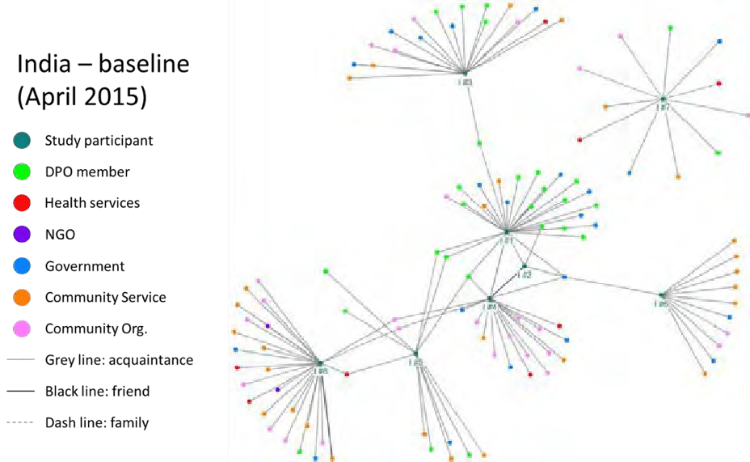

Figure 2
Social network map of India DPO members at time of study

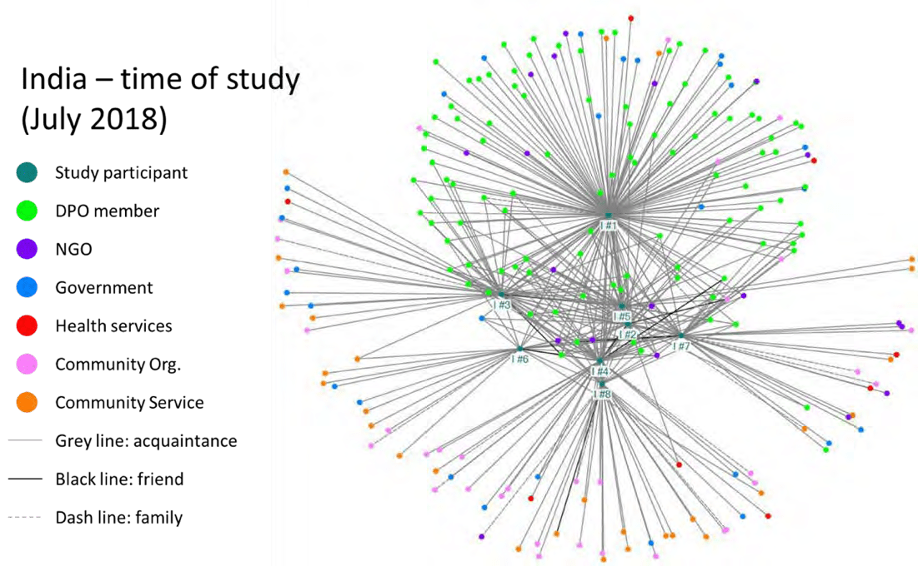

Table 1
Comparison of number of connections per positions for DPO members at baseline vs time of study – India DPO

Baseline I #1 I #2 I #3 I #4 I #5 I #6 I #7 I #8 TOTAL
DPO | 19 | 2 | 5 | 3 | 7 | 0 | 2 | 1 | 39
Health services | 0 | 0 | 1 | 3 | 1 | 0 | 2 | 3 | 10
NGO | 0 | 0 | 0 | 0 | 0 | 0 | 0 | 2 | 2
Government | 7 | 1 | 5 | 4 | 1 | 3 | 2 | 2 | 25
Community orgs. | 1 | 0 | 4 | 8 | 0 | 2 | 3 | 9 | 27
Community services | 2 | 0 | 4 | 3 | 3 | 6 | 2 | 9 | 29
TOTAL 29 3 19 21 12 11 11 26 132

Time of study I #1 I #2 I #3 I #4 I #5 I #6 I #7 I #8 TOTAL % change
DPO | 104 | 25 | 30 | 26 | 33 | 10 | 27 | 10 | 265 | 579%
Health services | 2 | 0 | 1 | 3 | 1 | 0 | 2 | 3 | 12 | 20%
NGO | 15 | 3 | 4 | 5 | 5 | 4 | 10 | 4 | 50 | 2400%
Government | 12 | 1 | 5 | 4 | 1 | 3 | 2 | 3 | 31 | 24%
Community orgs. | 6 | 1 | 4 | 10 | 2 | 2 | 6 | 9 | 40 | 48%
Community services | 2 | 0 | 5 | 3 | 3 | 7 | 2 | 9 | 31 | 7%
TOTAL | 141 | 30 | 49 | 51 | 45 | 26 | 49 | 38 | 429 | 225%
% change
386% 900% 158% 143% 275% 136% 345% 46% 225%

Figure 3
Social network map of Nepal DPO members at baseline
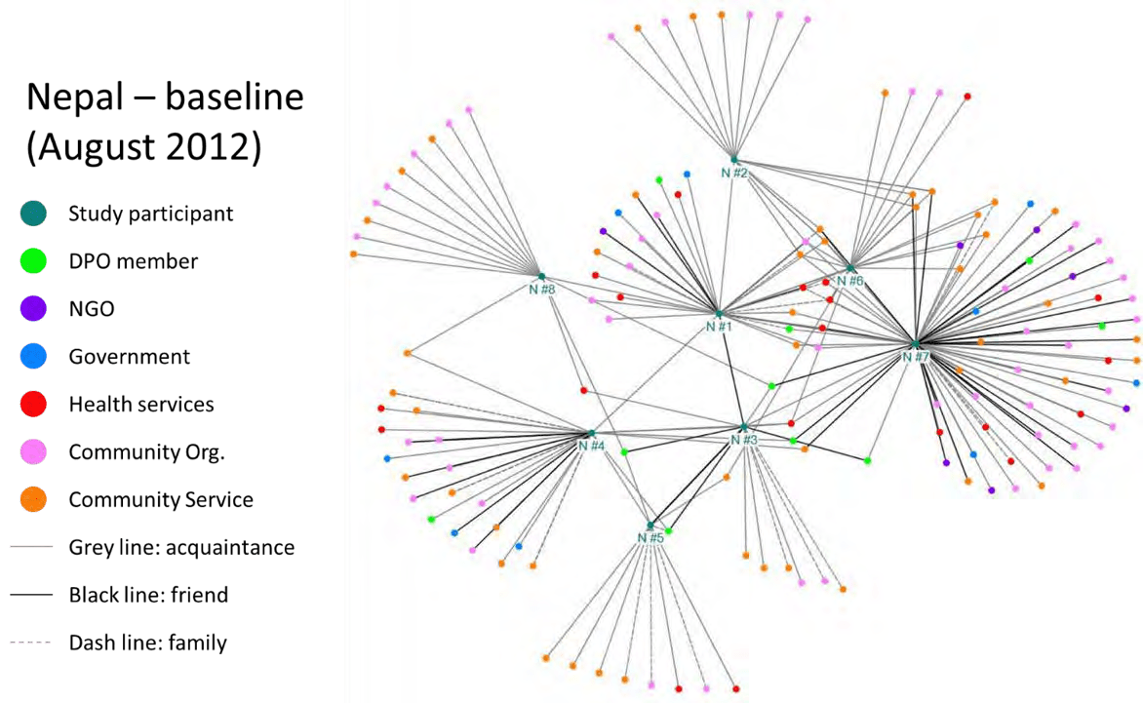

Figure 4
Social network map of Nepal DPO members at time of study

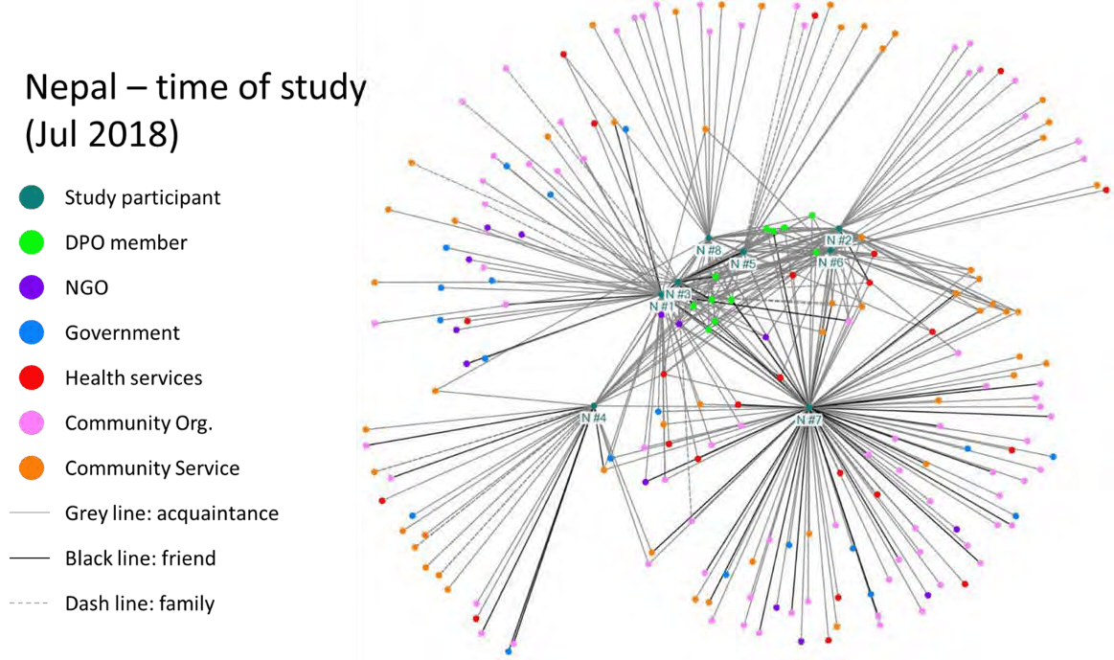

Table 2
Comparison of number of connections per positions for DPO members at baseline vs time of study – Nepal DPO

Baseline N #1 N #2 N #3 N #4 N #5 N #6 N #7 N #8 TOTAL
DPO 4 | 1 | 8 | 6 | 4 | 2 | 6 | 3 | 34
Health services 8 | 0 | 2 | 3 | 2 | 5 | 12 | 1 | 33
NGO 1 | 0 | 0 | 0 | 0 | 1 | 6 | 0 | 8
Government 1 | 0 | 0 | 3 | 0 | 0 | 4 | 0 | 8
Community orgs. 6 | 6 | 2 | 6 | 2 | 3 | 24 | 6 | 55
Community services 7 | 11 | 4 | 6 | 5 | 12 | 24 | 5 | 74
TOTAL 27 18 16 24 13 23 76 15 212

%
Time of study N #1 N #2 N #3 N #4 N #5 N #6 N #7 N #8 TOTAL change
DPO 17 | 18 | 16 | 12 | 17 | 17 | 20 | 17 | 134 | 294%
Health services 11 | 5 | 2 | 3 | 3 | 6 | 16 | 2 | 48 | 45%
NGO 10 | 2 | 3 | 1 | 2 | 1 | 9 | 2 | 30 | 275%
Government 8 | 0 | 0 | 3 | 0 | 0 | 9 | 0 | 20 | 150%
Community orgs. 15 | 6 | 3 | 6 | 2 | 4 | 44 | 7 | 87 | 58%
Community services 11 | 15 | 4 | 8 | 6 | 14 | 27 | 5 | 90 | 22%
TOTAL 72 | 46 | 28 | 33 | 30 | 42 | 125 | 33 | 409 | 93%

% increase
167% 156% 75% 38% 131% 83% 64% 120% 93%

Analysis of the social-network survey results also included a comparison of the types of relationships (acquaintance, friend or family) between baseline and time of study. Tables 3 (India DPO) and 4 (Nepal DPO) display a breakdown of the total numbers of connections according to these categories. Note that details of the definitions of acquaintance/friend/family are included in the social network questionnaires and are available on request.
The most notable change in numbers of connections according to relationship type (between baseline and time of study) was for connections to ‘acquaintances’, with a 260% increase in India (Table 3) and a 135% increase in Nepal (Table 4).

While there was a marked change in the number of connections to ‘friends’ for India (300% increase), there were no changes in connections to ‘friends’ in Nepal. Of the six new ‘friend’ connections at time of study for the India DPO, five of the connections were with other DPO members.

Table 3
Comparison of types of connections at baseline vs time of study – India DPO

India baseline |  | India time of study |  | % change
Acquaintance | 112 | Acquaintance | 403 | 260%
Friend | 2 | Friend | 8 | 300%
Family | 18 | Family | 18 | 0%
Total | 132 | Total | 429 | 225%

Table 4
Comparison of types of connections at baseline vs time of study – Nepal DPO

Nepal baseline |  | Nepal time of study |  | % change
Acquaintance | 145 | Acquaintance | 341 | 135%
Friend | 43 | Friend | 43 | 0%
Family | 24 | Family | 25 | 4%
Total | 212 | Total | 409 | 93%

Focus Group Discussion results

In opening all FGDs, respondents were asked whether DPO membership had increased or decreased the social networks of participants; exclusively, the response was that DPO participation had increased the social networks of people with disabilities. Table 5 provides a breakdown of themes that emerged during FGDs, demonstrating which FGDs the themes arose in, as well as whether the themes were considered to be positive or negative impacts. Detailed descriptions of each of the themes listed in Table 5 is provided below.
Discussions in the FGDs around this theme were prompted by the following questions:

- Have there been any positive effects of your DPG’s increasing social network?

- If so, what have been these effects?

- Have there been any negative effects of your DPG’s increasing social network?

- If so, what have been these effects?

Table 5
Impact of increased social networks – categorisation of themes emerging from FGDs

 | DPO members |  | As reported by staff
Nepal | Positive | Negative | Positive | Negative
 | Improved self-esteem | Time | Improved self-esteem | Time
 | Improved community | burden | Improved community | burden
 | perception |  | perception | Burden on
 | Access to government |  | Access to government | govt.
 | entitlements |  | entitlements | services
 | Access to health services |  | Access to health services
 | Friendship opportunities |  | Advocacy opportunities
 | Advocacy opportunities |  | Access to employment
 | Access to employment |  | opportunities
 | opportunities |  | Increased independence
India | Positive | Negative | Positive | Negative
 | Improved self-esteem | Time | Improved self-esteem | Burden on
 | Improved community | burden | Improved community | govt.
 | perception |  | perception | services
 | Access to government |  | Access to government
 | entitlements |  | entitlements
 | Access to health services |  | Friendship opportunities
 | Friendship opportunities |  | Increased independence
 | Advocacy opportunities
 | Access to employment
 | opportunities

The data for India and Nepal are reported together below, given the near complete overlap of themes.

Positive impacts

Improved self-esteem.

The strongest theme emerging across all four FGDs covering both research sites, and repeated by several participants from each group, was that of improved self-esteem as a result of an increased social network. DPO members and staff alike discussed the improvement in self-esteem (or self-confidence) that came from being better connected to others.

From the time I have joined this group, I got the chance to meet people from outside, to meet new people. Like before we could not talk to people but now our confidence has increased.
(India DPO member)

While not directly discussed here, improved self-esteem was also listed as a cause of increasing social networks (as well as an outcome) thus suggesting a cyclical relationship between increasing self-esteem and increasing social networks.

Improved community perception.

Directly related to improved self-esteem and also occurring across all four FGDs was the theme of improved community perception of people with disabilities (as a result of increased networks). This was often discussed in relation to how people with disabilities were viewed before they became a part of the DPOs.

Until I was involved in the group people often said what would I do with my life but now people say that I will do something. They have become more positive towards me. (Nepal DPO member)

Another stated “…people in the society have started to respect us and accept us” (India DPO member).

Access to government entitlements.

The final theme to occur across all four FGDs was that of access to government entitlements as a result of increased social networks. Discussions around this theme were related to both the increased awareness of entitlements as a result of being connected to the DPO, as well as improved access to entitlements through established connections.

In the meeting they discuss on [sic] topics like MNREGA scheme, Pradhan Mantri Yojna [Government of India welfare programs]. Before when they were at home, they didn’t know about these schemes, but now after attending these meetings they are aware about different schemes for them [people with disabilities].
(AKS staff)

[P]eople with disability [sic] and leprosy used to request for loan; due to their physical condition no one would provide them with loan but now due to … the groups’ relationship with other bodies, they … have received the seed capital amount from different related organizations. (NLF staff)

Access to health services.

Improved access to health services as a result of increased social networks was a theme occurring across three of the FGDs (both DPOs and the NLF staff FGD). Discussions related to this theme included access to medical care as well as counselling and access to assistive devices for people with disabilities:

…having a positive relationship with the local health post the members of the DPO and leprosy affected people have been able to get assistive devices [and] necessary counselling. (NLF staff)

Discussion also included improved access to health services for family members of people with disabilities, for example:

When my daughter got sick many others were sick too. Others took them to the witch doctors, and I took my daughter to the doctor. And mine survived and theirs died. (Nepal DPO member)

Friendship Opportunities.

A theme also occurring across three of the FGDs (both DPOs as well as the AKS staff FGD) was that of friendship opportunities arising from increased social networks. DPO members from both India and Nepal compared the connections developed in their groups to being part of a family:

Now after coming to the group we can gather together with our brothers and sisters, our sons and nephews… we can be as if we are relatives. (Nepal DPO member)

Participants also discussed friendships that had developed with people outside of the DPOs: “There are lots of benefits after being in the group, we have come to know people, people in different organizations, come to know friends and colleagues etc.” (Nepal DPO member).

Advocacy opportunities.

Another theme arising from three of the FGDs (both DPOs as well as the NLF staff FGD), was that of advocacy opportunities as a result of broadening social connections. For example:

Now we can take stand for our rights. Like for the electricity connection we went to the authorities. The work that was supposed to be finished in 8 days was completed in 3 days because of the good connections. (India DPO member)

As well as advocacy opportunities arising through being connected to people in positions of power, discussions related to this theme also centered on the benefit of having a collective voice with other people with disabilities, for example: “it is said if one spits it dries, but if many do it flows. So if one speaks the voice cannot be heard but if everyone does the voice is heard” (NLF staff).

Employment opportunities.

A theme also arising across three FGDs (both DPOs and NLF staff FGD) was improved access to employment opportunities as a result of increased social connections. For example: “…relationships developed [with] different organizations that provide vocational trainings, provide the opportunities of employment…” (NLF staff).

Increased independence.

Increased independence for people with disabilities as a result of increased social connections was a theme that only arose from the two staff FGDs. Staff from India discussed the notion of independence in a very general sense: “they [DPO members] have become independent because before their family took them as a burden.”

While staff from Nepal discussed independence in relation to economic standing:

…those who were completely dependent upon others are now economically stable and are actually able to support their family. They have become self- dependent after being involved in the groups.

Negative impacts

Time burden.

The theme of increased time burden as a negative impact of increased social connections arose across three of the FGDs (both DPOs and the NLF staff FGD). Increased time burden was discussed in relation to family time as well as work time, e.g.,

…we cannot give time at home and this starts fights. I myself have faced a huge issue on [sic] it. There was a time I had to give time somewhere and someone in my home was sick and I had to go home but I reached late. I had a group meeting here and I reached home late and I had issue on it. (Nepal DPO member)

Due to the increase of network of relationship of the group members, during their seasonal work the organizations and bodies call them for different programs, and this has created a bit …problem of time management. (NLF staff)

Burden on government services.

An interesting theme emerging only from the staff FGDs was the issue of increased social connections for people with disabilities creating a burden on government services. For example:

Before these people never questioned the higher authorized people, but after growing their connections, they have realized their schemes and some people have even given RTI (Right To Information) to these authorities, which is a demerit for these people in authority. (AKS staff)

Discussion

It is clear from the results of the social network surveys that DPO participation can make a marked difference on the social networks of people with disabilities both in terms of

the number of connections developed and the ‘interconnectedness’ of participants. The introduction of this paper has outlined the significance of social networks for a person’s health and wellbeing, as well as the fact that people with disabilities typically have smaller and less diverse social networks compared to the general population.
It is interesting to note that despite being facilitated by different NGOs in different (though somewhat similar) contexts, there are many similarities in the results of the social network surveys between the two different DPOs. A notable example of this is that the social network maps at time of study (Figures 2 and 5) are of a remarkably similar shape for both the Nepal and India DPOs.
In both settings, the changes in social connections between baseline and time of study varied quite markedly between individuals within each of the DPOs. This appears to be partly a function of how socially connected a DPO member was before joining the group, i.e., a person who already had multiple connections did not have a significant change through participation, while a person with very few connections did have a marked relative increase in connections. It should also be noted that the participants of this study were regularly attending DPO meetings. It is unclear if this increase would have occurred or be sustained for those who attended irregularly or dropped out of the DPO.
The most marked increases in connections between baseline and time of study for both settings is between DPO members and other people with disabilities (as well as AKS/NLF staff), which is unsurprising as one of the key functions of DPOs is to bring together people with disabilities to support each other (Young, Reeve, & Grills, 2016), a process which has been facilitated by AKS/NLF staff. SNA results have also demonstrated increases in the connections between DPO members and health services, community services, community based organisations and government staff, which have been found to be important functions of DPOs in other settings in seeking to empower people with disabilities to access

their human rights (Kleintjes et al., 2013; Polu et al., 2015; Young, Reeve, & Grills, 2016). Moreover, these increases in connections directly link to the results of the FGD section of this study, particularly the themes of ‘access to government entitlements’ and ‘access to health services.’
Results of the FGDs further align with the results of the SNA, with FGD participants confirming that participation in DPOs had increased the social networks of members and then discussing the impacts of these increased connections. The FGD results provide insight into the significance of the changes in social networks that are demonstrated by the SNA results. As per the results section above, FGD results were categorised under a list of themes that emerged under the broad theme of ‘impacts of increased social networks.’
The theme of ‘improved self-esteem’ as a result of increased social connections is echoed by Polu et al. in Bangladesh (another low-income South Asian setting), who suggested that DPO involvement resulted in a broadening of the social circle of group members, thus increasing self-esteem (Polu et al., 2015). Self-esteem has been described as a function of the degree to which an individual has experienced social rejection or acceptance in their community (MacDonald et al., 2003). Improvements in self-esteem as a result of increased social networks was discussed by multiple members across all four FGDs, suggesting a clear benefit of DPO involvement that is likely to be a sustainable change in the lives of study participants.
The theme of ‘improved community perception’ also corresponds to the findings of Polu et al. in addition to the findings of Dhungana and Kusakabe (2010) (investigating the roles of women’s DPOs in Nepal) with both studies suggesting that an impact of DPO involvement is increased respect from broader community members towards people with disabilities. While there is little in the literature to expand on the reasons why increasing social connections would improve community perception of people with disabilities, this

study’s FGD results reveal that it can be partly due to community members recognising that people with disabilities have a role to play in society.
There have been multiple studies (in a variety of LMIC contexts) demonstrating that DPOs may improve access to different services for people with disabilities. These studies do not articulate the mechanism behind the DPOs increasing access to services; possible mechanisms include the direct advocacy activities of the DPOs as well as increased social connectedness and awareness of services and how to access them. Nonetheless, these studies directly align to the three themes listed above related to improved access to services: (1) ‘access to government entitlements’ (Kumaran, 2011; Leung et al., 2019; Polu et al., 2015; Young, Reeve, Devine, et al., 2016), (2) ‘access to health services’ (Armstrong, 1993; Deepak et al., 2013; Kleintjes et al., 2013; Polu et al., 2015) and (3) ‘access to employment opportunities’ (Cobley, 2013; Dhungana & Kusakabe, 2010; Kleintjes et al., 2013; Kumaran, 2011; Miles et al., 2012). These changes in access, correlated by the SNA section of this study, suggest a significant change in the lives of DPO members: empowerment to independently access resources through relationships.
Through the FGDs the theme of ‘friendship opportunities’ also arose, with descriptions of friendships developing within groups as well as with outsiders. Other DPOs in LMICs have been found to also serve a function of facilitating social connections between group members (Cobley, 2013; Deepak et al., 2013; Polu et al., 2015). For example, Cobley’s study in India found that DPO members viewed meetings as ‘important social occasions.’ (Cobley, 2013). Notably, the theme of ‘friendship opportunities’ also specifically correlates to the SNA section of this study (see Figure 7 above) which demonstrates a marked increase in connections to ‘friends’ at time of study for the India DPO (which were primarily connections to other DPO members). It is interesting to note that while the theme of ‘friendship opportunities’ was also mentioned in the Nepal FGD, SNA revealed no increase

in the number of connections to ‘friends.’ Rather, a marked increase was seen in connections to ‘acquaintances,’ which is how most other DPO members were categorised by respondents. This discrepancy between the SNA results and the FGD results can likely be attributed to the definition of ‘friend’ compared to ‘acquaintance.’ In the social network survey, a specific definition of ‘acquaintance’ was given: “the respondent would know the person's name if he or she were to encounter the person by accident on the street and that both parties could initiate conversation with the other,” but ‘friend’ was left to be defined by the DPO member completing the survey.
In line with the theme of ‘advocacy opportunities’ (through increased social connections), studies of the roles of DPOs in multiple contexts discuss DPO participation as a means to advocate (particularly to government) for the rights of people with disabilities (Armstrong, 1993; Deepak et al., 2013; Kleintjes et al., 2013; Miles et al., 2012; Zhang, 2017). Further, a common theme emerging from the literature as well as the FGDs of this study is that of DPOs advocating in particular for inclusive education for children with disabilities (Deepak et al., 2013; Miles et al., 2012; Zhang, 2017). Through increased social networks, people with disabilities have access to a shared voice, empowering them to advocate for their own needs as well as for other people with disabilities in their communities.
The theme of ‘increased independence’ for people with disabilities as a result of expanded social networks was only mentioned by the FGDs with AKS/NLF staff, where there was little expansion on what was actually meant by the term independence, apart from in the NLF FGD where it was specified to be a reference to increased economic independence. This theme correlates to existing literature on DPOs in LMICs only in the sense that often an aim of DPOs is to become independent of NGO support (Polu et al., 2015; Young, Reeve, Devine, et al., 2016). It is possible that a sense of independence is developed

through additional social connections leading to an increase agency for DPO members, e.g., if a DPO member was able to access resources themselves, through new connections, rather than relying on family members.
There is a dearth of published evidence on the negative aspects of DPO participation in LMICs. Thus, the themes related to negative impacts of increased social connections raised in this study (‘time burden’ and ‘burden on government services’) cannot be directly compared to other literature. The potential for negative impacts of expanding the social networks of people with disabilities through DPO participation is a unique finding of this study, and warrants further investigation, as the early recognition and mitigation of such issues may help improve the sustainability of DPOs in LMICs.
In the above discussion, it should be noted that (apart from theme of improved self- esteem) the cited papers speak more broadly to the impacts of DPO participation, rather than particularly to the impact of broadened social networks for people with disabilities. The fact, however, that overall, the themes of this study are echoed by the results of other studies on DPO participation suggests that there is a good case for transferability of these results to DPO programs in other settings.
A broad implication of the findings of this study is that the results provide further evidence to justify the use of DPO interventions to improve the social capital of people with disabilities in low-income settings, interventions which hitherto have had limited justification through published literature. Furthermore, the findings provide a greater understanding of the significance of the improvements in social networks that can result from DPO participation. Study limitations
The small sample size of the SNA component of this study (eight people with disabilities in each setting from two DPOs) means that statistical significance cannot be claimed for either the relative increases in the number of connections that group members

have or the degree of centrality in social network maps.

The use of purposive sampling to obtain participants with a range of different types of disabilities (as well as gender/age) meant that the results are not necessarily representative of the selected groups. Further, selection bias may have been increased both through the choice of DPOs relatively active in community engagement, as well as through sampling group members with relatively high attendance. DPOs less active in community engagement, and irregular attendees of groups may be quite different cohorts and the DPO intervention may not have been an effective intervention for these groups. Moreover, the involvement of NGO staff as researchers may have led to a response bias.
A further study limitation, particular to the SNA component, is the reliance on the recall of participants to establish the social network maps at baseline. It is conceivable they did not recall all the contacts they had at baseline. Also, because participants first listed their current connections and then were asked to reflect on whether they had the same connections before joining the DPO, they were biased towards reporting increased networks as they were not prompted to think of people that they were connected to before joining the DPO but were no longer connected to at the time of study. However, considering that the study covers a relatively short period of time (three years for India and six years for Nepal), it seems unlikely that a participant would have stopped being acquainted with another member of their community between baseline and time of study.
Another limitation of this study was the restricted scope to identify other causes of increased social networks in the target communities. The network may have increased due to a temporal trend or from other government programs. However, there is some evidence that the social networks of people with disabilities tend to naturally contract over time rather than grow (Saarinen et al., 2018). Thus, with no DPO involvement it could have been expected that the social networks of the people with disabilities would have dwindled. Furthermore,

the mixed methods approach revealed that FGD participants attributed the changes in social networks to DPO participation.
Further research is needed to determine the mechanisms behind DPO participation leading to increases in social networks, as well as the optimal ways to facilitate the development and deepening of social connections for DPO members. More research is also required to understand how connectedness leads to the positive outcomes listed in this study.
A further recommendation from this study is that SNA be used more widely by AKS/NLF (as well as other organisations facilitating the development of DPOs) in the analysis of DPO interventions. A specific application of SNA in DPOs could be to identify potential outliers in social network maps. For example, more targeted support for developing connections could be provided to a person with a disability who appeared to have markedly fewer social connections compared to other DPO members.

Conclusion

Overall, the results of this study suggest that the AKS and NLF DPO programs have had a positive impact in terms of broadening and diversifying the social networks of people with disabilities. Furthermore, the themes emerging from FGDs revealed multiple positive benefits of these increased social networks which outweigh the possible negative impacts. Moreover, this study has demonstrated that social network mapping is a useful tool for assessing the impact of DPO interventions, providing a clear visual representation of the impact of DPO membership on the social networks of people with disabilities.
This study has demonstrated how DPO participation can grow social connectedness and in doing so have positive impacts for people with disabilities. It further strengthens the case for the development of DPOs in LMICs to promote the wellbeing, health and right to social participation of people with disabilities.

References

Armstrong, M. J. (1993). Disability Self-Help Organizations in the Developing World: A Case Study from Malaysia. International Journal of Rehabilitation Research, 16(3), 185-194. https://doi.org/10.1097/00004356-199309000-00002
Berkman, L. F. (1983). Health and ways of living: the Alameda County study [Book]. Oxford University Press.
Chen, J., Lin, T.-J., Justice, L., & Sawyer, B. (2017). The Social Networks of Children With and Without Disabilities in Early Childhood Special Education Classrooms. Journal of Autism and Developmental Disorders. https://doi.org/10.1007/s10803-017-3272-4
Cobley, D. S. (2013). Towards economic participation: examining the impact of the Convention on the Rights of Persons with Disabilities in India. Disability & Society, 28(4), 441-455. https://doi.org/10.1080/09687599.2012.717877
Cohen, S. (2004). Social relationships and health. American Psychologist, 59(8), 676-684. https://doi.org/10.1037/0003-066x.59.8.676
Cornielje, H. (2009). The role and position of Disabled People's Organisations in community based rehabilitation: Balancing between dividing lines. Asia Pacific Disability Rehabilitation Journal, 20(1), 3-14. https://www.dinf.ne.jp/doc/english/asia/resource/apdrj/vol20_1/guest-ed.html
Dalgard, O. S., Bjork, S., & Tambs, K. (1995). Social support, negative life events and mental health. British Journal of Psychiatry, 166(1), 29-34. https://doi.org/10.1192/bjp.166.1.29

Deepak, S., Rufino dos Santos, L., Griffo, G., de Santana, D. B., Kumar, J., & Bapu, S. (2013). Organisations of Persons with Disabilities and Community-based Rehabilitation. Disability, CBR & Inclusive Development, 24(3), 5-20. https://doi.org/10.5463/DCID.v24i3.269
Dhungana, B. M., & Kusakabe, K. (2010). The role of self-help groups in empowering disabled women: a case study in Kathmandu Valley, Nepal. Development in Practice, (7), 855. https://doi.org/10.1080/09614524.2010.508244
Eisenman, L. T., Farley-Ripple, E., Culnane, M., & Freedman, B. (2013). Rethinking Social Network Assessment for Students with Intellectual Disabilities (ID) in Postsecondary Education [Article]. Journal of Postsecondary Education & Disability, 26(4), 367-
384. https://eric.ed.gov/?id=EJ1026910

Ell, K., Nishimoto, R., Mediansky, L., Mantell, J., & Hamovitch, M. (1992). Social relations, social support and survival among patients with cancer. Journal of Psychosomatic Research, 36(6), 531-541. https://doi.org/10.1016/0022-3999(92)90038-4
Grills, N. J., Hoq, M., Wong, C.-P. P., Allagh, K., Singh, L., Soji, F., & Murthy, G. V. S. (2020). Disabled People’s Organisations increase access to services and improve well- being: evidence from a cluster randomized trial in North India. BMC Public Health, 20(1), 145. https://doi.org/10.1186/s12889-020-8192-0
Hanneman, R. A., & Riddle, M. (2011). Concepts and measures for basic network analysis.

In The SAGE handbook of social network analysis (pp. 340-369). SAGE.

Harel, D., & Koren, Y. (2002). A fast multi-scale method for drawing large graphs. Journal of Graph Algorithms and Applications, 6(3), 179-202. https://dx.doi.org/10.7155/jgaa.00051

Henderson, C., Mannan, H., & Power, J. (2017). Disability Inclusive Development Good Practices: Level of Commitment to Core Concepts of Human Rights. Disability, CBR & Inclusive Development, 28(3), 32-55. http://doi.org/10.5463/dcid.v28i3.608
Holt-Lunstad, J. (2015). Social Integration, Social Networks, and Health. In J. D. Wright (Ed.), International Encyclopedia of the Social & Behavioral Sciences (Second Edition) (pp. 365-370). Elsevier. https://doi.org/10.1016/B978-0-08-097086-8.14040-
1

Holt-Lunstad, J., Smith, T. B., & Layton, J. B. (2010). Social Relationships and Mortality Risk: A Meta-analytic Review. PLoS Medicine, 7(7), e1000316. https://doi.org/10.1371/journal.pmed.1000316
House, J. S., Landis, K. R., & Umberson, D. (1988). Social relationships and health. Science, 241(4865), 540-545. https://doi.org/10.1126/science.3399889
Kleintjes, S., Lund, C., & Swartz, L. (2013). Organising for self-advocacy in mental health: Experiences from seven African countries. African Journal of Psychiatry, 16(3), 187-
195. https://doi.org/10.4314/ajpsy.v16i3.25

Knox, S. S., & Uvnas-Moberg, K. (1998). Social isolation and cardiovascular disease: an atherosclerotic pathway? Psychoneuroendocrinology, 23(8), 877-890. https://doi.org/10.1016/s0306-4530(98)00061-4
Kreider, C. M., Bendixen, R. M., Young, M. E., Prudencio, S. M., McCarty, C., & Mann, W.

C. (2016). Social networks and participation with others for youth with learning, attention, and autism spectrum disorders. Canadian Journal of Occupational Therapy. Revue Canadienne D'Ergothérapie, 83(1), 14-26. https://doi.org/10.1177/0008417415583107

Kumaran, K. P. (2011). Role of Self-help Groups in Promoting Inclusion and Rights of Persons with Disabilities [article]. Disability, CBR & Inclusive Development, Vol 22, Iss 2, Pp 105-113 (2011) (2), 105. https://doi.org/10.5463/dcid.v22i2.78
Leung, M., Devine, A., Singh, L., Yip, T.-W., & Grills, N. (2019). ‘With Hope to Help Ourselves and Others’: The Impact of Disabled People’s Organisations on the Lives of Persons with Disability in Uttarakhand, North India. Review of Disability Studies: An International Journal, 15(2). https://rdsjournal.org/index.php/journal/article/view/896
Lin, N., Fu, Y.-c., & Hsung, R.-M. (2001). The Position Generator: Measurement Techniques for Investigations of Social Capital. In N. Lin, K. Cook, & R. S. Burt (Eds.), Social capital: Theory and research (pp. 57-81). Aldine de Gruyter.
MacDonald, G., Saltzman, J. L., & Leary, M. R. (2003). Social approval and trait self-esteem [Article]. Journal of Research in Personality, 37, 23-40. https://doi.org/10.1016/S0092-6566(02)00531-7
Marin, A., & Wellman, B. (2011). Social network analysis: An introduction. In The SAGE handbook of social network analysis (Vol. 11). SAGE.
McCausland, D., McCallion, P., Cleary, E., & McCarron, M. (2016). Social Connections for Older People with Intellectual Disability in Ireland: Results from Wave One of IDS- TILDA [Article]. Journal of Applied Research in Intellectual Disabilities, 29(1), 71-
82. https://doi.org/10.1111/jar.12159

Miles, S., Fefoame, G. O., Mulligan, D., & Haque, Z. (2012). Education for Diversity: The Role of Networking in Resisting Disabled People's Marginalisation in Bangladesh. Compare: A Journal of Comparative and International Education, 42(2), 283-302.

http://dx.doi.org/10.1080/03057925.2012.650482

Mithen, J., Aitken, Z., Ziersch, A., & Kavanagh, A. M. (2015). Inequalities in social capital and health between people with and without disabilities [Article]. Social Science and Medicine, 126, 26-35. https://doi.org/10.1016/j.socscimed.2014.12.009
Patterson, T. L., Shaw, W. S., Semple, S. J., Cherner, M., McCutchan, J. A., Atkinson, J. H., Grant, I., & Nannis, E. (1996). Relationship of psychosocial factors to HIV disease progression. Annals of Behavioral Medicine, 18(1), 30-39. https://doi.org/10.1007/bf02903937
Perkins, J. M., Subramanian, S. V., & Christakis, N. A. (2015). Social networks and health: A systematic review of sociocentric network studies in low- and middle-income countries [Article]. Social Science and Medicine, 125, 60-78. https://doi.org/10.1016/j.socscimed.2014.08.019
Polu, W., Mong, A., & Nelson, C. (2015). Social and economic inclusion of people with disabilities: practical lessons from Bangladesh. Development in Practice, 25(viii), 1182-1188. https://doi.org/10.1080/09614524.2015.1078289
Rosenquist, J. N., Fowler, J. H., & Christakis, N. A. (2011). Social network determinants of depression. Molecular Psychiatry, 16(3), 273-281. https://doi.org/10.1038/mp.2010.13
Saarinen, M., Holm, L., & Uusitalo-Malmivaara, L. (2018). Changes in the Social Networks of Three Women with an Intellectual Disability: A Qualitative Follow-Up Study.
Journal of Education and Learning, 7(3), 76-86. https://doi.org/10.5539/jel.v7n3p76

Schaefer, C., Coyne, J. C., & Lazarus, R. S. (1981). The health-related functions of social support. Journal of Behavioral Medicine, 4(4), 381-406.

https://doi.org/10.1007/BF00846149

Seeman, T. E., Berkman, L. F., Kohout, F., Lacroix, A., Glynn, R., & Blazer, D. (1993).

Intercommunity variations in the association between social ties and mortality in the elderly. A comparative analysis of three communities. Annals of Epidemiology, 3(4), 325-335. https://doi.org/10.1016/1047-2797(93)90058-c

Shakespeare, T. (1993). Disabled people's self-organisation: a new social movement?

Disability, Handicap & Society, 8(3), 249-264. https://doi.org/10.1080/02674649366780261
Smith, M., Ceni, A., Milic-Frayling, N., Shneiderman, B., Mendes Rodrigues, E., Leskovec, J., & Dunne, C. (2010). NodeXL: a free and open network overview, discovery and exploration add-in for Excel 2007/2010/2013/2016. In Social Media Research Foundation. https://www.smrfoundation.org
Uchino, B. N., Cacioppo, J. T., & Kiecolt-Glaser, J. K. (1996). The relationship between social support and physiological processes: a review with emphasis on underlying mechanisms and implications for health. Psychological Bulletin, 119(3), 488-531.
Young, R., Reeve, M., Devine, A., Singh, L., & Grills, N. (2016). A realist evaluation of the formation of groups of people with disabilities in North India [article]. Christian Journal for Global Health, Vol 3, Iss 2, Pp 72-90 (2016)(2), 72. https://doi.org/10.15566/cjgh.v3i2.145
Young, R., Reeve, M., & Grills, N. (2016). The Functions of Disabled People's Organisations (DPOs) in Low and Middle-income Countries: a Literature Review. Disability, CBR & Inclusive Development, 27(3), 45. http://doi.org/10.5463/dcid.v27i3.539

Zhang, C. (2017). 'Nothing about us without us': the emerging disability movement and advocacy in China. Disability & Society, 32, 1096-1101. https://doi.org/10.1080/09687599.2017.1321229

Disabled People’s Organisations grow Social Connectedness for People with Disabilities: Evidence from South Asia by James Montgomery, Andrew Sithling, Fairlene Soji, Matthew Reeve and Nathan Grills https://rdsjournal.org/index.php/journal/article/view/990 is licensed under a Creative Commons Attribution 4.0 International License. Based on a work at
https://rdsjournal.org.

THIS PAGE INTENTIONALLY BLANK

