Disability and Shame

Special Issue Forum: Creative Works

An Everyday Situation
Anna Faroqhi
Germany
Abstract: An Everyday Situation is a short fictional story about an awkward situation in a subway train.
Keywords: Invisible Disabilities; Embracing Disability; Everyday Situation; Shame
Figure 1. An Everyday Situation, Anna Faroqhi, April 2019
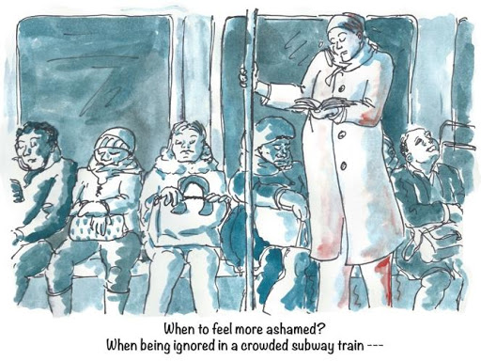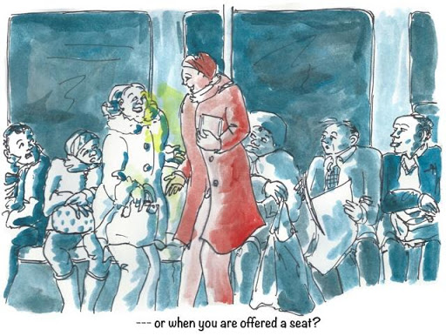

Image Description (left image): An illustration of a crowded subway car. Everyone is occupied with themselves. A woman with a hat is standing in the aisle. Her legs are trembling. Her standing position and shades of red on her coat in the monotone blue-grey of the image mark her as different from the rest of the crowd. Included with the illustration is text, “When to feel more ashamed? When being ignored in a crowded subway train—-”
Image Description (right image): An illustration of a crowded subway car. A passenger offers the woman her seat. The entire figure of the woman is drawn in red and now contrasts sharply with her surroundings. A yellow light between the friendly lady and the embarrassed protagonist symbolize that a more significant emotion than shame might develop here. Included with the illustration is text, “---or when you offered a seat?”
Imagine the following situation: you are well into your third week after chemotherapy. The deepest exhaustion is over, the body has already removed a lot of the healing poison and you are on your way to pick up your daughter from school after one of your many medical appointments. As usual, the subway is fully occupied during the after-work hours. There are no free seats left and you have to remain standing in the aisle. The train continues and then you feel it – the weakness that makes your legs tremble with exhaustion. It's been hitting you more often lately, probably because of the rapid ups and downs of physical processes. You wish for nothing more than for a seat.
Alas! everyone sitting on the benches around you seem to be deep in their own worlds or older in age than yourself. Some of them seem not too stable on their legs themselves, others are packed with bags and groceries. And so you stand there, with your trembling knees and a sinking feeling in your stomach. How desperately would you like to sit down now, indulge the weakness and finally rest? But also, how gladly have you remained invisible among all those people who seem to have a simpler life?
This is what shame feels like. You look like a healthy person, whereas you are not. You want to follow the needs of your body and fear not to do so. Illness, neediness might become visible. You might become visible in a way you do not want to see yourself.
And suddenly there is this woman. She looks tired, maybe from a long day in an office. Friendly and attentively, she offers you her seat.
An Everyday Situation by Anna Faroqhi is licensed under a Creative Commons Attribution 4.0 International License. Based on a work at https://rdsjournal.org. Permissions beyond the scope of this license may be available at https://www.rds.hawaii.edu/.

