Editorial

“Disability in Popular Horror: A New Trend?”
Raphael Raphael, PhD
RDS Associate Editor of Creative Works and Multimedia
University of Hawaiʻi at Mānoa, Center on Disability Studies
Since its inception, film has always been fascinated with disability, although we don’t usually like to mention it. (I have written elsewhere how imagining the disabled body and the experience of having a disability has helped shape the medium of film, in ways largely overlooked or disavowed.) As a genre, horror (which might be the most popular kind of film at the moment) has always been especially interested in disability; the threat of becoming disabled or the threat of being attacked by a character with a visible disability or disfigurement have long been dependable narrative devices. Even when a disabled character is presented as sympathetic, the very experience of having a disability is traditionally imagined as itself a source of terror. For example, in Wait until Dark (1967), we are invited to vicariously experience being a young, sightless Audrey Hepburn faced with threats made horrific precisely by her inability to see.
Recently, in just the past year, a very different trend might be emerging in horror films. Although this trend unsettles many years of cultural scripts about disability, it appears to be largely overlooked in the dominant, charged debates about recent horror films. This new trend---if it’s safe to call it that based on the two most popular recent horror films (A Quiet Place and Bird Box)---appears to imagine disability in an entirely new way. Audiences are invited to imagine having a particular disability, not as a source of fear, but instead as offering some advantage in the film’s story world. In A Quiet Place, a family struggles to survive by staying silent in a post-apocalyptic world inhabited by aliens who viciously attack anything they hear. Similarly, in Bird Box, survival is dependent on being sightless in a post-apocalyptic world filled with strange alien creatures, the mere sight of which will cause one to brutally commit suicide. While recent years’ horror films have continued the genre’s obsession with disabled characters and disability as a central narrative premise (as in for example, Hush), this new divergent trend seems to truly begin with the most successful horror film of last year: A Quiet Place.
The frame of the wildly popular film invites audiences to rethink what disability means. I’m in no way suggesting these films as models of representations of disability. If anything they comfortably fit into long-standing patterns of concerns about disability being everywhere in a film and no-where. (A Quiet Place has though received some praise for featuring an actress [Millicent Simmonds] in a major role with a disability, something still extremely rare in a mainstream, studio film). No one could confuse these films with offering an authentic experience of disability, nor do they approach the standard of “nothing about us without us” that many activists including Dominick Evans have been calling for years. At the same time, in these very popular films, considering the history of the genre’s relationship with disability, audiences do appear to be invited to think about disability in a different way. Instead of being presented as the source of fear, being able to skillfully navigate the world with (or as if one has) a disability is presented as a benefit. In A Quiet Place, living as if one is deaf offers a distinct survival advantage. Existing without the sense of sound and communicating in sign language are both crucial to staying alive in its narrative in which hungry, horrific alien beings are attracted to any sound.
If this is indeed a trend, the trend finds full expression in the recent phenomenon that is Netflix’s Bird Box. While very different films, the two most popular recent films of this cultural moment’s most popular genre, A Quiet Place and Bird Box, share a great deal. Besides being the two most popular films of 2018 (as suggested by Netflix’s viewing data, largely supported by Neilsen’s), most importantly for this discussion, the basic narrative frame of each presents a dystopic vision of family under constant threat from a deadly alien life form. In order to survive, each family must lose a certain ability or refrain from its use. The threat of losing this ability is not a source of horror itself as it frequently has been presented; instead it’s presented as offering a benefit to characters. In other words, both films create worlds in which it pays off to have (or act like you have) a particular disability: being deaf in A Quiet Place and without sight in Bird Box. Recognizing the connection between the films, some fans have called Bird Box A Blind Place.
Despite these connections, all the recent debates on Bird Box have bristled at any connection between the films. They instead choose to frame discussion about both in terms of ‘quality’ debates (‘good horror’ and ‘bad horror’) that have dominated a great deal of public discourse around popular horror and the elevated genre expectations in our post-Academy-Award-winning Get Out era. Compared to the critically acclaimed (and now Oscar-nominated) A Quiet Place, popular critical reviews of Bird Box have not been so kind. A generally favorable review on rogerebert.com says of the film, “It's imperfect, but you probably won't be returning it”; it is among the highest praise it receives in popular criticism.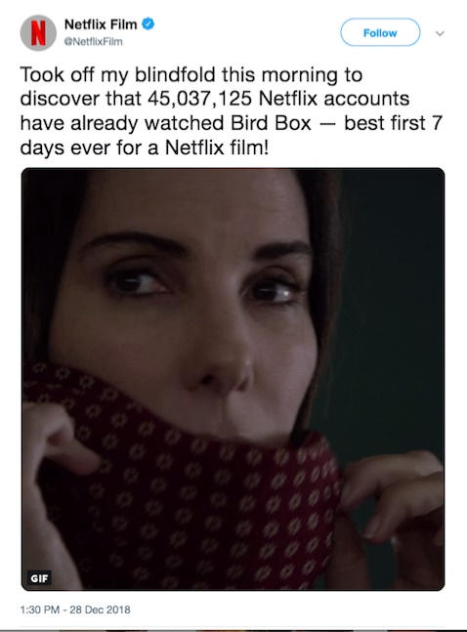
These dominant reactions have successfully controlled discussion, keeping the focus on arguments of quality, rather than consideration of the films’ relationship with disability. This is despite Netflix’s own viral ad campaign for Bird Box foregrounding its central pleasure: imagining what it would be like to be without sight.
Netflix’s first person Twitter feed for its most successful film so far seems to invite viewers to do what the central character of the film is forced to do: wear a blindfold. In the film, an unseen alien life force compels anyone who sees it to gruesomely take their own life. The only way to survive is to live as if one has no sight, wearing a blindfold in any public space. (The film, and this tweet marketing its growing popularity, appear to have unintentionally started a brief, dangerous viral fan campaign #birdboxchallenge in which fans posted videos of themselves completing everyday tasks while wearing a blindfold, including driving!) Moreover, this film inviting audiences to imagine the experience of being without sight is framed as a journey to reach the goal of a sanctuary which we eventually discover is actually a school for the blind.
Bird Box continues to be a central part of the way streaming giant Netflix defines itself in social media. In fact, at the time of this writing, Netflix’s Twitter page clearly announces the film as part of its identity: its ‘personal profile’ on the site identifies Netflix as ”Proud godparent of Boy and Girl” (two central characters of the film).
Summing up, what are we to make of these films and their relationship with larger questions about disability’s changing role in horror? Despite appearing to be central to the ways these narratives are structured, disability goes largely unmentioned in dominant debate about the films and their quality. While unacknowledged, disability appears to be a central informing voice of their narratives. Instead of a source of fear, though, disability appears to be increasingly presented as something of value. If anything it certainly points to viewers’ (and industry’s) continued fascination with disability and how this fascination is difficult to talk about or recognize. If this sounds like praise for these films, it is not. Instead it points to an opportunity the industry does not yet appear to have fully realized. When that happens, I’ll be writing about a wildly popular film that does for ableism what Get Out did for racism.
Your thoughts on these films and/or generally on disability and the horror genre?
Continue the discussion at: @RevofDisStud or @raphaelspeak .

"Disability in Popular Horror: A New Trend?” by Raphael Raphael is licensed under a Creative Commons Attribution 4.0 International License. Based on a work at https://rdsjournal.org/index.php/journal/article/view/923. Permissions beyond the scope of this license may be available at https://rds.hawaii.edu.

