Disability and Shame

Special Issue Forum: Creative Works

Ann’s Scan
Ann Millett-Gallant, PhD
University of North Carolina Greensboro, Bachelor of Arts in Liberal Studies
North Carolina, United States
Abstract: The painting, Ann’s Scan, is a small printed image of one of my brain scans following a Traumatic Brain Injury. The painting includes a plastic glove on the upper right corner and streaks of various colors descending from the glove and on to the brain image.
Figure 1. Ann’s Scan, 12 x 12 in., mixed media on canvas, 2018
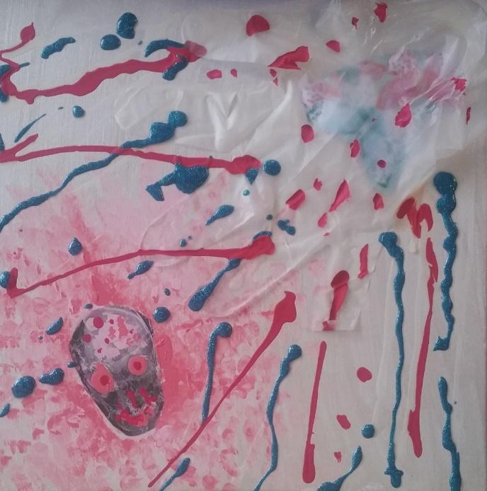
Image Description: This is a square 12 x 12 in. stretched canvas composed of mixed media. In the upper right-hand corner rests a translucent plastic glove that I scavenged from a box of hair dye. Included is a fragment of scrapbook paper patterned with interlocking butterflies with pale aquamarine and salmon hues nestled or hidden inside this mounted, opaque glove. I angled the paper at 45 degrees with the fingers pointing toward a printed image of one of my post-traumatic brain injury scans, which I highlighted with rose-colored paint on the eyes, nose and smile. Luminescent scarlet and blueberry acrylic-paint bursts and drips diagonally through the fingertips of the glove, descending into the space and gathering to cocoon this rosy, egg-shaped and stylized head. The painting is off-center, adorned, and appears to be buoyantly bouncing.
I want the viewer to imagine the streaks of paint escaping, enacting, and altering the problematic medical gaze. I am a congenital amputee who lives, works, writes, and paints with and about the consequences of surviving a Traumatic Brain Injury (TBI). This canvas frames the simultaneous visual pleasure, empathy, repulsion and horror that a viewer may experience, once they know the details about my history. Understanding and accepting the shame I often felt during my recovery inspires me to aestheticize my trauma and emotional/corporeal pain. Shaming is a targeted act, yet it reverberates. Shame feels imposing, abstract and indescribable, and in this work, I attempt to confront it. I materialize shame to communicate that it is never to ‘overcome,’ by the mind nor the body, but that shame can inspire transformation.
Ann Millett-Gallant, Ph.D., serves as Senior Lecturer for the University of North Carolina at Greensboro, by designing and teaching online art history, visual culture, and liberal studies courses. Her research bridges the disciplines of Art History and Disability Studies. Her books include The Disabled Body in Contemporary Art (2010); Re-Membering: Putting Mind and Body Back Together Following Traumatic Brain Injury (2016); and Disability and Art History, co-edited with Dr. Elizabeth Howie (2017). She has also published essays and reviews of art and film, and she enjoys painting and composing mixed-media collages.
Ann’s Scan by Ann Millett-Gallant is licensed under a Creative Commons Attribution 4.0 International License. Based on a work at https://rdsjournal.org. Permissions beyond the scope of this license may be available at https://www.rds.hawaii.edu/.

