Editorial

An Entry for the Irish Sporting Pages: Remember Susan O’Hara
Megan A. Conway, PhD
RDS Editor-In-Chief
I sat down to coffee with one of my students the other day, started dishing out advice, and realized that I was her mentor. And the scary thing was, she was actually listening to me. Throughout my life I have had the good fortune to know other people with disabilities who I have looked up to and who have given me the strength to persevere when things seemed impossible. Realizing that I have come of an age where I can and should do the same for others is sobering.
Photo below is of Megan and Susan at the DSP Graduation in 1992.
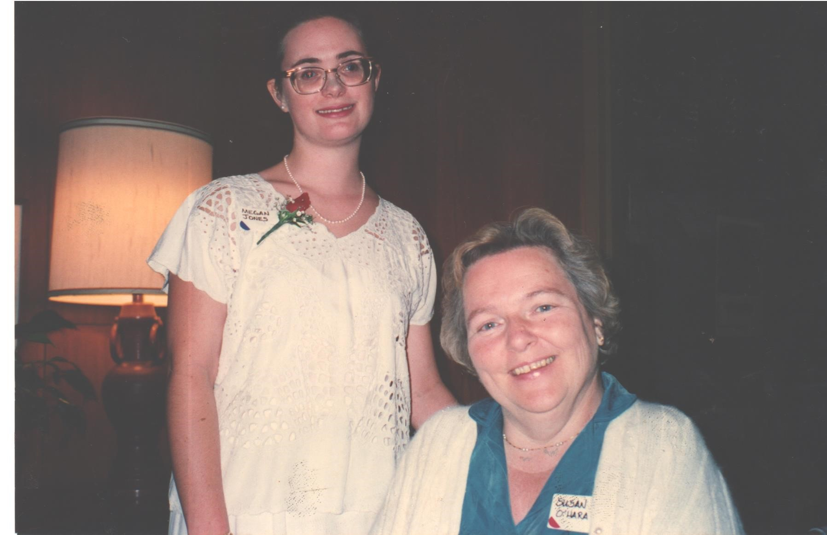
One of my dearest mentors and friends, Susan O’Hara, just passed away this summer at the age of 80. I first got to know Susan thirty years ago when she was Director of the Disabled Students Program (DSP) at UC Berkeley and I was an enthusiastic and overwhelmed Freshman. Susan, a polio survivor, gathered a group of disabled students together on a regular basis to discuss disability issues on campus and offer advice on how to address them. The advice I remember most is, “What are YOU going to do about it?” She encouraged us to identify specific problems that we all shared, think through solutions, and act collectively on those solutions. It seems cheezey to say this, but Susan “empowered” us. She made us feel like whatever life dished up, we could do something about it.
Susan saw the funny side of things that were also unfair or exasperating. A favorite story of mine was her description of first coming to UC Berkeley and visiting the “dorm” for students with severe physical disabilities. Instead of being housed with other students, their dorm was literally a wing of the campus hospital. “When I rolled in there I expected to see a bunch of sick people,” said Susan, “But the first thing that happened was somebody handed me a paper cup of Scotch and I thought to myself, ‘hmmmm, these folks are definitely not sick!’” She was soon to direct Berkeley’s first residential program for disabled students, which moved out of the hospital and into an actual dorm, but she recognized the wonderful irony of the sense of autonomy that students felt from having their own space even if it was in a hospital wing.
I last saw Susan a year before she died after she had been confined to her bed for several years due to illness. I will be honest, when I walked into her room I did expect to see a sick person. “Guess what?” she bubbled conspiratorially as I poured tea and selected from an assortment of cookies on the table next to her bed, “Word has it that Queen Elizabeth is going to step down and pass over Charles to make William King!” “Umm, are you sure about that?” I scrolled through the internet looking for a reputable source for this information. “Yes, my attendant told me so this morning. Can you imagine? What does Charles think about THAT?” “I’m sorry Susan but I can’t find anything that confirms that story is true.” “Oh no,” she crowed, “It looks like I have been the victim of fake news!”
Susan, of unabashed nosy Irish stock, used to call the obituaries the “Irish Sporting Pages.” She loved to read the stories of other people’s lives, or rather what their friends and loved ones thought were the stories of their lives. She was always modest about her own accomplishments; her leadership in establishing one of the first supported living university residential programs for students with severe disabilities, her years working to advocate for (and exemplifying) independent living, her travels abroad, her volunteer work for a Bay Area philanthropic Foundation, her passion for and contribution to the UC Berkeley Disability Rights and Independent Living Movement Oral History Project, and of course the many dozens of young (and old) people like me who she mentored and encouraged.
I bid you “adieu” Susan. If any one of us can contribute half as much material to the Irish Sporting Pages as you did, we will have accomplished much. But we still have time to work on our entry.

An Entry for the Irish Sporting Pages: Remember Susan O’Hara by Irish Sporting Pages: Remember Susan O’Hara Megan A. Conway is licensed under a Creative Commons Attribution 4.0 International License. Based on a work at http://rdsjournal.org. Permissions beyond the scope of this license may be available at https://www.rds.hawaii.edu.

