Research Article

Playing with Normalcy: A Disability Material Culture Analysis
Fady Shanouda, PhD & Karen K Yoshida, PhD
University of Toronto, Dalla Lana School of Public Health
Toronto, Canada
Abstract: We recast a toy figure as a cultural agent of various interlocking and hegemonic discourses, and in particular, explore how normative discourses are reflected in material objects. We suggest that the Toy Gymnast represents and reinforces these discourses and therefore influences how children learn that normative bodies are desirable.
Keywords: Disability; Toy; Childhood

Introduction
We play with them and learn from them, but as pedagogical artifacts, toys are much more than just playthings. In this paper, we explore the significance of toys in educating disabled children about their bodies and their agentic capacities. We explore the role of toys as cultural and pedagogical agents of interlocking and hegemonic discourses. In particular, we focus our analysis on the normative and eugenic discourses in a single child’s toy – the Toy Gymnast. Through a historical analysis of the representation of “ideal/normal” bodies in this toy, we illuminate how these discourses infiltrated a variety of cultures and continue to be embedded in everyday and commonplace objects. In exploring disability in an object often unassociated with experiences of difference, we seek to demonstrate the potential and complexity that a Disability Studies perspective provides to the analyses of everyday objects. Here, we follow Ott’s (2014) claim that disability material culture is found everywhere – and thus, in everything.
During the course of our research in 2011, we discovered the toy among a collection of materials from one participant (who we have given the pseudonym Lynn) who was part of a larger project on the experiences of Canadian polio survivors¹ (Yoshida & Shanouda, 2015; Yoshida, Shanouda & Ellis, 2013). In attempting to preserve memories of their time in the hospital or the rehabilitation center, participants, in addition to keeping iron braces and other medical materials, also intentionally kept items that might be similar to those collected and stored by non-disabled adults: stuffed teddy bears, porcelain dolls, bronzed baby shoes, photos of their younger selves, and childhood paintings and writings. We consider the relation between experiences of disability, race, gender, and heteronormativity and these childhood objects, which are often considered devoid of disability.
The Toy Gymnast (Figure 1), was a gift Lynn received when she was approximately ten years old and seeking treatment for the effects of polio in the hospital during 1949–1950.
Figure 1. The Toy Gymnast, circa 1940s. Photo credit, Karen Yoshida, 2009.
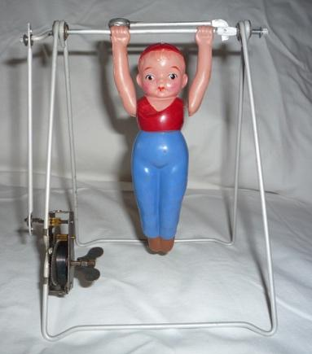

What follows is a detailed description we developed of the Toy Gymnast:
Between two thin steel A-shaped frames – with another thin steel bar between them (resembling a swing set) hangs a white, plastic, male figure. His hat, hair, face, shirt, pants, and shoes are painted on. His hat is red and sits flat on his head covering the majority of his blond hair. His arched eyebrows are spaced perfectly equidistant; his brown/black eyes are open. His cheeks are painted rosy and his lips are pursed. His chest is covered by a sleeveless shirt with a low neckline. The majority of the figure is made up of his legs, painted in blue, and which deceivingly start under the figure’s chest. The ends of the plastic figure’s legs depict shoes, painted in red. The figure is symmetrical, but disproportionate. A small mechanical winder is attached to the bottom of one of the A-shaped frames. When wound, the figure spins around the bar like a gymnast.
Lynn describes her time as a child playing with the object:
I’m not sure who gave me that [the toy object] but it was given to me when I was in the hospital. And I used to, you know, just play with it quite a little bit. And I don’t know; I have no idea who gave it to me. Cause I had so many things given to me at the time. But it was, you know, something I used to play with. There’s a little bar at the top; you can make him go around that if it’s lower, or whatever. Sometimes he just sways; sometimes he goes over the bar and things like that. That was one of the things that was given to me at the time (Yoshida & Shanouda, 2015; Yoshida, Shanouda, & Ellis, 2013).
Although she was given many things in the hospital, in response to our request Lynn selected this item as one of five of the most important objects to her during this time. The other items included a pair of salt and pepper shakers, a bride and groom doll set, and a couple of other dolls. The fact that she retained the gymnast for over 60 years confirms its significance as a cherished material object and as a vehicle for recalling memories of her time in the hospital, experiences of pain/triumph and fear/joy.
Her experiences in the hospital as a disabled person are tied to Lynn’s other identities at the time, as a young, white, woman from a middle-class family. Her disability is constituted in relation to those experiences, and to the materials around her. As Ott (2014) argues, “disability depends on the person, the environment, and the activity” (p. 121). Therefore, in analyzing this disability material culture object, we are cognizant of how the toy represents dominant gendered, racialized, and heteronormative discourses. We suggest that these discourses were powerful forces that contributed to Lynn’s knowledge of herself and that other participants also learned about themselves through their interactions with toys and other materials from their childhood. However, the toys also had the effect of teaching children about their agentic abilities to act upon the material objects around them.

Disability Material Culture
We approach material culture from the perspective of James Deetz (1996), an American historical archaeologist. To Deetz, material culture is not culture per se, but product. Deetz (1996) states that:
Culture is socially transmitted rules for behaviours, ways of thinking about and doing things… All such behaviour is reflected in subtle and important ways in the manner in which we shape our physical world (p. 35).
Material culture is usually linked to the study of artifacts, however, Deetz (1996) advocates for a broader definition of material culture, emphasizing how our ‘world’ is the product of “our thoughts, that sector of our physical environment that we modify through culturally determined behaviour” (p. 35). This definition of material culture is more encompassing and allows us to include everyday objects. According to Deetz (1996), objects such as a common pin, ceramic dishware, headstones, cuts of meat, the scientific breeding of livestock, all of these things are enacted according to culturally derived ideals.
Deetz (1996) also includes our bodies and language as part of material culture. With respect to bodies, material culture is interested in all aspects of kinesics or human motion, for example, parades, dancing, work, etc. For Disability Studies scholars, this is especially significant as the body is so often the site where disability is read. However, by including the physical-social environments that disabled people live in, we reframe disability not simply as an individual experience, but also a socially produced phenomenon. It is in the interaction with everyday objects, including the kinesics of the body, that disability is produced.
McVeigh (1996) adds to Deetz’s (1996) conceptualization of everyday objects by arguing that the insidiousness of the everyday object is in its ubiquity. McVeigh (1996) refers here to the gendered messaging communicated to women in the everyday ‘cute thing’ in Japanese culture, which he argues is pervasive. McVeigh’s (1996) conceptualization of cuteness as everywhere and, therefore difficult to locate and unpack is similar to the conditions that surround the concept of normalcy. Normalcy, as the prototypical condition of the human body and experience, is omnipresent; so much so, that to be normal is considered an optimal and attainable reality. The illusion of normalcy, that it is within one’s grasp, is one of the most powerful and insidious qualities of the concept. This message, much like gendered messaging described by McVeigh (1996), is uninterrupted and communicates beliefs about bodily ideals in everyday objects, such as toys.
Finally, the materials around us, the things we interact with, also have an impact on our understanding of the world. As Brown (2001) suggests, objects “…circulate through our lives, we look through objects (to see what they disclose about history, society, nature, or culture-above all, what they disclose about us) …” (emphasis in original, p. 4). Like windows, objects allow us to look through them to understand something about what is happening around us, and also maybe within us. Brown (2001) also argues, however, that we often fail to contend with the ‘thingness’ of objects, until they fail to work or operate as intended. Still, in breaking, fracturing, or disintegrating, things reveal themselves to us – remind us of their value and incite us to consider our connections to them in what Brown (2001) calls, “subject-object relation” (p. 4). We contend that such reminders help us to understand how things act upon us, and how we act upon and with them.
Examinations of disability material culture exist in the extant literature. Take for example, Ott’s (2002) examination of the history of prosthetics in the U.S. and halifax’s (2014) lyrical exploration of wearing/experiencing boots with lifts – describing it as, “the particular embodiment, that disability is embodied consciousness” (p. 7). Consider also Parrott’s (2005) exploration of the objectification and agency of decorating bedrooms and self-decorating through clothing and accessories of patients in a psychiatric unit. Both Yenika-Agbaw (2011) and Narduzzi (2013) explore how seemingly innocent representations of disabled and non-disabled characters in children’s literature are imbued with ableist discourses that privilege normative bodies often at the expense of disabled and non-normative bodies. There have also been large scale exhibitions of disability material culture. Whatever Happened to Polio? (n.d.), is a multimedia exhibition that tells the story of polio in the United States, including the impact of the disease on American society. Also, Out from Under, is an exhibit of 13 disability material culture objects, which present examples of disability struggle and resistance throughout Canadian history from the perspective of disabled people (Frazee, Church, & Panitch, 2016). This exhibit is now part of the permanent collection in the Canadian Human Rights Museum in Winnipeg, Manitoba.
Our examination, in addition to contributing to the extant literature, also invites scholars to consider objects often unassociated with disability. We hope this close examination, a treasure hunt for disability, will foster deeper analyses of the underlying political and cultural projects that constitute disability as unwanted, incomplete, and disposable. While we could give credit to these ideas to a number of historical events, including the Industrial Revolution, the World Wars, and other contemporary global events, we suggest that the hegemonic notion of normalcy, which constitutes disability as inferior, is a result of the international reach of the eugenics project.

The Construction of Normalcy
The eugenic project reached far beyond the brick and fenced walls of the concentration camps in Germany during the Second World War. Snyder and Mitchell (2006) remind us that the eugenics project was international in scale, it’s racist and ableist ideologies stretching far back into the 18th century and whose affects we continue to experience today. In addition to state practices that enforced eugenic ideologies, including the mass institutionalization and sterilizations of those deemed ‘unhealthy’ and ‘feebleminded’ and the eradication of hundreds of thousands of disabled people, the eugenics project was also a cultural project that constituted the characteristics, measurements, and even possibilities of a healthy, active, and productive human body. This normal body, supported by pseudo-science and a complex system whose goals were carried out by its advocates (Davis, 2006), influenced the construction and manufacturing of everyday objects and materials. The effort to eradicate difference throughout many Western societies in these first decades of the 20th century meant that many cultural objects were embedded with normative and hence eugenic ideologies (Cogdell, 2004).
In relation to children, Smith (2004) argues that eugenics entered the home and the early days of a child’s life through the capturing and categorizing of baby pictures and the ‘family album.’ Sir Francis Galton (as cited in Smith, 2004), the man who coined the term ‘eugenics,’ developed two family albums for parents to document everything about the family, including a specific section on the ‘ailments and illnesses’ of the family. Smith (2004) writes that Galton considered the “rise and fall of families [to be intricately tied and statistically important to] the rise and fall of the races” (Smith, 2004, p. 363). While eugenics may have entered the home through the organization and classification of the family album, it stayed current and influential by infiltrating the child’s toy chest. Ott (2014) describes how toys and baby books are, “powerful eugenic records that reinforce an aspiration to ‘normalcy’ and provide parents with ways of monitoring their children’s development and physical capabilities” (p. 132). The toy specifically, she argues, “can be read as reinforcing cultural beliefs about the undesirability of diversity in bodily difference” (Ott, 2014, p. 132). We can, therefore, classify the toy, any toy, as a disability material culture object. These toys are rooted in eugenic ideology: eliminate ‘defectiveness’ and ensure control over the evolutionary process.

The Toy Gymnast
The following is a disability material culture analysis of the Toy Gymnast. We recast this object as a cultural agent of various interlocking and hegemonic discourses, and in particular, explore how normative discourses are reflected in material objects. We suggest that the Toy Gymnast represents and reinforces these discourses and is therefore, one influence on how children learn that normative bodies are desirable. We trace the toy’s origins and its connection to national and international stages, the circus, the freak show, and the Olympics to demonstrate how commonplace and everyday objects are imbued with normative and eugenic discourses. Finally, and without negating the problematic discourses represented in the toy, we consider how it might also have helped children cope with their new circumstances in the hospital while teaching them about their capacity to act upon and shape the world in ways that could benefit them.

Object’s origins
To start accumulating some of this toy’s history, we began by searching for academic articles or other academic texts that describe the history of the toy; no such source was found. We then searched for other texts that describe the history of the toy; again, to our knowledge, no such document existed. However, in our online search for secondary sources we discovered two patents for toys similar to the Toy Gymnast. Moreover, we consulted with other sources of information and found further connections to the toy at The Strong National Museum of Play (Hogan, 2011). The curator’s interpretations at The Strong and the two patents we discovered help to tell a speculative history of the toy.
Figure 2. Crandall’s The Acrobats, circa 1867. Courtesy of The Strong, Rochester, New York (Hogan, 2011).

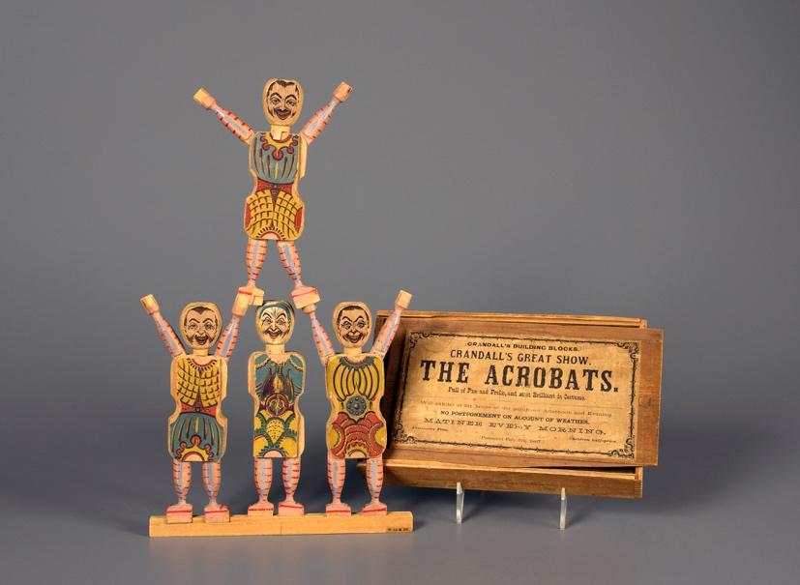

Image Description: Four small wooden figurines stacked on top of each other, three figures on the bottom row and one on the top row, much like a cheerleading pyramid. Beside the pyramid of figurines is a wood box where they are stored with the text, “Crandell’s Building Blocks. Crandell’s Great Show, THE ACROBATS. Full of Fun and Frolic, and Most Brilliant in Costume. Will exhibit at the house of the purchaser Afternoon and Evening. NO POSTPONEMENT ON ACCOUNT OF WEATHER MATINEE EVERY MORNING. Admission Free, Children Half-Price.”
Hogan (2011) provides us with a starting point to understand the fascination with acrobatic and gymnastic toys. She suggests that these toys originated as products meant to represent circus acts and trapeze performers. She argues that Charles M. Cardnall, the inventor of “The Acrobats” (Figure 2), was inspired by the circus acts that were an extremely popular form of entertainment in North America and Europe throughout the later part of the 18th and early 19th centuries (Hogan, 2011). ‘The Acrobats’ are miniature wooden figurines meant to stack on top of each other much like a cheerleading pyramid. While this object has no physical resemblance to the Toy Gymnast, it does represent both acrobatic and gymnastic talent, which is evocative of the object under study. More importantly, ‘The Acrobats’ provide a reasonable explanation for the fascination and popularity of these toys, the circus.
The first incarnation of Jacob Schwennesen’s toy invention – a toy similar to the one Lynn was gifted – was invented in 1872 (see Figure 3). The figure in this invention was connected to two wooden sticks by a short, loose string, which was threaded between the figure’s hands. Opposite from the figure, the player would squeeze the ends of the sticks, and the figure would then spin around the string in whimsical and silly ways. This toy, much like Cardnall’s ‘The Acrobat,’ was meant to portray the capabilities of a gymnast.
Figure 3. The Patent Drawings for Jacob Schwennesen’s Toy Invention, circa 1872 (Schwennesen, 1872).
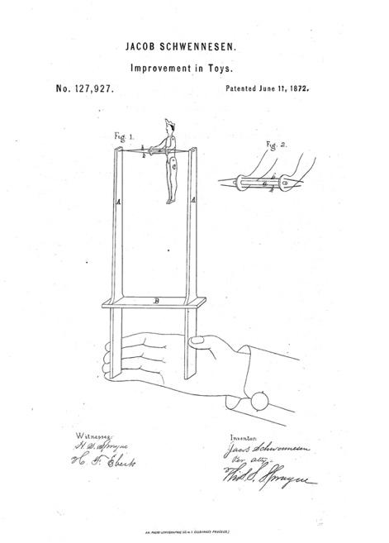

Image Description: A patent drawing of a small figure attached by a string to two wooden sticks, which when squeezed force the figure to spin around on the string. The drawing includes the text, “JACOB SCHWENNESEN. Improvement in Toys. No. 127, 927. Patented June 11, 1872. Witness [signature of two witnesses] and Inventor [signature of three inventors].”
Mechanical versions of the toy were not far behind. In fact, the patent for H. L. Brower’s first automatic toy was in 1873—just one year after Schwennesen’s original patent.
Figure 4. The Patent Drawings for Henry. L. Brower’s Invention, circa 1873 (Brower, 1873).
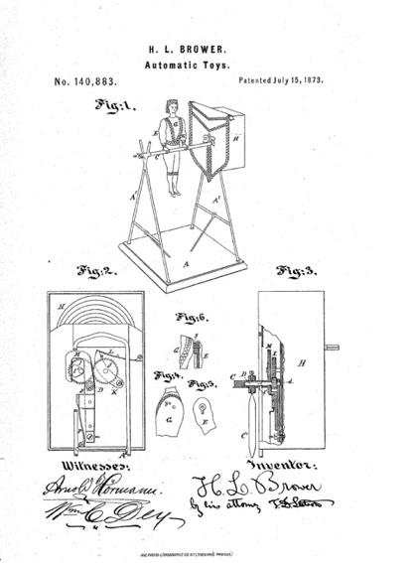

Image Description: A patent drawing of a small figure attached by a string to two wooden sticks, which when squeezed force the figure to spin around on the string. The drawing includes the text, “H. L. Brower. Automatic Toys. No. 140,883. Patented July 15, 1873. Witness [signature of two witnesses] and Inventor [signature of two inventors]”. This version includes a more stable base, and a widening mechanism.
Brower (1873), the inventor, describes the toy:
I make [sic] a toy image of an athlete with a bar capable of being revolved and oscillated and combine therewith clock-work and peculiar gearing which gives the bar such motions as [sic] induces a variety of fantastic movements. The figure if formed with a catch at the junction of one or both the arms with the body, to prevent an unnatural backward movement. The figure actuated by the mechanism performs partial or complete revolutions alternately in opposite directions around the bar under conditions which cause the movements to vary irregularly at nearly or quite every oscillation (p. 1).
In addition to explaining how the toy works, what is especially fascinating about Brower’s (1873) explanation is that he notes how the new mechanism now produces a more realistic representation of human movement. The toy figure no longer moves in fantastical ways; ‘unnatural backward movement’ has been eliminated. One must wonder why a toy would require such restrictions. It suggests that the toy is more than a plaything, rather, that meaning and knowledge are being conveyed and communicated between the player and the toy.
In addition to limiting the toy’s movements to represent more humanist features, the toy’s physical appearance also shifted during this time to closely resemble a human boy/man. We credit this shift to the changes in manufacturing material. With the introduction of plastics and specifically celluloid (between 1870–1920) we found that figures became more human like and representative of ideal human forms (Figure 5).
Figure 5. Antique USSR Child Mechanic Celluloid Toy Gymnast, circa 1950s. Courtesy of Global Antiques (n.d.).
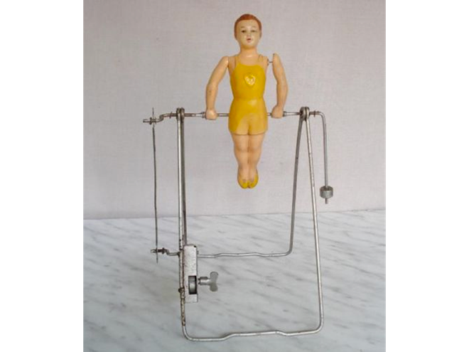

Image Description: Between two thin steel A-shaped frames – with another thin steel bar between them (resembling a swing set) hangs a white, plastic, male figure. A small mechanical winder is attached to the bottom of one of the A-shaped frames. When wound, the figure spins around the bar like a gymnast.
In Figure 5, the body is now more refined, with slightly bent arms at the elbow, more refined legs showing kneecaps and calf muscles; the face is given depth with sculpted cheeks and nose. The body depicted here is a well-formed, strong, white, male, gymnast. Although there are slight variations between Lynn’s Toy Gymnast and the toy in Figure 5, they are still very similar in style and composition. However, Lynn’s Toy Gymnast was mostly likely manufactured in Japan during its occupation by the U.S. in the 1940s (1945–52). The toy in Figure 5 was manufactured in Russia during the 1950s. After the 1930s we found that many figures had the same or similar features and that they all began to represent a single ideal body type: male, white, strong, and symmetrical. The toys all had perfectly shaped or sculpted arms; smaller higher waists; larger, further apart open eyes; and, proportional long legs. We found this to be an international phenomenon with objects discovered from around the world all having the same or similar features.
There are versions of the Toy Gymnast still sold today. At the time of publication, Hasbro has a version of the toy called, ‘Fantastic Gymnastics Game.’ This version allows the player to mechanically swing the figure back and forth on a bar and then release the figure in an attempt to ‘stick a landing’ on a velcro mat. This toy more accurately depicts the movements of modern or contemporary gymnasts in popular arenas, like the Olympics.

Playing with Normalcy
Any examination of the Toy Gymnast must start with the circus. In addition to being a major source of entertainment in the late 18th and 19th centuries, the circus also embodied all the curiosity and potential of human capacity that marked this time in history (Assael, 2005). Much of this curiosity was about the body itself, it’s potential strength and flexibility and its limitations or exceptionalities. Visitors to a circus would explore the human strength and agility of gymnasts, acrobats and contortionists and at the same time wonder, gawk, and stare at the fat, disabled, hairy, tall, and deformed bodies of the freak show. Freak shows were, after all, a major part of many famous circuses, such as those developed by P.T. Barnum (Garland Thomson, 1996). The circus and freak show, in sharing the same space, under the same big tent, offered opportunities for comparison and reinforcing of notions of ideal versus undesired bodily traits. The significance of the circus in relation to the freak show reinforces our thesis that the gymnast, and its representation in the toy, embodies hegemonic normative and eugenic discourses that constitute the normative body as desirable.
These normative discourses, embedded in the plaything, transform into expectations. This has both real and symbolic impact on the player and one’s understanding of disability, movement, and capacity, especially when one is playing with such a toy in the hospital. Varga and Zuk (2013), argue that books, toys, and other pedagogical tools have the ability to shape a player or child’s experience and understanding. The Toy Gymnast depicted an ideal human figure that symbolically perpetuated and promoted normative expectations about the body and movement (Davis, 2006). The toy, as a symbolic representation of normalcy, shaped the participants’ desired body. This is reinforced given the location, the proximity of the toy to the hospital, which is often a site for practices of normalcy.
We include in these practices all of the efforts undertaken to correct bodies effected by polio: surgical procedures, the casting of limbs, fusing of ankles, the use of hot wool towels which preceded the stretching of muscles (an often-painful experience as recalled by participants), and the rubbing of cocoa butter onto paralyzed legs to promote greater movement. Lynn and her family, like others, subjected themselves to various procedures to achieve or try to achieve normalcy:
I was walking with two braces and the crutches, but I was walking […]. Now from that [10 years old] until I was about 18 or 19, I think probably […] – in and out of [the hospital]. And they did umpteen surgeries there (Yoshida & Shanouda, 2015; Yoshida, Shanouda, & Ellis, 2013).
Her use of the word “umpteen” meaning “countless” or “innumerable” suggests that corrective surgeries became a commonplace and regular practice for Lynn and her family. In other parts of her interview, she recalls the many visits she made to the hospital throughout her young life. Our suggestion of the real and symbolic impact of normative discourses is especially revealing in Lynn’s case – however, this should not be considered anecdotal evidence. Of the 36 participants interviewed for our larger study, 24 of them had at least one surgery, with 11 participants describing having to undergo multiple corrective surgeries as children. Certainly, many of the surgeries were necessary; however, participants also described some of the surgeries as ‘utter failures,’ ‘experiments,’ and as ‘unwanted.’²
Moreover, the hospital, as the site where play was taking place, was not a welcoming space for bodies of difference. Lynn articulates this well. When asked if they traveled by wheelchair in the hospital, Lynn reveals the extent to which walking was not simply the most desired outcome, but the expected one:
No, no. No wheelchairs. I was never, ever put in a wheelchair. They didn’t even have such things, in the hospital. Maybe they did for transporting. But see you were expected to walk. If you didn’t walk, you were in bed. And that was it. […] And I remember getting up on my braces the first time and standing on crutches being pretty proud of myself. And my Mom and Dad just almost in tears seeing me there. But that’s what it was. I mean you either walked or you didn’t do anything, you were in bed. But there was NEVER a thought of anybody using a wheelchair. At least when I was there; now that was the way we were (Yoshida & Shanouda, 2015; Yoshida, Shanouda, & Ellis, 2013).
By removing wheelchairs and enforcing the desire to return to a supposed normative state, to walk again, hospitals ensured that bodies out of bounds would strive to reclaim their normalcy. This expectation was part of an emerging rehabilitation philosophy shaped by the aftermath of the Second World War (Anderson, 2011). Medical ideology of bringing back individuals to complete and healthy bodies was in many ways mirrored in the effort throughout Western countries to rebuild the nation state. Therefore, the disabled body, the body out of bounds, needed to be brought back in line with the image of the nation state as a healthy body (Garland Thomson, 1997; Lacom, 2002).
Nation building, according to Davis (2006) refers to a process of constructing a strong and powerful national image by perpetuating the dominance of the normal in everyday civilian lifestyles, including reinforcing normative body types and movement. The toy contributed to this dominance of normalcy by being a representation of what the body should look and act like, much like the gymnast in the circus (Davis, 2006). In fact, as Assael (2005) argues, the circus was a site of ‘consolidated patriotism’ where the theater of war was on display and patriotic representations were available for mass consumption. Thus, the toy body can be seen as a metaphor for the robustness and capacity of the national body. If one did not fit this image, or if one’s body was different from this form, (e.g. disabled, disfigured, other) then they were thought not to be able to contribute to society and were also seen as a potential burden on the nation (Davis, 2006).
The importance of a normative body to nation-building is also reflected in the Olympic movement. After all, the Toy Gymnast depicts an athlete and its continued popularity, even the existence of the toy, after both the circus and freak show lost their appeal in the late 19th century can be tied to the success of the sport at the largest athletic tournament in the world, the Olympics. Of course, the Olympics have always represented a normative ideal, but not more so than in 1936 when it was held in Berlin, Germany, just before the start of the Second World War. McFee and Tomlinson’s (1999) analysis of Leni Riefenstahl’s film Olympia of the 1936 Berlin Olympic Games and selected aspects of Reifenstahl’s film Triumph of the Will of the 1934 Nazi Party Nuremberg Congress—demonstrate how Riefenstahl’s emphasis on a visual celebration of the human body –using classical Greek antiquity– provides a representation of innocence. In addition, it diverts attention away from the racist and ableist values, and ideologies that are reproduced in the film. Specifically, the film in its opening scenes depicts a Greek landscape, with statues of antiquity that transform before our eyes into ‘live Aryan bodies,’ white, naked, strong, muscular, symmetrical and athletic. These figures throw the discus and the javelin, and we see the torch relay move through different regions in Europe before it reaches Berlin. According to McFee and Tomlinson (1999), the torch relay serves to link Berlin (and we suggest, by extension, the Nazi regime) with that classical past. While there is no accompanying commentary, the film speaks volumes about the type of body that is to be celebrated. We cannot ignore the fact that at the same time the Olympics were taking place, thousands of disabled people were being rounded up in Germany to be institutionalized and sterilized. An estimated 300,000 – 400,000 disabled people were sterilized before and during the Second World War, including individuals diagnosed with feeblemindedness, schizophrenia, and epilepsy (Snyder & Mitchell, 2006; United States Holocaust, n.d.). This does not include the hundreds of thousands of disabled people who were murdered by the Nazis during the Second World War.
The Berlin Olympic Games also hosted a shattering moment for the ‘science’ that constituted whites as racially superior – Jesse Owens’ four Olympic gold medals. This was a significant moment in history that reflected negatively on the Nazi Regime which had spent so much time and money ensuring a victory for their athletes. Still, Jesse Owens’ victory at the Olympics was not reflected in American material culture, especially in the figures and images that represented athleticism. For decades after Owens’ wins, children’s toys continued to depict prominent individuals as singularly white. Negative depictions of black people in children’s literature and the racist embodiment of black people in the Golliwog would continue for decades. Wilkie (2000) provides some clarification on this matter, suggesting that “toys not only mirrored societal ideals that emphasized Aryan features (blond, blue-eyed, fair-skinned), but also reflected racial stereotypes” (p. 105). The Toy Gymnast, as we described before was always depicted as white, even when manufacturing of the toy was not in Western countries. By ensuring that these pedagogical tools also reflected ideal physical features, the toy reproduced normative portrayals of whiteness and ensured the representations of white supremacy persisted. Although it may seem like an overstatement to constitute such authority onto a toy, any attempt to extricate the toy from the racial discourses it represents is problematic. Varga and Zuk (2013) make this especially clear when they argue that to “…disentangle the discourse of white childhood racist representation... [without acknowledging this action as,] ...an assertion of racial power [is] to reinstate a hierarchical order of human values that serves white interests” (p. 665). In the banality of playing with the Toy Gymnast, racist discourses are reproduced and racial hierarchies, which were equally inscribed onto society through the eugenic project, are reflected.
Others may suggest that a young woman playing with a figure so overtly masculine may be a moment of subversion. Young women did of course play with dolls and other traditionally female playthings in the hospital. Lynn is a primary example of this as she played with both dolls and the Toy Gymnast. However, to understand how heteronormative discourses might play out in this particular moment it is essential to consider Lynn’s gender in relation to her disability. Lynn’s femaleness might have prevented closer inspection or surveillance of the items she was playing with, and as such, she may have been able to play with toys traditionally for both male and female players. In fact, as Grant (2004) argues, it was young men’s interactions with playthings during this time that was of particular concern for medical authorities. Grant (2004) argues that boys who played with dolls or other traditionally female items, could become subject to medical or clinical intervention; to prevent them from becoming ‘sissies.’ Additionally, disabled bodies, including Lynn’s at the time, have a long history of being denied sexual experiences (Shakespeare, Gillespie-Sells, & Dominic, 1996). These dominant assumptions persist about disabled people’s inability to participate in sexual experiences (Kauffman, Silverberg, & Odette, 2003). Lynn, at the time of acquiring her disability would have been thought of as ‘damaged goods’ (Phillips, 1990), and therefore, both marriage and children would have been unthinkable and often times cautioned against. The same heteronormative expectations that exist for the rest of society do not always come into play for disabled people. Here, disability offers scholars an interesting limitation to heteronormative discourses; what happens when sexuality is considered not only inappropriate and dangerous, but also impossible?
The male representation of the Toy Gymnast, however, is still an important consideration in this analysis as it helps illustrate how normative and gendered discourses interlock. Thomas (2003) suggests that Barbies and other traditionally female playthings were culturally associated with gendered ideals of passivity, nurturing, and submission. These are not traits or characteristics commonly associated with the promotion of normalcy. In fact, a Disability Studies perspective draws us to consider how the Toy Gymnast, in enacting heteronormative male ideals—such as stoicism, perseverance, and self-reliance—was a purposeful gift that sought to instill in the player a drive to walk again, heal, and be active. After all, what was being asked of these children was not for them to care or nurture their bodies. Rather, quite the opposite. Like an athlete or a soldier, they were being asked to contort, manipulate, and essentially push their bodies to the edge. The Toy Gymnast was meant to inspire such movement and passion, swinging, rotating, swaying, always patterned, in flow, and in keeping with the pace. Furthermore, playing with dolls, which young women did in the hospital might have been a way for them to practice traditional female traits such as care, and express the affection and support they may have desired from family and medical staff who were pushing them so hard.

Learning agentic capacity
To continue this line of thought and as a way to avoid, what Baxter calls, “the imperial practices of adults”, that is the possibility of only discussing the object as it is reflected from the perspective of older individuals, we want to consider the possibility of the toy as an element that helped children cope with their changing circumstances (as cited in Brookshaw, 2009, p. 380). Moshenska (2008) describes how children’s collections of shrapnel during the Second World War, for both play and trading may also be read as a means of coping with the ravages of the War. Collecting and then playing with these once violent objects, Moshenska (2008) argues that this might have been a way for children to mitigate their experiences of war. We could argue that much like the children in war-torn Britain, but not analogous to those experiences of war, children affected by polio also relied on the material objects around them to make sense of and cope with the new conditions of their bodies. Although not shrapnel, toys and things they received from parents, siblings, and family members meant a considerable amount during this transition when many were forcibly confined to beds or iron lungs. The Toy Gymnast, powerful, muscular, mobile, the antithesis to the majority of the children’s experiences of their bodies at the time, in addition to promoting a particular discourse of normalcy may also be read as a tool that helped mitigate polio-children’s new circumstances. After all, the Toy Gymnast, mobile as he may be, also required the act of a child to move him. His actions and representation, although clearly hyper-normative, were also dependent on others and not without limitations. Moshenska (2008) theorizes that the collecting, ordering, and trading of shrapnel was about children’s attempts to regain a sense of power, specifically in relation to controlling the material that was causing the fear and death around them. Unlike shrapnel, the materials of disease, and specifically of polio, were out of reach for most children. Wheelchairs, stethoscopes, leg braces, cribs/beds, iron lungs as well as the hospital rules were not easy for children to manipulate, although they tried. One participant described spitting games from the confines of her crib and tossing balls back and forth and making staff retrieve them when they were dropped. Children in iron lungs, who only had the capability of using their mouths or face to manipulate the world around them, often used mirrors attached to the iron lung to communicate with each other and to play. Although they were confined, children did find ways to act upon and control the space around them, even in small ways, like in their ability to wind-up the mechanism that allowed the Toy Gymnast to sway. We suggest that in having this capacity to act upon the world around them, children learned about their agentic capabilities. The agency they learned, through playing with toys and other objects in the hospital, would prove to be beneficial as they grew up and had to actively navigate an inaccessible and often discriminatory society. The Toy Gymnast therefore was a site of learning both about how their bodies were different and could be classified as broken and non-normative (and in need of repair), but also how they could reject those discourses (however difficult) and act upon the material elements around them to change them to fit their needs. We return to Lynn, one final time for an example of how this worked. As Lynn expressed earlier, using a wheelchair was not an option in the hospital and for most of her life she adopted similar normative discourses, of perseverance and independence by opting not to use a wheelchair. However, Lynn did eventually decide to use a wheelchair in her place of employment. Her decision allowed her to continue to work and she negotiated its use in the workplace. Lynn does not attribute her use of the wheelchair later in life to playing with a Toy Gymnast as a child, nor are we arguing that this is the case. Rather, we are contending that as powerful and omnipresent as heteronormative discourses are in society and in the material things around us, especially around children, disabled people did push back against those discourses and practiced an agentic force that allowed them to advocate for access to work, love, life…and play.

Conclusion
We present in this paper a demonstration of the potential a Disability Studies perspective offers to material culture analyses. Although disability was an immanent part of the contextual history of this object, we have demonstrated the breadth and depth that a disability material culture analysis can provide to scholars. In addition to considering the gendered, racialized, and heteronormative features that are represented in the Toy Gymnast, and the spaces within which children were playing with it, we must also consider what messaging is being communicated to children about bodies of difference. The messaging that reinforces bodies of difference as inferior, incapable, or that more subtlety encourages normative and unattainable representations of the body need to be rejected and critiqued.
We cannot ignore the fact that this Toy Gymnast, for long parts in its history was made from celluloid, a highly flammable and combustible material that was later banned from use precisely because of its dangerous properties. We contend that there may be no better metaphor for the illusion of normalcy than to be compared to such a hazardous and precarious material. Normalcy is ultimately a harmful concept that does little else but create division in society and isolates those who fail to meet its unattainable standards. For those of us who are different, other or disabled, normal has always been an illusion, a mirage of significant proportions, with a devastating and deadly history. We have read this history onto the Toy Gymnast, a seemingly innocent plaything given to a child as a means to keep them company during their stay in the hospital. However, as we have demonstrated, the toy was also a cultural agent imbued with various hegemonic discourses that have, for those who played with it, both symbolic and real impact.
Fady Shanouda, PhD, Candidate at the University of Toronto. His research focuses on mapping disabled and mad students experiences of disclosure in higher education. Fady has published scholarly articles on issues related to Canadian disability history, disabled children’s experiences in primary school in the 1950s, and on barriers related to e-voting and online voting for disabled people.
Karen K. Yoshida, PhD, is a Full Professor in the Department of Physical Therapy and a full member of the Graduate Department of Rehabilitation Sciences, the Dalla Lana School of Public Health, University of Toronto. She received her Ph.D. in Community Health (Sociology of Health/Disability) and has been an active part of the disability community for over 25 years.

Acknowledgement
This research was supported by the Social Sciences and Humanities Research Council of Canada [grant number 410–2009-2272], awarded to Karen K. Yoshida as Principal Investigator.

References
Anderson, J. (2011). War, disability and rehabilitation in Britain: ‘Soul of a nation’. Manchester: Manchester University Press.
Ask Ottawa, British aid to fight prairie polio. (1953, August 15), The Globe and Mail.
Assael, B. (2005). The circus and Victorian society. Charlottesville: University of Virginia Press.
Brower, H. L. (1873). Automatic Toys. Patent No. 140883. Retrieved March 15, 2017, from https://patentimages.storage.googleapis.com/pdfs/d31913648c68478fe9f2/US140883.pdf
Brookshaw, S. (2009). The material culture of children and childhood: Understanding childhood objects in the museum context. Journal of Material Culture, 14(3), 365–383.
Brown, B. (2001). Thing theory. Critical Inquiry, 1(28), 1–22.
Cogdell, C. (2004). Eugenic design: Streamlining American in the 1930s. Philadelphia: University of Pennsylvania Press.
Davis, L. (2006). Constructing normalcy: The bell curve, the novel, and the invention of the disabled body in the nineteenth century. In L. Davis (Ed.), Disability studies reader: Second edition (pp. 3–16). New York and London: Routledge.
Deetz, J. (1996). In small things forgotten: An archeology of early American life. Toronto and New York: Anchor Books, Random House.
Frazee, C., Church, K., and Panitch, M. (2016). Fixing: The claiming and reclaiming of disability history. In C. Kelly & M. Orsini (Eds.), Mobilizing metaphor: Art, culture, and disability activism in Canada (pp. 25–52). Vancouver and Toronto: UBC Press.
Garland Thomson, R. (1996). Introduction: From wonder to error – A genealogy of freak discourse in modernity. In R. Garland Thomson (Eds.), Freakery: Cultural spectacles of the extraordinary body (pp.1–22). New York: New York University Press.
Garland Thomson, R. (1997). Extraordinary bodies: Figuring physical disability in American culture and literature. New York: Columbia University Press.
Global Antiques, (n.d). Retrieved March 15, 2015, http://www.ebay.com/usr/globalantiques
Grant, J. (2004). A “real boy” and not a sissy: Gender, childhood, and masculinity, 1890–1940. Journal of Social History, 37(4), 829–850.
halifax, n. v. d. (2014). Reading boots: Reading difference. Radical Psychology, 8(1), 1–15.
Hogan, P. (2011). Charles M. Crandell toys—Vintage playthings, modern play [Blog post]. Retrieved April 20, 2015, from http://www.museumofplay.org/blog/play-stuff/2011/03/charles-m-crandall-toys
Kauffman, M., Silverberg, C., & Odette, D. (2003). Ultimate guide to sex and disability : For all of us who live with disabilities, chronic pain and illness. San Francisco: Cleis Press Inc.
Lacom, C. (2002). Revising the subject: Disability as “third dimension” in “Clear Light of Day and You Have Come Back”. NWSA Journal, 14(3), 138–154.
McFee, G., & Tomlinson, A. (1999). Rienfenstahl’s Olympia: Ideology and aesthetics in the shaping of the Aryan athletic body. The International Journal of the History of Sport, 16(2), 86–106.
McVeigh, B. (1996). Commodifying affection, authority and gender in the everyday objects of Japan. Journal of Material Culture, 1(3), 291–312.
Moshenska, G. (2008). A hard rain: Children’s shrapnel collections in the Second World War. Journal of Material Culture, 13(1), 107–125.
Narduzzi, D. (2013). Regulating Affect and Reproducing Norms: Alice Munro's" Child's Play". Journal of Literary & Cultural Disability Studies, 7(1), 71-88.
Ott, K. (2002). The sum of its parts: An introduction to modern histories of prosthetics. In K. Ott, D. Serlin, & S. Mihm (Eds.), Artificial parts, practical lives: Modern histories of prosthetics (pp.1-44). New York: New York University Press.
Ott, K. (2014). Disability things: Material culture and American disability history, 1700–2010. In S. Bruch, & M. Rembis (Eds.), Disability histories (pp. 119–135). Urbana, Chicago, and Springfield: University of Illinois Press.
Parrott, F. R. (2005). ‘It’s not forever’: The material culture of hope. Journal of Material Culture, 10(3), 245–262.
Phillips, M. J. (1990). Damaged goods: Oral narratives of the experience of disability in American culture. Social Science and Medicine, 30(8), 849–857.
Schwennesen, J. (1872). Improvement in Toys. Patent No. 127927. Retrieved March 15, 2017, from https://docs.google.com/viewer?url=patentimages.storage.googleapis.com/pdfs/US127927.pdf
Shakespeare, T., Gillespie-Sells, K., & Dominic, D. (1996). Sexual politics of Disability: Untold desires. London & New York: Cassell.
Smith, S. M. (2004). Baby picture is always perfect: Eugenics and the reproduction of whiteness in the family photograph album. In V. R. Schwartz, & J. M. Przyblyski (Eds.), The Nineteenth-century visual culture reader (pp. 358–370). New York: Routledge.
Snyder, S. L., & Mitchell, D. T. (2006). Cultural locations of disability. Chicago: University of Chicago Press.
Thomas, J. B. (2003). Naked Barbies, warrior Joes, and other forms of visible gender. Urbana & Chicago: University of Illinois Press.
United States Holocaust Memorial Museum. (n.d.). Mentally and Physically Handicapped: Victims of the Nazi Era. Retrieved March 18, 2017, from https://www.ushmm.org/m/pdfs/2000926-Handicapped.pdf
Varga, D., & Zuk, R. (2013). Golliwogs and teddy bears: Embodied racism in children’s popular culture. The Journal of Popular Culture, 46(3), 647–671.
Whatever Happened to Polio?. (n.d.). Smithsonian National Museum of American History. Retrieved March 19, 2017, from http://amhistory.si.edu/polio
Wilkie, L. (2000). Chapter 8: Not merely child’s play: Creating a historical archeology of children and childhood. In J. S. Derevenski (Ed.), Children and Material Culture (pp. 100–114). London & New York: Routledge.
Yenika-Agbaw, V. (2011). Reading disability in children's literature: Hans Christian Andersen's tales. Journal of Literary & Cultural Disability Studies, 5(1), 91-108.
Yoshida, K. K. and Shanouda, F. (2015) A culture of silence: Modes of objectification and the silencing of disabled bodies. Disability & Society, 30(3), 432–444.
Yoshida, K. K., Shanouda, F. and Ellis, J. (2013). An education and negotiation of difference: The ‘schooling’ experiences of English-speaking Canadian children growing up with polio during the 1940s–1950s. Disability & Society, 29(3), 345–358.

Endnotes
1. This paper is part of a larger academic–community research project that focuses on documenting the oral life histories of Canadians who contracted polio prior to 1955 (see Yoshida & Shanouda, 2015; Yoshida, Shanouda & Ellis, 2013).
2. Our research discovered other treatments used to combat polio including serums, nasal sprays marketed as preventative measures, and even the Globe and Mail (1953) reported on a San Francisco treatment that used non-poisonous snake venom.

Playing with Normalcy: A Disability Material Culture Analysis by Fady Shanouda & Karen K. Yoshida is licensed under a Creative Commons Attribution 4.0 International License. Based on a work at https://rdsjournal.org. Permissions beyond the scope of this license may be available at https://www.rds.hawaii.edu.

