Multimedia

A Question & Answer with
Helen S. Cohen, Filmmaker of States of Grace
Raphael Raphael, PhD
RDS Associate Editor of Creative Works and Multimedia
Abstract: This article provides a brief discussion with the filmmaker Helen S. Cohen about her process creating States of Grace, a documentary that, over the course of four years, documents the rehabilitation of a physician critically injured in a car crash. The article including what Cohen has learned about disability in the process, the remarkable reactions she has received from others who have seen the film, and how this film fits in the larger trajectory of her practice as a filmmaker.
Keywords: rehabilitation, documentary film
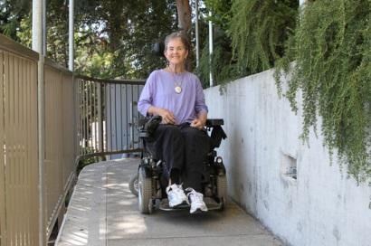
The documentary film States of Grace, created by Helen S. Cohen and her husband Mark Lipman, captured over the course of more than four years, intimately documents the rehabilitation of Dr. Grace Dammann, a physician who is critically injured in an automobile accident. It depicts her battle with and eventual acceptance of her condition. In her transformative experience, Grace is nurtured by the care of family and friends, particularly her partner, Furyu Nancy Schroeder (Fu), a Zen Buddhist Abbess. This article provides a brief discussion with the filmmaker Helen S. Cohen about her process creating the film, including what she has learned about disability, the remarkable reactions she has received from others who have seen the film, and how this film fits in the larger trajectory of her practice as a filmmaker.
Photo 1 Dr. Grace Dammann outside the rehabilitation facility in San Francisco. Photo credit: Mark Lipman.
RDS: As you undertook this work there surely was no way for you to anticipate what would ultimately happen. Thinking about your experience with making this film, what would you say you learned about disability in the process? And how might you place this in some dialogue with what you might have felt about disability before making the film?
HC: The subject of States of Grace, Dr. Grace Dammann, is an old close friend of mine, so making the film was a deeply personal and profound experience for me. Mark (my husband and co-director/cinematographer) and I set out to witness and document a process whose trajectory was completely unknown to us. The whole realm of trauma and disability and rehab was new, and we learned a tremendous amount in the process – four and a half years of following Grace and her family in the aftermath of the accident.
I was familiar with the world of developmental/cognitive disabilities since I have a daughter who is on the autism spectrum, and I knew Sabrina, Grace’s daughter, since she was born so I [had experience with a person using] a wheelchair and/or walker [to] navigate life with some physical limitations. But documenting Grace’s recovery and process of coming to terms with her severe disabilities and limitations was an eye opening experience, to say the least. Particularly watching someone who was so productive and active and independent have to deal with being utterly dependent on others for her acts of daily living – this was a humbling as well as inspiring part of the journey for me.
Since finishing the film and traveling with Grace all over the country to screen the film at conferences, festivals, and medical institutions, I’ve experienced another round of learning and eye-opening – really seeing what it takes to negotiate life in the world when you are in a wheelchair and dependent on others for just about everything. In addition to realizing how un-accessible things are – even things that are designed to be so! – I’ve also witnessed how people with disabilities are perceived or ignored or misunderstood by the public.
And I’ve learned what it takes to be someone’s caregiver, and have a whole new appreciation for the role of family members or people who do that for a living. But Grace is pretty unique because of her Buddhist perspective, her background as a doctor, and her personality. Being Grace’s caregiver when we travel has been a real privilege and honor, and we’ve made sure to have fun wherever we go. This is her mantra in life and I’ve bought into it completely!
RDS: You were obviously very close with the subjects of the film and were provided very intimate access. Can you speak a little in general terms about your methodology of creating this film?
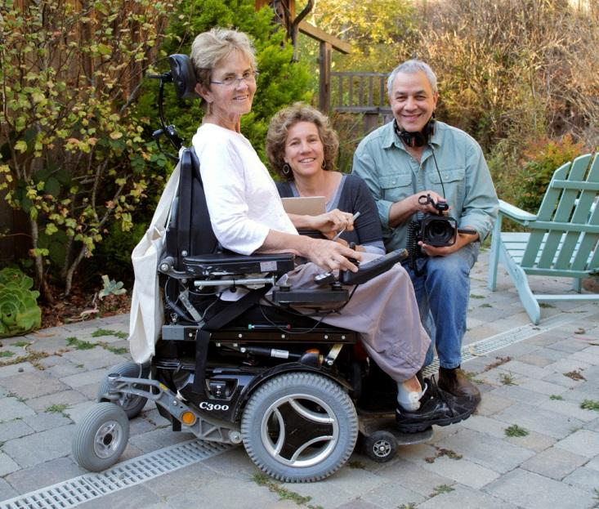
HC: As I mentioned, Grace and I are old dear friends which is what made it possible for us to make the kind of film that we did – intimate, vérité, and observational – following the process as it unfolded with no other agenda than to witness, document, and to some extent probe the meaning, insights, and lessons that were being learned by the subjects themselves. It was quite difficult at times for me to navigate the divide between friend and filmmaker, particular during the times when the going got tough and Grace went through some very painful times.
Photo 2 Dr. Grace Dammann with directors Helen S. Cohen and Mark Lipman. Photo credit: Nancy “Fu” Schroeder.
It helped that Mark did not know her as well prior to the accident and, as cinematographer ([he was] basically the entire crew), he could just keep shooting and following the story where it took us. Mark really kept his eye on the ball and was the engine that kept the filmmaking process going throughout the nearly five years we were filming. He kept in touch with Grace about her appointments and activities and would show up to film on his own many times; we scheduled interviews with Grace, Fu, and Sabrina periodically to check in about everything, and I conducted the interviews. We used the audio from these interviews to “narrate” the film, editing it pretty seamlessly into the vérité material.
RDS: Watching your film, as a viewer, with the intimate glimpse you provide, it is very easy to become very invested in the lives of your subjects. With this in mind, are there any relevant updates about the essential people in the film that you might in general provide?
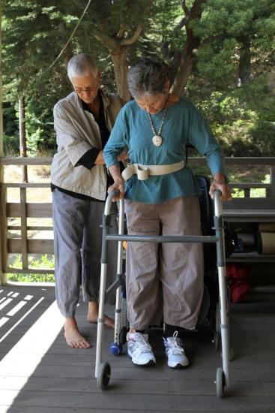
HC: I love to let people know that Grace finished her sewing! She has still not chosen to be ordained as a priest but might do so next year under the tutelage of her longtime teacher. In the meantime, she is still director of the Pain Clinic at Laguna Honda Hospital and (at age 70) has just begun a Buddhist Chaplaincy program to augment her work and credentials. She moved into an assisted living facility not far from Green Gulch about two years ago and though it was difficult to leave Green Gulch, that is working out quite well for her.
Fu became the abbess of Green Gulch, meaning she is the priest who is the highest spiritual leader and teacher in the community, and is fully involved in that role. She’s happy and has been able to travel to Japan and other places since the time we stopped filming. She and Grace continue to co-parent Sabrina and remain extended family.
Photo 3 Nancy “Fu” Schroeder assists partner, Dr. Grace Dammann, with physical therapy at their home at Green Gulch Farm Zen Center, Marin, California. Photo credit: Mark Lipman.
Sabrina graduated from Pitzer College in 2016 and is living in LA working for a social service agency and loves it.
Mack the dog accompanied Grace to Laguna Honda for many more years and died peacefully this summer of old age.
RDS: Many people have experienced the sudden onset of a disability. Few people, though, in the entire history of humanity, have then had their experience meticulously documented in a public film. What has Grace said about the ways in which this experience of being able to watch her experience unfold--this documented passage of time--has impacted her life?
HC: I would like to have Grace answer this question herself, as she has done many times at Q&A’s following a film screening. Some of her answers to this and other questions can be found on the film’s website where we have FAQs posted https://static1.squarespace.com/static/5498c523e4b01fe317ef4786/t/569d4e409cadb6436a8c938d/1453149765447/SoG_FAQs_F2.pdf
Though it was difficult at times to have us and the camera following Grace around, especially when she was in a bad mood or feeling really desperate about things, ultimately the documentation process and the witnessing we did was a gift to Grace, and she experienced it as an opportunity to process her feelings and have a mirror held up to her for reflection.
She also very much wanted the film to have a positive impact in the world and on people going through trauma of any kind; she’s been very pleased to experience the response to the film and to know that it is an inspirational and powerful resource for so many. That’s been gratifying to us as filmmakers as well, and to see the film provide a whole new platform for Grace to speak and teach and advocate which she does so well.
RDS: Helen, can you mention a bit about how this project fits into the larger trajectory and intent of your practice as a filmmaker?
HC: I’ve been making social issue documentaries for over twenty years; my films and filmmaking aspirations have always been about social change and having an impact on issues I care about. I also am a storyteller and love the creative process of telling a story through film. I’ve made a series of films for kids called “Respect for All” that deals with preventing homophobia and prejudice of all kinds among school-age kids (for more information see http://openstudioproductions.com). And I’ve been producing another series about community land trusts, affordable housing and equitable community development. (The most recent film in the series is called Arc of Justice, which traces the remarkable story of the first community land trust that emerged out of the Civil Rights movement in Southwest Georgia) – very relevant given what we are going through in our country at this moment.
States of Grace is my first personal film, and is much more visually poetic and creative in its storytelling than my other work. While purposeful and fulfilling an important social mission, this film was more about watching and witnessing and seeing what happened. And the seven months of editing was a challenging and fascinating process of piecing together the story and the many layers of meaning embedded in it. The whole journey was a wonderful experience for me as a filmmaker.
RDS: You have mentioned how many people have told you how the film resonated with some of their own experiences. From your discussions with those who have seen the film, does anything stick out to you about people's reactions to the film (particularly with respect to issues of disability)?
HC: There are really so many amazing reactions and stories to share – so many times people have been in tears letting us know that this film changed their life or made them feel hopeful about how to get through difficult, painful experiences. Here’s my favorite quote from a woman in a wheelchair who came to a screening at a theater and then wrote to us afterward:
“This film is a precious gift to the disability community, which has been hurt by many heroic expectations and misguided spiritual teachings. I think about disability rights as the hard-won right to be ordinary; ‘States of Grace’ reinforces that right with great compassion.”
-Beth Smith, LCSW, MA, clinical supervisor, Through the Looking Glass
RDS: Anything else you wish to add?
HC: I think it’s best to send people to the film’s website, https://www.statesofgracefilm.com. There’s a viewer’s guide, FAQs, Grace’s medical case history and lots more information that would be of interest to your readers. Our educational distributor is New Day Films (a co-op we are members of) and our film can be accessed there as well https://www.newday.com/film/states-grace.
Raphael Raphael is a film and media scholar focusing on the relationship of the body and media. His most recent work is Transnational Horror Cinema: Bodies of Excess and the Global Grotesque (with Sophia Siddique). Other writing includes contributions to Modern Language Association's Teaching Film(2012) and Transnational Stardom: International Celebrity in Film and Popular Culture (with Russell Meeuf) (2013). Dr. Raphael lectures at the University of Hawaii at Manoa. His scholarship is also informed by his own practice as a digital artist.

References
Dammann, G., Schroeder, N. F., Schroeder-Dammann, S., Cohen, H.S. & Lipman, M. (2015). States of grace: Frequently asked questions. Retrieved from https://static1.squarespace.com/static/5498c523e4b01fe317ef4786/t/569d4e409cadb6436a8c938d/1453149765447/SoG_FAQs_F2.pdf
Lipman, M., & Cohen, H.S. (Producer). (2014). States of Grace [Motion Picture]. United States: Open Studio Productions.
Open Studio Productions; Telling stories with impact. (2017). Retrieved from http://openstudioproductions.com

