Creative Works

Cancer Kung Fu: Fighting Back Through Writing and Drawing
Anna Faroqhi
Transart Institute
Abstract: Faroqhi describes the ways in which writing and drawing her graphic novel Krebs Kung Fu (Cancer Kung Fu) served as powerful coping mechanism during her diagnosis and subsequent treatment for cancer.
Keywords: graphic novel, disability studies
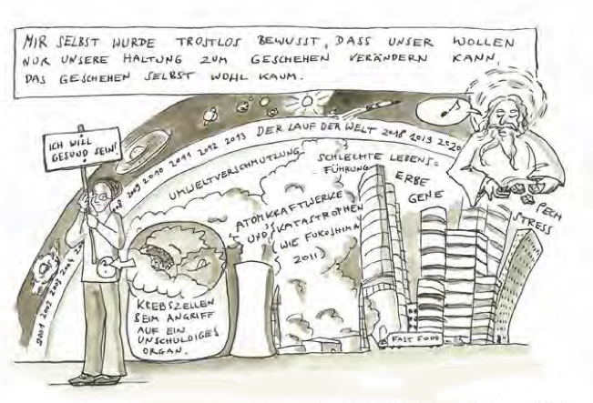
On September 1st, 2012, on my 6th wedding anniversary, I was diagnosed with Ovarian Cancer. The diagnosis changed me from a normal person who dreams up her life in steps within eternity to the “doomed” ones – my life’s end had become a certainty. The essayist Susan Sontag, who suffered from breast cancer compared the (terminally) ill ones with people who had forever forfeited the passport of a wonderful, happy and free land - the country of the healthy ones.
Image SEQ Figure \* ARABIC 1. Excerpt from graphic novel Krebs Kung Fu (Cancer Kung Fu)
When I heard about my diagnosis, I was shocked, incredulous, devastated, and very much afraid. My husband and I tried to hide the impact of the news from our children, we went to bed early and cried together. On the next morning I woke up, sat down for yoga and meditation as usual and decided not to give in to fear but to write a graphic novel about whatever was to come.
After all, I had become a person with a mission (overcome fear and face reality in all its aspects) under time pressure. I had become hero material. Why not make the best of it and become and draw my own story?
It took 4 years from this point to the finishing of the graphic novel Krebs Kung Fu (Cancer Kung Fu) which will be released with the German publisher Bebra in October of this year. In the meantime, I had to undergo surgery, chemotherapy and several complications and weaknesses. The goal to write a graphic novel about all of this was a good excuse not to be ashamed of my obsessiveness with every detail of the disease and its treatment.
For me, it was easier to feel lost in some waiting area or to be overwhelmed with leaden weakness after yet another chemotherapy session when I could tell myself I was some kind of witness to something universal that deserved to get recorded and told. And it felt even easier to make fun of myself and the absurdity of my fears.
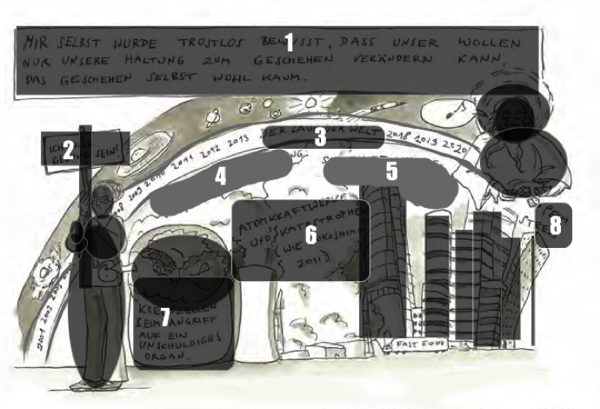
The graphic novel follows the narrator (the Anna character) through her daily routine as a cancer patient, from the first indication of the diagnosis until the end of a special treatment 1 ½ years later. The character starts as a neurotic person in distress and ends as a heroine grateful to life and everyone who has helped her during the process. The reader follows the character to various talks with doctors, friends and other patients, to the hospital for surgery and treatment. You see her at home with her husband and three very different children. You see her get obsessed with food and books that could convey promises of solace or even healing. You see her fight over nothing with her loved ones, doze on for hours and meanwhile imagine herself fighting a fierce fight against nasty cancer cells. You see her pursued, laughed at and arguing with cancer death and its tiny helpers, the Evil Cells.
Image 2. Accompanying legend for excerpt from Krebs Kung Fu graphic text translation

Translation of Krebs Kung Fu excerpt (Image 1)
(See Image 2 for positions of translated text in image)

1 - (beginning with “mir selbst”)
I came to the bleak realization that our intentions can only change our attitude to events, not the events themselves
2 - I want to be healthy
3 - the course of the world
4 - pollution
5 - unhealthy way of life, genes, inherited traits
6 - nuclear power plants and disasters (like Fukushima 2011)
7 - cancer cells attacking an innocent organ
8 - misfortune, stress

German-to-English translation of image graciously provided by Katharina Heyer, University of Hawaii
_________________________________________
As neither the heroine nor the doctors in charge can change her destiny for sure, a lot of what is being discussed is not how to fight cancer itself but how to fight the fear of suffering and death. Better: how to maintain a certain quality of life, how to remain an active character in your own life until its possible end.
The story has an open but happy ending.
For me, for the time being, it remains thus, as so far all check-ups have had the wished for results (as of Sept 2017). Ovarian cancer is an extremely dangerous cancer as it is hard to get diagnosed and when it does, you usually end up with a 50/50 chance to live or die soon.
I was often asked if humor was the correct approach to this kind of situation. For me, it is. The gravity is lifted off your own life when you have to ponder its ending.
The graphic novel allows you to find images for the most hilarious inner visions or emotional fits. If you see yourself as a green slimy monster that gradually becomes a human being again thanks to your husband’s love and attention, you can ban this image on paper and thus get rid of it.
During the process of conceiving and writing the graphic novel, I got tremendous support from family and friends. The physician who operated on me, Dr. Jalid Sehouli, played a huge part in getting the graphic novel released. He is a renown specialist on ovarian cancer. Patients from all over the world seek him out for treatment. He keeps telling his patients that everything is allowed and wished for that helps them improve their quality of life. The exchange with him was invaluable to the making of the graphic novel.
For a year now, the graphic novel has been given out to patients, physicians and others who showed an interest, by a big pharmaceutical firm which has helped finance the enterprise. I have also received touching responses.
For the entire experience I am extremely grateful.
Sept. 25, 2017
Durch die Erkrankung bin ich weder klüger noch besser geworden,
nur selbstbewusster vielleicht. Wie immer es weiter geht:
sehr viel Zeit habe ich nicht zu verschwenden. Mein Wunsch
ist, das Leben bewusst und wahrnehmend zu genießen.
Mit der zeitlichen Entfernung von der Diagnose Krebs und
den Therapien kehrt langsam meine Weltoffenheit zurück. Damit
verliere ich auch meine sorgfältig aufgebaute Tod-akzeptierende-
Leben-erringende Guerillahaltung. Ich werde eine dem
Leben und seinen Zerstreuungen Zugewandte, fast wie vor der
Diagnose. Was ich aber weiß ist, dass mir dank der Unterstützung
von Ärzten, Familie und Freunden eine konkrete Lebensmöglichkeit
geschenkt wurde. Jeder Tag ist ein Geschenk.

By the disease I have become neither wiser nor better,
only self-assured perhaps. As always,
I have made the most of the time. My wish
is to enjoy life consciously and perceptively.
As the time from the diagnosis of cancer and
the therapies passes, I slowly return my regular life. To do so,
I also lose my carefully constructed death-accepting-
Life-surrendering guerrilla attitude. I return to
Life and its distractions, almost as before
Diagnosis. What I know though is that thanks to the support
of doctors, family and friends, I have received the possibility of truly living.
Every day is a gift.
Special thanks to Katharina Heyer (University of Hawaii) for translating text of graphic novel image.
Anna Faroqhi is a Berlin-based filmmaker and illustrator. She trained as a classical singer, as well as in mathematics, physics, and film. Faroqhi’s body of work includes films, texts, illustrations, and educational works, and has been presented internationally in museums and art events. Faroqhi teaches video for opera directors and singers at the Hans Eisler School of Music in Berlin. She has given film seminars at the Beit Berl Film School, Israel; St. Joseph University, Beirut; Cornell University, New York, Transart Institute, Berlin; and was an advisor at the Filmuniversität Potsdam. In 2009, she was a recipient of the Villa Aurora work stipend in Los Angeles. Together with her husband and collaborator Haim Peretz, Faroqhi gives workshops in film and illustration for children and adults at various public schools, museums and institutions. The results of these workshops have been presented in public shows curated by the artist duo at museums, galleries, or movie theaters. Faroqhi sees her educational work—especially if participants come from underprivileged and/or migration backgrounds—as an empowerment for participants to voice their own stories. Anna Faroqhi’s work has been shown in Berlin at the Hamburger Bahnhof, Saalbau Neukölln, Akademie der Künste, Martin-Gropius-Bau, and at the Manifesta, Italy, New York Film Archives, Goethe Institute, Tel Aviv, etc.

