Research Article

Disability Policy and Wheelchair Users’ Accessibility in Jordan
Mohammad Ali Mulazadeh, PhD & Talal Soliman Alharbi, PhD
University of Kwazulu-Natal
Coventry University & Al-Areen Engineering Consultants
Abstract: The main purpose of this article was to evaluate wheelchair users’ access to public buildings in Jordan. The key assumption was that accessibility to public buildings in Jordan did not meet the needs of wheelchair users. Field observation method was applied using the accessibility checklist of Americans with Disabilities Act Accessibility Guidelines (ADAAG) as a tool to collect data from a randomly selected sample of 30 buildings in Amman city. Quantitative analysis was used and results show that the average level of accessibility compliance of the surveyed buildings was too low (23%) to meet the needs of wheelchair users. The study concluded that little progress has actually been achieved in terms of environmental accessibility, which implies that Jordan’s disability policy was not successful in creating accessible environments in which wheelchair users’ equal rights of access to education, employment and basic services is guaranteed. The conclusion also sends a clear message to professionals and decision makers that despite the existence of disability legislation, wheelchair users are still facing physical and social barriers that prohibit their access to public buildings. In other words, law without recognition of the rights of people with disabilities tends to become ineffective.
Keywords: Disability; Accessibility; Wheelchair User; Social Inclusion
Literature suggests that social exclusion is more apparent for those with mobility limitations as long as their equal rights of opportunities are not recognized by the wider society (Barnes, Mercer, & Shakespeare, 1999; Giddens, 1993). Creating an accessible built environment as such, cannot be achieved without societal recognition of the equal rights of people with disabilities to that of their peers. If this were achieved it would lead to their inclusion into mainstream society. This was also asserted by Napolitano (1996) who believed that securing access for people with disabilities to the built environment and their presence in the social sphere will enviably contribute to the acceptance and appreciation of their problems by the wider community. He added that:
“Being able to use the environment is about more than being able to 'get about’. At a deeper level it is about a sense of belonging. Until the environment supports mobility impaired people's participation with dignity and pride intact, this sense will continue to evade them” (Napolitano, 1996, p. 34).
This quotation sustains the theory behind the social model of disability which advocates that attitudes towards inclusion should go hand in hand with the design and construction of the built environment in order to give equal rights of accessibility to people with disabilities. Hisser (1995) who himself is a wheelchair user, emphasizes that the inaccessibility of public facilities “may cause disabled people to be alienated, ill, poor and marginalized” (p. 56). He recommended that wheelchair users’ accessibility of basic needs, services, basic education, and employment would guarantee their integration into mainstream society.

Disability Policy in Jordan
Following the proclamation of the 1981 International Year of Disabled Persons (IYDP) by the United Nations, large numbers of countries in the developed and developing world including Jordan, have initiated Acts to reduce the negative attitude of society towards people with disabilities and to assure their rights of equal opportunity with peers (Eleweke, 1999).
According to Article 9 Convention on the Rights of Persons with Disabilities, accessibility (CRPD) means:
“To enable persons with disabilities to live independently and participate fully in all aspects of life, States Parties shall take appropriate measures to ensure to persons with disabilities access, on an equal basis with others” (CRPD, 2006, p. 8).
Although the Conversion came into force on 3 May 2008, and has 160 signatories and 175 parties which includes 172 states the vast majority of people with disabilities who live in developing countries including Jordan are still waiting to practice their full rights of accessibility.
Within the context of this societal negative attitudes towards people with disabilities in Jordan, the poor accessibility of built environments was not far from expectation. As such, it is too difficult if not impossible, for disability law to change the attitudes of society and actually guarantee the equal rights of participation or equalization of opportunities for people with disabilities in developing countries.
The change of societal concepts according to Vasey (1989) can have a direct impact on the creation of built environments while negative perception can adversely affect environments and render them inaccessible. He asserts that “the attitudes of a given society must change if a disabled person is to realize his/her dream of being ... integrated into mainstream culture” (Vasey, 1989, p. 6). The change must begin within the home as early education of a child with a disability is an influential factor in shaping the future reactions of the child.
Jordan, which is officially called ‘The Hashemite Kingdom of Jordan’ is a Muslim Arab country in the Middle East with a population of more than 9 million in 2016 that has a high rate of disability. It was estimated that the population of people with disabilities in Jordan would reach 600,000 people by 2016, half of whom are living in the capital city of Amman (Nabawy, 2012). Nearly one third (27%) of people with disabilities are physically disabled and have no access to basic services, and are destined to be either isolated or more reliant on others (HCD, 2011). In response to this up surging number of people with disabilities, outcomes of Jordan’s government has initiated a policy in 1993 which was later advanced into Law No. 31 in 2007. This policy calls for the recognition of equal rights of people with disabilities and made public and private sectors liable by the law to create accessible built environments. Assessing the outcomes of Jordan’s disability policy and its outcomes in terms of creating accessible public buildings in which wheelchair users can use public spaces and live independently is important and is the focus of this study.

Purpose of the Study
This study was undertaken in order to define the degree of accessibility compliance of public buildings in Jordan, and the implication for wheelchair users’ access to education, employment and basic services. The findings of this study can be used as a reliable index against which the effectiveness of Jordan’s disability policy can be evaluated.

Method
Field observation method based on the checklist of the Americans with Disabilities Act Accessibility Guidelines (ADAAG) were applied to collect data from a randomly selected sample of 30 buildings in the city of Amman. The collected data was analyzed quantitatively from auditing the accessibility of public buildings. The access audit technique proved to be an essential technique by which accessibility of public buildings are measured and recorded (Ormerod, 2005). Buildings from all categories, public or private, that are involved in providing public services were categorized as public buildings. Government’s published and unpublished materials were also used to link the findings of this study with the actual condition of wheelchair users’ access to education, employment and basic services.

Procedures
The checklist of ADAAG is amended to fit this study and be used as the standard tool for measuring the accessibility compliance of buildings in Jordan. The checklist was modified in order to cover six accessibility areas including: parking, ramps, entrances, accessible routes, toilets and lifts. For two reasons the ADAAG was used for auditing the sample buildings and facilities. First, its suitability, reliability and applicably were approved by a number of published studies (McClain, Beringer, Kuhnert, Priest, Wilkes, Wilkinson, Wyrick, 1993; McLain, 2000; Useh, Moyo, & Munyonga, 2001; Rivono-Fisher, 2004). Secondly, Jordan’s disability law and its associated National Building Code (NBC) were short of providing any quantified accessibility standards to guide or assist constructors for implementation, and research for measuring the degree of accessibility compliance of buildings.
The buildings’ managers were approached before beginning the survey and informed about the purpose of the research, confidentiality of the data to be collected, and the caution that would be taken not to hinder or impede the activity of the building in query during surveying. After getting the buildings managers consent, data was collected through direct observations and measurements.
The authors were assisted by four volunteer students who were briefed and provided with measurement tools to carry out the survey. The compliance of an ‘area of accessibility’ in or about a building is measured in terms of its accessibility and closeness to the ADAAG standards. If the properties of an area of accessibility for instance, a ramp matches Section 4.8.2 of the ADAAG standards then its compliance degree would be satisfactory. The same procedures were used to calculate other ‘areas of accessibility’ based on the ADAAG guideline.
Calculating the degree of accessibility compliance of each building was however, obtained by dividing the number of available facilities complying with ADAAG standards over the total number of required accessible facilities in each building. For example, if ADAAG standards require five accessible parking places in a particular building but there was only one available, then the compliance of the building in terms of accessible parking is 20%. Accordingly, accessibility compliance of a building lacking any particular service area would be zero or non-compliant.

Findings of the Study
To begin with parking spaces, nearly 70% of the 30 buildings lacked accessible parking or zero accessibility and only 6 buildings had parking spaces with more than 50% accessibility compliance that matched the ADAAG standards. The same condition was found regarding accessible routes or footpaths connecting the parking to the entrances. The average compliance of the routes was almost absent (0.8%). For example, the width of the route connecting the parking and the newly constructed headquarter of the Court of Justice in Amman was too narrow to accommodate two pedestrians or allow wheelchair users to negotiate the path safely - let alone two wheelchair users meeting each other (Figure 1). The findings imply that construction regulations of buildings suggested by the Jordan’s disability law and its relevant NBC were either neglected or ill-defined with regard to accessibility for people with disabilities.
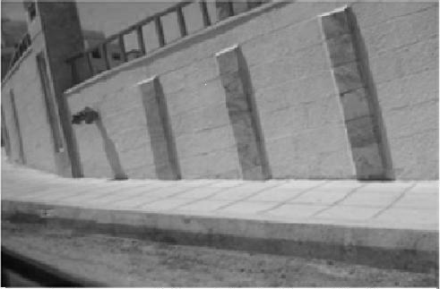
Figure 1. Photo of narrow path entering the Court of Justice.
Nearly 80% of the buildings (23 out of the 30) had either substandard or no ramp installed for wheelchair access. For example, in some cases, an unsafe iron sheet with a steep slope was installed as a temporary ramp which was far from being within the required standard (Figure 2). Only 23% of the buildings have provided ramps which were close to the required standards reaching 50-100% compliance.
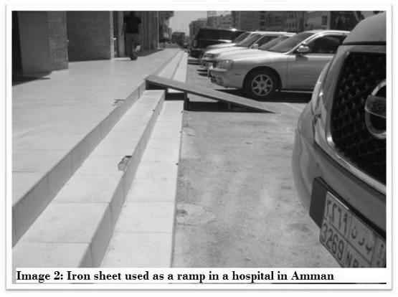
Figure 2. Photo of Iron sheet used as a ramp in a hospital in Amman.

The majority (80%) of doors entrances in all buildings had clear opening width (815mm) and a high level of accessibility compliance between 50%-70% but none of the buildings were 100% compliant with the applied standards. On the contrary, except for one accessible toilet in the HCD building, the rest of the buildings’ toilets were either substandard or no toilet was designed to be accessible for wheelchair users. Most of the toilets were found without a grab bar mounted on the wall and no washbasin at a suitable height. Doors opened outward and had no standard space for turning a wheelchair. Lifts in half of the buildings were either absent or substandard and in the remaining buildings the lifts satisfied the required standards for compliance.

Findings of Education Buildings
Secondary data revealed that the illiteracy level of people with disabilities is significantly higher (30.5%) than that of the national illiteracy rate of 9.3% (DOS, 2004; HCD, 2011). This big difference can be attributed to the inaccessible educational buildings that prohibit students with disabilities from entering them. The lack of/or unsafe ramps low compliance of lifts (11.6%), toilets (6%) parking (21.6%), and routes (25%) have all acted as barriers to enter educational buildings, which makes it more difficult for students with physical disabilities to enter and navigate the buildings.

Findings of the Workplace
The facilities for people with disabilities in the workplace were found to be worse than that of educational buildings. For example, Jordan’s NBC obligates constructors to install ramps in all buildings and lifts for buildings of more than four floors. However, accessibility compliance of ramps and lifts in most workplace buildings were found to be very low.
According to the ADAAG standards, accessible areas such as parking should be close and connected by accessible paths to the main building. However, the average accessibility of parking areas in workplaces including hospitals were rather low (21.5%) and located far from the main buildings. The distance of parking areas however, in the majority of observed buildings was much greater than the defined standard of 50m and lacking accessible paths. A number of accessible parking spaces had no symbol or sign to indicate that the parking is designated for people with disabilities though existence of such a sign cannot prevent the non-disabled from occupying the designated spaces.
A report by Malkawi (2015) in Jordan, confirms that the employment rates of people with disabilities in both public and private sectors showed little improvement and remained between 0.5% and 1%. Azzeh (2015) has also reported a high rate (48%) of unemployment among physically impaired people in Jordan which can be attributed to the low accessibility compliance of both educational (22%) and workplace (25.5%) buildings. Inaccessibility of workplaces has caused wheelchair users to remain jobless for longer periods of time than the rest of the working age groups.

Findings of Cultural and Recreational Buildings
A number of the recreational centers, such as parks, public libraries, mosques, and cinema halls had no ramp at the entry gate, which renders them inaccessible. The Grand Mosque and its toilets and ablution area were inaccessible ( Figure 3). An ablution area is considered as the prerequisite step before entering a mosque for praying. Nevertheless, the condition of internal doors and corridors and their components such as width and handrails were in a satisfactory condition.
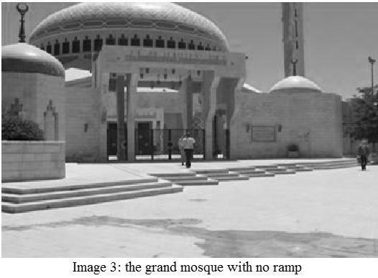
Image 3. Photo of grand mosque with no ramp.

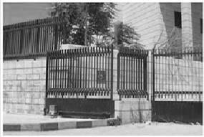
The stadium was the only recreational area which seems to have an accessible ramp inside the building. However, there was no ramp to connect the main road to the inside ramp beyond the gate that seems to be permanently locked for unknown reasons (Figure 4).

Figure 4: Photo of no ramp to connect the main road to the gate of the stadium.

The findings demonstrate that in spite of the implementation of disability laws in Jordan, the inaccessibility of public buildings and relevant services remain unchanged leading to under education, unemployment, and social exclusion of a majority of people with disabilities.

Discussion
Middle East Arab countries, regardless of their multifaceted economic position, are prohibiting wheelchair users from accessing public buildings despite the existence of disability legislations (Hall & Imrie, 1999). With no exception, the overall results of the accessibility auditing of public buildings in Jordan show that the average accessibility compliance of all buildings was only 23%. This low average implies that not much has actually been accomplished in the field of wheelchair users’ accessibility to the public buildings in Jordan.
Clause 1, Section E, Article 4, of the disability Law of Jordan for example, emphatically stresses on “inclusive environment that provide the freedom of movement and equal rights of accessibility for all” (Jordan Disability Law, 2007, p. 5). Article No. 32 of the National Building Code has also obliged public and private constructors to apply the building regulations concerning people with disabilities in ‘all new buildings and old buildings wherever possible (World Bank, 2005, p. 16).
Nevertheless, the HCD which was given power by the law in order to enforce the standards and tackle the inaccessibility problems by follow-up observation and evaluation has failed in enforcing the standards even in its own headquarter building. The gradient of a ramp which was installed in the entrance of the HCD main building was too steep for a wheelchair user to negotiate without a companion or people help (Figure: 5).
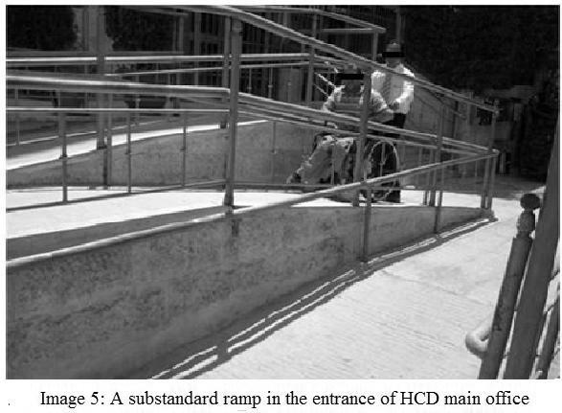
Figure 5. Photo of a substandard ramp in the entrance of HCD main office.

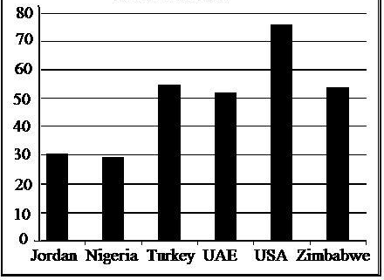
The results are not surprising when it comes to developing countries. The findings of a comparative study carried out by Welage & Liu (2011) for example, show a meaningful difference in the level of accessibility compliance of public buildings among developed and developing countries. The study by Welage & Liu (2011) indicated that the average accessibility compliance of buildings in developing countries including Zimbabwe, UAE, Turkey, Nigeria, and Jordan (added by the authors) is far less than the average accessibility compliance of buildings in the USA (Figure 6).
Figure 6. Accessibility compliance percent of buildings by country – Jordan (30%), Nigeria (29%), Turkey (55%), UAE (52%), USA (78%), Zimbabwe (54%)
Source: Welage & Liu (2011) and field survey in Jordan.

Without exception, the level of accessibility compliance of most buildings and their relevant services were too low to provide wheelchair users’ equal rights of access to education, employment, and basic services.
The consequence does not seem to be limited to Jordan’s legislation as Gleeson (2001) stated that “achieving the goals of human rights is still hampered by ineffective legislation inaccessible design regardless of political concern” (Gleeson, 2001, p. 259). In line with Gleeson (2001), and Kitchin & Law (2001, p. 288) also consider that the absence of accessible toilets “not just undermine social justice and disabled people’s rights of citizenship rather disregards their health and dignity problems as well”. Anderson and Kitchin (2000, p. 167) have also found it “vital for designers and architects, during the building processes, to take into account the difficulties experienced by disabled individuals throughout the course of their daily activities. This is true because environmental design is “the legal driver for curbing discriminatory situations by removing barriers” (Casserley & Ormerod, 2003, p. 153).
Accessibility of public buildings was found to be extremely limited in a manner that no one of the 30 surveyed buildings had a higher level of accessibility compliance than 58%. This means that Jordan’s disability legislation has failed in achieving its set target of creating an accessible built environment. Consequently, wheelchair users have no option but suffering more isolation and social exclusion.
In summary, a change in the living condition of people with disabilities, requires initial changes to the culture as a prerequisite for the change of societal attitudes. Change of culture and attitudes of a society is a long-term process that may take generations before people with disabilities are accepted and truly integrated into mainstream society. In other words, attitudinal changes cannot happen overnight or be dictated by legislation alone. Rather, re-education and greater understanding of the diversity of people's lives is the key to removing the discrimination and oppression of people with disabilities. In order to understand the people they are designing for, and appreciate the frustration of people with disabilities, designers, decision makers, and architects should have sufficient awareness of the societal attitudes toward disability. The designer should involve end-users in determining the design and contributing some of the expertise needed (Imrie & Hall, 2001).

Conclusion
In conclusion, the results of this study show that not much has actually been done in the field of wheelchair users’ accessibility of public buildings in Jordan. A key finding of the research indicates that overall low (23.8%) accessibility compliance of public buildings has created considerable difficulties for wheelchair users in reaching their daily needs. Based on this finding, it can be concluded that the Jordanian disability policy was not successful in providing wheelchair users with equal opportunities in accessing education, employment and basic services.
The results confirm that the environmental standard recommended by the ADAAG was not enforced by Jordan’s disability law. This is because the prevailing social negative attitude towards disability has curtailed the creation of an accessible environment. The problem of an inaccessible built environments goes far beyond physical barriers leaving wheelchair users with no option but to be socially isolated.
It is right to conclude that policy formulation cannot achieve its goals unless the wider society becomes aware of and recognizes the equal rights of opportunities for people with disabilities with their peers. In other words, law or regulation cannot be a success or make a difference on the ground unless they are accompanied by changes in societal attitude towards people with disabilities.
The findings of this research send a clear message to the planners, designers and decision makers that they were unsuccessful in bringing about what they have promised. Their efforts instead should focus on the inclusivity method in order to pave the way for wheelchair users’ social integration and their fullest participation in socio-economic activities.
This conclusion may also alert professionals and officials to the fact that effective implementation of a law in a society where negative attitudes towards people with disabilities is dominant is deemed to be difficult if not impossible. Accordingly, imposing a set of rules and standards which have no credentials in the belief and culture of a society, undoubtedly cannot achieve the expected results.

Message for Policy Makers and People with Disabilities
Creating a barrier -free built environment is a prerequisite step towards the ultimate goal of social inclusion which can preserve human dignity and contribute to the socio- economic advancement of society. In order to avoid discrimination against people with disabilities, designers should consider the participation of end users (wheelchair users) during the design process in order to create a 'wheelchair friendly' environment. The findings of this research might also be helpful in broadening the vision of legislators and building designers in Jordan and other similar countries in the region and stimulating them to strive for equal opportunities and adequate service provision.
Mohammad Ali Mulazadeh, PhD is an Associate Professor in Urban Planning focusing on Urban land-use, housing development and disability and Environmental Accessibility. As a multidisciplinary researcher and a lecturer he worked with Chamran University in Iran, London South Bank University in UK and University of Kwazulu-Natal in South Africa where he was retired. email: mmulazadeh@yahoo.co.uk, Tel: 00447716429252
Talal Soliman Alharbi, PhD is the CEO of Al-Areen Engineering Consultants and research fellow in Coventry University focusing on Urban Planning, disability, accessibility and adaptability of Built Environment. As an experienced researcher and environmental Developer he has participated in many KSA’s national projects to create a suitable environment for all.

References
Anderson, P., & Kitchin, R. (2000) Disability, space and sexuality: Access to family planning services. Social Science & Medicine, 51(8), 1163–1173.
Azzeh, L. (2015 April 02) 7.7% of people with disabilities are employed — report. Retrieved from: http://www.jordantimes.com/news/local/77-people-disabilities-are-employed-%E2%80%94-report.
Barnes, C., Mercer, G., & Shakespeare, T. (1999). Exploring disability a sociological introduction. Oxford: Blackwell Publisher.
Casserley, C., & Ormerod, M. (2003). The legal argument for inclusive design. In J. Clarkson, R Coleman, S Keates, & C Lebbon, (Eds). Inclusive design: Design for the whole population, London: Springer.
Convention on the Rights of Persons with Disabilities (CRPD). (2006). UN Convention on the Rights of Persons with Disabilities, Article 9. Retrieved from https://www.un.org/esa/socdev/enable/rights/convtexte.htm
Department of Statistics DOS. (2004). Distribution of disability by province in Jordan, Department of Statistics, govt. Publication, Jordan.
Eleweke, C. J. (1999). Special needs professional preparation and development in Nigeria: The challenges ahead. African Journal of Special Education, 4(2), 41–49.
Giddens, A. (1993). Sociology. 2nd ed. Cambridge: Polity Press.
Gleeson, B. (2001). Disability and the open city. Urban Studies, 38(2).
Hall, P, & Imrie, R. (1999). Architectural practices and disabling design in the built environment: Environ plan B, 26, 409–425.
Higher Council for Affairs of persons with Disabilities (HCD). (2011). Annual report on disability in Jordan.
Hisser, B. (1995). The nature and causes of transport disability in Barriers, G Zarb (Ed.). London: Policy Studies Institute.
Imrie, R., & Hall, P. (2001). An exploration of disability and the development process. Urban Studies Journal, 38, 333–350.
Jordan Disability Law, No 31. (2007). On the rights of people with disabilities.
Kitchin, R., & Law, R. (2001). The socio-spatial construction and accessible public toilets. Urban Studies Journal, 38, 287–298.
Malkawi, K. (2015). Laws on employment of people with disabilities not fully implemented. Retrieved from http://www.jordantimes.com/news/local/laws-employment-people-disabilities-not-fully-implemented%E2%80%99.
McClain, L., Beringer, D., Kuhnert, H., Priest, J., Wilkes, E., Wilkinson, S., & Wyrick, L. (1993). Restaurant and wheelchair accessibility. The American Journal of Occupational Therapy, 47, 619–623.
McLain L. (2000). Shopping center wheelchair accessibility: ongoing advocacy to implement the Americans with Disabilities Act of 1990. Public Health Nursing, 17(3), 178–186.
Nabawy, A. A. (2012). Perspective of parents and teachers about appropriate jobs for some categories of disabilities and the obstacles of getting a job. Life Science Journal, 10(2).
Napolitano, S. (1996). Mobility impairment. In G. Hales (Ed.). Beyond Disability Towards an Enabling Society (pp.30–35). London: Sage.
National Building Code. (2009). Specifications and standards recommended for the Jordanian construction code, govt. Publication.
Ormerod, M. (2005). Undertaking access audits and appraisals: an inclusive design approach. Journal of Building Appraisal, 1, 140–152.
Rivono- Fisher, D. (2004). Wheelchair accessibility of public buildings in Al Ain, United Arab Emirates. Disability and Rehabilitation, 26, 1150–1157.
Useh, U., Moyo, A.M., & Munyonga, E. (2001). Wheelchair accessibility of public buildings in the CBD of Harare, Zimbabwe. Disability and Rehabilitation, 23, 490–496.
Vasey, S. (1989). Disability culture: It's a way of life. Feminist Arts News, 2(10), 5–6.
Welage, N., & Liu K. P. Y. (2011). Wheelchair accessibility of public buildings: A review of the literature. Disability and Rehabilitation: Assistive Technology, 6(1), 1–9.
World Bank. (2005). Legal framework suggested best practice, Jordanian National Building Law No. 7/93, Ministry of Tourism and Antiquities, Amman, Jordan. Retrieved from: https://www.mota.gov.jo/Documents/Legal_framework.pdf.

Disability Policy and Wheelchair Users’ Accessibility in Jordan by Mohammad Ali Mulazadeh & Talal Soliman Alharbi is licensed under a Creative Commons Attribution 4.0 International License. Based on a work at http://rdsjournal.org. Permissions beyond the scope of this license may be available at https://www.rds.hawaii.edu.

