Multimedia

Picturing Scary Places: the Horror Genre and Mental Illness
Review of Disability Studies Interview with Perry Blackshear
Raphael Raphael
RDS Associate Editor for Multimedia & Creative Works
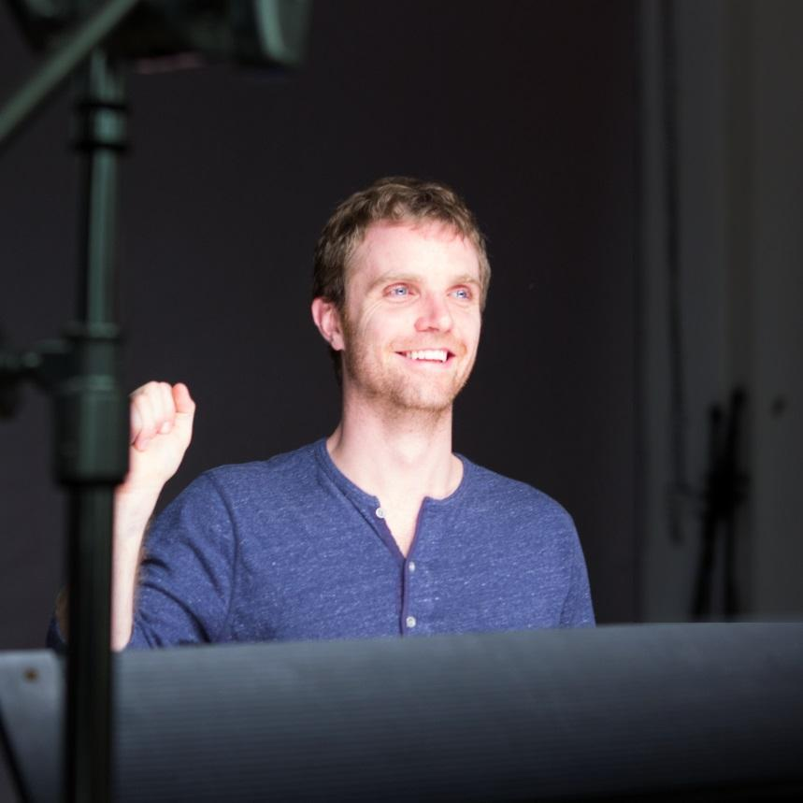
At the time of this writing, the most popular film in the United States is a film about mental illness, a movie that makes its central character’s disability a source of terror, M. Night Shalaman’s Split. The film builds on a long lineage of films, (beginning at least with Psycho in 1960), that present those who suffer in their perceptions of experience as repellent villains that audiences are invited to fear and revile. Given the popularity of the genre and its intense visceral connection with audiences, horror may serve as an especially important space for cultural conversations about the nature of mental illness.
Photo 1: Picture of Perry Blackshear
The following is an excerpt from a longer RDS interview with the filmmaker Perry Blackshear, director of the acclaimed independent horror film They Look Like People. The festival favorite about the experience of a sympathetic character enduring what appears to be a profound psychotic episode, is an unusual film. In addition to inviting audiences to identify with a character with mental illness, it is a horror film with few overt scares. It has also been considered the rare film that resists conventional genre boundaries, alternately considered drama and mystery, as well as horror. In this conversation, the director shares some of his intent with the film, the origins of his approach, and his feelings about the horror community’s embracing the film as one of their own. He also shares some anecdotal experiences of the way those whose actual lives have been touched by mental illness have experienced the film. The interview was conducted by Raphael Raphael, RDS Associate Editor of Creative Works and Multimedia.

RDS: For those who haven't seen the film, can you give a quick overview?
PB: The movie's called They Look Like People. It's a story about love and nightmares. Quick plot is that a young man thinks the world is being taken over by evil creatures. He doesn't know whether to protect his best (and only) friend from what he thinks is a war that is going to happen or from himself because he's actually losing his mind and is going to start hurting people.

RDS: Some of the reviews of your film focus in on the strengths of the relationships you create along with the effective elements of horror. I have just written a book on so I've been viewing a lot of contemporary films in the genre. Your film is among the finest, most elegant of the contemporary pieces I've seen. And while your film is generally classified as horror, many of those who review your film frequently describe it as bending genre. With this in mind, how do you define it? Do you call it a horror film?
PB: This is a discussion we had a lot early on. Originally, we were very inspired by two films. One of them was Jeff Nichols' Take Shelter. It was clearly a drama with a little supernatural or thriller element. The other was Absentia by Mike Flannigan. It was very much set in the real world. I read an interview early on with him, and he was asked if it was a horror movie. He responded that it was a movie about people undergoing very scary things.
I thought that was very nice. [M. Night Shalaman] talked about Sixth Sense in the same way. [They Look Like People] wasn't supposed to be scary originally; it was supposed to be more like Take Shelter. I'm not an expert [on mental illness] but I did a little bit of research, read a few textbooks, did some digging, looked at some people’s stories. [Their experiences were] so scary that it ends up being much scarier than we thought it would be. We also didn't know how people would react until we saw it in a theatre for the first time with a crowd.

RDS: (Laughter). Is that right?
PB: We didn't plan it to be a horror film. We just planned it to be sort of more like a--I don't know – – like a romance, but a non-sexual romance between old friends, and a drama about struggling with failure, but it ended up being a lot scarier than we thought, I think. So the whole [horror] community kind of adopted it.
And it got into a lot of horror festivals. We're still try to list it on IMDB not as a horror film but as a drama, a thriller and a mystery. But it became adopted a little bit.

RDS: With the adoption, are you okay with it being called a horror film?
PB: There's been an interesting discussion online about the recent sort of indie horror [revival], with It Follows, Babadook and The Witch. There was a group of people saying that horror is like metal: you can't just be some [poser] and come in and pretend to do it….
Like the blues, it’s something you have to earn, it's like blue-collar, a terrible life, blood...(Laughter). So I wonder if whether a movie is scary enough or not [is not a sufficient criteria]. There are some horror films that are not scary at all.
I had never heard that argument. I think it's actually kind of a compelling one. So we tried very hard when we to talked to people about it to let them know it wasn't a typical horror film because we didn't want people to be disappointed. So I'm conflicted about [the film's designation as horror film]. The best scary movies put you through a kind of frightening journey, and you feel you emerge from it kind of relieved, like from a nightmare where you wake up and you're like "oh gosh."
And I like that part of it, and I like the force of it. But I don't like some of the elements [of the genre] that are very "gross." And what they say about people not caring about human life. I don't know, there's part of it that has sort of a dirty conscience that I don't like. So I'm conflicted about it.

RDS: Yours is really ultimately a life-affirming film.
PB: I hope so.

RDS: So basically it sounds like you reluctantly accept the way it has been adopted by the horror film community.
PB: Yea, the best compliment I've gotten is from folks that were ready to just see another horror film and then had a great experience. If you look at a lot of good drama, it's actually not that different from those but it's very different from a lot of the sort of run-of-the-mill horror films. So people find it a nice palate cleanser after watching a lot of other kinds of horror.

RDS: Yes.
PB: The best experience I've had has been at screenings in which people find stuff in the film [that has meaning for them]. There was a young man whose brother was in the army and had undergone something like [what's depicted in the film], and the young man was still struggling with it, with his brother. He came up to me in the Q & A and he was crying, then I started crying.
We didn't really even talk much, we just sort of sat there. That was pretty cool. I think there are a lot of great movies [addressing these issues] that are dramas but people don't see them.
The film is based on a friend of mine who had a really bad string of luck. He lost his job and his girlfriend/fiancée. He had one week where, he told me afterwards, if he didn't have some good friends and a good family, he would probably be in jail, or dead. He's fine now, he's married and doing well. I wanted to make a movie about that week.

RDS: Yes.
PB: I think a lot of people when they're undergoing tough stuff go through a smaller version of what Wyatt [the central character] goes through.

RDS: Got you. I have read elsewhere you mentioned films that were inspirations; you just mentioned Take Shelter and Absentia, and I think elsewhere you talked about Jacob's Ladder. Where there any other films that inspired the work?
PB: Jacob's Ladder was actually never in my mind while making it. I can see when people talk about it--it makes a lot of sense--I had seen that movie many years ago so maybe it came through. But definitely the ones that I was watching or re-watching while I was making it--some of them are not actually even horror movies. Babadook came out while I was editing, and that was quite influential. Let the Right One in showed me that you could have a wonderful love story between kids and a scary vampire movie, and one made the other one more powerful. And also bizarrely there was a movie called Fishtank.

RDS: I haven't seen that one.
PB: It's a drama in England and the only thing that's remarkable about it--I mean it's a good movie – – but the third act jackknives into a totally different direction, and that was my inspiration for the last act of They Look Like People.

RDS: You mentioned a moment ago, and I've read elsewhere that you've talked about being approached by people who have seen the film and say it really resonates with their own personal experiences in either their own life or with a loved one. You mentioned the gentleman with whom you had a really intense moment together just being with the experience. I'm wondering what other kind of things have you heard about the way that it resonated with people's experience with mental illness?
PB: I think that when we were making it originally, we had ideas of it being a little bit more of an actual sci-fi type of movie. But when we decided to make the ending the way it was, I never wavered on [an approach emphasizing the experience of mental illness] for a minute. A lot of people were trying to get me to go the other way, and I held to that because that was my belief. When we decided we wanted to go that route, we really tried to do our research. The actor Macloud and I watched some documentaries; I read [books] on psychology, a few chapters on schizophrenia. We did what we could. There is also a video I think, it may have been through PBS, of sort of a VR experience of what it's like to be schizophrenic.

RDS: Yes.
PB: It was so frightening. We took a lot of inspiration from that. We knew we could not be experts. We wanted to have that moment in the movie when [the doctor] mentions schizophrenia and [the main character] sort of dismisses it, not to dismiss schizophrenia but to [show resistance to being labelled with the diagnosis].
From what I've read, mental illness is sort of stigmatized in a way that once you “have it,” you are “mentally ill.” And there's a hard line drawn there. From what I read, that's a bit of an archaic system; it stigmatizes [the experience] more than it should. Whether you have a history of depression, a mild bipolarism, or borderline, it's all a spectrum. I don't know whether this is valid, but the literature that I read points this way, that that's kind of where people want to try to push it.
It is sort of once you get the label that’s sort of your life, like [the way the term ‘cripple’] has been used. So we tried really hard not to make it [a totalizing definition of him], “oh, he schizophrenic,” but rather let the film demonstrate how a series of factors: timing, brain chemistry circumstance, and upbringing helped this stuff “kind of explode.”
And, moreover, to treat it as something very complicated.

RDS: Beautiful.
PB: The other thing we tried really hard to do was to show that always whenever we were writing it-- and I told the guys to call me on this—was to make sure he was never “plain crazy.” So whatever was happening, all of his motivations needed to be that of a rational person trying to do the right thing with this awful stuff in his head.

RDS: Yes, that really comes through.
PB: So in the same way, I've never really experienced this, but when I'm very drunk (Laughter) or undergoing tremendous pressure from a break up or something, I think at the time [what you’re thinking] makes sense but afterwards you like “that's crazy, that's awful.” But at the time when you're going through it, it totally makes sense. We knew we wanted to do our homework because we were really scared about [misrepresenting or minimizing the experience of] someone that had actually undergone this.
We get a lot of Q&As where people say “I work in the mental health field and we go”: [yikes!]. (Laughter). And so far in the Q&A's, we've always had positive responses and that's been really good. [This hasn’t always been the case] for my other friends who have made movies [about other people and identified groups’ real experiences]. So it's very scary when you’re a filmmaker and you make a film about something that isn't yours; so many people have done it wrong. And you try to do it right.

RDS: That attention is really evident in the film. Coming from a disability studies perspective that considers the ways that disability might be constructed in the ways in which it may be represented in media, it's obvious that you've done your homework and really bring a thoughtful approach to your depiction of mental illness.

I know that you mention this VR experience was among your inspirations. (I think it was Janssen Pharmaceutical). And part of their purpose was to try to have people see what it's like to experience schizophrenia so that caretakers and families could better understand what it's like and not just pooh-pooh it and say “you would be better if you just tried harder.” A similar intent really seems to come through with your work. MacLeod's character (Wyatt) comes through as a sympathetic character, and as you described, a rational person doing the best with the sensory information he has.

A few other questions: a great deal of what makes your work so effective is kind of what is not seen. I have read elsewhere that you say that some other films kind of dampen their ‘fear factor’ by showing the object of fear directly, like Babadook and Conjuring do. I think you mentioned that there's a certain relief for the audience once they've seen it, and in yours we never fully have a reveal of what is in his mind’s eye. And you mentioned that you scaled back a lot. Originally were some of his visions more visible?
PB: In an early draft of the script, we had kind of Emily Rose-style demon faces. We did a very long post-production process. What we discovered every time we showed [something scary]—there's really only two ‘scares’ in the movie: one is the moment the jaw is sort of unlocking, and the face changing—we found whenever we did that, once that moment was done, it was sort of a weird thing; it was like blowing up a balloon and releasing it: you had to work harder to pump it up, everytime.
John Carpenter said something interesting which is you have to scare the be-Jesus out of them right away so they'll be freaked out for the next 80 minutes. [In the process of making this film], I went through a lot of the movies that scared me and tried to write down what I was thinking about as I was watching. Paranormal activity is a pretty good movie, but it's really masterful at how little shown can be so scary.

RDS: For sure.
PB: When there's a monster with a sword and a kind of corporeal danger [it’s one thing], but when it's your own brain and you can't trust it at any given second that’s much scarier. There were ready two sides: I did what ended up scaring me the most; and technically, in film, we found it was much scarier the less we showed. It's pretty simple. I would also say it changes for different people. Sort of like how some people think awkward humor is funny, and some people find it painful. People like the jolty kind of scares [or not], depending on personal taste.

RDS: Judging by a lot of the reception of your film, it seems people are hungry for that restraint that you've shown.
Blackshear, Perry (Director). Evan Dumouchel, MacLeod Andrews, and Margaret Ying Drake (Performers). (2015). They Look Like People. United States: Gravitas Ventures, 2015.
Submissions: We welcome submissions of interviews/ artist statements from working media professionals as well as film and media reviews, responses or creative works that dialog with concerns about ability.
Questions, see submission guidelines at: http://www.rds.hawaii.edu/ojs/index.php/journal/about/submissions or contact Raphael Raphael, RDS Associate Editor, Creative Works and Multimedia: rraphael@hawaii.edu .

