Creative Works

A Thousand Threads
Elaine Stewart
‘Thread and fibre have always held me close. Words I may struggle with but any piece of cloth can speak to me. Thread lets me play and explore, it is a material that all people engage with. It is the clothes you wear and the sheets you sleep between. It ties things together.

Threads are used in labelling, but words are given precedence. I wrestle with a label that was given me. I read about it, I explore what is said about it in many different ways in our world. It takes over my processes. I fight back, but I I fall into letting it define me again. I am hoping that you will share a label that has been applied to you or a friend. That you will hang a tag on the walls of this box to share that label. I am hoping to use these words in an exploratory activity that will continue. I am beginning to see through this process.

A wheelchair is a standard icon for disability. It is usually interpreted as referring to disabilities that are present physically. I started making wheelchairs in my art practice because I do use one. It was a different way to explore the heavily laden subject of my otherness. The longer I have built wheelchairs of varying materials and sizes the more I have come to see my crafted wheelchairs as an exploration of a mind that is labelled 'mentally ill’. Myself, I cannot just push a label aside again.

I want to own it. I want to define it. And then, as an artist I want to illustrate it.’

Elaine Stewart became an artist through a complex and unreasoned route. Her mind was reshaped by the distress that has come to be called mental illness within our contemporary culture. Her very body was reshaped by this explosion of distress. She claims the name of disability as a point of curiosity and exploration. A fluid and uncharted territory open to exploration in a world endlessly malleable. It was her privilege to attend art school. As a lover of textiles and fabric she moved from the happy play of creating fun and fantastic children’s clothing to using the fibres themselves to explore new ways of seeing. Her continuing curiosity prompted an exploration of the academic field of disability studies. It was her joy to meet artists whose practices re-examined and redefined this thing labelled disability.elainestewart.ca

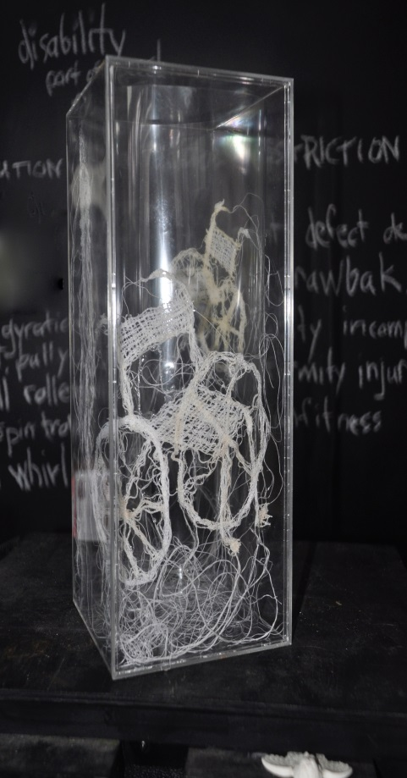
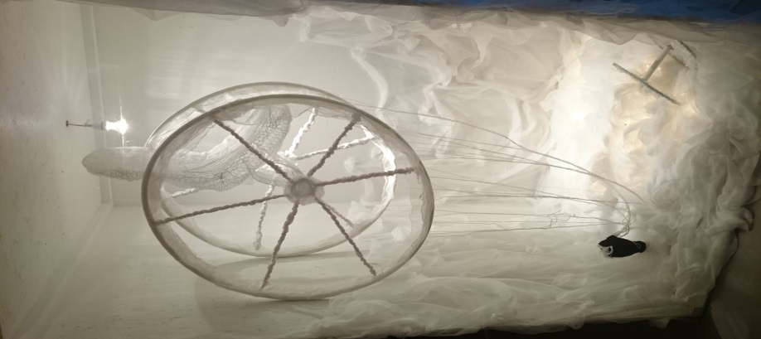

Figure 1: Photography of artwork from A Thousand Threads collection. Image description includes threads shaped into a wheelchair incased in a glass vase. A Thousand Threads copyright Elaine Steward, 2016

Figure 2: Photography of artwork from A Thousand Threads collection. Image description includes threads shaped into a wheelchair with spool and light fixture. A Thousand Threads copyright Elaine Steward, 2016

