Research Article

Changing Disability Status of Immigrants in Australia - Three Cases
Qingsheng Zhou
The University of Sydney
Abstract: This paper examines the changing disability status over five years of those born overseas who have lived in Australia for various periods of time. Sourcing data from the 2006 and 2011 censuses it explores in-depth three distinctive immigrant groups: recent immigrants arriving between 2002 and 2006; Chinese students coming to Australia in the late 1980s; and Vietnamese refugees settling in Australia in the late 1970s and early 1980s. The analysis shows that age is the most important factor influencing the trajectories of disability profiles of immigrants, just like their local counterparties.
Keywords: Australia, immigrants, disability statistics

Introduction
This study deals with the changing disability profiles of immigrants to Australia.¹ Australia has a largely immigrant population and successive waves of migration since European settlement have resulted in a highly culturally diverse society. According to the Australian Bureau of Statistics (ABS), at 30 June 2014, 28% (6.6 million people) of the population was born overseas. About half of Australians are either immigrants themselves (overseas born), or children of immigrants (at least one parent born overseas). An understanding of the disability characteristics of immigrant communities is crucial to the continued improvement of support systems to meet the changing needs of Australians with disability. Using the latest population statistics over the period 2006-2011 this paper demonstrates that while immigrants generally have a lower rate of disability on arrival, they tend to acquire disability at a much faster pace as they age than other Australians.

Research Question
This study questions how the disability status of Australian immigrants has changed over the five-years between 2006 and 2011. The relationship between immigrants of particular origins, their length of residence in host countries, and their health, wellbeing and specific diseases has been a subject of many studies (Alter and Oris, 2005; Gray, Harding and Reid, 2007; Harding, 2004; Johansson, Helgesson, Lundberg, Nordquist, Leijon, Lindberg, and Vingard, 2012). A recent review of the literature on the health status of migrants in Australia concludes that “migrants in Australia are generally in better health compared with the Australian-born population”(Anikeeva, Bi, Hiller, Ryan, Roder. and Han, 2010). This so-called ‘healthy migrant effect’ has also been used to understand the disability of immigrants. When explaining the relatively low presence of people born overseas in the specialist disability services, the Australian Institute of Health and Welfare (AIHW, 2010), for instance, state that:
“Immigrant populations often have lower death and hospitalisation rates, as well as lower rates of disability and lifestyle-related risk factors. To some extent, this can be explained by the fact that most migrants are partly selected on the basis of their health and, in some cases, their relatively high socioeconomic status.”
Zhou (2015) recently probed whether disability status of immigrants could be understood in the same way as that on the healthy migrant effect. Zhou revealed that Australians born overseas have the same level of disability and a greater level of profound and severe disability. In particular, immigrants who mainly speak a language other than English at home have relatively higher levels of need for assistance than English speaking groups.
However, Zhou’s study as a snapshot does not explore the issue of changes in disability status over time. Just like the health status of individual immigrants, disability is not static and will change over time through manifestation, acquiring, improving or deteriorating (Mutchler, Prakash, and Burr, 2007). These changes are embedded in an acculturation process which all immigrants experience to various degrees. In this process individuals or groups transition from living one lifestyle to the lifestyle of another culture, exposing them to a new physical and social environment, requiring them, at least to some extent, to adapt to new behaviours, values, customs, and language. Consequently, the trajectories of their disability status may be altered. The time factor also includes a natural process of aging that tends to result in a greater rate of disability.
Another factor associated with disability of immigrants is the selection processes by which people who voluntarily or involuntarily move to another country, and are filtered through immigration regulations of the host country. People settle in a different country for a variety of reasons, including family reunion, economic and political considerations, security necessity, lifestyle persuasion and access to government services. While both ‘self’ selection and ‘policy’ selection exist, it is debatable whether health status plays any significant role in the decision-making process (Findley, 1988; Kaestner and Malamud, 2014).
Relating to these self-selection processes is the factor of country of origin. It emphasizes the importance of disability profile of countries of origins of immigrants. Countries at different stages of development tend to have different levels of disability prevalence (World Health Organization and The World Bank, 2011). Countries that have suffered from major natural disasters or wars may have an increased prevalence of disability. Subsequently immigrants from these countries may have disability profiles that are different from their host country.
While the disability profiles of immigrants differ from their local population and this is a result of many intertwining factors, it is the impact of this time factor that this study attempts to explore. Each year, a certain number of immigrants arrive in Australia under a variety of programs. What happens to these people over a five-year period in terms of their disability?

Data and Method
This study uses the disability definition adopted by the Australia Bureau of Statistics (Australia Bureau of Statistics, 2006) in the five yearly Census of Population and Housing (the Census hereafter) and sources the data from the two most recent censuses, 2006 and 2011.
Being a complex and difficult concept to define and measure, disability is the umbrella term for impairments, activity limitations and participation restrictions, referring to the negative aspects of the interaction between an individual (with a health condition) and that individual’s contextual factors (environmental and personal factors) (WHO, 2001). Interpretation of disability varies from person to person and is also likely to vary across time for individuals. On a personal level, individuals may be reluctant or unable to identify themselves as having particular types of disabilities. In a data collection setting, responses to a disability question may be sensitive to the survey context – for instance, asking questions about other topics before asking questions on disability may encourage or discourage a particular type of response. It is especially difficult to capture the full complexity of the experience of living with a disability and accurately assess the full range of disability severity with a limited number of questions (ABS, 2007a).
Recognising this complexity, and aiming to overcome the difficulties, the ABS developed a two-dimensional measure for disability data collection. The first dimension, reflecting the International Classification of Functioning Disability and Health (ICF) activities and participation domains, says that a person has a disability if the person has a limitation, restriction or impairment, which has lasted, or is likely to last, for at least six months and restricts a range of daily activities (Australia Bureau of Statistics, 2013). These daily activities are further divided into core activities, namely: self-care, mobility and communication, and non-core activities. The second dimension addresses how frequently – always or sometimes – a person needs assistance in these daily activities. People who have limitations in one of three core activities and always or sometimes require assistance in these areas are classified as having a profound or severe disability.
The 2006 Census, for the first time, implemented the two-dimensional measure through a short disability module. It asked each person four disability-related questions: Whether the person ever (always or sometimes) needs someone to help with, or be with for (1) self-care; (2) body movement and (3) communication activities (Questions 20–22), and whether the reasons for the need for assistance in these questions are (1) short-term health condition; (2) long-term health condition; (3) disability; (4) old or young age; (5) difficulty with English language and (6) other cause (Question 23) (Australia Bureau of Statistics, 2005). The ABS however was only able to release an aggregated variable of ‘‘having need for assistance’’ that is derived from these four questions. This variable categorises people as needing assistance if they reported always or sometimes needing help in at least one of the three core areas of self-care, mobility or communication because of a disability, long-term health problem (lasting 6 months or more) or old age. Therefore, responses are coded to the category ‘‘does not have need for assistance with core activities’’, when the response to Question 23 is only ‘‘difficulty with English language’’ (ABS, 2006). Needing assistance with one or more of these activities is interpreted as an indication that someone has significant difficulties with basic human functions. These questions were repeated in the 2011 Census. These questions identify a population that is conceptually comparable to those with severe or profound core activity limitation which is targeted by specialist disability services in Australia (CSTDA, 2003; Evidence Base Development Unit, 2010, COAG, 2009), although it has been widely recognised that the disability population identified through the Census could not be directly interpreted as the prevalence rate of disability. To avoid using a long description such as, “people who have core activity need for assistance” and for ease of reading, this study simply uses terms the “disability” and “disability rate” to refer to this population.
This study primarily relies on disability statistics from census data (2006 and 2011) because of its size and comprehensive coverage which enables the examination of small populations by demographic, geographic or economic characteristics.²
The statistics presented in this study are not only sourced from the ABS standard publications but are also derived from special runs from the ABS TableBuilder. The TableBuilder allows researchers to access and manipulate census information in an unprecedented way (ABS, 2014). However, statistics sourced from these products may often be slightly different from other ABS publications, primarily due to how TableBuilder deals with the small counts.
The study identifies three distinctive subpopulations of immigrants from the censuses. The first is the most recent arrivals who came to Australia during 2002-2006. The second is the Chinese students who had arrived in Australia between 1989 and 1991. The third are those Vietnamese who sought refuge in Australia between 1977 and 1986. When they came to Australia, these people had different disability profiles. The 2006 census collected information about their disability status at the time when they had lived within local communities for different durations. Their disability status is reported again five years later in the 2011 Census, using the exact same survey instrument. Changes in these subgroups over this five-year period are examined in turn within the context of when and from where they came.

Analysis Results

Recent Arrivals - Case One
The first group are those who were born overseas and settled in Australia in the five years (2002 to 2006) prior to the 2006 Census. This group was more than half a million from all over the world (ABS, 2007b). This section examines the disability rates for these people in 2006 and compares them with their disability rates reported in 2011 Census.
Figure 1 plots the changes in disability rates for immigrants who arrived in Australia in each of these five years. In addition to the all-age combined column, Figure 1 shows three other typically reported age cohorts: 5-19 years, 25-34 and 60-79 in 2006. Each colour represents a specific year of arrival and each line depicts the disability rates in 2006 and 2011 for approximately the same cohort. Meanwhile, for comparison purposes, the disability rates of other Australians who are not recent arrivals are presented by dark black lines.
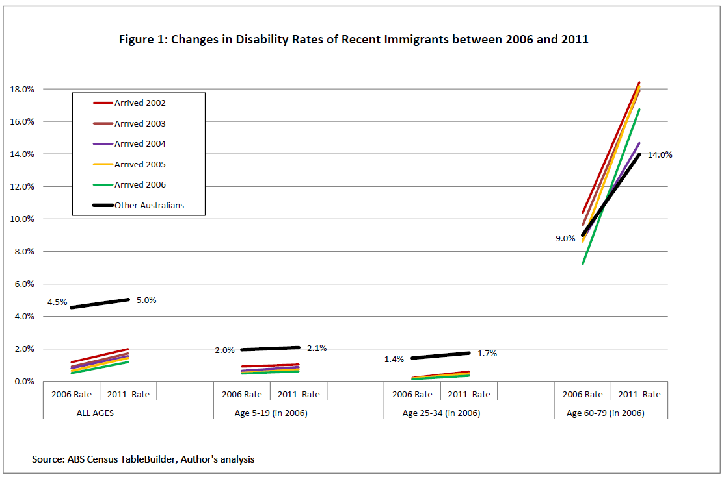
Alternative text description – The image above depicts a line graph titled Figure 1: Changes in Disability Rates of Recent Immigrants between 2006 and 2011 and provides source ABS Census TableBuilder, Author’s analysis. The y-axis ranges from 0.0% to 14.0% and the x-axis provides 4 categories: all ages, age 5-16 (in 2006), age 25-34 (in 2006) and age 60-79 (in 2006). Each category provides line measurements between 2006 Rate and 2011 rate and each year is indicated by a color, pink represents arrived 2002, light purple represents arrived 2003, dark purple represents arrived 2004, yellow represents arrived 2005, green represents arrived 2006, black represents other. In addition, numbered measurements are provided on the graph in the all ages category measures 2006 at 4.5% and 2011 at 5.0%, age 5-19 category measures 2006 at 2.0% and 2011 at 2.1%, age 25-34 category measures 2006 at 1.4% and 2011 at 1.7%, and age 60-79 category measures 2006 at 9.0% and 2011 at 14.0%.
Figure 1 shows that while the new arrivals as a whole clearly have fewer disabilities than their local counterparts, they are not all without disabilities. Relatively higher proportions of older new arrivals have a disability than younger people, resulting in an age-related disability distribution. The later arrivals have a lower rate of disability than those coming a few years earlier, indicating that some immigrants had an acquired disability, or their disability conditions had manifested in just a few years after arriving in Australia. For example, immigrants just arrived in 2006 as a whole reported the lowest rates of disability for all age cohorts, represented by the light green lines while those arrived in 2002 have much higher rates by 2006.
Furthermore, every cohort experienced an elevated rate of disability between 2006 and 2011, as indicated by the fact that the slopes of all lines go up. In other words, regardless of age at arrival and disability rate at arrival, more people acquired disability over the five years to 2011. However, older age cohorts acquire more disability at a much faster rate than younger ones, as shown by the varied degrees of the slopes for those aged 60-79. For instance, the upward trend of the lines for the youngest cohort (5-19 years in 2006) are minimal, meaning a very small increase over the five years as opposed to the older cohort of 60-79 year-olds for whom rates increase considerably regardless of arrival year. The sharpest rise is in the rates of those immigrants who arrived in 2006 when 60-79 years, from 7.2% to 16.8% over the five year reporting period.
Last, while recent arrivals overall have a lower rate of disability than other Australians, it may not be as clear-cut for older age cohorts. For example for those immigrants who were 60 to 79 years in 2006, only those who arrived in 2006, 2005 and 2004 have disability rates that are lower than that of other Australians. Nonetheless it is clear that older immigrants acquire disability at a much faster rate than both younger immigrants and other older Australians.

Chinese Students - Case Two
It is well documented that there were a number of “rushes” of Chinese immigrants to Australia with the most recent one occurring between 1989 and 1991 (Museum Victoria Australia, 2014). In Australia this group of Chinese immigrants is widely known as the Chinese students because the majority were student visa holders.³ According to ABS censuses, between 1986 and 1991 the China-born population in Australia more than doubled. Unlike earlier Chinese settlers these immigrants arrived in the late 1980s predominantly from families who could afford to pay college fees which were a substantial amount for a Chinese family at the time (Jupp, 2001).
After about twenty years living in Australia, they still report as a distinctive and stable population in the 2006 and 2011 censuses as seen in table 1 that compares the year of arrival of these Chinese students and their age ranges. For easy reading their age ranges are derived and presented both as in 1991 (showing they were mostly between 20 and 45 at the time of arrival) and at census times. The fact that the great majority of these people entered Australia under the student visa category means they had a healthy profile. Few, if any would have had a disability. These characteristics make it a good data set for this study to evaluate the relationship between duration of stay and disability.
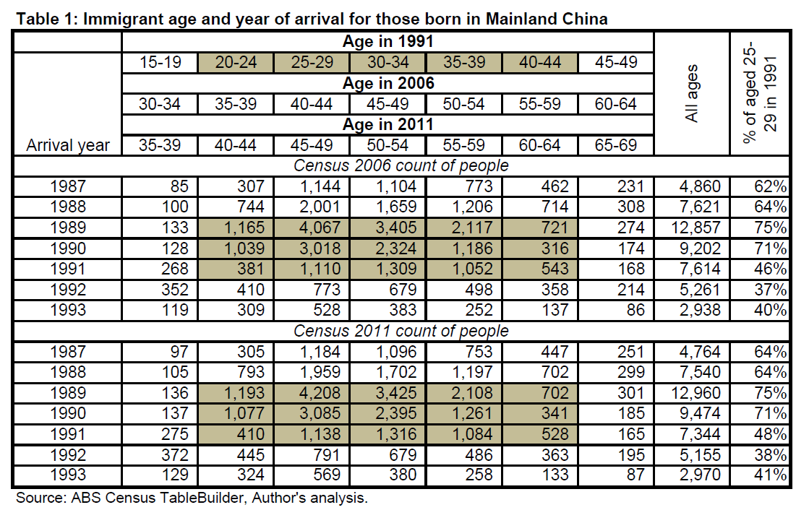
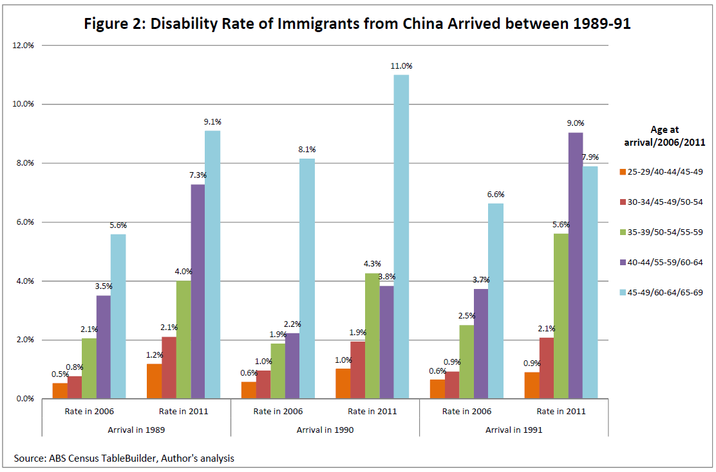
Alternative text description – The image above depicts a bar graph titled Figure 2: Disability Rate and Immigrants from China Arrived between 1989-91 and provides source ABS Census Tablebuilder, Author’s analysis. The y-axis ranges from 0.0% to 12.0% and the x-axis provides 3 categories: Arrival in 1989, Arrival in 1990, and Arrival in 1991. Each category provides 5 different measurements in 2006 and 2011 and the 5 different measurements are indicated by different colors, orange measures 25-29/40-44/45-49, red measures 30-34/45-49/50/54, green measures 35-39/50-54/55-59, purple measures 40-44/55-59/60-64, and blue measures 45-49/60-64/65/69.
Figure 2 plots the disability rates in 2006 and 2011 of the Chinese students who arrived at Australia for each of the three years between 1989 and 1991. Each colour represents a specific age cohort measured at the year of arrival. The cohorts are organised according to the age ranges which are presented as the time of arrival,⁴ Census 2006 and Census 2011 for easy reading.
Three observations can be drawn from Figure 2. The first is the different rate of disability among varied age cohorts in 2006 by which time the students would have lived in Australia for about 15 years. At the beginning of the 15 years, all cohorts were young and healthy students assumed to be without a disability. Some fifteen years later, older age cohorts have a much greater disability rate than younger age cohorts. For example, for those who arrived in 1989, only 0.5% of those aged 23-27 had acquired a disability by 2006, however 0.8% of the 28-32 had acquired it, and as high as 5.6% of these 20 years older had acquired it. In other words, if the assumption holds that few of these people had a disability when visas were granted, then age is clearly an accelerating factor in disability rates.
The second observation is that every age cohort experienced a deterioration of disability status within the 5 years without any exception. For example, as indicated by the orange bars, 0.5% of those who arrived in 1989 when aged 23-27 reported a disability in the 2006 Census. Five years later, in 2011, 1.2% reported having a disability. Similar increases are reported for those who arrived in the next two years. All other age cohorts show a similar upward direction of disability.
Thirdly, and perhaps most surprisingly, disability rates for those who were aged 45-49 at arrival (60-64 in 2006) reached 5.6%, 8.1% and 6.6% which is on par with the rest of Australians in that age range. Five years later in 2011, these rates become as high as 9.1%, 11.0% and 7.9%, which are around the overall rate of disability for all Australians in that age range (10.9%). In other words, living in Australia for 15-20 years has made the Chinese students the same as other Australians in terms of their disability profile.
Vietnamese Refugees - Case Three
The term ‘boat people’ entered the Australian vocabulary in the late 1970s with the arrival of the first wave of boats carrying Vietnamese people seeking asylum. Over half the population in Vietnam at the time was displaced in these years and, while most fled to neighbouring Asian countries, some embarked on the voyage by boat to Australia. Between 1976 and 1981 more than two thousand Vietnamese boats arrived at Australia (Phillips and Spinks, 2013) and a larger number of Vietnamese refugees came to Australia via air. The 1976 Census, in which the Vietnamese were recorded separately for the first time as a country of origin, reports less than 2,400 people born in Vietnamese in Australia. In the 1981 Census, the Vietnamese born population had bloomed to 41,000. By 1986 the number doubled to 83,000.
This research identifies those Vietnamese immigrants who arrived in Australia during the period 1977 to 1986 as the third case group. Between 1975 and 1986, almost all of the Vietnamese arrivals were refugees, making this cohort of immigrants distinctive from later Vietnamese immigrants.⁵ According to an ABS analysis based on the 1986 Census, the Vietnamese immigrants were different from many other immigrant communities in their higher proportion of younger people, poorer ability to speak English, many not living as a family member but as a boarder in a family, lower levels of school education and employment (ABS, 1991). These characteristics indicate that Vietnamese refugees in Australia were a distinctive, disadvantaged socioeconomic community in the mid-1980s.
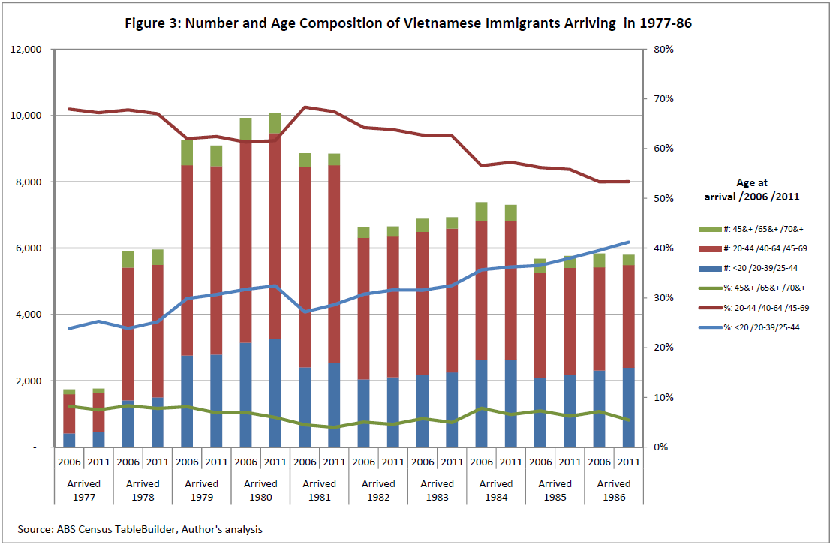
Alternative text description – The image above depicts a bar & line graph titled Figure 3: Number and Age Composition of Vietnamese Immigrants Arriving in 1977-89 and provides source ABS Census TableBuilder, Author’s analysis. The y-axis ranges from 2,000 to 12,00 and 0% to 80%. The x-axis provides 10 categories: Arrived 1977, Arrived 1978, Arrived 1979, Arrived 1980, Arrived 1981, Arrived 1982, Arrived 1983, Arrived 1984, Arrived 1985, and Arrived 1986. Each category provides 2 different bar measurements in 2006 and 2011 and in each bar there are multiple measurements Age at arrival/2006/2011 with green measures 45&+/65&+/70&+, red measures 20-44/40-64/45-69 and blue measures <20/20-39/25/44. In addition, there are line graphs which intersects with the bar graphs Age at arrival/2006/2011 with green measures 45&+/65&+/70&+, red measures 20-44/40-64/45-69 and blue measures <20/20-39/25-44.
Figure 3 shows the sudden increase and count of Vietnamese immigrants in these five years by year of arrival as reported in the two Censuses. It also shows that the age composition of the arrivals from Vietnam had shifted to having a higher proportion of young refugees in the second half of the ten year period. During the earlier years, about a quarter of the Vietnamese refugees were under 20 years old but in the final years they were about 40%. This shift would have implications for the disability of Vietnamese immigrants as a whole some 20 to 30 years later.
While it is clear that few Chinese students came to Australia with a disability; it is not necessarily the case for Vietnamese refugees at the time of arrival. Their specific characteristics means the understanding of changing status of disability over 2006 and 2011 will provide an interesting case study, in comparison to the previous two cases.
By the year 2006 when the Census, for the first time, started to collect information on disability, the refugees arriving in the 10 years to 2006 had lived in Australia 20-30 years. Figures 4a and 4b plot the disability rates reported in censuses 2006 and 2011 of Vietnamese refugees who arrived at Australia annually between 1977 and 1986 in the same manner as the earlier analysis of the Chinese immigrants. However, for presentation purposes we break the ten-year period into two sub-periods of five-years each (Figures 4a & 4b). While this is primarily because of presentation need the break point in 1981/82 is also consistent with a shift in the nature of these immigrants.⁶ These figures exclude the rates for age cohorts of the very young and very old, as these are based on small counts that have also been randomly adjusted by ABS for privacy reasons.
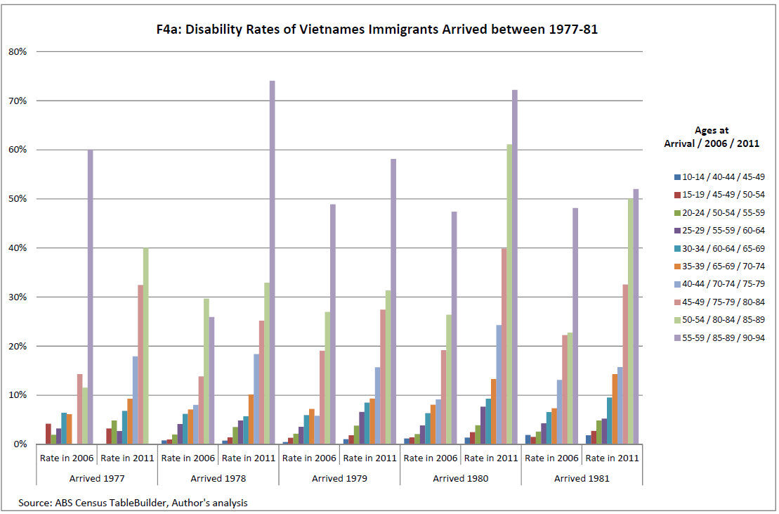
Alternative text description – The image above depicts a bar graph titled F4a: Disability Rates of Vietnamese Immigrants Arrived between 1977-81 and provides source ABS Census TableBuilder, Author’s analysis. The y-axis ranges from 0% to 80% and the x-axis provides 5 categories: Arrived 1977, Arrived 1978, Arrived 1979, Arrived 1980, and Arrived 1981. Each category provides 2 different bar measurements in 2006 and 2011 and in each bar there are multiple measurements Age at arrival/2006/2011 with dark blue measures 10-14/40-44/45-49, red measures 15-19/45-49/50-54, dark green measures 20-24/50-54/55-59, dark purple measures 25-29/55-59/60-64, teal measures 30-34/60-64/65-69, orange measures 35-39/65-69/70-74, light purple measures 40-44/70-74/75-79, pink measures 45-49/75-79/80-84, light green measures 50-54/80-84/85-89 and light purple measures 55-59/85-89/90-94.
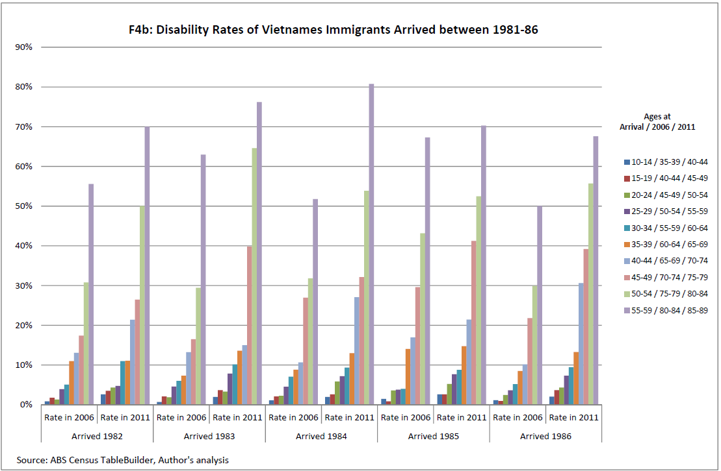
Alternative text description – The image above depicts a bar graph titled F4b: Disability Rates of Vietnamese Immigrants Arrived between 1981-86 and provides source ABS Census TableBuilder, Author’s analysis. The y-axis ranges from 0% to 90% and the x-axis provides 5 categories: Arrived 1982, Arrived 1983, Arrived 1984, Arrived 1985, and Arrived 1986. Each category provides 2 different bar measurements in 2006 and 2011 and in each bar there are multiple measurements Age at arrival/2006/2011 with dark blue measures 10-14/35-39/40-44, red measures 15-19/40-44/45-49, dark green measures 20-24/45-49/50-54, dark purple measures 25-29/50-54/55-59, teal measures 30-34/55-59/60-64, orange measures 35-39/60-64/65-69, light purple measures 40-44/65-69/70-74, pink measures 45-49/70-74/75-79, light green measures 50-54/75-79/80-84 and light purple measures 55-59/80-84/85-89.
Figures 4a and 4b not only confirm two general patterns that were identified in the earlier Chinese case analysis but also reveal some unexpected trends. First of all, by 2006 when these refugees had lived in Australia for some 20-30 years, the disability rates for people of different ages settled into a pattern that is similar to those of the general population. Older Vietnamese refugees tend to have a higher rate of disability than younger refugees. Take, as an example, the refugees who arrived in 1980 (the year with the largest number of arrivals); the disability rates increase progressively with the increase in age by 2006.
Second, between 2006 and 2011, almost every age cohort experienced a deterioration of disability rates. On average, 4.1% of all Vietnamese immigrants reported a disability in 2006. Five years later this rate increased to 5.9%. As the age spread of Vietnamese refugees is much wider than the Chinese students, the deterioration could be observed in both the younger and older age groups. At the youngest end, there are those as young as 10 years on arrival and about 40 years old in the census times; on the oldest end, there are those who were aged in their late 50s on arrival and in about their 90s at the census times. Of the 90 pairs of bars which compare the rates between 2011 and 2006 and are presented in Figure 5a and Figure 5b, 83 pairs show an increased rate.
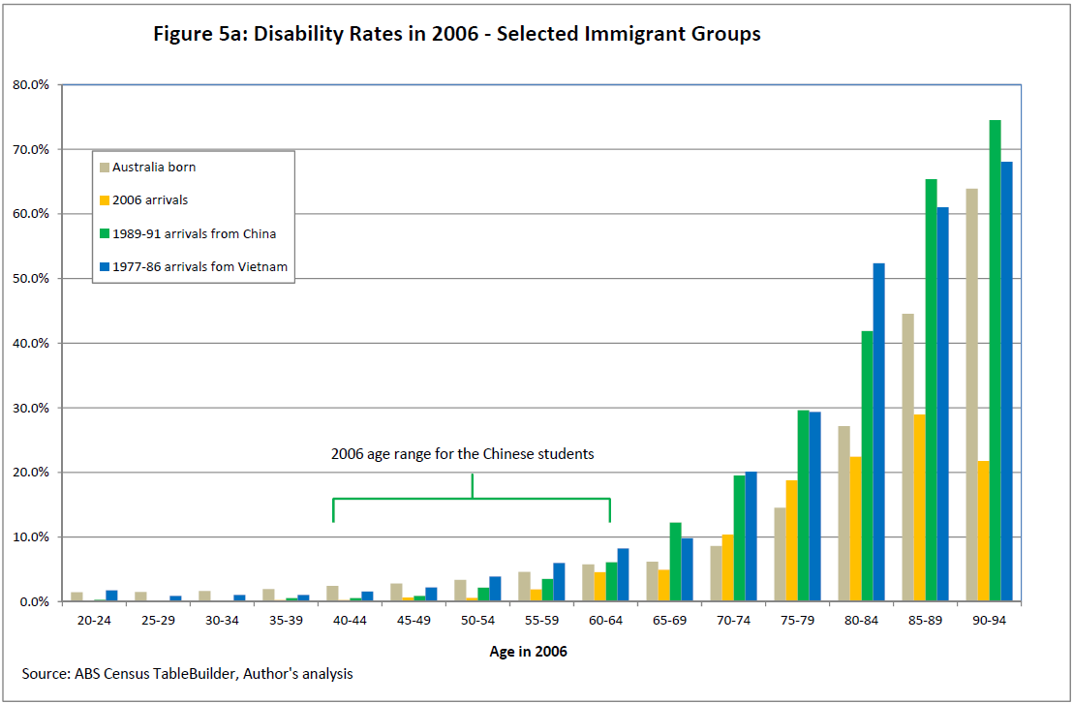
Alternative text description – The image above depicts a bar graph titled 5a: Disability Rates in 2006 – Selected Immigrant Groups and provides source ABS Census TableBuilder, Author’s analysis. The y-axis ranges from 0% to 80% and the x-axis titled Age in 2006: with ages 20-94 with 4 different categories Australia born, 2006 arrivals, 1989-91 arrivals from China and 1977-86 arrivals from Vietnam.
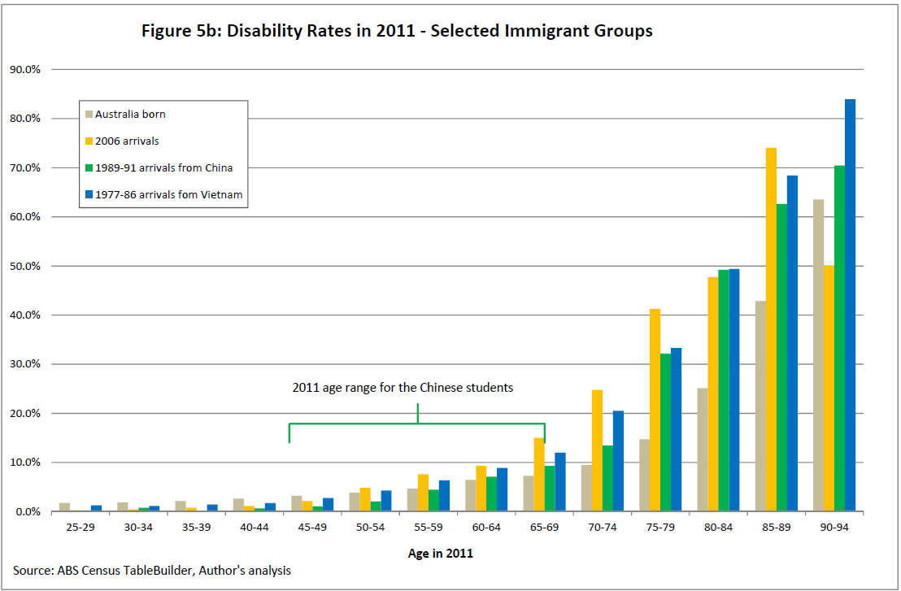
Alternative text description – The image above depicts a bar graph titled 5b: Disability Rates in 2011 – Selected Immigrant Groups and provides source ABS Census TableBuilder, Author’s analysis. The y-axis ranges from 0% to 80% and the x-axis titled Age in 2011: with ages 20-94 with 4 different categories Australia born, 2006 arrivals, 1989-91 arrivals from China and 1977-86 arrivals from Vietnam.
Moreover, and not surprisingly, older age cohorts have much greater increases in disability rates than younger age cohorts over these five years. For example, more than 80% of those in the oldest group who arrived in Australia in 1984 reported having disability in the 2011 Census, compared to 52% five years previously in 2006.
Careful readers might observe missing bars in Figures 4a and 4b. These are missing due to either there being no count of particular age groups. Another unexpected finding is in the disability 2006 profile for the first year arrivals (1977) that is strikingly different from those of other later years in that the correlation between age and disability rate is not as smooth. Upon further investigation of the data it was apparent that this untypical distribution was primarily due to the small cell count. As Figure 4a shows, the number of Vietnamese refugees in the first year (1977) is relatively small (less than 2,000 are reported in the 2006 Census). When this small number is further broken down by age and disability status, the numbers become too small to be statistically reliable. In addition, random adjustments performed by the ABS to protect privacy might have further distorted the underlying distribution that may be expected, as for the arrivals in other years.
Discussion
This paper examined the disability rates of three distinct immigrant groups over varied residence periods. The first group included those born overseas, old and young, who came to Australia up to five years prior to the 2006 Census. They came from all over the world for a variety of reasons. The short time between their arrival and the 2006 census means their reported disability status is treated as a proxy of the status at the time of entry. By the time of the 2011 Census, they had lived in Australia for at least five years. The second group, Chinese students, came to Australia in the late 1980s. They were predominantly student visa holders and few, if any, would have had a disability at the time of entry. By the 2006 Census, most of these people had been settled in Australia for more than 15 years. The final group, Vietnamese refugees, arrived in Australia in the late 1970s and first half of the 1980s. They were different from the first group in being from a single country of origin and being refugees. The Vietnamese were more diverse than the Chinese students in their age range, health and socioeconomic status and had lived in Australia for up to 30 years by the time of the 2006 census.
Analyses of these different immigrant groups suggests that age is one of the most important factors influencing the trajectories of disability status over the period 2006-2011. It has long been established that disability rate increases steadily with age (ABS, 2013). Disability prevalence tends to be much higher for older people regardless of the wealth of the country they live in (World Health Organization and the World Bank, 2011: Table 1 and Table 2). The data presented here make it evident that this is true for immigrant communities as well.
Recent immigrants to Australia present with considerably lower rate of disability than local communities of the same age who were Australia born or arrived earlier than them. To begin with, there exists considerable variation amongst these new arrivals in their level of disability. The older recent arrivals have higher rates of disability than the younger ones. One possible reason for this is that these older immigrants with a disability came to Australia primarily for family reunion. Even when Australian immigration regulation makes it unlikely that they came to Australia with a disability, which is reflected by a lower disability rate at the time of arrival (Figure 5a), they might have acquired a disability shortly after they landed in Australia. In a time-span of just five years, the rates of disability of young immigrants are in line with local people of the same age cohorts. For older cohorts (60 and over), the rates of change are much faster than that experienced by locals. After just five years, most of the older age cohorts of immigrants reported higher rates of disability than the local population (Figure 5b).
The Chinese student group presented similar trends over 15 to 20 years; although very few of them would have had any disability upon arrival. Some 15 years later, the rates of disability by age show a difference in age-related distribution that is similar to the local populations. More remarkable is the number of Chinese students in the older cohorts who had acquired a disability in the five years between 2006 and 2011; a much faster increase than that reported by the local born population in 2011 (Figure 5b). Interestingly, of those senior Chinese when arrived in the late 1980s their disability rates had reached the same level as the local population before 2006.
For Vietnamese refugees, disability rates surpassed those of the local population for all cohorts over 50 years old by the year 2006 by which time they had lived in the Australia for about three decades (Figure 5a). Five years later in 2011, the gaps had become even greater.
An intriguing question about the disability trajectory of immigrants in their host country is the amount of change since the time of entry. The present study had limited success in exploring this specific change as there are no comparable disability statistics at the time of entry. When examining the case of recent arrivals, we are able to take the 2006 statistics as a proxy of the disability profiles of these new arrivals because they have not lived in Australia long. In the case of Chinese students, it is assumed that few of these students had a disability at the time of entry. The study makes no assumption about the disability status of the Vietnamese boat people at the time of entering Australia. Instead it focuses the on changing status between 2006 and 2011.
This study makes no effort to untangle acculturalization processes in which the changes in disability status of immigrants occur. Immigrant communities, by definition, originated from different cultures, and individuals within these communities may interact with the local communities differently. At the same time they also influence and contribute to the hosting cultures as well. In an Australian context, immigrants have become the mainstream as more than a quarter of Australians were born overseas and more than half have at least one parent who was born overseas. Acknowledging the process of acculturalisation and its impacts on the disability, this study focuses on the latter on these first generation immigrants.
Clearly older immigrants tend to acquire disability faster than their local counterparts. However, it is not clear why this trend exists and what factors contribute to this trend. New research is required to answer these questions in order to develop effective social policy responses. Any new research must be multidisciplinary in nature in order to adequately explore the complex relationship between disability, aging and cultural diversity. Only through a multidisciplinary approach will researchers be able to assist policy makers to identify ways to change the disability trajectory of people from CALD backgrounds, to slow down the rate of disability manifestation and acquisition, and to develop culturally appropriate services to an increasing number of people with disabilities from CALD backgrounds in both disability and aged care service settings.
Conclusion
Of the current Australian population, about a quarter are first generation immigrants. While immigrants might as a whole have a rate of disability that is lower than their hosting population at the time of their arrivals, they are not a homogenous group. Few of these immigrants had a disability when arriving, some others acquired disability or their disability conditions manifested after their arrival. As demonstrated in this paper, age is the most important factor influencing the trajectories of disability status of immigrants, just like their local counterparties. Not surprisingly older immigrants tend to have a higher rate of disability than younger cohorts upon arrival. Furthermore, the older the immigrants are the faster they acquire disability. In about a generation, immigrants tend to have an aged related disability profile that is similar to the rest of the community. It is important to not underestimate this rate of the change when developing government policy and program design for specialist disability and aged care services.

Qingsheng Zhou Senior Research Fellow, National Centre for Classification in Health, Faculty of Health Sciences, The University of Sydney.

References
Alter G and Oris M. (2005). Childhood conditions, migration and mortality: Migrants and natives in 19th century cities. Social Biology, 52(3-4), 178-191.
Anikeeva O, Bi P, Hiller JE, Ryan P, Roder D. and Han G-S (2010). Review paper: the health status of migrants in Australia. Pacific Journal of Public Health, 22(2), 159-193.
Australia Bureau of Statistics. (2005). Census 2006 Household Form. Retrieved from http://www.abs.gov.au/ausstats/abs@.nsf/0/05d78f82343a3ae5ca25720900078b62/$FILE/2006%20Census%20Form.pdf.
Australia Bureau of Statistics. (2006). Census dictionary 2006 (reissue). Retrieved from http://www.abs.gov.au/ausstats/abs@.nsf/0/014F8C1E2D27DFF8CA25720A0010F03D?opendocument.
Australia Bureau of Statistics. (2007a). Comparing disability prevalence. Retrieved from http://www.abs.gov.au/AUSSTATS/abs@.nsf/7d12b0f6763c78caca257061001cc588/09eb653cd0138119ca2572dd0011eafc!OpenDocument.
Australia Bureau of Statistics. (2007b). 2006 Census of Population and Housing: Media Releases and Fact Sheets. Retrieved from http://www.abs.gov.au/AUSSTATS/abs@.nsf/7d12b0f6763c78caca257061001cc588/ec871bf375f2035dca257306000d5422!OpenDocument.
Australia Bureau of Statistics. (2013). Disability, aging and carers Australia: summary of findings 2012, Retrieved from http://www.abs.gov.au/AUSSTATS/abs@.nsf/DetailsPage/4430.02012.
Australia Bureau of Statistics. (2014). About Table Builder. Retrieved from http://www.abs.gov.au/websitedbs/D3310114.nsf/home/About+TableBuilder
Australia Bureau of Statistics. (2015). Basic survey design. Retrieved from http://www.nss.gov.au/nss/home.nsf/SurveyDesignDoc/20EDCFE8B204BE1FCA2571AB002479A2?OpenDocument.
Australian Institute of Health and Welfare. (2010). Australia's health 2010. Retrieved from http://www.aihw.gov.au/publication-detail/?id=6442468376.
Castles, I. (1991). Multicultural Australia. Australian Bureau of Statistics
Commonwealth/State Relations Section Office of Disability. (2003). Agreement between the Commonwealth of Australia and the States and Territories of Australia in relation to disability services. Retrieved from https://www.dss.gov.au/sites/default/files/documents/05_2012/cstda3may07.pdf.
Council of Australian Governments. (2009). National disability agreement. Retrieved from http://www.federalfinancialrelations.gov.au/content/npa/disability/national-agreement.pdf.
Evidence Base Development Unit. (2010). Report on people with disability and their careers in NSW. Sydney: Department of Family and Community Services. Retrieved from https://www.adhc.nsw.gov.au/__data/assets/file/0010/227953/35_ReportonpeoplewithadisabilityandtheircarersinNSW1.pdf.
Findley, S. E. (1988). The directionality and age selectivity of the health-migration relation: Evidence from sequences of disability and mobility in the United States. International Migration Review, 4-29.
Gray, L., Harding, S., & Reid, A. (2007). Evidence of divergence with duration of residence in circulatory disease mortality in migrants to Australia. The European Journal of Public Health, 17(6), 550-554.
Harding, S. (2004). Mortality of migrants from the Caribbean to England and Wales: effect of duration of residence. International Journal of Epidemiology, 33(2), 382-386.
Johansson, B., Helgesson, M., Lundberg, I., Nordquist, T., Leijon, O., Lindberg, P., & Vingård, E. (2012). Work and health among immigrants and native Swedes 1990–2008: a register-based study on hospitalization for common potentially work-related disorders, disability pension and mortality. BMC Public Health, 12(1), 845.
Jupp, J. (2001). The Australian people: an encyclopedia of the nation, its people and their origins. Cambridge University Press.
Kaestner, R., & Malamud, O. (2014). Self-selection and international migration: New evidence from Mexico. Review of Economics and Statistics, 96(1), 78-91.
Museum Victoria Australia. (2014). History of immigration from China. Retrieved from https://museumvictoria.com.au/origins/history.aspx?pid=9.
Mutchler, J. E., Prakash, A., & Burr, J. A. (2007). The demography of disability and the effects of immigrant history: Older Asians in the United States. Demography, 44(2), 251-263.
New South Wales Department of Education. (2015). Australian Communities: Vietnamese Australians. Retrieved from http://www.racismnoway.com.au/teaching-resources/factsheets/76.html.
Phillips, J., & Spinks, H. (2013). Boat arrivals in Australia since 1976. Department of Immigration and Citizenship, Parliamentary Library: Australian Government. Retrieved from http://parlinfo.aph.gov.au/parlInfo/download/library/prspub/5P1X6/upload_binary/5P1X6.pdf;fileType=application/pdf#search=%22boat%20arrivals%20in%20Australia%20since%22.
World Health Organisation. (2001). International classification of functioning disability and health. Retrieved from http://www.who.int/classifications/icf/icf_more/en/.
World Health Organization. (2011). World report on disability. World Health Organization.
Zhou, Q. (2016). Accessing disability services by people from culturally and linguistically diverse backgrounds in Australia. Disability and Rehabilitation, 38(9), 844-852.

Endnote
1 There are many ways to classify and count immigrants. This study adopts a simple and practical definition that an immigrant is a person who is born in a different country and comes to live for a considerable period of time in Australia, as self-reported in the Census of Population and Housing (ABS, 2006).
² The ABS (2015) generally recommends the uses of standard error (SE) and relative standard error (RSE) to indicate statistical reliability of any estimates based on the SDAC. Such indicators however are not necessary when the Census data are used as they cover the whole population and are therefore not subject to sampling error.
³ In the late 1980s, there was an increase in the number of people from China enrolling in post graduate studies in Australia universities. Meanwhile Australia came touting for Chinese students, offering visas and the chance to study English in private colleges for a fee. Consequently a large number of young Chinese rushed to Australia, not merely for the chance to study, but also the possibility of a new life. In 1989, the Australian government granted permanent visas to most Chinese students in the aftermath of the Tiananmen Square incident (Sydney Morning Herald, 2003 Dec 26). Several months later, a large number of Chinese citizens who had received a student visa prior to the Tiananmen incident also landed on Australia soil. Most of these people permanently settled in Australia.
⁴ For simplicity, arrival ages are based on 1991.
⁵ This decreased to around 45 per cent between 1986 and 1991 and only 22 per cent between 1991 and 1993 (NSW Department of Education, 2015).
⁶ In 1979, the Vietnamese government agreed to forcibly constrain unregulated departures, but to allow an Orderly Departure Program (ODP) in which Vietnamese were permitted to apply to migrate to specific countries. In 1982 the first Vietnamese immigrants under the ODP arrived in Australia. From the late 1980s this program was officially applied in Australia as the ‘Vietnamese Family Migration Program’ (VFMP). Under this program Vietnamese people with relatives in Australia were permitted to emigrate directly from Vietnam to Australia, subject to satisfying Australia’s standard refugee requirements.

