Creative Works

Three (or Infinite) Lenses: Translucent Still Life I
Kai Rands (PhD)

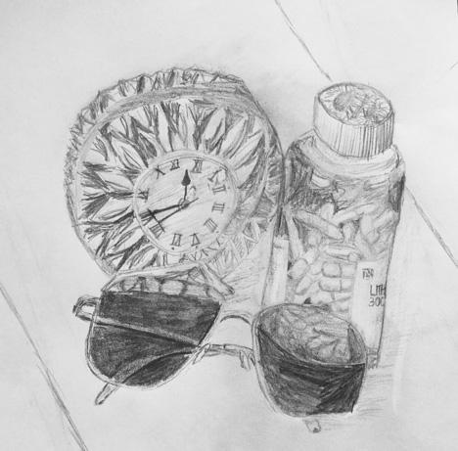

Description: A pair of folded sunglasses sits on a table in front of a round crystal clock with roman numerals and a bottle of capsules. The base of the clock and the bottom of the pill bottle can be seen through the top of the sunglasses. Part of the pill bottle label can be seen: "Lith. . .300. . . ."

Artist statement
The drawing prompts the viewer’s contemplation of lenses on three different levels. (By lens, I mean a device that transforms the user's experience in some way and designates a focus.) First, disability studies serves as a lens. Simi Linton (1998) has noted that disability studies is “a prism through which one can gain a broader understanding of society and human experience” (p. 118).
Second, on a literal level, the drawing includes three translucent objects that serve as lenses. The textures of the clock, the bottle, and the sunglasses create a proliferation of lenses refracting the viewer's focus in numerous directions. On this literal level, the lenses interact with one another so that the viewer has multiple views. For example, the sunglasses influence the experience of viewing part of the clock and part of the bottle, and hence, the view of some of the pills.
On a third level, the three objects prompt the viewer to contemplate the ways in which the objects function as metaphorical lenses. Time, represented by the clock, has served as a lens shifting my own experience of disability and disablement as well as designating different focuses. The disability studies perspective that nondisabled folks are "not presently disabled" draws on the lens of time to frame experience. Moreover, by problematizing the nondisabled/disabled binary, disability studies theorists point out that someone can be concurrently disabled and (en)abled in various ways, proliferating the lenses of time in the present moment. The other two items are also personally significant to me. Moods, and thus mood stabilizing medication, serve as lenses that affect my experience of the world. The third object, sunglasses, enables certain experiences of the world during migraines. Just as on the literal level the lenses interact with one another, on the metaphorical level, the lenses are experienced in ways that interact. For example, the experience of migraine can prompt shifts in mood and shifts in mood can influence the experience of migraine. Both can influence one's experience of time.
Dr. Kai Rands is an independent scholar, artist, educator, and activist focusing on queer and trans studies and activism as well as disability studies and activism.

Reference
Linton, S. (1998). Claiming Disability: Knowledge and Identity. New York, NY: University Press.

