Research Article

Photovoice: Life Through the Eyes of People with Disability in North India
Nathan Grills (PhD) and Gillian Porter (PhD)
Nossal Institute for Global Health and The University of Melbourne
Raj Kumar
Landour Community Hospital and Emmanuel Hospital Association
Jubin Varghese
Herbertpur Christian Hospital
Abstract: The authors used photovoice methodology to gain insight into the lives of 18 people with disabilities in rural North India. This project provided participants with an opportunity to express their joys and difficulties and provided important insights to help structure future programs and supports within the community.
Keywords: Photovoice, disability, community-based rehabilitation

Background and Introduction
It is estimated that about 15% of the global population has a disability (WHO, 2011b). People with disabilities are often some of the poorest in a community, on average having lower levels of employment and educational attainment than people without disabilities. Improving the lives of people with disabilities and their families is a significant challenge in India, as it is around the world.
According to the Indian government’s 2001 census, (Jeyalakshmi, 2011) the proportion of India’s population with disabilities is 2.1% and according to the 2002-2004 World Health Survey (WHO, 2011c) it is 25%. India ratified the United Nations Convention on the Rights of Persons with Disabilities (UNCRPD) in 2007, reinforcing that people with disability should be consulted about activities and policies affecting them. Despite the articulation of this core value within the UNCRPD – that of active inclusion of people with disabilities in policy and programming, community rehabilitation programs are rarely inclusive of the perspective of people with disabilities.
There is limited quantitative and qualitative research in India that characterises the situation for those with disabilities. It is important to include the perspective of those people with a disability, as they view things differently than those without a disability. However, their perspective is often difficult to elicit with traditional research tools, and so it is not included.
To help understand the voice of those with disabilities and responsively plan our program activities, we the research team trialled a novel research tool called photovoice. The point of interest was to determine whether this novel photographic tool could assist those with a disability to convey the elements of rehabilitation programs that are important to them. Likewise, the researchers sought to find out to what degree photovoice could enable the voices of people with disabilities, which are often overlooked and under-represented, to be heard.
By giving community members the opportunity to express their viewpoints through photography, the researcher gains a special insight into life within the community. Additionally, the photographs taken create empathy for those with a disability where otherwise it is difficult to imagine or understand how life looks from their perspective.
Catalani & Minkler (2010) identified three types of outcomes in photovoice projects (see Figure 1): (a) enhanced community engagement in action and advocacy; (b) improved understanding of community needs and assets, which in turn could have community or public health benefits; and, c) increased individual empowerment.
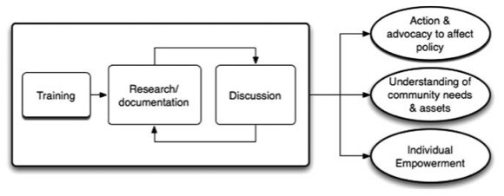

Figure 1. Three Types of Outcomes in Photovoice Projects

Research Questions
In what ways can using photovoice methodology provide an understanding of the lives of people with a disability from their own perspective? This research also aimed to investigate how photovoice methodology could influence self-advocacy for people with disabilities, enable them to raise awareness of their lived experience and advocate for their own rights.

Materials & Methods
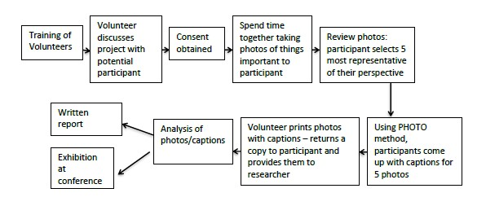
Figure 2. Ten-Point Framework of Photovoice
Hergenrather's ten- point framework for undertaking photovoice research (figure 2) was applied to the study, together with an adapted set of Hergenrather’s questions for participants (Hergenrather, Rhodes, Cowan, Bardhoshi, & Pula, 2009). The ten steps were as follows:
- Identification of community issue: The study area was in the state of Uttarakhand, North India. When speaking with people with disabilities it became apparent that they felt misunderstood and that their priorities were not considered.
- Participant recruitment: A mixture of convenience and purposive sampling was used to recruit 18 people with various disabilities (see Table 1). A person was eligible to participate in the study if they had a disability, were living in Uttarakhand and were already linked to two existing community based rehabilitation (CBR) programs. Participants were purposively selected so as to ensure representation of various disabilities.
Table 1: Overview of Participants
Data collected from 18 different participants are shown in the following table. The variables of the table include code, sex, age (years), disability description and photos.
Code | Sex | Age (years) | Disability description | Photos
P1 | M | 4 | Left infantile hemiparesis with difficulty walking and with motor activities | Figure 3  Figure 5
P2 | F | 14 | Moderate severity cerebral palsy and intellectual disability, walks with support
P3 | F | 23 | Moderate locomotor disability, walks with assistance Limb length disparity
P4 | M | 45 | Severe locomotor disability - non-mobile, post-polio | Figure 10
P5 | M | 9 | Mild intellectual disability, speech difficulties, minimal vocabulary
P6 | M | 18 | Severe locomotor disability and depressive symptoms Unable to walk
P7 | M | 15 | Dysmorphic, moderate intellectual disability, social impairment and speech impairment
P8 | M | 62 | Locomotor (amputation of both feet) and requires crutches to walk | Figure 4
P9 | M | 50 | Spinal injury, requires support to walk | Figure 6
P10 | M | 4 | Moderate spastic quadriplegic cerebral palsy | Figure 7
P11 | F | 7 | Moderate developmental delay and locomotor disability | Figure 8
P12 | M | 7 | Severe autism | Figure 9
P13 | F | 45 | Mild intellectual disability
P14 | F | 10 | Fine motor skills impairment, mild intellectual disability, speech difficulties
P15 | F | 15 | Moderate intellectual disability, mild impaired mobility, right hand affected, seizure disorder
P16 | M | 7 | Moderate autism spectrum disorder
P17 | F | 18 | Undiagnosed syndrome: physical deformity and epilepsy
P18 | F | 55 | Moderate locomotor disability prevents walking

- Photovoice training: Thorough training of current CBR staff and CBR volunteers was a key aspect of the photovoice methodology, as research shows a positive relationship between the intensity of training and community participation (Catalani & Minkler, 2010). The training provided information on the goals and aims of the study, including ethics, safety and consent.
- Camera distribution and instruction: Each participant was given a camera for 24-48 hours. The person with a disability and/or the carer received specific technical training from trained volunteers/staff on how to take photographs using the camera.
- Photography: The participants were advised to take the photos in their home or local village environment. Volunteers/staff were available to support people but they were specifically trained not to interfere unnecessarily and to accept all photos even if they might be considered irrelevant or of poor quality.
- Identification of photo assignment: After a discussion with local staff and community members in which culturally appropriate wording was determined, participants were given the following instructions: “Please photograph people, places and activities that are important to you,”and, “Please photograph people, places and activities that make you feel important.”
- Photo assignments discussion: After taking photographs, participants reviewed and selected the five most representative pictures of what was important to them, and were asked the following questions:
  - Describe the picture: what is happening?
  - Why is this important?
  - What does this tell about your life?
  - What does it show about opportunities to improve your life?
(Adapted from Hergenrather et al., 2009)
- Data analysis: A thematic analysis of data from the photographs and the descriptions of these photos was completed independently by two researchers. Each researcher used a grounded theory approach to iteratively group the data into categories and subcategories representing the perspectives of people with disabilities. The themes identified by each researcher had high coherence. The lead author then combined the two analyses to arrive at the common themes represented in the results.
- Presentation of photovoice findings: In addition to publishing the results, photovoice findings are typically presented through a public photo exhibition. This was conducted as part of a session on photovoice at the Asian Conference on Intellectual Disabilities. Key photos representing the themes were printed and presented at the conference.
- Creation of plans of action for change: Interrelated with the presentation of photovoice findings at the exhibition, participants were empowered to create plans of action for change.

Results
As outlined in Table 1, there were 18 participants with disabilities from 14 villages enrolled in this photovoice study. This included five adults, ten children under the age of 15 years old, and three adolescents aged between 16-25 years. The severity of disabilities ranged from mild to severe, and five of the participants had multiple disabilities. Two had speech impairment, two had autism, one had developmental delay, two had cerebral palsy (CP), one had an undiagnosed syndrome, five had locomotor disability, four had other forms of physical disability, and six had intellectual disability. For three participants with more severe/multiple disabilities, their respective carers helped them interpret the photos. The data from the 18 participants produced 95 photos with accompanying commentaries. The following themes and sub themes were found.

Family and Friends
The importance of strong, trusting and dependable relationships with family and friends was a dominant theme with many photos taken depicting family members. In describing the photos, participants expressed both love and, often in the same sentence, appreciation of the care they provided. As this boy with autism says:
“I love my grandma, she looks after me whole day”. (P1)
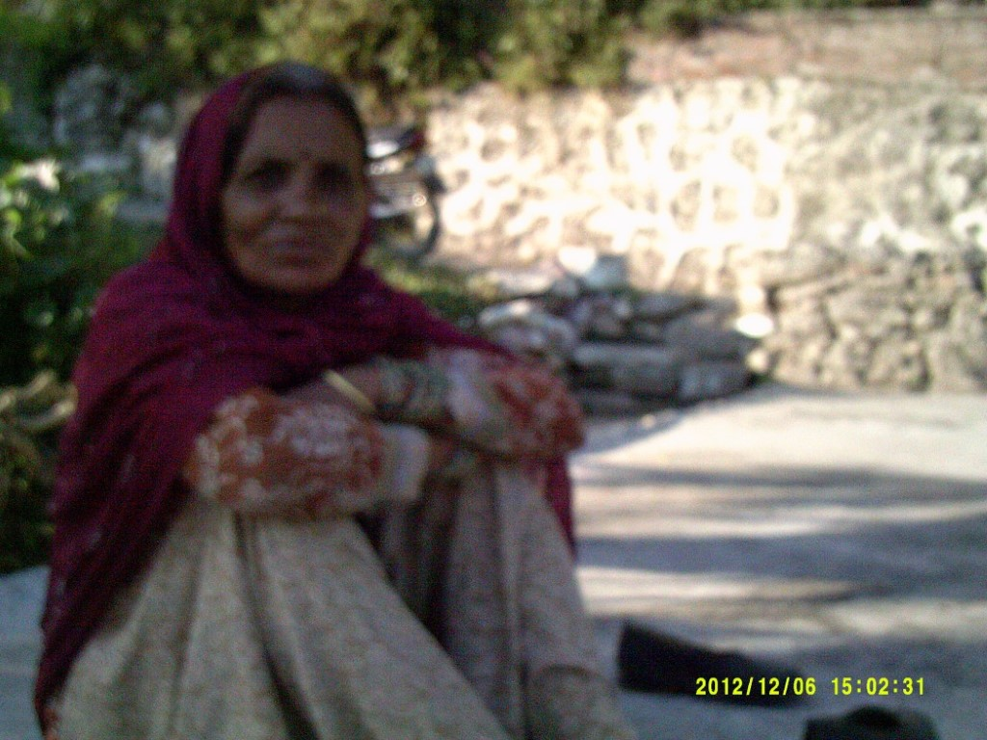
Figure 3. Photograph of primary carer (the grandmother) of P1
Various quotes described their primary care givers as a strong and reliable support with whom they had developed strong bonds through large amounts of time spent together.
The carer was often referred to as the paternal grandmother – a common phenomenon in the village where both parents are employed in subsistence economies. A child with autism demonstrates:
“I wanted a picture of ammi (paternal grandmother)… She looks after me, takes me to different places, gives me my favourite food. I wanted to give her a photo of herself. Will you give this photo to me? I want to give it to her. It will make her happy.” (P2)
Various pictures and descriptions also detailed the role of friends. Friends clearly provided meaning and overcame the boredom that was described as typically accompanying disability:
“I love my niece and nephew. My brother used to live with us until he got married. Now they live separately but his children come every evening to spend time here. So I spend time with them. When the children are not around I feel bored. But I don’t like too much noise.” (P3)
Many people with disabilities were dependent on friends for companionship, and also relied on them like they did on their family members for practical support such as travel and personal care.
A number of the commentaries on photos specified how the person with a disability desired to express love and appreciation in a tangible way. This reciprocity of caring and contributing to their family seems to be important, as did the interdependent nature of their friendships:
“This picture is of my friends… helps to have support. My family… my friends support me, especially when I have to travel somewhere, they take me with them. They have their own difficulties and I try to help them too.” (P4)
Concern about the family’s ability to care for the person with a disability in the long-term was expressed when speaking with carers:
“We hope that we can teach him to do basic things. We have opened an account in the bank for him so that when he is older he will have his own money. Nowadays, everyone cares only for themselves. Who knows what will happen after we are gone? We are hoping that if he has money of his own, his siblings may be willing to look after him.” (P5)
With little access to a reliable social security or disability care system, the ongoing role of care typically falls to siblings and other relatives when the parents and grandparents are no longer able. In India and other low and middle-income countries the dependency on family is prominent and often perceived as permanent.

Employment, Financial Security
The importance of employment for people with disabilities was evidenced in the photos and descriptions of most participants. In most instances the importance of employment was closely related to the desire for financial security for these mostly poor families:
“… [It’s] difficult to run a household with only one income... being poor is the worst thing especially when I am disabled.” (P6)
This clearly describes the double burden of disability and poverty. Evidently, in a country with little dependable social security, employment is key. Employment provides not only financial security, but also contributes to self-esteem, identity and inclusion in society. One participant with locomotor disability describes:
“Through hard work like this I have never considered myself disabled. I always thought I should live and encourage others. I should not beg. I should not have to stretch my hand before anyone… my desire [is] to encourage people with disabilities as much as possible and to use my body in service. That is my desire.” (P4)
Employment was perceived as an effective way to be respected by family, friends and the community. Where those with a disability described their employment, it was mostly in the informal economy and consisted of contributing to subsistence farming and domestic chores. One example described how a boy with intellectual disability was able to contribute:
“... He looks after the cattle… follows them around and makes sure they get back home safe. He also looks after them here, washes them and makes sure they are ok.” (P7)
However, many who had capital, such as a family business or farms, complained that they were no longer able to work in their fields, local shops or restaurants. For example, one man who had lost the use of his arm describes:
“ I own fields, but unlike my other fellow villagers, I cannot plough or till my own fields.” (P8)
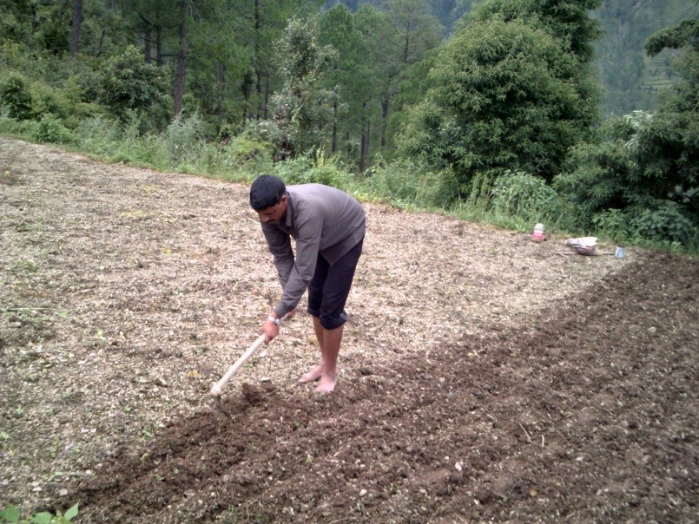
Figure 4. Photograph of worker in the fields adjacent to the house of participant P8
Once unable to work due to their disability, finding alternative employment was difficult. The data showed that opportunities for work were limited due to the disability and others’ discriminatory attitudes:
“The main problem is employment. Even if they are able to learn a trade, they have no equipment. Even if they have equipment, they have no place… The main thing is employment. If there is employment we don’t even need a pension.” (P4)
The participant quoted above iterates that employment is the most important thing for him. He also describes how vocational training is hard to get for a person with disability, and often makes little difference to employment opportunities. Another adult with locomotor disability comments similarly:
“I have studied until fifth standard [grade]. I tried to learn some trade but could not get any help, like every human being looks for help. But I did not get any help. I did try to learn a trade but going up to the junction is difficult for me. You must have noticed how far it is from here. To go to the place where I must learn the trade – that also will be difficult.” (P6)
A photo showing people walking to work demonstrates a sub-theme about the prevalence of corruption that magnifies the difficulty of people with disability getting pensions and work reservations. Its photographer describes how he has been trying to get a government job through the quota reserved for those with disability but he was told they are ‘not available’:
“Only those with contacts, only they get [a job]. A lot of people who have contacts [got one]. I’ve not been able to develop a contact yet. I think that I should get a job based on my ability.” (P3)
Another participant commented along similar lines:
“There are opportunities but with corruption, it is difficult to access these opportunities” (P6)

Social Attitudinal Barriers
The data showed that attitudinal barriers not only contributed to difficulty in gaining employment but also to social exclusion and a feeling of being unwanted. A person with locomotor disability described his experience of trying to fix his tricycle:
“People see and pretend not to see... no one is willing to help. Most people in the village don’t even know my name. They just call me ‘lungda’ [cripple]. How can I move forward without support?” (P6)
Another adult with locomotor disability described similar discriminatory attitudes:
“Many people pass comment about my disability… People also think that despite being disabled why does he keep joining people, and why do people respect him? But I don’t listen to them.” (P4)
Other such comments were common in the data, and the participants identified tackling such discrimination as an important area for action.

Physical Barriers and Travel, Transport, Accessibility
The data indicated that even if people with disabilities were welcomed by their community, physical barriers perpetuated exclusion. In the home, there were barriers to using basic facilities, e.g. access to sanitation. A boy with post-polio paralysis commented:
“I wish this wash basin could be reachable to me.” (P1)
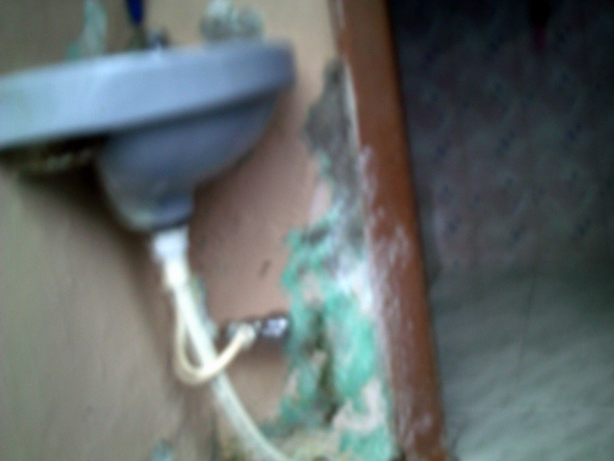
Figure 5. Photo of wash basin that is out of reach of participant P1
The most significant barriers the data highlighted relate to movement in and between villages. Such barriers, identified by 13 of the participants, typically limit their independence, mobility and community involvement. A 50 year-old man with locomotor disability describes his photo:
“Due to my physical impairment, I just sit at the door. I would wish to go to and fro from this door.” (P9)
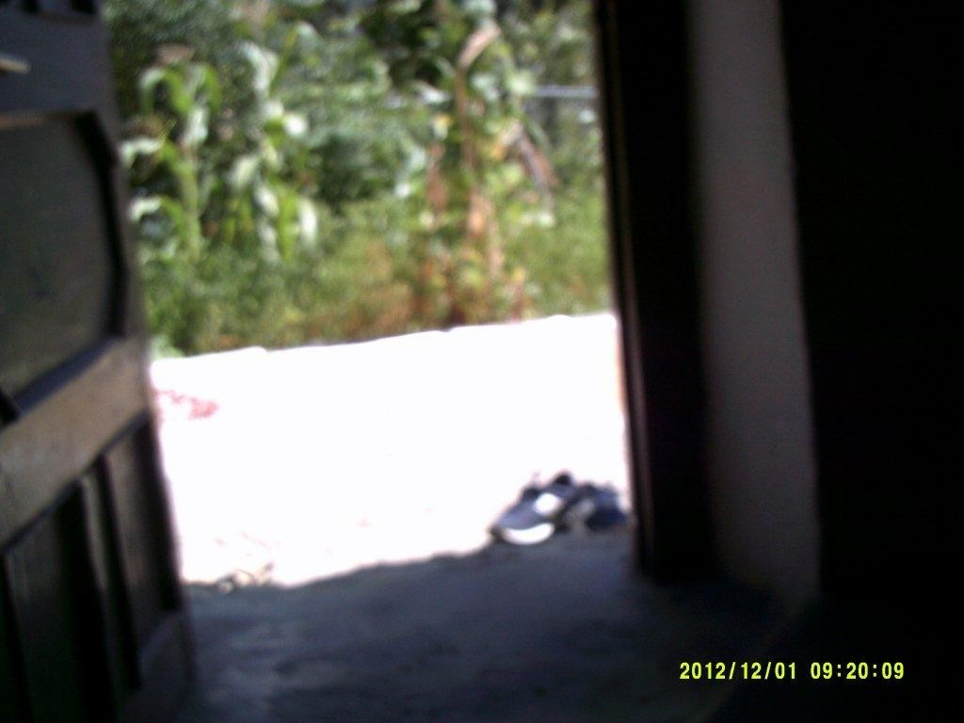
Figure 6. Photo of the open doorway through which a man (P9) with locomotor disability looks
Assistance was only partially effective due to cost. Many thought they might benefit from transport assistance, like a modified scooter, and that it would increase their independence and participation:
“….It [is] so much easier to have my own scooter… [a] scooter will help me be independent… [I] will not have to depend on somebody else to go with me or take me depending on their plans.” (P4)
However, such aids were expensive. There was some evidence of people accessing government accessibility schemes, in particular for tricycles and subsidised public transport. Yet even where transport was available there was little evidence of environmental modifications to facilitate the person with a disability to move around their community:
“You see, I got the tricycle from the government for free. It is helpful for short distances, but in the rain, when we have to travel long distances, or when we have to go up a slope, the tricycle is very difficult.” (P4)
Even if tricycles were available in the mountains, they would be difficult to use unless there were significant modifications to roads and paths. A number of people with disabilities commented that current roads and paths are difficult to access on a tricycle. The lack of community infrastructure and support to overcome these barriers was also evident in the data, which highlights both the importance of lobbying for more accessible roads and the theme of inclusive transport options:
“I took the picture of the path leading to the house. It is very difficult to manoeuvre the tricycle through the path to my house.” (P6)

Nature, Beauty, Food, Recreation
Though not always a priority for disability community based programs, enjoyment of nature, recreational activities and food were considered important by those with a disability. An appreciation for nature was described as being important by various participants. Several photos and their descriptions demonstrated the value of nature to many with a disability. A child with cerebral palsy and another with developmental delay commented, respectively:
“I am inspired from this tree, I daily see this tree.” (P10) and “I love nature especially flowers. I wish I could have a garden like this” (P11)
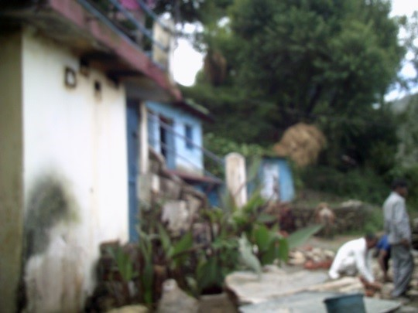
Figure 7. Outside the house of participant P10, showing housing, greenery and a two men in the yard.

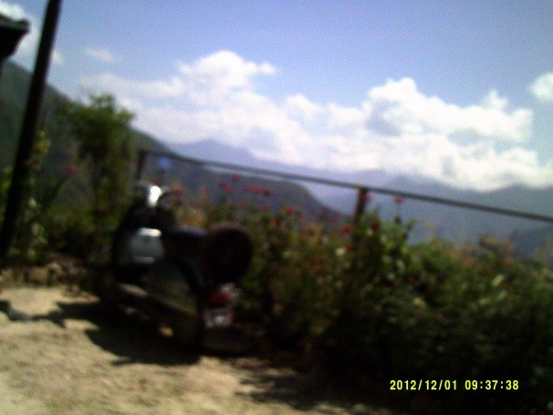
Figure 8. The garden of participant P11, including the mountains in the distant background past the garden fence.
One example demonstrated how the love of nature can translate into increased wellbeing and participation. The parents of one child with an intellectual disability explained why he took a photo of a bullock cart:
“That was the first picture he took. He loves his animals. Every day he wakes up in the morning and cares for them. He spends a lot of time with them... Maybe that’s why he took the picture of the bull. As compared to before, he has become quite independent now. He knows all that he must do and wakes up in the morning and does all the tasks one after another.” (P5)
Photos were taken of many objects relating to recreational pursuits such as a television, a playground and animals. It is clear that recreation was valued by many children as a means of enjoyment, passing the time and engaging with others. However, where children were excluded from recreational activities, there were feelings of resentment. A child with autism who commented on his photo illustrates this:
“All the children are playing. No one wants to play with me.” (P12)
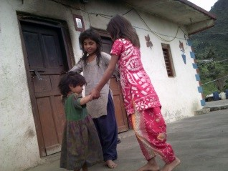
Figure 9. Three children holding hands in a circle (P12)

Food was featured in many photos. It was described not only as a source of enjoyment or comfort but also as something that helped children gain self-confidence and engage in the community. Food can be a very effective tool to assist with development, as was indicated by the explanation of a photo of biscuits taken by a child with an intellectual disability:
“He loves biscuits. He knows which is his favourite one. He walks to the shop by himself, and points to the one he wants. He knows that he has to give money and will [get] change in return. He does not know how much change he will get back. But the shop owner knows us well and he sends the right change back. R*** knows to walk carefully on the road and to cross carefully. Sometimes I give him a list of things to buy. He will take the list and give it to the bhaiya and bring back what he gives. He is slowly becoming more independent.” (P5)

Spirituality
The data demonstrated that spirituality was important to the participants. Spiritual beliefs provided many with an explanatory framework for disability, and in so doing provided comfort, promoted acceptance of the disability and helped define a sense of purpose to the disability. A lady with an intellectual disability explained:
“There are lots of problems… This is all the work of god. It is not as if it is the work of men. A lot of people laugh. There are so many who cannot even walk, who need a lot of help from others. I thank God that at least I can walk about [with] the help of my stick. I can bathe myself, wash clothes, cook food.” (P13)
Other participants also referred to god or faith as a source of strength for them to face their difficulties. A man with a locomotor disability took a photo of a temple and explained:
“I allow only god to dictate how I live my life. I choose to live in a way that I am not dependent on anyone. The strength I need, god gives. Belief in god keeps me going... that he is there, with whatever difficulty I have been given.” (P4) 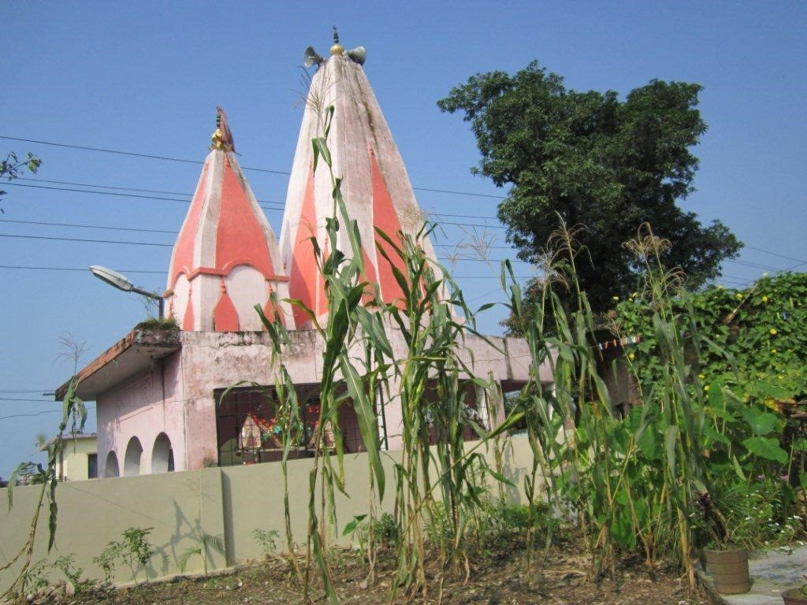
Figure 10. Photo of a pink temple taken by participant P4

Discussion
Photovoice proved to be a useful methodology in raising awareness about issues that are important to those with a disability. The different ages and disabilities provided different and unique insights and challenged any homogenous notion of disability. Consistent with previous uses of photovoice, it was a simple and inexpensive method, which will assist in program planning, raising awareness and most importantly giving voice to the voiceless (Jurkowski, 2008). Even within this small sample there were examples of how this approach enabled people with disabilities to tell their own story and advocate for their own rights, such as transport. In response to the research question, the photovoice methodology provided an understanding of the lives of people with disabilities from their own perspective. It revealed aspects of life that are of significant value to people with a disability, including family, access to transport and employment, overcoming social and physical barriers, the enjoyment of nature, food and recreation and spiritual belief. These results support most of the important elements in the WHO CBR matrix, which indicates five components for response and 25 important elements to consider. Additionally, however, the study highlights areas, such as spirituality, that are deemed important to people with disability but absent from the CBR matrix (WHO, 2011a) .
Family was central and valued in the experience of those with a disability in India. Children and adults thought positively of these dependent relationships, which differs from the typical western mindsets that view dependence on family as a weakness in the pursuit of independence and autonomy. Rather than becoming obsessed about independence from their family, people with a disability showed the desire to remain in close contact with their families, to be able to contribute to the family unit in a meaningful way, or, at the very least, to be able to demonstrate their appreciation of their family.
A key issue for the participants in this study was that of gaining employment, and the associated barriers for a person with a disability. Providing adequate employment is an area in which many CBR programs struggle. In India there are government schemes, like the Mahatma Gandhi National Rural Employment Gurantee Act, that provide a guarantee of minimum work whether living with or without a disability. These schemes are largely non-operational in rural areas. Thus, efforts need to be made to ensure that people can avail themselves of existing programs. The data suggest that a certain degree of this entails encountering corruption, which often means that the intended beneficiaries are not included. Creative schemes need to be considered, as suggested by one person with a disability in this project:
“If we can have an area for the disabled to set up stalls for shops, we can pay rent for the space… but we should advocate that [the government] give us the land.” (P13)
The study demonstrated how valuable work is for people with disabilities, not only in providing a livelihood but also in providing a sense of identity and integration into the community. This makes it an even higher priority for CBR programs.
Areas that might not otherwise be incorporated into a CBR program were raised as important. For example, with a focus on therapy and inclusion, one of the most basic aspects of normal life is overlooked. That is, recreation may be particularly important for the mental health of those with a disability, who may feel a lack of enjoyment and meaning due to their impairments. Beyond mere enjoyment and the use of play as therapy, recreation also provides an opportunity to promote the inclusion of children with disabilities in society. The study has shown that this is often not the case; children were excluded from play and were sometimes teased as part of play.
Likewise, the results highlight that people with disabilities value the natural environment yet it has limited place in formal therapy. It could be that there are opportunities, therefore, to incorporate exposure to or interaction with the natural environment into therapy or use it to promote livelihood activities such as farming. This was the case with one participant who had autism: his focus on nature allowed him to be trained to be a shepherd, which helped with his general development and skills acquisition. However, in the authors’ experience, few CBR programs in India incorporate interaction with the natural environment as part of therapy and special education. This research encourages programs to develop alternative ways of approaches to early intervention, education and vocational training for people with disabilities.
As mentioned previously, spirituality was another aspect that was shown to be of importance to those with a disability, yet is not often incorporated in CBR projects, and indeed the CBR matrix. The study shows that religion can be key to individual and community life, yet CBR projects have difficulty incorporating religion whether for reasons, such of religious tensions in the community or other. Given that religion is often central to individual and community life in India, it would be beneficial to further investigate the impact of religion on disability with a view to assisting individuals and communities to achieve optimal outcomes in CBR projects.
The intrinsic effect of undertaking the research with the participants was not the focus, however, a number of participants informally reported that having the camera gave them a certain status and respect in their village. One reported that others from the village wanted to play with him and be part of the exercise. The participants also reported that they felt empowered in that they had a means to tell their story (camera) and an audience to listen (the researchers). It is recommended that a process evaluation be undertaken to formally record the impact of the research on the participants themselves.

Limitations
The limitations in this study included its small sample size, the technical aspect of the photography exercise and the timeframe given for photography. A sample size of 18 is consistent with most photovoice studies, which have had between five and 13 participants (Catalini et al., 2012; Jurkowski, 2008; Vaugh, 2011). Generalisations cannot be made from the small study population, however the study still does provide insight into the lived experiences of people with disabilities in the selected community, and highlights some areas that are omitted from CBR practice. This study design is well suited for exploring such areas (Hergenrather et al., 2009).
The technical side of taking photos could have been improved, as many of the photos were blurred or of poor quality. This might limit the usability of the photos for advocacy and awareness raising exhibitions. More thorough training could have been provided to the participants on how to use the camera, and participants could have been more closely supervised. However, the study team estimates that the quality of the photos partly reflects some of the challenges faced by people with disabilities in communicating and, thus, giving participants freedom to take photos without close supervision allowed them to tell their story sufficiently for the purposes of this research.
The limitations of the research and limited access to cameras meant participants only had access to cameras for short timeframes. A wider range of photographs would have been likely if cameras had been shared for a longer period of time, as has been done in other studies (Catalani & Minkler, 2010; Hergenrather et al., 2009; Vaughn, 2011). This would allow participants to familiarise themselves with the technical side of the camera, and possibly better tell their story and explore how to use the camera for advocacy. As the cameras are still owned by the programs, it is planned is to utilise them for such purposes in the future.
Another improvement that was suggested by the participants, and has been used by others (Catalani et al., 2012; Jomhari, Gonzalez, & Kurniawan, 2008; Warren, Knight, Holl, & Gupta, 2014) was the use of alternative/additional technology, such as video (Videovoice) or Youtube to showcase findings. This is increasingly easy with the advent and widespread usage of smart phones, which avoid the difficulty of training participants to use unfamiliar devices. However, to protect the confidentiality of those with a disability, and particularly of those with intellectual disabilities, the distribution of media needs to be restricted or limited by strict ethical guidelines. Where the internet and smart phones are involved becomes increasingly difficult. The potential for damage is significant if images and videos are misused.

Conclusion
Photovoice projects are intended to be action-orientated research whereby there is an intention to use the data to empower people with disabilities and advocate for their rights (Catalani & Minkler, 2010). In parallel to this paper, these findings have contributed to a set of recommendations and the photos have also been exhibited, with permission, in public forums, including the Asian Federation on Intellectual Disability conference. The results were presented back to the study communities and the participants have been encouraged to use their photos to raise awareness and advocate on issues of importance to them.
In conclusion, despite the limitations and risks of the photovoice approach, it can be an effective methodology to draw attention to issues faced by otherwise voiceless and marginalised groups, such as those with disability.
Declaration of interest The authors declare no conflict of interest.
ACKNOWLEDGMENTS Ms. Nicole Hughes and Ms. Nicole Butcher for copyediting and having input into the writing.
Nathan Grills – MBBS [Monash 1st class honours], PHD [Oxford], MPH [Oxford], DPH [Monash] and Fellow of Faculty of Australian Public Health Medicine, Royal Australian College of Physicians (FAFPHM). Dr Nathan Grills is a Public Health Physician and Senior Research Fellow with the Nossal Institute for Global health at the University of Melbourne. Dr Grills works largely on disability in the Indian context where he researches disability measurement with the Public Health Foundation of India, coordinates the Samvedna CBR program in North India, and has extensively researched faith-based health programs.
Dr Gillian Porter is a General Practitioner in suburban Melbourne. She is also a Master of Public Health student at Melbourne University and her main research interests include community and primary health care.
Raj Kumar is the project director for Samvedna disability program at Landour Community Hospital, Mussoorie, North India. He has worked with the Emmanuel Health Association for over 15 years and has extensive experience in community health and development.
Jubin Varghese - Masters in Applied Psychology, University of Delhi (South Campus), India. Bachelors in Psychology, Women’s Christian College, University of Madras, India. Ms Jubin Varghese is the head of the disability department for the Emmanuel Health Association (EHA) and as such she is responsible for overseeing disability inclusion across their network of 20 hospitals and 43 community health programs. Ms Varghese is responsible for leading five disability-specific Community-Based Rehabilitation programs.

References
Catalani, C., & Minkler, M. (2010). Photovoice: A review of the literature in health and public health. Health Education and Behavior, 37(3), 424-451.
Catalani, C.E., Veneziale, A., Campbell, L., Herbst, S., Butler, B., Springgate, B., & Minkler, M. (2012). Videovoice: Community assessment in post-katrina new orleans. Health Promotion Practice, 13(1), 18-28.
Hergenrather, K. C., Rhodes, S. D., Cowan, C. A., Bardhoshi, G., & Pula, S. (2009). Photovoice as community-based participatory research: A qualitative review. American Journal of Health Behavior, 33(6), 686-698.
Central Statistics Office, Ministry of Statistics & Programme Implementation, Government of India. (2011). Disability in India – A statistical profile. Retrieved from http://mospi.nic.in/Mospi_New/upload/disablity_india_statistical_profile_17mar11.htm
Jomhari, N., Gonzalez, V. M., & Kurniawan, S. H. (2008). Telling my baby's stories: Family communication and narrative practices of young mothers living abroad. In Proceedings of the 20th Australasian Conference on Computer-Human Interaction: Designing for Habitus and Habitat (pp. 311-314). ACM.
Jurkowski, J. M. (2008). Photovoice as participatory action research tool for engaging people with intellectual disabilities in research and program development. Intellectual and Developmental Disabilities, 46(1), 1-11.
Vaughn, C. (2011). A Picture of Health: Participation, Photovoice and Preventing HIV among Papua New Guinean Youth. PhD Thesis, London School of Economics and Political Science.
Warren, C. M., Knight, R., Holl, J. L., & Gupta, R. S. (2013). Using Videovoice Methods to Enhance Community Outreach and Engagement for the National Children's Study. Health Promotion Practice, 15(3), 383-394.
World Health Organization. (2011a). Disabilities and Rehabilitation: About the community-based rehabilitation (CBR) matrix. Retrieved 16 January, 2015, from http://www.who.int/disabilities/cbr/matrix/en/
World Health Organization. (2011b). World Report on Disability. Geneva: World Health Organisation.
World Health Organization. (2011c). World Report on Disability, Techical Appendix A. Geneva.

