Enacted Assessment of Disability Support: A “Lived” Method for Assessing Student Life
E. Duff Wrobbel, PhD; Sarah Vanslette, PhD; & Tiffany Eickhoff
Southern Illinois University Edwardsville

Abstract: How does an institution assess the experiences of only one one-thousandth of its overall population? And how does it assess something as non-discrete as “student experience”? In the on-going efforts to assess the quality of life for mobility-impaired students on a mid-sized residential campus, the authors built upon focus group research that identified areas of both success and shared concern by developing a novel form of video-based assessment utilizing split-screen analysis. This analysis was neither especially time-consuming, nor especially expensive, nor particularly difficult to conduct, yet produced immediate, valuable, and useful data.

Key Words: split-screen analysis, post secondary education, mobility impairment

Introduction

Rarely does the average person get to experience life from the perspective of a mobility-impaired person. Perhaps we have the occasional need for a crutch or wheelchair, but it is still difficult for us to understand the lived experience of someone who lives with a physical disability on a daily basis. This study was designed so that universities everywhere can begin to understand the lived experience of a physically disabled person on campus, including the extra amount of time and effort it takes for them to complete everyday tasks such as getting a student identification card or finding a place to sit in class. The investigators tested out a new method of assessment involving video taken from the perspective of both a student using a wheelchair and an ambulatory student, comparing the routes taken and the time spent completing normal student tasks on campus. The method was successful in highlighting the need for more accommodation of the physically disabled students on campus, especially when it comes to physical accessibility in and around campus buildings. The authors believe this method could be used at other universities and similar institutions to assess accessibility.

First we will review the literature on accessibility issues in higher education, and how to assess the accessibility of a university. Then we will discuss possible solutions to accessibility issues in higher education. Next we introduce the new video methodology used in this study and outline our results. Finally, we conclude a discussion of the results, including some of our study’s limitations, along with some suggestions for future research.

Literature Review

Disability Accessibility Issues in Higher Education

Disabled college students face a wide variety of accessibility problems, and among the most fundamental problems are those associated with buildings that were not built within the ADA guidelines. Clearly, if students experience difficulties getting around campus or in and out of buildings, the quality of their educational experience has been diminished. While this study focuses on these foundational physical accessibility issues, disabled students often face additional challenges on campus.

College students with disabilities are requesting in-class accommodations and many universities have not yet been able to meet the demand for accommodations, as they can be both expensive and logistically difficult. Mandi Hayden, a deaf student at College of the Redwoods in California, sued her university for failing to offer qualified sign language interpreters for all of her classes (Freedman & Freedman, 2007). The judge assigned to her case emphasized that under federal law, universities must allow “individuals with disabilities to request the auxiliary aids and services of their choice” and “honor that choice unless it can demonstrate that another effective means of communication exists or that use of the means chosen would constitute an undue hardship or burden” (p. 4).

It has also become colleges’ responsibility to make sure that recreation programs are accessible to disabled people. As Fujii and Woodard (2006) pointed out, required “accessibility refers not only to architecture but also to the programs provided and the availability of information”(p. 7). In a study of the accessibility of recreation programs on college campuses, Fujii and Woodard found that of those schools that offered fitness/wellness classes and intramural sports, less than 20% offered programs specifically for students with disabilities (p. 7). Additionally, less than 25% of schools surveyed provided training for their staff specifically related to students with disabilities - something that we experienced directly during our own research.

Evaluation of Accessibility in Higher Education

Goode (2007) points out that, “Research about people with disabilities has sometimes alienated them by failing to reflect their own perspectives”(p. 35). Some scholars have attempted to incorporate student perspective in accessibility assessment research through the use of videos and in-depth student interviews (Goode, 2007; Hadjikakou, Polycarpou, & Hadjilia, 2010). These studies were more qualitative in nature, but did attempt to capture the lived experience of the disabled students in a way that quantitative assessment studies could not.

Losinsky, Levi, Saffey, and Jelsma (2003) performed a study on campus accessibility in a more quantitative manner. In their study, they tracked the movement of wheelchair-using students around campus between classes. They measured distance with average speed and time travelled between classes. They determined that the changeover time between classes was not long enough for students using wheelchairs (Losinsky et al., 2003). While our study does compare the time travelled between wheelchair-using students and ambulatory students, our study differs from this study in at least two key ways. First, while Losinsky et al. measured the time it takes to travel between classes, we compared the time it took wheelchair-using and ambulatory students to do mundane tasks as well as to travel to and from classes. For example, we timed how long it took both students to purchase a beverage from an on-campus store, and we compared the time it took both students to get to the office where they can get a student identification card. The second way our study differs from the Losinsky et al. study is that along with the timer, we compared the travel time of the wheelchair-using student and the ambulatory student by videotaping from their perspectives. We believe this is the most important contribution to the study of evaluation of accessibility, as the use of film adds so much to the assessment process in terms of understanding the lived experience of the student.

Film has proven to be an “effective pedagogical methodology that provide[s] an entertaining and meaningful way to generate discussion and change attitudes about disabilities” (Schwartz, et al., 2010). The use of video in the present study includes both qualitative and quantitative investigative considerations. The split-screen timer tool clearly offers a quantitative comparison between the experiences of the wheelchair-using students and the ambulatory students. At the same time, the nature of video allows the viewer to experience life from the perspective of a wheelchair-using student, and this allows for the emergence of new questions, new theories, and new hypotheses about how those students make meaning from their circumstances. As in other methods of qualitative research, the researchers look for patterns in the experiences captured on video. Triangulation of data is recommended, either by using different participants who use wheelchairs, different methods of data collection, or different investigators reviewing the collected data. In this study, the researchers used focus groups to cross-check the findings of the video observations.

Addressing Accessibility Issues in Higher Education

Many campuses are considering modification of buildings and campus layouts in order to better accommodate students with disabilities. A new system called Remote Accessibility Assessment System (RAAS) has recently been studied and proven to be an efficient and cost effective way to evaluate accessibility of buildings and rooms (Kim & Brienza, 2006). Kim and Brienza are developing an RAAS that uses three-dimensional (3-D) reconstruction technology, which will enable clinicians to evaluate the wheelchair accessibility of users’ built environments from a remote location (p. 257). The RAAS uses standard digital camera photos and 3-D reconstruction computer software to create 3-D models of the users’ environments that can be remotely evaluated by evaluation specialists, architects, or rehabilitation engineers. This sort of technology could allow universities in rural areas or those without on-staff disability support services to evaluate the accessibility of their campus facilities.

Online classes may be one solution for universities that do not currently have the funds to redesign or retrofit their campus or facilities to appropriately accommodate students with disabilities. However, as previous studies have noted, this solution presents its own set of potential pitfalls including separation of students from one another, special audio and visual equipment for students, and also requires the same accommodations from professors that would be necessary in a classroom environment (Fichten, et al., 2009; Seale, Draffan, & Wald, 2010).

Another way to address accessibility issues in higher education is to provide longer transition times between classes. By adding five minutes to the typical fifteen minute class transition time, a university could make the process much easier for students with physical disabilities. Students in this study expressed concern regarding tight class schedules given the additional time it takes them to move from one class to another, so this accommodation will be discussed later in the paper.

A more complex approach to accommodation would be to educate the professors and staff of the university about how they can offer more accommodations to disabled students on an individual basis. As Cory (2011) says, “Together…faculty and DS should be able to create a plan for students that is effective in meeting disability-related needs and the needs of specific academic disciplines” (p. 29). Disability support offices could offer training for faculty and staff about how to best help students with various disabilities, and also train the students how to more clearly explain their individual needs when they find that university staff or faculty are not accommodating them. If faculty invest a minimal amount of time trying to understand how their students learn and in what ways the traditional learning experience needs to be altered to fit their disabled students, students could reap the benefits.

Some medical schools have introduced student support cards, to empower students with disabilities and health issues to request reasonable adjustments (Cook, Griffin, Hayden, Hinson, & Raven, 2012). The credit card-sized laminated card states the nature of the student’s need for support and the adjustments or accommodations required from the instructor. The request for accommodation comes from the Dean for Students, not the student. A study to assess the value of the student support cards found that they were well-received by students, but these programs are still in their infancy. It is possible that they could be more widely adopted, to be used by students throughout universities and not just by medical schools.

Finally, all members of the university community can work together to foster an inclusive culture at universities. As Bessant (2012) points out, “The ‘burden of justice’ continues to rest heavily on students, which indicates that the provision of greater support for students as they negotiate university processes seems warranted”(p. 280). Tools like the aforementioned student support cards provide students with written support from the Dean of Students when discussing their accommodation needs with instructors.

Clearly, there are many approaches to solving accessibility problems. Our own institution has adopted several of them. When institutions adopt any of these, however, it is then incumbent upon them to assess the effectiveness of those approaches. It was with this goal in mind that the following sets of analyses were undertaken.

Methods and Analysis

Focus Group Study

Disability support at Southern Illinois University, Edwardsville (SIUE) has always been good. There has long been a dedicated office, staff and budget all devoted to making sure that students with disabilities have full access to the university experience. That said, this structure pre-dates a significant transition made over the last decade from a commuter to a residential campus. As a result, while it has a clear mandate to focus on academic accessibility, responsibility for the inevitable “student life” issues that come with a residential facility are less clear. One of the authors of this study, who is a student with Cerebral Palsy, wished to access fitness services at the campus fitness center. Such services are available to all students, with costs covered by mandatory student fees. However, the author found that when she attempted to access those services, she was rebuffed by a staff unsure of how to proceed, concerned about liability issues, and wholly unfamiliar with ADA laws. While all involved worked in good faith and the situation was ultimately worked out to satisfy everyone, there was a great deal of confusion about who was responsible for what, and what to do about it. At about the same time, both this same author and another woman with a mobility impairment became advisees of the other two faculty authors of this study. Embarrassingly, this was the first time either of the non-disabled faculty authors actually noticed the lack of an automatic door opener to the office suite. Once again, this problem was resolved, but again, not without considerable challenge and confusion.

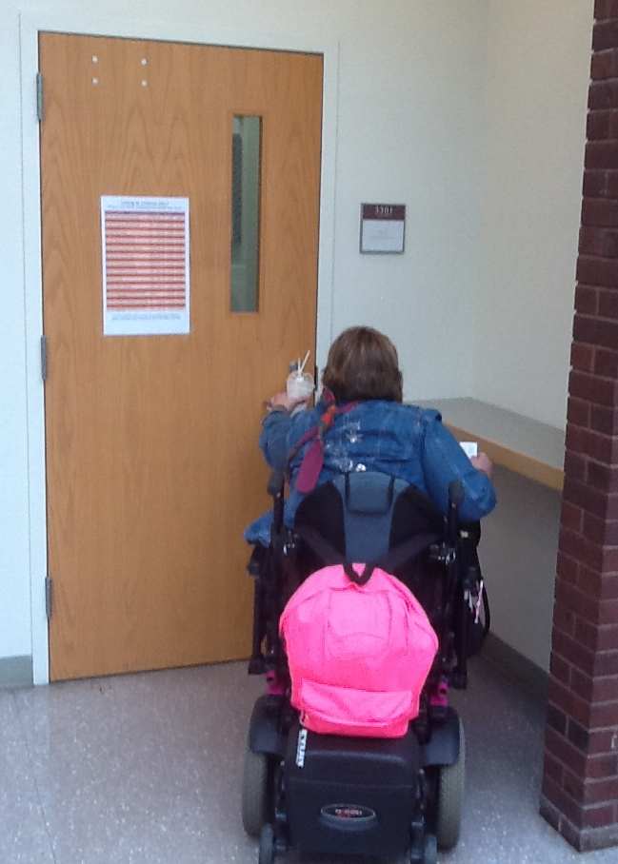
Figure 1 Author attempting to enter her department offices

Motivated by these experiences, a team of graduate students initially undertook a focus-group study in which most of the population of mobility-impaired students on campus were queried directly about their experiences. They were asked about both physical and social challenges they faced, about what was working well on campus, and about ways to improve the things that were deficient (Shaw, McQuiggan & Cox, 2010). Research questions were as follows: RQ 1: What physical challenges have students with disabilities face on the SIUE campus? RQ 2: What social challenges have students with disabilities face on the SIUE campus? RQ3: What suggestion do the students with disabilities have to alleviate the challenges they face on the SIUE campus? RQ 4: What areas have SIUE successfully met the challenges of student with a disability. Results generally fell into 2 overall categories, facilities/maintenance, and people. Under the first of these were issues such as inoperable automatic door openers and elevators, poor communication about those problems, general access to buildings and grounds, and issues with ongoing construction. Under the second were issues such as a lack of planning/consideration of the needs of persons with disabilities, intentional and unintentional insensitivity, and specific concerns about aspects of Disability Support. They did also note a host of positive experiences. This study was well-received, and many of the issues it raised were acted upon by university administrators. Several of the student participants in this study, however, came away feeling as though much of their story remained untold. Many felt that if a non-disabled person had to spend time in a wheelchair, it would go a long way toward fleshing out the story.

Day-in-the-Life Video

Intrigued by the notion of providing the non-disabled with the experience of life at SIUE in a wheelchair, the authors contacted colleagues in the Mass Communication Department. We met with both a faculty member and a student and pitched them the idea of a “day-in-the-life” video. After filming two of the wheel-chair-using students on campus, interviewing them both, and interviewing two faculty members as well, a short film was produced (Seering, 2012 - https://vimeo.com/60858582). The video starts with a narrator posing questions to get people to think about everyday accessibility. It then transitions into a series of one-on-one interviews with professors and disabled students talking about not only their concerns but also their everyday experiences with physical accessibility and academics. On the one hand, the film was so good it ended up winning an Award of Merit at the 2012 Best Shorts competition in La Jolla, California. On the other hand, it ended up still feeling too “pretty” and cinemagraphic to capture the real experience of life in a wheel chair. However, there was a scene in the film in which a disabled student was shown side-by-side with a non-disabled student as both went to the same place to get a bite to eat. This scene came closest to capturing what the authors hoped to capture, and provided the inspiration for developing split-screen analysis

New Methodology: Split-Screen Analysis

To capture the “enacted” experience of life in a wheel chair, we first created a simple, discrete wheelchair mount for a video camera:
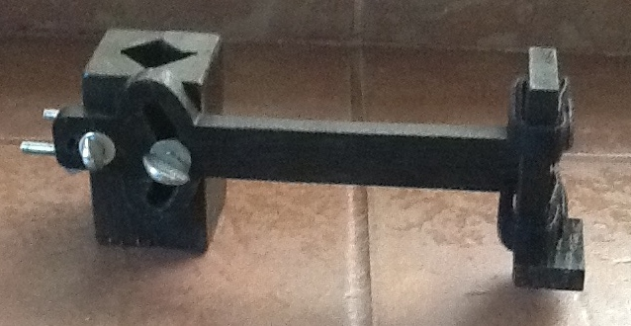
Figure 2 Home-made wheel-chair camera mount

This mount was attached to the wheelchair of one of the authors, along with a standard 2 hour “Flip Video” camera. Once installed, it simply blended in with the other electronics on the chair. The author then went about her normal day while taping until the camera was full. After doing this several times, we had hours of mostly mundane, routine data. While there are some long and complex segments awaiting future analysis, we settled on 10 short and utterly ordinary moments, and selected these segments from the larger videos. Our method was simple. We identified an exact starting point (ie passing through the east door of Alumni Hall), and an exact ending point (ie entering room 1301) and a target behavior (ie taking a seat in the classroom). We then enlisted several non-disabled student confederates to help. We provided each with that same starting point, ending point, and target behavior as found in the existing video segments we’d collected. We then installed the same video camera on our confederate by simply fastening it to his or her shirt. Once they had completed their tasks, we then had matching videos of both the disabled and non-disabled experiences of each of these routine activities, allowing for a true side-by-side comparison.

At this point, we called our film-making colleague and once again threw ourselves on her mercy. By using equipment routinely available in university editing labs and software called Final Cut Pro 7, she was able to create a single frame in which both segments run side by side in real time. Adding text and timers available within the software then became straightforward edits. The end result was what we had all originally envisioned - as “lived” an experience as we could create for readers short of having them spend a day in a wheel chair (to view the film, go here: http://vimeo.com/59445320).

Results

We analyzed ten pairs of video segments, ranging from as short as 3 seconds to several minutes in length. All were chosen based on how ordinary they were. Included are simple activities such as getting into a classroom building, finding the classroom, taking a seat, using the restroom, and getting a soft drink. Nothing in this corpus is uncommon or unusual in any way. All represent things all students do on a regular basis. Once we displayed the videos beside one another on the screen, we added only two more elements. First, we made note of when an activity required assistance. For example, in one case, a faculty member had propped open the classroom door with a chair to allow for circulation. The student in the wheelchair could not maneuver around this chair, however, and required assistance from the faculty member to gain access to the room. Second, we compared the total times that it took to complete each activity. For example, if it took the disabled student 30 seconds to do a given activity and it took the non-disabled student 20 seconds to do that same activity, we provided both the difference in real time (10 seconds) and a simple ratio (in this example, 1.5:1). When we had completed an individual analysis of each of the 10 activities – that is, when we had times-to-completion for all disabled and non-disabled activities - we also averaged all the times together.

What we found was that fully half of the utterly ordinary and routine activities our disabled students engaged in, while taking place on a modern, accessible, fully ADA-compliant campus, still required assistance at least once to complete. Further, we found that the difference in time commitment between the disabled and non-disabled student was far greater than anticipated (at least by the non-disabled authors of this study). Activities taking a non-disabled student a total of 6 minutes and 21 seconds took a disabled student 16 minutes and 33 seconds, for a difference of 10 minutes and 13 seconds, and a ratio of 2.63:1. If we apply that ratio to the rest of the day, we can see how potentially burdensome this difference would become.

Conclusion and Future Research

While the split-screen procedure was well-suited to comparison of like events, there were clearly several limitations. First, this analysis is strictly visual. While watching 2 locomotor events simultaneously was useful, we found that we tended to turn off the sound. Listening to two events simultaneously turns out not to work very well. Thus, this form of analysis would not be useful for events with a significant “audio” component. Second, we found that we were only able to consistently assess times and the need for assistance. Other issues initially identified in the focus group study, such as the differing reactions of passers-by, could not be observed. Third, some of the most interesting segments of video simply do not lend themselves to a side-by-side analysis. For example, in one segment, when asked about the availability of Zumba classes, a staff member at our fitness center replied with what can only be described as a bit of incredulity before providing the requested information. When actually arriving at Zumba for the first time in a wheelchair, our author was ignored entirely. In future, we hope to tape comparable experiences with a non-disabled confederate for comparison, but do not expect split-screen analysis to be especially useful. Finally, we must acknowledge that there are limitations to a time-based assessment. Clearly, the amount of time it takes for a 50 minute class is the same whether sitting in a classroom chair or a wheelchair. Thus, this analysis is useful primarily for considerations of transition times and other times when mobility, or the lack of it, is most salient. And since not all disabilities are mobility-related, further study is needed to determine methods to assess the support levels and environmental quality for students with sensory and cognitive impairments.

While there are obvious limitations to the application of this method, the authors believe that it provides a useful, novel approach to the assessment of student life for the mobility impaired. If just one picture is worth a thousand words, then video, more than either numerical or even narrative data, is worth far more. By showing that the many mundane transitional activities that make up much of a typical college student’s day can take more than two and a half times as long for the mobility-impaired person, and by identifying unexpected places where assistance was required, we believe that we can aid in both identifying areas for improvements and in making accommodations where such improvements are not necessarily feasible. Simple things could be done such as sending regular reminders to faculty to not block doorways, or asking faculty to regularly remind students to not block aisles with their backpacks. More thoughtful things could be done as well, such as having deans take increased transition times into account while building course schedules all flow from this analysis. Above all, this simple analysis makes undeniably “real” differences in the lived experiences of persons with mobility impairments in ways other methodologies simply can do. We are excited to see what others might do with this technique, as it seems as useful tool a for empowering persons with disabilities engaging in self-advocacy as it is for academics.

Knowing how critical time issues can be for the mobility-impaired, consider the following e-mail, recently sent to one of the authors of this study:
Subject: Two Elevators Out Of Service

To: T.E.

The elevator on the west end of Rendleman Hall is undergoing repair and will be out of service until further notice. The central elevator in the Engineering Building is also currently down until further notice. Facilities Management regrets any inconvenience this may have caused.

While such an e-mail is certainly cause for groans to those of us who must now slog up 3 or 4 floors toting a briefcase instead of taking the elevator, this analysis suggests that it represents much more than an “inconvenience” to someone with a mobility impairment. If there is already barely enough time to transition between one class and the next, such an inconvenience could create an unreasonable burden for someone in a wheelchair. It is our hope that this study is a step toward helping to identify and remediate such burdens, and to track our efforts along the way.

E. Duff Wrobbel, PhD is an associate professor of communication at Southern Illinois University, Edwardsville and has been active in assessment scholarship for a number of years.

Sarah Vanslette, PhD is an assistant professor of communication at Southern Illinois University, Edwardsville with a growing interest in both assessment and disability support.

Tiffany Eickhoff is a senior in the Applied Communication Studies major at Southern Illinois University, Edwardsville. As a person with a disability, she has been both a research subject and a co-author for this project.

References

Bessant, J. (2012). ‘Measuring Up’? Assessment and students with disabilities in the modern
university. International Journal Of Inclusive Education, 16(3), 265-281.

Cook, V., Griffin, A., Hayden, S., Hinson, J., & Raven, P. (2012). Supporting students with
disability and health issues: lowering the social barriers. Medical Education, 46(6), 564-574. doi:10.1111/j.1365-2923.2012.04267.

Cory, R. C. (2011). Disability services offices for students with disabilities: A campus resource.
New Directions For Higher Education, (154), 27-36. doi:10.1002/he.431

Fichten, C. S., Asuncion, J. V., Barile, M., Ferraro, V., & Wolforth, J. (2009). Accessibility of e-
Learning and Computer and Information Technologies for Students with Visual Impairments in Postsecondary Education. Journal of Visual Impairment & Blindness, 103(9), 543-557.

Freedman, I., & Freedman, E. (2007). Lawsuit Filed by Deaf Student Over Disabled Services
Heads to Trial in California. Community College Week, 19(13), 4-42.

Fujii, T, & Woodard, R. (2006, Summer). Accessibility in Campus Recreation Programs.
Palaestra, 22(3), 6-7

Goode, J. (2007). ‘Managing’ disability: early experiences of university students with
disabilities. Disability & Society, 22(1), 35-48. doi:10.1080/09687590601056204

Kim, J.L., & Brienza, D.M. (2006) Development of a remote accessibility assessment system
through three-dimensional reconstruction technology. Journal of Rehabilitation Research & Development, 43(2), 257-271.

Losinsky, L. O., Levi, T. T., Saffey, K. K., & Jelsma, J. J. (2003). An investigation into the
physical accessibility to wheelchair bound students of an Institution of Higher Education in South Africa. Disability & Rehabilitation, 25(7), 305.

Prellwitz, M. M., & Tamm, M. M. (2000). How Children with Restricted Mobility Perceive their
School Environment. Scandinavian Journal Of Occupational Therapy, 7(4), 165-173.

Schwartz, D., Blue, E., McDonald, M., Giuliani, G., Weber, G., Seirup, H., Rose, S., Elkis-
Albuhoff, D., Rosenfield, J., & Perkins, A. (2010). Dispelling stereotypes: promoting disability equality through film. Disability & Society, 25(7), 841-848.

Seale, J., Draffan, E. A., & Wald, M. (2010). Digital agility and digital decision-making:
conceptualising digital inclusion in the context of disabled learners in higher education. Studies In Higher Education, 35(4), 445-461.

Seering, A. (2012). Disability Awareness Project [Motion picture]. United States.

Shaw, V., McQuiggan, A., & Cox, J. (2010). Experiences of Students with Disabilities on SIUE
Campus. Unpublished manuscript.

