The Future of Medicaid

Arnold Birenbaum, Ph.D.

Albert Einstein College of Medicine

Abstract: Medicaid, the US federal-state financed program that assists people to gain access to health services when they cannot afford them, is in peril. Some of the recently defeated proposals to change financing of the program, the shift to managed care, and massive state deficits all threaten to limit optional and Home- and Community-Based Waiver Services to people with long-term care requirements. This policy research paper will explore some current myths about Medicaid, what states are doing to reduce Medicaid expenditures, and propose 10 principles and observations that should shape a response from the disability community to efforts to shrink Medicaid.

Key Words: Medicaid, block grant, long-term care

Medicaid, the United States federal-state financed program that assists people to gain access to health services when they cannot afford them, has been in the news of late. Unfortunately the news is disquieting for people who count on this program for health care and rehabilitation services. In fact, when Medicaid is in the news, it is the equivalent of the Weather Channel coming to report on your hometown. You really don’t want them to be there because TV coverage only arrives with a natural disaster. Perhaps something positive will come out of what we can characterize as a dust storm. But unlike weather forecasts, my predictions at the end of this essay require that we become proactive to control damage.
The refinancing of Medicaid is one of the things that the Bush administration has sought. It, along with the privatization of services, and state fiscal woes, may produce the perfect storm. The new is not always better than the old. Change is not always the friend of vulnerable people, and in this instance, it can be downright disruptive when it comes to accessing services. Because they are not well organized, people with Medicaid coverage do not have political clout, even though more people are covered by Medicaid than Medicare (e.g., the public insurance program for almost all people over the age of sixty-five and some people with disabilities). New Bush administration proposals and ongoing practices could be particularly harsh for people with disabilities. The current fiscal crisis of the states—brought about by the bursting of the technology stock bubble—has made the future of Medicaid even more uncertain. Those who follow the state of the states closely, such as the Kaiser Commission on Medicaid and the Uninsured, are seeking to determine the impact of state fiscal conditions on health coverage in all 50 states. Kaiser’s presentation on September 22nd, 2003, was covered widely by health policy specialists in the print media.
For those who need an update, Medicaid today provides long-term care and health care coverage for more than 50 million people, among them, 12 million elderly and persons with disabilities, including 6 million Medicare beneficiaries (dually eligible) who rely on Medicaid for long-term care, prescription drugs, and help with Medicare cost-sharing. It also supplies inexpensive health insurance for 38 million people in low-income families, covering one out of every four children in the USA. Therefore, the expensive and the inexpensive are supported in this safety net.

FIGURE 1
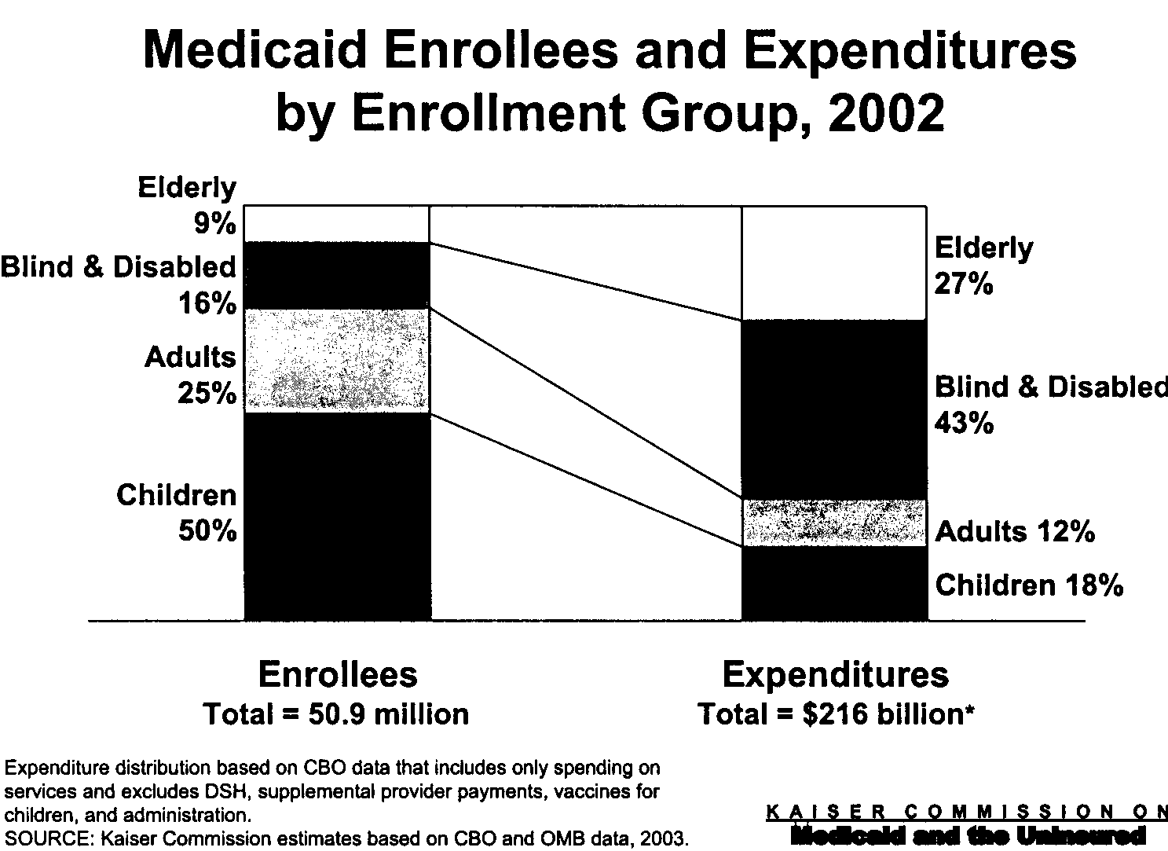

This paper will first address recent Medicaid block grant proposals, then the trends in Medicaid managed care, and finally, how state deficits have resulted in measures attempting to rein in the costs of Medicaid. The paper will also try to dispel some myths about Medicaid as a massive burden on the federal government and state governments as well. Finally, the paper will draw out some principles and predictions from Medicaid, privatization trends and state efforts to reduce spending.

Block Granting

First, on February 3, 2003, Tommy Thompson, Secretary of the U.S. Department of Health and Human Services (HHS) and the former governor of Wisconsin, made a bold proposal: allow states to generate any waivers they wish, without prior federal approval. Funding for Medicaid would be split into two pots--acute and long-term care. On February 20, the HHS Secretary sought the approval of the National Governors Association for this plan, one that would give states options in how they spend their proposed block grants. The former Wisconsin governor compared these reforms to Temporary Assistance to Needy Families legislation (TANF). It is important that we think about how his proposal will impact children with special health care needs and adults with disabilities.
Determining the intended and unintended consequences of major health care reforms is a central task in any responsible health policy analysis. Even proposals to extend coverage do not always understand what Medicaid does. For example, Ted Halstead, president of the New America Foundation, in an Op-Ed piece in the New York Times (1/30/03, p. A27), called for guaranteed universal coverage, which, he claims, will eliminate the need for a separate Medicaid system for the very poor. Halstead was well intentioned but misinformed. Medicaid is more than a safety net for poor people; it is a complex program that is extremely valuable for those who have long-term health and social support needs.
Medicaid has to be handled with care. Many of the services it pays for are special. It’s the health care and social support system of such fictitious Americans as grandma Bessie in the nursing home, uncle Bill, a person with a history of mental illness who lives in a half-way house, and cousin May, a child with severe chronic illness and a developmental disability. These homey examples are not meant to make the reader reach for a box of tissues, but to point out how Medicaid has evolved into a mix of health, social, and psychoeducational programs, each tailored to a specific client population.
Medicaid, from its start, has offered states the choice of furnishing an impressive range of optional services to clients. It has also subscribed to definitions of medical necessity that are far broader than those found in commercial insurance policies. Optional services and definitions of medical necessity complement each other; they encourage medical providers to prescribe speech, physical, and occupational therapies, even when cure or recovery are not possible.
The Social Security Act, which authorizes the Medicare and Medicaid programs, allows the Secretary of the Department of HHS to waive the Department's rules and regulations, permitting states to make applications to innovate. Waivers are especially important in encouraging children and adults with serious chronic illnesses and/or disabilities to lead normal lives, including living in the community and with family. Consider the Katie Beckett Waiver program, conceived when Julie Beckett, the mother of a three-and-a-half year old with viral encephalitis, discovered that Medicaid would pay thousands of dollars to support her daughter Katie in a hospital, but would not pay for medical services and equipment, e.g., a portable respirator, that would allow Katie to live at home. Katie was eligible for Medical Assistance because the family had spent most of their assets to pay for her extraordinary medical bills. The state of Iowa would not pay Katie's bill, a smaller expense than hospital care, if she returned home, so Julie petitioned President Ronald Reagan to waive the Medicaid rules to permit Katie (and 300,000 others) to have home care and remain with her family (Roberts and Considine, 1997: 164).
Established in 1981 by the HSS Secretary, the "Katie Beckett Waiver," as it became known, is an override on Department regulations. It permits states to use Medicaid funds to assist children with special health care needs to avoid hospitalization and be with their families at home.
The story continues to validate the idea that consumers can be the best advocates. Julie Beckett not only made Medicaid more flexible, she later founded a voluntary association, Family Voices, made up of parents just like herself. In 1998-1999, a national survey (Policy Brief, 2003) was conducted by Brandeis University and Family Voices, with funding by the David and Lucille Packard Foundation. In this study, 2,220 families of children with special health care needs reported that their satisfaction with care and services paid for by Medicaid was greater than the care paid for by private insurance.
Thus, Medicaid plays an essential role in assisting families of children with special health care needs. This impact goes far beyond keeping American children healthy. Children who have access to skilled and experienced specialists, physical, occupational, and speech therapy, and other optional services miss fewer school days and are less subject to hospitalization. Cognitive and social development is encouraged by opportunities to be in school and be with the family of orientation.
Putting a human face on health care does not stop with children. The Home and Community Based Waiver Program (HCBW), made law as a part of the Omnibus Budget Reconciliation Act of 1981 (PL 97-35, section 2176, 1981), was created as a way to contain increasing costs of institutional care paid out of federal revenues. The funding authority for this program came from amendments to the Social Security Act, wherein states could receive Medicaid matching funds to provide home and community-based services to individuals who otherwise would receive care in a nursing home. What is truly unique about this program was the authorization to states to pay for clinically appropriate non-medical services, including care coordination, habilitation services (i.e., occupational, physical, and speech therapies), homemaker services, personal care, and adult day care.
The original purpose of the HCBW Program was to dampen the demand for institutional care by making other, more affordable community-based services available to low-income individuals with chronic disabilities and illnesses. Under the HCBW, the U.S. Department of Health and Human Services allows states to finance community services through Medicaid for people with developmental disabilities who would otherwise be in Intermediate Care Facilities (ICF/MR). By 1995, all 50 states were participating in the HCBW.
The HCBW initially accounted for only a small percentage of total expenditure on community services in the United States, but it grew rapidly during the 1980s, making it, by 1994, the largest source of federal funds for community services. The program establishes individualized service options and family supports, administered by the state mental retardation and developmental disabilities agency, through direct payments to service providers. Included among these services are habilitation services, respite care, family counseling, equipment to promote adaptation or safety, architectural adaptation of the home, in-home training, education, behavior management, and recreational services.
In my opinion, optional services and waiver programs represent the impressive flexibility already built in Medicaid. The Bush administration sought to throw states facing substantial deficits a lifeline without having to appropriate additional funds to assist them. At the National Governor's Conference on February 24, 2003, President Bush told the disappointed of both parties that no further assistance for their enormous deficits were going to be fueled by the federal treasury. Moreover, this new move toward state autonomy will only lead down the path of allowing states to avoid being out of compliance with their established obligations when they start restricting access to optional services and waiver programs. No longer will state departments of health be able to identify an appropriate benefit for a patient population with expensive medical bills or long-term intervention requirements, including cost-saving care coordination services, and "Medicaiding" difficult problems. This safety valve encourages providers to do the necessary interventions for the medically needy and the disabled. Moreover, experimentation will be less frequent under block granting of funds because states won’t receive additional federal funds for attempting innovations. While the block grant would be front-end generous, it becomes less so over the years, making the states more cost-driven than before. In sum, cost-driven approaches to health care make the primary goal of the agency that administers the state Medicaid program to restrict spending to within the limits of the block grant, thereby disincentivizing state planners to create new programs.
Do we dare risk further deterioration of our health care system by downsizing or eliminating an extremely important set of services and programs? Maintaining adequate funding of Medicaid, two-thirds of which goes to pay for optional services, is especially important for vulnerable populations.

Managed Care

A second way Medicaid has made the news is on the front page of the business section of the New York Times (February 19th, 2003: B1). Medical business reporter Milt Freudenheim, on February 19th, found a trend toward privatization of Medicaid services via for-profit managed care companies. These companies, with the encouragement of the Bush administration, have skimmed off the most frequent types of Medicaid recipients: healthy children and their mothers, clients who need very little in the way of services.
An additional problem has emerged with regard to Medicaid managed care plans. In New York State, plans have recently reported a turnover of almost half their members over the course of a year, usually through involuntary disenrollment, when eligibility is lost. Absent, under these conditions, are the advantages of managed care, prevention and early detection through regular contact with a primary care provider (Perez-Pena, 2003).
The trend toward enrollment in managed care plans for Medicaid recipients does not mean that the quality of care is improved, despite the achievement of cost containment via per-person-per-month, or capitated payments, to managed care plans. Because many managed care plans serve both Medicaid funded and commercially insured beneficiaries some comparisons are possible. To what extent is the quality of care (QOC) the same for both populations? The September 17th 2003 issue of JAMA contained an article on the quality of care for children in commercial and Medicaid managed care (Thompson, et al., 2003). Analyses restricted to data from plans reporting both commercial and Medicaid results for children were performed in a national study. In so doing, potential variations between plans on corporate philosophy, structures, management strategies, and types of delivery network were controlled. Using data from the Health Plan Employer Data and Information Set (HEDIS), the authors found that clinical quality (immunizations rates), access (visit levels) and procedures (myringotomies) were less frequent in Medicaid managed care than in commercial managed care patients.
What happens to children with disabilities in managed care plans? Using less rigorously drawn samples, but with 58% of the children covered by Medicaid, in a national survey, investigators found that parents reported that more than a third of the children with autism, over a fifth with mental retardation, and more than a fifth with other disorders had problems accessing needed care from specialty physicians. Referrals were not always available from primary care physicians and locating specialists with the appropriate experience were some of the difficulties cited by parents (Krauss, Gulley, Sciegaj, and Wells, 2003).
While an intriguing question, it is not known to what extent children served by Medicaid managed care organizations (MCOs) are receiving better or worse care than Medicaid children not enrolled in MCOs. Nor do we know if more vulnerable children are better served. More sophisticated measures for quality introduced recently for children with special health care needs will furnish a more in-depth look at Medicaid managed care in comparison with commercial plans. Impressionistic evidence suggests that managed care plans recycle the expensive child with special health care needs back into fee-for-service Medicaid. The “carve-out” for different categories of special needs children makes managed care plans avoid risks to their bottom line.
Managed care companies supply preventive health services to the relatively low-cost population of healthy children and their parents and avoid elderly and disabled Medicaid recipients, most extensive users of services. Profit making depends on selection and avoiding adverse risks. Once in Medicaid managed care plans, those who are seriously ill are sometimes denied authorization for services, or, when they receive services, their providers find that it is tough to get paid by the plans.
What is hidden from view by the move toward privatization is the skewed distributions of expenditures in Medicaid. Most of the costs of Medicaid go to pay for long-term care services for people with disabilities, the elderly, and those with serious chronic illnesses. Many of these procedures are found in the optional services section of this public insurance program, which states may pay for or decline to support.
This trend toward privatization brings us back to the block grant approach, or what was being peddled in 2003 by Thomas Scully, then Administrator for the CMS, as the “alternative global financing option.” The public may believe that using for-profit managed care plans is the way to save the state money. This is a way of creating cost-driven thinking. It is another way to divide Medicaid recipients into low cost and expensive groups. Do we need to further divide the Medicaid service system and the populations that it serves? A cost-driven health-care payment system will lead to denials of access for the categorically needy or those receiving Temporary Assistance to Needy Families (TANF) and the medically needy (i.e., people with medical expenses that overrun their assets and incomes). Some providers, particularly hospitals and academic medical centers, are already unwilling to contract with Medicaid managed care plans that refuse to pay or delay payment for several months

The Fiscal Crisis of the States

All of these changes, proposed or ongoing, today rest on a shaky platform of state debt. The states address the issue of loss of tax revenue by cutting capitation payments to managed care plans and providers in the fee-for-service parts of Medicaid or limiting eligibility to the poorest part of the population. Under-funding will produce penalties for consumers as providers leave plans. Moreover, patients may seek more accommodating plans or will follow their doctors to other plans. This kind of "churning" has consequences. It will mean that the combined service advantages of managed care (i.e., intensive care coordination) and Medicaid (i.e., removal of the financial barriers to access to care) will be unrealized. They will be eclipsed by the need for consumers to learn about new rules and regulations, once again, of the new managed care plan; or the providers will be compelled to make new assessments of what patients require in the way of care.

Current Myths About Medicaid

If the real estate game is all about three things: location, location, location, attitudes toward Medicaid is all about perception, perception, perception. There are three myths that make Medicaid a target in future budget cuts.

1. Medicaid spending is out of control.

According to the Kaiser Commission on Medicaid and the Uninsured, Medicaid spending growth declined for the first time in seven years. In 2003 it dropped to 9.3 percent and is lower than the national average for growth in health care spending of 12 percent.

2. State fiscal crises are the result of increased spending for Medicaid over the past seven years.

The sudden falloff in tax revenues has played a larger role in this current fiscal crisis than increases in Medicaid spending. The fall off in state revenues is 7.4 percent compared to 3.5 and 3 percent respectively in the recessions of 1990-91 and 1980-82. Capital gains income would have to double to return to the tax revenues of just two years ago. The drop in revenue collection is 61.8 billion while the growth in Medicaid spending is $6.9 billion. States would be in even worse shape today without the $20 billion added to federal assistance to states, which went largely for Medicaid.

3. The increase in Medicaid spending is due to rapid enrollment of large numbers of unemployed and their children becoming eligible for Medicaid.

Sixty percent of the growth of Medicaid spending over the last two years is related to the elderly and disabled, particularly for acute care services and including prescription drugs. More attention could be paid by providers to secondary prevention, a cost-offsetting intervention which should work with chronically ill individuals and people with disabilities. A takeover of prescription costs from the states for the dually eligible by a new prescription benefit in Medicare, which may be a long time coming, would be helpful. We are all living longer, including persons with disabilities, and this means, over a lifetime, more maintenance medications, visits to doctors, and hospitalizations.

What Are States Doing to Reduce Medicaid Expenditures?

There are four ways of doing this: 1. Increase the income eligibility requirements, 2. Freeze or reduce payments to providers, 3. Limit benefits, or 4. Require that Medicaid recipients share some of the costs through co-payments for prescriptions or visits to providers. A survey of all 50 states and the District of Columbia tracks current and future efforts to relieve some of the fiscal pressures.

FIGURE 2
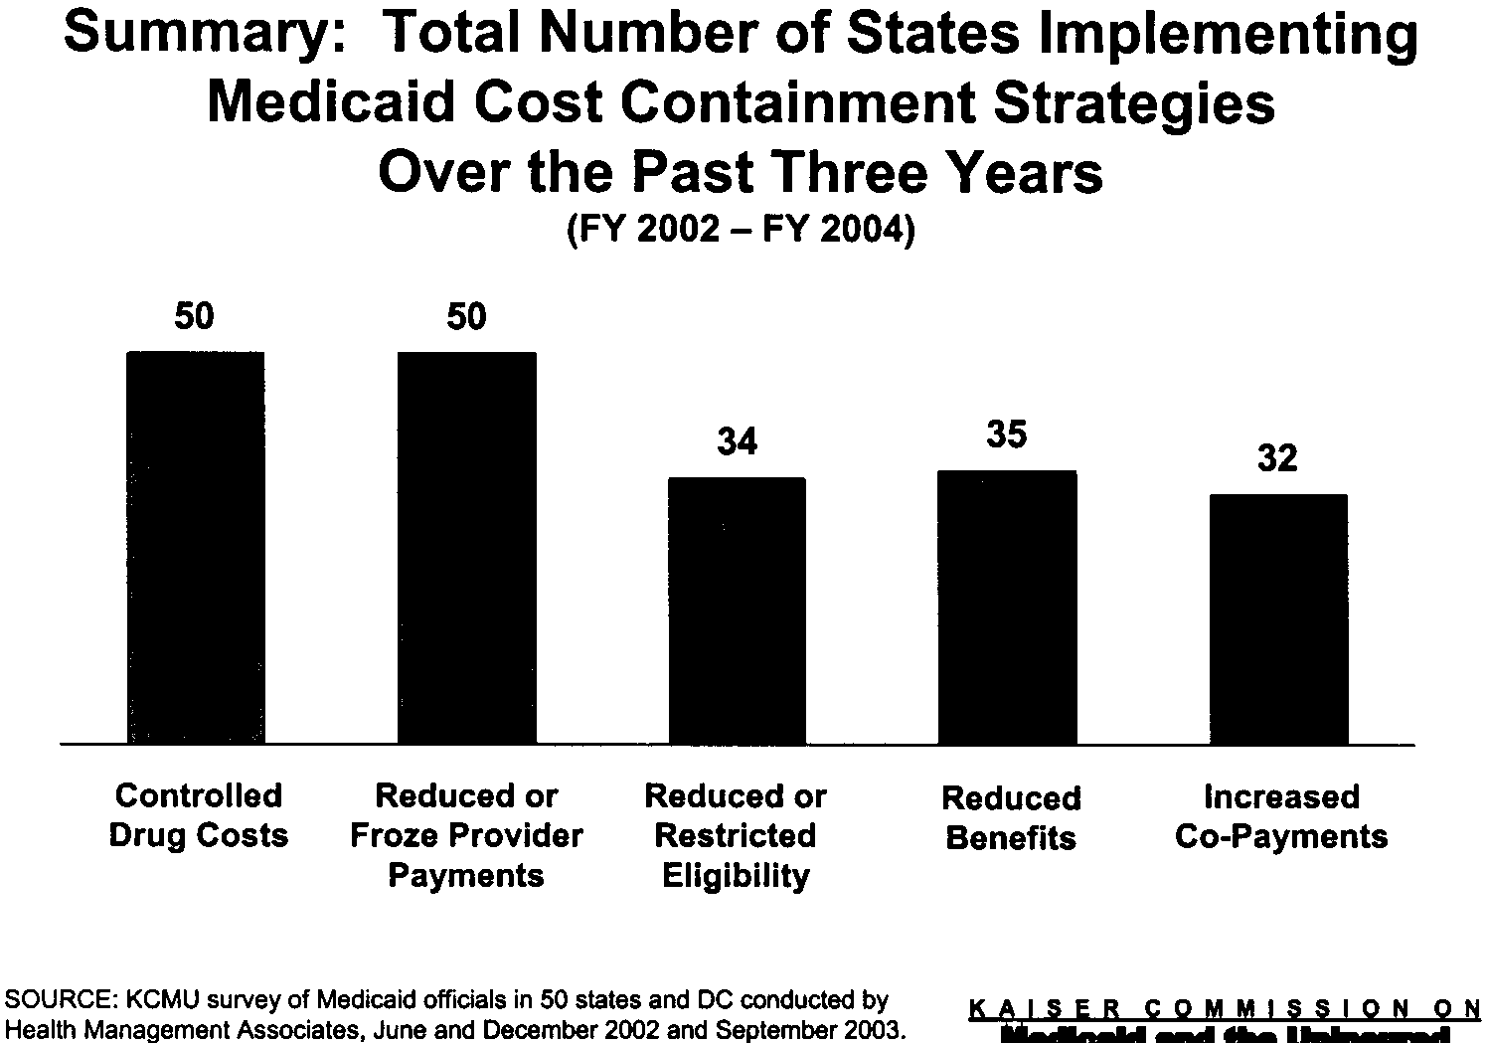

Despite federal contributions, ranging from 50% to 75% of the cost to a state, Medicaid has become the second largest item in state budgets, following educational expenditures. This situation could lead to the pitting of health care vs. education advocates for the shrinking tax dollars.
Moreover, of late, counties and cities that are required by state law to share Medicaid costs are also complaining about the added burden of Medicaid costs. They are also seeking ways to limit access to services, especially nursing home care (Saeed and Wallace, 2003).

Conclusion

Since its inception in 1966, Medicaid has worked as an acute care safety net for the categorically needy and taken on the characteristics of a wrap-around patchwork quilt for people with long-term care needs. It has evolved into 50 different state programs because the level of generosity of each program varies--the income cutoff levels, the extent to which optional services are offered, and the payment schedules for physicians, hospitals, and other providers—are different from state-to-state. It does not need to be fixed through block granting and creating more health plans. It needs a powerful infusion of funding to attract more quality providers and an environment that encourages the continuation of the availability of long-term care services to populations that depend on them. It may also require additional funds from the federal government to extend it to families with children with special health care needs, who cannot afford to purchase private health insurance, or who are regarded as adverse risks in the insurance marketplace. This new entitlement is already part of proposed omnibus federal legislation, the well-intentioned Family Opportunity Act (HR1811/S622), a law up for Congressional approval during the Summer of 2004, but unlikely to be signed into law.
In other words, Medicaid is more than a safety net for those who live in extreme poverty. It is a medical and social program that has grown incrementally according to need. Protecting Medicaid today is as important as protecting Medicare. Currently, it is in danger of being divided by block granting and privatization. So long as the United States fails to introduce universal coverage with appropriate benefits for children with special health care needs, the elderly, and people with disabilities, Medicaid represents federal and state creativity .
Here are some important principles, based on recent history, which can be used to create a support network for Medicaid:
- Coalitions of consumers and providers are required to tell the story of Medicaid to the Congress and state legislatures. Medicaid, through case law, is an entitlement upheld in numerous court decisions when administrative agencies have not been willing to approve services. Access to the courts means entitlement to a process rather than to specific services. This due process protection of rights has worked for people with disabilities.
- Medicaid is the closest thing we have to a federal health entitlement in the U.S.A. The CMS, by law, can hold states accountable when they do not make payments sufficient to attract providers so that an acceptable service capacity is maintained.
- Providers need to forcefully present the case that frozen rates or lower payments to providers will threaten a state’s capacity to deliver vital services to the categorically and medically needy.
- Capacity cannot be improved without federal support for recruitment, training and a living wage in areas of employment with critical shortages. Trends toward community housing in the least restrictive environment (Olmstead Decision) will be based on both the availability of housing and an adequate supply of personal care assistants (paid for by Medicaid). Both are critical to the success of these federal mandates. The Center for Medicare and Medicaid Services must insist that states have payment rates that can attract and retain personnel to carry out these tasks.
- The state budget declines will continue until tax revenues improve. Advocacy groups need to have members who can head off the expected battle between funding Medicaid and funding education. Localities do not want to raise taxes to support education and are willing to pressure their elected officials to maintain or increase state aid for education. Parents of children with developmental disabilities and adults with disabilities are good at articulating that there should not be an agonizing choice between access to a good education and access to good health care.
- The volatility of tax revenues from capital gains should be taken into account when planning state budgets. Whatever spikes will come down again. Funding of programs should not be based on mandated spending of a proportion of the incoming tax revenues on education, as in California.
- The parable of seven fat years and seven lean years can be instructive for state officials. The economic boom years will see a reduction of the Medicaid rolls as employment and benefits grow. Surpluses generated during those years can be put aside for spending in economic downturn years, when it can be predicted, that Medicaid spending will rise to biblical proportions.
- We can anticipate from the increase in the number of people living in poverty, moving up to 12.1 percent in 2002 from 11.7 percent in 2001, that Medicaid enrollment will continue to increase (Associated Press, 2003).
- Given these needs, federal subsidization of Medicaid beyond the $20 billion appropriated in 2003 would appear to be required if not inevitable to avoid the kind of public health disaster predicated on continued state fiscal woes.

Organizations such as the Association of University Centers on Disability (AUCD) should start working now to defend Medicaid rather than wait until governors and state legislatures begin their cuts in the next round of budget formation.

- Do not let the anti-government (“let’s shrink the beast”), pro-business public relations campaigns organized by small government advocates make you believe that less is more. There are some things that only the federal government or a federal-state partnership can create. These initiatives go well beyond national defense and fighting terrorism. Orwellian rhetoric about weapons of mass destruction and phony linkages of Saddam Hussein to 9/11 only obscure the value of a healthy population.

Medicare and Medicaid are paradigms for universal support for and access to health care. Politically protected by virtue of the claim made by participants that they have paid for health care after 65 through payroll taxes, the concept of an exchange or social insurance lends Medicare powerful stability. Medicaid is also a bridge to universal access. The more people eligible, the more support for it. It is, perhaps, an on-ramp to the future. As Timothy Stoltzfus just wrote in his impressive new book, Disentitlement? The Threats Facing Our Public Health-Care Programs and a Rights-Based Response, “Only universal access undergirds the sense of solidarity necessary to sustain health-care entitlement in the long run.”

Arnold Birenbaum, Ph.D. is the Associate Director of Rose F. Kennedy University Center for Excellence in Developmental Disabilities and Professor of Pediatrics at the Albert Einstein College of Medicine.
Correspondence regarding this manuscript should be sent to 1410 Pelham Parkway So., Bronx, NY 10461, TEL: (718) 430-8523.
This paper was presented at the annual meetings of the Association of University Centers on Disability, Bethesda, MD, November 11, 2003.

References

Associated Press. (2003, September 26). Number of people living in poverty in U.S. increases again. New York Times. Retrieved June 2nd, 2004 from http://www.nytimes.com/aponline/national/AP-Poverty.

Freudenheim, M. (2003, February 19). Some Concerns Thrive on Medicaid. New York Times, B1.

Halstead, T. (2003, January 30). To guarantee universal coverage, require it. New York Times, A27.

Just, T. S. (2003). Disentitlement: The threats facing our public health-care programs and a rights-based response. New York: Oxford University Press.

Krauss, M. W., Gulley, S., Sciegaj, M., & Wells, N. (2003). Access to specialty medical care for children with mental retardation, autism, and other special health care needs. Mental Retardation, 41, 329-339.

Perez-Pena, R. (2003, October 14). Report faults Medicaid managed care plan. The New York Times. Retrieved October 15th, 2003 from http:///www.nytimes.com

Public Law 97-35, section 2176. (1981). United States Codes.

Policy Brief. (2003). The importance of public insurance/Medicaid coverage for children with special health care needs. Retrieved October 30th, 2003 from www.familyvoices.org .

Roberts, B. S., & Considine, B. G. (1997). Public policy advocacy. In H. M. Wallace, R. F. Biehl, J. C. MacQueen, & J. A. Blackman (Eds.), Mosby's resource guide to children with disabilities and chronic illness (pp. 162-171). St. Louis, MO: Mosby-Year Book.

Saeed, K., & Wallace, J. (2003, November 2). Health care costs burden taxpayers. The Journal News, A14.

Thompson, J. W., Ryan, K. W., Pinidiya, S. D., & Bost, J. E. (2003). Quality of care of children in commercial and Medicaid managed care. Journal of the American Medical Association, 290, 1486-1493.

