Music to My (Deaf) Ears: The Installation Work of Joseph Grigely
Ann Millett

Abstract: The installations of artist and literary theorist Joseph Grigely compose memories, mannerisms, messages, (mis)communications, and music to explore the perceptions of and interfaces between deaf and non-deaf worlds. Grigely has been deaf since the age of ten. His visual and literary works exhibit memory and communication as multi-sensual and fragmented, while they deconstruct stereotypes of deafness.

Key Words: Artwork, deafness, music

"Can you feel the music?"
"It's just hard to be a rock star after say, 33."¹

The work of artist and literary theorist Joseph Grigely composes memories, mannerisms, messages, (mis)communications, and music. The pieces convey the various meanings of the verb to compose: to invent, to create, to collect and arrange, to write text or music, and to make art. His art installations, the focus of this paper, are multimedia and multisensory compositions. They make visible improvisational, fragmented, and dissonant rhythms and voices. These works and their musical themes inform Grigely’s larger project of exploring the perceptions of and interfaces between deaf and nondeaf worlds.

Music reverberates throughout Grigely’s written and visual forms, which seems at first ironic in light of Grigely’s deafness (due to an accident at the age of 10). His installation Remembering is a Difficult Job, But Someone Has to Do It (2005) (fig. 1) centers on the artist’s fond memories of the television show “Gilligan’s Island”; clips of the show’s introduction and unforgettable jingle are projected throughout the gallery against theatrical backdrops (photographs of ocean scenes), film stills of the cast, and imagined visions of a fictive paradise. The work ties visual culture and, most profoundly, sound to Grigely’s memories of childhood, such that it encompasses his memories of hearing and embodied perceptions prior to his accident. The work portrays the phenomenological experiences of hearing loss in a multi-sensorial experience for the viewer, as the music jingle becomes a tactile, visual element in the piece. Grigely’s recent work St. Cecelia (named after the patron saint of music) takes these themes further, as he collaborates with the Baltimore Choral Arts Society to create a video of Christmas carols, performed by the choir and rewritten by Grigely to reflect common misperceptions of lyrics.² Grigely here comments on the nature of perception for individuals with all levels of hearing capability, for the jumbling lyrics in order to keep the rhythm of music intact is a common mistake for all, and yet particularly amplified when one is lip reading.

This kind of amusing juxtaposition of words and mistaken meanings characterize Grigely’s most pervasive visual work. The two snippets quoted above are drawn from Grigely’s series of Conversations with the Hearing installations, in which he assembles on gallery walls and incorporates into three dimensional installations pieces of dialogue written on paper for him by nondeaf people. The random records of speech often become ironic and humorous in juxtaposition and lead the viewer to question the arbitrary nature of communication. For example, in what context does one respond, “It’s hard to be a rock star after say 33”? One could imagine a conversation partner writing to Grigely, “Can you feel the music?,” due to his deafness, although this phrase is also a familiar dance expression. By sampling such comments and mediating them through visual arrangement, Grigely frames his own fragmented perceptions of communication in a world that does not accommodate deafness. These themes extend beyond the perceptual frames of Grigely’s body, as the works visually portray the disjointedness and performativity of all human memory and communication.

Irony is at the heart of Grigely’s work. His primary subject is visual and oral mediation and the mixed messages inevitably produced. Communication, particularly in our technologically driven culture of emails, cell phones, text and instant messages, the internet, and online chatting and blogging, is endlessly disjointed. Despite, and perhaps because of all the communicating devices at our hands, lips, and ears, miscommunication defines contemporary culture. Similarly, memory proves always multisensory and fragmented. For Grigely, remembering the musical jingle to Gilligan’s Island is no more a feat than anyone, hearing-impaired or otherwise, recalling music or words from the past. The show itself and viewers’ memories of it are based in imagination. What most people remember iconically and exclusively from the musical jingle is the repetition of, “A three hour tour, a three hour tour,” as well as the melodious run down of the cast’s identities, from Gilligan to Mary Ann. Again, such random sampling composes human memories and experiences.

The seemingly antithetical, indeed ironic juxtaposition of music with deafness is Grigely’s point. The notion that those with hearing loss cannot experience and enjoy music is a common misconception, for the majority have some range of aural access to music along the spectrum of hearing loss, and all people (deaf and nondeaf) experience music orally, visually, and sensationally to varying degrees; after all, “feeling the music” can elicit a physical and emotional act of memory, joy, or catharsis. Music educators Ann-Alice Darrow and Diane Merchant Loomis (1999) investigate how pervasive stereotypes of deafness in the media affect perceptions about students with hearing loss, finding repeated scenarios in cultural representations in which nondeaf characters pity those with hearing loss for their inability to hear music. Music defines the “lack” associated with deafness in popular representations. The work of many deaf musicians, such as Jamie Berke, percussionists Evelyn Glennie and Shawn Dale Barnett, and the rock band Beethoven’s Nightmare, as well as the popular Gallaudet Dance Company and a 2000 production of the musical West Side Story, performed at MacMurray College in Jacksonville, Illinois, with students from the Illinois School for the Deaf as the Sharks Deaf Side Story (Rigney, 2003), adamantly challenge this false assumption. Likewise, Grigely’s work takes to task the assumed disconnection between deafness and music. Darrow and Loomis add that making rhythm visual greatly adds to deaf students' perception and enjoyment of music; in relation, Grigely creates a rhythm of words and sounds with his artwork, making visual the dynamics of conversation and music. Darrow and Loomis define the popular assumption that a hearing impairment forecloses one’s access to music as a form of ethnocentrism – the act of judging and degrading another culture by the standards of one’s own. Grigely’s work turns the tables on such ethnocentric biases and historical practices. His Conversations with the Hearing installations invert the scenario of the Western “able-bodied” scientist studying the deaf “Other,” as he performs an archeology of conversations, records nondeaf culture in fragments, and displays his archive (Davidson, 2002). Grigely’s hearing loss and need to communicate with nondeaf populations make this work possible, as deafness becomes the source and inspiration for art.

Grigely also inverts the traditional hierarchy of oralism and sign language in the Deaf/deaf community. The distinction between these two terms relates to whether one was born with or acquired deafness, how oral one is or chooses to be, and how one identifies himself or herself. People who are “deaf” tend to be more oral, as many (like Grigely) have been at one time part of the nondeaf population. This term often refers to hearing-impairment in general, whereas “Deaf” individuals share a common language of sign and consider themselves a linguistic minority. Oralism, the practice of communicating through speech versus sign language and the predominate basis of deaf education, has a long ideological history, associated with not only ableism (ethnocentrism of the nondeaf), but also eugenics of the “deficient” (Mirzoeff, 1995). According to these traditions, deaf people were supposedly “cured” when they could most conform to the nondeaf, oral world.

The privileging of spoken over written word, which Grigely’s works challenge, transcends deaf histories. In Western theology and theory, the oral word is associated with truth and logic. Jacques Derrida and other post-structuralists have interrogated these traditions in their questioning of language as a basis of knowledge. Derrida coined the term “deconstruction” to describe literary and visual acts that invert and confuse conventional language systems. Deconstruction bears implications well beyond the scope of this paper, but the elements most relevant to Grigely’s work are pervasive fragmenting and quoting ironically, taking quotes in and out of context, and, in these acts, critiquing convention and systems of knowledge. In relation, deconstruction as a practice also involves Roland Barthes’ theories surrounding the death or demystification of the notion of a self-contained, original, independent author/speaker. Deconstructive tendencies arise in Grigely’s assemblages of fragmented and decontextualized quotes, whose anonymity further suggests a gesture toward the irrelevance of the specific speaker or author in favor of foregrounding the perceptions of the viewer/reader. Grigely showcases how communication and memory are illogical – nonlinear, random, and incomplete.

Grigely is well-versed in these theoretical practices. His book, Textalterity: Art, Theory and Textual Criticism (1995), asserts the significant changes in meaning and connotation of texts (both visual and literary) over time. He argues that new contexts inform and transform historical texts’ signification and how the viewer/reader makes meaning of history itself. Grigely writes: “As a consequence, textalterity is less related to the medium of a work than to the ways or processes in which the work is disseminated” (p. 53). Grigely asserts that the ultimate significances of texts and viewer/reader’s perceptions of them is always codependent on the texts’ mediation over time and in and out of contexts. For Grigely, all texts are multicontextual and accumulate fragmented meanings.

Themes of deconstruction and accumulation materialize in Grigely’s artworks. In wall hangings such as Multiples (2000) (fig. 2) and 223 Conversations (2005) (fig. 3), Grigely assembles notes written to him in a variety of situations and on a variety of media. These works display doodles, scribbles, cartoons, and nonlinear fragments recorded on materials that are themselves taken out of context: notebook paper, post-it notes, postcards, stationary, envelopes, menus, napkins, pieces of tablecloths, matchbook covers, gallery programs and brochures, foreign bills, claim-check stubs, registration cards, recipe cards, and pages from magazines and catalogs. The media or fabric of these works crosses genres of high and low art while crossing public and private social settings. The collection of these fragments into the shape of a traditional painting or mural presents the false illusion of integration. In Multiples, different sized, but all straight-edged index cards, sheets of colored paper, scraps from small note pads, and the back of an envelope, all in various shades of blue, are evenly spaced and assembled in a perfect square. From a distance the work resembles a colorfield painting by Mark Rothko or an example of Yves Klein’s canvases saturated with his trademark blue. In 223 Conversations, different colors and sizes from a variety of transcribed materials are arranged in rectangular mural; from a distance it looks like an abstract painting, in a geometric pattern that traditionally in art history contains no tangible subject matter. However, the work is composed of communication. As one gets closer to translate the texts on the individual pieces of Multiples, written in all directions, one encounters: “She scored some VIKADIN [sic] (pain reliever) mixed w/liquor = superfun”; “sex kitten”; “Olivier very good friend”; “that’s not what I’m taking about”; a sketch of a cartoon dog about to be hit by a flying newspaper and staring down at a gun; and “What? Not in a bar! I thought you said Ass.” These curious and humorous sound bites implicate the viewer in eavesdropping and escape explanation. The works depict visually the vivid color of conversations in a chorus of dissonant voices.

Davidson (2002) has described Grigely’s work as the perception of communication when “encountered through a deaf optic,” choosing a strategically ironic concept that underscores the multisensory and multilingual experience of communication for deaf people through fragmented acoustics, lip reading, body language (sign, gesture, and expression), and contextual clues. With these disjointed puzzles, Grigely recreates for the viewer his own embodied experience of interpreting “conversations with the hearing” while suggesting that the nature of all communication is puzzling.

Grigely deconstructs communication, particularly in the creative media of literature, art, and music, as purely oral OR visual. Like his methodology in Textalterity, Grigely’s visual art methods frame images as texts, but specifically ones that are interpretively open for and lost in translations. In the booklet Vox Populi (2003) (fig. 4), Grigely reproduces works by the famous 17th century painter of Italian cityscapes, Canaletto, literally turning art into a text. A life-size fiberglass sculpture of a dog drawn from one of Canaletto’s works, titled Dog from Canaletto’s Riva Degli Schiavoni (2003) (fig. 5), stands in for a viewer posed outside the frame and external to the conversations inside the paintings.

Art critic Frank Nicholas (2004) has likened this pairing of the dog with the paintings to the relationship of any beings that speak different tongues and communicate through combinations of gestures and sounds. Canaletto’s paintings were popular among tourists to 18th-century Italy and served as souvenirs and fragmented memories of travel. In art history, conversation pieces are paintings of people engaged in socializing and leisure. They are traditionally silent, yet portray conversation and exchange through gestures and body language, similar to sign language (Mirzoeff, 1995). Painting, sculpture, photography, and a range of artworks communicate through visual and textual cues, and in this sense most art is nonoral in its communicative modes. Art historian Nicholas Mirzoeff underscores how all artwork, with its multiple forms of communication, is always dynamic, gestural, and open to interpretation and individual perception. In these ways, Mirzoeff compares art with performing sign language and with deafness itself. The means by which visual art mediates its content, context, and expression is always fragmentary, multi-sensual, performative, and subject to endless misunderstandings, as Grigely’s art makes vivid. His subject matter is the nature of mediation.

Grigely’s modes of mediation are most musically analogous to electronic sampling. Music historian Mark Katz (2004) explains that digital sampling is a type of computer synthesis in which sound is rendered into notated data. Katz writes: “On the simplest level sampling works like a jigsaw puzzle: a sound is cut up into pieces and then put back together to form a digitized ‘picture’ of that sound” (p. 138). Katz’s description of musical sampling resembles Grigely method of making sound visual and “puzzling.” Parallel to musical sampling, Grigely quotes, fragments, recontextualizes, and mediates sound into a unique arrangement. A remixed musical piece, according to Katz, composes representations of original sounds, on which infinite manipulations to tempo, pitch, reverberation, and frequency are performed. These sounds can be “reversed, cut, looped, and layered” (p. 139). Grigely makes this process visual in his Conversations installations, as the colors of the materials written on, variations of writing style, scribbling and doodling, and the juxtapositions of the comments change the tone, pulse, and flavor of the individual quotes.

Many of Grigely’s scholarly articles also employ sampling methods. In 1986, he produced a series of 32 postcards to the artist Sophie Calle in response to her exhibition, “The Blind,” in which she photographed a series of blind people, asked them to describe their notion of beauty, and recreated what she interpreted from their responses in a photograph. Grigely found the exhibit problematic in its exploitation of blindness as a metaphor and because of Calle’s ethnocentric mediation of what the subjects “saw” as beauty. On these postcards, he sampled the conventional discourses of disability represented in Calle’s (in his opinion) ableist work. He also included his own embodied experiences as a deaf person perceiving the work. The content of these postcards was assembled in an essay that serves as art and disability commentary (Grigely, 2000).

A more recent essay by Grigely, “Blindness and Deafness as Metaphors: An Anthological Essay” (2006), follows in this vein, as he assembles a series of quotes from a variety of writers who engage problematic metaphors of blindness and deafness. Among the analogies in these clips, blindness and deafness symbolize ignorance and acts of ignoring the “truth.” This random sampling demonstrates the repetition and pervasive dissemination of these derogatory metaphors in culture, in sources ranging from popular media to postmodern art to critical race theory. The varying sources are samples and arranged to create a larger narrative of cultural ableism. Finally, Grigely assembled a similar narrative drawn from historical scholarship on deafness from the Renaissance to the present, which he titled Deaf & Dumb: a Tale (1994). As in his other sampling acts, the original context is indicated, yet fragmented for discursive comparisons. The materials, which demonstrate that deaf people have been medicalized, demonized, pitied, infantilized, and eugenicized historically, create a metonymic pattern. The underlying cultural narrative associates deafness again with ignorance and individual failure to “overcome” affliction.

In Grigely’s visual works and in musical sampling, fragments of manipulated sound are drawn into larger rhythmic compositions. Grigely’s visual sampling compares to Katz’s (2004) example of the composer Paul Lansky. In Notjustmoreidlechatter, Lansky digitally manipulates speech into rhythms of musical sound. In all his prior work, rather than quoting original music Lansky draws on the rich music of everyday life, from conversations to the background “noise” of private and public spaces. Katz writes: “Notjustmoreidlechatter wonderfully demonstrates the musical and aesthetic potential of digital technologies. Like an alchemist, Lansky transforms the ordinary into the precious, where a spoken word becomes a superhuman chorus” (p. 144). Similarly, Grigely draws multiple voices into a kind of magical, electronically produced chorus. In Blueberry Surprise (2003) (figs. 6 and 7) (displayed alongside Vox Populi and The Arch of Septimus Severus), Grigely presents a digital print that loops conversation fragments in alternating red, orange, and black electronic font, relating to how Katz identifies the process of manipulating sound in digital sampling. Samples of the type read: “Coney Island Cap Ferret Irish people”; “lots chives & parsley lots cheese on top”; “ashtrays, tools. They sent a robot down.” The work is composed of notes, literally, and Grigely creates a colorful rhythm of voices and notes with beats of endless chatter and punctuated statements. Katz describes Lansky’s technique as creating an illusion of clarity, which questions the viewer’s desire to extract clear meaning from the music. Similarly, Grigely’s patterns and dissonant melodies ask his viewers to experience sound sensually rather than cerebrally – to stand back and take in the view.

The puzzling and indecipherable components of Lansky’s and Grigely’s works are aesthetic and symbolic. Katz describes the “countless unintelligible voices” in Lansky’s Notjustmoreidlechatter as “what one might take for the Babel of legend.” “Babel” signifies a confusion of voices, particularly in singing, as well as a scene of noisy confusion. Derived from the Hebrew Babylon, the term Babel originates from the Biblical story in which humans attempted to build a tower high enough to reach Heaven. According to the scripture, God intervened by confusing the languages of the builders so they could not communicate, therefore preventing human access to Heaven and producing the origin of different languages on Earth. Grigely’s work composes such a Babel of voices, exemplified by the commissioning by and including of his work in a 1999 exhibit at the Ikon Gallery titled Babel: Contemporary Art and the Journeys of Conversation. The 11 artists’ work featured in the exhibit share themes of translation, interruptions, alphabets, relationships of text and image, language taken in and out of context, Freudian slips, utterances, chatter, and communication losses. Grigely’s work incorporates all of these subjects in his sampled and mediated visual fragments and oral bites.

Similarly, the 2006 Alejandro González Iñárritu film Babel incorporates manifestations of the Babel metaphor in a specifically contemporary, technological, global culture. The metonymically related stories that take place across the globe in the film are thematically linked by the loss of communication, despite the characters’ desperate attempts to cross language and cultural borders, to utilize cell phones and other information systems, and poignantly, to communicate in a variety of languages, including those of the deaf.

One of the main characters, Chieko (played by Rinko Kikuchi) is a deaf Japanese teenager struggling with the suicide of her mother and her raging and confusing sexuality. Like many teenage girls, no one seems to understand her, which is amplified by the fact that she communicates with the nondeaf world, like Grigely, through sign, lip reading, body language, and written notes. The film captures her perceptual experiences. For example, a scene in a dental office waiting room eliminates audio sound, and the gestures, actions, and movements of lips – observations of everyday life – seem random and incomprehensible through the background silence and through Chieko’s eyes.

In a later scene in a disco, Chieko’s perceptions of the strobe lights and ear-piercing American techno music are intensified by the intermittent absence of only the musical sound and by the camera’s fast editing. Chieko “feels the music,” which is also intensified from her use of drugs and alcohol. In this Babel of sensory stimulation, Chieko’s deafness does not prevent her from having a powerful moment of understanding. No words are necessary as she witnesses the boy she has a crush on making out with her girlfriend. The silence surrounding her as she walks home captures her feeling of isolation and complete absorption in her internal world.

Larger themes of the film manifest in Chieko’s interaction with technology: dancing in the disco, signing with her deaf girlfriends through portable video devices, text messaging, becoming alerted by timed lights in her apartment, and channel surfing the television, during which she briefly touches on a news story about a shooting in Morocco that, unbeknownst to her, is connected to her family history. These technological media both enable and disable her communication with others. Tragedies in Babel among all the characters occur because of misinterpretations and assumptions of the “Other.” Those in power cause anxiety and provoke defiance in the marginalized, producing the disempowered to react with violence and destruction. In reaction to boys who have rejected her because of her deafness, Chieko signs angrily to her deaf friend: “They look at us like we’re monsters… I’ll show them the real hairy monster,” as she removes her underwear and prepares to flash them. She becomes or shows the “monster” they assume her to be. Meanwhile in the film, random, unpredictable relationships arise that cross cultural, geographic, and communicative barriers. Characters make unexpected connections emotionally, despite the seemingly divided world.

This kind of metaphoric border is the site of Grigely’s work. His works take place in the interactions between the deaf and the non-deaf and capture the dynamic intersections of cultures and languages. Nicholas Mirzoeff states (1995, p. 10-11):

“Deafness can never be stable or essential, but is always a cultural construction in need of renewal, and an image in need of focus and definition….In order to visualize deafness, a screen must be created and defined, which in turn requires that it be framed; that is, have defined borders and parameters. Neither the hearing nor the deaf live in self-contained worlds, but are interdependent on each other. For as the hearing look at the deaf, the deaf look back and disrupt or confirm the image produced. The result is what I shall call the ‘silent screen’ of deafness, which depicts neither the deaf themselves nor the view of the deaf seen by the hearing, but rather the product of the interaction of the two looking at each other. It takes two people for deafness to be seen, one with hearing and one without. The screen is the product of the intersection of two gazes which forms a certain space for perception, making it possible (in this case) to see the deaf within a category known as deafness. This notion of the screen is derived from that proposed by Jacques Lacan: ‘the screen is the locus of mediation’ between the gaze and the subject of representation.”

The screen, which Mirzeoff’s describes as the interaction between deaf and nondeaf worlds, pixilates in Grigely’s work. His compositional frames perform and record the performances of such interfaces.

Grigely’s work both documents and embodies performances. At the Barbican Art Centre in London, Grigely composed Barbican Conversations (1998) from exchanges with visitors whom he approached at the centre. He sampled these interactions and printed them on brochures and posters, which were redistributed throughout the Art Centre’s information and communication systems. Here, the pieces document live performances and take part in multiple forms of performative exchange. Katz (2004) states that quotations and sound fragments that are decontextualized and recontextualized in digital sampling are only complete when performed, such that by nature sampling is a performative form of quotation (p. 140). One of the main tenants of performance art is the engagement of the artist’s work/body with the viewer. The interactions with viewers and live audiences compose performance pieces. Because Grigely extracts the identity of individual speakers in his quotes, like how most musical sampling eviscerates any meaning attached to the original song/sound, the works are about perception of the viewer/speaker. Their main subject is the medium of conversation and the dynamics of communication rather than the specific content of the words. The viewer/listener then becomes a performer/reader and part of the performance.

With metaphorical turntables, Grigely’s visual, oral, and written mixes turn the tables on conventional language and knowledge, most explicitly, but not exclusively about deafness. Darrow and Loomis (1999) note that mis- or lack of communication between deaf and nondeaf communities lead to misunderstandings and false stereotypes. But within the interfaces of cultures and languages, albeit fragmented, unexpected relations do occur, as they do in the film Babel. Connections go hand-to-paper, sign-to-sign, lips-to-eyes, alongside misconnections. Grigely’s work, in highlighting and documenting the flavors, melodies, and colors of social interactions, suggest that all communication is a multimedia performance, composed of gestures, expressions, body language, and intonation. All means if communication contribute to the rhythm of seeing, speaking, performing, quoting, talking, talking back, uttering, chatting, and babeling.

Ann Millett received her PhD from the University of North Carolina at Chapel Hill in 2005, where she focused on modern and contemporary art history and disability studies. She is currently teaching full time for the University of North Carolina at Greensboro.

References

Banner, F., Biggs, S., Jones, S., & Ikon Gallery. (1999). Babel: Contemporary art and the journeys of communication. Birmingham, UK: Ikon Gallery.

Biemiller, L. (2000, November 17). Art that pricks up your ears. Chronicle of Higher Education 47: 1(1), A88.

Brueggemann, B. J. (1999). Lend me your ear: Rhetorical constructions of deafness. Washington, D.C.: Gallaudet University Press.

Cash, S. (2006). New and now (Vol. 94). Brant Publications, Inc.

Darrow, A. (2006). The role of music in deaf culture: Deaf students' perception of emotion in music. Journal of Music Therapy, 43, 2-15.

Darrow, A., & Loomis. D. M. (1999). Music and deaf culture: Images from the media and their interpretation by deaf and hearing students. Journal of Music Therapy, 36, 88-10.

Davidson, M. (2002). Hearing things: The scandal of speech in deaf performance. In S. Snyder, B. J. Brueggemann, & R. Garland-Thomson (Eds.), Disability studies: Enabling the humanities (pp. 76-87). New York: The Modern Language Association.

Fineman, M. (2007). Reviews 1996: Joseph Grigely at AC Project Room. Retrieved from,http://www.artnet.com/magazine_pre2000/reviews/fineman/fineman7-10-96.asp

Frank, N. (2004, May/June). Oak Park, Illinois. Art Papers, 28(3), 51-52.

Gandy Gallery, The. (n.d.). Retrieved July 8, 2007, from http://www.gandy-gallery.com

González Iñárritu, A. (Writer/Director). (2006). Babel [Motion picture]. United States: Paramount Home Entertainment.

Grigely, J. (2006, August). Blindness and deafness as metaphors: An anthological essay. Journal of Visual Culture, 5(2), 227-241.

Grigely, J. (1994). Deaf & dumb: A tale. New York, N.Y: J. Grigely & White Columns.

Grigely, J. (1995). Textalterity: Art, theory and textual criticism. Ann Arbor: University of Michigan Press.

Grigely, J. (2000). Postcards to Sophie Calle. In T. Siebers (Ed.), The body aesthetic: From fine art to body modification (pp. 17-40). Ann Arbor: University of Michigan Press.

Grigely, J. (2003). The next Documenta should be curated by an Artist. Retrieved, 2007, from E-Flux (Electronic Flux Corporation).

Heartney, E. (2006). Joseph Grigely at Cohan and Leslie. Art in America, 94, 189-190.

Kaiser, K. A., & Johnson, K. E. (2000). The effect of an interactive experience on music majors' perceptions of music for deaf students. Journal of Music Therapy, 37, 222-234.

Katz, M. (2004). Capturing sound. Berkeley: University of California Press.

Kimmelman, M. (2001, August 31). Bits and pieces from the intersection where a deaf man meets the hearing. New York Times. Retrieved May 27, 2007, from http://www.nytimes.com

Kotaji, V. (2007). Michèle Didier Gallery. Retrieved May 27, 2007, from www.micheledidier.com

Leslie and Cohan Gallery. (2007). Retrieved July 8, 2007, from http://www.cohanandleslie.com

Mirzoeff, N. (1995). Silent poetry: Deafness, sign, and visual culture in modern France. Princeton, N.J.: Princeton University Press.

Rigney, M. (2003). Deaf side story. Washington, DC: Gallaudet University Press.

Rubinstein, R. (1996, April). Visual voices. Art in America, 84, 94-101.

Schuchman, J. S. (1988). Hollywood speaks: Deafness and the film entertainment industry. Urbana: University of Illinois Press.

Scott, M. (1999-2007). Joseph Grigely: Conversations and portraits. CIRCA art magazine. Retrieved May 27, 2007, from http://www.recirca.com/

Stoesz, D. (2003, June). Must-see TV. ARTnews, 102(6), 78, 80, 82.

Williamson, A. (1999, October). Writing art. Art Monthly, 230, 13-17.

Figures

Fig. 1: Joseph Grigely, Remembering is a Difficult Job but Someone Has to Do It (2005)

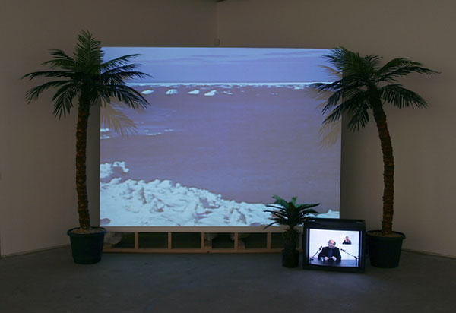

Fig. 2: Joseph Grigely, Multiples (2000)

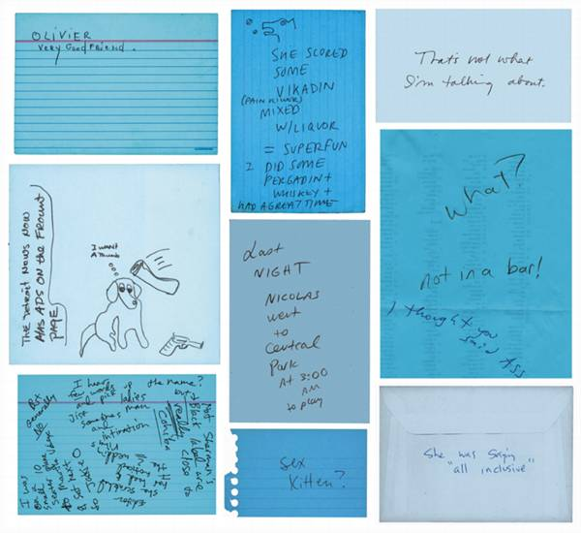

Fig. 3: Joseph Grigely, 223 Conversations (2005)
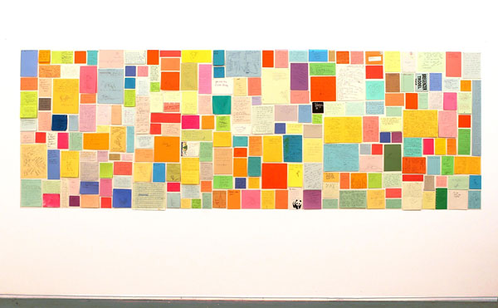

Fig. 4: Joseph Grigely, image of a Canello painting from Vox Populi (2003)

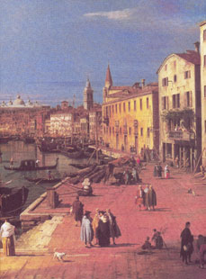

Fig. 5: Joseph Grigely, Dog from Canaletto’s Riva Degli Schiavoni (2003)

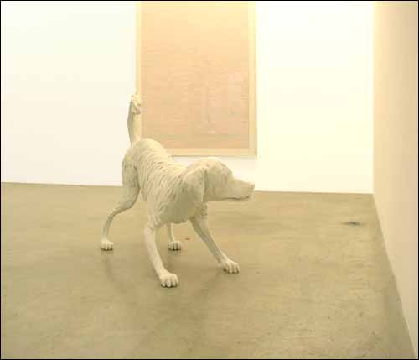

Fig. 6: Joseph Grigely, Blueberry Surprise (2003)

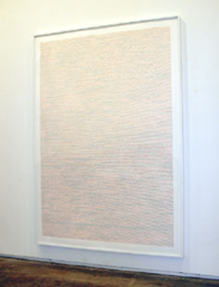

Fig. 7: Joseph Grigely, detail from Blueberry Surprise (2003)
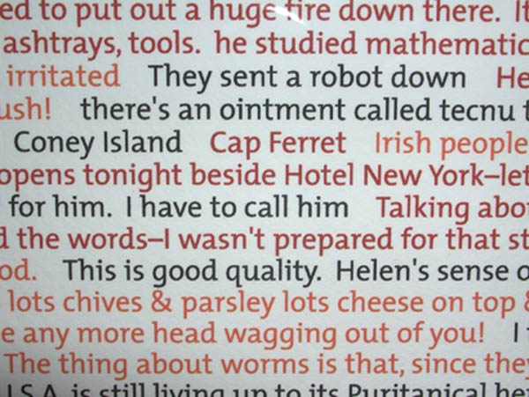

Endnotes

¹ These phrases from Grigely’s work are quoted in Scott, 1999.
² St Cecelia will be exhibited May 5-August 19 at The Contemporary Gallery in Baltimore, MD.

