Vive la Révolution

Essya M. Nabbali
Simon Fraser University
Vancouver, Canada

Abstract: Through the presentation of qualitative data, this verse reflects the author’s sincere effort to reconcile the divide between “town and gown,” all the while exploring the experiences and subsequent perceptions of activists within Mad Pride. In so doing, it creatively illustrates the broad dynamics and challenges that face those on the receiving end of the psychiatric system today.

Key Words: madness, activism, Mad Pride

Drawing on ethnographic and historical research undertaken between 2007 and 2009,¹ this verse traces – in a fanciful way – my uncertain and sinuous path to an “engaged sociology.” In so doing, it creatively illustrates the diversity and ethos of Mad Pride, an international coalition which buttresses events celebrating and demystifying what it means to be “mad.” It is intended to be sufficiently open-ended to stimulate curiosity, allow for imaginative interpretations, encourage Foucaultdian problematization and invite further dialogue as a result. While the interview² snippets (cited in italics) are not quoted in full, and thus do not reflect the entirety of the participants’ view, they have not been taken out of context. Moreover, I wish to make clear that such excerpts are used as a means of illuminating ideas so the portrayals of an “expectant mother,” an “elderly bloke,” a “babbling mental patient” and the likes, do not characterize the references whatsoever.

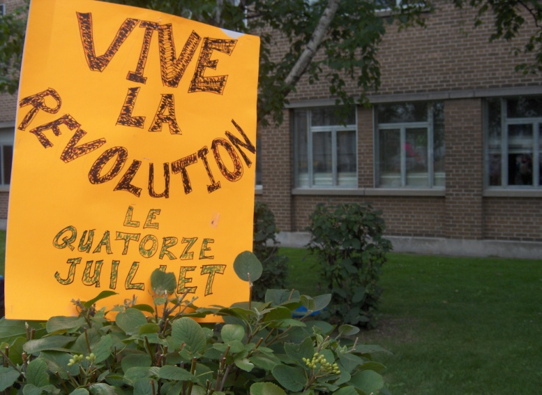 | “Long Live the Revolution,  the Fourteenth of July”  Poster mounted in the shrubbery of the Centre for Addiction and Mental Health (CAMH) at the Second Annual Toronto Mad Pride Bed Push parade on Saturday, July 19, 2008.  Photo: Essya M. Nabbali

“choice, empowerment, self-determination” (Oaks)
I close my eyes...
July, 1789. Paris.
intoxicated with liberty and enthusiasm
the French masses storm La Bastille³
upheaval, insurgence, bloodshed
the first great triumph of the forces of anarchy⁴
freedom for all
“vive la revolution,” I hear a man bellow
I open my eyes...
July, 2008. Toronto.
“vive la revolution,” he shouts again
I look around
a jamboree of people
wearing all kinds of fucked up shit (Fabris)
a shirt reads “Nutter on Board”
a cape declares “Captain Crazy”
a hat reveres “Lithium Life”
purple pyjamas with moons
red thongs worn over slacks
jester crowns, masks and painted faces
just about anything that challenges the normative culture (Fabris)
it is beautiful
I want to clap but I don’t
“choice, empowerment, self-determination” (Oaks), the horde repeats
the rhythmic beating of bongo drums
and people’s cheers echo
“we need to get democracy hands-on” (Oaks), an expectant mother urges
another revolution?
a gentle voice murmurs “satyagraha”
seemingly a more peaceful one
I close my eyes once more...
April, 1933. India.
the outset of Ghandi’s “fast unto death”
to restore communal amity
suddenly, I am startled
a young woman, probably in her early twenties
with dishevelled hair, smudged make-up and smoking a cigarette
grabs my hand, “come, join us, make a statement”
she promptly cries, “we’re here, we’re people like you and we have rights too” (Briggs)
noticing my puzzled expression, she explains
“You don’t necessarily have to have seen a psychiatrist to be here.
You don’t need to be on Zyprexa or Prozac.
Perhaps, as a result of wealth or some semblance of togetherness
or whatever else it is shrinks stay away from,
you’ve managed to elude the system.
Whatever it is, whatever your story,
if you see the oppression,
if you are or could be included in that oppression,
celebrate Mad Pride!” (Anonymous1)
her friend earnestly elaborates, “we need people to say ‘I’m proud of the fact that
I’ve had experiences that could get me locked up” (Fabris)
“but,” an elderly bloke interrupts, “[you] do not have to identify explicitly” (Reville)
I look around again
the mad, the oppressed, the ex-inmates of society
asserting themselves
demanding inclusion and diversity (Oaks)
harmony and respect (Bach)
as well as access and services (Briggs)
carrying signs such as “Keep your labels off my mind”⁵
I snatch one which heralds “stop loneliness once and for all!” (Briggs)
“We need a voice for mental health consumers” (Oaks), some roar
others charge, “The drugs and the electroshock and all that needs to go bye bye.
[They’re] completely screwing us all to hell!” (Briggs)
a plethora of embodiments
multiple political struggles
intersecting oppressions
it’s complicated shit (Bach)
I sit next to the mental patient who’s babbling on “medication”
“We recognize that there’s differences,” he clarifies, “and we’re trying to celebrate
those differences and the ways we can reframe various experiences.
Mad Pride is providing the space to do that” (Bach)
so much for “babbling”
a moment of silence
to remember people who’ve been killed or who’ve died in mental hospitals (Oaks)
candles, flowers, speeches
In a way, it’s ‘Take Back the Night’ (Reville)
a campaigner then re-arouses the collective when she proclaims
“[Psychiatrists] tried to change us, tried to silence us
but we survived everything they threw at us!
That is something we should all be proud of”⁶
the rally starts to march
pushing a hospital bed, chased by a giant syringe
a father, clutching his child affectionately, informs me that we’re staging Britain’s “Great Escape Bed Push” as a means of drawing attention to the flagrant abuse of power by the state (Fabris) and the lack of humane alternatives in mental health services
over 100 people flock from CAMH to PARC⁷
frolicking, refreshments and a bbq await
“It’s a big thing – free food – when you’re hungry” (Anonymous2)
avers an activist dancing the characteristic “thorazine shuffle”⁸
upon arrival, the crowd chants
“Show me your Mad Pride.
I’ll show you my Mad Pride.
We’ll show the world Mad Pride!”
an impromptu piano recital from a member of the audience
laughter, chit chatting, togetherness
I casually probe the syndicate
in an effort to better understand this phenomenon
“Mad Pride, well, what you’re doing is you’re backing away from the original intent of the psychiatric liberation movement,” a bearded man grumbles, “you’re trying to put a soft shell on the movement and it’s not going to work because the issues are too intense. They’re too difficult for people to just come out and wrap up into [some public celebration]”⁹ (Fabris)
a woman draped in blue and gold sequence thwarts, “I’m not worried that psychiatry is all of a sudden going to snap back and say ‘oh, okay, we’ll stop with the force. Yes, we’ll stop with the force.’ That’s not going to happen too soon, just look at the money” (Fabris)
the circle pauses
I linger patiently for a riposte
“We’ve dealt with a lot of failure,” blurts the woman’s partner, hidden behind a Venetian feather mask, “so we’re not, maybe, the kind of political movement that sees winning as the only goal.
I think that winning has to come with people’s sense of self” (Fabris)
she continues, “We don’t feel good about ourselves. People who live in the boarding homes, they don’t even have it together to go and talk to another human being. It’s pretty intense.
You have to give people a sense that they’re okay, a sense of something worthy” (Anonymous2)
Indeed, “It’s not about pride or dignity and all of that stuff,” another bolsters,
“I mean I hear those words and I just go ‘yeah, yeah, whatever! What about safety, space?’
It’s more like, there are people who really do need to feel safe, just feel like they can live in their own bodies, and it’s that kind of stuff that I think [Mad Pride] has a lot to offer” (Fabris)
worthy of note
my attention turns to the adolescent addressing a journalist
“I feel that Mad Pride is really something much broader than any of this in the sense
that human beings can embrace pride in being different, unique, creative, unusual and
that’s what we mean by Mad Pride. It’s really ‘Human Pride.’ To be alive, to think, to be, to exist as a human being, as a living entity, it’s not normal. It’s a strange experience, inherently. In fact, science is finding in complexity theory that life exists on the edge between chaos and order, far from equilibrium. I think we’re always in that state, on the edge of chaos
in the sense that none of us have a grip on reality” (Oaks)
he bewilders and frustrates the reporter
“To put it more simply, Mad Pride is something that everybody can get involved in. It’s about having fun and being different. Everyone can celebrate that” (Oaks)
he smiles
the journalist smirks
I can’t help but giggle to myself

Essya M. Nabbali is a doctoral student in Sociology at Simon Fraser University, British Columbia, Canada. Her areas of interest span the fields of identity politics, cultural pluralism, human rights and grassroots pedagogy, particularly within public health and medical sociology. She has presented scholarly papers on such themes at the provincial, federal, and international levels.

The research upon which “Vive la Révolution” is based was conducted during her tenure as an M.A. student at York University, Ontario, Canada, under the remarkable (and much appreciated) tutelage of historian Geoffrey Reaume. Essya wishes to wholeheartedly thank Ryan Docherty, despite endings, for having been her muse and strength as she found her academic footing. She would also like to dedicate this poem to her beloved Nanny and two little munchkins, Lauren and Lexie Hood, whom may never read this, but if/when they do, will know that she is thinking of them, always.

Endnotes

¹ Nabbali, E. M. (2009). “A ‘Mad’ Critique of the Social Model of Disability,” International Journal of Diversity in Organisations, Communities, and Nations, 9 (4), 1-12.

² With artistic licence from Anonymous1 (self-styled “manically eccentric”), Anonymous2 (someone who has been “brutalized” by psychiatry), Jeremiah Bach (one of the central organizers of Mad Pride Toronto 2007 and 2008), Bonnie Briggs (ally), Erick Fabris (former psychiatric inpatient), David Oaks (director of MindFreedom International whose vision is for a non-violent revolution in the mental health system) and David Reville (psychiatric survivor). Approved over the months of October and November, 2008.

³ Mignet, F. A. (1885). History of the French Revolution from 1789 to 1814. London: George Bell and Sons.

⁴ Moreton-Macdonald, J. R. (1915). A History of France. New York: MacMillan.

⁵ Reaume, G. (1993). Psychiatric survivors hold Pride Day. People’s Voice, November issue, p.5.

⁶ Reaume, G. (1994). Psychiatric survivor festival. People’s Voice, June issue, p. 13.

⁷ Centre for Addiction and Mental Health (CAMH); Parkdale Activity and Recreation Centre (PARC)

⁸ A phrase referring to the stiff gait and involuntary muscle movements (especially around the mouth – often causing drooling – and in the arms and legs) resulting from tardive dyskinesia or the long-term use of neuroleptic drugs.

⁹ Fabris made this comment when discussing his earliest views on Mad Pride.

