Legacies: Burning Books A-Foot in Heaven?

By Steven E. Brown, Ph.D.
University of Hawai‘i, Mānoa

In the early 1990s, on a panel at a Society for Disability Studies annual meeting and trying to model in some way the AIDS quilt, I shared a few names and a couple of stories of friends who had passed on. Afterwards, people shared some of their own names and stories. That led to the writing of “Martyrs,” a poem that begins:
The following have drawn their last breath,
They've been courted by death
Many gave their lives to the cause
Their passing should give us pause
Many gave all their hearts had to give
So the rest of us might live (Brown, lines 1-7)

Interspersed between stanzas are names. In 2010, too many names have been added to this poem, which now lists more than 100 people. Others continue to send names and some of these, along with “Martyrs” can be found at www.instituteondisabilityculture.org.
The Review of Disability Studies (RDS) began amidst life passages when Founding Editor, David Pfeiffer, passed on suddenly prior to publication of the journal’s first issue. In Volume III, Issue 4, we published an “In Memoriam” to RDS Distinguished Fellows Frank Bowe and Rolf Bergfors. In the current issue, we pay tribute to one of the giants of disability studies and acknowledge others who have impacted disability studies, Disability Culture, and our lives.
One morning in early August 2010, I received an email asking if I had heard about Paul Longmore’s passing. I had not and I had difficulty accepting the news without confirmation. Beginning a web search I could find no indication of Paul’s death. But when signing onto Facebook I read rumors, which Paul’s sister later confirmed. Paul had passed on the previous night.
Paul left a lasting legacy, including understanding and writing about how disability issues affected history (The New Disability History) and how he, as a scholar-activist, also impacted history (Why I Burned My Book). Not long before his death, Paul learned, and enthusiastically shared, the news that he had been awarded a prestigious Switzer Fellowship to write an American history college textbook about disability.
Like many of us in our 50s and 60s (he was 64 at the time of his passing), he came to disability rights activities because of discrimination. These activities led him to disability studies. A scholar of American history, Paul’s book on George Washington—the book he burned in a successful protest against the Social Security Administration’s recording royalties as income which threatened his benefits—remains highly regarded.
At the time of his passing, Paul was Director of San Francisco State University’s Institute on Disability as well as a professor of American history. Losing a friend is always difficult; losing a friend and colleague who is also a giant in his field is even harder. At one of Paul’s final public appearances—a Disability Pride event celebrating the 20th anniversary of the signing of the Americans with Disabilities Act in San Jose, California, in July 2010—Paul said:
“Great leaders do not create great movements. Great movements give rise to great leaders.... No movement can exist without in this case millions of ordinary men and women asserting themselves to demand dignity and their rights. So that’s what our movement is all about. That’s our past. That’s our present. That’s our future” (Feingold, 2010).
Paul will be missed, but his was not the only huge loss of 2010. Cartoonist, humorist, musician, and writer John Callahan also moved on during this year. Author of numerous cartoons depicting disability with an eye toward moving people’s boundaries, Callahan’s autobiography, Don’t Worry: He Won’t Get Far on Foot (1990) remains a classic look into the life of becoming disabled and adapting to it. I never met Callahan, but his work impacted my Disability Culture perspectives and I read everything of his I could find. In the early days of presenting about Disability Culture I often passed his cartoons around the room and waited for a myriad of reactions, from laughter to “Oh, that’s gross.” Callahan constantly challenged our assumptions.
Too many others have left the planet this year to describe each in detail, but also missed will be disability rights activist and one of the founders of the oldest, ongoing Disability Pride Parades (in Chicago), Barb Bechdol; playwright and editor, Paul Kahn; writer and artist, Robert Mauro; photographer Tom Lee; musician and elder statesman William Loughborough; and activist Barbara Knowlen.
Two deaths—more personal and local—of this year include Tom Carter, a colleague from El Paso, who directed an independent living center there at the same time I directed one in Norman, Oklahoma and Mitch Stuart in Honolulu. Mitch was a person with a developmental disability who served on some Center on Disability Studies committees. He was also a recruiter for the Self-Advocacy Advisory Council. A perfect job for Mitch, whose booming voice and enthusiasm were hallmarks of his presence.
After writing and submitting this piece, we learned of the passing of another giant of the disability rights movement, Paul Miller, a former RDS Distinguished Fellow, who relinquished that title when he went to work in the Obama administration. Paul also worked in the Clinton administration, where he was instrumental in hiring persons with disabilities to work in Washington, D. C. An attorney and an advocate, Paul lived in Seattle, Washington, where he was Henry M. Jackson Professor of Law at the University of Washington and director of its disability studies program.
Each of these individuals in some way bettered others and the cause of disability rights. While they have moved on, we who remain have plenty left to do. “Martyrs” concludes:
These tales we tell have begun
Songs and poems and stories in all their glories
These tales we tell have begun
I don't believe an ending will ever come. (lines 86-90)

Steven E. Brown is Associate Professor at the Center on Disability Studies at the University of Hawai‘i and an RDS editor.

References

Brown, S. E. (1995). Martyrs. Pain, plain and fancy rappings: Poetry from the Disability Culture. Las Cruces, NM: Institute on Disability Culture.
Brown, S. E. (2007). In Memoriam. Review of Disability Studies: An International Journal, III(4), 3.
Callahan, J. (1990). Don’t worry, he won’t get far on foot: The autobiography of a dangerous man. New York: Vintage.
Feingold, L. (2010). Paul Longmore: Giant of the disability rights movement (1946-2010). Retrieved from http://lflegal.com/2010/08/paul-longmore/
Longmore, P. K. (1988). The invention of George Washington. Berkeley: University of California.
Longmore, P. K. (2003). Why I burned my book and other essays on disability. Philadelphia, PA: Temple.
Longmore, P. K. & Umansky, L., Eds. (2001). The new disability history: American perspectives. New York University.
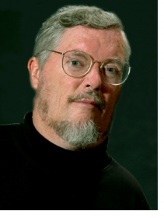
Paul Longmore, photo by Christopher J. Rozales
SF State News (Online newsletter). (2005, March 14).
http://www.sfsu.edu/~news/2005/spring/26.htm

Paul S. Miller, public domain, US Federal Government
http://en.wikipedia.org/wiki/File:Paul_Steven_Miller_EEOC.jpg

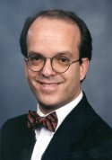

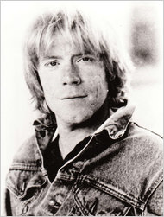

Weber, B. (2010, July 28). John Callahan, Cartoonist, Dies at 59. The New York Times. http://www.nytimes.com/imagepages/2010/07/28/arts/28callahanimg.html

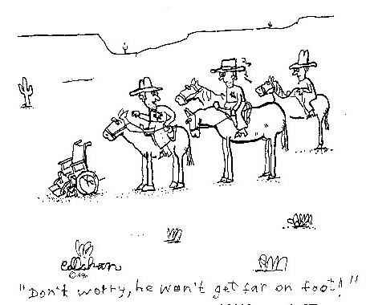

Michelitch, J. (2010, July 27). It Hurts To Laugh: R.I.P. Cartoonist John Callahan 1951-2010. Comics Alliance (Online newsetter). http://www.comicsalliance.com/2010/07/27/John-callahan-remembered/

