**Research Articles and Essays**

**The Fatigue in Educational Contexts Survey (FEC): Elevating, Empowering, and Engaging Deaf and Hard of Hearing Students**

Natalia Rohatyn-Martin¹, Denyse Hayward², Lynn McQuarrie², Linda Cundy²,

Stephan Rohatyn³, Jerry Gan², and Sydney Dickner4

¹MacEwan University

²University of Alberta

³McLennan Community College

4University of Calgary

**Abstract**

This research addresses the lack of inclusive fatigue measures for Deaf or hard of hearing (DHH) students in educational settings. It introduces the Fatigue in Educational Contexts (FEC) survey, designed to assess and interpret fatigue in DHH students, enabling better understanding, advocacy, and mitigation of fatigue-related challenges in the classroom.

*Keywords*: Deaf, hard of hearing, fatigue assessment, inclusive educational tools

### The Fatigue in Educational Contexts Survey (FEC): Elevating, Empowering and Engaging DHH Students

Classrooms comprise an ongoing array of cognitive, visual, auditory, and attentional demands. Students who are Deaf or hard of hearing (DHH) must navigate these demands with degraded hearing amidst competing auditory sounds (e.g., teacher’s voice, chair movements, and hallway conversations) for up to six hours a day, five days a week. The increased effort and exertion needed to learn contributes to greater levels of fatigue that is compounded when students are denied resources known to minimize fatigue. Fatigue in educational settings for students who are DHH is poorly understood by both students and educators. Students often disregard fatigue symptoms or internalize the causes, have limited or maladaptive coping strategies, and minimize the serious consequences these actions have on their learning and academic success. Teachers frequently misconstrue ineffective coping behaviors as a lack of motivation, and those who liken hearing devices to jewelry fail to recognize the importance of educational supports moderating cognitive, auditory, and visual exertion. Thus, our goal is to provide a means for DHH students and their educational team to understand the impact of fatigue, to advocate for appropriate supports (strategies and programs) and to moderate fatigue in educational contexts. Thus, we designed the Fatigue in Educational Contexts (FEC) survey. The purpose of the survey is to accurately identify, describe, and interpret the presence and intensity of fatigue, and inform alleviation approaches.

## What is Fatigue?

Fatigue is a complex and multifaceted construct to define. Fatigue is often misconstrued as synonymous with being tired. Although tiredness may be a symptom of fatigue, fatigue cannot be resolved with rest. Fatigue results when cognitive, emotional, or physical attentiveness is required for prolonged periods of time. When an individual is tired, sleep can help to alleviate feelings of tiredness. Current definitions vary, based on whether fatigue is defined subjectively or objectively. Subjectively, fatigue is defined as a decline in the efficiency of an individual’s focus, concentration, and alertness and objectively defined as a decline in an individual’s performance due to sustained or prolonged demands (Hornsby et al., 2017; Hornsby, 2013).   
 Three types of fatigue have been identified in the literature: cognitive or mental fatigue, social-emotional fatigue, and physical fatigue. Cognitive fatigue refers to a decline in an individual’s focus, concentration, and alertness due to prolonged demands (Bess & Hornsby, 2014a; Bess & Hornsby, 2014b). For DHH students this could look like cognitive energy spent on localizing a teacher’s voice in a noisy classroom, trying to simultaneously watch the teacher and signed language interpreter to comprehend instruction, or understanding a signed (e.g. ASL) message and translating it to create academic notes in written English. Social-Emotional Fatigue occurs when interpersonal effort results in feeling emotionally worn out and feeling drained (Michielsen et al., 2004). For example, feeling a lack of motivation, frustration, or sadness, and a need to push oneself to complete schoolwork or socialize. Finally, physical fatigue stems from physical effort creating muscle strain or injury (Bourland Hicks et al., 2002). For example, eye strain from hours of watching an ASL interpreter or attempting to speechread/lipread and decipher a teacher’s facial expressions.

More likely, a combination of these three types of fatigue will impact students. However, it is important to differentiate between them as they will impact different aspects of the students’ school life and social life. Separating these aspects of fatigue into categories helps to identify the difficulty students are presenting with, to better support students with their fatigue.

## Auditory Effort and Visual Effort

There are two factors that may contribute to higher levels of physical, social-emotional, and mental fatigue for DHH students: auditory effort and visual effort. Auditory effort refers to the cognitive exertion required to attend to, and understand, a spoken message (McGarrigle et al. 2014). Spoken messages in classrooms must often be processed and understood in the presence of noise (e.g., classmate chatter, squeaking of moving chairs, ventilation systems, or hallway noise). Notably, Goldberg and Richburg (2004) reported that younger students in general perform more poorly in noisy classrooms than adolescents regardless of hearing ability. Thus, students with compromised auditory systems will need to work much harder to attend to and understand spoken messages than students with adequate hearing abilities (Bess et al., 2020; Hornsby et al., 2021; Hornsby et al., 2014). Even the seemingly simple act of localizing sound sources in a classroom may be inordinately challenging for students who are Deaf, particularly when there are competing noises or when speaker utterances overlap (Tharpe, 2008).

Visual effort refers to the physical and mental exertion required to visually attend to and comprehend a message (Rohatyn-Martin & Hayward, 2016). Classroom examples include looking at the person communicating a spoken message, reading a textbook, or watching a video. Fatigue can result due to the auditory signal in amplification devices, which is rarely equivalent to normal hearing, resulting in students attempting to use visual information to supplement and compensate for the diminished auditory signal (Bess & Hornsby, 2014a). For students who communicate or learn through a signed language, greater levels of fatigue related to visual effort may also arise as students attempt to attend simultaneously or alternatively to their teacher and an interpreter to comprehend classroom instruction or conversation.

Few studies have investigated student fatigue within the classroom despite the negative effects of fatigue on student’s education being widely acknowledged in research (Bess et al., 2020; Bess & Hornsby, 2014b; Davis & Hornsby, 2023; Hornsby et al., 2014). Additionally, students have seldom been placed in the role of primary informant regarding their educational experiences. Authentic student voices provide the opportunity to uncover beneficial or potentially disadvantageous educational practices within classrooms, which can help to mitigate the compounding effects of fatigue. The social, academic, vocational, and economic outcomes of students are significantly compromised when student voices are absent or ignored. Furthermore, investigating students' experience of fatigue within inclusive education is valuable for educators and policy makers. Students’ perspectives can inform and enhance decisions on educators’ pedagogy with respect to fatigue to support increased student engagement, motivation, and achievement within the classroom.

## Development of the FEC

The objective of our program of research is to establish a framework for DHH students and their educational team to understand the implications of fatigue, advocate for suitable supports (including strategies and programs), and moderate fatigue within educational environments. The first phase of the research involved the development of the Fatigue in Educational Contexts (FEC) survey. This phase aimed to construct a survey instrument to accurately identify, describe, and interpret the presence and intensity of fatigue, and inform alleviation approaches.

The development of the FEC survey encompassed a systematic progression of measures, including the conduct of focus group interviews with DHH experts (i.e., DHH post-secondary students; parents of DHH students; and DHH professionals—teachers and clinicians). These expert groups provided complementary perspectives, experiences, and knowledge related to fatigue.

Understanding the perspectives of DHH students is essential as they give first-hand experience of how they are affected by fatigue in their educational and home settings. Student voices have traditionally not been considered credible sources in instrument development, yet students themselves possess unique insights that enhance instrument credibility and applicability (Hayward et al., 2013).

Perspectives of parents/caregivers of students who are DHH are also essential as they provide first-hand accounts of the effect of fatigue for their child at home, enact key advocacy roles throughout their child’s education, and tend to consider education beyond academic outcomes, which include social, emotional, and vocational values. Like student voices, parent voices have traditionally not been considered credible sources in instrument development, yet parents possess unique insights that enhance instrument credibility and applicability (Hayward et al., 2013).

Professionals included teachers, speech-language pathologists, and audiologists who have a minimum of 5 years’ experience supporting students who are DHH in educational settings. Teachers can speak to their classroom experiences, successes and challenges encountered in employing fatigue-mitigation strategies, and professional training received to support diverse student needs. Speech-language pathologists and audiologists can provide assessment, intervention, and consultation support in educational settings for students who are DHH. Their professional training and focus on individual students rather than an entire classroom of students offers a complementary lens to that of teacher experts. Knowledge gained from interviews was used to create a draft version of the FEC survey, and two parallel versions for parents/caregivers and teaching/professional teams. The FEC was then revised based on expert feedback, enhancing credibility, reliability, and validity of the survey for Phase 2.

**Figure 1**

*The Fatigue in Educational Contexts Survey Timeline*

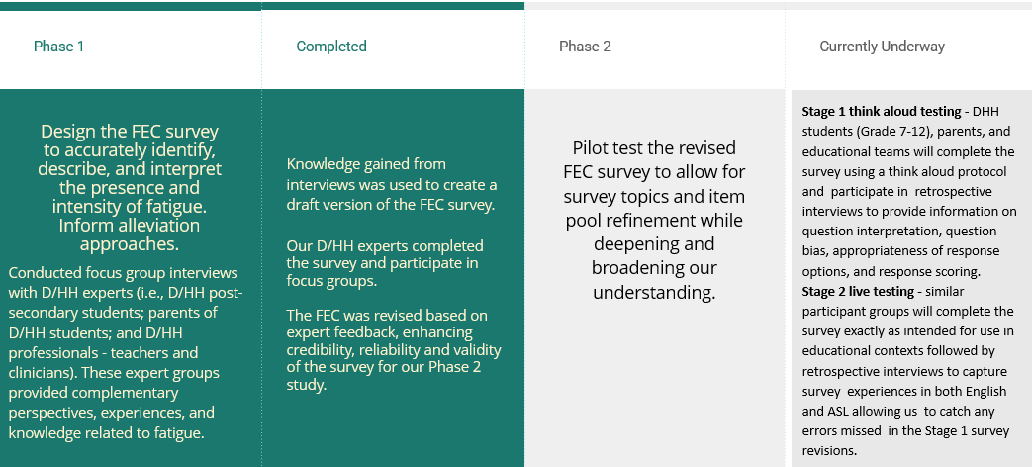

Through the revision process, we received feedback to incorporate additional visual components to the FEC survey. We have worked to ensure various accessibility features are present in the survey to be inclusive of all DHH individuals. As illustrated in Figure 2, each survey question will present individuals with options to view the question as text, listen to an audio recording of the question, and watch a video of the question signed in ASL with subtitles. Additionally, individuals will be presented with each of the response options as visual icons, signed in ASL, and spoken language audio recordings. These features will cater to the heterogeneity of students who are DHH—spoken language users, signed language users, and dual language (spoken and signed) users who may be monolingual, bilingual or multilingual.

**Figure 2**

*Accessibility Features on the Fatigue in Educational Contexts Survey*

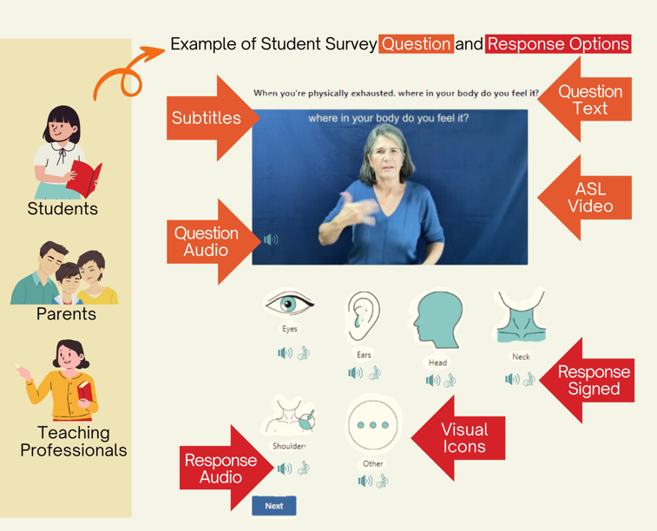

The second phase of development of the FEC is currently underway and is dedicated to the pilot testing of the refined Phase 1 FEC survey. This stage facilitates the refinement of survey themes and item pool, thereby fostering a deeper and more comprehensive understanding of fatigue within educational settings. The pilot testing will unfold in two stages, each designed to address specific facets of refinement and expansion.

The first stage of Phase 2 involves facilitating think aloud testing. Secondary DHH students (Grade 7-12), their parents/caregivers, and educational teams will complete the survey using a think aloud protocol and participate in retrospective interviews to provide information on question interpretation, question bias, appropriateness of response options, and response scoring. The second stage will involve live testing of the survey. Similar participant groups will complete the survey exactly as intended for use in educational contexts followed by retrospective interviews to capture survey experiences in both English and ASL, providing opportunities to catch any errors that may have been missed during stage 1 (think aloud testing) survey revisions.

The ongoing pilot testing of the FEC survey marks a significant step towards refining our understanding of fatigue and implementing effective strategies to support students in managing and mitigating its effects. By acknowledging and addressing fatigue, educators, policymakers, and stakeholders can foster more inclusive and supportive learning environments that promote student engagement, motivation, and achievement. Furthermore, it is imperative to highlight the accessibility features embedded within the FEC survey and underscore their importance. Recognizing the diverse needs of students, including those who are DHH, we have intentionally worked to ensure that the FEC survey is accessible to all participants. To that end, incorporating visual design alongside accessibility features such as screen reader compatibility and language representation in spoken, written, and signed modes enhances the usability and inclusivity of the survey. This commitment to accessibility is essential in ensuring all students are empowered, regardless of their abilities or communication preferences, to actively engage in the survey process. Intentionally prioritizing accessibility, we not only defend principles of equity and inclusion but also ensure that the voices and experiences of all participants are heard and valued. Thus, the FEC survey, designed to elevate, empower, and engage DHH students will serve as a cornerstone in promoting genuine understanding and meaningful insights into the experiences of DHH students regarding fatigue in educational contexts.

# References

Bess, F. H., & Hornsby, B. W. (2014a). Commentary: Listening can be exhausting—Fatigue in children and adults with hearing loss. *Ear and Hearing, 35*(6), 592-599. <https://doi.org/10.1097/aud.0000000000000099>

Bess, F. H., & Hornsby, B. W. (2014b). The complexities of fatigue in children with hearing loss. *Perspectives on Hearing and Hearing Disorders in Childhood, 24*(2), 25-39. <https://doi.org/10.1044/hhdc24.2.25>

Bess, F. H., Davis, H., Camarata, S., & Hornsby, B. W. (2020). Listening-related fatigue in children with unilateral hearing loss. *Language, Speech, and Hearing Services in Schools, 51*(1), 84-97. <https://doi.org/10.1044/2019_lshss-ochl-19-0017>

Davis, H., & Hornsby, B. (2023). Listening-related fatigue in Deaf and hard of hearing students: Understanding and managing the "fatigue factor." *The Volta Review, 123*(1), 21-34.

Goldberg, L. R., & Richburg, C. M. (2004). Minimal hearing impairment: Major myths with more than minimal implications. *Communication Disorders Quarterly, 25*(3), 152-160. <https://doi.org/10.1177/15257401040250030601>

Hayward, D. V., Ritter, K., Grueber, J., & Howarth, T. (2013). Outcomes that matter for children with severe multiple disabilities who use cochlear implants: The first step in an instrument development process. *Canadian Journal of Speech-Language Pathology & Audiology, 37*(1).

Hornsby, B. W. (2013). The effects of hearing aid use on listening effort and mental fatigue associated with sustained speech processing demands. *Ear and Hearing, 34*(5), 523-534. [https://doi.org//10.1097/aud.0b013e31828003d8](https://doi.org/10.1097/aud.0b013e31828003d8)

Hornsby, B. W., Werfel, K., Camarata, S., & Bess, F. H. (2014). Subjective fatigue in children with hearing loss: Some preliminary findings. *American Journal of Audiology, 23*(1), 129–134. <https://doi.org/10.1044/1059-0889(2013/13-0017)>

Hornsby, B. W., Davis, H., & Bess, F. H. (2021). The impact and management of listening-related fatigue in children with hearing loss. *Otolaryngologic Clinics of North America, 54*(6), 1231-1239. <https://doi.org/10.1016/j.otc.2021.07.001>

Hornsby, B. W., Gustafson, S. J., Lancaster, H., Cho, S. J., Camarata, S., & Bess, F. H. (2017). Subjective fatigue in children with hearing loss assessed using self-and parent-proxy report. *American Journal of Audiology, 26*(3S), 393-407. <https://doi.org/10.1044/2017_aja-17-0007>

Hicks, C. B., & Tharpe, A. M. (2002). Listening effort and fatigue in school-age children with and without hearing loss. *Journal of Speech, Language, and Hearing Research, 45*(3), 573–584. <https://doi.org/10.1044/1092-4388(2002/046)>

McGarrigle, R., Munro, K. J., Dawes, P., Stewart, A. J., Moore, D. R., Barry, J. G., & Amitay, S. (2014). Listening effort and fatigue: What exactly are we measuring? A British Society of Audiology Cognition in Hearing Special Interest Group ‘white paper’. *International Journal of Audiology, 53*(7), 433-445.

<https://doi.org/10.3109/14992027.2014.890296>

Michielsen, H. J., De Vries, J., Van Heck, G. L., Van de Vijver, F. J., & Sijtsma, K. (2004). Examination of the dimensionality of fatigue. *European Journal of Psychological Assessment, 20*(1), 39-48. <https://doi.org/10.1027/1015-5759.20.1.39>

Rohatyn-Martin, N., & Hayward, D. V. (2016). The challenge of fatigue for students who are Deaf or hard of hearing in inclusive classrooms. *International Journal of Learner Diversity & Identities, 23*(3), 23-31. <https://doi.org/10.18848/2327-0128/cgp/v23i03/23-31>

Tharpe, A. M. (2008). Unilateral and mild bilateral hearing loss in children: Past and current perspectives. *Trends in Amplification, 12*(1), 7-15. <https://doi.org/10.1177/1084713807304668>

 **The Fatigue in Educational Contexts Survey (FEC): Elevating, Empowering and Engaging DHH Students** by Natalia Rohatyn-Martin, Denyse Hayward, Lynn McQuarrie, Linda Cundy, Stephan Rohatyn, Jerry Gan, and Sydney Dickner.

<https://rdsjournal.org/index.php/journal/article/view/1351> is licensed under a [Creative Commons Attribution 4.0 International License](https://creativecommons.org/licenses/by/4.0/). Based on a work at [https://rdsjournal.org](https://rdsjournal.org/)