**Research Articles and Essays**

# The Exploratory Survey of Usage Data with Chatbot for Neurodiverse Individuals

Akira Kashihara1, Fukuko Hasegawa1, Tomone Takahashi2, Masayoshi Ogura3,

Hideyuki Haraguchi4, and Ginga Sasaki1

1Institute of Human Sciences, University of Tsukuba

2Institute of Education, Shinshu University

3Graduate School of Education, Naruto University of Education

4Tokorozawa City Child Support Center

**Author Note**

This research was approved by the Research Ethics Committee, Institute of Human Sciences, University of Tsukuba, Japan (Proposal No. 2023-134 A). This work was supported by JST RISTEX Japan; Grant Number: JPMJRS22I6.

Correspondence concerning this article should be addressed to Fukuko Hasegawa, Institute of Human Sciences, University of Tsukuba, 1-1-1 Tennodai, Tsukuba, Ibaraki 305-8577 Japan. Email: hasegawa.fukuko.gm@u.tsukuba.ac.jp

**Abstract**

In Japan, people facing daily challenges without a medical diagnosis have difficulty receiving public support services. We aimed to improve their accessibility to support information through text-based chat communications using chatbots and professionals. This study discusses the roles of chatbots and professionals based on our developed chatbot usage data.

*Keywords:* neurodiversity, chatbot, online support system

# The Exploratory Survey of Usage Data with Chatbot for Neurodiverse Individuals

In Japan, public services, such as economic or life support, are provided to neurodiverse individuals based on medical diagnoses. Thus, people who have the characteristics of developmental disabilities without medical diagnosis cannot receive any public services in Japan. The characteristics of autism are included under the broad category of autism spectrum disorder (ASD) (Centers for Disease Control and Prevention, 2022). There is a related idea called “neurodiversity,” which means that the nature of the human brain and nervous system is diverse, not just for individuals with autism but generally (Singer, n.d.). From these perspectives, a medical diagnosis may exclude an individual, even if the characteristics of a developmental disability are present. In the Japanese public support system based on medical diagnosis, there is a problem whereby people without a medical diagnosis who experience daily challenges due to the characteristics of developmental disabilities have difficulty receiving public support or outreach from support organizations. From this background, it is necessary to establish a society and system in which everyone, regardless of a medical diagnosis, can achieve self-actualization. This is possible by individuals demonstrating their abilities in their studies and work and by society ensuring access to support resources, according to the difficulties that such individuals face. Through this chatbot implementation, we aim to build a culture of belonging in which all people are accepted, included, and able to establish their identities.

Even if they have not been diagnosed with developmental disabilities, people with the characteristics of ASD, attention-deficit/hyperactivity disorder (ADHD), or specific learning disorders (SLD), and who have difficulties in their daily lives due to the characteristics of developmental disabilities may have various challenges, such as difficulty in face-to-face conversations, frequent nighttime activities because of a lack of rhythm in their lives, and difficulty in verbalizing their problems. We focused on a chatbot that can provide support information and outreach in an interactive format via smartphones, which are used by 97.1% of Japanese citizens (Institute for Information and Communications Policy, 2023). Since digital technology can best meet individuals’ needs, chatbots can provide a ready source of support. The technology, automatic response systems that use artificial intelligence (AI), can respond without face-to-face communication, regardless of the location or time of day. Therefore, chatbots can effectively support people facing difficulties in their daily lives owing to the characteristics of developmental disabilities.

However, although chatbots have advanced, they come with technical limitations in providing human services. According to OpenAI, which developed ChatGPT, a chatbot that uses generative AI and has been advancing rapidly in recent years, may provide incorrect information, even if it presents users with plausible answers (OpenAI, 2022). In addition, chatbots that run on artificial intelligence, including generative AI, are based on machine-learning algorithms, which are subject to the constraints of learned language models and other limitations. Therefore, it is difficult for chatbots to respond to unlearned inputs as flexibly as humans do. It is also difficult for them to obtain background information on users to respond appropriately and provide information accordingly. These are serious problems in the context of human services, which must appropriately identify users’ support needs and provide evidence-based or correct support resources based on these needs. Solving this technical limitation involves a long process and considerable time.

Considering the background presented above, we proposed a “dabot network,” where not only professionals, such as psychologists, and users who face daily challenges but also people with solutions to daily challenges arising from developmental disabilities can give and benefit from support resources. These resources can include support information and coping strategies, provided through cooperation between humans and digital technology using chatbots. By providing this network, we aim to achieve two things for users who face daily challenges owing to the characteristics of developmental disabilities: provide appropriate, well-founded, and correct information through chatbots, regardless of time and place, and provide support that appropriately identifies the support needs of the user.

The dabot network consists of four elements: (a) users, (b) dabot supporters, (c) human operators, and (d) support organizations. Users seek solutions to their daily challenges based on their characteristics of developmental disabilities. Dabot supporters are volunteers who suggest coping strategies for daily challenges to the human operators. Human operators are professionals, such as psychologists, who provide appropriate coping strategies in interactions with users, and they review and register all coping strategies for dabot. Support organizations include medical facilities and developmental disability service centers that provide support resources, such as coping strategies and support information. In this network, each element plays a role in the system to support the user. Human operators provide support information by corroborating, selecting, and editing evidence from the practical coping strategies that dabot supporters suggest for achieving the goal of providing appropriate, well-founded, and correct information through chatbots, regardless of time and place. Users obtain coping strategies by interacting with dabot. Some of these coping strategies involve public or private support facilities that allow user access. To address dabot’s technical limitation, which is difficult to overcome, the network has human operators who help provide support that appropriately identifies the needs of the user by suggesting appropriate coping strategies through text-based chats with users. In addition, human operators can provide outreach to users when follow-up is necessary by chatting with users.

In a trial version, we provided dabot without human operators since there is a need to clarify the roles of operators and the dabot network when providing human intervention.

Several studies have been conducted to ensure access to information and resources by individuals with developmental disabilities. Bradford et al. (2020) provided resources through a chatbot as one way to make support more accessible to higher education students on the autism spectrum and those with related conditions. Grové (2021) is also working with young people, its intended users, to design a chatbot that can communicate evidence-based resources, mental health information, and other coping strategies through artificial intelligence and rule-based AI. The aim is to help young people who struggle to cope appropriately with stressors, such as school stress and feelings of depression and anxiety. However, these projects aim to develop and design appropriate chatbot content and conversations that support people in higher education and other youth through the collaborative efforts of key stakeholders. As such, no actual implementation of chatbots has been undertaken to determine the support needs of users or to survey their use of chatbots. Research has been conducted to identify the usage needs for mental health chatbots by having those who self-identify as having ASD use a mental health conversational agent and then analyzing the messages between the user and agent (Aghakhani et al., 2023). However, this study focused only on the need for chatbot use and did not examine the division of roles by focusing on the relationships between supporters and chatbots. Therefore, the purpose of this study was to clarify the roles played by dabot and human operators based on the analysis of usage data to provide dabot users with access to appropriate support resources.

# Method

## Participants

We provided a trial version of dabot through our cooperating facilities, including medical facilities, developmental disability support centers, and higher educational institutions. We recruited 527 dabot users registered from January 23 to August 31, 2023 for this retrospective study. Twelve users declined to participate. The total number of participants was 515. Of the 515 participants, 166 were from a higher educational institution, 139 were from medical facilities, 111 were the dabot supporters, 48 were from welfare facilities, 16 were from government offices, 13 were from parents’ associations, and 22 were unknown. “Unknown” means that dabot could not record their referrer due to a system malfunction or a method that does not record the source of the inflow.

## Materials

Our developed chatbot called “dabot” automatically suggests coping strategies to users facing daily challenges. The use of dabot by university students has been shown to reduce the feelings of difficulties related to developmental disabilities, regardless of the presence or absence of a medical diagnosis or tendency of developmental disabilities (Sasaki et al., 2022). The dabot has two main user functions to access appropriate coping strategies: coping strategies suggestion and support needs assessment.

*Note.* These figures are screenshots of dabot providing some support information and support needs assessment to users. The dabot indicates support information according to menu selection (left) and typing (the second from left) by the user. The second image from the right is a screenshot of the support needs assessment input form. The right image is an example of the result of support needs assessment.

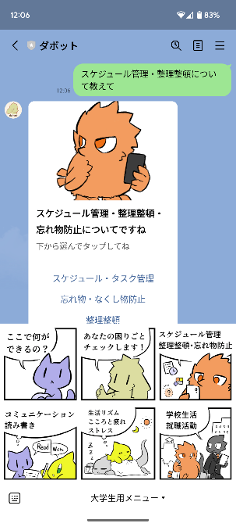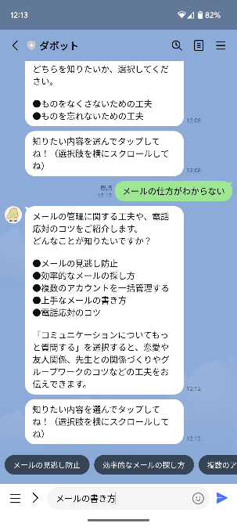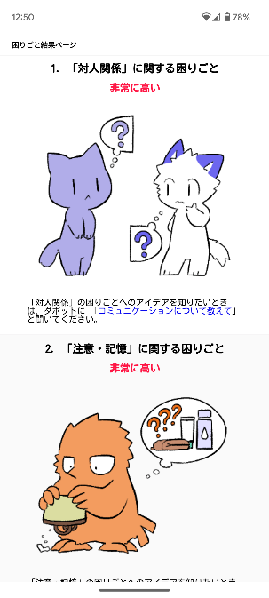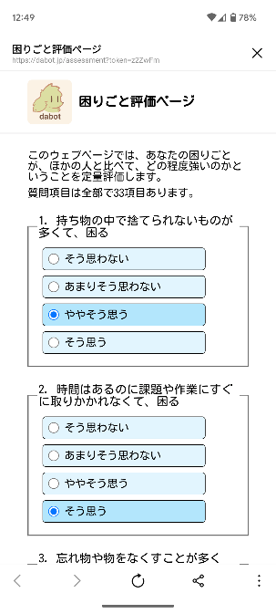

**Figure 1**

*Overview of dabot*

### Coping Strategies Suggestion

Coping strategies suggestion has two kinds of interfaces: “Menu selection” and “Typing.” Menu selection allows users who have difficulty verbalizing their daily challenges to access appropriate coping strategies by selecting an item displayed by dabot (left in Figure 1). The main menu that is shown on the left in Figure 1 has five items related to daily challenges, such as “Daily Challenge Categories,” and one item that is a link to support needs assessment. The “Daily Challenge Categories” are: “What Can I Do Here?,” “Schedule Control, Tidy Up, Keep Your Stuff,” “Communication, Reading and Writing,” “Daily Rhythm, Physically and Mentally Drained, Stressed,” and “University Life, Job Seeking.” However, users can readily access coping strategies by typing if they can verbalize their daily challenges.

### Support Needs Assessment

The support needs assessment allows the user to determine the tendencies of their support needs related to developmental disabilities by answering 33 questions with “Disagree,” “Disagree a little,” “Agree a little,” and “Agree” (the second from left in Figure 1). These questions have a significant correlation with the characteristics of ASD and ADHD as measured by the Autism Spectrum Quotient (AQ) and Conners’ Adult ADHD Rating Scales (CAARS) (Nakano et al., 2021). After the assessment, cute characters inform the user of the assessment results. In addition, a flow line allows users to ask dabot about the coping strategy in which they are interested by clicking the link on the results page.

## Data Extraction

We can obtain two types of data: input to dabot using menu selection or typing and input to support needs assessment. All input data to dabot was textual and was linked to the input date and time. We processed them using natural language processing (NLP) in the analysis. The input into dabot was categorized as either menu selection or typing and was classified into one of five daily challenge categories. The input into the support needs assessment is numerical and calculated at the level of each daily challenge category based on the percentile value as calculated following Sasaki et al. (2018). The levels of each daily challenge category are “Average,” “Somewhat High,” “High,” and “Extremely High.”

# Results and Discussion

## Tendencies of Support Needs

**Figure 2**

*Tendencies of support needs among dabot network users*



*Note.* We obtained 95 uses by 81 people and calculated the level of support needs based on the percentile value calculated by Sasaki et al. (2018).

The support needs assessment was used 95 times by 81 participants. Percentile values are standardized by the data based on Sasaki et al. (2018) and should be monotonically decreasing in the following order: “Average,” “Somewhat High,” “High,” and “Extremely High.” However, the results presented in Figure 2 were unexpected. In particular, the ratio of “Extremely High” was the highest in Human Relations and Sensation, indicating that the participants of this survey who used the support needs assessment tended to have these two types of support needs.

## Hours of Use and Input Daily Challenges Categories

**Figure 3**

*Timeline of accessing the dabot network and the categories the participants searched*

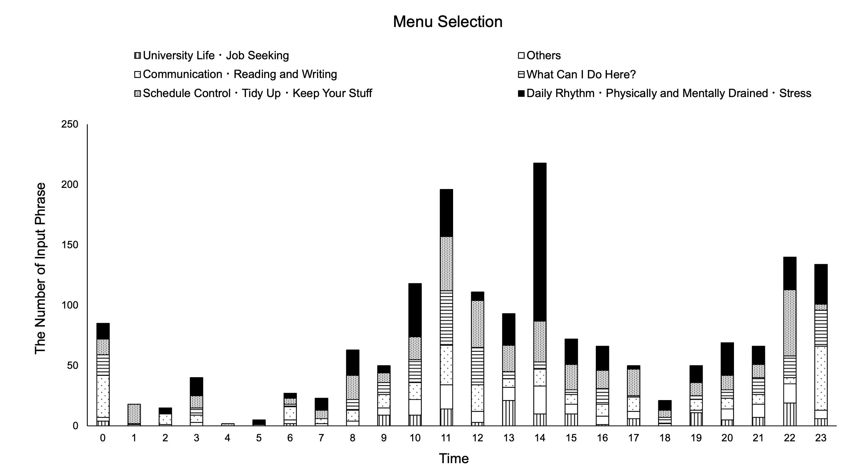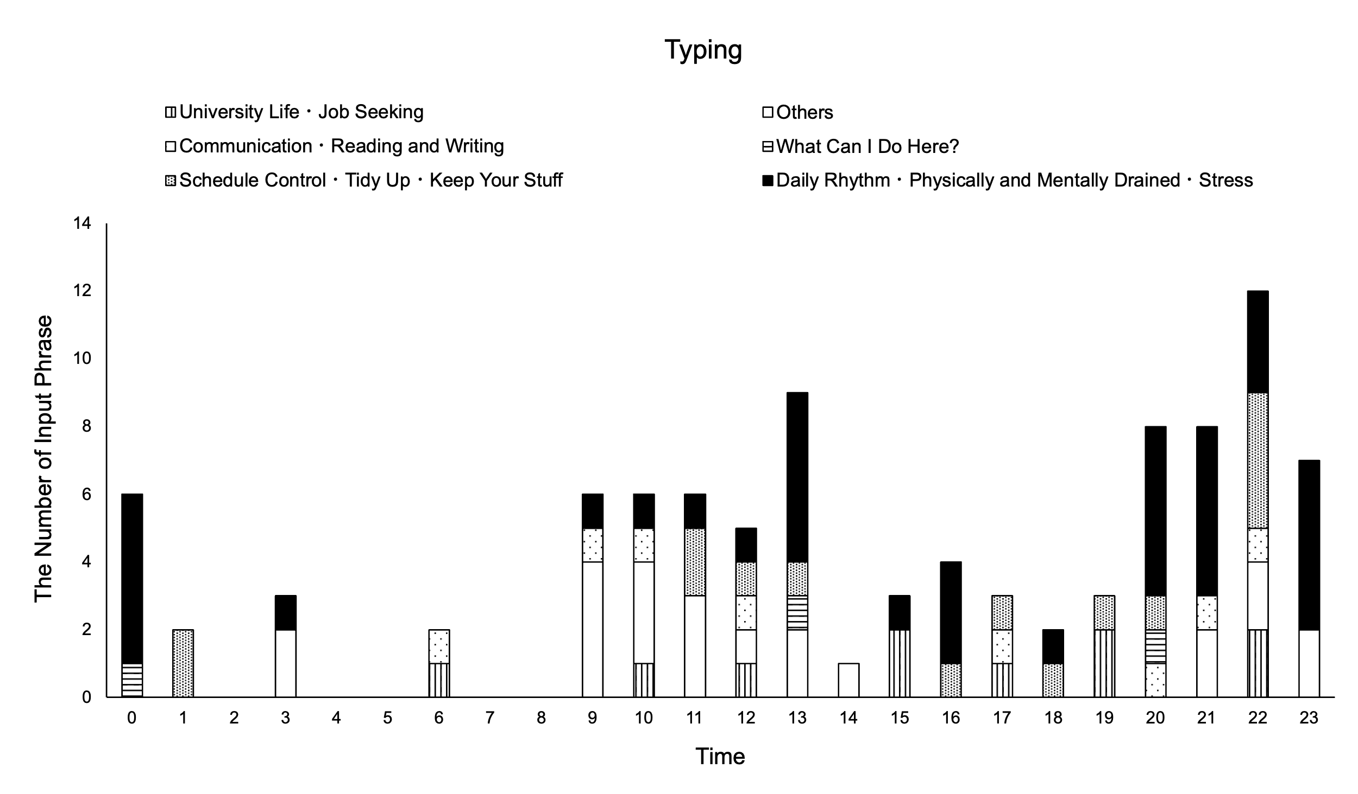

*Note.* The top graph was generated from the menu selection input. The bottom graph was generated from the typing input.

The input into dabot was categorized into an appropriate daily challenges category. The dabot obtained 1,720 inputs through the Menu Selection interface. They were classified as follows: 487 inputs (28.3%) into “Daily Rhythm, Physically and Mentally Drained, Stressed,” 394 inputs (22.9%) into “Schedule Control, Tidy Up, Keep Your Stuff,” 289 inputs (22.9%) into “Communication, Reading and Writing,” 247 inputs (14.4%) into “What Can I Do Here?,” 166 inputs (9.7%) into “Others,” and 137 inputs (8.0%) into “University Life, Job Seeking.” The dabot obtained 96 typing inputs in total. They were classified as follows: 38 inputs (39.6%) into “Daily Rhythm, Physically and Mentally Drained, Stressed,” 22 inputs (22.9%) into “Others,” 15 inputs (15.6%) into “Schedule Control, Tidy Up, Keep Your Stuff,” 10 inputs (10.4%) into “University Life, Job Seeking,” 8 inputs (8.3%) into “Communication, Reading and Writing,” and 3 inputs (3.1%) into “What Can I Do Here?” Among the typing inputs, those classified as “Others” were inputs that had nothing to do with the coping strategies, such as “greetings” and “self-talk,” and inputs that did not fit into any of the categories of daily challenges we set, such as “childcare” and “tantrum.” In addition, inputs from the results page of the support needs assessment totaled 38. They were classified as follows: 14 inputs (36.8%) into “Daily Rhythm, Physically and Mentally Drained, Stressed,” 13 inputs (34.2%) into “Communication, Reading and Writing,” and 11 inputs (28.9%) into “Schedule Control, Tidy Up, Keep Your Stuff.”

Figure 2 indicates that the support needs of the user who used the support needs assessment are high in “Human Relations” and “Sensation.” However, in the coping strategies suggestion, many inputs related to “Daily Rhythm, Physically and Mentally Drained, Stressed” and “Schedule Control, Tidy Up, Keep Your Stuff” were included, except for “Others.” According to Nakano et al. (2021), “Human Relations” is highly correlated with many characteristics of AQ, and “Sensation” has a correlation with the overall score of AQ and the subscale “interest in details.” Therefore, it can be inferred that many users who used the support needs assessment had characteristics of autism. However, this point needs to be carefully discussed in the future using scales of developmental disability characteristics such as the AQ and CAARS, as in the study conducted by Nakano et al. (2021). Furthermore, the large number of inputs of “Daily Rhythm, Physically and Mentally Drained, Stressed” and “Schedule Control, Tidy Up, Keep Your Stuff” is probably because the users had these characteristics. However, not all users of dabot used the support needs assessment, and the results of the support needs assessment did not link the input to dabot with each user. Thus, it is necessary to implement information-gathering systems in the dabot network to validate this possibility.

The number of users using the flow line from the support needs assessment results page to the coping strategies suggestion in dabot was 38, which represents 40% of the 95 users of the support needs assessment. This indicates that the flow line may help users develop coping strategies.

Figure 3 shows the inputs received by dabot from users and their categories plotted in a time series. This graph shows that dabot usage was relatively high around noon and late at night (around 10 p.m.). Menu selection tended to be performed around noon, whereas typing tended to be performed late at night. The most common late-night input in the typing category tended to be “Daily Rhythm, Physically and Mentally Drained, Stressed.” However, there was only one input related to sleep in the typing category during the night, between 6 p.m. and 8 a.m., and there was only one input related to the description of a time factor, such as not being able to sleep at night. In particular, the sample size of the typing category was small, and it is necessary to continue collecting data on the relationship between time and input categories to investigate and verify the relationship periodically, but “Daily Rhythm, Physically and Mentally Drained, and Stressed” tends to be common at midnight. In addition, when looking at the individual user inputs for typing, we found that many required repeated dialogue to gather the user’s background information. There were cases in which dabot could not provide a suitable response to the user in a single turn. For example, the coping strategies sought are not clear if the input is only “tantrum.” It is unclear if the user feels difficulty because they are having a tantrum or there are people around them who are having tantrums. Therefore, it is possible that the information provided by dabot was not in line with users’ needs. In addition, owing to the limitations of current technology, there is a possibility that chatbots may provide inappropriate answers. Therefore, in cases where the reliability and appropriateness of the presented information are required, a manned response by an expert is necessary. Looking at typing usage in Figure 3, it was found that this occurred was mostly at night. Considering the social background of Japan, where there is a shortage of volunteers for telephone counseling (The Hokkaido Shimbun Press, 2023; TOWNNEWS-SHA CO., LTD., 2024), it is preferable that dabot responds during nighttime hours. Thus, it may be necessary for dabot to gather the users’ basic information at night because dabot can smoothly pass the baton to human operators to provide appropriate coping strategies the next day if the suggested information from dabot is not the information the user was seeking.

# Limitations

We used NLP to categorize the user text chat inputs so the classification accuracy might be less than 100%. However, we attempted to decrease the number of incorrect classifications through visual checks. Further, we were unable to collect personal information or link it to any data, such as support need tendencies.

# Conclusion

People facing daily challenges without a medical diagnosis have difficulty receiving public support services in Japan. We developed a chatbot called dabot to provide support resources, including support information and coping strategies for people’s daily challenges regardless of a medical diagnosis. However, chatbots have technical limitations during conversations with people. Thus, it is necessary for professional human operators, such as psychologists, to converse with users if dabot cannot respond appropriately. To realize this cooperative relationship between chatbots and professionals, we aimed to clarify the reasonable roles of dabot and professionals based on data-driven analysis to supplement the technical limitations of chatbots, where they cannot appropriately converse with users. We recruited participants from the users of the trial version of dabot and analyzed the text chat data and input for the support needs assessment. We confirmed the helpfulness of a flow line from the results page of the support needs assessment to a coping strategies suggestion. In addition, we clarified the needs of dabot users at noon and at night. In future studies, we aim to clarify the needs of users linked to personal information to analyze the association between input into dabot and the support needs tendencies. Additionally, we will gather users’ basic information related to their daily challenges on dabot; the chatbot should be able to gather users’ basic information to pass to human operators who can provide appropriate support information based on the users’ background. The most important contributions of this study are in obtaining suggestions about the division of roles between professionals and dabot and in clarifying the frequency of time usage by analyzing dabot’s data. In doing so, dabot may help people who face daily challenges in developing coping strategies, regardless of whether they have a medical diagnosis.

# References

Aghakhani, S., Carre, N., Mostovoy, K., Shafer, R. W., Baeza‐Hernandez, K., Entenberg, G. A., Testerman, A., & Bunge, E. L. (2023). Qualitative analysis of mental health conversational agents messages about autism spectrum disorder: A call for action. *Frontiers in Digital Health*, *5*. <https://doi.org/10.3389/fdgth.2023.1251016>

Bradford, D., Ireland, D., McDonald, J., Tan, T., Hatfield-White, E., Regan, T., Kidd, T., & Farr-Wharton, G. (2020). ‘Hear’ to help chatbot: Co-development of a chatbot to facilitate participation in tertiary education for students on the autism spectrum and those with related conditions. *Final Report.* *Brisbane: Cooperative Researcher Centre for Living with Autism.* <https://www.autismcrc.com.au/sites/default/files/reports/3-062_Hear-to-Help-Chatbot_Final-Report.pdf>

Centers for Disease Control and Prevention (2022, December). *Basics about Autism Spectrum Disorder (ASD).* <https://www.cdc.gov/autism/about/?CDC_AAref_Val=https://www.cdc.gov/ncbddd/autism/facts.html>

Grové, C. (2021). Co-developing a mental health and wellbeing chatbot with and for young people. *Frontiers in Psychiatry*, *11*. <https://doi.org/10.3389/fpsyt.2020.606041>

Institute for Information and Communications Policy (2023, June). *Reiwa4nendo jouhou tsuushin media no riyoujikan to jouhoukoudou ni kansusu chousa houkokusyo* [Survey Report on Information and Communication Media Usage Time and Information Behavior in FY2022]. Ministry of Internal Affairs and Communications, Institute for Information and Communications Policy. <https://www.soumu.go.jp/main_content/000887660.pdf>

Nakano, Y., Takahashi, T., Okazaki, S., Nakajima, N., Waki, T., Sueyoshi, A., Matsuta, N., & Sasaki, G. (2021). *Daigakusei wo taisyo toshita “Komarigoto sitsumonshi”no datosei narabini hattatsu shogai tokusei to ninchi noryoku tono kanren no kensyo* [Study of the Validity of “Support Needs Inventory” for University Students and Its Relation between “Support Needs Inventory,” Developmental Disability Characteristics and Cognitive Abilities] *Japanese Journal of Disability Sciences, 45*(1), 31–41. <https://doi.org/10.20847/adsj.45.1_31>

OpenAI. (2022, November 30). “Introducing ChatGPT.” <https://openai.com/blog/chatgpt>

Sasaki, G., Sueyoshi, A., Takahashi, T., Ogura, M., Takeda, K., & Haraguchi, H. (2022, September 10-11). *Hattatsusyogai ni kanrensuru taisyohou teian chatbot no musakuika hikaku shiken* [*Randomized controlled trial of coping suggested chatbot related to developmental disabilities*] [Poster session abstract]. The 41th Annual Conference of Japan Society for Educational Technology, Kawasaki, Kanagawa, Japan. <https://www.jset.gr.jp/taikai41/program.html>

Sasaki, G., Takahashi, T., & Takeda, K. (2018, July 16-20). *The relationship between support needs, grades, and needs for consultation of students with ASD and/or ADHD in Japanese University* [Poster session abstract]. Association on Higher Education and Disability (AHEAD) 41th Annual Conference, Albuquerque, New Mexico, United States. <https://www.ahead.org/events-programming/conferences/2018-annual-conference>

Singer, J. (n.d.). *Neurodiversity: Definition and discussion*. Retrieved March 11, 2024, from <https://neurodiversity2.blogspot.com/p/what.html>

The Hokkaido Shimbun Press. (2023, April 18). *Inochi no denwa, kensu saita nanoni soudanin husoku. Hokkaido no kensyusei 30niti made bosyu* [Inochi No Denwa, Lack of counselors despite the highest number of cases. Recruiting trainees in Hokkaido until the 30th.]. *Hokkaido Shimbun*. <https://www.hokkaido-np.co.jp/article/833966/>

TOWNNEWS-SHA CO., LTD. (2024, January 18). *Motomu Soudan-Bora!* [Wanted! Counseling volunteer]. *TOWNNEWS*. <https://www.townnews.co.jp/0115/2024/01/18/715996.html>

 The Exploratory Survey of Usage Data with Chatbot for Neurodiverse Individuals by Akira Kashihara, Fukuko Hasegawa, Tomone Takahashi, Masayoshi Ogura,

Hideyuki Haraguchi, and Ginga Sasaki. <https://rdsjournal.org/index.php/journal/article/view/1348> is licensed under a [Creative Commons Attribution 4.0 International License](https://creativecommons.org/licenses/by/4.0/). Based on a work at [https://rdsjournal.org](https://rdsjournal.org/)