Organizing the Youth Leadership Circle: Lessons Learned across Southern Spaces
Xuan Thuy Nguyen¹, Thi Xuan Nhi Truong², Dana Corfield³
¹Carleton University
²Hue University of Science
³York University

Acknowledgements
We would like to express our gratitude to the young women and girls with disabilities in the Youth Leadership Circle for sharing their stories with us. We also extend our thanks to the ENGAGE research team members for their support and coordination in organizing this event. Additionally, we thank the Social Sciences and Humanities Research Council of Canada and UNICEF Vietnam for their financial support of this research project.

Abstract
The Youth Leadership Circle is a transnational group of young women and girls with disabilities from across Southern spaces who come together to learn and to develop their leadership skills. In this paper, we explore our experiences supporting this group and the decolonial possibilities and struggles that emerge through this work.
Keywords: Youth Leadership Circle; transnational, young women and girls with disabilities, decoloniality, Global South

Organizing the Youth Leadership Circle: Lessons Learned across Southern Spaces
There are approximately 180 to 220 million young people with disabilities among the estimated one billion people with disabilities in the world, and most of these young people live in the global South (UNFPA & WEI, 2018). Included within this large group are young women and girls with disabilities, who encounter significant barriers within male patriarchal and historically colonized contexts. Despite their active engagements in transnational spaces to mobilize their rights and foster feminist engagement (Nguyen & Johnson, 2017), inquiries into how young women and girls with disabilities in the global South participate in research and organize their activist agendas has been lacking.
Learning with and from the global South: Engaging young women and girls with disabilities from Southern spaces (ENGAGE), a research project involving girls and women with disabilities across three Southern spaces in Vietnam, India, and South Africa, is an initiative to tackle such epistemic issues. Funded by the Social Sciences and Humanities Research Council of Canada (2021-2024), the project aims to examine the ways in which young women and girls with disabilities, along with partners in three communities in the global South, participate, negotiate, build leadership roles, and promote knowledge sharing within these communities. Our explicit use of the term ‘global South’ within this project exemplifies a shift in focus from typical issues of ‘development’ or cultural difference within international work, to one that emphasizes the history of colonialism, imperialism, and unequal geopolitical power relations (Dados & Connell, 2012). The global South, therefore, refers not to a geographical region per se, but denotes spaces and epistemic struggles of peoples experiencing geopolitical and economic inequalities through the continued impacts of colonialism, neo-colonialism, and globalization.
In this paper, we will reflect on our collective organizing of the ENGAGE Youth Leadership Circle (YLC) transnational workshop – a research event aimed at creating decolonial spaces and conversations among young women and girls with disabilities from Empangeni, KwaZulu-Natal province, South Africa; West Bengal, India; and A Luoi district, Vietnam. Our aim herein is to share our experiences with organizing and creating space for the engagement, networking and knowledge production of girls and young women situated in the global South, while being mindful of our positionality and our different perspectives, in hopes of contributing to a new conversation about decoloniality in disability studies. We argue that learning with and from young women and girls with disabilities across Southern spaces is a decolonial approach that facilitates our collective learning and transnational praxis and that has the potential to challenge epistemic injustices in North American and Eurocentric disability studies (Grech, 2015). It also allows us to re-imagine decolonial futures with disabled girls and women in the global South.
A note about authorship is important here: while the co-authors of this article are researchers working from/with the global South, this work would have been impossible without the engagement and contribution of each and every member of our team. We consider it imperative to resist the Western academic conventions involving the individualization of collective work when publishing. Instead, we call for a decolonial path (Alvarado Garcia et al., 2021) that recognizes intellectual contributions and relationality among the collective of scholars, partners, and activists from the Southern spaces with whom we have been engaging and learning.
Decolonial disability studies as epistemic struggles
Why learning with and from the global South? Why does knowledge from the global South matter, to whom, and for whom? These questions remind us of the space and locations of knowledge that have been, and continue to be, marginalized in the global regimes of knowledge production (Connell, 2007). This politics of knowledge reflects epistemic struggles within disability studies. Indeed, much of what has been written about disabled people in the global South has been taken from perspectives of scholars in the global North (Swartz, 2018). Even as the number of projects and publications addressing issues in the global South has increased, the majority of these continue to be conceived and viewed through a Northern lens, and the global North’s imaginings of the lived realities of disabled people in the South have continued to be decontextualized, simplified, and generalized by disability scholars and practitioners.
The emergence of Southern, decolonial, and transnational disability studies therefore reflects epistemic struggles within the field of disability studies - struggles that highlight the need to understand the limits of Western disability studies and to open a path for decoloniality (Chen et al., 2023; Grech, 2015; Nguyen, 2018; Nguyen, 2023; Puar, 2023). Such decoloniality recognizes and problematizes the historic legacies of power imbalances and inequities that continue to inform and fuel global and local structures and relationships, while simultaneously affirming alternative paradigms that emerge from marginalized communities in the global South (Mignolo, 2011). And, as decolonial scholars have argued, the impact of these North-South power differentials goes beyond the geopolitical, economic and epistemic realms, yielding continued effects on all areas of life, including on peoples’ ways of being and living (Mignolo, 2011; Maldonado-Torres, 2007).
Nguyen (2023) argues that Western approaches in disability studies tend to reinforce “coloniality of power” (Quijano, 2000) – the long-standing power and knowledge hierarchies that were spread through colonialism and that continue to influence all aspects of life today – through their uncritical application of the same concepts and theories to historically colonized spaces. Indeed, there are usually generalized assumptions about the situation of disabled people in the global South, whose representations are often described and quantified through numbers or inferential statistics. Similarly, damage-centered research (Nxulalo and Tuck, 2023), which is also very common in the Southern context, does little to benefit communities in the South. Howell et al. (2019) from South Africa argue that, if we are to change the status quo regarding disability in the global South, we must resist such epistemic violence by facilitating new ways of understanding disability from the lived experiences of disabled people and their organizations from such spaces.
Within the ENGAGE project, we therefore strive to create alternative spaces for knowledge production in ways that contest the hegemonic notion of Western epistemic superiority by working and learning with and from Southern spaces – not through the extractive means that have typically been used by colonialism and transnational capitalism (De Soussa Santos, 2018) – but instead, by implementing a decolonial disability framework that challenges the hegemonic relationships framed within Western disability studies. Decoloniality thus asks us to center and reflect on alternative perspectives and knowledge traditions of those individuals and groups who have previously been marginalized, and whose lives, experiences and knowledges have been deemed irrelevant and insignificant by Western modernity. It is our hope that such work may lead to decolonial disability futurities – that is, to collectively reimagine alternative disabled futures in colonized spaces, and to reconsider the notions of what is possible and what could be. In contrast to the neoliberal futures that currently predominate the imaginations of powerful elites in both the global North and the global South, we posit that the concept of decolonial disability futurities has the potential to create new possibilities and lifeworlds that center and celebrate disabled bodyminds (in all their diversity) based on the values and priorities of marginalized disabled peoples. In so doing, decolonial disability futurities can create new spaces for co-theorizing (Nxulalo & Tuck, 2023) – for re-imagining disability futures from and with marginalized people across historically colonized spaces.
Organizing the YLC: A decolonial process
One of the primary objectives of the YLC was to utilize research as a decolonial praxis – one that acknowledges and challenges existing geopolitical power dynamics by centering the “unique experiences, knowledge, identities, and wisdom of the global South,” particularly Indigenous and ethnic minority peoples (Murillo Lafuente et al., 2021, p. 136). Furthermore, we aimed to support the building of relationships, leadership, and activism among the girls and young women with disabilities. To achieve this, we brought together twelve young women and girls with disabilities and their personal assistants from all three contexts, along with three disability and youth activists from different provinces in Vietnam. The youth participants (aged 16 - 34) came from marginalized communities in India, South Africa, and Vietnam and represent diverse disability communities, including people of short stature, those with visual, physical, and/or intellectual disabilities, and Deaf people. The majority of the participants are students and teachers, while others work in health care facilities, NGOs, DPOs, or in their homes.
Stage 1: Building relationships through local workshops
In the first year of the project, the local researchers and local Disabled Persons’ Organizations (DPO) in each of the project sites co-organized a 2- to 3-day community workshop that engaged and built relationships with and among girls and women with disabilities, communities, disability organizations, and researchers. These workshops were designed to suit the local context and were intended to engage not only the participants, but also the researchers, in the process of learning about disability in the context of the global South. During these sessions, 12-14 young women and girls from each site partook in a variety of participatory methods such as photovoice, cellphilm-making using mobile phones, and creating a local magazine through artistic methods, in order to identify and express their views about issues that are important to them and their communities. The methods used varied from site to site depending on the interests and expertise of the researchers, the DPOs, and the participants. By building these decolonial connections between research and activism, our approach centered the priorities and perspectives of DPOs and women and girls with disabilities in the global South in an effort to underscore their local insights and expertise (Nguyen et al., 2019).
The participants were also empowered to elect representatives, consisting of 2 to 4 young women and girls with disabilities, to join the transnational YLC event in Vietnam. In certain contexts, such as Vietnam, we encouraged the participants to select their best representatives through consultation with their family members. In India, the research team worked closely with participants’ families to ask for their permission to allow their girls and women to participate in the workshop. This was because there are cultural and religious factors affecting the decision-making of these families and consequently the ability of the girls to travel. The team in South Africa was elected by their peers and schoolteachers. The selected representatives then took on leadership roles and served as the community's voice in making certain decisions involving, for instance, how to represent their communities at the YLC, and in providing consultation to the research team members in the project's subsequent stages.
Stage 2: Transnational Virtual Space
Once the youth leadership group was established, they participated in three monthly meetings with technical support/coordination from the research team in each community. Using Zoom, this group actively engaged in the planning process for the YLC event in Vietnam. The online sessions focused on setting the proposed agendas for the YLC, establishing long-term and short-term goals, and exploring possible participatory activities. This virtual platform became an effective approach for building relationships among the girls and young women in different global South locations because it provided multiple opportunities for the youth leaders to initiate and develop cross-border relationships, laying the groundwork for their direct engagement at the transnational event in Vietnam.
Stage 3: Youth Leadership Circle event
The results of data analysis from local workshops and virtual meetings in the first and second stages served as the foundation for the research team to identify the objectives of the YLC. We then developed an agenda in coordination with each of the local teams, as well as with the partners, stakeholders, and participants. In addition to transnational networking, the YLC research event focused on the process of knowledge production and on the generation of shared understandings of the issues that disabled women and girls encounter in their spaces, thus promoting collective action among the young women and girls with disabilities (McAdam et al., 1996).
The three-day event was designed around interactive discussions and participatory arts-based methods of engagement, including several activities such as collage-making (wherein each participant created their own collage to tell their stories of leadership and activism), creative zine-making (wherein participants identified issues facing young women and girls with disabilities in their communities and developed their advocacy strategies), and the development of a Disabled Girls’ Manifesto (a declaration created by young women and girls with disabilities at the YLC 2023). Following these activities, we created an exhibition to showcase the artwork produced by all the participants; this was an effort to facilitate dialogues within and beyond their communities. As Vanner et al. (2019) suggest, art productions have the potential to create dialogues with the community, and this work increases the “possibility of being seen ‘over and over and over’ again, reaching many different audiences—so that the circle gets bigger” (Vanner et al., 2019, p. 6).
Stage 4: Connecting the global and local YLC
At the time of this writing, we are planning for stage 4, in which the virtual meetings with the YLC group will continue. This stage builds upon the collective strategies and actions established at the YLC workshop in Vietnam. The participants made a commitment during this event to sustain their engagement with one another and to create an active participant network within their communities. The YLC members will therefore continue to engage in transnational online meetings, updating one another on their learning, on the actions they have implemented at the local level, and on the challenges they face. We hope that this will serve as an important tool to enhance the effectiveness of the decolonial learning network established through the YLC.
Learning with and from the global South: A critical reflection on the YLC
The learning network established through the YLC sheds light on the opportunities and limits of decolonial theory and praxis in the global South. Menon (2022) suggests that decolonial theorizing must start with intellection from the South, rather than reiterating a Eurocentric episteme in Southern spaces. Decolonial thinking therefore prioritizes knowledges from the global South beyond what is usually referred to as “epistemological corrective” and the politics of citation (Puar, 2023). That is, beyond citing a plethora of texts produced by Southern disability scholars, our decolonial thinking/praxis has engaged with knowledge produced by young women and girls with disabilities across three project sites in the global South, as part of our struggle for epistemic justice (De Soussa Santos, 2018). This approach transgresses the global North’s treatment of disabled people in the global South as passive subjects of disability rights violations and invites new ways of engaging with the discourses and practices emerging from these spaces.
Thinking with the global South: Girls and young women with disabilities as knowledge producers
From a decolonial perspective, the YLC offers an alternative approach to working with young disabled women and girls that departs from typical top-down, academia-led, and global North-driven approaches that have dominated knowledge production in Western academic institutions. Instead, the YLC has emerged from distinctive post-colonial spaces wherein girls and young women with disabilities are often overlooked within highly disadvantaged communities. As shared by the Vietnamese group regarding the issues that women and girls with disabilities face, "society often has prejudice against women with disabilities…", "they [able-bodied people] will think that disabled women will not be able to do anything." Furthermore, Ly, a young girl with visual impairment from A Luoi, Vietnam expressed, "... When people said something, I felt abandoned and wanted to cry… I was not accepted by everyone.” She felt that she was rejected due to the lack of respect for her disability (Group discussion, YLC 2023).
Across our learning sites, the girls and young women shared their experiences of being denied, disrespected, abused, and excluded. At the same time, using creative tools such as arts-based materials and methods, they found alternative ways to express themselves and to explore and share their stories, experiences and perspectives. This approach ensures that disabled young people’s voices are centered in the knowledge-making process. For example, through her collage creation, a Deaf woman from West Bengal in India, Anika, shared that she encountered exclusion in school as her Deaf experiences were defined by hearing teachers and friends. Importantly, the very fact that her mother became a strong advocate for her child’s right to education inspired Anika to become a self-advocate for her rights, as well as for the educational rights of Deaf children more broadly. As she said, “girls come together to solve the problem.”
Figure 1
Collage created by a young woman with disabilities collage created by a young woman with disabilities, aged 27, at the YLC 2023.
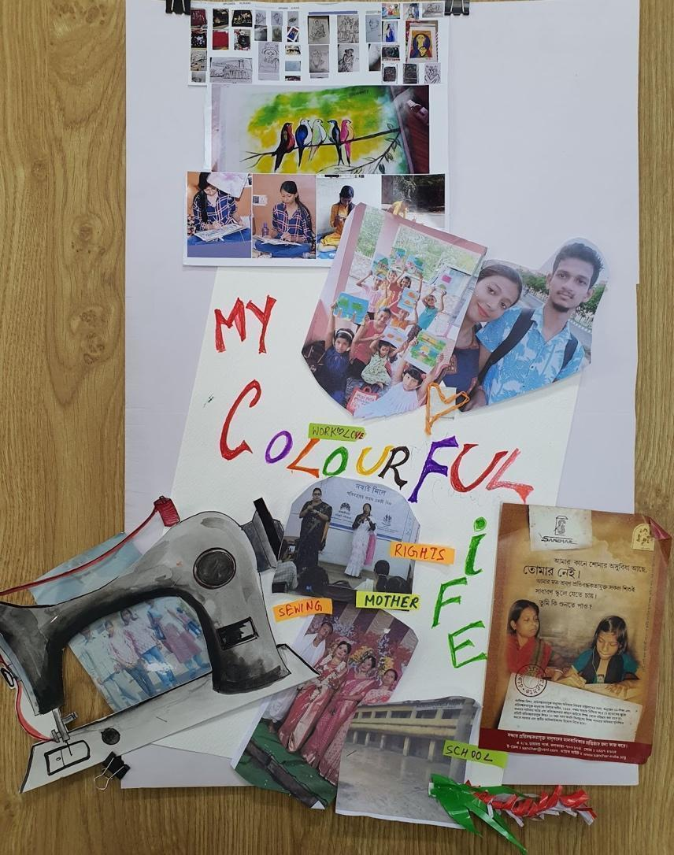
Image description: A white poster board lays on a wooden surface. The words “MY COLOURFUL LIFE” are handwritten in multiple colors in the center and lower half. There are images of a sewing machine, paintings, a teacher and student, and work and social gatherings attached to the posterboard.
While Anika’s narrative of exclusion from education may share some common experiences with other girls and young women with disabilities in the global North and South, her journey to leadership and activism for the educational rights of Deaf girls emerged from a specific space in the state of West Bengal in India where disabled girls and women have experienced multiple forms of marginalities. Ghosh (2020) found that disabled women and girls in West Bengal tend to internalize the social impositions of traditional gender roles and responsibilities that are ideologically enforced upon their bodies, where (able-bodied) girls are trained to fulfill their gendered roles as wife and mother. Thus, the presence of a disability is usually seen as a catastrophe within the family, since the disabled girl is deemed less capable than other girls. Yet, through her art, Anika was able to reconstruct her story, and her experience with exclusion was transformed through activism and teaching. This decolonial space thus enabled her to use her expertise to build her leadership. In fact, she took various initiatives to design her group’s zine and other visual products during the workshops, suggesting that she was empowered to take leadership within the YLC.
Another girl from South Africa, Theresa, actively engaged in various discussions and dance performances. She attends a special school for students with intellectual disabilities in a relatively rural area. She shared stories of being seen as a “naughty girl” throughout her childhood, which caused her to internalize ableist notions. We noticed, for instance, that Theresa sometimes accepted her teachers’ assessment that she needs to be in control of her anger to become a “good” student in school. Ableism is implicated in the ideological assumption that disabled girls’ anger is “bad” and should be under control. Interestingly, when engaging with the girls from other contexts, however, Theresa appeared to push back against this assumption. On various occasions when we met, she became very forceful in her identification of the stigmas and exclusions that girls with disabilities shared in her school, and this reveals her potential to become a self-advocate by refusing to accept ableism as a given. As she provocatively articulated, “Don’t let anyone define you. It’s you who define yourself” (Fieldnote, YLC2023).
These examples testify to the need to reflect on the politics of knowledge – that is, who speaks, whose knowledge counts, and from what locations. Speaking from some specific locations in the global South, the girls and young women with disabilities in the YLC shared some similar experiences with exclusion and societal prejudices. And yet, their stories suggest that the embodied experiences in each of these spaces are distinctive. For example, participants from South Africa saw gender-based violence as the most poignant, such that they chose this issue to articulate their desire for change, whereas the girls and young women in India identified collective struggles for their education, enhancing knowledge, and fostering economic inclusion as the most pressing for their communities. The YLC therefore offered an alternative platform for knowledge sharing that enabled the girls and young women to reflect on ableist assumptions and practices that they had encountered in each of their spaces and to articulate their visions on social change.
Re-imagining girls and young women with disabilities as leaders
Through their participation in the YLC event, these girls and young women demonstrated that they possess the knowledge and experience to tackle issues that are important to them and to build this into their leadership-development efforts. They engaged in activist platforms by expressing their views, identifying their networks, supporting their fellow members, and, in some instances, by inspiring others to become leaders through the sharing of experiences. A woman with disabilities from Vietnam, Tinh Tam, for example, shared her experiences mobilizing various informal spaces for youth with disabilities to engage with one another. Recognizing that young people with disabilities have been multiply marginalized in their communities and associations, Tinh Tam established a club for youth with disabilities in the province, successfully mobilizing 88 youth members to join and to engage in various activities and training programs. As she shared upon her collage making: “What I want to share here is not about being in the best ten or the best one. The message behind it is that if you have a dream, make an effort to make it successful. Turn your thoughts to the actions, thoughts create actions, actions create habits, and the habit will be successful. And I believe that we all have dreams, and we will do it in our own ways” (Collage presentation and storytelling by Tinh Tam, YLC 2023).
Tinh Tam’s commitment for action exposes the need for decolonial praxis that can serve as a way of repositioning young women and girls with disabilities from the global South as capable of becoming leaders in their communities. The young women and girls in this project often expressed their aspirations for building their networks by learning to engage with one another and fostering their collective activism. This counters the individualistic approach to leadership. As Antonio Jimenez-Luque (2021) puts it, while mainstream leadership approaches are characterized by the Eurocentric colonial structures of power that universalize and hegemonize the dominant worldview, decolonial leadership is “the process that aims to decolonize society [by] debunking myths and narratives [of leadership] imposed with the Eurocentric social order” (p. 155). Jimenez-Luque (2021) argues that because subaltern groups’ perspectives have been historically excluded, it is critical to “make visible more distributive and participatory ways of exercising leadership” in ways that empower them to act collectively (p. 155).
We suggest that the YLC creates space for decolonial leadership in an emancipatory process that is informed by subaltern perspectives and politics. It emphasizes the need for relationship building and learning from subaltern group’s learning experiences. For example, in her “leadership roadmap for the future,” Parvati, a young woman with disabilities from India, shared her plan for developing a club of women with disabilities in her own community. Her “roadmap” suggests an aspiration to learn and teach young people with disabilities the skills and knowledge that she had acquired from participating in training workshops (See Figure 2).

Figure 2
“Leadership roadmap for the future,” created by a young woman with disabilities from India, Youth Leadership Circle 2023.

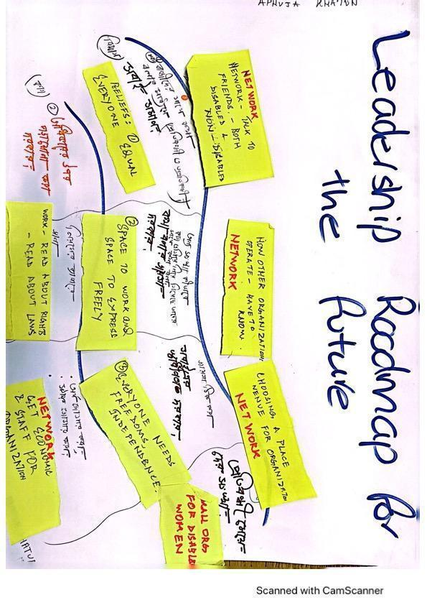

Image description: A white poster board with the words “Leadership Roadmap for the future” handwritten in large letters at the top. A road is drawn across the page with text in Bengali on and below the road. Yellow Post-it notes are attached and provide text in English about networking and disability rights.
Parvati’s leadership ‘roadmap’ reflects her idea of community engagement. For instance, she highlighted the need to be strategic and to talk to disabled and non-disabled friends alike as a way of building her communities. She saw networking as an integral activity, allowing her to strategically support her club for women with disabilities. Alongside networking, she also clearly communicated a desire for knowledge and further learning, including learning how things operate in an organizational structure. And all of her planning was informed by a set of beliefs including “everyone [is] equal,” “everyone needs freedoms and independence,” and everyone needs a “space to work and space to express freely.” This belief system demonstrates her firm values for equal rights for young women and girls with disabilities. Also interestingly, rather than striving to become an individual leader, her community-engaged approach to leadership seeks to be in relation with others to achieve her goal for establishing a club of women with disabilities in her community.
As another example, during the zine-making workshop entitled Bringing about Change, a girl and young woman in India created their stories for change by first identifying barriers that they had encountered, such as difficulty accessing education due to the lack of accessible language. They also discussed difficulties related to accessing healthcare services, since doctors do not have enough time to effectively communicate with them. Through this activity, they visualized particular solutions together and they advocated for constructing their own network by "com[ing] together, learn, and do something new" (Zine production presentation, YLC 2023). As they articulated, "Everybody stands together. These girls are not alone" (Zine production presentation, YLC 2023).
Thus, while the group had different experiences with exclusion based on their disabilities and social locations, these discussions generated some collective stories about exclusion, enabling them to develop advocacy strategies that reflect these experiences. This suggests that such decolonial spaces and opportunities can empower younger women and girls with disabilities to recognize their potential for leadership within their communities. This approach is “decolonial” because it works to unsettle the colonial/modernist and individualistic approach to leadership, which is male- and able-bodied-driven, and which systematically excludes women and disabled young people from engaging in leadership building. In contrast, the participants recognized that collectively, they can strategically build their networks and inspire young, disabled people to think with one another and take collective actions to bring about change.
Our learning from this space also suggests that opportunities for leadership building among these girls and young women with disabilities tend to be uneven. Factors such as class, gender, disability, caste, and social status all play an important role in affecting girls and women with disabilities’ opportunities to engage and sustain relationships with one another. For instance, not all participants in the three project sites were able to travel to the YLC due to limited resources and opportunities. Furthermore, among those who were elected to attend the YLC workshop, not everyone has had the opportunity to take leadership positions in their own schools or communities. Some girls and young women shared that they were relatively isolated from the community in which they live or study. In fact, a workshop participant raised the question about who is privileged to take leadership positions, indicating that some women and girls with disabilities may not have the institutional support and conditions they need to create change (Personal communication, YLC 2023).
As decolonial researchers, we believe that her argument was critical as it can help to unsettle and challenge power dynamics usually ignored in colonial and neoliberal approaches to leadership building. Specifically, it reveals that leadership capacities and opportunities may be conditioned by an individual’s class, race, gender, disability, caste, religion, which result from centuries of colonialism in distinctive spaces in the global South. In the case of leadership building for women and girls with disabilities, we are mindful of the modernist regimes of development, wherein the discourse of leadership tends to be institutionalized as a modern standard which categorizes who fits into the colonial/modernist norms. These colonial implications of leadership, we argue, can be unmasked through a crip narrative of leadership that refuses to conform to the modernist standards that define who can be a leader and what leadership should look like. A crip narrative challenges dominant narratives about leadership, and instead, recognizes the power relationships among the girls and young women with disabilities within their specific spaces. We believe that, while the YLC is still far from being fully accessible, it is an example of decolonial praxis that is crucial for connecting girls and young women with disabilities in the South and for redefining understandings of leadership, while simultaneously building knowledge and sharing their stories (which have yet to heard within the North American disability justice movement). And, by creating spaces for disrupting the normative assumptions about leadership as male, able-bodied, and global North-driven, our research with girls and young women with disabilities creates possibilities for collective organizing and theorizing about decolonial leadership from the lens of young women and girls with disabilities in Southern spaces.
Further reflections on our learning experiences
We acknowledge, with caution, that our reflections herein are a discourse of knowledge in the making – something that cannot be universalized or assumed to be the only form of knowledge that represents the perspectives of girls and young women with disabilities from the global South. As Mignolo and Walsh (2018) remind us, taking such a universalizing approach would simply reproduce coloniality. Indeed, our ongoing learning experiences were often filled with tensions, debates, and sometimes frustration and incompletion. As researchers engaging in disability studies from the global South as a part of broader epistemic struggles (Nguyen, 2023), we are cognizant of, and sometimes frustrated about, the colonial structures within which we function. Moosavi (2020) argues that global North scholars need to “recognise how we are privileged by coloniality and even implicated in its enduring structures of inequality” (p. 333), and so we grappled with navigating through this (de)colonial process with a critical reflexivity on our privileged position. The resulting epistemic and political discord evoked “crip feelings” (Chen et al., 2023, p. 2) – the recognition that coloniality has continued to morph into decolonial research in ways that impact our feelings and embodiment, such that it is entangled within the colonial and ableist regimes of Western academic institutions and operates through issues such as funding, resources, and power relations. And yet, through our positionings and experiences across these spaces, we found that the YLC provided us with an opportunity to work towards epistemic justice by centering knowledge, perspectives, and praxis from the global South, recognizing our privileges in research relations, and examining how this may impact our efforts to build relationships with participants.
Furthermore, through our organizing experiences we learned that individuals have different timeframes when processing things such as language and expressing ideas. For example, our Deaf participant experienced language at different paces and modalities because her communication required different processes of interpretation between Bengali, Indian Sign Language, and English. As such, we must cater for diverse access requirements, rather than “bend[ing] disabled bodies and minds to meet the clock" (Kafer, 2013, p. 27). Crip time thus helps us to reshape our understanding of time, orienting it towards diverse abilities and the needs of disabled individuals, and becoming conscious of, and resistant against, the colonial/neoliberal regimes which circumscribe our crip experiences. And, as Ellen Samuels and Elizabeth Freeman (2021) argue, “Even as crip time is a space of frustration and often of loss, then, it is also a space that offers new kinds of connections and presence that are fundamental to imagining a new world into being” (p. 250).
Conclusion
At the core of decoloniality is the agenda of shifting the geography and biography of knowledge, bringing identity into epistemology – who generates knowledge and from where? Decoloniality’s point of departure is existential realities of suffering, oppression, repression, domination, and exclusion (Ndlovu-Gatsheni, 2015, p. 492).
An important goal of decolonial theory and praxis is, as Ndlovu-Gatsheni observes, to shift the locus of enunciation in relation to its epistemological vantage point from the Euro-North American centric as the epistemic locale from which the world is described to the “ex-colonized epistemic sites as legitimate points of departure” (p. 489). This intellectual project does not merely involve theory from the global South (e.g., Connell, 2007). Rather, it emerges from praxis that exposes the ways in which the coloniality of power has sustained modernity and it creates tools for re-imagining a different side of humanity.
The development of the YLC offers a unique way of learning with and from the global South. This transnational praxis, implemented through different learning platforms such as Zoom meetings and transnational engagements among girls and young women with disabilities, creates several opportunities for researchers to reconsider different possibilities for knowledge construction with these girls and women. By supporting them to see themselves as young leaders with valued experiences and insight, the YLC becomes a space of knowledge generation and transnational activism that unsettles the global North’s assumptions about women and girls with disabilities in the global South. Instead, what we have seen in the YLC is a range of potentialities for re-imagining the spaces in which decolonial knowledge can be constructed, learned, and shared among disabled girls and women, as well as with their networks and broader communities.

References
Alvarado Garcia, A. et al. (2021, May). Decolonial pathways: Our manifesto for a decolonizing agenda in HIC research and design. In Extended Abstracts of the 2021 CHI Conference on Human Factors in Computing Systems (pp. 1-9), Yokohama, Japan.
Connell, R. (2007). Southern theory: The global dynamics of knowledge in social science. Polity.
Chen, M. Y., Kafer, A., Kim, E., & Avril Minich, J. (2023). Crip Genealogies (p. 380). Duke University Press.
Dados, N., & Connell, R. (2012). Global South. Contexts, 11(1), 12-13. https://journals.sagepub.com/doi/10.1177/1536504212436479
De Sousa Santos, B. (2018). The end of the cognitive empire: The coming of age of epistemologies of the South. Duke University Press.
Ghosh, N. (2020). Bhalo Meye: Cultural construction of gender and disability in Bengal. In Disability Studies in India (pp. 201-219). Routledge India.
Grech, S. (2015). Decolonising Eurocentric disability studies: Why colonialism matters in the disability and global South debate. Social Identities, 21(1), 6-2.
Howell, C., Lorenzo, T., & Sompeta-Gcaza, S. (2019). Reimagining personal and collective experiences of disability in Africa. Disability and the Global South, 6(2), 1719-1735.
Jimenez-Luque, A. (2021). Decolonial leadership for cultural resistance and social change: Challenging the social order through the struggle of identity. Leadership, 17(2), 154-172.
Kafer, A. (2013). Feminist, queer, crip. Bloomington: Indiana University Press.
Maldonado-Torres, N. (2007). On the coloniality of being: Contributions to the development of a concept. Cultural studies, 21(2-3), 240-270.
McAdam, D., McCarthy, J. D., & Zald, M. N. (1996). Comparative perspectives on social movements: Political opportunities, mobilizing structures, and cultural framings: Cambridge University Press.
Menon, D. M. (Ed.). (2022). Changing theory: Concepts from the Global South. Wits University Press.
Mignolo, W. D. (2011). Geopolitics of sensing and knowing: On (de) coloniality, border thinking and epistemic disobedience. Postcolonial studies, 14(3), 273-283.
Moosavi, L. (2020). The decolonial bandwagon and the dangers of intellectual decolonisation. International Review of Sociology, 30(2), 332-354.
Murillo Lafuente, E. M., & Sherry, M. (2021). Disability in Bolivia: A feminist Global South perspective. In C. Figueroa & D. I. Hernández-Saca (Eds.), Dis/ability in the Americas: The Intersections of Education, Power, and Identity (pp. 135-166). Palgrave MacMillan.
Ndlovu‐Gatsheni, S. J. (2015). Decoloniality as the future of Africa. History Compass, 13(10), 485-496.
Neilson, A. (2017). The socio-political importance of blackouts in South Africa. Social Space (Przestrz. Społeczna), 13, 79-93. http://socialspacejournal-archive.eu/pliki/13/Social%20Space%20Journal%2012017(13).pdf#page=79
Nguyen, X. T., & Johnson, P. (2017). Transnational conversations in the context of disability rights: Building the potential for global activism. Third World Thematics: A TWQ Journal, 1(3), 396-410.
Nguyen, X. T. (2023). Decolonial disability studies. In Mill, M., & R. Sanchez (Eds). Crip authorship. New York University Press.
Nxumalo, F., & Tuck, E. (2023). Creating openings for co-theorizing. Qualitative Inquiry, 29(1), 137-146.
Puar, J. K. (2023). Critical Disability Studies and the question of Palestine: Toward decolonizing disability In M. Y. Chen, A. Kafer, E. Kim, & J. A. Minich (Eds.), Crip genealogies (pp. 117-134). Duke University Press.
Quijano, A. (2000). Coloniality of power and Eurocentrism in Latin America. International sociology, 15(2), 215-232.
Samuels, E., & Freeman, E. (2021). Introduction: crip temporalities. South Atlantic Quarterly, 120(2), 245-254.
Stienstra, D., & Nguyen, X. T. (2020). Opening to the Possible: Girls and Women with Disabilities Engaging in Vietnam. In S. M. Wiebe & L. Levac (Eds.), Creating spaces for engagement (pp. 139-160). University of Toronto Press.
Swartz, L. (2018). Representing disability and development in the Global South. Medical Humanities, 44(4), 281-284.
UNFPA & WEI. (November 2018). Women and young persons with disabilities: Guidelines for providing rights-based and gender-responsive services to address gender-based violence and sexual and reproductive health and rights. https://www.unfpa.org/sites/default/files/pub-pdf/UNFPA-WEI_Guidelines_Disability_GBV_SRHR_FINAL_19-11-18_0.pdf
Vanner, C., Lucotti, M. E., Khan, F., Lamb, P., Mitchell, C., Nyariro, M., ... & Sadati, H. (2019). Creating circles: A handbook on art-making with young people to address gender-based violence. Montreal: Participatory Cultures Lab, McGill University.

In this article, we use pseudonyms to ensure participants’ anonymity. Organizing the Youth Leadership Circle: Lessons Learned across Southern Spaces by Xuan Thuy Nguyen, Thi Xuan Nhi Truong, Dana Corfield https://rdsjournal.org/index.php/journal/article/view/1305 is licensed under a Creative Commons Attribution 4.0 International License. Based on a work at https://rdsjournal.org.

