Inclusive Education in China:
From Policy to Implementation to On the Ground Experiences
Helen McCabe¹ and Tian Jiang²
¹Education Department, Daemen University
²Warner School of Education, University of Rochester

Author Note
Helen McCabe, PhD, BCBA is an Associate Professor of Education at Daemen University. She has conducted research as well as provided training and support to teachers and families of children with autism in China for over 20 years.
Tian Jiang, MS, BCBA is a doctoral candidate at the Warner School of Education and Human Development, University of Rochester. Jiang’s work involves training teachers and parents on implementing ABA-based strategies, and advising policymakers on creating initiatives which suit the Chinese context.
Correspondence for this article should be addressed to: Helen McCabe, Education Department, Daemen University, Amherst, NY 14226 hmccabe@daemen.edu 716-839-8201
Helen McCabe: https://orcid.org/0000-0001-5692-186X Tian Jiang: https://orcid.org/0000-0003-0616-0921

Abstract
Inclusive education rights in China are increasing, yet gaps remain between policy and practice. Increasing access to inclusion (suiban jiudu) is important. To understand policy implementation, this qualitative study examined how families experience the schooling of their children with disabilities. Results demonstrate that children’s rights to inclusive education are recognized, though a stronger support system is still needed.
Keywords: inclusion, inclusive education, policy, China

Inclusive Education in China: From Policy to Implementation to
On the Ground Experiences
Commitment to the right to inclusive education in China has increased in policy and practice over the past few decades. Many scholars reference the Salamanca statement, which stated that children should have access to inclusive education with accommodations (UNESCO, 1994), as an important origin of this work in China (Du & Feng, 2019). Moreover, since China signed the Convention on the Rights of Persons with Disabilities (CRPD) in 2008, despite ongoing limitations, disability policy has evolved and increasingly positively impacts inclusion and disability rights (Zhao & Zhang, 2018).
Despite increasing calls for equal educational opportunity and for promoting rights to inclusive education (Zheng at al., 2019), there remains a gap between policy and the realization of rights (Xu, 2020). School enrollment rates remain low, with 69% of school-age children with disabilities enrolled in school in 2017 (China Daily, 2018). Increasing access to general education has long been an important channel to expand school enrollment in China, in the form of suiban jiudu (Huang & Wu, 2021; Xu, 2020; Zhu & Wang, 2011).
Suiban jiudu has been translated as “Learning in Regular Class” (LRC), meaning educated in the same class as typically developing peers (Su et al., 2018). Suiban jiudu was first mentioned in government documents in 1987, followed by the 1994 Trial Measures for Carrying Out Suiban Jiudu for Children and Adolescents with Disabilities (1994 Trial Measures) (Huang & Wu, 2021; National Education Committee, 1994). By 2016, about half of students with disabilities who were in school were educated in special education settings, and half were in general education settings through suiban jiudu (Guo & Deng, 2021; Yin, 2016). (In this article, suiban jiudu is used when referring specifically to practices in China, and inclusion is used when referring broadly, or when it is specifically used in policy).
Current policy emphasizes increasing the enrollment of students with disabilities in general education settings (yingsui jinsui) (Guo & Deng, 2021; MOE, 2020). Yet policies also limit inclusion, because many policies state that only children with the ability to adapt to general education settings may attend (Xu, 2020; National People’s Congress, 2006; 2008; State Council, 1994). Moreover, the language is vague, with no standard criteria for what “ability to adapt” means.
This article examines how inclusive education policies are implemented in China, as demonstrated by how families experience the schooling of their children with autism spectrum disorder (ASD) and other developmental disabilities. Research questions include: How have parents experienced the process of seeking, securing, and maintaining educational opportunities for their children, particularly in general education settings? How do their experiences confirm or differ from what is recommended by policies?
Literature Review
In order to analyze participant experiences with inclusion within the policy context, literature and policies related to special education and inclusive education/suiban jiudu were reviewed, including an overview of suiban jiudu, examination of the rights provided by policies, and analysis of policy limitations.
Suiban jiudu and Inclusive Education in China
Suiban jiudu is the practice of educating students with disabilities in general education classrooms, integrating two separate systems of special education and general education (Xiao, 2005). It has been described as a localized model of inclusion, combining inclusive education practices in other countries with the local Chinese context (Guo & Deng, 2021; Huang & Wu, 2021; Xu & Jia, 2020). The term ronghe jiaoyu, inclusive education, has been used recently in policy documents. For example, the Action Plan for the Development and Improvement of Special Education in the 14th Five-Year Plan (2021 Action Plan) calls for exploring models of inclusive education and better integrating general and special education for more effective and equal educational opportunity (State Council, 2021).
Rights to Education in Policy
Several laws and policies in China provide important foundations for the right to inclusive education (See Table 1). The 1986 Compulsory Education Law, the 1990 Law on Protection of Persons with Disabilities (Protection Law) (National People’s Congress, 1986; 1990), and the 1994 Regulations on Education for Persons with Disabilities (State Council, 1994) all called for the right to nine years of compulsory education. Regarding inclusive
education, the Protection Law and 1994 Regulations both indicated a continuum of options, with children to be placed in general or special education classes based on their disability category and “learning receptiveness.” The 1994 Regulations mentioned suiban jiudu in general education, special education classes at general education schools, and special education schools (National People’s Congress, 1990; State Council, 1994).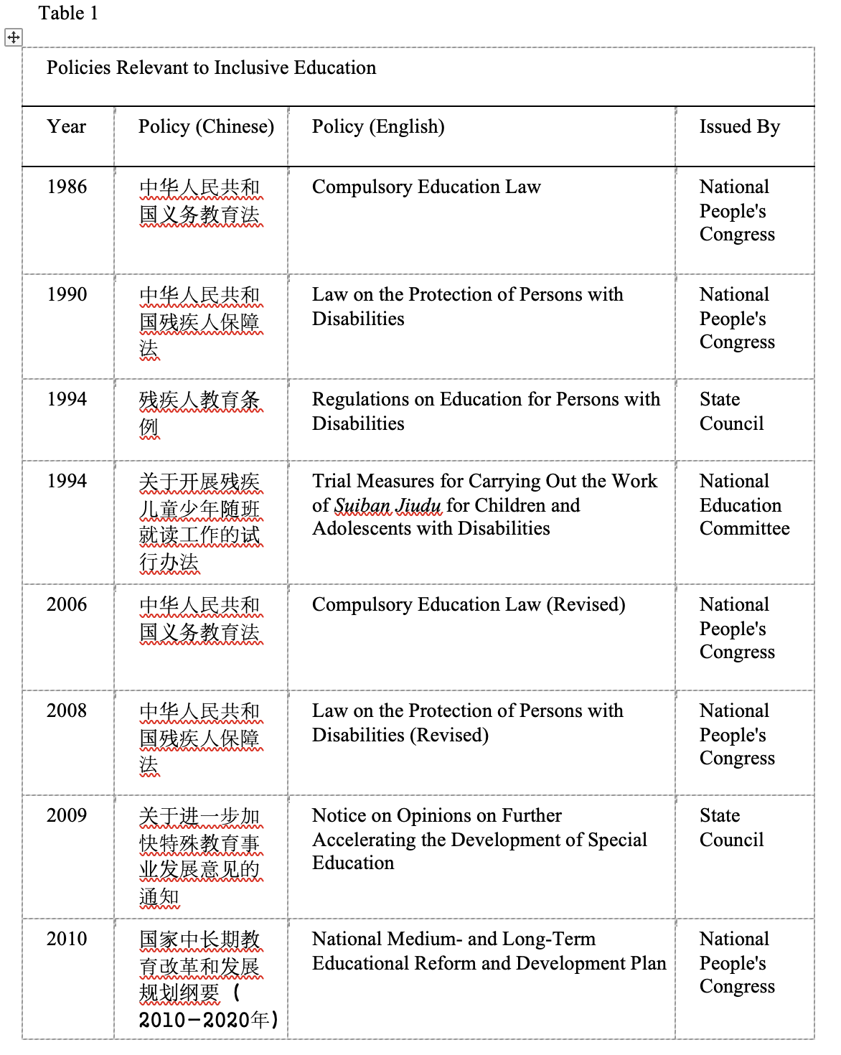
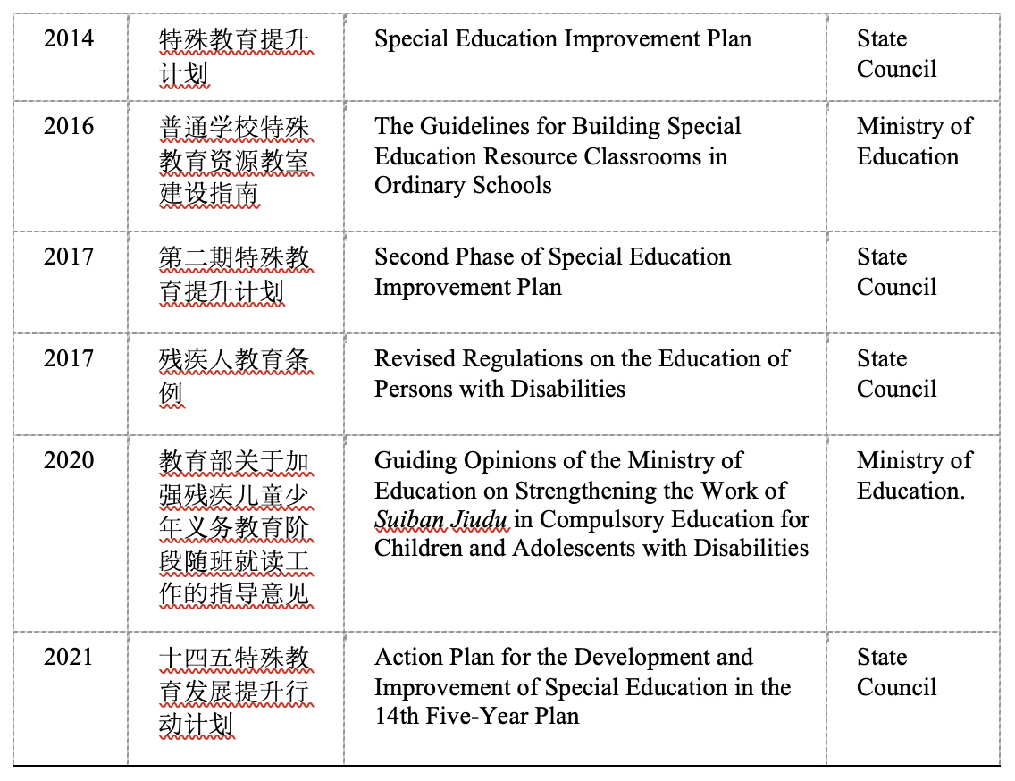
The revisions of the Compulsory Education Law and the Protection Law continue to state that children and adolescents with disabilities have the right to education, including at general education schools for some (National People’s Congress, 2006, 2008). The Revised Regulations on Education for Persons with Disabilities in 2017 called for promoting inclusive education (ronghe jiaoyu) in general education as the main channel of instruction (State Council, 2017b; Yang, 2022; Xu & Jia, 2020). Zhao and Zhang (2018) note that these education regulations moved closer to the ideals of equal opportunity and inclusion. Updated laws and regulations state that schools cannot refuse school-age children “who have the ability to receive general education and suiban jiudu” (National People’s Congress, 2006, 2008; State Council, 2017b).
Three Action Plans for the Development and Improvement of Special Education (State Council, 2014, 2017a, 2021) also promote school acceptance. The First Action Plan called for expanding the scope of compulsory education through suiban jiudu and resource rooms, as well as special schools and home-based education for children with significant disabilities. At the conference of the Second Action Plan, the “zero reject” principle was emphasized, with local education authorities called on to enroll every student with disabilities. This did not mean placement in inclusive education, but rather individualizing placements according to “one person, one case,” including a continuum of services from home-based to general education. This plan promoted suiban jiudu in nearby schools as the priority placement for children with disabilities (Li, 2017; State Council, 2017a). Currently, the third Action Plan continues to promote school enrollment, inclusion, and differentiation of instruction (Ding, 2021; State Council, 2021). In addition, an inclusion-relevant concept, yingsui jinsui (for those who should suiban jiudu, promote it as much as possible), was noted in the 2020 Guiding Opinions of the Ministry of Education on Strengthening the Work of Suiban Jiudu in Compulsory Education for Children and Adolescents with Disabilities, to increase the enrollment and quality of suiban jiudu instruction (Ding, 2021; Huang & Wu, 2021; MOE, 2020).
Support Systems and Role of Special Education Schools
A strong and effective inclusive education system requires support systems. Provision of support for students with disabilities in general education in China is included in many policy documents. The 1994 Regulations noted that assistance should be provided in general education settings according to student needs and, when possible, schools could provide individualized instruction or “tutorial classrooms” (State Council, 1994). The 1994 Trial Measures suggested tutorial rooms, staffed with part- or full-time tutoring teachers with special education training, to work with students and assist general education class teachers in individual planning and assessment (National Education Committee, 1994).
Special education schools and resource classrooms are currently both important sources of support for suiban jiudu in China (Yang, 2022). The function of special schools is shifting to comprehensive support services, including overseeing suiban jiudu and resource rooms (Huang & Wu, 2021; MOE, 2016; Xia & Xu, 2017). Special education schoolteachers are called on to periodically serve general education schools as itinerant teachers, provide training and consultation, and support students receiving home-based education (State Council, 2009, 2017b). In the National Medium- and Long-Term Educational Reform and Development Plan (2010-2020), in addition to a goal of providing special education schools in all localities with over 300,000 people, there was also a goal to grow the scale of suiban jiudu and special classes, in order to increase compulsory education enrollment (State Council, 2010; Xu & Jia, 2020; Zhu & Wang, 2011).
Qualified staffing is essential for effective support in inclusive education, and the Revised Regulations on the Education of Persons with Disabilities (Revised Regulations) call for staffing resource rooms with teachers who have special education backgrounds (State Council, 2017b). The Second Action Plan calls on local authorities to hire specialized resource teachers for students with disabilities (State Council, 2017a; Zhang & Lu, 2020), specifically including "public institution tenure track" (bianzhi) teachers and professionals (Ding, 2021), which is very important and encouraging.
All three Action Plans (State Council, 2014, 2017a, and 2021) expanded the number of children obtaining compulsory education (Xu & Jia, 2020; Liang et al., 2015) and provided guidance on improving support for inclusion (Yang, 2022; Yin, 2016) including the promotion of resource rooms and resource centers. While this is promising, the Guidelines for Building Special Education Resource Classrooms in Schools also addressed problems including shortage of resource teachers and ineffective resource classrooms (Huang & Wu, 2021; MOE, 2016).
Policy Limitations on Inclusive Education Rights
While policy context since the 1980s has demonstrated a commitment to rights to educational opportunities and inclusive education, beginning in the mid-1980s there has been a phrase in policy documents indicating restrictions on access to suiban jiudu. Many policies state that children with disabilities may be included in general education classes if they have the ability to do so (e.g., National People’s Congress, 1986, 1990, 2006, 2008; State Council, 1994, 2017b). The Compulsory Education Law states that schools “shall accept school-age children and adolescents with disabilities who are able to receive ordinary education, to suiban jiudu,” and notes that failing to do so would be corrected or sanctioned (National People's Congress, 1986; 2006). The 1990 and Revised Protection Law and the 1994 and Revised Regulations use similar language, including requiring that children are able to “adapt to the study and life” of general education elementary and middle schools (National People’s Congress, 1990, 2008; State Council, 1994; 2017b).
Both rights and restrictions for individuals with significant disabilities in particular are also noted in the First Action Plan and the Revised Regulations. These policies describe home-based education for students with severe disabilities “who need special care and are unable to attend school” (State Council, 2014, 2017b). This fits with global practices of a continuum of services for students with disabilities, from less to more restrictive. However, determining a child’s ability to learn and adapt in school “according to type of disability, degree of disability… school-running conditions and other factors” (State Council, 2017b) leads to decisions based on categories and local resources, and not on individual needs.
Another potential restriction in policy language is in the 2020 Guiding Opinions of the Ministry of Education on Strengthening the Work of Suiban Jiudu in Compulsory Education for Children and Adolescents with Disabilities, which calls for expanding suiban jiudu opportunities to all who should be included (yingsui jinsui) (MOE, 2020). Although policies related to disability and education demonstrate increasing recognition of inclusive educational opportunities, the concept of yingsui jinsui is vague about who “should” be included, and the term “sui” (follow) indicates a hierarchical division between students with and without disabilities. In suiban jiudu practice, children with disabilities attend general education classrooms but, while some have school status (xueji) there, others have their school status at the local special education school. Thus, suiban jiudu implies a hierarchy, where typically developing students are full members of the class while others are “following along” with the class (Guo & Deng, 2021).
Regional Development and Policy Language
Uneven regional development of opportunities results from practical differences based on context and vague policy language. Vague language means “the right to inclusive education is a ‘can’ instead of a ‘must’” linked partly to limited resources (Zhao & Zhang, 2018, p. 134). Regarding contextual differences, the third Action Plan notes that development follows regional economic and population differences (State Council, 2021). Vague national policy is followed by regional implementation documents, which inevitably differ, and may overlook some policy goals (Ren & Wang, 2020). Of course, needs differ across regions, and implementation guidelines are not precise. More practical and implementable policies are needed (Fang, 2019; Xia & Xu, 2017).
Policies, Institutions and Human Experiences
Recent policies make clear that more attention is being paid to the rights to education for children with disabilities, including to attend both special and general education settings. An understanding of the lives of people impacted by those policies can provide a snapshot of how policies are being implemented, in the context of the boundaries, limitations and strengths of local educational institutions. We took a unique approach here by focusing mainly on policy documents themselves for the literature review, in order to then consider families’ experiences with their children’s schooling as on the ground outcomes of these relevant policies.
Methodology
Part of a larger study targeting teachers and parents, this qualitative study examined 11 parents’ experiences with inclusive education for their children with ASD and other developmental disabilities. Specifically, we examined discourse surrounding access, opportunities, and challenges in inclusive education. Qualitative research “generate[s] knowledge grounded in human experience (Sandelowski, 2004)” (cited in Nowell et al., 2017, p. 1) which was appropriate for the focus of this study. Qualitative research design included open-ended semi-structured interviews conducted via WeChat.
Participants, Recruitment, and Interview Protocol
A Qualtrics survey was posted in WeChat parent and teacher groups that the first author belongs to, and on that author’s “moments” WeChat page. Participant criteria included being a parent of a child with ASD or other developmental disabilities who attended general education schooling at the elementary school level. Initially, 56 people with complete contact information responded and 11 parents met the criteria. Nine parents had children with ASD, and two parents had children with other developmental disabilities. (See Table 2)
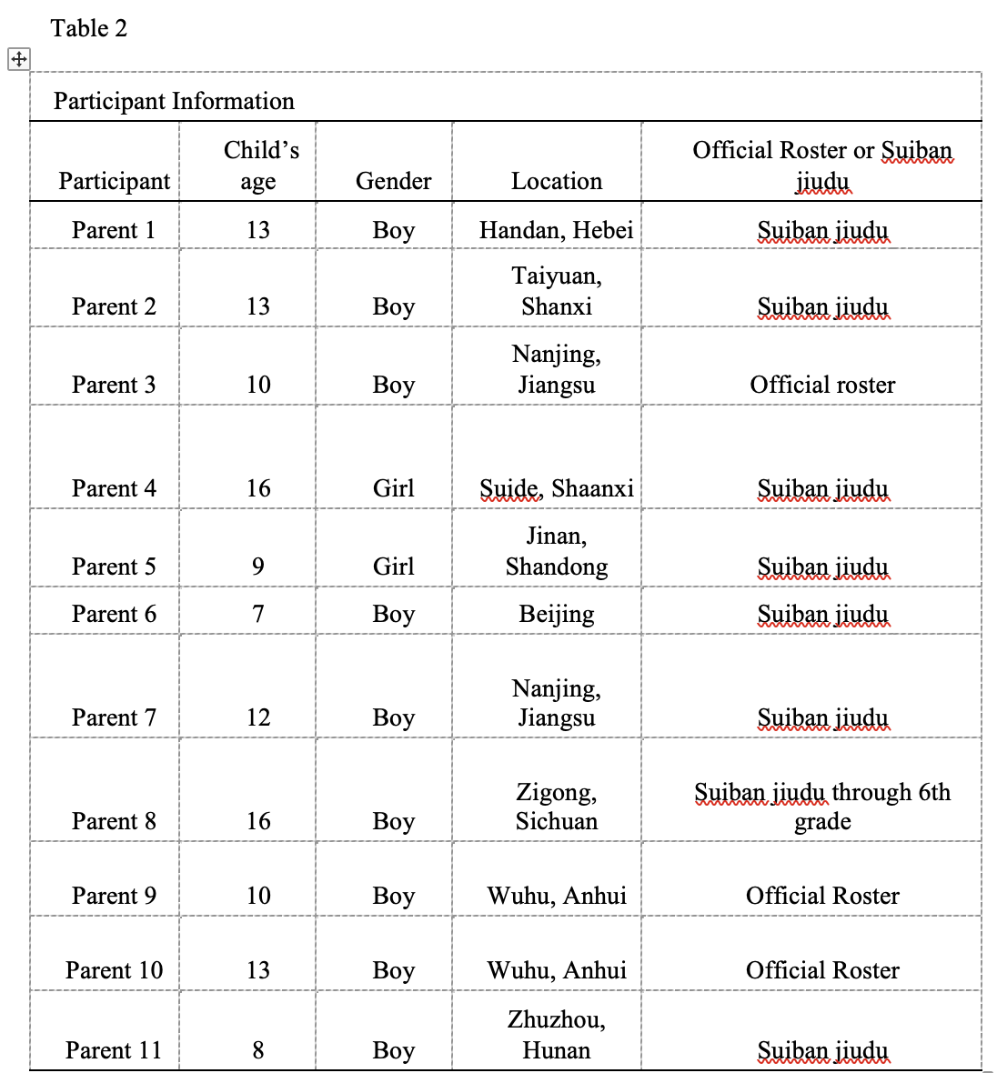
Regarding inclusive education and access to education, sample interview protocol questions included: What was the process of gaining access to your child’s school? Share your experience in interacting with school administrators and teachers. What supports are provided for your child in the classroom/school? All interviews lasted approximately one hour and were conducted in Mandarin Chinese, the native language of participants, by the first author.
Data Analysis
After transcribing all interviews, they were translated into English for analysis. Thematic analysis used an inductive approach, generating codes and examining emerging themes (Braun & Clarke, 2006). Analysis of the codes used the constant comparative approach (Glaser & Strauss, 1967; Miles & Huberman 1994). Some codes included “process of getting into school,” “barriers to inclusive education,” and “perspective on educational placement.” Both authors transcribed, translated, and reviewed the data. Specifically, through an iterative process of conducting interviews, coding, defining, reviewing and refining themes (Braun & Clarke, 2006; Lincoln & Guba, 1985; Nowell et al., 2017), themes emerged to explain the phenomenon of gaining access to, and experiences in, inclusive education.
Results
The increasing focus on suiban jiudu and inclusive education in educational policy in China is promising. Despite limiting language, rights to education for children with disabilities are mentioned directly in important laws and regulations. Here we present a snapshot of families’ experiences of policy implementation on the ground, through listening to the voices of parents of children with disabilities. Themes from data analysis include recognizing children’s rights to education; the need to demonstrate ability and qualifications, and a subtheme of gaps in support systems; and concern for the impact on the teacher and the school.
Recognizing Children’s Rights: Rights to Education in General Education
Many of the participants discussed and recognized that their children had rights to education under current policies. However, they had a range of experiences that demonstrated regional variations and varied impacts of policies. For example, Parent 11 explained:
It’s not easy finding a school that can accept him. Public schools have to admit children, but admitting and accepting are different, and requires cooperation with schools and teachers.… It’s difficult for a child like him to truly integrate into the environment. There’s basically no inclusive education; it’s stuck at the policy level.
“Stuck at the policy level” indicates the challenges that schools face when they do not have the support systems in place to effectively teach a student with autism. For example, Parent 5 also noted that, though the Action Plans call for support systems like resource classrooms and teachers, “but now we basically don’t have any.” Though most participants were aware of educational policies, they remained worried: “When we went to elementary school, we were always worried about being rejected by the school” (Parent 3).
Despite hesitation and institutional limitations, participants’ experiences demonstrate that schools recognize children’s rights to education, including in general education. When Parent 6 registered her son for school, she said, “I knew the school couldn’t refuse him … in developed areas like Beijing and Shanghai, at least physically, it should be well implemented. In other words, the school may not want to admit a child, but the child must be admitted.” Parent 6 further explained, “Now the country also has laws and regulations, and ‘zero reject’.… My household registration is here, so … the school cannot refuse him.” Similarly, two other children were easily accepted by their local schools. Parent 9 recalled, “The teacher found out he has Asperger’s … [though she was unsure] she didn’t say he can’t come. They let him come to school … they didn’t say … he can’t adapt to this (environment) ... and thus reject him, it didn’t happen.” Even in middle school, Parent 7 said, “The country has a policy. Now, the middle school can’t reject you, they have to accept you. We can attend a nearby middle school.”
Parents in multiple cities reported experiences of schools that hesitated but did not reject their children. Parent 7 explained, “For us to enter general education school wasn’t easy…. China hadn’t … said [schools] must accept unconditionally.” Parents worked with schools to find solutions, including parents accompanying children to school (peidu) and signing responsibility waivers. For example:
Because our home is in this district, we signed up for this school ... it’s just according to where you live. If you meet those conditions, you can sign up and attend ... [but he was very disruptive and they called us in after the first day] ... the teacher’s meaning was, they don’t want this child, they were rejecting him. But after all, we’re from the area, and now inclusive education has begun, it’s being promoted. It’s called ‘zero reject’. And we parents persisted, we wanted to stay here, we’ll figure out a way, whatever problems exist … if something happens, we parents are responsible, that is, it has nothing to do with the school. So we signed the guarantee letter (Parent 2).
Given the logistical challenges faced by schools in implementing inclusion, even given the recognition of and desire to provide those rights, one strategy used by several parents to convince hesitant schools was through connections. Parent 4 explained, “The principal knew we came here after attending another school and didn’t want to accept her.” Though she was rejected by several teachers, her relative was a teacher there, so she transferred to the relative’s class, following the relative “up and down grade levels.” Parent 1’s son also gained access to general education through family connections at school. Parent 2 noted that being from a smaller town was helpful; they “found an acquaintance to go with us to sit at the principal’s house” and then kept building a good relationship with the teacher, which helped the teacher to be understanding and the process to be smoother. Parent 8 recalled:
I told the teacher when he was in the first grade [he has autism], because…if I don't say it, the teacher will find out. When I told them, at first, they didn’t want to admit him. They were afraid, what if problems come up…? So we asked friends, and used connections to talk to the principal. That’s how we were admitted.
Reaching out personally was often helpful in seeking access to school and, in one case, parents pleaded their case to other parents for an equal right to education. Parent 9 shared that, after her child demonstrated challenging behavior one day, “The next day many parents’ response … was [to write in a group WeChat] about not letting him attend school.” She and her husband responded in the group, writing, “Every child has the right to nine years of compulsory education…. If as parents you don't have your child … attend school near your home, that’s against the law. It’s his right, you’re depriving him of his rights.” Then, the other parents stopped complaining and trying to kick him out.
Parents noted both the right to education, and the need to be qualified: “At age 7, I didn’t delay his starting school, because I think he’s a person in society, he should keep up with society’s rhythm. His ability is insufficient, so I definitely chose to accompany him (peidu).” Parent 5 also recommended letting the school know one’s child’s strengths. When enrolling her daughter for suiban jiudu, she told them about her child’s disability, and, “…never did they say they would reject us … I think parents should be fully prepared. Our child may have insufficient abilities, but we also highlight her strengths…. Let them know she has a certain learning ability first.” The teacher was understanding, and the principal admitted them to suiban jiudu as soon as they got the hospital disability certification.
Demonstrating Ability and Qualifications
In practice, results demonstrate that the right to attend general education was not seen as a given. Parent 5, while pleased with her school’s accepting her child, did not interpret policies to mean that everyone should be accepted in general education: “Some parents feel that since it’s compulsory education, a school must accept me. I have never felt there’s any ‘must’... if your child cannot adapt to the environment, nobody said they have to accept you.” Her child was quiet and followed teacher instructions, positively impacting her admission. Similarly, Parent 7 explained “China hasn’t … said you must accept unconditionally. When you enter school there’s an interview, and if a child has some abilities that aren’t good, they will recommend that you attend a special school.” This understanding echoes policies, many of which clearly state that, in order to be accepted for suiban jiudu, students must demonstrate receptivity to general education, including the ability to adapt to school. Parent 7 shared, “Actually, it’s not easy to get into regular school. The problems faced by my child to get into general education school were quite numerous, because of the expectations of a child’s abilities.”
Many parents mentioned enrollment interviews that were used to demonstrate qualifications for admission. Parent 9 recalled, “For the enrollment interview he passed everything. Plus during the interview they didn’t find anything different about him so we didn’t worry that he wouldn’t be able to be enrolled, and we didn’t talk to the teacher about [the child’s disability] in advance.” Some delayed the interview and enrollment, including Parent 2:
...because at the time I felt he had a lot of deficiencies, so we delayed a year. After delaying a year, we registered. He passed the interview, and that afternoon we were very happy, but on the first day they discovered his problems. Originally, I felt he had improved, and that we could hide (his disability).
Similarly, Parent 1 delayed enrolling her son in school until age 10, because “He didn’t have the ability to attend school at age 7 … even if I accompanied him.” By age 10, he had gained motor and behavioral skills, but several schools rejected him due to safety concerns. Finally, through connections they found a school. Regarding the child’s school status, Parent 1 explained, “We talked about the issue of setting up his school status” and then her son was registered as a suiban jiudu student with school status at the local special education school.
Interview data showed that, even if a student enrolls under suiban jiudu status, they must perform at a certain level in class. Thus, for students with more significant behavioral or learning needs, “if the family doesn’t have anyone appropriate to accompany (peidu) … attending school [general education] is difficult, so what can you do? The child must attend special school. In other words, [government policy] gives you the opportunity to attend school, but if you can’t adjust to the school’s atmosphere, then you must attend a special school” (Parent 7). Parent 3 said, “We worried about being rejected because, before us, many children like this were rejected by general schools because children need an interview before going to school. When the teacher sees you have a problem, many schools refuse to accept you.” In her situation, her child did not pass the interview but was still allowed to attend at first; when he had difficulties the first day, “The teacher called me…and said they needed me to accompany him [peidu].”
Lack of Support in General Education
Related to the need to be qualified was the reality that general education settings experienced by the participants in this study lacked the support needed by students with disabilities. Given this issue, when considering the results, it is important to remember that institutional limitations on the ground, in addition to policy, are factors impacting families’ experiences. Many parents accompanied their children in school [peidu] for all or some of their schooling, because they needed individual classroom support. Parent 7 explained that, although her city had policies against schools rejecting children with disabilities,
They accept these children, but there’s not enough support provided. Although there are some resource rooms, and peidu teachers, that's for very few students. The majority [of support] is still parents or someone hired by parents. The country doesn’t provide resources like this.... In China, in terms of resources, it’s still not enough. So we have this slogan, and this model, but actual implementation isn’t solid yet.”
Thus, she said, for many children with disabilities, if a family “can’t find someone to go with them, they must attend special school.”
Regarding policies and the related school support, Parent 6 reflected that regulations are clear now, but “everything has just begun, the school doesn’t know what to do…. There are more than 40 people in a class and one head teacher…. So it’s impossible for teachers to have extra energy to take care of our children. Not to mention they lack technical and professional support.” This parent researched local regulations and found that special education schools in her city had resource centers “to support suiban jiudu students” and successfully advocated for a resource teacher to go to her son’s school twice a week for two hours to provide individual classes for him.
While Parent 6 found support from a resource center in Beijing, due to her knowledge of the law and advocacy efforts, and being located in a major urban center, others had less support. Parent 9 commented, “I really need special education support, but this school isn’t equipped with [that]. It’s just a typical classroom and teaching. So my child cannot keep up with the group … so I’m thinking if there were a special education teacher, how great that would be!” Without support, she continued, “this kind of environment is also wasting his time” (Parent 9). Because of this lack of professional support, Parent 10 focused on her child’s progress compared to himself, rather than keeping up with the class, because in her own understanding and experience, “there’s no resource classroom in China.”
Suiban Jiudu Decisions: Considering the Impact on Class and Teachers
Most parents noted that their children could not keep up in class and they worried about teachers’ and administrators’ attitudes. This concern was because low grades would lower the class average, thus impacting teachers, whose evaluation is tied to student performance (Liu & Zhao, 2013). This was a major consideration in deciding on registering for suiban jiudu status or not. The goal for Parent 5 was to be in the school environment: “We just want her to improve. Such an environment may help her … but we don’t want to burden teachers too much.” Parent 10, whose son had regular school status, explained:
Although my child isn’t suiban jiudu, he cannot keep up academically…. So if this impacts the teacher, it’s not fair to the teacher.… We’d feel a lot of pressure…. After communicating, the principal said the child [child’s scores] won’t enter into the class average, so now the teacher is very relaxed about his studies.
Parent 4, concerned about the impact on the teacher and school, described her strategy: “They say our child lowers the scores ... she’s on the official school roster, so she participates in exams. I’m afraid she’ll bring the scores down, so I never allow her to take tests.”
To avoid having a negative impact on the class average, some parents chose suiban jiudu status. Parent 8 said, “His examination results aren’t recorded towards teachers’ performance because he’s a suiban jiudu student.” Similarly, Parent 7 said, “I signed him up as suiban jiudu, and I said to the principal, if you have requirements of teachers regarding assessment, then we’ll register as suiban jiudu. I don’t want to give any teacher or the school additional burden.” Demonstrating the hierarchical nature of suiban jiudu versus official school status, she continued, “If they had no such requirements then I wouldn’t sign up as suiban jiudu.” Parent 1’s son also enrolled as a suiban jiudu student at the general education school, with school status at the special school.
Discussion
Scholars point to progress towards educational rights for children with disabilities, as well as room for improvement in suiban jiudu in China (Ren & Wang, 2020; Xu, 2020; Zhao & Zhang, 2018). We investigated parents’ experiences gaining and maintaining access to educational opportunities for their children with disabilities. By examining relevant policies, followed by parents' voices, we considered how these experiences illustrate the impact of policy and implementation in their lives. The themes of recognizing children's rights, the importance of demonstrating ability, and suiban jiudu decisions made by parents and schools resonate with issues in literature. Together, these findings point to the importance of developing a support system to ensure effective implementation and expansion of inclusive education. Indeed, the experiences of parents and children are impacted both indirectly by policy as well as more directly by institutional resources, practices, and challenges on the ground.
The Right to Effective Education: Placement Options
Many parents in this study referred to “zero reject,” explaining that policies give children the right to attend local elementary schools. Scholars have noted that this concept originates from western concepts of inclusive education (Xiao, 2003; You, 1997) and, within policy documents, positively impacts inclusion (Sun et al., 2020). In China, suiban jiudu has been described as the main channel of special education, so that most students with disabilities should be in general education schools (Zhu & Wang, 2011), while special education schools are transitioning to both educate children directly and support an inclusive education system (Xia & Xu, 2017; Yang, 2021).
At the other end of a continuum of placements, increasing attention to the educational rights of students with significant disabilities is noted (e.g., State Council, 2014, 2017b). Though the ability requirement clauses exclude this population from suiban jiudu, policies call for other means of providing compulsory education, including special schools and home-based education, for those previously excluded. Though not an inclusive or equal opportunity, this demonstrates an important range of options. Yang (2019) points out that promoting inclusion, constructing special schools, and efforts for home-based education are linked, so this is a way to take the strengths of both systems, and explore collaboration to promote inclusive education. A focus on collaboration between general and special education is essential and there is enormous potential through the development of resource centers within special education schools to truly “give full play to the respective advantages of general education schools and special education schools” (Yang, p. 9) in a way that fits China’s context. In other words, the development and new roles of resource rooms and resource centers may serve as an important factor in removing systemic barriers between general education and special education schools. They can continue to serve in their distinct roles but, with more collaboration between the two, more supports might be introduced into general education schools.
Accessing and Succeeding in General Education
From comments about accessing school, beliefs on what their children needed to be ready for school, and efforts to avoid having a negative impact on teachers and classes, analysis of the interviews found parents understood that children should demonstrate qualifications to enroll in general education schools, whether with official school status or suiban jiudu status. Access to general education was not assumed, and many parents knew that policies do not guarantee the right to inclusive education for all (Zhao & Zheng, 2018). Thus, parents communicated with principals and teachers to gain access, and frequently provided support including accompanying children to school, sitting beside them, and providing academic and behavioral support (authors, 2023).
Indeed, many policies continue to limit suiban jiudu to children who do not require support in a classroom (National People’s Congress, 1990, 2008; State Council, 1994; 2017b), demonstrating a continued phenomenon where students do not all have a right to attend general education schools, but rather must demonstrate that they have qualifications to attend independently. Requiring students to demonstrate ability is linked to the lack of special education support systems in general education. Classrooms do not typically differentiate instruction (Li, 2022) and parents reported that individualized support is rare; this may be linked to the large class size, little to no special education support available in schools, and traditional group instructional practices in China. The CRPD states that, in realizing the right to inclusive education, “Persons with disabilities receive the support required, within the general education system, to facilitate their effective education” (United Nations, 2006). If children must demonstrate a certain ability and adaptability to school, the responsibility seems to be on them to demonstrate qualifications, rather than on schools to provide individualized accommodations. Thus, students still are rejected or, once enrolled, may soon drop out (Xu, 2020). To understand why policy is implemented as it is, we must look at institutions in society. Between policy and family experiences are conditions on the ground, such as the separate special and general education systems and schools, allocation of resources and large class size, and limited supports in general education schools. This organization of educational systems is one important factor making effective implementation of inclusive education difficult.
Support System Challenges
The results of this research indicate that, while there are many policies promoting suiban jiudu and inclusion, and schools and teachers are increasingly willing to admit students with disabilities, a significant challenge of providing needed support remains. Institutional limitations, such as staffing, create barriers. Because there is often not enough staff, and not enough staff with special education backgrounds, such as special education classroom teachers, resource room teachers, or classroom assistants, it is difficult to effectively include students with disabilities. Our interviews demonstrate that parents are grateful for their children’s schooling opportunities, though children cannot keep up on their own. Some authors argue that, due to a lack of formal support mechanisms, some children included in general education are still just “sitting” in class (suiban jiuzuo) and not “learning” in class (suiban jiudu) (Ding, 2021; Xu, 2020; Zhu & Wang, 2011).
The systematic establishment of a high-quality support system for inclusive education is a needed key step in the development of suiban jiudu (Xu, 2020; Yin, 2016). Special schools are slowly transferring their role to provide needed expertise and guidance for inclusion (Xia & Xu, 2017; Yang, 2021). As general and special education systems collaborate more, special classes are also important and serve as an important bridge in general education schools (Yang, 2022). Support systems require new staffing allocations in general education schools, and new roles for special education schools and teachers. While, typically, general education schools do not have special education full-time staff (bianzhi), it is promising that policies specifically note that in schools with suiban jiudu, the needed professionals and resources should be provided. Effective inclusion requires full-time special education teachers, and teaching assistants, to collaborate in general education settings (Ding, 2021; Xu, 2020).
In this study only one family was supported by a resource center, though policies indicate the new function of special schools as a resource center, which should oversee resource rooms staffed with resource teachers (State Council, 2021; Xia & Xu, 2017; Zhu & Wang, 2011). This would bring two separate systems together, rather than adding new special education expertise and full-time staff hired directly by the general education school. Relying on existing special education resources may be efficient, but it should be noted that special education schools have a heavy responsibility to continue providing education within their own schools, as well as supporting and guiding other schools’ suiban jiudu. This transformation is still in its early stages, with some special and general education school leaders not fully aware of this and how it impacts them (Yang, 2019).
Interdisciplinary collaboration is a key ingredient for successful inclusion. In China, collaboration between general and special education, across levels of schooling, and between education systems, health systems, Disabled Persons' Federations, and civil affairs systems, is needed (Xu, 2020). Within schools, teachers who are well-trained in the field of special education, based in general education schools, are essential, as are more resource classrooms (Xu, 2020). Having professional special education teachers within schools and classrooms is essential to meet the diverse needs of children, including more individualized education and instruction (Li, 2022; Xu, 2020).
Limitations and Directions for Future Research
The goal of this qualitative study was to understand families’ experiences with inclusive education within China’s policy context. We recruited widely without limiting by region. Yet policies are vague, leading to inconsistent implementation (Guo & Deng, 2021) and, because local regions implement policies according to their specific situation, there is variation in how parents experience these policies. Future research might focus on families in one geographic area or compare experiences across two areas. In addition, the ages of participants ranged from 7 to 16. Focusing on students closer in age would provide a clearer picture of the most current situation. Another limitation related to participants is the lack of inclusion of students’ experiences from their own perspectives. Including interviews with the children, in the manner of communication that is accessible to them, should be included in future studies. Regarding observation and direct observation of students’ experiences, data was collected during the period of COVID-19 when travel was very limited, thus ruling out any classroom observation.
Future research should examine inclusion both in the classroom, as well as from a leadership perspective. Examining classroom experiences in more detail should include students' experiences with peers, curriculum, and overall school supporting systems. Children with disabilities are being educated in general education through suiban jiudu, and scholars and parents call for special education supports, so it is important to understand children’s classroom experiences. Observational research, in collaboration with schools, would provide a foundation for developing supports appropriate to the present Chinese context. As another perspective, future research should also examine school leaders' experiences with inclusive education, to understand their decision-making in implementing policies. It is important for teachers, principals, policymakers, and researchers to better examine the quality of education that students receive, and work together to design effective inclusive education opportunities.
References
Braun, V. & Clarke, V. (2006). Using thematic analysis in psychology. Qualitative Research in Psychology, 3(2), 77-101.
China Daily. (2018). 适龄残障儿童入学状况调研报告显示:2017年适龄残障儿童申请入学成功率仅为69% [Survey report on the enrollment status of school-age children with disabilities shows: In 2017, only 69 percent of children with disabilities enrolled successfully]. http://ent.chinadaily.com.cn/2018-03/05/content_35785933.htm
Ding, Y. (2021). “十四五”时期我国特殊教育高质量发展的思考与建议 [Thoughts and suggestions on the high quality development of special education in China during the period of “14th Five-Year Plan”]. 现代特殊教育, 7, 8–15.
Du, L., & Feng, Q. (2019). 国际融合教育研究进展综述及对我国的启示 [A review of the progress of international inclusive education research and its enlightenment to China]. 残疾人研究, 3, 19–24.
Fang, J. (2019). 江苏融合教育发展从顶层设计到务实推进 [The development of inclusive education from top-level design to practical promotion in Jiangsu]. 现代特殊教育, 3, 8–11.
Glaser, B., & Strauss, A. (1967). The discovery of Grounded Theory: Strategies for qualitative research. Mill Valley, CA: Sociology Press.
Guo, Z., & Deng, M. (2021). 融合教育模式的中国话语及实践路径 -- 基于教育部随班就读《指导意见》的分析与反思 [Chinese discourse and practical path of inclusive education model-- An analysis and reflection on the Guiding Opinions on Learning in Regular Classroom of the Ministry of Education]. 中国特殊教育, 12, 3–9.
Huang, Y., & Wu, J. (2021). 我国融合教育政策的动力变迁及其优化路径 [The dynamic change and Its optimal path of inclusive education policy in China]. 现代特殊教育, 14, 8–13.
Li, S. (2017). 在《第二期特殊教育提升计划(2017—2020年)》部署会上的发言 [Statement at the Second Phase of the Special Education Promotion Plan (2017-2020) Conference]. 中国特殊教育,08, 3-4.
Li, L. (2022). .融合教育教学的几个基本问题探究 [Several fundamental issues in inclusive education].中国教育学刊, 01, 54-58.
Liang, S., Xu, J., Sun, Y., Song, X., Wang, S., Sun, Q., Zhu, Z., Peng, X., Yao, L., Zhang, M., Li, T., Wang, H., Dang, Q., Liu, H., & Li, J. (2015). 北京市融合教育资源教室（中心） 办学条件标准（设备类）细则的研究与思考. [Research and thinking on the Detailed Rules for Standards for Running Beijing Inclusion Resource Classes (Centers) (focus on equipment)]. 中国现代教育装备, 24, 13–16. https://doi.org/10.13492/j.cnki.cmee.2015.24.035
Liu, S., & Zhao, D. (2013). Teacher evaluation in China: Latest trends and future directions. Educational Assessment, Evaluation and Accountability, 25(3), 231-250. https://doi.org/10.1007/s11092-013-9168-8
McCabe, H. & Jiang, T. (2023). Views of Peidu: Parents accompanying children with autism and other developmental disorders to school in China. Submitted.
Miles, M. B., & Huberman, A. M. (1994). Qualitative data analysis. An expanded sourcebook (2nd ed.). Thousand Oaks, CA: Sage.
​​Ministry of Education (MOE). (2016). 教育部．教育部办公厅关于印发《普通学校特殊教育资源教室建设指南》的通知［The Guidelines for Building Special Education Resource Classrooms in Ordinary Schools] http://www.moe.gov.cn/srcsite/A06/s3331/201602/t20160216_229610.html
Ministry of Education (MOE). (2020). 教育部关于加强残疾儿童少年义务教育阶段随班就读工作的指导意见 [Guidelines of the Ministry of Education on Strengthening the Work of Learning in Regular Class for disabled Children and Adolescents during Compulsory Education Period]. 现代特殊教育, 15, 4–6.
National Education Committee. (1994). 关于开展残疾儿童少年随班就读工作的试行办法 [Trial Measures of Implementing Learning in Regular Classrooms for Children and Adolescents with Disabilities]. 现代特殊教育, 5, 8–9.
National People’s Congress. (1986). 中华人民共和国义务教育法 [Compulsory Education Act of the People’s Republic of China]. Beijing: Law Publishers.
National People’s Congress. (1990). 中华人民共和国残疾人保障法 [Law on the Protection of Persons with Disabilities], http://www.scio.gov.cn/xwfbh/xwbfbh/wqfbh/33978/34988/xgzc34994/Document/1488991/1488991.htm
National People’s Congress. (2006). 中华人民共和国义务教育法 [Compulsory Education Act of the People’s Republic of China, Revised]. Retrieved: http://www.gov.cn/flfg/2006-06/30/content_323302.htm
National People’s Congress. (2008). 中华人民共和国残疾人保障法 [Law on the Protection of Persons with Disabilities (Revised)]. http://big5.www.gov.cn/gate/big5/www.gov.cn/test/2008-12/11/content_1174760.htm
Nowell, L. S., Norris, J. M., White, D. E., & Moules, N. J. (2017). Thematic analysis: Striving to meet the trustworthiness criteria. International journal of qualitative methods, 16(1), https://doi.org/10.1177/1609406917733847
Ren, S., & Wang, Y. (2020). 我国特殊教育政策的执行困境 [Difficulty in implementing special education policy in China]. 办公室业务, 10, 37-38,45.
Sandelowski, M. (2004). Using qualitative research. Qualitative Health Research, 14, 1366–1386. https://doi.org/10.1177/1049732304269672.
State Council. (1994). 残疾人教育条例 [Regulations on Education for Disabled Persons]. Beijing: China Legal Publishing House.
State Council. (2009). 关于进一步加快特殊教育事业发展的意见 [Notice on Opinions on Further Accelerating the Development of Special Education], 现代特殊教育, 5, 5-7.
State Council. (2010). 国家中长期教育改革和发展规划纲要(2010-2020年). [National Medium- and Long-Term Educational Reform and Development Plan] http://www.gov.cn/jrzg/2010-07/29/content_1667143.htm
State Council. (2014). 特殊教育提升计划(2014-2016年) [Special Education Improvement Plan (2014-2016)]. 中国特殊教育, 2, 3-5.
State Council. (2017a). 第二期特殊教育提升计划 (2017-2020年) [Second Phase of Special Education Improvement Plan (2017-2020)]. http://www.gov.cn/xinwen/2017-07/28/content_5214071.htm
State Council (2017b). 残疾人教育条例 [Regulations on Education for Disabled Persons]. http://www.gov.cn/zhengce/content/2017-02/23/content_5170264.htm
State Council. (2021). 国务院办公厅关于转发教育部等部门“十四五”特殊教育发展提升行动计划的通知 [Action Plan for the Development and Improvement of Special Education in the 14th Five-Year Plan], (2021). http://www.moe.gov.cn/jyb_xxgk/moe_1777/moe_1778/202201/t20220125_596312.html
Su, Q.X., Cooper, P., & Sin, K. (2018). The ‘Learning in Regular Classrooms’ initiative for inclusive education in China, International Journal of Inclusive Education, 22:1, 54-73, https://doi.org/10.1080/13603116.2017.1348547
Sun, Y., Wang, S., Du, Y., Zhu, Z., & Chen, Y. (2020). 基千生态系统理论构建的融合教育专业支持系统探究 —以北京市为例 [A study on an ecosystem theory-based professional support system for inclusive education: A case of Beijing]. 中国特殊教育, 7, 24–30.
UNESCO. (1994). The Salamanca Statement and Framework for Action on Special Needs Education. https://unesdoc.unesco.org/ark:/48223/pf0000098427
United Nations. (2006). Convention on the Rights of Persons with Disabilities. https://www.un.org/development/desa/disabilities/convention-on-the-rights-of-persons-with-disabilities.html
Xia, F., & Xu, Y. (2017). 第二期特殊教育提升计划实施背景下新型特教学校建设的理念和策略 [The concept and strategy of new-type special education school construction under the background of The Second Phase of Special Education Promotion Plan]. 现代特殊教育, 17, 5–8.
Xiao, F. (2003). 观念现代化:特殊教育发展的动力源 [Concept modernization: The power source of special education development]. 人民教育, (06), 22-23
Xiao, F. (2005). 中国的随班就读：历史、现状、展望 [Mainstreaming in China: History, actuality, perspectives]. 中国特殊教育, 3, 3–7.
Xu, X. (2020). 权利视阈下的特殊儿童融合教育支持体系构建 [The support system construction of inclusive education for special children from the perspective of rights]. 社会工作与管理, 20(4), 89-96.
Xu, Z., & Jia, Z. (2020). 融合教育的本土化研究 [A study on the localization of inclusive education]. 昭通学院学报, 42(1), 78–83.
Yang, Y. (2019). 辅助教师支持随班就读自闭症谱系障碍学生课堂参与的行动研究 [Action research on the paraprofessionals supporting the class participation of a student with Autism Spectrum Disorder in regular class] (Master's thesis, Southwest University).
Yang, C. (2021). 融合教育背景下自闭症儿童入园适应的个案研究 [A case study of the adaptation of autistic children to the kindergarten under the background of inclusive education]. (Master Thesis, Hunan Normal University).
Yang, X. (2022). 我们需不需要发展特教班:谈义务教育阶段普通学校设立特教班的意义 [Do we need to develop special education classes: Reflection on its significance in regular compulsory education schools]. 中国特殊教育, 1, 10–14, 21.
Yin, Y. (2016). 迎接挑战，应对转型：完善和加强特殊教育支持保障体系 [Welcome challenges, cope with transformation: Improve and strengthen the special education support system]. 现代特殊教育, 7, 5–7.
You, B. (1997). 当代特殊教育理念综述 [A literature review of contemporary special education theories]. 外国教育资料, (04). 46-50.
Zhang, Y., & Lu, Z. (2020). 常熟市普通学校融合教育资源中心建设的实践探索 [Practice and exploration of the construction of integrated education resource center for ordinary schools in Changshu City]. 现代特殊教育, 9, 23–25.
Zhao, X., & Zhang, C. (2018). From isolated fence to inclusive society: The transformational disability policy in China. Disability & society, 33(1), 132-137.
Zheng, W., Zhang, M., & Wang, P. (2019). 建国以来我国融合教育的实践理路——基于政策文本的分析 [Practice of inclusive education in China since the founding of the PRC -- Based on an analysis of policy documents]. 中国特殊教育, 1, 3–10, 24.
Zhu, N., & Wang, Y. (2011). 融合教育背景下特殊教育学校职能的转变 [Function change of special education schools in the context of inclusive education]. 中国特殊教育, 12, 3–8.

Inclusive Education in China: From Policy to Implementation to On the Ground Experiences by Helen McCabe and Tian Jiang https://rdsjournal.org/index.php/journal/article/view/1281 is licensed under a Creative Commons Attribution 4.0 International License. Based on a work at https://rdsjournal.org.

