Love’s in Sight: Japan’s Graphic Narrative of Blindness

Yoshiko Okuyama¹ and Osamu Kurikawa²
¹ University of Hawaiʻi at Hilo
² Ritsumeikan University

Author Note
This article is dedicated to the late Professor Shinya Tateiwa and Dr. Mark Bookman, scholars affiliated with Ritsumeikan University's Graduate School, Institute of Ars Vivendi, in recognition of their profound contributions to disability studies. Despite their untimely departures, Shinya and Mark’s invaluable work has significantly advanced our understanding of disability, inclusion, and human rights in Japan. Their legacies continue to guide scholars in the field. We also express gratitude to Cornell University’s East Asia Program for providing Yoshiko Okuyama with the opportunity to present the brief history and potentials of Voice Comics, an emerging genre of audible manga, in April 2023.

Abstract
By utilizing its accessible format, Voice Comics, a sighted disability comics scholar and a blind scholar of disability studies examine Love’s in Sight, a Japanese comic about a blind girl, and analyze how this comic can help increase disability awareness and remove the label of “otherness” from people with disabilities.
Keywords: blindness, manga (Japanese comics), Voice Comics

Love’s in Sight: Japan’s Graphic Narrative of Blindness
Disability is an internationally significant topic, transcending borders as it encompasses discrimination, poverty, and equity issues affecting individuals with disabilities and their families. According to the World Health Organization (WHO), 16% of the world’s population, or 1.3 billion out of 7.8 billion people, is reported to have some form of disability. With the rising prevalence of disability, partly due to advancements in medical technology and increased longevity, WHO emphasizes that experiencing disability is an aspect of being human. Given this trajectory, nearly everyone is likely to experience disability at some point. Therefore, it is crucial for all of us to eliminate the “otherness” label attached to people with disabilities, both in reality and fiction.
This article examines Love’s in Sight (original title, Yankiikun to hakujō gāru), a widely acclaimed comic that explores the romantic relationship between a blind girl and a sighted boy. One of this paper’s authors, Uoyama, draws inspiration from personal experience, as her father shares the condition of low vision similar to that of the comic’s heroine. By bypassing outdated narrative strategies, this story highlights blind individuals’ everyday encounters with sighted people. We argue that comics like Love’s in Sight can make a positive impact on disability awareness, helping remove the label of “otherness” from people with disabilities and normalize their lives.
Furthermore, while we commend the author’s effort to portray the diverse aspects of visual disability, we also critique certain stereotyped or underdeveloped elements in its narrative about the blind community in Japan. The strength of this paper lies in the collaboration between Yoshiko Okuyama, a sighted scholar, specializing in disability representation in Japanese comics (e.g., 2020; 2022), and Osamu Kurikawa, a blind scholar whose expertise focuses on the employment and inclusive education of Japanese people with disabilities, particularly those with visual impairments (1996; 2012; 2020).
In this paper, we first establish the theoretical framework for our comic analysis by examining problematic representations of disability in popular culture outlets, including manga, or Japanese comics. For example, we highlight the supercrip trope, identified and criticized in Western disability studies, and extrapolate how this trope reinforces the image of disabled characters as the “Other.” Additionally, while briefly touching upon manga’s influence, we emphasize the importance of realistic representations of disability in this medium and argue for a realistic shift away from “extraordinary” portrayals to focus on the ordinary aspects of disabled lives. In the methodology section, we outline our approach to comic analysis, providing a brief description of the comic’s innovative and accessible format, Voice Comics, which facilitated our collaboration. In the analysis section, we delve into a detailed examination of Love’s in Sight from the perspectives of US and Japanese disability studies. The objective of our study is twofold: first, to demonstrate how Love’s in Sight provides an alternative perspective to the outdate narratives about disability like the supercrip trope; and second, to delineate the specific disability topics on which this manga has the potential to serve as an educational tool in helping to raise awareness of visual disability among sighted readers.

Theoretical Framework

Historically, disability has been misrepresented in various media. Research has found disabled characters are often underrepresented in media. When present, they are frequently shown only as background characters or defined solely by their disability. For instance, Schwartz et al. (2010) state disabled individuals are largely absent from mainstream media, while Moeller and Irwin (2012), in their analysis of graphic novels, point out the underrepresentation compared to real-world disability rates. Both cite the need for better representation of disabled characters.
Many books, including Reframing Disability in Manga (Okuyama, 2020), have analyzed the portrayal of disability in various popular culture outlets. They point out common stereotypical portrayals of disability in media, such as the “supercrip” who overcomes their disability through superhuman feats, as well as the negative portrayals of “the Other,” such as evil avenger villains motivated by their disability and object-of-pity figures who are helpless and in need of care. Negative representations in the media have been shown to adversely influence public attitudes towards disability (Shakespeare 1999; Ellis and Goggin 2015), as well as the self-image of people with disabilities (e.g., Nagai 1998; Zhang and Haller 2013).
In disability studies, the term supercrip is employed to describe a disabled superhero—a character hailed for their extraordinary physical abilities despite their disability. While the supercrip may appear to be a more positive characterization compared to depictions as either an evil avenger or pitiful figure, relying on portrayal. However, counteracting negative stereotypes solely with the superhero archetype is not only inadequate but can also be detrimental. First, casting the protagonist as a supercrip reinforces a sense of otherness towards the character by unintentionally accentuating the character’s disability rather than normalizing it, further contributing to societal perceptions of individuals with disabilities as inherently different. Second, the supercrip trope perpetuates an outdated narrative centered around “overcoming” disabilities through extraordinary feats, a common expectation in superhero stories. Films like X-Man and Eternals, while exploring themes of differences and diversity, portray characters with disabilities—visible or implied—as more powerful than able-bodied, non-superhero characters. This inadvertently places emphasis on the physical traits and strengths of characters, potentially leading viewers to judge their worth based on these criteria (Brylla, 2018). Moreover, the supercrip trope places a burden on individuals to navigate challenges themselves, deflecting attention from societal transformation needed in how they are treated. This approach detracts us from the imperative of fostering inclusivity and equal opportunities for people with disabilities. Finally, examining US comics, Alaniz (2014) posits that the supercrip portrayal obscures the lived reality of disabled people. Similarly, discussions on X-Men films by Hopkins (2009) and Ilea (2009) note that the trope often obscures authentic disability experiences, further distancing the representation from the actual challenges faced by individuals with disabilities.
Therefore, the supercrip trope, while initially appearing as a positive deviation from negative stereotypes, ultimately falls short in providing a nuanced and realistic portrayal of individuals with disabilities. Authentic representation in media is critical, especially because many people’s first exposure to certain disabilities occurs through popular culture outlets such as film and comics when they lack opportunities for direct interaction, whether at school or work. For instance, Ellis and Goggin (2015) assert that, for those with minimal or no firsthand experience with disabled people, media becomes a primary avenue through which they encounter disability. Similarly, Moeller and Irwin (2012) argue that popular media serves as the primary source of education about disability for many non-disabled individuals, especially in the absence of direct interpersonal contact with the disabled community. In this regard, the supercrip trope hampers the education of able-bodied students regarding the challenges faced by them. Therefore, we argue for media representations to transcend the supercrip trope and instead strive to provide authentic, realistic depictions of disabled individuals.
In the 1970s and 1980s Japan, the supercrip trope prevailed in the portrayal of characters with physical, mental, and intellectual differences in popular culture, oddly coexisting with discriminatory language in the media. Contemporary manga, like Gangsta, still tend to exaggerate the protagonist’s considerable feats. As we emphasized in this paper, to foster public understanding of their lived experiences, there is a crucial need for comics that depict disabled characters in daily life (Corbella and Acevedo 2010; Okuyama, 2020). Furthermore, employing a narrative strategy where an ordinary person tackles challenging, if not humanly impossible, goals emphasize the journey of overcoming obstacles (Barasch 2001). This strategy introduces a disabled character as a tragic figure, highlighting their triumph “despite” the loss of sight. Paradoxically, in such narratives, disability is downplayed rather than embraced. Portraying disabled protagonists as the Other sustains their minority status, reinforcing isolation and segregation from mainstream society. Instead of being cast as different, disabled characters should be depicted like everyone else, advocating for their rights to wellness and happiness. Media portrayals of people with disabilities should not only increase visibility but also emphasized our shared human humanity. Rather than glorifying imagined extraordinariness, the focus should be on embracing our ordinary selfhood.
Manga holds a significant and pervasive influence as a medium of entertainment in Japan and beyond. Contemporary representations of disability within manga are progressing positively; while a minority of manga still perpetuate inaccurate and stereotypical depictions, an increasing number of titles, such as A Silent Voice, feature characters with disabilities in prominent roles. The central concern now shifts from a lack of representation to the refined portrayal of these characters, as accurate representation is pivotal in fostering disability awareness and dismantling the “Other” label associated with this demographic.
The urgency, therefore, lies in cultivating a broader array of high-quality comic depictions of disability and recognizing their potential as catalysts for change that can promote acceptance and reshape social attitudes. A new wave of manga titles is emerging with the explicit goal of making a positive impact on disability awareness, seeking to function as agents of change in eliminating the pervasive stigma of “otherness” attached to people with disabilities. We contend that Love’s in Sight exemplifies such a transformative work based on the following reasons:
First, this particular manga avoids using the element of disability as a narrative prosthesis in the plot. Coined by Mitchell and Snyder (2000), the term “narrative prosthesis” refers to the intentional incorporation of disability into a story to drive the plot forward. In this narrative framework, disability is introduced as a defining aspect of the protagonist’s identity, ultimately becoming the central focus of the story and inadvertently amplifying the otherness of the character. Unlike manga from decades ago, Love’s in Sight does not employ the heroine’s visual disability in that manner, as confirmed by the author during an interview with DI-AGENT (2021).² Second, bypassing the supercrip trope, its narrative strives to normalize the lives of people with visual impairments. Third, the heroine of this manga not only possesses agency but also articulates her life philosophy clearly throughout the story, making her an unconventional central figure even by today’s standards for comics featuring disabled main characters. The topic of agency in disabled heroines will be further elucidated in the analysis section of this paper. Fourth, this manga holds the potential for educational benefits for the sighted reader, as the majority of its episodes are highly relevant to real-life situations within the target community. Particularly, scenes that touch upon important social issues pertinent to that specific community. In other words, Love’s in Sight frames blindness in the social model of disability,2 illustrating how societal oppressions and obstacles impact the well-being of the heroine and the daily lives of other blind characters. To demonstrate this comic’s potential educational benefits regarding visual disability, examples of relevant episodes will be described in the analysis section.

Methodology
The methodology begins by providing the criteria for selecting Love’s in Sight for analysis as well as an overview of its plot. Subsequently, it examines our approach to comic analysis.

Selection of Manga
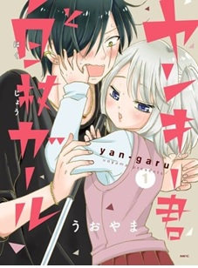
Figure 1
Cover page image: Love’s in Sight Volume 1
This paper centers on the graphic novel, Love’s in Sight, a yon-koma (four-panel) manga (Figure 1) published as an eight-volume series by KADOKAWA from June 2018 to February 2022. This manga gained immense popularity, leading to its adaptation into a Hulu drama series in 2021. Notably, the series included a narration broadcast (kaisetsu hōsō) for viewers with visual impairments. Despite its classification as a romcom tailored for teen and young adult readers, the comic provides a rich source of visual and narrative elements that warrant in-depth analysis. Our selection of this manga is grounded in several factors, including its critical acclaim in Japan, its contribution to the authentic portrayal of disability issues in the manga industry, and our belief of Love’s in Sight as a valuable resource for teaching about visual disability, as mentioned earlier. An English-language translation was published by Viz Media in April in 2023.3
The protagonist, Yukiko Akaza, is an ordinary 17-year-old high school girl with low vision attending a school for the blind (mōgakkō).4 Her boyfriend is Morio Kurokawa, a sighted 18-year-old high school dropout. Their story unfolds when Morio falls head over heels with Yukiko on the very day they meet. Despite their differences, both face societal labeling as “the Other,” leading to similar challenges and prejudice. Notedly, the original Japanese title, Yankiikun to hakujō gāru, designates Yukiko as the hakujō gāru (girl with a white cane) and Morio as a “yankee” (a slang word for a male juvenile delinquent in Japanese). In the translated title, Love’s in Sight, the word “sight” carries a dual meaning, referencing Yukiko’s loss of sight and Morio’s love at first sight. The characters are artistically crafted with a comical dissonance in both appearance and demeanor. Morio’s rebellious exterior, characterized by small, fang-like teeth, multiple-pierced ears, and a long, deep scar beneath his left eye, sharply contrasts with Yukiko’s cute, doe-eyed, petite stature. Morio frequently adopts the behavior of an obedient dog with a wagging tail, whereas Yukiko radiates a more self-assertive demeanor, intensifying the artistic dynamic between the two.

Data Collection Methods and Types of Analysis
Another pivotal factor in choosing this manga is its accessibility for blind readers. Traditional printed comics pose challenges for readers with visual impairments like Kurikawa. Despite various innovative attempts, such as shokuzu (textile graphic conversion), to make manga accessible to the visually impaired (Mori 2018), the predominant format remains standard print or digital, primarily processed visually. However, a novel comic format, known as Voice Comic, or voisu komikku in Japanese, played a crucial role in facilitating our collaborative analysis of the manga. This format presents the manga with still images while audibly narrating not only the manga’s dialogs (i.e., text written in speech balloons) but also environmental sounds (onomatopoeic expressions written in the background) and the characters’ emotions and behaviors (other written expressions called manpu) in each panel. The narration in Love’s in Sight closely aligns with the style of onsei-gaido (audio description) provided for blind movie-goers or television viewers.5 In addition to Voice Comic, Love’s in Sight is available in other accessible formats such as the Daisey format (Braille version).
Our examination of Love’s in Sight employed a comprehensive methodology that integrates textual, visual, semiotic, and content analyses. Textual analysis focuses on the written narrative, encompassing dialogues (print text within speech balloons), inner speech (print text in thought balloons or written directly in the background), and handwritten side notes, evaluating language use, literary techniques, and narrative structures employed by the author. Visual analysis involves a close inspection of graphic elements, such as panel layout, color, balloon shape, and artistic style on each manga page. Semiotic analysis enhances our understanding of the visual narrative by identifying and interpreting visual signs and symbols (e.g., manpu, onyu, dosen), considering their connotations and conveyed messages. Content analysis categorizes and quantifies specific aspects of the comic, including the frequency of metaphors, recurring themes, and character interactions. This systematic exploration allows for the identification of key patterns within the material and enabled us to understand how visual elements contribute to the storytelling process while collecting this data. In addition, our interdisciplinary approach incorporates insights from the scholarly backgrounds of both authors, ensuring a comprehensive examination of the comic’s various elements.
A brief background of the population with disabilities in Japan should facilitate our following discussion of selected social issues that involve the blind community. Japanese government data categorizes disability in three groups: physical, intellectual, and mental disabilities. According to the 2021 disability whitepaper, 7.6% of the population has some form of disability. Specifically, 3.45% have physical disabilities, 0.87% have intellectual disabilities, and 3.32% have mental disabilities. Breaking down the physically disabled group, a 2016 Ministry of Health, Labor and Welfare report reveals that 7.3% (312,000) are visually disabled, while the largest subgroup (45.0%) consists of individuals with mobility disabilities.6

Results of the Analysis

Overall Assessment of the Narrative: Perspective as a Blind Teacher

Love’s in Sight opens with Yukiko confronting Morio, who casually stands on the tactile paving, blocking Yukiko’s path. Outraged, Yukiko prods Morio in the buttocks with her white cane, yelling, “You’re in the way!” Morio, attempting intimidation with menacing looks, soon realizes she cannot see him. Instead of mocking her disability, Morio narrates his “scary” appearance to her. Unintimidated, Yukiko reacts by stroking his cheeks, asking if he needs medicine for his “large” scar that he has exaggerated. Touched by her kindness, Morio takes a liking to her. To some readers, this boy-meet-girl start may seem farfetched. Yet, it is a common experience for blind people in Japan when sighted individuals obstruct Braille block users.
One of this paper’s authors, Kurikawa, finds this opening hilarious and a testament to Morio’s unbiased attitude toward Yukiko. Throughout their relationship, Morio never makes an issue of Yukiko’s disability. He is aware of her low vision but does not use it to define her; instead, he tries to learn her way of seeing the world. Kurikawa wishes that Japan had more people like Morio. This paper’s other author, Okuyama, initially sees the “punk” and “physical different” couple as a narrative device for dramatic effect. However, a blind person like Yukiko, Kurikawa recounts his experience as a high school teacher, during which students dealing with their challenges often sought guidance from him instead of their sighted homeroom teachers. Initially, they would engage in conversation and offer frequent assistance. As trust developed, they began confiding in him, seeking advice on their concerns. Morio, in the manga, used to be ridiculed and ostracized by classmates because of his “illegitimate” family and eventually dropped out of high school. Yukiko says, “Morio needs someone who listens to him.” Kurikawa believes that troubled teens likely empathized with him, recognizing his marginalized position as the sole blind teacher in the school, and that this perception made him more approachable, akin to Morio’s perception on Yukiko. Both labeled as “the Other,” Yukiko and Morio are opposite sides of the same coin. Therefore, Kurikawa feels that this pairing is highly probable.

Challenging Ableist Stereotypes in Manga: Yukiko’s Empowering Agency
In manga, disabled female characters are often subjected to ableist stereotypes, portrayed as either powerless heroines or objects of pity (e.g., a blind woman in To Terra; a woman with mental illness in Emma; a deaf girl in A Silent Voice). However, Yukiko’s character defies these conventions: she is neither a pitiful, helpless figure nor disabled superhero. She is not portrayed as a “tragic” heroine “struggling” with her loss of sight. Instead, Yukiko is a young woman with strong agency, and Morio admires her as a senior in life, despite her being a year junior. This section delves into Yukiko’s agency to highlight the effective representation of her voice in Love’s in Sight.

Figure 2
Love’s in Sight Volume 1, p. 53
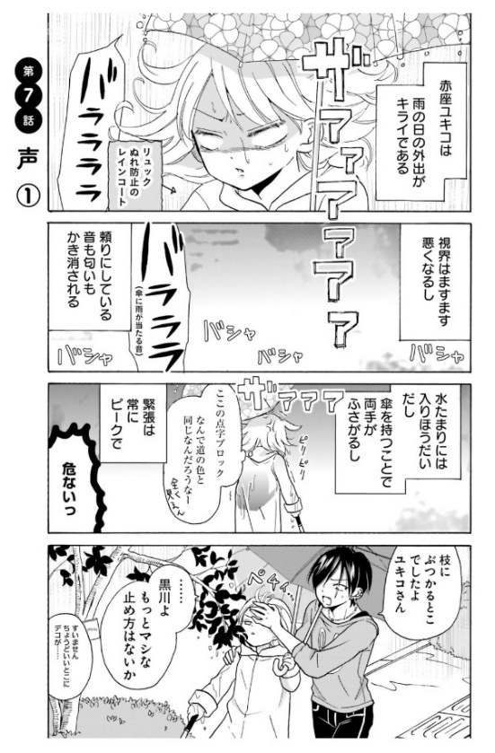
Yukiko, the rough-spoken, spirited protagonist of this manga, consistently takes charge in the storyline. She initiates decisive moments, such as suggesting and planning their dates, showcasing her proactive and determined nature. Unlike the stereotypical portrayal seen in 1960s and 1970s manga, Yukiko rejects victimhood, co-creating a romantic journey with Morio. Her assertiveness, clear opinions, and strong-mindedness attract Morio, highlighting her agency in the narrative.
In this excerpt (Figure 2), Yukiko emerges as a resilient individual while navigating her way through difficulties stemming from inclement weather and inadequately designed tactile paving. She confronts failures independently and adapts to unexpected situations. While Morio, akin to a protective knight, often intervenes to prevent Yukiko from accidental mishaps, his role is not to pity or perceive her as a weakling.
Their unique relationship is further illuminated through the use of role-specific language, or yakuwarigo. Visually contrasting, with Morio as an older, taller character with an intimidating appearance, and Yukiko as a younger, shorter figure resembling a “super cute” girl with big eyes typically depicted in the moe manga genre, their roles are completely reversed verbally. Yukiko addresses Morio by his last name, “Kurokawa,” adopting the tone of a senior addressing to a junior student, while Morio respectfully calls her “Yukiko-san.” Yukiko punctuates her speech with zo, a linguistic marker denoting authority, leadership, and manliness (Kinsui 2014:113-114), whereas Morio’s speech is marked with the ssu-ending, suggesting a subordinate position (127-128). This linguistic contrast cleverly subverts traditional gender role and age-based hierarchy.
A love story devoid of challenges may lack the intensity for compelling drama. In this narrative, the couple encounters occasional difficulties, resolving them through heart-felt conversations. However, these struggles serve as a dual purpose: not only do they contribute to the storyline, but they also underscore the social challenges faced by blind individuals, aligning with the social theory of disability. While manga stories featuring disabled heroines often adhere to the pure-love-tested-by-hardship formula, such a narrative tactic may reinforce the misconception that being close to a disabled individual inherently invites hardship. The couple’s romance unfolds through trial and error, stemming not solely from Yukiko’s disability but mainly from the natural awkwardness and inexperience of a young couple. Though Yukiko’s low vision adds a layer of complexity, Morio’s struggles, such as feeling inadequate when describing artwork at a museum or a cave environment at a national park, stem from his sincere effort to understand Yukiko’s perspective. Despite initial clumsiness, these instances are woven into moments of intimacy, shaping a genuine love story.
Figure 3
Love’s in Sight Volume 2, p. 29
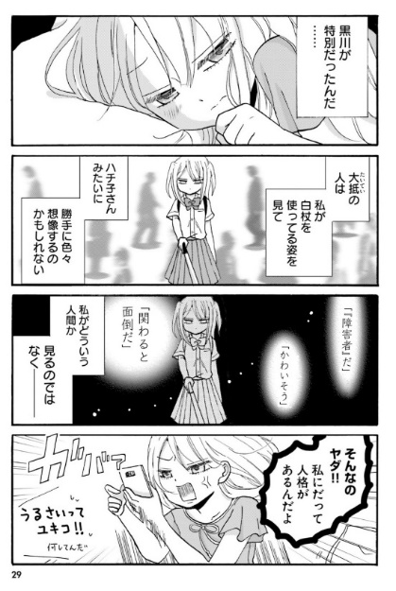
In this example (Figure 3), Yukiko reminds herself of how uncommon Morio is (first panel), free from the biased assumptions and negative stereotypes about visually impaired people typically held by sighted people, like his friend Hachiko (second panel). Despite feeling disheartened by society’s tendency to pigeonhole her as “disabled” rather than recognizing her as an individual human being (third panel), Yukiko resolves not to accept this label and advocate to be judged based on her character, not her disability (fourth panel). This episode demonstrates Yukiko’s strong determination for equal treatment. Her insistence on autonomy, despite occasional frustrations and disappointments, renders her a human and relatable heroine. Moreover, she is unapologetically independent while open to seeking Morio’s help when necessary, carrying important implications for the broader world where interdependence transcends disability.

A Myth Buster
Each person with a disability possesses a unique set of experiences. Therefore, it is important to recognize the diversity of these experiences beyond one individual blind person. Common misconceptions in Japan include assuming all visually disabled people are completely blind, expecting blind people to always wear dark sunglasses, associating white canes exclusively with those with complete blindness, and assuming all blind individuals proficiently read Braille (Shibata, 2015). However, Love’s in Sight challenges these myths.
Figure 4
Love’s in Sight Volume 3, p. 17
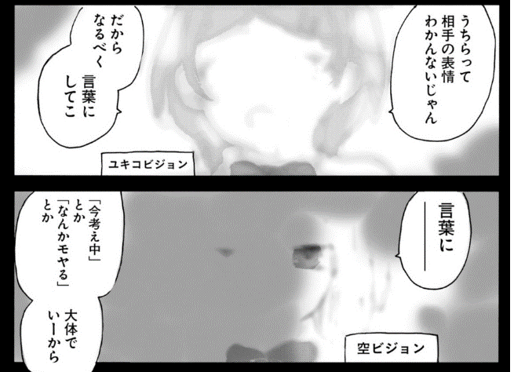
Love’s in Sight visually articulates different types of blindness in several episodes. Illustrated in a sample image (Figure 4), Yukiko experiences central vision loss, and her hazy vision is akin to viewing the world through a film (top panel). In contrast, her classmate Sora has peripheral vision loss, particularly on the left side (bottom panel). Aono, another classmate, deals with complete blindness, depicted with a black background.
This manga effectively portrays the diversity within the visual impaired population in Japan. Merely 10% experience total blindness, while the majority (80-90%) have low vision like Yukiko and Sora, and less than 10% have other types, such as color blindness (Japan Federation of Visually Impaired 2016; MIC, 2009). Visual acuity, determining partial blindness (20/70 to 20/200) or legal blindness (above 20/200), varies within the low vision group, with each case differing in blind spots, blurriness, and night vision. Despite some remaining sight, skills in Braille reading vary widely. Therefore, not all students in a mōgakkō can use Braille, as illustrated in one episode when Yukiko’s boss, a fast-food manager, presents a Braille menu to her and classmates, revealing that Aono can read it.
Yukiko and Aono are the only characters depicted using a white cane, whereas Sora, sensitive to sunlight, wears dark sunglasses. Yukiko and Sora, representing the majority with low vision, highlight additional diversity within this group. Yukiko perceives vivid colors and a frame with no details, whereas Sora’s narrow vision, particularly on the left side, poses challenges, hindering her sight at distances of 20 or 30 feet. In one episode, Sora stumbles over a bicycle while jogging at night, a time she claims her vision is better. Through these and numerous other episodes, this manga dispels common myths about visually disabled people, in Japan, earning its status a myth buster.

Normalizing Disabled Characters and Everydayness of Their Lives
Love’s in Sight offers a refreshing departure from the common narrative prosthesis in depicting characters with disabilities. Furthermore, unlike traditional romcom manga that use the protagonist’s disability as a challenge testing the couple’s love, a trend prevalent since the 1990s (e.g., Kimi no te ga sasayaiteiru; Pāfekuto wārudo), Love’s in Sight explores a different dynamic by focusing on Morio’s internal struggles. This manga’s story sheds light on Morio’s self-doubt, wondering whether a jobless yankee like him is worthy of Yukiko’s love. In doing so, it emphasizes his personal growth and efforts to make Yukiko’s time with him enjoyable, steering away from that conventional trope found in typical manga featuring disabled heroines.
Figure 5
Love’s in Sight Volume 3, p. 6
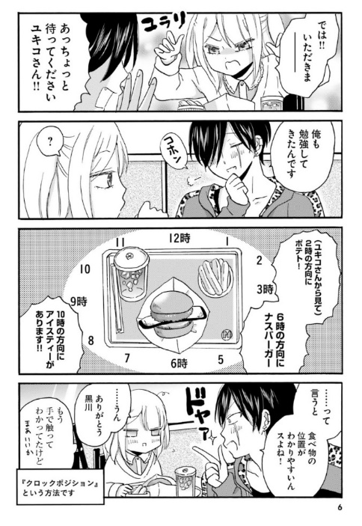
In this episode (Figure 5), Morio proudly demonstrates his newfound knowledge of the clock position, a method used by sighted individuals to assist blind people during meals by indicating where each food item is placed on a clock face (e.g., “A cup of soup is at 3 o’clock”). While the actual techniques are more intricate, Love’s in Sight presents this valuable information in a humorous style, avoiding a medical guidebook feel. For instance, Morio, reading off like a script, informs Yukiko about the items on her plate. In response, she thanks him but thinks to herself, “I already knew where they were by touching them. Well, whatever.” Morio’s well-intentioned but awkward assistance serves as comical relief, contributing to the manga’s engaging storytelling.
Figure 6
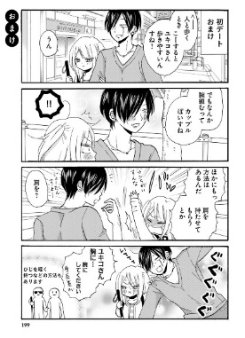
Love’s in Sight Volume 1, p. 199
Like the clock position episode, Love’s in Sight features various scenes showcasing techniques for guiding the blind, often concluding with a humorous touch. For instance, in this episode (Figure 6), as Morio has Yukiko’s body close to him, allowing her to hold his arm, he makes a playful comment about them walking “like a lovey-dovey couple.” His remark leaves Yukiko blushing and switching her hold to his shoulder, momentarily trapping him due to their significant height difference. Even though a blind person can walk independently on a familiar route, knowledge of walk-guide techniques, such as offering one’s arm, elbow, or shoulder for guidance, become helpful when accompanying them. As these examples show, Love’s in Sight weaves humor into Yukiko’s routines, creating an entertaining and informative narrative that seamlessly alternates between comical and serious moments, capturing the essence of everyday teenage life.
Love’s in Sight distinguishes itself by humorously and educationally showcasing a high schooler’s ordinary activities, steering clear of the mundanity often associated with slice-of-life comics. Similar to the main characters of Saso Akira’s Hana ni toitamae (2014-2015) and Sone Fumiko’s Itsukushimi no shiya (2015), Love’s in Sight portrays Yukiko as an everyday person without becoming entangled in trivial details. Kurikawa underscores the problem of relying solely on supercrip portrayals, like the protagonist of Zatoichi, to represent blind people. Although he finds superhero movies quite entertaining, he believes that multiple representations are essential for depicting people with disabilities. To dismantle the “Other” label and foster inclusivity, Okuyama has also argued for more manga that focus on ordinary aspects of their lives, such as dating and shopping (2020; 2022). It is imperative for comics to illuminate the everyday life experiences of individuals with disabilities, opting out of the narrative prosthesis approach or supercrip trope.
Figure 7
Love’s in Sight Volume 6, p. 122
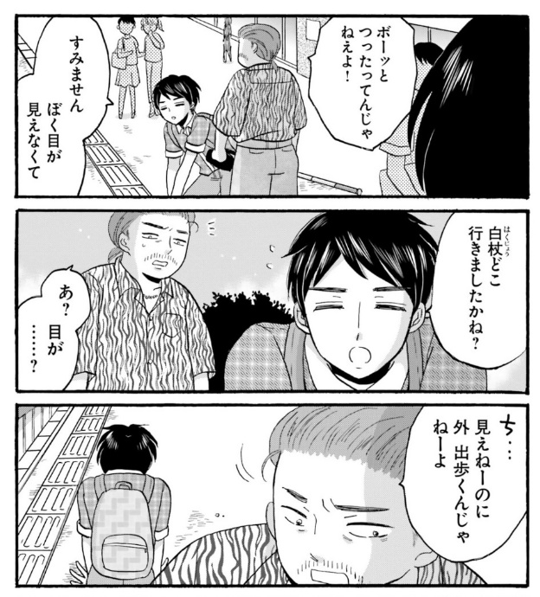
Moreover, Love’s in Sight excels in conveying that disability is not just someone else’s story but “our” story. In a pignant scene (Figure 7), Yukikoʻs classmate, Aono, stands on the Braille blocks, awaiting someone. When bumped into by a man who scolds him, “Don’t just stand there! Pay attention!” Aono reveals that he is blind and asks about his white cane. Disregarding Aono’s question, the man insists, “Why don’t the blind just stay home?” This assumption reflects the view that the street belongs exclusively to the sighted. Blind individuals often face such clashes in crowed public spaces, with hurrying passersby shouting, “Watch where you are going!” (Iijima and Hirose, 2022). Inclusive communities must recognize that the streets belong to everyone, blind or sighted.
Figure 8
Love’s in Sight Volume 6, p. 202
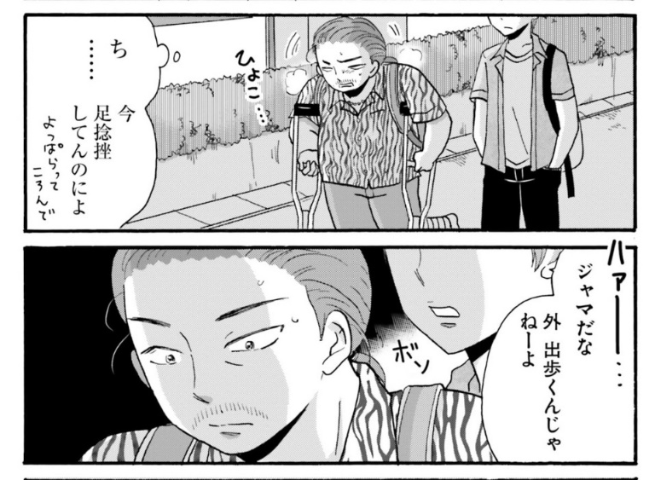
Ironically, in the same volume, the same man is depicted walking now using crutches. In this scene (Volume 6, p. 202), the man limps, overtaken by a younger able-bodied man who callously remarks, “Folks like you are in my way. Don’t hang out outside.” It is a what-goes-around-comes-around moment, echoing the man’s earlier reaction to Aono. This scene illustrates that anyone, like the nameless character, can find themselves marked as the “Other” at any given time.
Toward “Barrier-Free” Public Spaces
Japan’s advanced public transportation, while beneficial for sighted commuters, poses hazards for blind people. Ishimura (2019) points out that nearly half of visually impaired commuters face harmful incidents involving Braille blocks, accessible pedestrian signals, and platform screen doors. Nor do these devices fully meet the needs of the blind community in Japan. As Ishimura (2019) emphasizes, depending solely on a white cane or a guide dog alone is insufficient for safe navigation; the watchful eyes and support of fellow passengers are also necessary.
Figure 9
Love’s in Sight Volume 7, p. 2
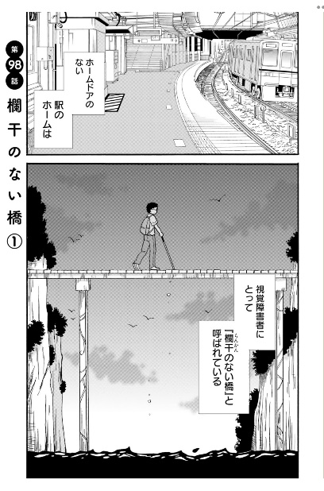
Love’s in Sight, Volume 7 depicts Aono’s rescue by fellow passengers as he teeters on the train platform. This volume begins with the metaphor “Rankan no nai hashi” (a bridge without railing), illustrating the risk of a train platform without a “form door” (hōmu doa in Japanese), an automatic platform screen door ensuring safety, especially for the blind (Figure 9). While all platforms feature a tactile paving system for navigation, some sighted passengers thoughtlessly place their belongings on the braille blocks, obstructing blind passengers. Despite the decline in falling cases due to form doors and other cautionary measures, approximately 2.2% of the 3,000 platform falling cases in 2019 involved visually impaired passengers,7 and 36% of them fell on the tracks8 (MLIT, or Ministry of Land, Infrastructure, Transport and Tourism 2021). This percentage is notably high, given that blind people constitute less than 0.3 % of Japan’s population.
Figure 10
Love’s in Sight Volume 7, p. 172
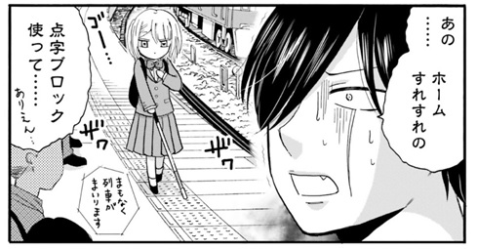
Love’s in Sight also presents data on train platform hazards for the blind. In this episode (Figure 10), Morio, visibly alarmed (implied by the manpu signs of his sweat beads and pale shade), learns about grim statistics from the mōgakko’s teacher. He envisions Yukiko walking on Braille blocks near the platform edge as the train station announcement blaring “The train is arriving shortly.”
Figure 11
Love’s in Sight Volume 2, pp. 148-149
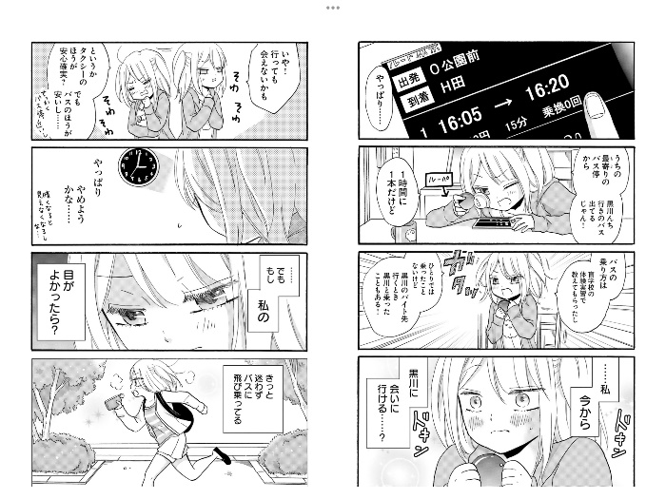.
Experiencing social invisibility is a common aspect of having a disability, notably due to the accessibility challenges in Japan’s public transportation, as illustrated in a scene from Volume 2 (Figure 11) of Love’s in Sight. Determined to visit Morio after weeks of silence, Yukiko debates the challenges of taking the bus versus a more expensive yet easier cab ride (first to third panels on right and first panel on left). Her heart beats rapidly partly because she has been yearning to see him but largely because she anticipates the complication involving the bus ride (fourth panel on right). Momentarily, she even thinks of giving up on the idea as she stares at the clock (second panel on left). However, telling herself, “If I were a sighted person, I would jump on the bus by now,” she refuses to let her disability restrict her life and chooses the bus. Unfortunately, the episode takes on an unexpected turn: Yukiko boards the wrong bus and eventually takes a taxi home, discovering Morio eagerly waiting for her in her room. Concealing her failed attempt, Yukiko feels disheartened when Morio innocently remarks about the “easy and convenient” public bus system. These episodes underscore that, as shown, both the train and bus systems are not readily configured for all users.

The Old Notion of Blind Students
No manga is flawless, and Love’s in Sight, while addressing disability with care, inadvertently reinforces stereotypes and leaves some aspects ambiguous. To enhance the narrative, we recommend the following improvements:
The manga artist Uoyama, drawing inspiration from her own father’s low vision, interviews with blind people, and visits to mōgakkō and organizations for the blind (DI-AGENT 2021), approaches the subject with sensitivity, ensuring the fair treatment of the blind heroine and the sighted characters (Sobikoto 2019). However, despite these efforts, some aspects of Love’s in Sight convey the author’s “outsider” perspective on the blind community, as noted by Kurikawa. For example, the depiction of blind characters attending the fictional mōgakkō, Nijimachi Public School for the Blind, mistakenly implies a commonality in educational choices for visual impaired children. This portrayal oversimplifies reality, as students with low vision, like Yukiko, are more commonly enrolled in regular high schools, aligning with Japan’s inclusive education movement, or inkurūshibu kyōiku. Although the narrative offers a brief backstory about Yukiko’s transfer from a regular school to this mōgakkō when her sight began to deteriorate, Kurikawa worries that this simplistic portrayal may mislead readers unfamiliar with the blind community.
Figure 12
Love’s in Sight Volume 2, p. 47
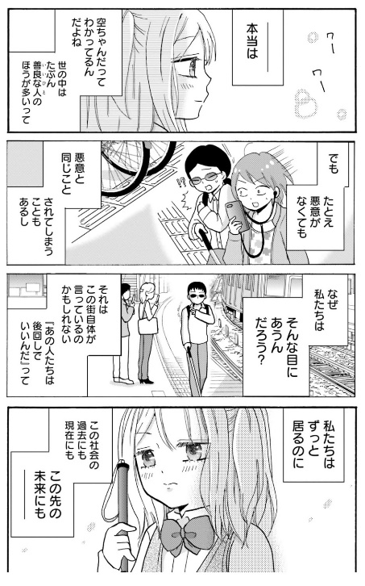
In this example (Figure 12), Yukiko’s monologue reflects her understanding of Sora’s resentment towards sighted people.9 Initially, she asserts, “Both Sora-chan and I know that there are more kind-hearted people out there than those who aren’t.” However, in the next three frames, Yukiko showcases incidents where sighted individuals unknowingly disregard people like her, behaving as if the blind are invisible and insignificant, albeit without malicious intent. This and other similar episodes position Yukiko as a voice representing many white cane users.
Before Japan initiated its inclusive education campaign,10 the majority of visually impaired children were placed in mōgakkō. In 2011, 79.2% were in such institutions with only 20.8% mainstreamed, with 6.3% in regular classes, and 14.5% in special education classes (Mithout, 2017). However, since 2014, multiple legislative measures have been implemented in in conjunction with the Rights of Persons with Disabilities (JASSO 2022), and educational segregation is no longer reinforced on children with visual disabilities who do not have other, compounding disabilities. The 2021 data from the Ministry of Education, Culture, Sports, Science and Technology (hereafter, MEXT) show that only 25% of blind students were in mōgakkō, while 74.3% were in regular schools (of which 65.7% in regular classes and 8.6% in special education classes).11 By contrast, overall enrollment in special support schools is rising due to the rapid increases “in the categories of ‘developmental disorders,’ ‘health impairment or chronic disease/conditions,’ and ‘mental disorders’” (JASSO 2022: 11). Similarly, the 2022 White Paper on Persons with Disabilities reports on the installation of various structural accommodations (e.g., bathrooms and sidewalks for children in a wheelchair) in regular schools for a “barrier-free” public education, as well as a sharp increase of children with developmental disorders placed in special support schools (Shōgaisha Hakusho, 2022). Amid these changes, the declining number of visual impaired children and the push for inclusive education also challenge the survival of mōgakkō (Nakamura, 2019). While rare, schools like Tsukuba School for the Blind stand out, with large enrollments and selective admissions for applicants from all prefectures aspiring to pursue higher education. However, in Kurikawa’s hometown in Niigata, two special support schools merged due to low enrollment in 2022. Therefore, Kurikawa believes placing the heroine of Love’s in Sight in a regular high school and showing her encounters with sighted high schoolers would have been a more realistic setting, given current inclusive education trends in Japan.
Moreover, the absence of adult character with visual disabilities in Love’s in Sight creates another unrealistic portrayal. The sole teacher shown, Ms. Kida, is sighted, leaving Yukiko and her classmates without a role model at Nijimachi Public School for the Blind. While unintentional, this reflects a reality in the Japanese educational system. In 2019, MEXT established a shōgaisha katsuyaku sokushin team to promote active participation by the disabled, outlining six plans. Plan Number 6 advocates for the inclusion of disabled teachers, covering mandatory activities and policies from teacher training to hiring practices to post-employment support services. Despite these efforts, the increase in hiring disabled teachers has been limited, crucial for achieving true inclusive education (Harada, 2021). Kurikawa believes that disabled teachers can serve as valuable role models for disabled students and foster a more direct understanding of disability among sighted students, teachers, and staff. Their presence is critically important to establish a more egalitarian relationship among the entire school community, breaking down the traditional dichotomy of educator/benefactor and learner/beneficiary (Harada, 2021).

Conclusion
In 2012, MEXT initiated “more inclusive education” (inkurūshibu kyōiku) to align with Japan’s broader goal of creating an “inclusive society” (kyōsei shakai) for active participation of disabled individuals. The 2017 establishment of a universal design committee resulted in various inclusive policies, such as a booklet with sample activities connecting regular and special school students. Progress has been made, yet achieving a truly inclusive society necessitates not only inclusivity for disabled students but also a more supportive environment for disabled teachers (Harada, 2021). To cultivate a society where no one is marginalized as the Other, it is imperative to create comics that feature ordinary people with disabilities leading ordinary lives.
Despite the intense focus on Yukiko and Morio’s romance, Love’s in Sight does not obscure its portrayal of Yukiko’s daily struggles with social barriers. Rather than treating her disability as a mere narrative device or dismissing as unimportant, the story highlights it as a key characteristic essential for Morio and other sighted characters to understand for equal coexistence. The inclusion of other blind characters like Sora and Aono also addresses important social issues within the blind community in Japan, revealing a broader context of disability.
While some manga continue to exaggerate their protagonists’ extraordinary feats, works like Love’s in Sight have begun to be published, enabling able-bodied readers to emotionally connect with the experiences of ordinary blind people and offering valuable insights for pedagogical applications. We argue that such comics can serve as heuristic material for readers across demographics, shedding light on the blind community and emphasizing the imperative for genuine inclusivity in Japanese society. As representation of disability in Japanese comics improves, caution is needed to avoid stereotypical descriptions of disabled people. Supporting for serious comic representations of disability and ensuring accurate portrayals of the lived experience of people with disabilities remain crucial. Lastly, we advocate for the expansion of manga titles in audio formats like Voice Comics to foster inclusivity and accessibility in entertainment, aligning with the broader objective of building a more inclusive society.

References
Alaniz, J. (2014). Death, disability and the superhero: The silver age and beyond. The University Press of Mississippi.
Barasch, Moshe (2001). Blindness: The history of a mental image in western thought. Routledge.
Brylla, C. (2018). Bypassing the supercrip trope in documentary representations of blind visual artists. Disability Studies Quarterly, (38)3.
Corbella, M. B., & Acevedo, F. S. (2010). The representation of people with visual impairment in film. Journal of Medicine and Movie, 6(2), 69-77.
DI-AGENT. (2021). “Shōgaisha’ dakedenaku ikizurasa wo kakaeta subeteno kata e: ‘Yankii-kun to hakujō gāru” sakusha Uoyama sensei intabyū (An interview with Uoyama, author of Love’s in Sight, Not just for “people with disabilities” but for any minority group). https://di-agent.jp/tips/entry101.html.
Ellis, K., & Goggin, G. (2015). Disability & the media. Palgrave Macmillan.
Harada, T. (2021). A visually impaired teacher’s identity work in a school culture where being sighted is taken for granted: “Strategies for transforming disability into advantage” and “strategies against bias.” Kinjogakuin University Anthology, Social Science Series, 18(1), 65-85.
Hatano, M. (2018). The teaching profession is an important profession: Difficulty of the teaching profession and disability. In Hatano, M., Teruyama, J., & Matsunami, M. (Eds.), Teachers with disabilities: The intersections between disabilities and teaching professionals (pp. 85-105). Seikatsu-shoin.
Hopkins, P. D. (2009). The lure of the normal: Who wouldn’t want to be a mutant? In
Housel, R. & Wisnewski, J. J. (Eds.), X-Men and philosophy: Astonishing insight and uncanny argument in the Mutant X-Verse (pp. 5-17). John Wiley & Sons.
IIjima, S., & Hirose, K. (2022). Shikaku shōgai to shinkō no sekai – Shokujōsha no ikikata (Visual impairment and the world of beliefs: The way of the tactile person). Shūkyō Kenkyū, 92(2), 227-302.
Ilea, R. (2009). The mutant cure or social change: Debating disability. In Housel, R. &
Wisnewski, J. J. (Eds.), X-Men and philosophy: Astonishing insight and uncanny
argument in the Mutant X-Verse (pp. 170–182). John Wiley & Sons.
Ishimura, O. (2019). Ammashitōhō fusoku dai jūkyūjō ni okeru shikakushōgaisha e no yūgūsaku (Preferential measures for visually impaired individuals in the 19th Amendment to the law concerning Anma masseurs, or the Ahaki-hō). Senshūhōgakuronshū, 135, 349-366.
Japan Federation of Visually Impaired (Nihon Shikaku Shōgaisha Dantai Rengō). (2016). A research report on how to support people with low vision in their reading and writing endeavors (Yomikaki ga konnanna jakushisha no shien no arikata ni kansuru chōsakenkyū jigyō). http://nichimou.org/all/news/secretariat-news/170327-jimu/.
JASSO (Japan Student Services Organization). (2022). National survey of supports for students with disabilities in higher education settings in Japan. https://www.jasso.go.jp/en/statistics/shougai_gakusei/__icsFiles/afieldfile/2022/07/15/fy2018_survey.pdf
Kinsui, S. (2014). Yakuwarigo Shōjiten. Kenkyusha.
Kurikawa. O. (1996). Isai wa baria furii – Shikakushōgai kyōsi ga “shōgai” wo tou (Brilliance is accessibility: A blind teacher’s inquiry into ‘disability’). Niigata Nipojigyosha.
Kurikawa. O. (2012). Shikakushōgai wo motte ikiru – dekirukoto wa yaru, dekinaikoto wa tasukeau (Living with a visual disability: Independence and cooperation). Akashishoten.
Kurikawa. O. and Nakao, K. (2022). Shōgaikyōin no koyō jittai to sono teimei no seisakuteki yōin (The political failures of low employment for school teachers with disabilities). Sokō, 3, 2-22.
Okuyama, Y. (2020). Reframing disability in manga. University of Hawaiʻi Press.
Okuyama, Y. (2022). Tōjisha manga: Japan’s graphic memoirs of brain and mental health. Palgrave Macmillan.
Matsunami, M. (2018). Can we reduce the workplace difficulties experienced by teachers with disabilities? The possibility of and issues with the introduction of “reasonable accommodations” concepts to the workplace. In Hatano, M., Teruyama, J., & Matsunami, M. (Eds.), Teachers with disabilities: The intersections between disabilities and teaching professionals (pp. 109-138). Seikatsu-shoin.
Mitchell, D. T. and Snyder, L. S. (2000). Narrative prosthesis. The University of Michigan Press.
Moeller, R., & Irwin, M. (2012). Seeing the same: A follow-up study on the portrayals of
disability in graphic novels read by young adults. School Library Research 15, 1-16.
Mori, S. (2018). A practical study on writing to contribute to manga experience for the visually impaired. Journal of College of Image Arts and Sciences, 217-243. Ritsumeikan University.
Mithout, A. L. (2017). The transformations of special schools for the blind in times of inclusion: A French-Japanese perspective. Ars Vivendi Journal, 8/9, 34-55.
Murata, M. (2021). Shikakushōgaisha shien kara yunibasaru seihinkaihatsu he (Product development from simply supporting the visually impaired to universal design). Ningenkogaku, 57, supplement issue, 1-2.
MIC (The Ministry of Internal Affairs and Communications, or Sōmushō). (2009). https://www.soumu.go.jp/soutsu/hokuriku/resarch/houkoku/houkokusho.html
Nagai, A. (1998). Manga no naka no shōgaishatachi: Hyōgen to jinken. (Disabled people in manga: Representations and human rights). Kaihō shuppansha.
Nakamura, M. (2019). Nihon shōgai kyōikushi (Japan’s history of education for disabled children). Akashishobo.
Schwartz, A., Blue, E., McDonald, M., Giuliani, G., Weber, G., Seirup, H., Rose Sage, Elkis-Albuhoff, D., Rosenfeld, J., & Perkins, A. (2010). Dispelling stereotypes: Promoting disability equality through film. Disability & Society, 25(7), 841-848.
Shakespeare, T. (1999). Art and lies? Representations of disability on film. In Corker, M. & French, S. (Eds.), Disability discourse (pp. 164-172). Open University Press.
Shōgaisha Hakusho (The White Paper on Persons with Disabilities). (2022). The Cabinet Office of Japan. https://www8.cao.go.jp/shougai/whitepaper/r04hakusho/zenbun/index-pdf.html.
Sobikoto. (2019). Shōgaisha no kazoku ni kitaisaretemo kazokkute sonnani bannō janai. (The family alone cannot do everything for a person with a disability.) https://sibkoto.org/articles/detail/36.
Tateiwa, S. (2010). Tada susumerubeki koto/tamerainagara susumubekikoto (Special education and multi-knowledge convergence). http://www.arsvi.com/ts/20100119.htm#10
Zhang, L., & Haller, B., (2013). Consuming Image: How Mass Media Impact the Identity of People with Disabilities. Communication Quarterly, 61(3), 319–334.

Footnotes
Manga, denoting Japanese comics, is a medium comprising still, primarily monochrome visual images accompanied by written words.
² In the interview, Uoyama emphasized avoiding the use of Yukiko’s disability as a narrative device to make this story a “tear-jerker.”
³ In the 1970s, only a fraction of those engaged in disability studies in Japan endorsed the social model. However, spurred by significant political movements led by people with disabilities, the transition from the medical to the social model occurred in the 1980s.
⁴ Disclaimer: Our discussion of Love’s in Sight in this paper is not receiving benefits or favors from the publisher, Viz Media.
⁵ The official title of mōgakkō is now shikaku shōgai tokubetsu shiengakkō, reflecting the introduction of the special support schools system (tokubetsu shiengakkō) in 2007. Compulsory education for the blind and the deaf predates that for children with mobility disabilities or intellectual disabilities, and mandatory education for all children with disabilities was finally implemented in 1979 (Tateiwa, 2010).
⁶ Specializing in this format, the publisher KADOKAWA began converting widely popular manga titles like One Piece, around 2010. Okuyama speculates that the recent surge in fandom around voice actors and increased anime consumption during the pandemic has led to the conversion of more new titles into this format. However, not all manga titles are available in Voice Comics on KADOKAWA’s website, and not all Voice Comics titles are narrated in the onsei-gaido style. For example, the romcom manga Heika kokoro no koe ga dada more desu (His Majesty, Your Inner Voice is Audible to Me) only features audio translations of dialogues.
⁷ Murata et. al (2021) reported the numbers, which are also available on the National Institute of Information and Communications Technology (NICT) website at https://barrierfree.nict.go.jp/relate/statistics/population1.html.
8 Ministry of Land, Infrastructure, Transport and Tourism’s “Safety Report Concerning Train Transportation,” November 2021, notes a decrease in falling incidents among the visually impaired in 2020, due to pandemic-related reduction in transportation usage. (国土交通省「鉄軌道輸送の安全に関わる情報（令和2年度）」2021年10月 https://www.mlit.go.jp/tetudo/tetudo_fr7_000032.html.)
⁹ Ministry of Land, Infrastructure, Transport and Tourism’s “Midterm Report: Safety Measures for Visually Impaired People Using the Train Platform,” July 2021 (国土交通省「新技術等を活用した駅ホームにおける視覚障害者の安全対策について ～中間報告～」
¹⁰ In manga, characters’ non-vocalized thoughts are written in boxy speech balloons, while their spoken words are framed in round speech balloons.
¹¹ In 2007, as part of educational renovation efforts, MEXT combined three types of schools specialized for students with particular disabilities – mōgakkō for the blind; rōgakkō for the deaf; and yōgokkō for children with other disabilities including mobile and intellectual disabilities – under one category of tokubetushien gakkō (lit. “special support schools”). This
¹² In 2012, MEXT initiated “more inclusive education” (inkurūshibu kyōiku) to align with Japan’s broader goal of creating an “inclusive society” (kyōsei shakai) for active participation of disabled individuals. The 2017 establishment of a universal design committee resulted in various inclusive policies, such as a booklet with sample activities connecting regular and special school students. Progress has been made, yet achieving a truly inclusive society necessitates not only inclusivity for disabled students but also a more supportive environment for disabled teachers (Harada 2021).

Love’s in Sight: Japan’s Graphic Narrative of Blindness by Yoshiko Okuyama and Osamu Kurikawa https://rdsjournal.org/index.php/journal/article/view/1265 is licensed under a Creative Commons Attribution 4.0 International License. Based on a work at https://rdsjournal.org.

