Media Representation of Women with Disabilities Affected by COVID-19:
Evidence from China

Ying Xiong and Xiuli Wang (corresponding author)
School of New Media, Peking University, Beijing, China

Author Note
Ying Xiong is a post-doctoral researcher at School of New Media, Peking University. Her research focuses on communication for social development, media culture, and health communication. She has published in journals such as Journal of Disability Research, Chinese Women’s Studies, and Global Journal of Media Studies.
Xiuli Wang is an associate professor at School of New Media, Peking University. Her research focuses on public relations, health communication, and human-machine communication. She has published in various journals such as Journalism and Mass Communication Quarterly, Computers in Human Behavior, American Journal of Media Psychology, and Chinese Journal of Communication.
Abstract
Based on the content analysis of news samples from 23 Chinese media outlets, this study examines the media representation of women with disabilities affected by COVID-19. We found that women with disabilities are marginalized, stereotyped, and stigmatized under the combined influence of ableism, sexism, and the pandemic.
Keywords: women with disabilities, media representation, COVID-19

Media Representation of Women with Disabilities Affected by COVID-19:
Evidence from China
Persons with disabilities (hereafter refers to as PWD) are among the most marginalized in any crisis-affected community. Coronavirus Disease 2019 (hereafter refers to as COVID-19) and related control measures have further compounded this situation, disproportionately impacting PWD both directly and indirectly (United Nations, 2020). As a marginalized group both in disability status and gender, women with disabilities (hereafter refers to as WWD) affected by COVID-19 are more vulnerable than men with disabilities (hereafter refers to as MWD) and non-disabled women in various aspects (Thomas et al., 2021). Meanwhile, WWD have shown powerful resilience when responding to the crisis (Le, 2020). However, it was hard to find more scientific data referring to WWD affected by COVID-19 worldwide.
China was the first country to report COVID-19 cases to World Health Organization and was one of the hardest-hit countries in the early phase of the pandemic. As the world’s most populous country, China is home to at least 85 million PWD (China Disabled Persons’ Federation, 2021), and nearly half of them are women or girls. Even so, the situation of Chinese WWD affected by COVID-19 was severely under-researched, making it difficult to examine and reflect on their human rights situation and relevant policies or practices.
As the setter of public agendas (McCombs & Shaw, 1972), the grantors of social status (Lazarsfeld & Merton, 1948), the constructor of historical memory, and the watchers of future risks, media play a crucial role in constructing the social realities of WWD (Cai & Xiong, 2021). In this study, we investigated the media representation of WWD in the Chinese context to better understand the relationship between WWD and COVID-19, to reveal the representation strategies of Chinese media, and to support various social subjects (media outlets, government departments, PWD organizations or communities, etc.) to construct a more diversified, equal, and inclusive social environment in the post-COVID-19 era. These subjects can choose to serve either as the target of criticism, the source of policy advocacy and project development (van Zoonen, 1994) or as the foundation for potential dialogue and cooperation.
Literature review
Media representation of marginalized groups
As a significant topic in communication research, media representation refers to constructing the so-called social reality (Chang & Wang, 2016) “by means of selection and interpretation which operate through gatekeeping and according to agendas which are suffused by ideology” (Watson & Hill, 2012, p. 259).
Due to their subordinate positions in social structure, marginalized groups (such as women, PWD, children, older persons, etc.) have always been represented as the Others -- “the outgroups” that deviate from the mainstream social norms (Ni, 1998), which may exacerbate their social exclusion. There are several frequently used representation strategies regarding marginalized groups (Nie, 2010; Ni, 1998): (1) Marginalization, ignoring or looking down upon marginalized groups as a whole or some aspects; (2) Categorization, repeatedly describing some surface characteristics of them and having “a whole range of belief that is anchored in the stereotype” (Gowman, 1957, p. 198); (3) Stigmatization, emphasizing negative comment “that is deeply discrediting” (Goffman, 1963, p. 3) targeted at marginalized groups. “Abominations of the body -- the various physical deformities” (Goffman, 1963, p. 4) mainly refer to disabilities, and are among the types of stigmas.
Media representation of marginalized groups involves a series of selections from perspectives of how language constructs meanings (Ni, 1998) within different dimensions of media text (Braun & Clarke, 2006). On the quantity distribution dimension, media need to select marginalized groups’ presence or absence, and foreground or background (Fairclough, 1995). For instance, topics “in the lead paragraph in a press report, are informationally foregrounded” (Fairclough, 1995, p. 119).
On the semantic or explicit dimension, media select and organize the surface meaning of media texts (Braun & Clarke, 2006), such as role allocation and related actions, events, or relationships of marginalized groups (Ni, 1998), which are suffused by ideology (Watson & Hill, 2012). For example, as “a significant component of social structure” (Schaefer, 2012, p. 101), individuals can be categorized into these roles in the private sphere (e.g., daughter, wife, and mother) and those in the public sphere (e.g., medical worker and government official), correlating with the discourse and environment of different marginalized persons.
On the interpretive or implicit dimension, media select the latent meaning of texts that reaches underlying ideas, assumptions, conceptualizations, and ideologies (Braun & Clarke, 2006), often reflected in the reporting perspectives of news coverage. For example, if marginalized groups are consistently described as “responsible agents” of negative actions, then we may assume that such propositional “framing” itself adds to the negative portrayal of such a group, and therefore has an ideological basis (van Dijk, 1995).
Media representation of PWD and women
Since representation has long been an important field of feminist media studies (van Zoonen, 1994), the study of disability as a field of representation has also developed over the last three decades into a coherent and compelling body of critical work (Garland-Thomson, 2006). Both PWD and women “are portrayed as helpless, dependent, weak, vulnerable, and incapable bodies” and beneficiaries of benevolent rescuers’ philanthropic actions (Garland-Thomson, 2002).
Specifically, media outlets tend to dehumanize, criminalize, patronize, and medicalize PWD, or treat them as evidence of political achievements (Beauchamp-Pryor, 2011; Cai, 2016). Barnes (1991) summarized 10 commonly recurring disabling stereotypes from English-language mass media such as “social burden,” “super cripple,” and “sexually abnormal.” Mitchell and Snyder (2000) used the term “narrative prosthesis” to refer to “the pervasiveness of disability as a device of characterization in narrative art” (p. 9) which “affirms and shapes discriminatory attitudes” (Garland-Thomson, 2006). Quayson (2007) indicated that “aesthetic nervousness” is seen “when the dominant protocols of representation within the literary text are short-circuited in relation to disability” (p. 16). In the aftermath of the 2007-2008 global financial crisis, British tabloids more frequently described PWD as “folk devils,” thus justifying social welfare cuts (Briant et al., 2013). Zhou et al. (2021) argued that Chinese online media tended to portray PWD in the COVID-19 pandemic from three aspects: special groups receiving assistance, devotees actively fighting against COVID-19, and hardworking and self-improving socialist workers. Xiong and Wang (2021) also found that Chinese mainstream media constructed PWD affected by COVID-19 as the Others under the perspective of ableism.
Women have long been subject to “symbolic annihilation” in mass media (Tuchman,1978), and have been portrayed mainly as housewives who serve men, sales promoters who solicit (male) consumers with attractive appearances, and those who dress up for the benefit of men (Hole, 1971; Liu et al., 1997). The COVID-19 pandemic has once again exposed the conspicuous invisibility of women and gender issues in global public health governance (Feng, 2020), whether in developing countries like India, Kenya, Nigeria, South Africa, and China, or developed countries like Australia, the United Kingdom, and the United States. Women were underrepresented as protagonists, sources, and experts in news coverage of the pandemic, of which more than 99% lacked a gender equality perspective (Kassova, 2020; Fletcher, 2021). Although Chinese female medical workers were mainly represented as “lady warriors” or “contemporary Mulan” in actions fighting against COVID-19, the essence of these labels affirms the status of women through the social recognition of masculinity under the dominant patriarchal discourse (Zhang, 2020).
The above-mentioned literature indicates that PWD and women have always been underrepresented and misrepresented in daily life. Moreover, the COVID-19 pandemic, a public health emergency with a short response time and involving an infectious disease with severe and intricate influences on both marginalized groups and media outlets (Wang, 2022), worsened the underrepresentation and misrepresentation of PWD and women to varying degrees.
Media representation of WWD
Su (2016) proposed to emphasize the daily work and life experience of marginalized women (including WWD) from multiple levels such as gender, disability, and an urban-rural dichotomy, and to use intersectionality to assist the women in voicing their views collectively rather than individually. Garland-Thomson (2002) regarded representation as one of the four fundamental and interpenetrating domains of feminist theory and advocated integrating disability as a category of analysis to articulate and foster feminist disability theory.
Situated at the intersection of disability and gender, very limited research can be found on media representation of WWD. Humeira and Nurbaya (2017) claimed that, compared to MWD, media outlets represented WWD as weak, pitied, and highly dependent on other persons. Mother-blaming is ubiquitous in the professional literature about disability, with negative judgments like “indifferent,” “hysterical,” and “emotional” (Hillyer, 1993, p. 90); and it becomes more complicated when a mother of children with disability is also a WWD (Quayson, 2007). Pompper and Holtzthum (2022) suggested that “Push Girls” (an American reality television) relied heavily on “sex object” and “supercrip” images to represent WWD. In contrast, the representations of Amber and Dooneese (two characters on “Saturday Night Live”) “signal freedom and agency regarding their display of displeasing behaviors as physically disabled women” (Hungerford, 2022). Media representation studies about WWD are even fewer in mainland China. Gao and Liu (2016) found that media coverage of Chinese women with hearing disabilities was significantly less prominent than that of men with hearing disabilities, and People’s Daily tended to portray them as “beautiful angels of the silent world” who won readers’ sympathy and admiration.
Based on existing literature, this study attempts to achieve three goals: first, to examine “how disability functions along with other systems (like gender) of representation” (Garland-Thomson, 2002) to construct disability and gender discourse, which potentially affect our perception and practice regarding the interaction of body, identity, and the risk society; second, to compile historical data about the life experiences of WWD in public health emergencies as a reference for future crises based on the “authenticity” of news coverage; and third, to transcend the unevenness of disability and culture studies for being “U.S.- and Eurocentric, white, and middle class” (Davis, 2011) by providing evidence from China, a populous member of the Global South.
Research questions
This paper aims to answer two questions: what are the characteristics of Chinese media’s representation of WWD affected by COVID-19? What kind of media politics is reflected in their representation strategies? To arrive at the answers, we pose three specific research questions based on three dimensions of media text:
RQ1: On the quantity distribution dimension, how prominent have WWD been in Chinese media’s COVID-19 news coverage?
RQ2: On the semantic dimension, what news facts regarding WWD affected by COVID-19 have been reported by Chinese media?
RQ3: On the interpretive dimension, from what disability or gender perspective has Chinese media covered WWD affected by COVID-19?
Method
To answer the above research questions and facilitate the comparisons among various marginalized groups under a similar analytical framework (Xiong & Wang, 2021), this study applied content analysis, “the systematic and replicable examination of symbols of communication, which have been assigned numeric values according to valid measurement rules” (Riffe et al., 2019, p. 23) and a frequently used method for media representation studies (Krippendorff, 2019) to analyze the news coverage of WWD affected by COVID (hereafter referred to WWD news). The study was operationalized for news coverage featuring WWD affected by COVID-19 as primary or secondary news figures according to their length in the news texts.
Data collection
WeChat is China’s most popular social media platform with over 1 billion active users in 2020 (China Internet Network Information Center, 2020). This study selected the official WeChat accounts of 23 representative and influential Chinese media outlets based on their ownership structure and business scope: (1) State-owned full-scope media (People’s Daily, Xinhua News Agency, CCTV News, and News Broadcast); (2) State-owned health-focused media (Health News, Life Times, and Health Times); (3) Market-oriented full-scope media (Southern Metropolis Daily, Southern Weekly, Bing Dian Weekly, Beijing Youth Reports, The Paper, Ifeng.com, Jiemian.com, China News Weekly, Portrait, Sina News, China Business News, Caijing Magazine, 21st Century Business Herald, and Caixin Media); and (4) Market-oriented health-focused media (DXY and Tencent Medipedia).
News coverage from December 31, 2019 to December 31, 2020 were collected, covering the period in which China was hardest hit by COVID-19, the time of national resumption, and the subsequent localized and overseas pandemic. Firstly, our data provider, Shanghai Watch Mdt InfoTech Ltd., collected 52,553 examples of COVID-19 news coverage based on 10 COVID-19-related keywords. Because of the complexity and scarcity of WWD news, two doctoral researchers and one master student majoring in communication studies screened out 169 PWD news samples based on 45 PWD-related keywords through manual filtration. Then the researchers obtained 28 WWD news samples (as shown in Table 1) with the help of keywords indicating female news figures, such as “woman/women,” “female,” “she/her,” “girl,” “maiden,” “lady,” “daughter,” “wife,” “grandma,” “pregnancy,” “menstruation,” and “gynecology.” The second and third steps were performed under investigator triangulation.

Table 1
The list of 28 WWD news samples.
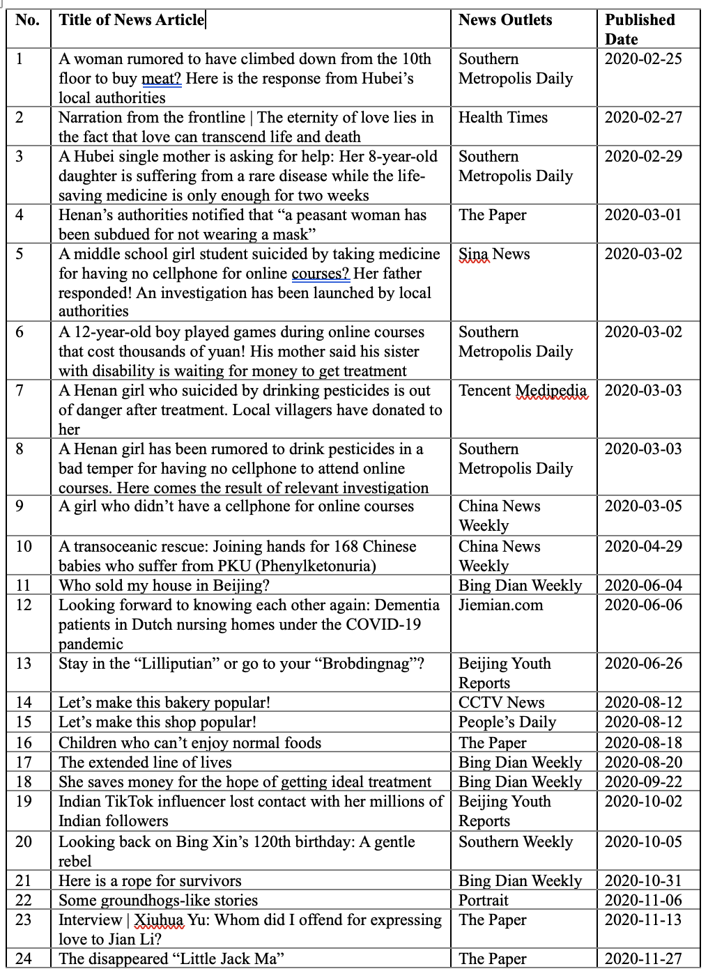
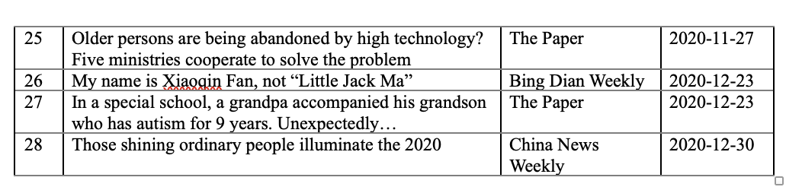Analytical framework
This study adopted an analytical framework consisting of three themes: quantity distribution, news fact, and reporting perspective, corresponding with the three levels of media text (Braun & Clarke, 2006; Fairclough, 1995; Ni, 1998) and respective research questions.
Specifically, quantity distribution refers to the amount of WWD news samples and their distribution on published date, news location, page position, and length, indicating the presence or absence, foreground or background (Fairclough, 1995) of information about WWD.
News fact refers to the concrete content of WWD news samples on the semantic dimension (Braun & Clarke, 2006). Given that the COVID-19 pandemic is a public health crisis, we focused on examining the roles (Schaefer, 2012) played by WWD -- what roles media outlets allocated to WWD and the problems they faced; what vulnerabilities of WWD and relevant attributions media outlets covered; and the support WWD received or provided -- how media outlets represented the social support for WWD and their resilience during the pandemic. We constructed the categories of each variable (as shown in Table 2) based on precoding and existing categories (House, 1981).
Lastly, reporting perspective refers to the disability or gender perspectives reflected on the interpretive dimension (Braun & Clarke, 2006) of news samples, indicating the ideologies or media politics of the representation of WWD. Since categorization and stigmatization are two frequently used representation strategies imposed onmarginalized groups (Nie, 2010), raising the disability or gender equality awareness of news outlets has always been advocated by programmatic documents such as the United Nations Convention on the Rights of Persons with Disabilities (Article 6 and Article 8) and Beijing Platform for Action (Article 245). We took the operational definition and categorization matrix of a “gender-sensitive news article” (Bu et al., 2019) as a main reference.
We further divided the two reporting perspectives into four categories as below. First, disability or gender equality, which is operationalized as any of the following criteria (Cai & Xiong, 2021): (1) For image-building, the sample explicitly stated WWD’s identity as the subject of human rights, rather than merely projecting positive images for them; (2) For perception, it explicitly acknowledged that disability or gender is socially constructed and is a part of human diversity; (3) For attribution, it explicitly recognized that the plight of WWD stemmed from a lack of human rights or inequity in social structure; and (4) For action, it explicitly advocated that social subjects (like media outlets, government departments, PWD organizations or communities, etc.) should take actions to protect the rights of WWD, such as opposing behaviors that undermine their dignity, eliminating disability or gender-based violence, and empowering WWD.
Second, disability or gender-based stereotype, which means a sample used positive or neutral role models to portray WWD, such as “broken in body but firm in spirit,” “poor imbeciles,” or “ladylike.” Third, disability or gender-based discrimination, referred to a sample that either explicitly or implicitly gave negative comments about WWD as a group or their identity, or used other specific stigmatizing terms like “cripple,” “midget,” and “moron” (Goffman, 1963), or other abelist or sexist expressions, including “PWD are a hazard or burden to society” or “women are simple-minded or hysterical.” Fourth, “unclear” -- a sample that does not contain any content that indicates any of the above-mentioned perspectives.
We designed a coding scheme consisting of 15 variables and divided each variable into several categories. We then assigned values to them, as shown in Table 2.
Table 2
Coding scheme of WWD news samples
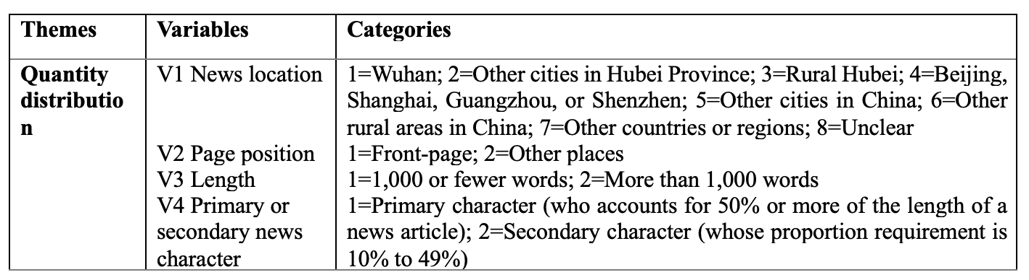
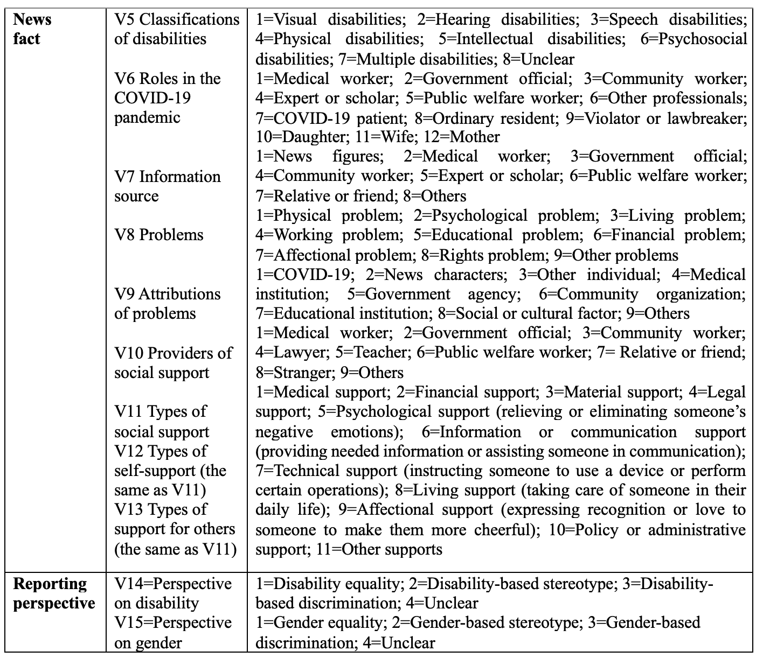
Reliability
The coding was completed by one doctoral researcher and one master student who are experienced in content analysis and attended targeted coding training to better understand the coding scheme. Ir coefficient (Perreault & Leigh, 1989) was used to test the intercoder reliability of V8-V15, the eight relatively subjective variables. In the first round, the reliability coefficients were not ideal, especially V9, V14, and V15. We conducted the second round of intercoder reliability test after discussion and modification of problematic categories, such as distinguishing between a “psychological problem” and “affectional problem,” and clarifying operational definitions like “social or cultural factor” and “disability/gender equality.”
Table 3
The reliability coefficients of V8-V15
As a result, all the coefficients (as shown in Table 3) were 0.8 or higher, coming up to the standard of intercoder reliability. SPSS 22.0 was used in data analysis.
Results
Quantity distribution of WWD news
Of the 52,553 examples of COVID-19 news coverage, only 0.05% of them were WWD news. This proportion was less than 20% of the number of MWD news (Xiong, 2022) and also less than the proportion of WWD in the national population (China Disabled Persons’ Federation, 2021). In other words, WWD affected by COVID-19 were severely underrepresented by the 23 media outlets and nearly “absent” in the Chinese media environment.
Given that our data spanned the full year of 2020, one WWD news item appeared approximately every 13 (13.1) days. Only on 23 of the 366 days did the 23 media outlets report WWD news, far less than the continuity of PWD news, of which one news article appeared approximately every two days (Xiong, 2022).
Regarding news location, more than half (53.6%) of WWD news occurred in Chinese urban areas such as Wuhan, Beijing, and Shanghai, and less than one-third (28.6%) occurred in rural areas, whether in or out of Hubei Province. With the COVID-19 pandemic occurring overseas, Chinese media also reported a few (7.1%) WWD news stories in developed countries but showed a lack of attention (3.6%) to WWD of developing or underdeveloped countries.
Among the 28 WWD news samples, 75.0% were headlines, 85.7% had more than 1,000 words, and 67.9% had WWD as primary news figures, which were “foregrounded” in terms of page position, length, and the share of news character. However, given the extremely small proportion of WWD news, their visibility was still extremely low.
News facts reported in WWD news
Roles played by WWD. At first, we counted the classifications of disabilities and found that news figures of women with physical disabilities (28.6%) had the highest frequency, followed by women with psychosocial disabilities (21.4%), intellectual disabilities (17.9%), multiple disabilities (10.7%), hearing disabilities (7.1%), and visual disabilities (3.6%). There were no news figures with speech disabilities. The classifications were “unclear” in 10.7% of the news samples.
Taking the populations of different Chinese PWD (China Disabled Persons’ Federation, 2021) as a reference, women with psychosocial disabilities (7.4%) and intellectual disabilities (6.7%) were overrepresented, echoing the common images of “crazy women” and “stupid women” in misogynistic culture (Manne, 2018). In comparison, male figures with psychosocial disabilities (3.5%) and intellectual disabilities (1.4%) were underrepresented (Xiong 2022), projecting overall a rational, stable, and intelligent image.
Meanwhile, women with hearing disabilities (24.2%), visual disabilities (14.9%), speech disabilities (1.5%), multiple disabilities (16.3%), and physical disabilities (29.1%) were underrepresented in differing degrees. As with MWD (Xiong & Wang, 2021), the first three kinds of WWD were severely underrepresented. This might have resulted from their perceived lower news value and difficulties in obtaining and disseminating information to media outlets during the pandemic. In contrast, men with physical disabilities (68.1%) were highly overrepresented, and 78.6% of them were doctors with mild physical disabilities who fought against the pandemic (Xiong, 2022).
Further, we analyzed the social roles played by WWD news figures and compared the results to the corresponding findings of MWD (Xiong, 2022).
Table 4
Proportions (%) of social roles played by WWD news figures (N=28) and MWD news figures (N=144)
 | WWD |  | MWD
Roles in the public sphere
Medical worker |  | 0.0 | 53.5
Government official |  | 0.0 | 11.1
Expert or scholar |  | 0.0 | 0.7
Community worker |  | 0.0 | 0.7
Public welfare worker |  | 14.3 | 4.2
Other professionals |  | 32.1 | 22.9
COVID-19 patient |  | 7.1 | 2.1
Ordinary resident |  | 28.6 | 15.3
Violator or lawbreaker |  | 7.1 | 0.7
Roles in the private sphere
Daughter/Son |  | 28.6 | 27.1
Wife/Husband |  | 25.0 | 20.1
Mother/Father |  | 39.3 | 11.8

As shown in Table 4, most WWD news figures featured in a positive or neutral social role, with only 7.1% of them playing negative roles as violator or lawbreaker, although this proportion is 10 times higher than the corresponding value of MWD. Except for public welfare workers, WWD were rarely portrayed as filling powerful roles in the public sphere. MWD received more opportunities to be represented in anti-COVID-19 roles, especially as medical workers and government officials. In comparison, WWD’s common roles in the private sphere, especially that of mothers, were more frequently covered than that for MWD.
Concluding this part of the study, we examined the information source, asking who had the privilege of defining and constructing specific events or problems. In 53.6% of the news samples, WWD news figures were not the information sources. This was especially for women with psychosocial disabilities (46.2%), hearing disabilities (15.4%), and multiple disabilities (15.4%), indicating they had less discourse power to construct COVID-19-related subjective experience, cognition, and understanding. Correspondingly, government officials (46.2%), relatives (46.2%), and even netizens (46.2%) were endowed with more power to define and construct WWD-related matters in the pandemic, depriving WWD of opportunities to voice their views independently.
Problems faced by WWD. The unequal effects of the COVID-19 pandemic are reverberating along preexisting fault lines and creating new ones (Robinson et al., 2021). All of the news samples mentioned the challenges encountered by WWD news figures. Nevertheless, as shown in Table 5, the preexisting problems were more frequently covered than new problems that occurred after the outbreak of the pandemic. This phenomenon never appeared in media representation of PWD, MWD, or women affected by COVID-19 (Xiong & Wang, 2021; Xiong, 2022).
One potential reason is that the 23 media outlets studied did not notice the various impacts of COVID-19 on WWD. They tended to use the long-existing vulnerabilities of WWD as the indispensable background for their situations in the pandemic. For example, the Sample No. 3 article only mentioned one post-outbreak problem of a girl with tuberous sclerosis, reporting “cheap medicines couldn’t be bought while expensive medicines couldn’t be afforded because of the lockdown and quarantine during the COVID-19 pandemic.” Meanwhile, the journalist presented a series of long-existing problems faced by the girl, including her poor health condition, “being unable to live independently,” and the financial constraints of her family. The following findings may resonate with the above analysis.
Table 5
Proportions (%) of problems faced by WWD news figures (N=28)
 | Total (%) |  | Prior-existing (%) | Post-outbreak (%)
Physical problem |  | 89.3 | 89.3 | 17.9
Psychological problem |  | 42.9 | 28.6 | 25.0
Living problem |  | 53.6 | 39.3 | 28.6
Working problem |  | 28.6 | 25.0 | 14.3
Educational problem |  | 32.1 | 32.1 | 14.3
Financial problem |  | 46.4 | 39.3 | 7.1
Affectional problem |  | 35.7 | 21.4 | 17.9
Rights problem |  | 21.4 | 25.0 | 3.6
Other problem |  | 57.1 | 35.7 | 35.7

The physical problems of WWD were most frequently reported on, especially for older women who had multiple disabilities or underlying diseases. For some WWD, their chronic diseases were expected to worsen due to treatment disruptions in the pandemic, even if they did not contract COVID-19.
The second most covered issue dealt with living problems, which mainly involved disruption of daily life in terms of clothing, eating, housing, and transportation, or the lack of necessities. A 93-year-old woman with multiple (physical, hearing, speech, and intellectual) disabilities had lost nearly all ability to live independently during the pandemic, and “could only take liquid diet by nasal feeding through a gastric tube” (Sample No.2).
The third most covered problem faced by WWD related to financial issues, such as heavy reliance on basic living allowances, rehabilitation training expenses embezzled by family members, inability to afford ultra-expensive drugs to cure rare diseases, and inability to earn money during the pandemic.
The psychological problems of WWD were also frequently mentioned in the samples, which referred to negative psychological states like anxiety, depression, and self-abasement. For instance, Sample No.12 cited the finding of a survey conducted by Alzheimer’s Society in which 79% of nursing homes participating believed that the mental health of persons with dementia had been severely damaged in the COVID-19 pandemic. In addition, WWD also faced dilemmas in the domain of affection, such as that related to kinship, friendship, and love. A girl with dwarfism (little people) believed that the reason for her separation from an “able-bodied” boyfriend was that “he needed face (‘Mianzi’ in Chinese)” rather than a girlfriend with disabilities “under the gaze of outsiders” (Sample No.13).
While almost all the “problems” could be understood as human rights issues, only those involving exclusion, discrimination, humiliation, or infringement of rights by others or rights not fully protected were categorized as a “rights problem” in this study. That is why an older woman with visual disabilities who lost her only property under the “house-for-pension” scam (Sample No.11) was coded as a “rights problem.” Another example came from Xiuhua Yu, a famous contemporary poet and woman with cerebral palsy. She has been humiliated as a “slut” or “shrew” because of her bold remarks (Sample No.23).
It is worth noting that the rights problems mentioned in the samples were not directly related to the COVID-19 pandemic. Additionally, compared with problems frequently faced by PWD, those that were more common to women, such as lack of sanitary pads, heavy housework, and domestic violence, were scarcely mentioned in our news samples.
All the samples listed tried to identify the reasons behind the above-mentioned problems, and 67.9% of them attributed the subject’s challenges to COVID-19 or the pandemic. Besides that, 71.4% of the samples attributed those problems to specific persons, objects, or events at the micro level, citing WWD themselves, the financial hardship of their relatives, discrimination, or someone’s violent behavior. At the meso level, 39.3% of the samples attributed the problems to organizations, such as medical ones that lacked resources and testing capacity and government departments which implemented improper prevention and control policies. At the macro level, 14.3% of the samples involved attribution to cultural or social factors, such as a digital divide, prejudice or discrimination within the mainstream society.
Supports received or provided by WWD. It is noteworthy that the WWD were not only portrayed as vulnerable persons afflicted by COVID-19 but also resilient fighters against the pandemic. Of the news samples, 53.6% described WWD helping themselves and 57.1% described their support of others. However, a much higher proportion of coverage represented WWD as recipients of social support (89.3%). In our news samples, the subjects providing social support to them mainly were relatives or friends (75.0%), government officials (60.7%), medical workers (46.4%), public welfare workers (42.9%), and enterprise personnel (42.9%). Only 3.6% of the samples mentioned support provided by community workers.
Among the forms of support, financial support (64.3%), medical support (53.6%), and living support (46.4%) ranked in the top three, while administrative support (21.4%), psychological support (17.9%), and legal support (10.7%) ranked in the bottom three.
WWD news figures offered relatively more financial support (28.6%), information support (25.0%), and material support (14.3%) to themselves. They also provided relatively more of these supports to others, which are financial support (25.0%), information support (28.6%), and material support (17.9%). However, they rarely provided support in legal, medical, technical, administrative, and other areas requiring more public resources or having a high technical threshold.
In the news samples, WWD have been victims of the COVID-19 pandemic, but some of them had also been proactive survivors and doers. In Sample No.18, several WWD had been actively promoting “the legal system design and policy response to rare diseases.” In Sample No.19, an Indian woman with physical disabilities had been “motivating children in slums to ‘dream big’” by teaching them living and artistic skills. She also provided psychological and information support to release the loneliness, insecurity, stress, and fear of people suffering from the pandemic. However, this kind of sample is quite uncommon.
Reporting perspectives of WWD news
Of the samples, 10.7% adopted a perspective of disability equality, which not only emphasized the strong initiative of WWD but also criticized social prejudice against them or advocated for disability equality. For example, the reporting perspective of Sample No.19 was revealed through the viewpoint of its WWD protagonist: “PWD have always been ignored by the mainstream society, so that’s why I can imagine how many social restrictions and prejudices he (a dancer with physical disabilities) has to break to dance so freely.” In Sample No.22, a female volunteer wrote and shared the stories of persons recovered from leprosy because she wanted to illustrate that they were “individuals with unique personalities, neither a type of people, a suffering group, nor an example in history.” In addition, 7.1% of samples adopted a perspective of gender equality through expressing feminist ideas by quoting the comments of famous women like Qing Wu (such as “woman should always be a human before a woman”) (Sample No. 20), and Xiuhua Yu (Sample No. 23).
The most common stereotypes displayed in the samples were disability-based (39.3%), where WWD were regarded as “poor imbeciles” who have tragic life experiences and would always be the objects of sympathy, care, or remedy. In Sample No. 27, “a group of children with autism, cerebral palsy or Down syndrome (including WWD)” were represented as setting “the tragic backdrop for the whole story” while “the grandpa (non-disabled)” who gave them caring and warmth was described as their savior, a typical example of this stereotype.
Another disability-based stereotype can be named “weird idiot,” which is commonly found in the samples of women with intellectual disabilities. Take the intriguing representation of Sample No. 24 as an example. The journalist used double-quotation marks (“”) to imply an abnormal and ludicrous “reading” behavior of a woman with intellectual disabilities, without any scientific testimony or information.
Further, 10.7% of the samples involved expressions of gender stereotypes, such as “she gave birth to two sons for Jiafa Fan (Sample No. 26).” In Sample No.13, a news article about persons with dwarfism (little people), the MWD portion focused on men’s career experience and expectation. The WWD part weighed in on affectional topics, or presented content about makeup, dress-up and a plan of “engaging in occupations that can make me beautiful,” revealing a gender-based divide of media representation.
We found 10.7% of the samples involved relatively implicit disability-based discrimination. One of them quoted negative judgments from WWD themselves, describing PWD in terms of “more or less self-abasement” or lacking “high literacy” (Sample No. 21). The other two established unnecessary or inadequate connections between individual deviant behaviors (like evading health examination and taking illegal trips, etc.) and disability identity, the negative implications of which might be extended from individuals to the group (van Dijk, 1995). Similarly, 7.1% of samples involved gender-based discrimination.
Conclusions and Discussions
This study examined the representation of WWD affected by COVID-19 from 23 influential Chinese media outlets and found that WWD were predominantly depicted using neutral or positive images. Some of the media outlets noticed the connection between WWD’s long-existing vulnerabilities and post-outbreak problems, presented their resilience to some extent, and reflected little explicit disability or gender-based discrimination, which could be seen as progress compared to previous findings (Cai, 2016). Despite this, deficiencies of the WWD’s media representation should be underlined.
Heavily marginalized
Compared with categorization and stigmatization of WWD (Humeira & Nurbaya, 2017; Pompper & Holtzthum, 2022; Hungerford, 2022), marginalization has received less attention from the academic community, but we think it still needs to be monitored as the fundamental concern in the representation system of disability and gender. According to our results, the marginalization of WWD affected by COVID-19 manifested on multiple levels. First and foremost, WWD were ignored or looked down upon as a whole (Nie, 2010), manifesting in limited, low continuity of coverage and resulting in a kind of “symbolic annihilation” (Tuchman, 1978), even within women-related COVID-19 news (Xiong, 2022). Women with disabilities and WWD in Chinese villages and from the Global South were severely underrepresented. The voices of women with psychosocial disabilities were substantially unheard. Last but not least, the 23 Chinese media outlets paid relatively scant attention to WWD’s human rights problems, especially those related to COVID-19 and to WWD’s particular issues as women.
PWD were far less noticed by Chinese media outlets than other marginalized groups like women, children, and older persons (Xiong, 2022), while gender as a representation category worsened the marginalization of WWD (Xiong & Wang, 2021). Additionally, the suddenness and infectivity of the COVID-19 pandemic and related quarantine measures might have exacerbated the “absent” and “background” of the problems facing WWD and specific subgroups. Factors like news value and barriers during news reporting processes may have also played a part.
Moderately stereotyped
As revealed by this study, only a few WWD news outlets adopted a perspective of disability or gender equality. On the contrary, more than one-third and one-tenth of the news samples used disability-based and gender-based stereotypes, respectively.
MWD were subject to diversified and even capable labels such as “supercrip” whether at usual times or during the COVID-19 pandemic (Barnes, 1991; Zhou et al., 2021; Xiong & Wang, 2021). So were WWD at usual times (Pompper & Holtzthum, 2022; Hungerford, 2022). However, the typical stereotypes of WWD affected by COVID-19 were relatively monotonous and forceless, dominated by descriptions like “poor imbecile” and “weird idiot” (Humeira & Nurbaya, 2017).
Other findings like “WWD were rarely portrayed as powerful roles in anti-COVID-19 actions,” “WWD were more frequently represented as recipients of social support than providers,” and “women with psychosocial disabilities and intellectual disabilities were relatively over-represented” resonated with other stereotypes from various dimensions and aspects.
The result that “the 23 media outlets tended to attribute problems of WWD to individuals rather than social circumstances” could be implicitly related to another stereotype, that is disability is the origin of difficulties faced by PWD. This acts as the “narrative prosthesis” (Mitchell & Snyder, 2000) of news stories.
It is worth noting that the frequency and types of stereotypes of WWD affected by COVID-19 are less than those of women as a whole (Xiong, 2022), both before (Hole, 1971; Liu et al., 1997) and after the pandemic (Zhang, 2020; Fletcher, 2021). The reason may be that WWD’s disability identity relatively transcends gender in the Chinese media environment, resulting in the lower social expectation for them as “women,” especially during a severe public health emergency. That is why female medical workers were praised as “contemporary Mulan” (Zhang, 2020) who chose to be fighters instead of mothers, while WWD could only play the roles of victims or beneficiaries.
Lightly stigmatized
Although disability and gender-based discrimination (Barnes, 1991; Beauchamp-Pryor, 2011; Briant et al., 2013; Cai, 2016) were not prevalent in media representation of WWD affected by COVID-19, they still appeared in indirect or subtle ways, such as in quotes of self-deprecation expressions from WWD, which may contribute to discriminatory practices like eugenic programs, selective abortion, infanticide, coercive rehabilitation, and domestic violence (Garland-Thomson, 2002).
Another common but routinely overlooked implicit discrimination -- establishing unnecessary or inadequate connections between individual deviant behaviors (especially those violating the anti-COVID-19 policies and measures) and their disability or gender identity -- is also worthy of vigilance. The stigmatization of these identities was exploited as the “prosthesis” of constructing COVID-19-related mainstream discourse and practices, which are harder to recognize and eliminate than explicit ones.
Recommendations
This study suggests redefining the objectified Others (Ni, 1998), transforming the subordinate position of WWD in media representation, and establishing a more equal and inclusive WWD-related discourse in the post-COVID-19 era. Based on the above results, we make the following recommendations for media outlets (including the alternative media of PWD): (1) Increase the quantity of WWD news during a public crisis, especially news about women with visual disabilities, hearing disabilities, speech disabilities, multiple disabilities, and WWD in rural areas and Global South; (2) Boost the independent voice of WWD during a public crisis, particularly women with psychosocial disabilities, hearing disabilities, and multiple disabilities; (3) Focus more on the resilience and contributions of WWD during a public crisis, highlighting their expertise, professionalism, and leadership. For example, an organization of WWD named “Beijing Enable Sister Center” provided adult diapers, Pull-Ups, various necessities, and psychological support for “sisters with disabilities” around China, and spread the voices of WWD to the public during the COVID-19 pandemic (Le, 2020); (4) Pay more attention to the multifaceted impact of a public crisis on WWD, especially their human rights problems and unique challenges as females; (5) Seek to attribute the problems to multiple levels of factors, especially the barriers in social structure, to promote the innovation of cultural environment, and the participation of multi-subjects in the establishment of WWD’s social support network; (6) Adopt or develop reporting projects that advocate disability and gender equality while refusing stereotyping and discrimination in any form. For instance, if WWD’s deviant behaviors during a public crisis have no relation to their disability status or gender, we suggest media outlets keep such information private and use titles like “resident,” “citizen,” or other appropriate descriptions.
These suggestions might be implemented through the following approaches: (1) Supplement WWD and public crises-related content in textbooks, ethics guidelines, and government regulations involving journalism and communication, or develop specific training or regulating texts; (2) Carry out normalized news reporting training on the basis of above materials while localizing and customizing them according to different subjects and situations; (3) Strengthen and deepen the participation of WWD and their organizations that have a strong awareness of disability and gender equality in every procedure of news reporting. Additionally, WWD and their organizations can also use proactive counter-representation and self-construction to influence the media agenda and the pseudo-environment.
The above conclusions, recommendations, and analytical framework could go beyond the context of COVID-19 and be extended to other future public crises to differing degrees. The analytical framework might also be applicable for studying the media representation of WWD in other countries and regions after the corresponding adjustment, which will be beneficial to horizontal comparisons and relevant collaborations across regions. Considering the limitations of this study, our next step is to improve the depth and complexity of the analysis of news samples, especially in terms of intersectionality and the features of crisis reporting.

References
Barnes, C. (1991). Discrimination: Disabled people and the media. Contact, 70(4),164-172.
Beauchamp-Pryor, K. (2011). Impairment, cure and identity: Where do I fit in. Disability and Society, 26(1), 5-17. http://doi.org/10.1080/09687599.2011.529662
Braun, V., & Clarke, V. (2006). Using thematic analysis in psychology. Qualitative research in psychology, 3(2), 77-101. http://doi.org/10.1191/1478088706qp063oa
Briant, E., Watson, W., & Philo, G. (2013). Reporting disability in the age of austerity: The changing face of media representation of disability and disabled people in the United Kingdom and the creation of new “folk devils.” Disability & Society, 28(6), 874-889. http://doi.org/10.1080/09687599.2013.813837
Bu, W., Liu, X., Tian, S., Xiong, Y., Huang, A., & Wu, H. (2019). Media representation study on school-related gender-based violence. Journal of Chinese Women’s Studies, 1, 5-18.
Cai, C. (2016). Rights of persons with disabilities and public communication: Analysis of the top 10 Chinese incidents about the rights of persons with disabilities in 2015. Disability Rights Studies in China, 3(2), 1-26.
Cai, C. & Xiong, Y. (2021). Handbook on media reporting for promoting disability equality in China. UNESCO. https://zh.unesco.org/sites/default/files/mei_ti_bao_dao_cu_jin_zhong_guo_can_zhang_ping_deng_zhi_nan__0.pdf
Chang, H., & Wang, J. (2016). From “handicapped” to “disabled”: A content analysis of disability labels and discourse in Taiwanese newspapers, Taiwanese Sociology, 31, 1-41. http://doi.org/10.6676/TS.2016.31.1
China Disabled Persons’ Federation. (2021). The number of Chinese disabled persons with different types and levels of disabilities at the end of 2010. https://www.cdpf.org.cn/zwgk/zccx/cjrgk/15e9ac67d7124f3fb4a23b7e2ac739aa.htm
China Internet Network Information Center. (2020). The 45th China statistical report on internet development. http://www.cnnic.net.cn/hlwfzyj/hlwxzbg/hlwtjbg/202004/t20200428_70974.htm
Davis, L. J. (2011). [Review of the book Aesthetic nervousness: Disability and the crisis of representation, by A. Quayson]. Modern Philology, 108(3), E210-E213. https://doi.org/10.1086/659010
Fairclough, N. (1995). Media discourse. Edward Arnold.
Feng, J. (2020). Seeing female workers: The female We-media and discourse activism in Covid-19. Shanghai Journalism Review, 10, 32-44. http://doi.org/10.16057/j.cnki.31-1171/g2.2020.10.003
Fletcher, S., Joe, M. B., Hernandez, S., Toman, I., Harrison, T. G., & Ruzycki, S. M. (2021). The gender of COVID-19 experts in newspaper articles: A descriptive cross-sectional study. Journal of General Internal Medicine, 36(4), 1011-1016. http://doi.org/10.1007/s11606-020-06579-3
Gao, Y., & Liu, H. (2016). A Content analysis of news reports on persons with hearing disabilities in People’s Daily. Disability Rights Studies in China, 3(1), 21-41.
Garland-Thomson, R. (2002). Integrating disability, transforming feminist theory. NWSA Journal, 14(3), 1-32. http://www.jstor.org/stable/4316922
Garland-Thomson, R. (2006). [Review of the book Narrative prosthesis: Disability and the dependencies of discourse, by D. T. Mitchell, & S. L. Snyder]. American Literature, 78(2), 411-412. https://doi.org/10.1215/00029831-2006-018
Goffman, E. (1963). Stigma: Notes on the management of spoiled identity. Prentice-Hall.
Gowman, A. G. (1957). The war blind in American social structure. American Foundation for the Blind.
Hillyer, B. (1993). Feminism and disability. Oklahoma University Press.
House, J. S. (1981). Work stress and social support. Addison-Wesley.
Hole, J., & Levine, E. (1971). Rebirth of feminism. Quadrangle.
Humeira, B., & Nurbaya, S. (2017). Framing of women with disabilities on online media. Advances in Social Science. Advances in Social Science, Education and Humanities Research, 153, 116-119.
Hungerford, K. A. (2022). Hegemonic constructions and corporeal deviance in portrayals of physically disabled women characters on Saturday Night Live. In: Jeffress M. S. (Ed.), Disability representation in film, TV, and print media (pp. 88-107), Routledge.
Kassova, L. (2020). The Missing Perspectives of Women in COVID-19 News: A special report on women’s under-representation in news media. https://www.iwmf.org/wp-content/uploads/2020/09/2020.09.23-The-Missing-Perspectives-of-Women-in-COVID-19-News.pdf
Krippendorff, K. (2019). Content analysis: An introduction to its methodology. Sage.
Lazarsfeld, P. F., & Merton, R. K. (1948). Mass communication, popular taste, and organized social action. In: Bryson L. (Ed.), The Communication of Ideas (pp. 95-188), Harper.
Le, Y. (2020). Difficulties and challenges faced by women with disabilities during the COVID-19 pandemic. Beijing Enable Sister Center. https://mp.weixin.qq.com/s/RasFiqbsp1S5RS-TMjVFzw
Liu, B., Bu W., & Chen, X. (1997). Analysis on the gender stereotypes in Chinese TV ads. Journal of Chinese Women’s Studies, 2, 19-24.
McCombs, M. E., & Shaw, D. L. (1972). The agenda-setting function of mass media. Public Opinion Quarterly, 36, 176-187.
Manne, K. (2018). Down girl: The logic of misogyny. Oxford University Press.
Mitchell, D. T., & Snyder, S. L. (2000). Narrative prosthesis: Disability and the dependencies of discourse. University of Michigan Press.
Ni, Y. (1998). The politics of representation: Negative constructions of the Other in media. Mass Communication Research, 58, 85-111.
Nie, K. (2010). Study on image representation of farmer and rural migrant workers in 27 years of Chinese spring festival gala. The Master thesis of Graduate School of Chinese Academy of Social Sciences. TTOD Academic Dissertation Database. http://cdmd.cnki.com.cn/Article/CDMD-80201-2010208941.htm
Perreault, W. D., & Leigh, L. E. (1989). Reliability of nominal data based on qualitative judgments. Journal of Marketing Research, 26(2), 135-148. http://doi.org/10.2307/3172601
Pompper, D., & Holtzthum, K. (2022). Women with disability: Sex object and supercrip stereotyping on reality television’s Push Girls. In: Jeffress M. S. (Ed.), Disability representation in film, TV, and print media (pp. 24-43), Routledge.
Quayson, A. (2007). Aesthetic nervousness: Disability and the crisis of representation. Columbia University Press.
Riffe, D., Lacy, S., Fico, F., & Watson, B. (2019). Analyzing media messages: Using quantitative content analysis in research. Routledge.
Robinson, L., Schulz, J., Ragnedda, M., Pait, H., Kwon, K. H., & Khilnani, A. (2021). An unequal pandemic: Vulnerability and COVID-19. The American Behavioral Scientist (Beverly Hills), 65(12), 1603-1607. https://doi.org/10.1177/00027642211003141
Schaefer, R. T. (2012). Sociology. McGraw-Hill.
Su, Y. (2016). Intersectionality: A new perspective for the Chinese gender sociology. Sociological Studies, 31(4), 218-241.
Thomas, R., Cooper, M., Urban, K. M., et al. (2021). Women in the workplace 2021. https://leanin.org/women-in-the-workplace/2021
Tuchman, G. (1978). The symbolic annihilation of women by the mass media. In: Crothers L. & Lockhart C. (Eds.), Culture and politics: A reader (pp. 150-174), Palgrave Macmillan.
United Nations. (2020). Policy brief: A disability-inclusive response to COVID-19. https://unsdg.un.org/sites/default/files/2020-05/Policy-Brief-A-Disability-Inclusive-Response-to-COVID-19.pdf
Van Dijk, T. A. (1995). Discourse semantics and ideology. Discourse & Society, 6(2), 243-289. http://doi.org/10.1177/0957926595006002006
Van Zoonen, L. (1994). Feminist media studies. Sage.
Wang, X. (2022). Health communication: Theory and practice. China Renmin University Press.
Watson, J., & Hill, A. (2012). Dictionary of media and communication studies. Bloomsbury Academic.
Xiong, Y. (2022). The marginalized groups in the COVID-19 pandemic: A media representation study on 23 Chinese media. The Post-Doctoral Research Report of Peking University (unpublished).
Xiong, Y., Wang, X. (2021). Persons with disabilities in COVID-19 news coverage: Based on a perspective of media representation. Disability Research, 4, 44-54.
Zhang, Z. (2020). Reconstruction of the female identity by the story of Mulan under COVID-19. Dynamics of Social Sciences, 9, 40-45.
Zhou, Y., Zhang, C., & Chen Z. (2021). Analysis of media communication on social integration of the disabled in the context of the COVID-19 pandemic. Disability Research, 2, 81-89.

Media Representation of Women with Disabilities Affected by COVID-19: Evidence from China by Ying Xiong and Xiuli Wang https://rdsjournal.org/index.php/journal/article/view/1242 is licensed under a Creative Commons Attribution 4.0 International License. Based on a work at https://rdsjournal.org.

COVID-19-related keywords: Coronavirus Disease 2019 (COVID-19), virus, pneumonia, pandemic, anti-epidemic, Wuhan, Hubei (Province), mask, doctor, medical supplies.
PWD-related keywords: disability, disabled, handicap, barrier-free, visual disabilities (with one synonym), blind person (with two synonyms), white cane, guide dog, hearing disabilities, dysaudia, deaf (with two synonyms), surdimutism, speech disabilities, lalopathy, dumb, physical disabilities, cripple, lame person, wheelchair, crutch, paralysis, cerebral palsy, intellectual disabilities, amentia, Down syndrome, Down baby, psychosocial disabilities, psychonosema, autism (with one synonym), rare disease, “orphan” disease, albinism, osteogenesis imperfecta (with one synonym), scoliosis, amyotrophic lateral sclerosis, myatrophy, Ice Bucket Challenge, “broken in body but firm in spirit” (a Chinese idiom).
Pa≥1/k; Ir= 0, for Pa < 1/k (Pa refers to inter-rater agreement; k refers to number of categories).

