**Understanding Parents’ Voices in Mainland China**

**– A Sequential Mixed Methods Study**

Yue Wu1 and Peggy M. Martin2

1Rehabilitation Science, Rehabilitation Medicine, University of Minnesota

2Program in Occupational Therapy, University of Minnesota

**Author Note**

Correspondence concerning this article should be addressed to Yue Wu, [wu000150@umn.edu](mailto:wu000150@umn.edu)

**Abstract**

This sequential quantitative to qualitative mixed method study explored the impact of regional, cultural, and socio-economic differences on accessibility and people’s perception of disability and rehabilitation services. A quantitative survey study was first conducted to collect demographic information and caregivers’ perception of rehabilitation services from two rehabilitation centers in two regions known to be distinctively different culturally and socio-economically. Qualitative focus group interviews followed six months later with fifty participants from the survey populations whose children received treatment from two selected rehabilitation centers. The overall question of each focus group was: W*hat is your experience of having a child with disabilities?* Interviews were recorded, transcribed, and translated from Chinese to English. In Vivo coding and emotion coding were applied during data analysis. Five themes emerged from the focus group interviews: (1) being different; (2) feeling vulnerable; (3) being resilient; (4) valuing kindness and support; and (5) accepting disability.

*Keywords*: disability, regional differences, cultural differences, socio-economic differences, perception

**Understanding Parents’ Voices in Mainland China**

**– A Sequential Mixed Methods Study**

Services for persons with disabilities have increased in Mainland China. This is reflected in the 2016 report published by China’s Central Party Committee and State Council entitled *Blueprint Outline of the Healthy China 2030*. This report, according to the World Health Organization, is the first national level medium- to long-term strategic plan for the health sector since the founding of the People's Republic of China in 1949 (WHO, 2016). The blueprint specifically addressed access to healthcare services and public health equity. The government aimed to improve access to basic medical care and health services to reduce regional health inequalities (Zhuang, 2016). According to the report, new policies would increase disability care for families, increase medical financial aid for low-income people with disabilities, and develop barrier-free medical facilities (Li & Chen, 2020).

Rehabilitation tailored to children with disabilities can help them better adapt to society, gain knowledge and skills, and eventually become valuable contributors to society (Liang & Liang, 2018). In 2014, the Chinese General Office of the State Council published the *Proclamation of the Advancement of the Special Education Promotion Plan of the Ministry of Education and Other Departments (2014-2016).* Through the Proclamation, the government committed to carrying out the ‘healthcare and education integration’ project and exploring a special education model that integrates education and rehabilitation (General Office of the State Council, 2014). Addressing disabilities is not only a medical concern but also a challenging and costly social, public health, and ethical concern. Consequently, it is important to hear the voices of caregivers about their perceptions and experiences of having a child with disabilities. Moreover, people from different regions with different social economic and cultural backgrounds might have different experiences with rehabilitation.

Due to the country’s large territory, various ethnic groups reside in different areas of mainland China and, therefore, have distinct cultural and religious traditions. Because of the uneven distribution of wealth in different regions, socio-economics factors play an important role in the accessibility of healthcare services. Previous studies showed that the top three statistically significant factors affecting rehabilitation accessibility in China are cost, knowledge about rehabilitation, and the belief in therapeutic benefits (Dai, Xue, Yin, & Xiao, 2006). Most people do not understand the importance of rehabilitation, nor do they have information about therapy options and their effectiveness (Dai et al, 2006). In this study, the authors focused on populations associated with rehabilitation centers in two regions in mainland China: Shandong Province and the Ningxia Hui Autonomous Region (hereafter “Ningxia”). Shandong is a coastal province in east China, where the Yellow River created rich land for agriculture. It is the birthplace of Confucius, who had a fundamental influence on Chinese culture and philosophy. Shandong has always been part of China’s territory since the beginning of Chinese civilization. The major ethnicity of Shandong is Han, and the traditional religions are Taoism and Buddhism. On the other hand, Ningxia is an autonomous region of the Hui ethnicity, where the primary religion is Islam. Ningxia is upstream from the Yellow River; a sparsely settled, mostly desert region. It was on the route of the Silk Road that connected the East and West trade network. Throughout the five thousand years of Chinese history, Ningxia has been located far from the political center and has endured constant conflicts between different ethnic groups. The western region is less developed economically, and it is harder for people to access rehabilitation resources (Kwong, 2015). Culturally, traditional thinking has a stronger root in the western region (Chu, 2011).

These two regions were chosen as focus areas due to existing professional connections and access to the healthcare and rehabilitation facilities in these two regions. Moreover, Shandong and Ningxia appear to be appropriate for this comparative study due to their notable differences in geography, location, socioeconomics, development, environment, ethnicity, culture, religion, customs, and lifestyles. Each region contained a rehabilitation facility that agreed to participate in this study. Both facilities serve children with autism spectrum disorder, cerebral palsy, intellectual and developmental disabilities, and hearing impairment. Both facilities were owned by the government, received funds from the central and local Disabled People Federations, and served children from two to fourteen years old. Therefore, children who enrolled in these two rehabilitation centers received intervention at no additional cost to families. The rehabilitation model in both rehabilitation centers requires close parent involvement. Caregivers were required to be in the same classroom with their children to learn strategies and to practice at home with their children. If a child did not cooperate when caregivers were present, the classroom teacher would ask the caregivers to go out and take a video of the session for caregivers to learn what was covered.

This research had both quantitative and qualitative aims. The quantitative aims were to:

(1) Understand the differences of family backgrounds between the two identified regions; and (2) Explore the impact of regional, cultural, and socio-economic differences on accessibility and people’s perception of disability and rehabilitation services. The qualitative aim was to better understand the in-depth experience of families caring for a child with disabilities in two different regions of Mainland China.

Caregivers of children with disabilities from all over the world have documented difficulties in the areas of physical health, emotional health, and financial burden (Pilapil, Coletti, Rabey, & DeLaet. 2017; Gilson, Johnson, Davis, Brunton, Swift, Reddihough, & Williams, 2018). Caregivers need support and training to understand their children’s diagnoses and provide better care (Scarinci, Erbasi, Moore, Ching, & Marnane, 2018; Spratling & Lee, 2020). However, little research has explored the experiences and perspectives of people from different regions in Mainland China regarding disability and rehabilitation services. The authors suggested that it is important for healthcare providers to have a clear understanding of the impact of cultural factors to provide better care. This sequential quantitative to qualitative mixed methods study compared responses from care providers for children with disabilities between two distinct regions (east and west). These two regions of China were selected because of their regional, cultural, and socio-economic differences. Both quantitative and qualitative phases were drawn from the same population of care providers, but the specific samples differed.

A sequential quantitative to qualitative mixed methods design was used to comprehensively understand the impact of regional, cultural, and socio-economic differences on accessibility and people’s perception of disability and rehabilitation services. As a native of China, the first author understands the cultural customs of the local people. A quantitative survey study took place first to collect basic demographic information and participants’ opinions followed by a qualitative focus group six months later to further understand the participants’ perceptions and experiences. Questions asked in the focus group were informed by the survey study results.

**Phase 1 - A Quantitative Survey Study: Factors Affecting Accessibility and Perception of Rehabilitation in Two Regions in Mainland China**

**Methods**

The purposes of the first phase were to understand the differences of family backgrounds between the two identified regions and people's perception of rehabilitation; and to explore the impact of regional, cultural, and socio-economic differences on accessibility and people’s perception of rehabilitation services. An online survey collected demographic information from parents of children attending two rehabilitation centers in two regions that are distinctively different culturally and socio-economically.

***Participants***

Participants were caregivers of children who were currently receiving services at the two selected rehabilitation centers.

**Inclusion Criteria for Parents.** The participating parents or guardians were recruited through text invitations by the administrator of each rehabilitation center Parents or caregivers were included if they:

1. Had a child receiving treatment in one of the two identified facilities;
2. Currently lived in Jinan, Shandong province or Yinchuan, Ningxia; and

(c) Had a child with disabilities limited to cerebral palsy, autism spectrum disorder, intellectual and developmental disabilities, or hearing impairment.

There were 64 caregivers from Yinchuan (hereafter “the west region”) and 37 parents from Jinan (hereafter “the east region”) who filled out the survey. The survey was written in English and translated into Chinese. Of the participants in the west region, 62.5% were of Han ethnicity and 37.5% were of Hui ethnicity. On the other hand, in the east region, 97.3% of the participants were of Han ethnicity and 2.7% were of Hui ethnicity. A Chi-square test of independence was performed to examine the relationship between ethnicity and region. The relation between these variables was significant, *X*2 (1, *N* = 101) = 15.24, *p* = .000095. People living in the western region are more likely to be of the Hui ethnicity than people from the eastern region.

**Figure 2.1**

*Ethnicity Ratio of the Parents from the Two Regions*

A graph of ethnicity ratio of parents from two regions with blue representing Han and orange representing Hui.


Among the west region participants, one person had no education (1.5%), seven only had an elementary level of education (10.9%), fourteen had a middle school education (21.9%), thirteen had a high school education (20.3%), thirteen had a vocational education (20.3%), and sixteen had a college education (25%). Seventy-eight percent of people had an annual household income less than 50,000 RMB (Chinese currency). Eighty-six percent of parents were in their 20’s and 30’s at the time of the survey. Among the east region participants, two had a high school education (5.4%), twenty-four had a vocational education (64.9%), six had a college education (16.2%), and five had gone to graduate school (13.5%). Seventy percent of people had an annual household income of less than 50,000 RMB. Ninety-two percent of parents were in their 30s and 40s at the time of the survey. A Kruskal-Wallis test was performed and demonstrated a significant difference of parents’ ages between the west and east groups (*p*= .017). The rehabilitation center in the west region served families from a wider geographic area than the one in the east region. In the west region, participants were from a few different provinces. However, in the east region, all participants were from Shandong province, though different cities and suburbs.

**Table 2.1**

*Demographic Information of the Parents from the Two Regions*

|  |  |  |  |  |  |
| --- | --- | --- | --- | --- | --- |
| **Region** | **Sample Size** | **Ethnicity (n) (Han: Hui)** | **Age** | **Education Level** | **Location** |
| **West** | 64 | 40:24 | 20-30’s | No education - college | Close by regions |
| **East** | 37 | 36:1 | 30-40’s | High school – grad school | Within province |

***Procedure***

The first author took field trips in December 2018 to Jinan, the capital city of Shandong, and Yinchuan, the capital city of Ningxia, to visit the most representative rehabilitation facilities in each city. The author created an online survey through REDCap based on theories in existing literature (Dev & Qayyum 2017; Bapaye & Bapaye, 2021; Yiğitalp, Bayram, & Çifçi, 2021). The survey was distributed to the parents of children with disabilities through the facility administrators. The survey contained 11 multiple-choice questions take took 5-10 minutes to complete (see Appendix). The survey questions focused on the participants’ family background, including their ethnicity, regions of residency and social-economic status, as well as the parents’ perception of rehabilitation services. Due to the incidence of illiteracy in Ningxia, adaptations of the survey were made available, such as having a facility staff read the questions to caregivers, to enable participation. Participants responded to the survey anonymously and no contact information was collected.

***Data Analysis***

The quantitative survey study data were collected, processed, and analyzed in REDCap. Percentage statistics were generated to describe demographic differences and report service barriers. Statistical analysis was performed on RStudio (RStudio Team, 2020) to compare findings between the two respondent groups. Various statistical tests were performed.

**Results**

The survey results demonstrated that there were a few major differences between the two regions including ethnicity, educational levels, household income, and perception of rehabilitation. Participants’ perceptions of the development of rehabilitation, impact factors, and types of therapies vary between the two regions.

***Perception of the Quality of Rehabilitation in the Local Region***

The perceptions from the parents on the quality of rehabilitation between the two regions were significantly different. Overall, most participants in the western region perceived their rehabilitation services as “very good,” (70.77%), whereas the majority of parents in the eastern region perceived the quality of local rehabilitation services as only “so-so” (56.76%).

**Figure 2.2**

*Parents’ Perception of the Quality of Rehabilitation in the Two Regions*

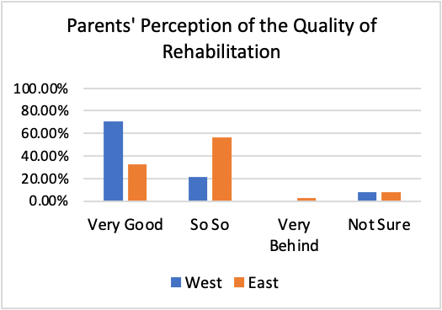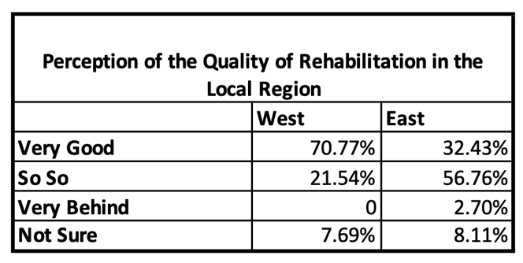

***Factors Affecting Quality and Accessibility of Rehabilitation***

The top three caregiver-chosen factors that affected the quality and accessibility of rehabilitation services are the same between the two regions: “little knowledge about rehabilitation therapy,” “financial,” and “little policy support.” However, the west region respondents chose “little knowledge about rehabilitation therapy” (64.06%), whereas east region respondents chose “little policy support” (62.16%) as the top factor that affected the quality and accessibility of rehabilitation locally. Participants were asked to select all that pertained.

**Figure 2.3**

*Parents’ Perception of the Factors Impacting the Quality and Accessibility of Local Rehabilitation Services*

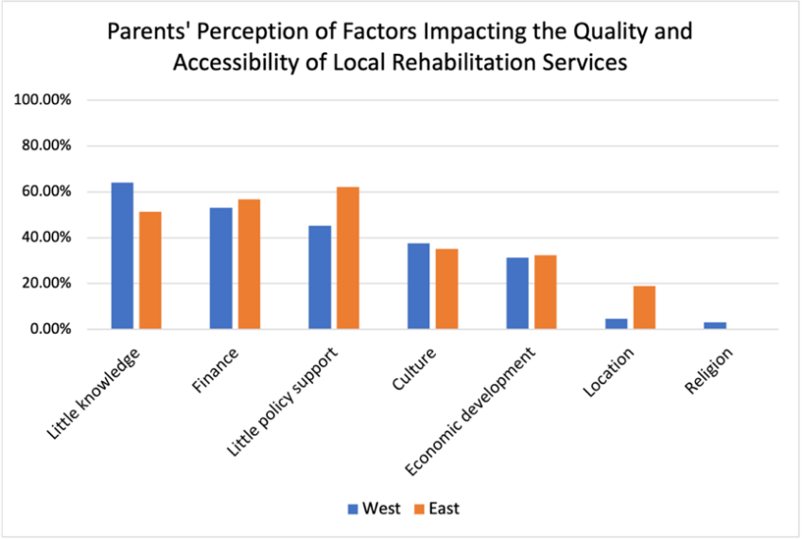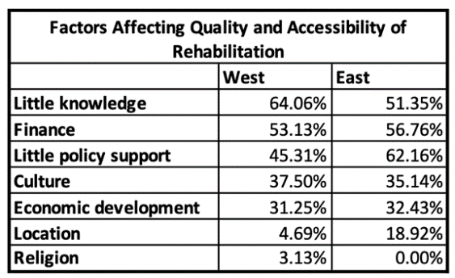

***Awareness of the Types of Therapies Available for Children with Disabilities***

When asked about what types of therapies parents were aware of, the top four types in both regions identified were: (1) speech therapy; (2) play therapy; (3) music therapy; and (4) auditory therapy. The bottom four in both regions were: (1) physical therapy; (2) recreational therapy; (3) dance therapy; and (4) occupational therapy.

**Figure 2.4**

*Parents’ Perception of Types of Therapies*

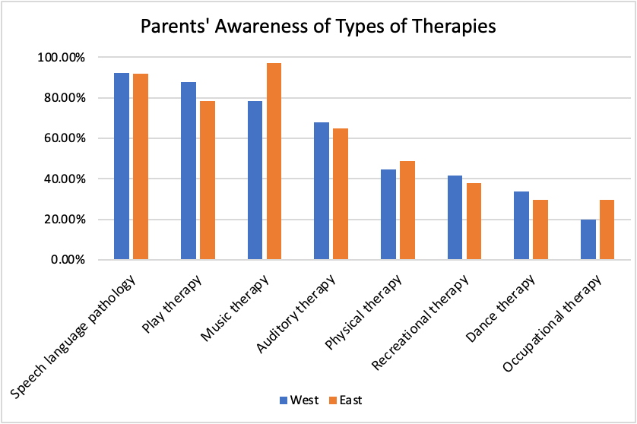 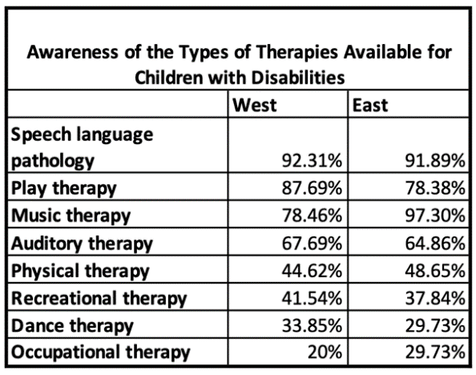

**Discussion**

To better serve people in rehabilitation settings, it is important to understand the impact of regional, cultural, and socioeconomic backgrounds had on people’s experiences and perception of rehabilitation services. The purpose of this sequential quantitative to qualitative mixed method study was to explore and understand the impact of regional, cultural, and socio-economic differences on accessibility and people’s perception of disability and rehabilitation services. The survey was designed to collect demographic information and participants' opinions on rehabilitation services.

An association was observed among education and parents’ age. As reported by the staff, some caregivers in the west region were illiterate, which made it harder for them to learn information and seek help. On the other hand, most parents in the east region had post-secondary education and had an easier time accessing the information they needed. However, no causal factors were determined in this observation. Many factors may contribute to this phenomenon, for example the cost of living in the east region is higher than that in the west. A household with an income of 50,000 RMB in the western region may live better than a household with an income of 50,000 RMB in the east region. In the western region, participants were from a few different provinces. However, in the east region, all participants were from the local province, though different cities and suburbs. This difference suggested a lack of resources in the western part of China. Policies that favor the development of healthcare in west China are needed to attract health professionals to work in these less-developed areas. Financial support would be another key factor to help upgrade the medical equipment in hospitals to provide better care to patients.

As mentioned before, the western region was relatively lacking resources and that was why participants from surrounding provinces moved to this region for treatment. However, most participants from the western region rated the local development of rehabilitation as “very good.” On the contrary, most participants from the east region chose “so-so” even though they had easier access to rehabilitation resources due to the availability of information and their higher educational level. A possible interpretation could be that because of a lack of resources, parents in the west region perceived their rehabilitation services as being “very good” when there were services available. Another interesting finding is that speech language pathology, play therapy, music therapy, and auditory therapy were much better known by participants from both regions than physical therapy, recreational therapy, dance therapy, and occupational therapy, which are typical rehabilitation services in the U.S.

One reason for this difference might be that in China, the definition of each type of therapy is the same as in the U.S.; however, the scopes of practice may differ. Special education teachers at the centers may receive training in physical, occupational, and speech therapy, and may carry out rehabilitation goals in special education classes. In addition, physical and occupational therapy are embedded under the umbrella term, “rehabilitation therapy”. Most of the staff would use the principles and techniques of physical and occupational therapy without being certified as physical or occupational therapists. Therefore, parents were not aware of the terms.

The survey study provided demographic information on caregivers in the two regions. The results confirmed the noticeable differences between the two regions culturally and socioeconomically. Moreover, it revealed significant findings regarding participants’ perception of rehabilitation and the impact of regional, cultural, and social economic factors. As these findings were limited by the nature of quantitative study, the researchers could not fully understand participants’ perceptions. Unanswered questions included how accessibility and differences in perception might affect parents’ experiences of having children with disabilities. To better understand this, the researcher then ran a focus group, posing the question: *What is your experience of having a child with disabilities?* There were six-months between Phase 1 and Phase 2 of the study; the primary reason was this was that the researcher was studying in the U.S. and could only return to China for the focus group study during a school break. Moreover, the 6-month ensured the researcher had enough time to analyze the quantitative data and design the focus group study.

**Figure 2.5**

*Procedural Diagram: mixed methods quantitative to qualitative explanatory study*

**Phase 1**

**Quantitative Survey**

**(n=101)**

**Phase 2**

**Focus Group Interviews**

**(n=50)**

To collect demographic information and caregivers’ perception of rehabilitation services from two culturally and socio-economically different regions.

To understand caregivers’ experiences of having a child with disabilities

**Phase 2**

**Focus Group Interviews (n=50)**

To collect demographic information and caregivers’ perception of rehabilitation services from two culturally and socio-economically different regions.

To understand caregivers’ experiences of having a child with disabilities

**Phase 2 - Parents’ Experiences with Rehabilitation in China**

**Methods**

A qualitative focus group study asked open-ended questions to a sample of eastern and western regions participants to better understand their experiences parenting a child with disabilities and their perspectives of rehabilitation. Questions were informed by results of the phase 1 survey study (Wu, 2021) to a different sample within the same population. Both the survey and the focus group studies used the same population and inclusion/exclusion criteria and may reflect some duplication in samples. The staff at the rehabilitation centers recruited twenty-five parents from each facility for the focus group study.

***Procedure***

Recruitment occurred via a text message sent by an administrator of each rehabilitation center to all parents of current children receiving treatment. The staff sent the recruitment information to parents weekly, starting a month before the focus group starting date. As the majority of mainland China speaks Mandarin Chinese, the recruitment statement was translated into Chinese by the first author. Translated consent forms were also provided. Six semi-structured focus group discussions were then held in the summer of 2019, approximately 6 months after the survey phase was completed. Five focus groups of 5 people each were held in the western region, and one large focus group of 25 people was held in the eastern region. The western region focus groups ran five consecutive days, lasting 60-90 minutes each and located in the same room, with five different participants per group. In the rehabilitation center in the eastern region, one focus group of twenty-five participants was held only once due to time constraints of the center. This focus group lasted 3.5 hours. Each caregiver attended a single focus group. Having five focus groups, 60-90 minutes each, from the western region yielded more text than the one 3.5-hour focus group in the eastern region.

Each focus group began with the primary investigator describing the research question, explaining consent, and responding to questions. Questions included:

* What is your experience of having a child with disabilities?
* What does rehabilitation mean to you?
* What are your hopes for your children in the future?
* How can healthcare services better support your needs?

Focus group discussions were audio recorded, transcribed into Chinese, translated into English, and later analyzed for themes. Each participant was given a pseudonym at the time of transcription to ensure anonymity. Transcribed English text from the focus group discussions was selected and labeled as meaning units separately by the researcher and an experienced qualitative researcher, and then compared to ensure agreement. When disagreements arose, researchers discussed until agreement was reached, most often in response to cultural norms.

***Data Analysis***

The transcribed words, translated from Chinese to English, were the basic form of data used in the qualitative focus group study (Miles, Saldaña, & Saldaña, 2014). Reverse translation (from English to Chinese) was applied to ensure original Chinese translation was accurate. The first author approached each interview using an open stance to prevent leading participants toward answers. The descriptive information compiled during the focus groups was coded into meaning units. In Vivo coding (Miles, Saldaña, & Saldaña, 2014) and emotion coding (Miles, Saldaña, & Saldaña, 2014) were applied in this study. In Vivo coding uses the words from the participant's own language directly as codes (Miles, Saldaña, & Saldaña, 2014). This coding strategy helped to capture existing group cultural categories. For example, one participant said “The child’s father does not want him. He felt that having such a child would not be acceptable.” The researchers coded the meaning unit as “having such a child would not be acceptable.” Emotion coding “provides insight into the participants’ perspectives, worldviews, and life conditions” (Miles, Saldaña, & Saldaña, 2014). For example, one participant said, “I was so angry that I was grinding my teeth.” The researchers coded the meaning unit as “so angry grinding teeth.” In Vivo coding focuses on participants’ exact language while emotion coding pays attention to participants' emotional language to reflect their perspectives. After coding each individual focus group transcript, themes were categorized across all focus group discussions. To reduce their influence, both researchers openly discussed personal biases about rehabilitation in China before analyzing data. Strategies used to reduce bias included using the participants’ own words to describe a theme, finding agreement between the two researchers who independently read and identified meaning units first separately, and the final assignment of a meaning unit by agreement between the two researchers.

**Figure 2.6**

*Data Analysis Procedure*

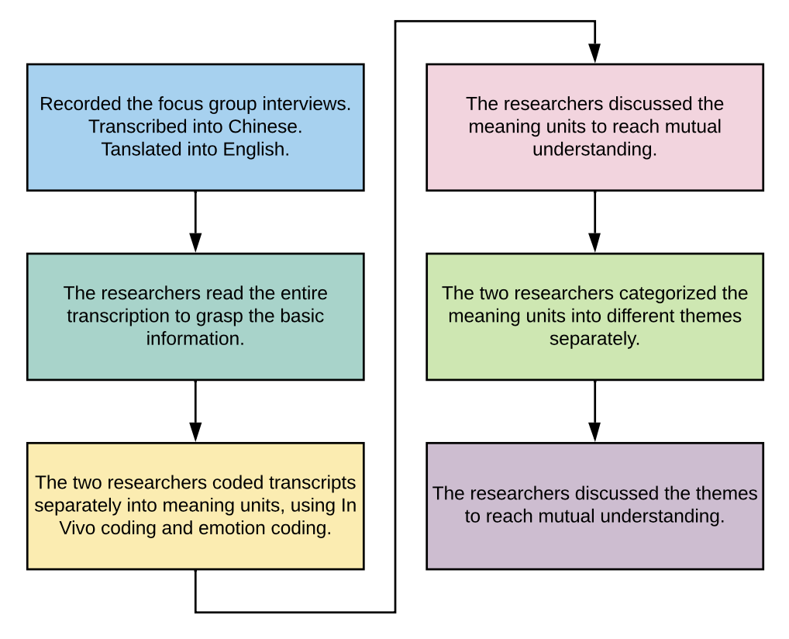

**Results**

The following key themes emerged from the words spoken by focus group participants: Being Different, Feeling Vulnerable, Being Resilient, Valuing Kindness and Support, and Accepting the Disability.

**Figure 2.7**

*Themes that Emerged from the Focus Group Interviews*

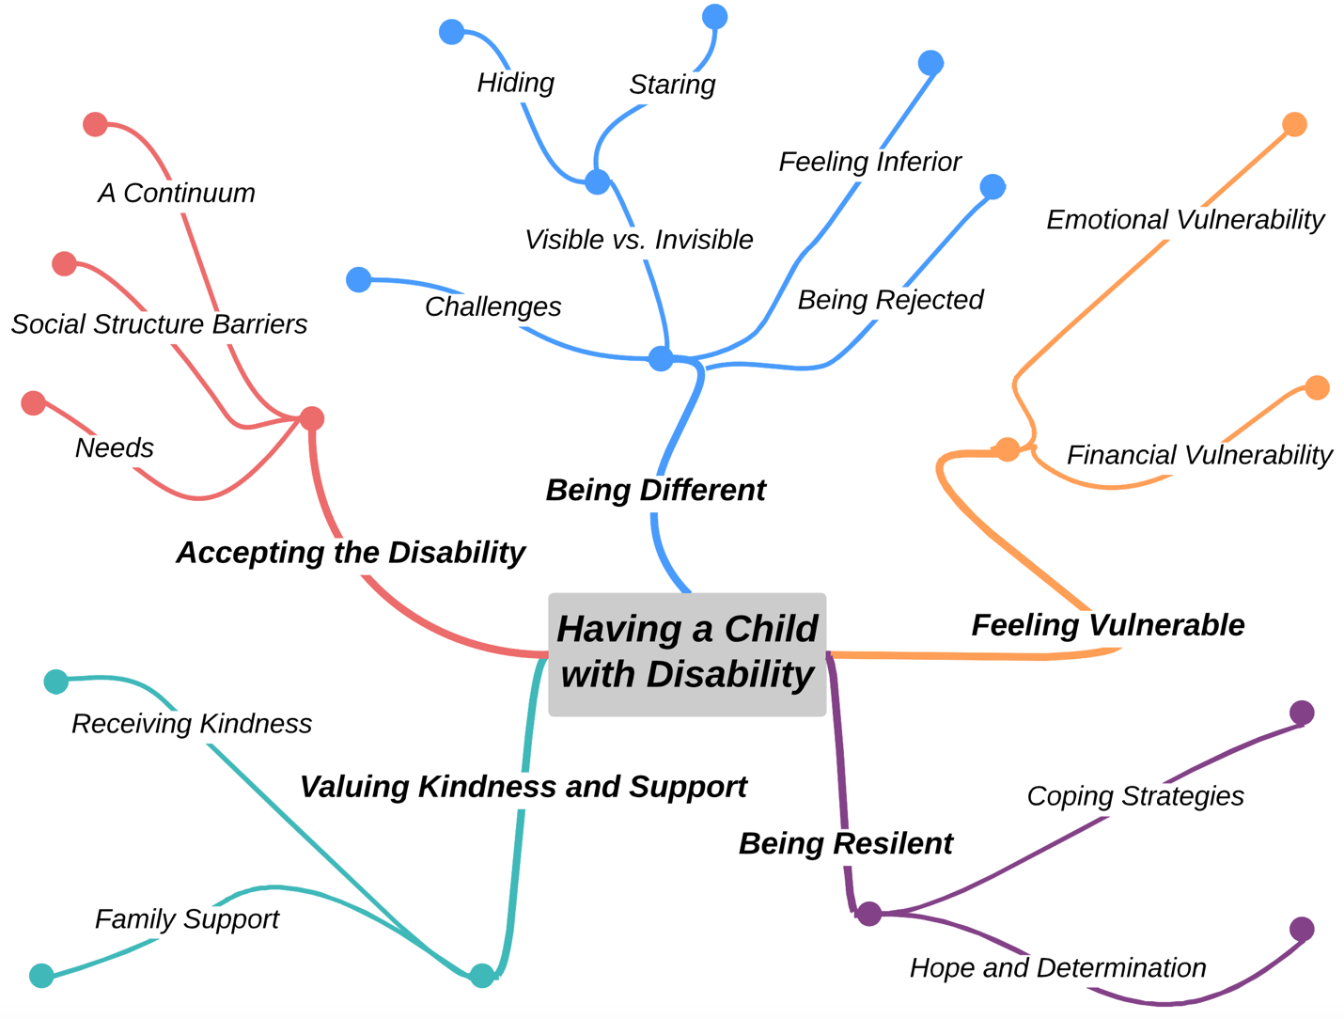

***Being Different***

The presenting symptoms of a neurodiverse child are different from a neuro-typical child. Jie said that her little girl “sometimes laughs so loudly and screams. Other caregivers realize that there is something wrong with her.” Caregivers observed that some people saw their children but pretended not to; others would stare at their children. According to Jie, “sometimes other caregivers look at my child strangely.” Children who have cochlear implants may easily draw people’s attention. Ting mentioned that “sometimes when I take my son out, someone will ask him ‘What are you wearing? Do you have a hole on your head?’” Sometimes, families, neighbors, and strangers' reactions to their children made caregivers feel inferior. Jie shared an incident when her daughter attended a community dance class and pulled another girl’s hair. The other girl’s grandma came and slapped her daughter’s hand, "What are you doing? Why are you touching my granddaughter and making her hair messy?!" Jie wept and said, “I cried that time.” Qiang also reported that once, when he heard other children calling his son a derogatory name, “I was so angry that I was grinding my teeth.”

Physical and behavioral differences make disability visible. Emotional and social behavioral challenges that make children with disabilities different can result in inappropriate attention and comments from community members. As a result, caregivers of children with disabilities may experience feelings of inferiority and rejection because of how people treat their children.

***Feeling Vulnerable***

Caregivers experience both emotional and financial stresses due to social stigma, lack of support, and limited accessibility to public rehabilitation services, and financial hardships. Some participants expressed feeling emotionally vulnerable. Su, a grandparent said, “As the grandma, I feel that my daughter has been depressed in the past two years because of stress. I think that having such a child makes caregivers feel ashamed.” The stress parents experience may also have a negative effect on their temperament. “My husband was always very patient. But now, because of our child, he loses his patience very easily,” Zhen said.

As Dong pointed out, “caregivers are deeply anxious and desperately need help.” Caregivers wanted more information about how they could help their children at home: “I don't know where to start when I get home, how to teach my child.” Wen spoke of her own stress about this: “I have a headache every time I think about this. Where do I take her afterwards [after she ages out of rehabilitation services]?” “Rehabilitation is not something short-term,” Yan said, “We can hardly afford the private treatment centers.” Limited availability and access to public rehabilitation centers, resulted in some families leaving their homes to move to a different city. Such was the case with Ran’s family: “We are not local, so we have to rent an apartment which brings economic pressure.” For families that did not have grandparents able to watch the child, parents negotiated working and child watching duties, often not working outside of the home at the same time. These families reorganized their schedules to cope with the situation. As Ling described: “Usually my husband comes home after work and stays with our child and then I go to work.” Li agreed: “One parent will go out to earn money and the other takes care of the child, or one of the parents switches to night shifts to take care of the child during the day.” With one parent staying home with the child, the household income is basically cut in half.

Caregivers in this study were vulnerable both emotionally and financially. Participants expressed feelings of loneliness, desire for family and community support, and concerns about the high cost of services to help their children with disabilities.

***Being Resilient***

Caregivers developed a variety of coping strategies, including self-care. Ling said, “If you think too much about the future, you will put too much pressure on yourself. It is good just to live one day at a time.” Other caregivers used coping strategies such as talking to colleagues, going to movies, planning family vacations, and shopping. “I play sports with my neighbors as a way of venting and relaxing… I think, as parents, our attitude is very important. Attitude determines altitude,” Lin said. Jia described another way of coping, “The way I handle it is that the more you look at my son, the more I stare at you.” Hong tried another option, “I would try to bring my child to say hello to others, try to be friendly first. If you are friendly first, others will be friendly to you.” Caregivers frequently brought up hope: “I also want to have hope and I feel that I must change my mindset. If I have a good attitude, I can pass positive energy to my child,” Zhen said. Regardless, they are determined to provide the best to their children, as Pu said, “There is no other way. I will use all my strength to raise my grandson.” “It will get better and better as long as .... we all look after our child,” Jia echoed.

Caregivers developed different coping strategies in dealing with their stress of daily life. Some reported “thinking too much,” some reported doing fun things with family and friends, and some learned how to confront injustice. Caregivers expressed their hope and determination, eager to provide the best support for their children.

***Valuing Kindness and Support***

Another theme that arose from the focus group discussions was how participants valued kindness and support those caregivers received. Unlike resilience, which comes from within, kindness and support were provided to individual caregivers by external sources. Kindness and support included kind words from a neighbor, support from family members including the grandparents’ involved in taking care of the children. Lan described, “In the community, most people who see such a child [with a disability] will sympathize with his parents. They feel that the parents will be with this child for a lifetime” (Qing). Others commented that the kindness and encouragement from neighbors and strangers were heart-warming and let the caregivers feel “there are more good people in the world.” Qiang described, “A lady in her 50’s in our neighborhood is very kind. My child goes to visit that lady every day at noon.” This kindness is also mutual, Qiang continued, “The lady said to me, ‘Look, your son’s heart is clear. I talk to him, and he knows me.’ My son knows that only this lady talks to him, so he loves her back.” Jia, another participant responded, “Our neighbors are very good. When they see us, they say, ‘The child is much better now.’ These words are so warm.”

The compassionate words from others and practical help from family members are important to caregivers of children with disabilities. They became the fuel to keep them going and provided hope for the families that “there still are more people who are kind.”

***Accepting Disability***

The perception of rehabilitation is caregivers’ opinion related to rehabilitation, including what rehabilitation is to them, how they use rehabilitative concepts in their daily lives, what rehabilitative goals they want their children to achieve, and barriers in the long-term rehabilitation process. At the beginning, many caregivers, particularly in the rural areas, had little knowledge about early childhood development. “There are no similar children around. I never knew what autism, developmental delay, or Down syndrome was. We didn’t know what the milestones of a child’s development are and when a child should talk,” Jie said. Some caregivers seek information on their own to continue the rehabilitation process. Lin creatively used his knowledge of rehabilitation and took every opportunity to help his children gain functional skills: “My son’s hobby is like mine. We love to fix things. Sometimes I take out some old devices for him to play with. I use this to develop his fine motor skills.”

Caregivers expressed need for greater support to help better integrate their children into society. Ye, a parent from the eastern region stated, “Social acceptance is not enough, and it is difficult for children to integrate. Caregivers identified a lack of service options and professional support. Yao stated, “We parents read books or watch videos to learn about rehabilitation… still we lack professional support.” Social structure change and legislative support are common requests of caregivers. They realize individual efforts are not enough to support their children’s long-term rehabilitation. Dong stated “We need assurance for our children’s future. We don't have a sense of security right now.” Jing followed, “I hope there will be more organizations for the children to go to later. I hope that with the development of our society, there will be a public care institution that will give caregivers a break.” Although, rehabilitation services and policies have come a long way in mainland China, there are still many needs to be addressed.

In answering the overarching question: *what is your experience of having a child with a disability,* caregivers expressed and elaborated on their experiences of being different, feeling vulnerable, being resilient, valuing kindness and support, and accepting disability. The similarities and differences between the eastern and western regions are discussed in the following section.

**Discussion**

The qualitative results supported previous research on caregivers’ experiences of physical, emotional, and financial strains, as well as the needs of support programs and skill training (Schulz & Sherwood, 2008; Goudie, Narcisse, Hall & Juo, 2014; Pilapil, Coletti, Rabey & DeLaet. 2017). Caregivers need continuous education and training in facing and addressing new situations as they manage the care of their children at home (Spratling & Lee, 2020). Findings from the current focus group study confirmed the needs of respite care, sustainable programs, and skill training in better serving children with disabilities and their caregivers.

Care providers from various countries describe similar experiences, yet culturally nuanced (Jones, Ward, Hodkinson, Reid, Wallis, Harrison & Argent, 2016; Tennant, Allana, Mercer & Burns, 2022). According to previous research, families who are affected by disabilities experience stress and financial hardship; however, the support they receive contributes to their resilience (Farrell & Krahn, 2015). A phenomenological study on caregivers’ experiences in Swaziland found that parents experience “challenges at work, home, school, and in the community such as emotional stress, failure to cope with the children’s disability and financial challenges” (Thwala, Ntinda, & Hlanze, 2015). The study also suggests the need for parental training programs and government policies to ensure the children’s welfare.

Two ways of thinking about rehabilitation emerged from the focus group discussions. The medical model of rehabilitation focuses on skill-development, such as improving language, social communication, and emotional regulation skills (Marks, 1997). On the other hand, the social society’s attitudes towards disabilities, providing social structures, and adapting the environment to better support individuals with disabilities (Marks, 1997). Caregivers supported rehabilitation at home by incorporating new information into their children’s daily activities. Some participants demonstrated their understanding of “family shared occupation” and acted like amateur therapists (Pickens & Pizur‐Barnekow, 2009; Sachs & Nasser, 2009).

**Limitation and Future Research Directions**

The interpretation might be biased because of the first author’s familiarity with the east region of this study. However, in-vivo coding was used to preserve participants' essential meaning and prevent biased interpretation. Because both the quantitative survey study and the qualitative focus group study drew from the same population, there might be bias in the results. Another limitation was that different focus group formats were used in the two regions and this difference might bias results towards the west region where five smaller focus groups occurred.

Future studies may look at gender differences about the perception of rehabilitation in greater depth. This current study combined and analyzed the data from both east and west regions. Future studies might want to just look at one region at a time to compare the difference of experience in different regions. This study also inspires other study questions. For example, why people under the same circumstance have different experiences? What are the factors that contribute to that? As the field of rehabilitation is rapidly developing in mainland China, the authors anticipate that people’s access to and perception of rehabilitation services will change accordingly. A longitudinal or follow-up study might be worth conducting to capture the development and progress of rehabilitation services in mainland China.

**Conclusion**

This mixed method study provided a comprehensive view of how caregivers who have children of disabilities from two culturally, socially, and economically different regions viewed rehabilitation services in mainland China, and how these differences impacted their experiences of having a child with disabilities. Despite all the differences between the two regions, caregivers’ experiences have some consistently similar themes. The east region, more culturally open and economically developed, had better access to more rehabilitation services compared to the west region. Moreover, their perception of rehabilitation services was more sophisticated; that is, rather than focusing on immediate rehabilitation needs, they were concerned about developing long-term legislative changes. The results suggest the needs for continued coping strategies for managing care, enhanced public education to reduce stigma and misunderstandings towards disabilities, and the existence of long-term care plans supported by disabilities legislation.

**References**

Bapaye, J., & Bapaye, H. (2021). Demographic factors influencing the impact of coronavirus-

related misinformation on WhatsApp: Cross-sectional questionnaire study. *JMIR Public Health and Surveillance, 7*(1), E19858.

Bedford, O., & Hwang, K. (2003). Guilt and shame in Chinese culture: A cross‐cultural

framework from the perspective of morality and identity. *Journal for the Theory of Social Behaviour, 33*(2), 127-144.

Bunning, K., Gona, J. K., Newton, C. R., & Hartley, S. (2017). The perception of disability by community groups: Stories of local understanding, beliefs and challenges in a rural part of Kenya. *PloS one*, *12*(8), e0182214. <https://doi.org/10.1371/journal.pone.0182214>

Chen, W., & Liu, J. J. (2009). *Future Population Trends in China: 2005-2050*. Centre of

Policy Studies and the Impact Project. <https://www.copsmodels.com/ftp/workpapr/g-191.pdf>

Chu, Y. (2011). The influence of the mode of traditional thinking on Chinese social life.

*Journal of Beijing University (Humanities and Social Sciences), 9*(1), 30-34.

Dai, H., Xue, H., Yin, Z. J., and Xiao, Z. X. (2006), The need and its influence factors

for community-based rehabilitation services for disabled persons in one district in Beijing. *Biomedical and Environmental Sciences 19*, 495-497.

Dev, S., & Qayyum, N. (2017). Major factors affecting students' perception towards faculty

evaluation of teaching (SET). *Journal of Social Studies Education Research, 8*(3), 149-167.

Farrell, A., & Krahn, G. (2014). Family life goes on: Disability in contemporary families.

*Family Relations, 63*(1), 1-6. <https://www.ncbi.nlm.nih.gov/pmc/articles/PMC4501905/>

Fitzgerald, N., Ryan, P., & Fitzgerald, A. (2015). Team-based approaches in early intervention services for children with disabilities: Irish parents' experiences. *Journal of Policy and Practice in Intellectual Disabilities, 12*(3), 199-209. <https://onlinelibrary-wiley-com.ezp1.lib.umn.edu/doi/pdfdirect/10.1111/jppi.12126>

Gilson, K., Johnson, S., Davis, E., Brunton, S., Swift, E., Reddihough, D., & Williams, K.

(2018). Supporting the mental health of mothers of children with a disability: Health professional perceptions of need, role, and challenges. *Child: Care, Health & Development, 44*(5), 721-729.

Goudie, A., Narcisse, M., Hall, D., & Kuo, D. (2014). Financial and psychological stressors

associated with caring for children with disability. *Families Systems & Health, 32*(3), 280-290.

Hasmath, R., & Macdonald, A. (2018). Beyond special privileges: The discretionary

treatment of ethnic minorities in China's welfare system. *Journal of Social Policy, 47*(2), 295-316.

He F. (2007). Continuous standard home-based rehabilitation for stroke patients [in

Chinese] *Mod Med Heal, 18*, 2790–2791.

Hou, J. (2015), Report on the situation, influences, and factors that prevent disabled

children in our country from attending school. *Chinese Special Education*, 1. <http://www.cssn.cn/jyx/jyx_tsjyx/201505/t20150522_1977101.shtml>

Huang Y.L. (2011). Research on developing community-based rehabilitation in the

background of health reform [in Chinese]. *Fujian Univ Tradit Chin Med, 21*, 65–66.

Jones, C., Ward, A., Hodkinson, P., Reid, S., Wallis, L., Harrison, S., & Argent, A. (2016).

Caregivers' experiences of pathways to care for seriously ill children in Cape Town, South Africa: A qualitative investigation. *PloS One, 11*(3), E0151606.

Kübler-Ross, E. & Kessler, D. (2005). *On grief and grieving: Finding the meaning of grief*

*through thefFive stages of loss*. Scribner.

Kwong, M. (2015). China’s east west income gap widens. *South China Morning Post*.

<https://www.scmp.com/news/china/money-wealth/article/1811156/chinas-east-west-income-gap-widens>

Li, B., & Chen, Y. (2020). *Tutorial for outline of the Healthy China 2030 Plan: National Health Commission of the Peoples Republic of China.* Springer.

Liang, Q. D. & Liang, Q. Y. (2018). Research on the application of music therapy concept in

special children's music education. *Journal of Jiangsu University of Technology, 24*(6), 111-114.

Ling T.Y., Wang H., Wang X.L. (2005). Survey on community health needs of patients

with cerebral vascular diseases [in Chinese]. *Chin General Pract, 8*, 249–251.

Mao, Q. (2009). On the essence of the collective culture in Confucianism. *Liaoning Normal*

*University Journal, 32*(1), 11-15.

Marks, D. (1997). Models of disability. *Disability and Rehabilitation, 19*(3), 85-91.

Miles, H., Saldaña, H., & Saldaña, J. (2014). *Qualitative data analysis: A methods sourcebook* (3rd ed.). SAGE Publications.

National Bureau of Statistics of China (2000). *The Fifth National Census Database*.

Ottenbacher, Jette, Fuhrer, & Granger. (2012). Looking back and thinking forward: 20

years of disability and rehabilitation research. *Archives of Physical Medicine and Rehabilitation, 93*(8), 1392-1394.

Pickens, N. D., & Pizur‐Barnekow, K. (2009). Co‐occupation: Extending the dialogue. *Journal of Occupational Science, 16*, 151-156.

Pilapil, M., Coletti, D., Rabey, C., & DeLaet, D. (2017). Caring for the caregiver: Supporting

families of youth with special health care needs. *Current Problems in Pediatric and Adolescent Health Care, 47*(8), 190-199.

Pope, A. M., & Tralov, A. R. (1991). *Disability in America: Toward a National Agenda for*

*Prevention*. National Academies Press.

Rong, X., Peng, Y., Yu, H., & Li, D. (2017). Cultural factors influencing dietary and

fluid restriction behaviour: Perceptions of older Chinese patients with heart failure. *Journal of Clinical Nursing, 26*(5-6), 717-726.

RStudio Team. (2020). RStudio: Integrated Development for R. RStudio, PBC, Boston, MA.

Sachs, D., & Nasser, K. (2009). Facilitating family occupations: Family member perceptions of a specialized environment for children with mental retardation. *The American Journal of Occupational Therapy: Official Publication of the American Occupational Therapy Association*, *63*(4), 453–462. <https://doi.org/10.5014/ajot.63.4.453>

Scarinci, N., Erbasi, E., Moore, E., Ching, T., & Marnane, V. (2018). The caregivers' perspective of the early diagnostic period of their child with hearing loss: Information and support. *International Journal of Audiology, 57*(Sup2), S3-S14.

Schulz, R., & Sherwood, P. (2008). Physical and mental health effects of family caregiving.

*American Journal of Nursing, 108*(9 Suppl), 23-27.

Spratling, R., & Lee, J. (2020). Caregivers’ experiences in symptom management for their

children who require medical technology at home. *Journal for Specialists in Pediatric Nursing, 25*(1), E12275-N/a.

Sun, J., & Cheng, D. (2018). *China's generation gap* (Routledge contemporary China series; 183). Abingdon, Oxon; New York, NY: Routledge, an imprint of the Taylor & Francis Group.

Tennant, R., Allana, S., Mercer, K., & Burns, C. (2022). Exploring the experiences of family

caregivers of children with special health care needs to inform the design of digital health systems: Formative qualitative study. *JMIR Formative Research, 6*(1), E28895.

Tigere, B., & Makhubele, J. (2019). The experiences of parents of children living with

disabilities at Lehlaba Protective Workshop in Sekhukhune district of Limpopo province. *African Journal of Disability, 8*(1), 1-9. <https://www.ncbi.nlm.nih.gov/pmc/articles/PMC6779969/>

The Information Office of the State Council, the People’s Republic of China, *National Human Rights Action Plan of China, 2012–2015* (June, 2016)https://www.cecc.gov/resources/legal-provisions/national-human-rights-action-plan-of-china-2012-2015

Thwala, S., Ntinda, K., & Hlanze, B. (2015). Lived experiences of parents’ of children with

disabilities in Swaziland. *Journal of Education and Training Studies, 3*(4), 206. <https://files.eric.ed.gov/fulltext/EJ1067249.pdf>

Tu, M. (2018). Education, migration and family relations between China and the UK: The

transnational one-child generation (First ed.). Bingley: Emerald Publishing.

United States Social Security Administration. *Supplemental Security Income Home Page – 2022 Edition.* (2022). Retrieved April 25, 2022, from <https://www.ssa.gov/ssi/>.

Wang, B., & Mi, Z. X. (2012). Research on rehabilitation medical service system

construction in China. *Chinese Hospitals, 16*(6), pp:9-10.

Wang B.H., Mi Z.X., Cheng J. (2012). Research on rehabilitation medical service system

construction in China [in Chinese] *Chinese Hospitals, 16*, 9–10.

Wang, Y. (2016, March 7). A glance at people with disabilities in China. *China Source*.

<https://www.chinasource.org/resource-library/articles/a-glance-at-people-with-disabilities-in-china>

World Health Organization*.* (2016). Healthy China, *World Health Organization*.

Whitmore, K., & Snethen, J. (2018). Respite care services for children with special healthcare

needs: Parental perceptions. *Journal for Specialists in Pediatric Nursing, 23*(3), E12217-N/a.

Wu, T. (2018). A historical review of teacher training for special education in modern China.

*Teacher Development Research, 2*(3), 81-87.

Wu, Y. (2021). The impact of social economics and cultural factors on accessibility and

perception of rehabilitation in mainland China. *Archives of Physical Medicine and Rehabilitation, 102*(10), E58.

Xiao, Y., Zhao, K., Ma, Z.-X., Li, X., & Qiu. Y.-P. (2017). Integrated medical rehabilitation delivery in China. *Chronic Diseases and Translational Medicine,* *3*(2), 75-81.

Yiğitalp, G., Bayram Değer, V., & Çifçi, S. (2021). Health literacy, health perception and related factors among different ethnic groups: A cross-sectional study in southeastern Turkey. *BMC Public Health, 21*(1), 1-1109.

Zhang, H., & Shen, Q. (2014). The current situation of rehabilitation medical service

system in China: Problems and challenges. *Business and Management Research,* *3*(2), 42-46.

Zhuang, N. (2016), *Outline of the Healthy China 2030 Plan* [Powerpoint slides].

<https://www.sahealth.sa.gov.au/wps/wcm/connect/d39abd8041032c76a711ff1afc50ebfc/1645+Ning+Zhuang.pdf?MOD=AJPERES&CACHEID=ROOTWORKSPACE-d39abd8041032c76a711ff1afc50ebfc-msgAXUQ>

Creative Commons CC:BY logo **Understanding Parents’ Voices in Mainland China – A Sequential Mixed Methods Study** by Yue Wu and Peggy M. Martin <https://rdsjournal.org/index.php/journal/article/view/1229> is licensed under a [Creative Commons Attribution 4.0 International License](http://creativecommons.org/licenses/by/4.0/). Based on a work at<https://rdsjournal.org>.