The Past, Present and Future:
Hukou as a Social Status and Its Impact on Chinese Disabled Migrant Workers’ Social Mobility in the Labor Market
Cunqiang Shi¹ and Debbie Foster²
¹ Bangor University
² Cardiff Business School, Cardiff University

Abstract
Liberalization has transformed the economy in China, but legacy policies such as the hukou system undermine free movement of labor and embed discrimination in the labor market. Opportunities for social mobility are restricted for all migrant workers, but this article argues disabled migrants experience a specific form of ghettoization.
Keywords: disability, employment, hukou discrimination, China.

The Past, Present and Future:
Hukou as a Social Status and Its Impact on Chinese Disabled Migrant Workers’ Social Mobility in the Labor Market
Over the past four decades the rights of Chinese disabled people have attracted increased public attention because of the establishment of disability advocacy institutions, such as the Chinese Disabled People’s Federation (Stone, 1998), and the Chinese government’s ratification of the United Nation’s Convention on the Rights of Disabled People (UNCRPD). Despite this interest, however, disabled people do not appear to have benefited significantly from rapid urbanization and modernization in China. And, as this article demonstrates, they have been particularly disadvantaged by the legacy of past policies that continue to perpetuate social-spatial disparities in employment (Liao et al., 2016; Zhao & Li, 2019). The consequences stemming from the legacy of the hukou system, a means of categorizing the population as well as monitoring and controlling migration, is one such example. This essay argues that, not only is the hukou system unsuited to a reformed labor market, but its operation has doubly disadvantaged and divided disabled people, operating as an obstacle to their economic independence and identity as a group.
The hukou system is a form of household registration, and although there is evidence that it is detrimental to all migrant workers’ social mobility (Song, 2016; Wang et al., 2021), little is known about the specific experiences of disabled migrant workers as a sub-category. By drawing on 48 semi-structured interviews with disabled people in China examining their labor market experiences, this essay addresses this gap in current literature. It will illustrate the ways in which the hukou system shapes an individual’s social status and interacts with the socially and culturally constructed category of ‘disability’ within a Chinese context.
After examining the discriminatory impact hukou has had on disabled people as a socially disadvantaged group in China, the essay then considers social, educational, and employment disparities that are disproportionately faced by disabled migrants. This population is likely to face direct and indirect discrimination. Finally, the article highlights the contradictory legacy of the hukou system and the drive for labor market liberalization. As such, it argues that the tensions between the past and present have particularly disadvantaged disabled migrant workers, negatively impacting their access to economic prosperity.
The Legacy of the Planned Economy: The Historical Context of Hukou
The hukou system was originally intended as a social status identification system. It enabled the state to differentiate citizens during the Maoist centrally planned developmental era (1949-79) for purposes of controlling the national migration flow from rural to urban areas (Greenhalgh & Winckler, 2005). The consequences of its continued application to citizens in the modern era, however, are often not fully appreciated (McElroy & Yang, 2000; Chan, 2010). What was essentially viewed as a functional dualistic socioeconomic structure implemented by the Chinese Communist Party has in contemporary China created significant inequalities. This is particularly true in relation to access to education, healthcare, and employment between urban and rural citizens (Qi et al., 2015), evident in patterns of geographical inequality. The liberalization and marketization of the Chinese economy has involved a significant relocation of migrant workers from rural to urban regions. The original purpose of hukou as a migration control policy, therefore, no longer appears to be served. Instead, it could be argued that this has actively created social divisions by limiting equal access to employment opportunities. Wang et al. (2021) suggest that, despite several reform attempts by the government to reduce hukou’s effects on social mobility, hukou has continued to play a major role in discrimination in the Chinese labor market. We will examine new policies and rules aimed at addressing urban-rural integration.
Hukou, the Ableist Discourse of Citizenship and the Myth of Meritocracy
Rapid economic growth, the need to relocate labor, and an acceleration in urbanization have led to migration from the countryside to cities. However, this labor migration has created the so-called “floating population” of more than 200 million people; these individuals do not have local hukou but are resident in cities (Chan, 2010). Among disabled people in the population, 76.7% have the status of rural hukou (Ling et al. 2018), which is concerning when contrasted with a national urbanization rate of 64.72% in 2021 (State Council of the People’s Republic of China, 2022). Thus the probability of disabled people who move to cities making up a high proportion of those with urban hukou is low. Despite no official data on the urbanization rate of the disabled population, it can be reasonably assumed that lack of accessible infrastructure in transportation and barriers to enter the urban job market disadvantage disabled people’s social mobility in China.
When migrating to a city, disabled workers place themselves at significant risk because of the mismatched hukou of their original hometown and their current residential emigrating city (Xiao et al., 2018). This mismatched hukou status has excluded migrants from local service provisions such as healthcare and vocational training, which are particularly important if migrants wish to increase their competitiveness in the job market.
For migrants who wish to settle in cities, there are, however, two potential ways to obtain urban hukou. The first option is through urban expansion: people who live in suburban areas might be granted urban hukou in exchange for their land ownership (Wu & Zheng, 2018). This is a lottery system because citizens do not have any control over the scheme. The second method is a so-called ‘merit-based’ selection system. Hukou is used to attract talent and investment into regions, but in reality, it is mainly wealthy, educated people who are selected by local government to qualify as there are strong connections between education and income inequality (Xu et al., 2018). Disabled people are less likely to be selected under these criteria as many have not attended mainstream schools and, if located in rural areas, are materially disadvantaged. Furthermore, critics suggest that, under this scheme, local government takes over the role of employers in judging the value of laborers, which in turn contributes to regional inequalities as fiscally richer cities are more likely to attract the most ‘able’ and ‘talented’ migrants than poorer ones (Cooke & Wang, 2019). This classification of migrants on an individual's economic contribution and education will favor wealthy and educated citizens over those more likely to have socially-economically disadvantaged hukou.
The Marginalization of Disabled People in the Labor Market as Consequence of Hukou
Although the hukou policy is applicable to everyone in China, it has particularly negative implications for disabled people and their social mobility in the ever-changing labor market. The way hukou distinguishes between rural and urban citizenship is an indicator of access to social-economic opportunities and resources and should be regarded as an important contributor to one’s social status, something associated with birth and social position. In the Chinese context, research suggests the employment rate among disabled urban citizens is statistically significantly higher than that of their rural counterparts (Liao et al., 2016). This suggests status advantages from possessing urban hukou.
To understand hukou as part of an individual’s social status and how it marginalizes disabled people in the labor market, several Chinese contextual characteristics need to be considered. The hukou system is particularly associated with individual households or families. Existing research on the role of the family’s economic and social position in influencing disabled people’s career choices suggests a substantial gap between rural and urban households (Fisher & Jing, 2008). In urban areas, the annual income of households with and without disabled members is substantially different (14,505.9 yuan [≈US$ 2,000] vs 24,564.5 yuan [≈US$ 3,500]), with the gap being narrower in rural regions (6,971.4 yuan [≈US$ 1,000] vs 7,913.1 yuan [≈US$ 1,140]). In addition, due to the lack of state financial support to accommodate medical or physical adjustments, households with disabled members are likely to shoulder the ‘extra cost of disability’ (Loyalka et al., 2014).
Hukou also determines a citizen’s access to educational opportunities and choices, as most public schools only admit students from their local communities. Urban, disabled people are more likely to receive higher quality education, which in turn provides more opportunities in the job market, as educational qualifications are a main criteria for career success in China (Xu et al., 2018).
The kinship oriented social relational tradition in China, along with the dualistic urban/rural socio-economic structure, likely further disadvantage disabled people in the labor market. The Chinese concept of guanxi or social ties, often forged from informal social relations, enhances a person’s social capital and has been shown to be significant in networking and progressing careers (Chen & Volker, 2006). Guanxi is based on an exchange of favors among social members in the circle to which they belong (quanzi); it is predicated on the belief that such exchanges will improve the collective interest of the group by connecting social resources possessed by members (Bian & Ang, 1997). Interdependence and mutual obligations are, therefore, core features of guanxi based on belonging to a social group (Bian & Logan, 1996). Guanxi can interfere with what should be neutral recruitment and selection decisions (Whyte & Parish, 1984), career progression (Bian & Ang, 1997) and social relations at work (Chen & Volker, 2016). Furthermore, because of the unbalanced economic and political structure that has been influenced by differences in hukou status, urban citizens tend to have more powerful guanxi networks than rural migrants, who tend to have fewer favors to offer in exchange for access to a valuable guanxi network (Gold et al., 2002). This is likely to have a significant impact on disabled migrant workers in the labor market who could find themselves doubly disadvantaged by the absence of urban hukou and, because of their poor social integration, reduced social capital.
Current debates about the hukou system in China have not considered the experiences of disabled people as a group, especially those who are migrants from rural areas or smaller cities. If reform of the hukou system is to take place, it is important disabled people’s voices are included; the qualitative data presented here helps illuminate the diversity of those experiences.
Research Questions and Methodology
The previous section provided contextual background for considering hukou as social status of Chinese citizens and its impact on disabled people’s social mobility in China’s contemporary labor market. To bridge the knowledge gap identified, the following research questions are posed:
- Are the lived experiences of disabled people in China affected by their social-spatial status? If so, how?
- What impact has the hukou system had on the social mobility of disabled people in the Chinese labor market?
A qualitative approach to data gathering was adopted to give Chinese disabled people opportunities to highlight their lived experiences in the labor market based on their different hukou status and its impact. It is important to acknowledge that the emancipatory nature of this study is to identify and address disabling barriers that all disabled people face in Chinese society, with a specific objective of delivering disabled people’s voices to a broader audience.
Forty-eight semi-structured interviews were conducted in late 2019. The participants’ demographic backgrounds were mixed with variations in education experience, gender identity, employment status and hukou status. Details of each participant can be found in the table below. Except for one informant who refused to reveal their hukou status, there were 19 urban hukou holders and 28 participants with rural hukou. Among the 48 participants, 28 had migration experiences. This can provide a meaningful insight into the role of hukou for disabled migrant workers.
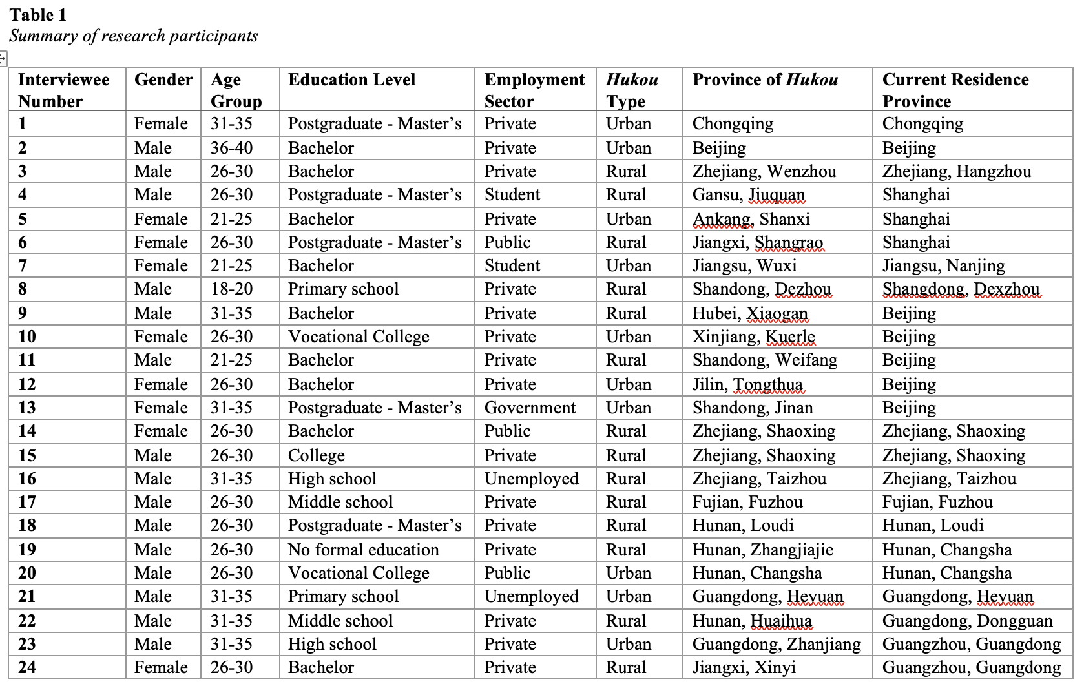
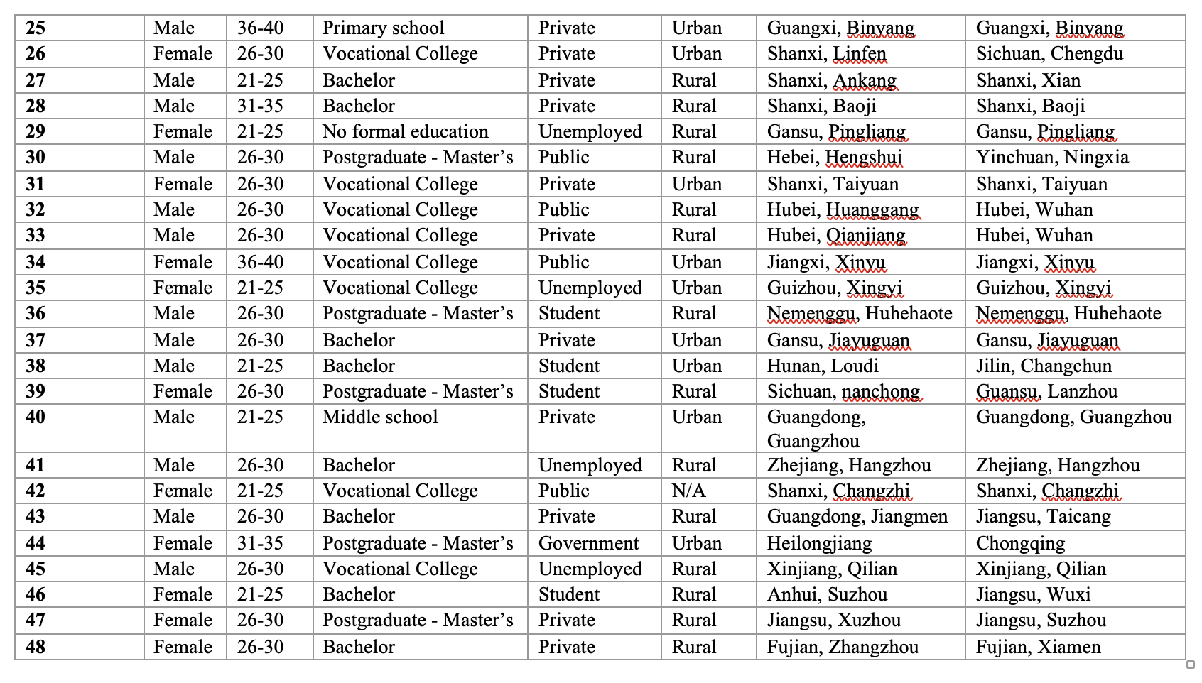
Research Findings
Findings revealed that the most apparent effect of hukou status is the source and extent of social support that a disabled citizen can access. Uneven development and the Chinese government’s focus on improving urban areas are both reflected in rural participants reporting comparatively less social support related to their impairment. The consequence of this for disabled people living in rural areas is greater dependency upon family as well as limited choice of alternative sources of support. Findings also suggest family support is unpredictable and dependent on the goodwill and financial circumstances of each household. This is illustrated by examples from interviews with disabled rural citizens below. These two interviewees had different educational experiences, qualifications and family support that affected their career opportunities:
I was born in an extremely poor village … having a child like me caused my parents a great deal of financial pain … but they have faith in supporting my education, and I could not achieve a postgraduate degree without their dedicated support. (Interviewee 6)
It used to be 600 yuan [≈US$ 85] a year in order to [receive an] education, but my family could not afford it… so I had to drop out of middle school, and now I have no work. (Interviewee 21)
In contrast, disabled interviewees that possessed urban hukou reported receiving or having access to some local government funding making them less dependent on their families, although the amount of financial support was dependent upon location and hukou status. In an economically developed region with a relatively rich local council, disabled people reported receiving significant financial support to help them live independently.
According to Interviewee 41, a worker who has lived in various cities, the amount of money disabled people can receive from the government in a rich region like Zhejiang (where he currently lives), can be up to 2,000 yuan a month. This is about ten times what he could get in his original town. In addition to welfare benefits, disabled workers can also claim tax reductions when working in cities. Interviewee 23, for example, works in Guangzhou (a highly international city) and refers to a substantial personal income tax reduction. In contrast, interviewees from rural areas or less developed cities mention few supportive tax or fiscal benefits.
In addition to differences in support based on residential and hukou status, disabled migrant workers who do not have local hukou are likely to experience higher costs when commuting in cities, despite the better accessibility of the public transport system. For interviewees who had migrated from a rural region or smaller city to economically prosperous cities like Shanghai and Beijing, many reported positive experiences with accessibility when commuting using public transport. Furthermore, it is likely these benefits will be further enhanced for disabled city dwellers because of legal commitments to continue to improve the accessible built environment. Nevertheless, increased accessibility comes at a cost to those who travel frequently, consuming a significant proportion of their monthly income. Many disabled employees also reported being in low-income jobs, which meant they had to live on the peripheries of the city. Disabled residents with local urban hukou, by contrast, could apply for a travel pass from the local council, which can be used for claiming discounted travel fares.
The other significant disadvantage reported by interviewees who were migrants in cities without local hukou was their lack of access to social security provisions. As migrant workers without local social contacts (guanxi), participants also tended to be concentrated in low aspiration, labor-intensive jobs. This could put their health at greater risk than non-disabled workers as many disabled workers need to manage pre-existing impairments; it also meant access to social security was more, not less important. Interviewee 10 worked in a call center, for example, where shifts were pre-arranged by managers. She was constantly concerned about her health because of the intensive nature of her work but tried not to be absent:
Generally, we are not supposed to take sick leave because it will cause significant disruption to other team members… if I become sick (which I try to avoid), I essentially force other colleagues to take on more work. And I cannot afford the huge medical bills if I got sick; it could easily cost me a couple of month’s salary (Interviewee 10)
Other disabled migrant workers without local hukou reported similar worries about their financial vulnerability due to their exclusion from local social security schemes (see interviewees 6 & 22).
Social relations, or guanxi, were found to be important for disabled employees and had a moderate but important connection with hukou status. Interview findings suggest that urban citizens are more likely to have more influential guanxi as they are more likely to be connected with urban employers. Interviewee 31 (a woman with a visual impairment) who has urban hukou in her city used her guanxi network to her advantage to secure her job at a local healthcare organization:
I applied for a job in a public hospital … I was initially rejected, with the excuse that ‘we do not need people on this job anymore’, but later the decision was overturned because I managed to use my guanxi to contact the senior manager in the hospital … then I was told that I could work for the hospital. (Interviewee 31)
This suggests that privileges derive from urban hukou and are interrelated with linkages to a guanxi network that ‘outsiders’ cannot access. Disabled migrants are likely to be disadvantaged by the absence, not only of access to this network, but also lack of social integration as disabled workers. As migrant workers from rural areas, many participants had only socialized with their local communities and reported that they found it difficult to establish guanxi networks in urban workplaces due to the lack of common topics to talk about with colleagues:
My social circle is very small, so I have limited access to resources, and I am unable to have fruitful conversations with others…this made me hugely marginalized because I am not popular at work. (Interviewee 22)
The role of hukou in social relations is relatively indirect. Participants with rural hukou reported few kinship connections in urban cities. This became a major barrier for many who experienced hardship and social exclusion in their attempt to seek and secure employment opportunities. Insecure employment status and poor social networks were problematic for disabled migrants, and interviewees shared their experience of facing further barriers in attempts to obtain local urban hukou. Firstly, the meritocratic standard used to award hukou was more likely to disadvantage disabled people because of education inequalities. According to interviewee 41, who is campaigning for education equality, the number of disabled people who graduate from a higher education institute is significantly lower than non-disabled people:
From 2015-to 2018, only 20,000 disabled students entered higher education (including special education), but the number of total students is 20,000,000. That means only 0.1% of new students are disabled, and only 1% of disabled people can enter higher education. (Interviewee 41)
It is clear by examining the demographic characteristics of the interviewees that education plays a significant role in upgrading social mobility in the labor market. Those originally from urban cities tend to have higher educational qualifications that allow better opportunities to secure employment. Despite most participants in this study having some higher education experience (including vocational colleges), only two interviewees (both having worked for the civil service) were able to obtain local urban hukou. This may indicate a general perception of employers that disabled workers as less desirable.
In addition to the need for educational qualifications, there are financial barriers associated with claiming urban hukou. The experience shared by interviewee 23, who is considered to be one of the higher earners among the participants, demonstrates his concerns related to settling down in Guangzhou:
In most Chinese cities, a standard requirement for claiming a local Hukou is that you have to pay the social insurance for a consecutive period of time and possess a house.… In my current city, for people like me from the rural area without a good education and with poor income, it is nearly impossible for us to claim the local Hukou. (Interviewee 23)
For those interviewees in low-income jobs where many disabled participants were located, few paid social insurance. This is because many urban job contracts are non-permanent. Interviewees thus reported a general lack of employment security; the state disability employment legislation (2007, article 12), which is intended to encourage employers to hire disabled people, in effect, does this at the expense of their employment rights.
The findings from interview testimonies collected by this study suggest that, although hukou acts as a nationwide barrier to migrants, it is likely to confer additional disadvantages on disabled people. This study found restrictions were financial, social, familial, and educational. Whilst these might also be relevant to some non-disabled migrants, for disabled people in a society where stigma and marginalization is still prevalent, this means opportunities to obtain urban hukou are limited even further.
Discussion and Conclusion
Previous research about the Chinese hukou system has largely focused on non-disabled migrant workers (Whalley & Zhang, 2007; Bosker et al., 2012). Quantitative studies have highlighted spatial and social disparities among the disabled population (Liao et al., 2016), but there have been few qualitative studies that have documented the lived experiences of disabled migrant workers and have tried to understand the generic mechanisms behind the phenomenon of what can only be described as a form of ‘disability ghettoization’.
A key argument advanced in this paper is that the Chinese hukou system is not only a household registration system and a means of evaluating migratory patterns; it is a signifier of social status and identity, as well as a determinant of access to employment opportunities and social mobility. While recognizing that disabling barriers, most notably negative social attitudes, can be experienced by all disabled people across the country, evidence from qualitative interviews in this research suggests disabled migrants face additional disadvantages. Moreover, the dualistic structure of the hukou system, by spatially and socially excluding disabled people, illustrates how enduring economic, social, and cultural factors in Chinese society contribute to the continued devaluation of disabled people’s labor.
Findings suggest that, in urban job markets, migrant workers are more likely to be concentrated in low skilled manual work in small and medium sized cities. This is despite such jobs often being viewed as unsuited to disabled people because the jobs are physically intensive and little consideration is given to adapting the jobs. In big cities such as Shanghai, Guangzhou, and Beijing, nevertheless, this study suggests that disabled people fared better where they were able to access white-collar jobs in the growing knowledge economy, which required educational qualifications. The intersecting role of education and hukou in determining opportunities in the labor market is important. Existing evidence and data from this study suggest disabled people continue to face significant educational barriers, particularly in rural, but also in urban regions (Xu, 2018). As China’s economy transitions and more highly skilled sectors develop, there is a possibility that there will be more opportunities for educated disabled people to enter white-collar knowledge jobs. For this to happen, however, not only do the inequalities hukou places on access to education and training need to be addressed, but the current education system that promotes segregation and stereotyping needs to be reformed through a better understanding of how it is shaped by ableist attitudes and values.
This exploration of how hukou interacts with family, social, and economic factors, also highlights the ways in which hukou contributes to the creation of a two-tier labor market among and between disabled people. Disabled people with urban hukou in large cities have the benefits of a more accessible built environment and greater access to public resources from local councils to support their education, health and vocational training (although this may be insufficient). Meanwhile, disabled migrant workers from rural locations are more dependent on private and family resources, yet this familial capital in an urban labor market is likely to be less influential (Bian & Ang, 1997). The formative experiences of disabled migrants are often shaped by rural life, segregation and ‘misplaced paternalism’ (Foster & Hirst, 2020), all of which are not helpful in their attempts to penetrate urban networks.
A major stumbling block to a fully liberalized labor market, which requires free movement of labor, is the so-called ‘meritocratic’ process of awarding hukou to migrants (Qi et al., 2015). It was found that the income threshold for claiming urban hukou, especially in bigger cities, is extremely high and beyond the reach of most disabled migrants concentrated in low status jobs because of their poor educational qualifications. The ‘meritocratic’ system of awarding hukou could be said, therefore, to have been ‘created by the ableist and for the ableist’ (Wu & Zhang, 2018); such a system favors the ‘ideal’ (non-disabled) worker who is always ready to work in a standardized job with standard qualifications (Foster & Wass, 2013) and perceived as being able to contribute to local economic development (Zhang, 2007). Disabled migrants are less likely to fit within this ‘ideal,’ and their rights to settle in cities are, therefore, often denied.
It should be noted that urban hukou may also have created unintended consequences, including contradictions between central and local government policies on disabled people’s employment. Relatively high welfare payments made by local government to disabled people with urban hukou in mega cities may discourage them from entering employment where low paid work is their only available option. Furthermore, hukou plays an uneven role in the national disability employment quota scheme: only disabled people with local urban hukou employed by companies are acknowledged by local government as counting towards meeting quota total. The incompatible fiscal structures of central and local government are the source of this problem, but the consequence is that the aims and objectives of the national quota system are undermined by its implementation at local level. Abolishing hukou nationwide might address these anomalies, but even so there would need to be better local incentives for employers to provide improved vocational training and employment opportunities.
Findings from this research substantiate those of other authors, e.g., Song (2016) and Wang et al. (2021) have argued that the current hukou system creates labor market discrimination, reinforcing the position of already socially marginalized and disadvantaged groups. In terms of the future, a draft Barrier Free Environmental Development Law (2022) is welcomed because of its potential to improve public accessibility, but its impact is likely to be uneven, with urban rather than rural areas (where most disabled people reside), benefitting most. Furthermore, in 2022 a new policy, the 14th five-year new urbanization implementation plan, was proposed by the central government and is intended to ease the hukou awarding restrictions in small-medium cities (< 5 million population). The new points-based hukou awarding system in mega cities (>5 million population), nevertheless, still uses education qualifications, type of employment, income, and possession of real estate as criteria, and is likely to continue to disadvantage disabled migrants. It is essential, therefore, that China, as a signatory member state of the UNCRPD, safeguard disabled people’s rights, at a very basic level, to equal access to education, regardless of family situation or hukou status. If future disability discrimination law is to be effective, we also argue it must be enforced evenly across geographical regions to ensure equal opportunities are available to all, regardless of location or position in the labor market (Zhang, 2007).
Several methodological limitations reduce the applicability of the findings from this study to other contexts. The participants involved in this research were relatively well qualified in terms of educational background and are not fully representative of the disabled population in China. It should be noted, however, that despite the over-representation of educationally qualified disabled people in this study relative to population, many reported experiencing a labor market glass ceiling; this may indicate the power of hukou-based discrimination but almost certainly also illustrates disadvantages associated with being disabled. Another limitation of our discussion is that it mainly focuses on the migration flow from rural to urban regions, rather than disabled migrants’ experiences of moving from smaller urban towns to larger cities. Further research on such disabled workers would enhance the understanding of those whose social mobility may not be hugely restricted by hukou status and might also further reveal the relative impact of being disabled.

References
Bian, Y. & Ang, S. (1997). Guanxi networks and job mobility in China and Singapore. Social Forces, 75(3), 981–1005.
Bian, Y. & Logan J.R. (1996). Market transition and the persistence of power: the changing stratification system in urban China. American Sociological Review, 61, 739–758.
Boffy-Ramirez, E. & Moon, S. (2018). The role of China’s household registration system in the urban-rural income differential. China Economic Journal, 11(2), 108-125.
Bosker, M. Brakman, S. Garretsen, H. & Schramm, M. (2012). Relaxing Hukou: Increased labor mobility and China’s economic geography. Journal of Urban Economics, 72, 252–266.
Chan, K.W. (2010). The household registration system and migrant labor in China: Notes on a debate. Population and Development, 36(2), 357– 364.
Chen, Y. & Volker, B. (2016). Social capital and homophily both matter for labor market outcomes– evidence from replication and extension. Social Networks, 45, 18–31.
Cooke, F.L. & Wang, M. (2019). Macro-level talent management in China. In Vaiman, V. et al. (Eds.), Macro talent management (pp. 64-84). Routledge.
Fisher, K & Jing, L. (2008). Chinese disability independent living policy. Disability & Society, 23(2), 171-185.
Foster, D. & Hirst, N. (2020). Legally Disabled? The career experiences of disabled people working in the legal profession. Full report. Cardiff University. http://www.legallydisabled.com/
Foster, D. J. & Wass, V. J. (2013). Disability in the labour market: an exploration of concepts of the ideal worker and organisational fit that disadvantage employees with impairments. Sociology, 47(4), 705-721.
Gold, T. Guthrie, D., & Wank D. (2002). Social connections in China: institutions, culture and changing nature of guanxi. Cambridge University Press.
Greenhalgh, S. & Winckler, E.A. (2005). Governing China’s population, from Leninist to neoliberalist biopolitics. Stanford University Press.
He, L. Phillips, M.R. & Zhang, Y.L. (2013). Employment outcome for people with schizophrenia in rural v urban China: population-based study. The British Journal of Psychiatry, 203, 272-279. https://doi.org/10.1192/bjp.bp.112.118927
Liao, Y. Wang, J., Li, X., & Liu, Y. (2016). Using spatial analysis to understand the spatial heterogeneity of disability employment in China. Transactions in GIS, 21(4), 647–660.
Loyalka, K. Liu, L., & Song, H. (2014). The cost of disability in China. Demography, 51, 97–118.
McElroy, M. & Yang, D.T. (2000). Carrots and sticks: Fertility effects of China’s population policies. AEA Papers and Proceedings, 389-392.
Qi, L. Liang, Y., & Wang, Y. (2015). Household registration reform, labor mobility and optimization of the urban hierarchy. Social Sciences in China, 36(2), 130-151.
Song, Y. (2016). Hukou-based labour market discrimination and ownership structure in urban China. Urban Studies, 53(8), 1657–1673.
Stone, E. (1998). Reforming Disability in China: A Study in Disability and Development. PhD thesis, University of Leeds, UK.
Xiao, Y. et al. (2018). How far has China’s urbanization gone? Sustainability, 10, 2953-2969.
Nie, J. (2014). China’s one-child policy, a policy without a future. Cambridge Quarterly of Healthcare Ethics, 23, 272–287.
Xu, S.Q. Liang, Y., and Wang, Y. (2018). The ‘Learning in Regular Classrooms’ initiative for inclusive education in China. International Journal of Inclusive Education, 22(1), 54-73.
Wang, H. & Wang, Y.Q. (2015). Social stratification, institutional division and social inequality – a welfare sociology study of China’s pension system. Academics, 1, 47–60.
Wang, F. Milner, C., & Scheffel, J. (2021). Labour market reform and firm-level employment adjustment: Evidence from the hukou reform in China. Journal of Development Economics, 149.
Whalley, J. & Zhang, S. (2007). A numerical simulation analysis of (Hukou) labour mobility restrictions in China. Journal of Development Economics, 83, 392–410.
Wu, X. & Zheng, B. (2018). Household registration, urban status attainment, and social stratification in China. Research in Social Stratification and Mobility, 53, 40–49.
Whyte, M. K., & Parish, W. L. (1984). Urban life in China. University of Chicago.
Zhang, E.G. (2007). Employment of people with disabilities: international standards and domestic legislations and practice in China. Syracuse Journal of International Law and Commerce, 34(2), ABI/INFORM Global.

Note
In this article, the UK social model of disability is used, and as such, we refer to “disabled people.” This model makes a distinction between a person’s impairment (or medical condition) and barriers in society (physical, attitudinal, sensory) that disable people. Disability in this respect is seen as belonging to society, not solely the individual. This terminology contrasts with the people-first language often used in the United States, i.e., “people with disabilities.”
The exchange rate applied between Chinese yuan and U.S. dollar in this article was based on May 12, 2023 data.

The Past, Present and Future: Hukou as a Social Status and Its Impact on Chinese Disabled Migrant Workers’ Social Mobility in the Labor Market by Cunqiang Shi and Debbie Foster https://rdsjournal.org/index.php/journal/article/view/1217 is licensed under a Creative Commons Attribution 4.0 International License. Based on a work at https://rdsjournal.org.

