Creative Works

‘The Matutu Girl’ Karolina Wambui, Albinism Society of Kenya

Abstract

Production stills from DemWaMa3, a web series about a young woman with albinism.

Keywords: photography, albinism, web, Africa

These production stills are taken from DemWaMa3, a 3-episode web series about a young woman with albinism, directed by Karolina Wambui and executively produced by Black Women Disrupt the Web, a competition that seeks to highlight the creativity and brilliance of Black women filmmakers. The web series seeks to highlight the challenges faced by persons with albinism in their daily life, focusing on a young woman with albinism working in the matatu (bus) industry. The images were taken at Korogocho - one of the largest slum neighborhoods of Nairobi, Kenya. Korogocho is home to 150,000 to 200,000 people pressed into an area of only 1.5 square kilometers and is located to the northeast of the city center.
This young lady with Albinism lives in an in-between world where she is white but not white enough, black but not black enough. She is educated but has not managed to secure a job in her area of study. She is hired as a tout (a person who solicits business) by a man who owns a fleet of matatu. In this male-dominated industry, she encounters a different challenge every day. Sharon works alongside Kadere, the driver of the matatu. Kadere doesn't like working with her and is always complaining about how she is slowing him down and that he is afraid that Sharon is an informer. His wish is to have a male tout with whom he will make deals and make extra cash without the owner of the matatu finding out. Sharon's biggest dream is to own a fleet of a matatus, which she believes will earn her the acceptance she craves in a society that doesn’t understand exactly how to treat her.

Figure 1

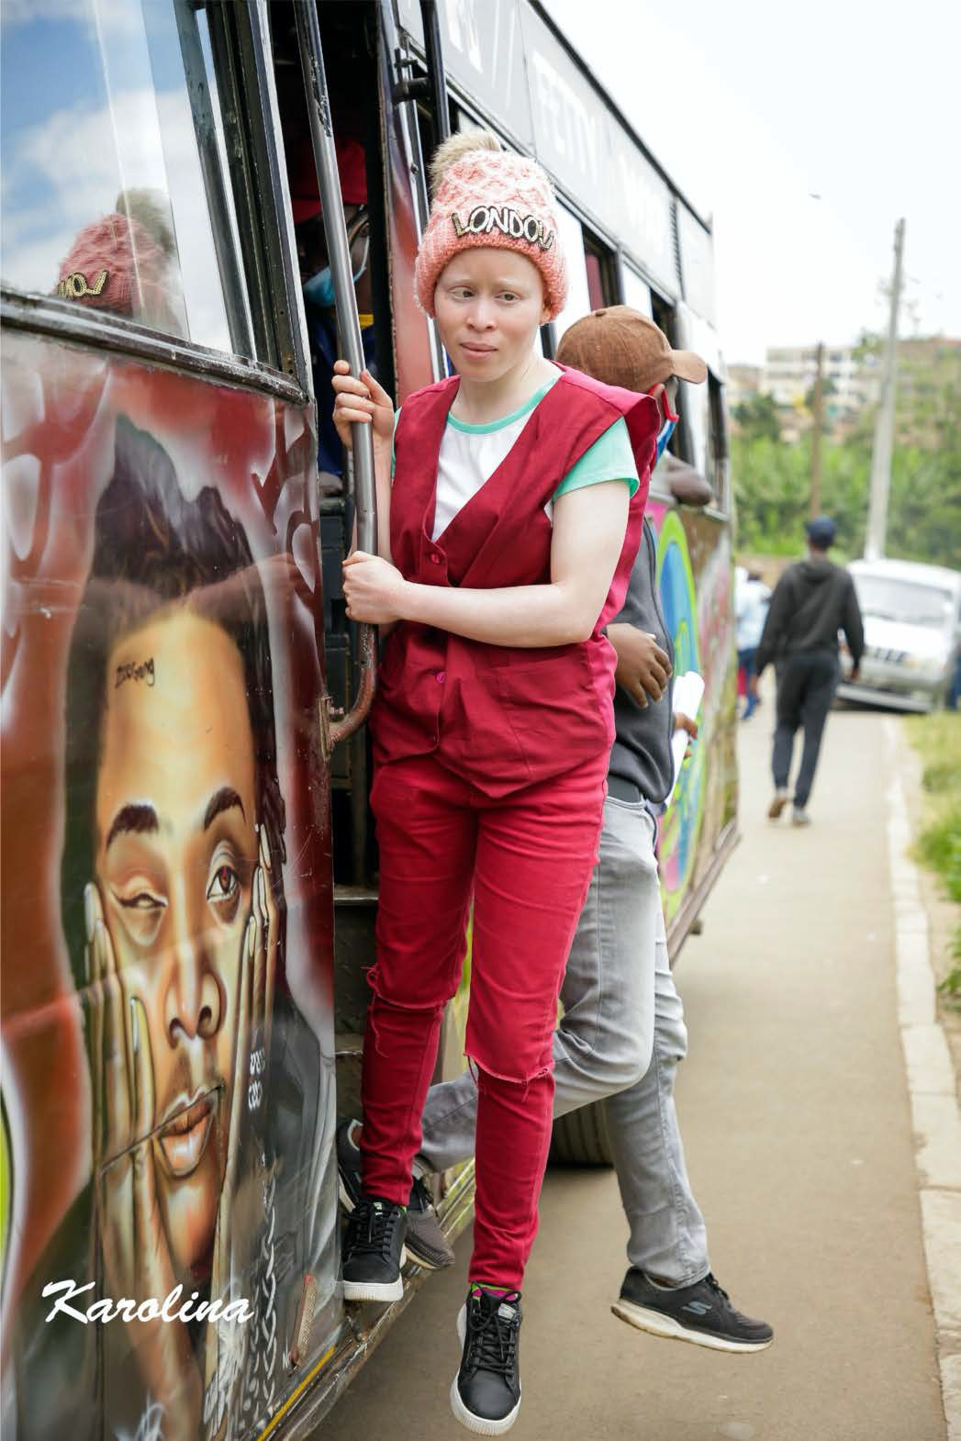
Image 1: Photo of Sharon, a woman with albinism, working as a tout on a matutu bus in Korogocho, Nairobi.

Figure 2

Image 2: Photo of Sharon counting money as she leans from the window of the matutu bus.

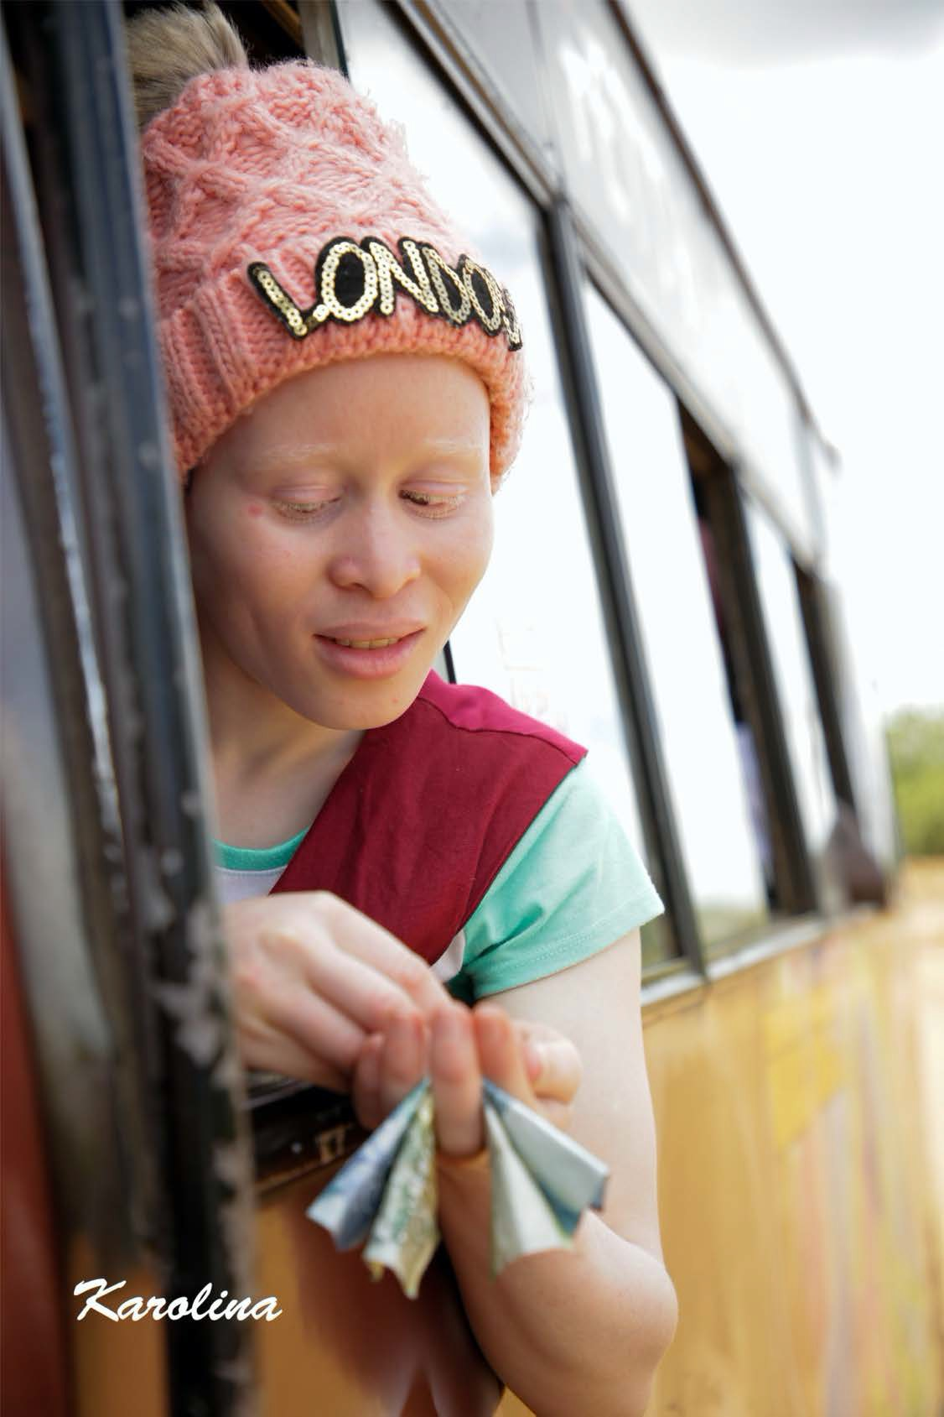

Figure 3

Image 3: Photo of Sharon leaning out of a matutu bus as it comes to a halt.

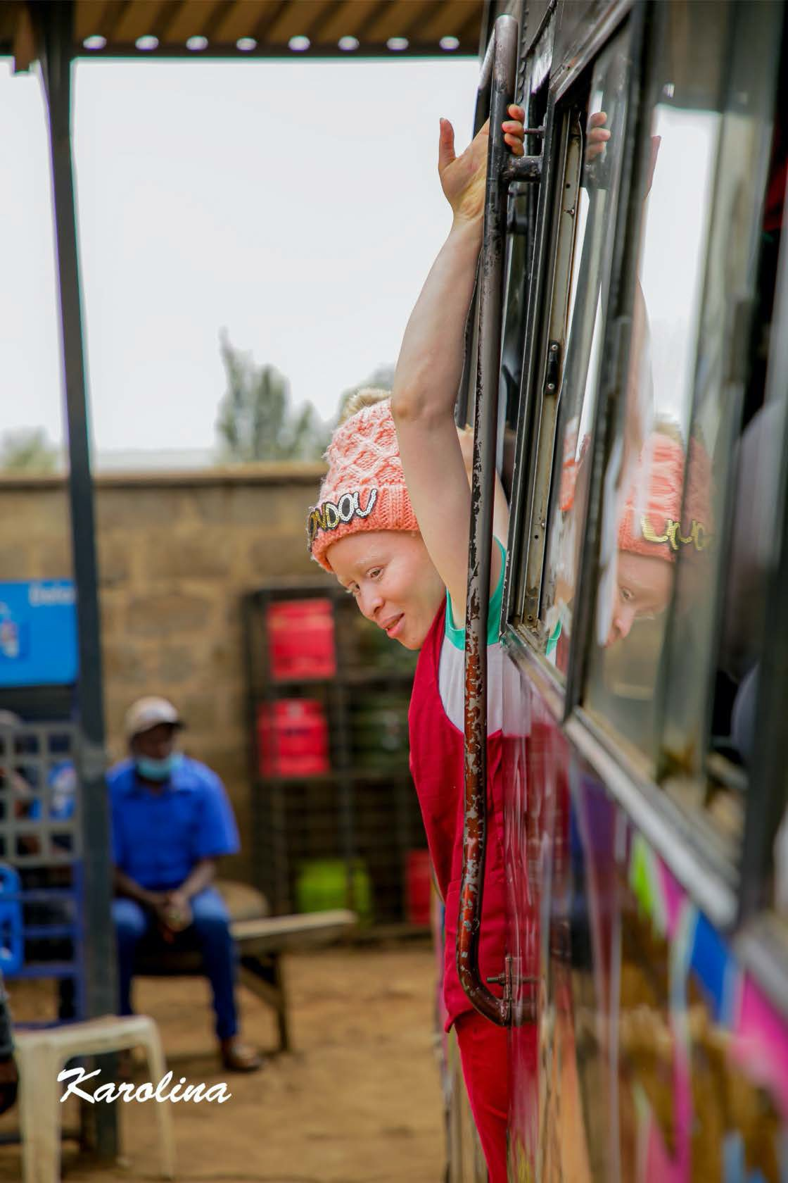

Figure 4

Image 4: Photo of Sharon. She holds on to a rail as she leans from the doorway.

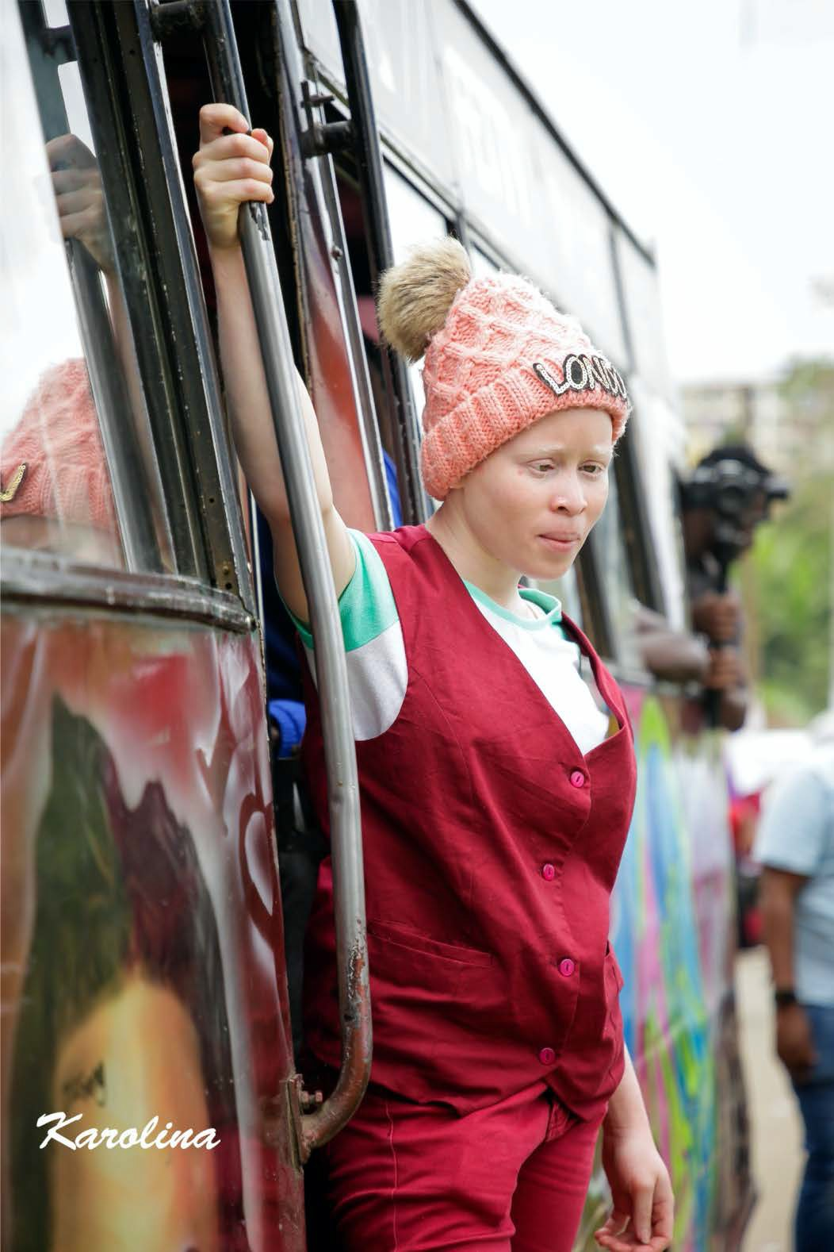

Sharon faces a different challenge in every episode. Episode one focuses on her search for a partner. Over the years, she has received little male attention because most men do not understand her condition and fear it might be a curse. Thus, they shy away from approaching her, but she eventually finds acceptance by a young man who makes passes at her. In the second episode, a young lady who is irritated by a middle-aged commuter begins verbally abusing Sharon because of Sharon’s visual impairment. Sharon brings the money close to her eyes, and the young lady asks if she is blind or whether she wants to eat that money, questioning why her eyes dart back and forth. In episode three, Sharon is attacked by angry commuters who accuse her of collaborating with thieves to steal a passenger’s phone. They become very angry and start making remarks about selling her to a neighboring country because they have heard that her skin and her body parts are worth a lot of money.
These challenges highlight assumptions and misconceptions about disability. Many of these were also experienced during the shooting of the series. There were instances where the bystanders would point at the main character, Sharon, and whisper to each other. There were also instances where they would shout “Mnatembea na pesa” [You are walking with cash].
By this, they meant that we are walking with a person whose body parts are worth a lot of money. The series aims at highlighting the traditional and religious beliefs that make the lives of persons with albinism so difficult, and through its diary format, demystify these beliefs .

‘The Matutu Girl’ by Karolina Wambui https://rdsjournal.org/index.php/journal/article/view/1207 is licensed under a Creative Commons Attribution 4.0 International License. Based on a work at https://rdsjournal.org.

