Creative Works

Seen and Unseen Trails of Trust

Jean L. Cathro, University of Highlands and Islands

Abstract

This is the story of the making of a sculpture called the Steps to Success built in a Special Needs School in Umlazi Township in Durban, South Africa. It is a story not just about the stones, metal wire, concrete and paint of the steps. It is a story about all the people that made it possible and how those memories are hidden in the steps. The sculpture was built by the learners and teachers at the school and a Scottish organization called Crossing Countries. It is still being added to by the school and other organizations. It is a story about how art helps to build trust overtime between people who have different skills and come from different countries.
Keywords: disability, socially engaged art, South Africa, trust

Figure 1

Cathro, S. (2022) Seen and Unseen Trails of Trust

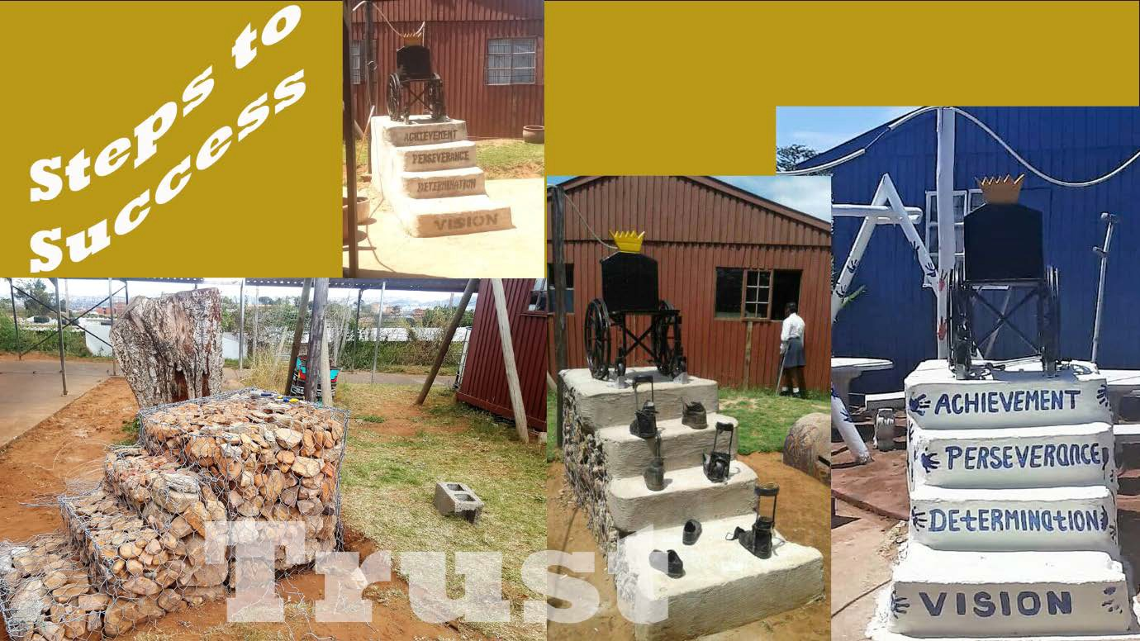

There are many kinds of trails. Seen and unseen, planned pathways to the future or unplanned marks left in a voyager’s wake. Sometimes the track splits, and a narrow trail leads away from the main track then disappears into the unknown. A scuff on the floor, the whiff of perfume in a lift, a cup ring on a wooden tabletop, all leave a mark and tell a story.
This sculpture, named Steps to Success by the art educator, Njabulo Hlongwane, and the learners of Mason Lincoln Special School (http://masonlincolnschool.co.za/) in Umlazi
Township, Durban, South Africa, stands next to the courtyard where they hold their daily morning assemblies. The seen and unseen trails that weave around and through this sculpture originate in relationships of trust forged over years and through art. One of these unseen trails hidden in the sculpture is the founding and journey of Crossing Countries (http://www.crossingcountries.org/), a Scottish social enterprise, and its relationship with socially engaged art and disability. Our original idea was to provide opportunities and

adventures for disabled and nondisabled people to volunteer and have a fun in Durban; we soon discovered that our path led towards the arts. Creativity was a road we could travel together as a team and with the people we met on the way. ‘Art,’ in its widest sense, and socially engaged art in particular, gave us the space to explore what it means to be uniquely human and how to build trust between and within diverse communities. Njabulo, the school staff and learners, see it as a reminder of the acceptance by the local community that learners with disabilities should be given a chance to attend school, learn and achieve their goals.
Throughout time humans have left their handprints, from cave walls to city sidewalks, their imprints marking their passage. The handprints on this sculpture mark its belonging to the learners but, for me, they also signify a personal unseen trail from an art activity I organized for the children in a street kids’ project in Durban in 2012 to a digital photograph received in 2022. Living on the streets, often addicted to glue and running away from abuse, leaves street children vulnerable and alone. Creating their own ‘family tree’ from their multi- colored painted handprints was not only a fun respite but also symbolized a family that they had the power to create themselves. Time travel to 2016, many trips and projects later and a year after I founded Crossing Countries: A mural, covered with the rainbow painted handprints of learners, educators and Crossing Countries volunteers welcomes visitors into Mason Lincoln Special School. The school, which was once a hospital, looks down on V section in Umlazi, the ramshackle collection of buildings caters for approximately 230 children of all disabilities from the ages of 4 years to 24 years; some live in and others return home at the end of the day. Each name and brightly colored handprint on the mural shows the bonds and trust that had been made through the years. Each mark on the wall unique, a sign of personhood, and yet also, signifying a community. And now, in 2022, a sculpture started in 2019, bears the same motif, blue handprints, another physical reminder of our passage over

time and connections grown through trust.

The steps of the sculpture represent a decade of slowly building trust, relationships nurtured across physical and cultural similarities and differences. The foundation, a wire gabion, bent into the shape of steps, is filled with stones that were cast aside by others and collected by the learners. The metal mesh of the gabion simultaneously representing the constraints and the opportunities they face: fencing them in but also hinting at the possibility of escape, through the gaps, to success. The steps are wrapped in concrete, painted white, the stones and wire structure, now unseen but still there, embodying those learners whose disabilities are hidden.
Atop the steps rests a wheelchair, the international symbol of disability, and a crutch, both now discarded, no longer constraints to success, but rather, tools of empowerment. The wheelchair is adorned by a yellow crown, its colour signifying courage, wisdom, and happiness. The crown represents triumph but also the past and present power and symbolism of African kings and queens.
Just as these words leave a digital footprint online or an inky trail across the printed page, the blue words painted on the risers of the steps are there to inspire the learners. These words to live by also make visible the story of how socially engaged art and authentic collaboration over time build trust. Four steps, four words: vision, determination, perseverance, and achievement.
The first riser, inscribed with the word ‘vision’ is, literally and figuratively, the common ground on which the sculpture and the other steps to success rest. Vision: it is the foundation of the relationship between Njabulo and me, a shared vision: to see disabled people given the opportunities to flourish, to be valued members of their communities and the

world, to be able ‘To make a difference’ - the motto of the school. Our aim, to do this through socially engaged art, a space in which values and beliefs can be voiced and heard. Our friendship and collaboration comes from years of gifting each other time and trust. It is a slow process of being open both personally and professionally, taking time to share and listen to each other’s experiences and beliefs, creating a place together where we can be interdependent and equitable. There was no formal invitation to collaborate, just a chance meeting and then years of small acts of recognition, of shared future possibilities, and common dreams.
The second riser is inscribed with the word ‘determination.’ The government of the United Arab Emirates uses the term ‘people of determination’ instead of disabled people. Although, based on the medical/charity model of disability, ‘people of determination’, captures not only the state of mind that disabled people need to succeed in this ableist world but also one of their often-unrecognized strengths. The word determination evokes positive emotions; it hints of agency and motivation to reach a goal. It took our entire trip in 2019 for Njabulo and me to create a design and source a gabion. Two days before we left the learners, Njabulo scoured the school compound to find stones and bend the wires into shape so we could see the fruits of our joint determination before we flew home.
The third riser is inscribed with the word ‘perseverance.’ The steadfast quality of patience and the heroic virtue of perseverance go hand in hand. The shiny, silver trail of the snail on a concrete path, the whirling dust of the cheetah running on the savannah grasslands, the legacy of the now dead struggling artist, the drips of sweat from the Olympian’s brow, all describe trails of seen and unseen perseverance. Challenges and obstacles are met and overcome, trust in others and self to forge new paths when barriers block the way to old ones. An authentic collaboration builds into it this flexibility, this acceptance of a joint venture, the

ability to change but hold steadfast to the vision, to not give up. Although physically separated, Njabulo and I are still able to share the process. After we left Durban. and as Njabulo and learners built the first version of the sculpture, I was still able to write the words explaining the sculpture’s meaning back in Scotland.
And finally, inscribed on the final step is ‘achievement.’ In 2022, I received a ping, a photo on Whatsapp from Njabulo. There I was smiling from ear to ear. I felt many emotions, one of them was achievement. With the support of another organization, the sculpture had been re-painted, and a new seating area added, an ‘epaki’ (park), as the learners call it.
Achievement is often seen as a realized end goal. The painting was accepted for an exhibition; an award was given for an art project that created social change. What if achievement is not about the artifact or the acknowledgment but about the process and the unknown future of infinite collaborative relationships? Socially engaged art, and in particular collaboration, involves knowing when to let go, to give others agency and ownership, when to acknowledge interdependency and diversity and the quest for mutual benefits, and when to recognize that commitment to a vision does not mean commitment to one path. The relationships nurtured through this sculpture led Njabulo, me and a Crossing Countries volunteer to write an article for an edited volume for Routledge Press on the Hierarchies of Disability Human Rights. Without the trust built between us over the years, this would not have been possible. It is trail not visible but one that can be traced back.
These traces and marks, visible and invisible, known and unknown, will wind their way into the future and like green shoots and plump rhizomes grow both above and below the soil nourishing new trails, seen and unseen.

Further Reading

Helguera, P. (2011). Education for Socially Engaged Art: A Materials and Techniques Handbook, Jorge Pinto.
Hlongwane, N., Drake, J. & Cathro, J. (Forthcoming). ‘An Invitation to Contemplate: Dialogues about disability hierarchies between South Africa and Scotland’ in Meyers, S., McCloskey, M. & Petri, G. (eds) Hierarchies of Disability Human Rights, Interdisciplinary Disability Studies Book Series, Routledge Press.
Leeson, L. (2018). Art: Process: Change: Inside a Socially Situated Practice, Routledge, New York: Routledge. https://doi.org/10.4324/9781315617527

Mataraso, F. (2020). A Restless Art: How Participation Won, and Why It Matters. https://arestlessart.com/the-book/download-a-digital-copy/
Sánchez de Serdio, A. (2018). ‘(Mis)trusting Strangers’, in Hablarenarte Impossible Glossary

CAPP.

http://www.hablarenarte.com/catalogos/doc_glosario_ed2/PDF/glosario2018_en.pdf

Seen and Unseen Trails of Trust by Jean L Cathro https://rdsjournal.org/index.php/journal/article/view/1158 is licensed under a Creative Commons Attribution 4.0 International License. Based on a work at https://rdsjournal.org.

