Time is Running Out for People with Disabilities

Sujal Manohar
Baylor College of Medicine

Author Note

Sujal Manohar is a first-year medical student at Baylor College of Medicine interested in the intersections of the arts and medicine. She graduated summa cum laude from Duke University in 2020 with degrees in neuroscience and visual arts. In 2020-2021, she served as a Hart Fellow and AmeriCorps Artist in Residence at Imagine Art. View more of her creative work at sujalmanohar.com.
Abstract
The two drawings included were informed by experiences teaching drawing to artists with disabilities. Through their stories, the artists described problems many people with disabilities encounter daily.

Keywords: disabilities, artists, teaching

Time is Running Out for People with Disabilities

Many times, your students can be your best teachers. As I shared drawing techniques with artists with disabilities at Imagine Art, a nonprofit art studio for people with disabilities in Austin, Texas, the artists with whom I worked taught me about systemic challenges facing many people with disabilities. These interactions directly influenced the themes of these art pieces.
For example, many artists highlighted their challenges with Medicaid waiver programs which provide financial assistance for in-home services, such as occupations offering repetitive tasks with limited opportunities to learn new skills (“Daytime Habilitation in Texas,” 2018). Artists have also struggled with receiving appropriate accommodations for daily activities.
In the first piece, “The Pace of Progress,” the snail advertises reform of support systems for people with disabilities, symbolizing the overall slow pace of progress. The next drawing, titled “Waiting for Waivers,” depicts the numerous people with disabilities who remain on Medicaid waiver waitlists for decades. Unfortunately, some do not live long enough to receive benefits (“Case for Inclusion 2020 Key Findings,” 2020). Each hourglass represents one individual waiting for a Medicaid waiver spot; as years go by, the sand in the hourglass buries them. The ground is littered with the skeletons of people who never received the services they desperately needed.
These pieces are connected to my larger body of work exploring the intersections of the arts and health (found at sujalmanohar.com). I have previously created artwork about health conditions, such as mental illnesses and asthma and allergies, depicting the stories and experiences of people affected by illness. My interactions at Imagine Art opened my eyes to the broken support system for people with disabilities, inspiring me to create artwork on this topic. As a future physician, I am interested in utilizing the arts as a tool for health advocacy and patient engagement.

The Pace of Progress
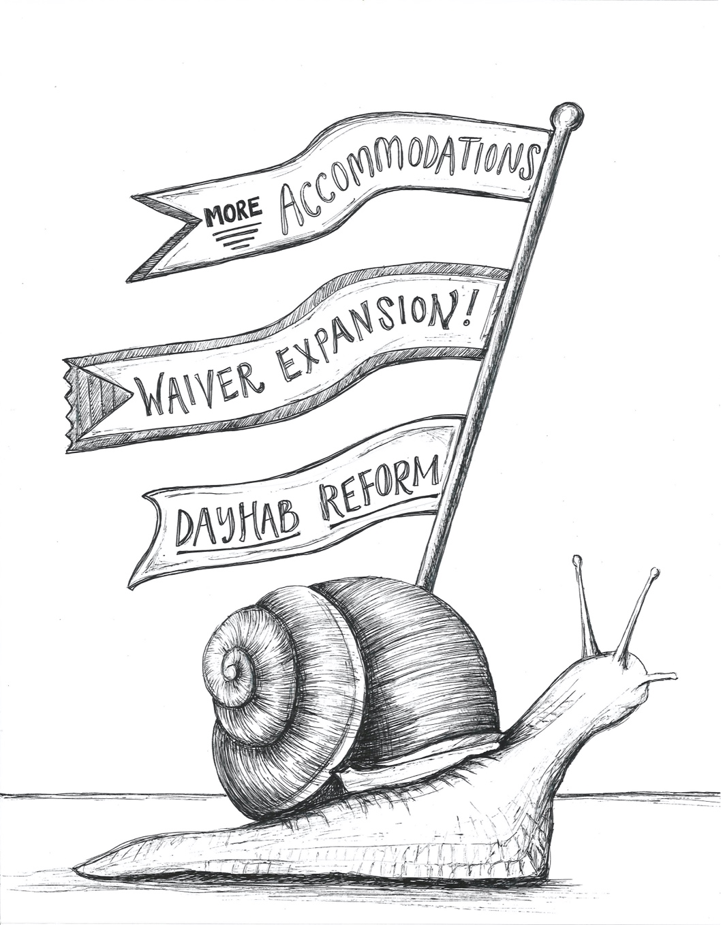

Waiting for Waivers

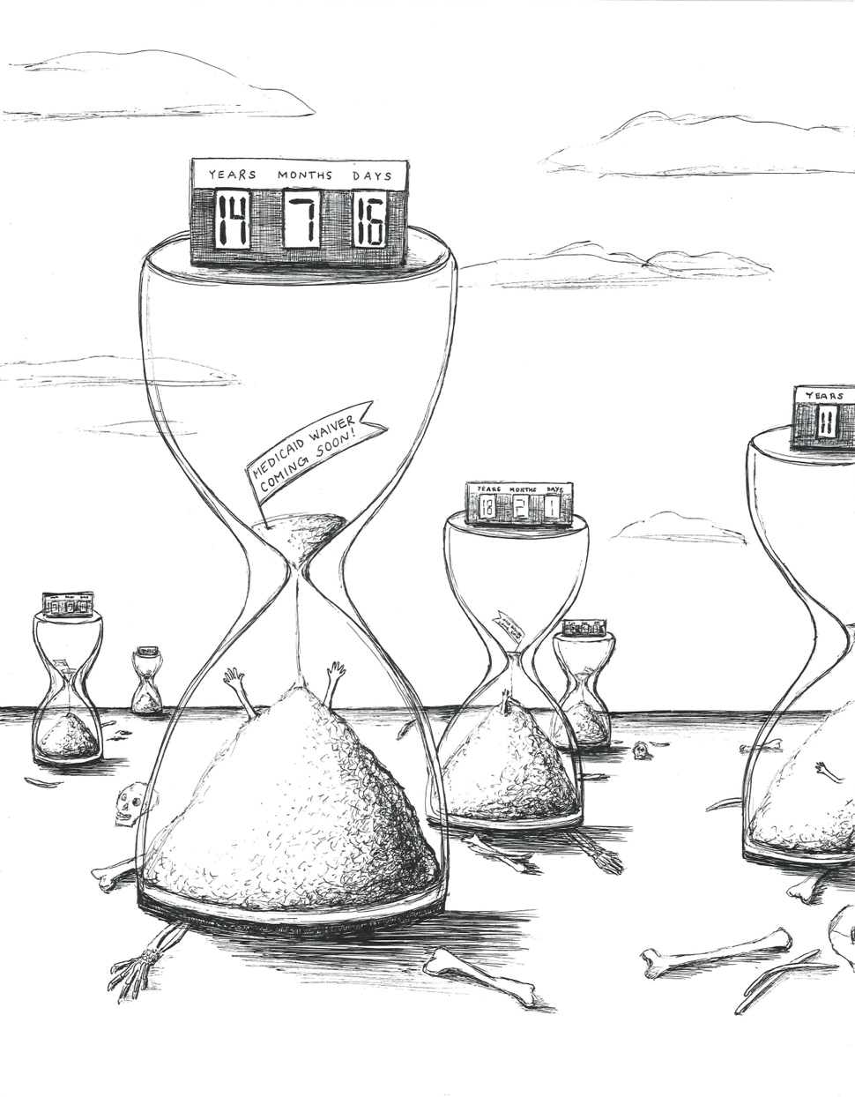

References

ANCOR Foundation & United Cerebral Palsy. (2020). Case for inclusion 2020 key findings report. https://caseforinclusion.org/application/files/5015/8179/5128/Case_for_Inclusion_2020_Key_Findings_021420web.pdf
Daytime Habilitation in Texas. (2018, November 13).
Eiserer, A. T. (2019, May 18). Special needs families: 10 years too long to wait for state help. https://www.wfaa.com/article/news/local/investigates/special-needs-families-10-years-too-longto-wait-for-state-help/287-7b11d72e-39bf-497c-bd8b-79ca258d3666

Time is Running Out for People with Disabilities by Sujal Manohar https://rdsjournal.org/index.php/journal/article/view/1131 is licensed under a Creative Commons Attribution 4.0 International License. Based on a work at https://rdsjournal.org.

