U.S. Postsecondary Students with Disabilities:

Where Do They Enroll and Document Their Disability?

Z. W. Taylor¹ and Ibrahim Bicak²
¹The University of Southern Mississippi
²University of Chicago

Abstract
To date, no quantitative studies have explored what types of institutions of higher education enroll college students who document a disability (SWDs) over extended periods of time. This study leverages five years of institutionally reported (IPEDS) data related to the enrollment patterns of SWDs. This data suggests urban, public, and bachelor’s-level institutions have enrolled more students with documented disabilities than other institution types over time. Additionally, we find that enrollment of SWDs in U.S. higher education has steadily increased since 2013. Implications for research and practice are addressed.
Keywords: disability studies, IDEA, IDEIA, higher education, postsecondary education, United States

U.S. College Students with Disabilities:
Where Do They Enroll and Document Their Disability?
Decades of research has suggested students with disabilities (SWDs) have been a consistently minoritized student population in U.S. higher education, evidenced by much lower enrollment rates in higher education compared to students without disabilities (Adams & Proctor, 2010; Plotner & Marshall, 2015; Renn & Reason, 2013; Postsecondary National Policy Institute, 2023; Stanley, 2000; Yssel et al., 2016). To close these access gaps between SWDs and non-SWDs, researchers have advocated for secondary school counselors and other stakeholders (community members, parents, etc.) to provide college counseling for SWDs (Adams & Proctor, 2010; Brinckerhoff et al., 1992), in addition to institutions of higher education providing SWDs with pre-college experiences to inspire SWDs to pursue higher education and inform them of their opportunities (Renn & Reason, 2013; Skinner & Lindstrom, 2003). Yet, despite advocacy for SWDs supported by empirical research, SWDs have continued to lag behind non-SWDs regarding enrollment in higher education. This access gap has been further exacerbated by the negative impact the pandemic had on SWD enrollment in higher education (Postsecondary National Policy Institute, 2023).
Yet long before empirical research identified these access gaps, U.S. legislation has attempted to open the door to higher education for greater numbers of SWDs through institutional policy reforms. In 1973, U.S. Congress passed the Rehabilitation Act of 1973 containing Section 504 (Rehabilitation Act of 1973). Section 504 allows postsecondary institutions to “require students who are requesting services on the basis of a disability to submit documentation that verifies the nature and extent of the disability” (Madaus & Shaw, 2006, p. 13). However, no regulations have provided guidance regarding what type of documentation is acceptable or required, and how institutions of higher education have conducted the disability verification and documentation process varies tremendously and may be simpler or more difficult depending on where a student enrolls (Madaus & Shaw, 2006).
Shortly after passing the Rehabilitation Act in 1973, Congress passed the Education for All Handicapped Children Act in 1975—known later as the Individuals with Disabilities Education Act (IDEA, enacted in 1997) and even later as the Individuals with Disabilities Education Improvement Act (IDEIA, enacted in 2004)—which guarantees access to a free, appropriate, public education (FAPE) in the least restrictive environment to every child with a disability. Extending to higher education, IDEA requires U.S. institutions of higher education provide reasonable accommodations for students with documented disabilities. Yet, as the processes that SWDs must follow to document their disability at their institution varies (Madaus & Shaw, 2006), accommodations services also vary greatly by institution and are often slow to adapt to an ever-changing student population (Bursick et al., 1989; Madaus, 2011; Plotner & Marshall, 2015; Skinner & Lindstrom, 2003; Stanley, 2000).
As a result, despite legislative intervention, researchers have identified three structural issues facing SWDs pursuing higher education:
- Enrollment has been difficult (Renn & Reason, 2013; Postsecondary National Policy Institute, 2023; Yssel et al., 2016).
- After enrollment, navigating the process to have one’s disability documented at their institution of higher education has been difficult (Brinckerhoff et al., 1992; Cawthon & Cole, 2010; Madaus & Shaw, 2006).
- Once one’s disability has been documented, accommodation quality may vary by institution and be inadequate for a SWD to be successful in higher education (Bursick et al., 1989; Madaus, 2011; Plotner & Marshall, 2015; Skinner & Lindstrom, 2003; Stanley, 2000).
As a result, a large body of research has examined how secondary school students with disabilities can best transition to higher education (Adams & Proctor, 2010; Brinckerhoff et al., 1992; Getzel & Thoma, 2008; Plotner & Marshall, 2015). Because many support services provided in the K-12 school system are not carried into higher education settings, students with disabilities who successfully access and thrive in U.S. higher education have needed to be effective self-advocates, meaning these students must advocate for their rights and educational needs (Getzel & Thoma, 2008; Mamiseishvili & Koch, 2012). This has led school choice researchers to suggest that students with disabilities—in concert with their parents or support network—explore institutions of higher education in depth and learn how certain institutions support students with disabilities on their campus (McGuire & Shaw, 1987; Skinner & Lindstrom, 2003; Renn & Reason, 2013) before deciding where to enroll.
Although work related to the self-determination of college students with disabilities is important, disability-related research in higher education has predominantly analyzed this phenomenon through qualitative measures, finding that SWDs often struggle to complete college admissions processes to gain enrollment and then struggle to navigate the process to document their disability on campus (Adams & Proctor, 2010; Kimball et al., 2016; Mamiseishvili & Koch, 2012; Quick et al., 2011; Plotner & Marshall, 2015; Paul, 2000). Understanding this work, it seems critical to understand what types of institutions successfully enroll students with disabilities who successfully navigate the process of documenting their disability. Without this information, students with disabilities, researchers, policymakers, and other interested stakeholders lack insight into which types of institutions may better facilitate SWDs’ transition to U.S. higher education through enrollment and disability documentation processes.
However, Fichten et al.’s (2003) study “Canadian Postsecondary Students with Disabilities: Where Are They?” leveraged institutional characteristics to explore where college students with disabilities enrolled—in this case, in a Canadian context. Employing survey and quantitative methods, Fichten et al. (2003) suggested 8% of Canadian institutions reported enrolling zero SWDs, 2% of students had their disability registered with their institution, and junior colleges had a higher percentage of students register their disability with their institution than four-year universities (Fichten et al., 2003). Additionally, Québécois institutions enrolled a smaller proportion of SWDs than did other provinces (Fichten et al., 2003). Here, Fichten et al.’s (2003) quantitative research revealed that—in a Canadian context—institutional differences did exist when considering where SWDs enrolled and where these students successfully navigated the disability documentation process, informing the college choice of prospective students and their support networks.
Regarding similar studies in a U.S. context, the National Center for Education Statistics and the U.S. Department of Education sporadically publishes a report detailing where students with disabilities enroll in U.S. higher education, how many students disclose their disability and receive accommodations and services, and how many students with disabilities earn a postsecondary credential (U.S. Department of Education, 2000, 2017). The last report in 2017 provided a breakdown of which types of students were most likely to document their disability and a broad overview of where SWDs have their disability documented. It found that public less-than-2-year institutions (16.2% of undergraduates documenting a disability) and for-profit 4-year institutions (16.0%) enrolled the highest percentage of college students having their disability documented (U.S. Department of Education, 2017, p. 30.). Beyond this brief report and Fichten et al.’s (2013) Canadian study, no quantitative studies have leveraged institutional characteristics to predict enrollment of college students who have had their disability documented by their institution. A quantitative analysis in U.S. contexts could explore potential relationships between institutional enrollment processes, institutional disability documentation processes, and whether certain institutions are more adept at enrolling SWDs and facilitating the disability documentation process.
As a result, this study seeks to make a unique contribution to the literature and leverage institutional characteristics over time—such as urbanicity, sector, type, and institutional spending—as they predict the enrollment of students with documented disabilities to answer the question Canadian researchers have previously answered (Fichten et al., 2013): Where are they?
This study’s research questions are as follows:
R1: In recent years (2013-2017), which institutional characteristics are predictive of enrollment of college students with documented disabilities?
R2: Of institutions whose students with disabilities population is higher than 3%, which institutional characteristics predict an increase in enrollment of students with documented disabilities?
By answering these questions, educational researchers, policymakers, and students with disabilities will better understand which U.S. institutions of higher education enroll the greatest percentages of students with documented disabilities, informing disability policies aimed at increasing access to and support in higher education for this minoritized student population. Moreover, this study will expand the wealth of research focused on students’ self-advocacy by understanding which institutional characteristics may or may not facilitate a living and learning environment in which students may be better self-advocates, and thus, successful in accessing U.S. higher education.

Literature Review
Educational research has produced a voluminous amount of work related to students with disabilities and their transition from secondary to postsecondary education, in addition to how these students are supported once they arrive on campus (Haber et al., 2016; Kochhar-Bryant et al., 2009; Madaus, 2011; Paul, 2000). An extensive review of this literature does not substantially support the aims of this study. Instead, this brief review will focus first on the scant research focused on institutional predictors of enrollment of students with disabilities, as well as how these students transition from secondary to postsecondary education. Then, the review will briefly focus on the few studies which have identified institutional characteristics that may be supportive of students with disabilities.

Where Are They? What We Do Know
The National Center for College Students with Disabilities (NCCSD) routinely publishes reports that gather information from a variety of secondary and postsecondary databases to inform the community regarding both student access to and success at institutions of higher education. In the NCCSD’s most recent report providing an overview of postsecondary enrollment patterns of students with disabilities, Avellone and Scott (2017) argued that, despite there being 11 different databases including information relevant to SWDs, there are “significant gaps in the breadth and usability of current datasets that include information on college students with disabilities,” (p. 3). This includes that these databases often rely on student surveys and institutional self-reporting, which may be incomplete or flawed. Of these databases, Avellone and Scott (2017) reasoned that many, including the Beginning Postsecondary Longitudinal Study (BPS) and the National Survey of Student Engagement (NSSE), do not publish on data related to students with disabilities due to potential privacy concerns, and these organizations require students to complete a survey, which may marginalize students with disabilities who are unable to access or take a survey without assistance. For example, the most recent BPS report in 2011 titled “Trends in Attainment Among Student Populations at Increased Risk of Noncompletion” did not mention students with disabilities once (U.S. Department of Education, 2011, p. 1). This is even though the research community has long known that the SWD population is perhaps at the highest risk of noncompletion of any population in higher education. From here, Avellone and Scott (2017) concluded that much more work should be done to learn more about where students with disabilities enroll in U.S. higher education and earn their degrees, as extant databases are insufficient to inform support of this population.
The most recent national-level report of students with disabilities enrollment in U.S. institutions of higher education was the 2017 U.S. Department of Education’s “Characteristics and Outcomes of Undergraduates with Disabilities.” Therein, the U.S. Department of Education (2017) synthesized data from multiple sources (e.g., the High School Longitudinal Study of 2009, the 2012/14 Beginning Postsecondary Students Longitudinal Study). Via survey, the study explained that nearly 12% of undergraduates reported having a disability in 2011-2012, and that only 13.8% of high school students who received special education services in 2009 expected to earn a bachelor’s degree in the future. In addition, of high school students who received special education services in 2009, administrative data suggested that 37.4% had not enrolled in any level of postsecondary education by 2013. If students with disabilities did pursue higher education, public less-than-two-year institutions (16.2% of undergraduates documenting a disability) and for-profit four-year institutions (16.0%) enrolled the highest percentage of college students having their disability documented (U.S. Department of Education, 2017, p. 30.). Beyond this reporting of institutional percentage share of enrollment of students with disabilities, the U.S. Department of Education (2017) did not report on any other data besides self-reported student-level characteristics (e.g., race, sex, age, immigrant status, and veteran status) and broad student disability types (e.g., cognitive, ambulatory) that were not tied to any institutional characteristics.
Similarly, Fichten et al.’s (2003) study examined the enrollment of students with disabilities in Canadian postsecondary institutions. Their results also suggested students with disabilities are a minoritized population in higher education—albeit a Canadian context—as 8% of postsecondary institutions reported enrolling zero students with disabilities in 2000. In addition, only 2% of the overall postsecondary population of Canadian students with disabilities were registered to receive disability-related services (Fichten et al., 2003). Parallel to U.S. contexts, Fichten et al. (2013) also found that Canadian junior and/or community colleges enrolled a higher percentage of students with documented disabilities than Canadian universities, akin to 2017 U.S. data suggesting that U.S. public and private non-profit two-year institutions enrolled a higher percentage of students with documented disabilities than U.S. universities (U.S. Department of Education, 2017). Importantly, Fichten et al.’s (2003) study suggested that the geography of Canadian institutions may play a role in the enrollment of students with disabilities, as the researchers found Québécois institutions enrolled a smaller proportion of students with disabilities than did other provinces in Canada, even though the population of people with disabilities was not significantly lower in Québéc than other provinces. However, Fichten et al. (2013) did not elaborate on why Québécois institutions may have been more successful in enrolling SWDs and facilitating their disability documentation process.
Ultimately, both the U.S. Department of Education’s (2017) report and the Fichten et al. (2003) study did not consider other institutional characteristics that may or may not predict the enrollment of students with documented disabilities. Although it is useful to understand that 29.9% of students with disabilities who received special education services in 2009 enrolled in either public or private nonprofit two-year institutions (U.S. Department of Education, 2017), these descriptive statistics do not strongly inform policy or practice. It is important to expand upon this work and learn how institutional characteristics may influence the enrollment of students with disabilities, such as geographic location, Carnegie classification (a U.S. higher education measurement of institutional research intensity), sector, type, and institutional expenses on student services, academic support, and instructional support.

Barriers Faced by Students Transitioning to Higher Education
Students with disabilities often face barriers when transitioning from secondary school to higher education, including barriers related to disability type, knowledge of higher education, difficulty in documenting one’s disability, and institutional support. Since the passage of IDEA in 1997 and its updates in the form of IDEIA in 2004, researchers have written about how students with disabilities transition from secondary to higher education, especially given that many Section 504 protections no longer apply in higher education settings, such as functional and formative assessments and creation of individualized education plans (IEPs) to ensure students are meeting benchmarks and accommodations are provided by instructors (Madaus & Shaw, 2006). According to the most recent survey of the National Longitudinal Transition Study (NLTS) in 2009, college students with documented disabilities most commonly have a hearing (73%) or visual impairment (67%), while far fewer have autism (39%) or multiple disabilities (28%), suggesting that students with certain disability types may face fewer barriers when accessing higher education and documenting their disability. Additionally, students with disabilities from higher-income homes tend to attend higher education in larger numbers, a finding supported by subsequent research (Cheatham & Elliott, 2013), while both race and gender were not significantly different between nondisabled students and students with disabilities who attend institutions of higher education. However, at the time of this study, the NLTS is already over a decade old and draws upon a small survey of students with disabilities and not the entire population of students with disabilities in U.S. higher education.
Given the persistent hurdles facing students with disabilities as they pursue postsecondary education, researchers have argued that disability services offices at institutions of higher education are often not equipped with the knowledge base or the resources necessary to support students with disabilities as they explore institutions and research services to inform their college choice (Cawthon & Cole, 2010; Kochhar-Bryant et al., 2009). In addition, researchers have pointed to weak data systems and communication networks between secondary and postsecondary schools, including how secondary schools communicate IEPs with institutions of higher education to help postsecondary staff understand how students with disabilities were supported at the secondary level (Kochhar-Bryant et al., 2009; Sitlington, 2003).
Of these major hurdles faced by SWDs during their transition from secondary to postsecondary education, researchers have found that recent and accurate documentation of one’s disability can be cumbersome and costly for SWDs and their families. For example, according to the National Longitudinal Transition Study in 2009, students with disabilities were more likely to pursue higher education as they got older, as 65% of 25-year-olds took at least one postsecondary course, whereas only 58% of 21-year-olds took at least one postsecondary course (Institute of Education Sciences, 2009). Madaus and Shaw (2006) argued that, as students with disabilities leave the K-12 system and their disability documentation becomes outdated, institutions of higher education may require updated documentation and accommodations information, while also asking to review copies of a student’s (potentially outdated) IEP while they were still a K-12 student. In these situations, many SWDs and their support networks—especially those from low-income backgrounds—may struggle to procure updated, accurate disability documentation information, possibly restricting a student from navigating the institutional process of documenting their disability.
Recently, in 2019, Scott (2019) from the NCCSD conducted focus groups with 46 students with disabilities currently enrolled in institutions of higher education to learn more about their transition to postsecondary education and any barriers to access that they experienced. Students consistently reported that communicating with campus disability resource offices was difficult, as students claimed that accommodations were inadequate, and professionals working at the offices did not provide students with necessary information for navigating office procedures and resources for skill development. Moreover, students also claimed that class instructors were not informed of campus policies and were often unresponsive to student needs, even if that student correctly documented their disability and requested reasonable accommodations through the disability services office. Finally, students also asserted that accessing higher education was difficult due to gaps in online information about resources and services, as well as campuses being situated in areas that were physically difficult for students to access and navigate without substantial support given poor building accessibility and a lack of accessible transportation.
Given this scant prior work (Madaus & Shaw, 2006; Scott, 2019), researchers have pointed to the IDEIA update in 2004 and its focus on transition documentation as a possible pathway for more secondary schools and K-12 systems to better support students with disabilities transition to higher education. Madaus and Shaw (2006) explain that a Summary of Performance or SOP would require K-12 school systems to “provide the child with a summary of the child's academic achievement and functional performance, which shall include recommendations on how to assist the child in meeting the child’s postsecondary goals” (p. 14). Given this new requirement levied by IDEIA, Madaus and Shaw (2006) reason:
A well-developed SOP will comment on what modifications and accommodations are actually used and how effective these have been in helping the student to be successful at the secondary level. It will likely be a substantial improvement over current IEPs and perhaps offer professionals working with students with disabilities meaningful and relevant data for planning interventions. (p. 14)
In a review of IDEIA’s new documentation of transition planning which extended IDEA’s notion of secondary student transitions to adult life, Sitlington and Clark (2007) reason that a SWD’s SOP should detail a SWD’s academic progress, skills and abilities, levels of connection and communication with one’s community, socioemotional background, and other information relevant to informing a student’s transition to postsecondary education. An extension and elaboration of a SWD’s IEP, a SOP could serve two purposes: 1) as a guiding document for both SWDs to be their best self-advocate when exploring institutions of higher education and support services, and 2) an institution of higher education’s guiding framework for supporting a SWD and attempting to mirror a SWD’s secondary support services in their new higher education setting.
Since IDEIA’s mandate of a SOP and augmented transition planning, several SWDs and their families have sued K-12 school systems, alleging violations of IDEIA and improper transition planning. Prince et al. (2013) reviewed 11 such court decisions and argued that although transition planning goals were often vague and necessary public agencies were not invited to the SWD’s transition planning meetings, many K-12 school districts did not violate IDEIA because they “supplied the family with substantial information and assistance” (p. 287). Moreover, additional case law has suggested that K-12 districts will not be liable for additional transition services as long as “the IEP or transition plan [SOP] provides for a free appropriate public education” (p. 287). For example, Prince et al. (2013) briefed Sherri High et al. v. Exeter Township School District, a case where a SWD sued their school district for failing to facilitate postsecondary and adult transition services, including ACT and SAT testing, course placement evaluations, and job application practice sessions. In the case, the court ruled in favor of the district, reasoning that the district did provide the resources and did not violate IDEIA: The district did not facilitate the services, including making ACT or SAT appointments and providing private tutoring services, which do not fall under the purview of IDEIA.
Ultimately, Prince et al. (2013) argued that SOPs should contain “results-oriented, measurable, and appropriate postsecondary goals” (p. 289) that may or may not include plans for pursuing higher education or providing higher education planning services, such as course placement testing, ACT and SAT preparation, or evaluations of a college or university’s disability services, including the institution’s process for documenting a student’s disability. From here, even with enhanced higher education planning mandated by IDEIA in the form of a SOP and more robust transition planning, students with disabilities must still be self-advocates and follow up on the resources provided by the SOP and their K-12 school district, as IDEIA case law has largely dictated that K-12 districts can provide the information, but SWDs must act on the resources and facilitate their own higher education transition on their own.
Evaluating Institutional Support for Students with Disabilities
Prior to important legislation meant to support students with disabilities pursuit of U.S. higher education (e.g., the Americans with Disabilities Act and IDEIA), disability in higher education research addressed how important the higher education exploration process is for these students and their families (Bursick et al., 1989; McGuire & Shaw, 1987; Wiseman et al., 1988).
McGuire and Shaw (1987) explored the higher education decision-making strategies of students with disabilities and their parents, finding that both students and parents should consider the specific disability of the student and then attempt to locate institutions that provide specific supports for that disability. Of institutional characteristics that students with disabilities and parents should consider, McGuire and Shaw (1987) asserted that an institution’s criteria for determining a disability and the overall admissions processes should be evaluated. In addition, students and parents should assess an institution’s disability programming, including how many full-time staff are employed, how many hours per week the institution funds disability support services, whether peer mentoring groups are present and active, and how many students with disabilities persist and earn their degree (McGuire & Shaw, 1987).
To better understand the level of institutional support provided to students with disabilities, Bursick et al. (1989) surveyed a national sample of college students with disabilities across several two- and four-year institutions (n=197) and learned only 33% of institutions provided counselors trained in disability services and only half provided remedial instruction to develop social skills. Regarding institutional characteristics which predicted disability services, Bursick et al. (1989) found students with disabilities reported that smaller schools were more likely to facilitate individualized group tutoring for all students (p < 0.01) and remedial mathematics instruction for all students (p < 0.01) than larger institutions. Finally, the researchers learned two-year institutions were more likely to review individualized education plans (IEPs) for their students than four-year institutions (p < 0.001), while two-year institutions were also more likely to provide broad remediation services than four-year institutions (p < 0.01).
Wiseman et al. (1988) also surveyed currently enrolled students with disabilities in U.S. institutions (n=100 students) and learned that social and emotional involvement with peers, in tandem with institutional support, may not be enough to overcome a lack of sense of belonging on campus. After measuring the students’ relationships between peers and their campus and the level of institutional support, Wiseman et al. (1988) argued “if the disabled student feels alienated from campus, these factors [institutional supports] will not be sufficient to ensure the student’s retention in the university” (p. 266). However, Wiseman et al.’s (1988) study did not address the factors related to SWDs and their enrollment patterns, instead focusing on institutional and social predictors of academic success.
After the passage of the Americans with Disabilities Act (ADA), the amendments to Section 504 of the Rehabilitation Act, and the passage of the Individuals with Disabilities in Education Act, the number of students with disabilities in U.S. higher education has increased, but this population is still considerably underrepresented (U.S. Department of Education, 2017). However, rigorous quantitative work has not been performed to explore institutional characteristics as they predict the enrollment of students with documented disabilities. Prior research has provided evidence that an institution’s physical location (Fichten et al., 2003), sector (public or private) (Bursick et al., 1989; U.S. Department of Education, 2017), and level of institutional support (Madaus & Shaw, 2006; Mamiseishvili & Koch, 2012; McGuire & Shaw, 1987; Plotner & Marshall, 2015; Wiseman et al., 1988) may all contribute to the enrollment of students with disabilities and their success in higher education. As a result, this study considers longitudinal institutional data alongside U.S. higher education enrollment trends of students with documented disabilities to answer a simple but informative question: Where are they?

Methods
The following sections will detail how data was collected, how quantitative methods were determined, and how the research team addressed limitations.

Data
The research team employed the Integrated Postsecondary Education Data System ([IPEDS], National Center for Education Statistics, 2019) to explore where students with documented disabilities enrolled in U.S. institutions of higher education. IPEDS provides annual, comprehensive, standardized data on U.S. colleges and universities through annual institution-level surveys that collects information related to institutional enrollment, graduation rates, student financial aid, and many more characteristics which allows for comparison between institutions in different sectors (public, private, two-year, four-year, etc.). A limitation to be addressed later, IPEDS only includes percentages of SWD at the 3% threshold. This means that institutions that enroll less than 3% SWD do not report individual percentages, and institutions who enroll 3% or more SWD population report their percentage without reporting specific enrollment numbers or the types of disabilities that students have reported.
As a result, the research team collected IPEDS data from a total of 6,165 institutions of higher education across five years—descriptive statistics of this population can be found in Table 1. Institutional characteristics included sector (e.g. public or private), Carnegie classification, geographic location (e.g., rural, urban), four-year and less-than-four-year programs, student services expenses (aggregated), academic support expenses (aggregated), and instructional expenses (aggregated), student-faculty ratio, and average institutional grant aid (non-government aid). These variables were included in the data collection process, as extant research has supported that these institutional characteristics may influence the enrollment of SWDs at institutions of higher education (Bursick et al., 1989; Fichten et al., 2003; Mamiseishvili & Koch, 2012; McGuire & Shaw, 1987; Plotner & Marshall, 2015; U.S. Department of Education, 2017; Wiseman et al., 1988).

Analytic Strategy
Given the limitations of how SWDs data is reported by institutions and collected by the National Center for Education Statistics (2019), this study employed a random effects probit model with reporting of robust standard errors. Given the binary reporting structure of the data (institutions with 3% or less SWDs versus more than 3% SWDs), the data justified the use of a random effects probit model (Gibbons & Hedeker, 1994; Wooldridge, 2009). A random effects probit model is appropriate for longitudinal data predicting a binary outcome including both time varying (e.g., academic support expenses) and time invariant characteristics (e.g., institutional sector).
The random effects probit model formula employed in this study can be found below, where:
$Υ_{it}= B_{0}+ B_{1}Χ_{it}+ B_{2}Ζ_{it}+ α_{i}+ τ_{t}+ ε_{it}$ (1)
The outcome variable of interest—$Υ_{it}$—represents an institution i’s first-time undergraduate students with disabilities enrollment in a given year (t). $Χ_{it}$ represents institution i’s time-varying characteristics (such as student services expenses per FTE). $Ζ_{it}$represents institution i’s time invariant characteristics (such as geographic location) in the equation 1. Institutional-level fixed effects ($α_{i}$) considers differences in observable and unobservable characteristics across institutions. $τ_{t}$represents time dummy variables, which control for observed and unobserved events that may affect students with disabilities enrollment over the time (such as the law, or technological change). $ε_{it}$ is the robust standard error term.

Limitations
The primary limitation of this study—and all disability-related studies in higher education—is the way in which SWDs data is reported by institutions and collected by the National Center for Education Statistics (2019) and/or the federal government. Because specific enrollment numbers (instead of percentages of overall enrollment) and disability types (e.g., autism, deafness) are not made available by the institutions themselves or data reporting entities, quantitative, higher education-focused disability studies must employ a blunt instrument to articulate a highly contextualized, nuanced student population and their institutional environment(s). To date, it is unclear why NCES—and their IPEDS database—does not provide more robust information or request more robust SWD-related information from institutions of higher education, suggesting further research could explore why the NCES operates the way it does and limits the robustness of the information they collect related to SWD.
As a result, this study—and others employing quantitative measures—do not adequately explain how students with a wide range of disabilities may or may not access a diverse, wide range of institutions, each with institution-specific nuances and subtleties. Decades of research has given SWDs an amplified voice in higher education settings, but institutional characteristics must be considered to provide a more holistic, comprehensive understanding of how institutions support SWDs. From here, disability studies researchers and policymakers must continue to advocate for SWDs and encourage institutions of higher education to provide anonymous, detailed SWDs data in order to analyze extant policies and advocate for more inclusive, supportive policies to facilitate SWD access to higher education.

Results
Descriptive statistics of 2017 institutional-level data can be found in Table 1 below. Data from 2013, 2014, 2015, and 2016 can be found in the Appendix.
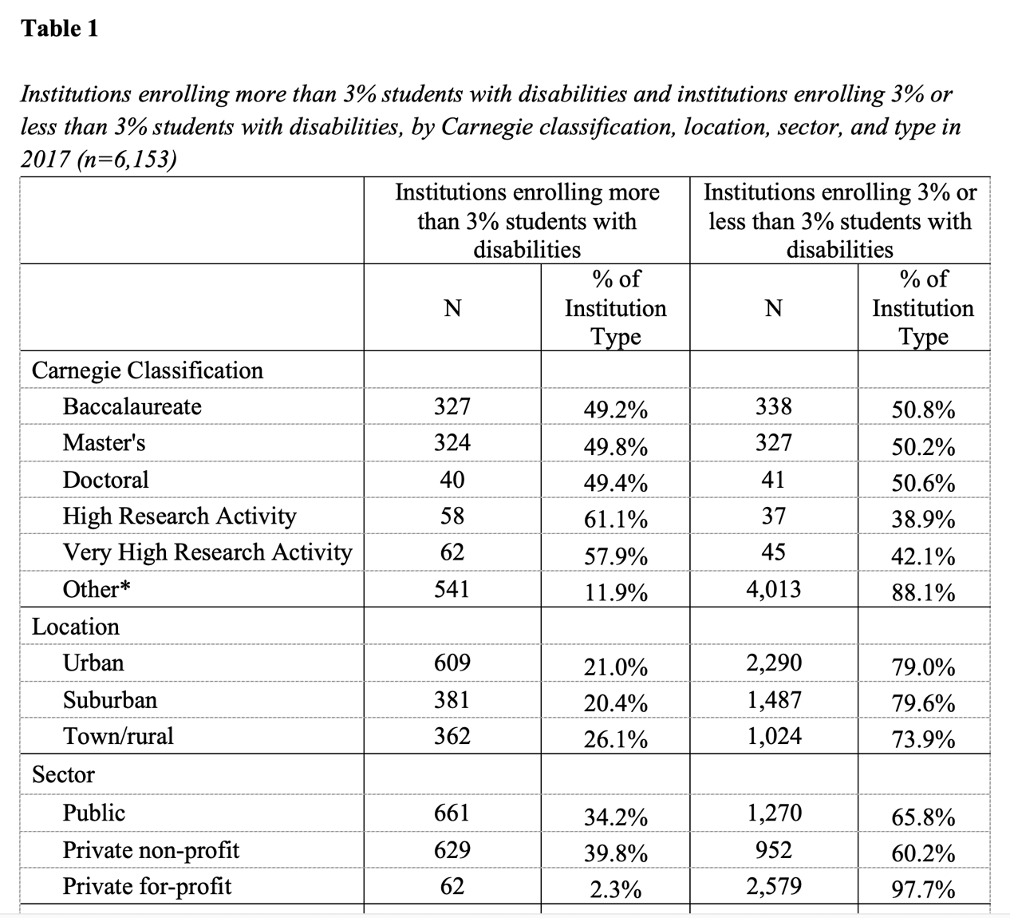
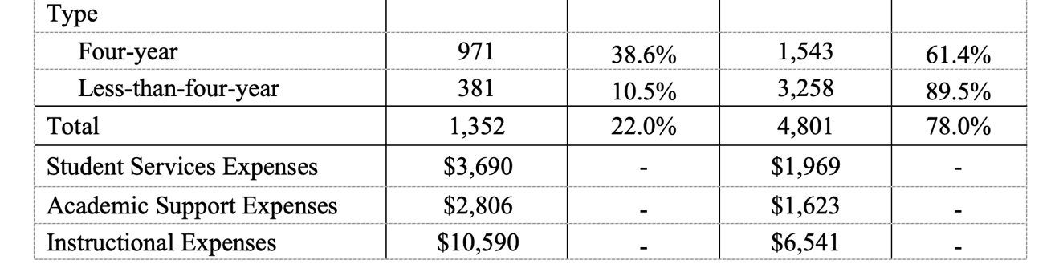
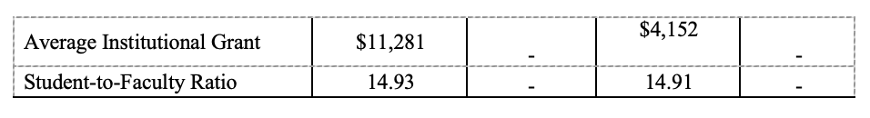
*Notes: Other includes associate’s institutions, special focus higher education institutions (trade schools, barber colleges, rabbinical institutions, etc.), and Carnegie unclassified institutions; All expenses figures were calculated per enrolled student.
Across all institutional characteristics, most U.S. institutions of higher education (78.0%) do not enroll greater than a 3% SWDs population, with institutions in urban settings, public institutions, and four-year institutions being more likely to enroll a greater than 3% SWDs population in 2017. In addition, institutions enrolling greater than 3% SWDs spent more per enrolled student on average in student services, academic support, instructional expenses, and average institutional grant aid. Student-faculty ratio between 3% and non-3% institutions was similar in 2017.
A random effects probit model predicting enrollment of students with disabilities in U.S. institutions of higher education (N=6,165) can be found in Table 2 below: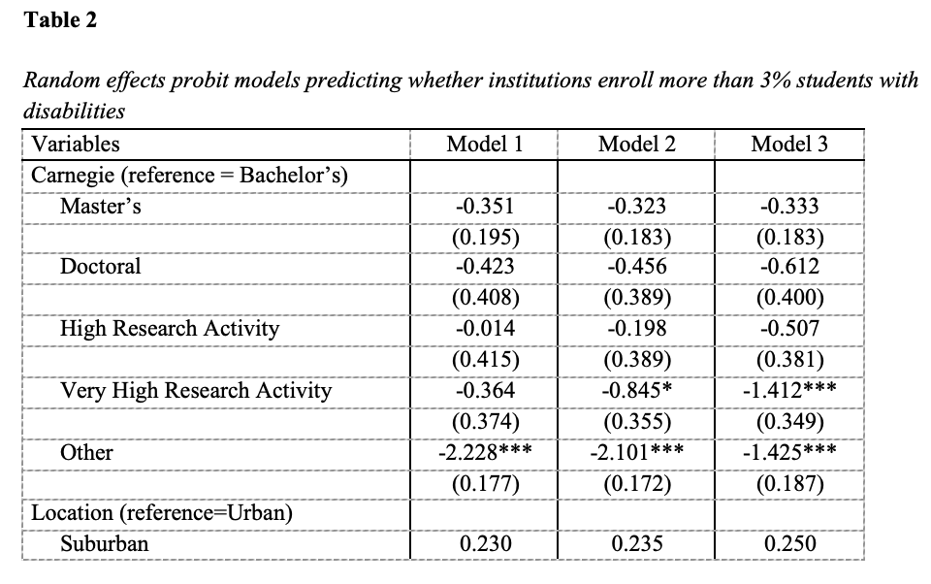

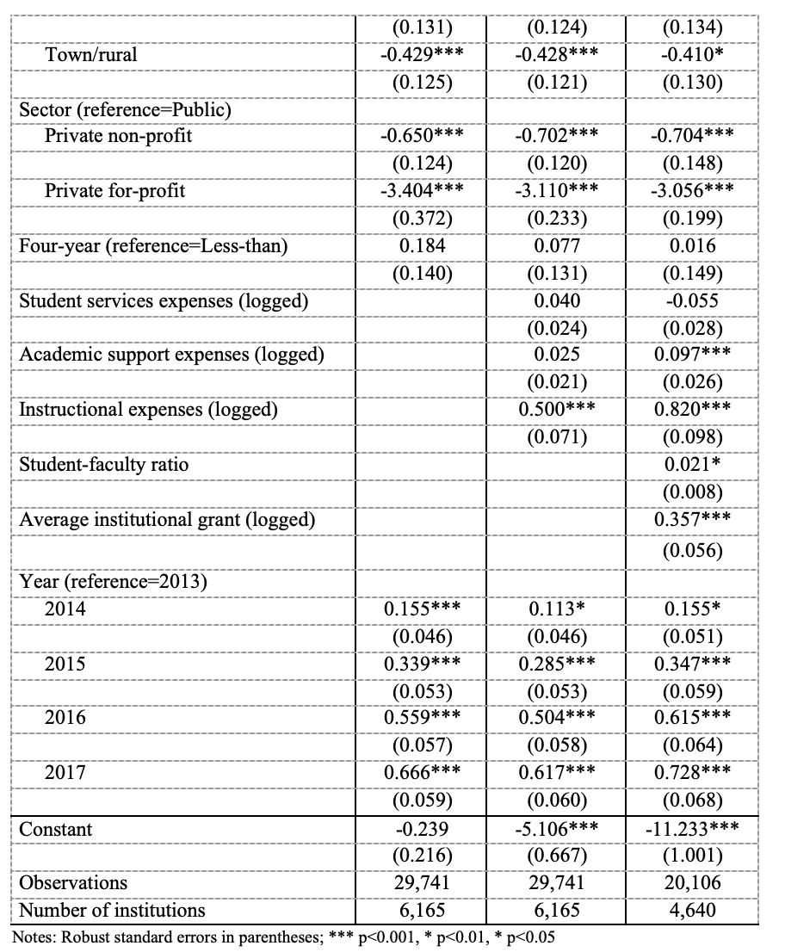
Model 1 included all institutional-level time invariant characteristics across the entire population (N=6,165). Data indicate SWD were less likely to enroll in associate’s, special focus, or non-Carnegie classified institutions (p < 0.001) than bachelor’s institutions, institutions in town/rural settings (p < 0.001) than urban settings, and private institutions (nonprofit = p < 0.001, for-profit = p < 0.001) than public institutions.
Model 2 included both institutional-level time invariant and varying characteristics across the entire population (N=6,165). Data indicate SWDs were less likely to enroll in associate’s, special focus, or non-Carnegie classified institutions (p < 0.001) and institutions with very high research activity (p < 0.05) than bachelor’s institutions, institutions in town/rural settings (p < 0.001) than urban settings, and private institutions (nonprofit = p < 0.001, for-profit = p < 0.001) than public institutions. Instructional expenses were also associated with greater percentages of SWDs (p < 0.001), echoing prior qualitative studies suggesting increased instructional support may benefit SWDs (Bursick et al., 1989). Controlling for institutional-level time invariant and varying characteristics, longitudinal data also suggest a steady increase of enrollment of SWDs.
Model 3 included both institutional-level time invariant and varying characteristics, while also including student-faculty ratio and average institutional grant aid which were reported by 4,640 institutions across the five-year panel data period. Data indicate SWDs were less likely to enroll in associate’s, special focus, or non-Carnegie classified institutions (p < 0.001) and institutions with very high research activity (p < 0.001) than bachelor’s institutions, institutions in town/rural settings (p < 0.05) than urban settings, and private institutions (nonprofit = p < 0.001, for-profit = p < 0.001) than public institutions. Academic support expenses (p < 0.001), instructional expenses (p < 0.001), and average institutional grants (p < 0.001) were also associated with greater percentages of SWDs enrolling in U.S. institutions of higher education. Across Models 1, 2, and 3, longitudinal data also suggest a steady increase of enrollment of SWDs in U.S. higher education, a result echoed by prior research (Postsecondary National Policy Institute, 2023; Yssel et al., 2016).
Discussion and Implications
Over a longitudinal period, data in this study suggests institutional characteristics may influence the enrollment of students with documented disabilities in U.S. institutions of higher education. From this work, many connections to prior research can be made, as well as implications drawn for future research, policy, and practice.
To begin, this study extends Fichten et al.’s (2013) work into U.S. contexts, with both studies finding that the geographic setting of an institution may influence the enrollment of students with documented disabilities in those institutions. In U.S. higher education settings, this study suggests SWDs enroll and document their disability in urban institutions at higher percentages than institutions in any other geographic setting. Recent U.S. population research suggested that people with disabilities are more likely to live in rural areas than urban areas (Crankshaw, 2023). In fact, according to the U.S. Census Bureau, only 19.8% of the U.S. population in 2023 was classified as rural, but 14.7% of this population reported having a disability. Inversely, the U.S. Census Bureau found 80.2% of the U.S. population in 2023 was classified as urban, but only 12.6% of this population reported having a disability. Here, given U.S. population data, one may assume that greater percentages of SWDs would enroll and document their disability at rural institutions of higher education, yet this study suggests that the inverse is true. Subsequently, disability studies researchers and policymakers should explore how urban institutions support SWDs and whether an institution’s geographic setting is more or less conducive to SWDs enrollment and disability documentation in higher education.
Results also suggest SWDs are less likely to enroll and document their disability in associate’s, special focus, or non-Carnegie classified institutions and very high research Carnegie classified institutions. Here, prior research has suggested that students pursuing certain careers may face unique challenges in enrolling in degree plans and documenting their disability at their institution, including students pursuing science, technology, engineering, and mathematics (STEM) degrees (Prema & Dhand, 2019) and professional education programs (Squires & Countermine, 2018). Building upon this research, data suggest SWDs may struggle to enroll and document their disability in special-focus institutions (e.g., rabbinical schools, chiropractic colleges) and research intensive-majors (e.g., chemistry, engineering) at very high research intensity institutions. Such a phenomenon may lead a SWD to attend less research-intensive institutions that offer general education majors and fewer specialized, research-intensive plans of study. These results are difficult to interpret, as no research has explored how the difficulty or lack in provision of accommodations for SWDs may differ across majors and institution types.
Recently, Mamboleo et al. (2020) surveyed college students with disabilities (n=289) across six different four-year universities and learned that these students often struggled with the same issues related to documenting their disability, including instructors’ lack of understanding, lack of knowledge of institutional documentation processes and accommodations, and students feeling a sense of stigma while navigating the disability documentation process. However, Mamboleo et al. (2020) did not analyze data to uncover institutional differences, rather reporting aggregate statistics. Relatedly, Bursick et al.’s (1989) study found smaller schools were more likely to facilitate individualized group tutoring and remedial mathematics instruction than larger institutions, while two-year institutions were more likely to review secondary IEPs and provide broad remediation services than four-year institutions. However, institutional enrollment or two- or four-year classification may not correlate with research output and Carnegie classification: Here, disability studies researchers should explore institutional differences regarding disability documentation guidelines and accommodations provision to determine whether certain institutions or institution types facilitate a more equitable learning environment for students with disabilities.
This study’s data also suggests that enrollment of students with documented disabilities has been greater at public institutions in recent years, suggesting public institutions may streamline their enrollment or disability documentation process for students with disabilities when compared with private peers. Prior research suggests public K-12 schools serve a larger proportion of SWDs across the U.S. (Kimball et al., 2016), while private K-12 schools are not required to follow the special education regulations of IDEA, mandating that SWDs receive a free, appropriate public education. This phenomenon suggests that SWDs may be better served and accommodated at public K-12 schools, leading these students to pursue a postsecondary education at public institutions.
To date, no studies have explored how secondary students with disabilities view public versus private higher education options, and future research could explore how SWDs perceive public versus private higher education, investigating whether enrolled college SWDs have experienced more or less institutional support at different sectors of institutions. Additionally, researchers could explore how SWDs and their support networks procure long-term documentation of a student’s disability and how that documentation is communicated to disability services offices at institutions of higher education. It may be that there is a disconnect in communication between public K-12 schools and private institutions of higher education, or that a student’s support network is more familiar communicating with public schools and prefers their student to attend a public institution of higher education. In either case, further research is needed to explore the disconnect between public K-12 school enrollment and private higher education enrollment of students with disabilities.
Finally, academic support expenses, instructional expenses, and average institutional grants were also associated with greater percentages of SWDs enrolling in U.S. institutions of higher education. These results are supported by prior research suggesting institutional support positively impacts SWDs on college campuses (Bursick et al., 1989; Mamiseishvili & Koch, 2012; Plotner & Marshall, 2015; Quick et al., 2011; Wiseman et al., 1988). Although prior work has not examined how institutional grants affect the higher education enrollment patterns of SWDs, institutional grant aid has been effective in enrolling students in higher education from other minoritized backgrounds, including low-income students and students of color (Hu, 2010). Thus, a positive relationship between institutional grant aid and higher education enrollment of SWDs has numerous implications. Perhaps awarding institutional grant aid to a student with a disability helps establish a positive relationship between an institution and a student, encouraging communication. Moreover, such an award may render any accommodations or individualized education services more affordable, such as a personal assistant, transcription services, or assistive technologies. Ultimately, data in this study suggest institutions who spend more on academic support services, instructional expenses, and institutional grants per student enroll greater percentages of students with documented disabilities than institutions that do not spend, urging researchers and policymakers to explore institutional spending on student services, possibly increasing higher education access for students with disabilities.
Conclusion
A wealth of qualitative research has provided a voice to countless students with disabilities pursuing U.S. higher education (Cawthon & Cole, 2010; Getzel & Thoma, 2008; Mamboleo et al., 2020), yet this study sheds new light on which institutions may best facilitate higher education access for students with disabilities. Data suggest that perhaps the most fertile, supportive higher education environment for SWDs may be at urban, public, bachelor’s-level institutions that provide adequate academic and instructional support and award adequate institutional grant aid. If this is the case, researchers and policymakers must engage with these institutions to develop inclusive, supportive policies for SWDs pursuing U.S. higher education, in hopes that other institutions replicate this work and adopt more inclusive enrollment and disability documentation policies and practices.
Understanding that Section 504 and IDEIA protections are greatly reduced at institutions of higher education compared to K-12 schools, U.S. researchers and policymakers must continue to advocate for SWDs in higher education, encouraging students to share their experiences and pave a path for future students. However, enrollment could be greatly increased if institutions themselves begin collecting and reporting more detailed, robust data regarding SWDs, thus informing the disability research and policy community. This effort could start with the U.S. Department of Education requiring public K-12 schools to create standardized Summaries of Performance (SOP) that SWDs and their support networks could attach to college applications or have electronically shared between K-12 schools and institutions of higher education, namely their disability services offices. Moreover, the U.S. Office of Federal Student Aid includes a question related to disability benefits on the Free Application for Federal Student Aid (FAFSA). Instead of asking a student or their contributor about disability benefits, the FAFSA could be updated to include one question about a student’s disability status or disability services received, allowing students with disabilities to share their status safely and securely with institutions of higher education. This data-sharing mechanism would allow institutions of higher education to proactively communicate with students with disabilities during the enrollment process, facilitating a potentially smoother process for a student to document their disability and advocate for appropriate accommodations.
Ultimately, of the over 6,000 institutions in this study, simply determining that urban, public, bachelor’s-level institutions tend to enroll greater percentages of students with a documented disability is not enough. The disability studies community should not have to ask, “Where are they?” Until data collection and reporting policies change and are mandated by the federal government to inform radical action to improve accessibility and inclusion, students with disabilities will continue to experience hurdles on their path toward a higher education, even if we have a baseline understanding of where they are.
References
Adams, K. S., & Proctor, B. E. (2010). Adaptation to college for students with and without disabilities: Group differences and predictors. Journal of Postsecondary Education and Disability, 22(3), 166-184. https://eric.ed.gov/?id=EJ906691
Avellone, L., & Scott, S. (2017, March). National databases with information on college students with disabilities. NCCSD Research Brief, 1(1). https://vtechworks.lib.vt.edu/server/api/core/bitstreams/3848b769-da92-426c-a1b8-efa755c9b1e2/content
Brinckerhoff, L. C., Shaw, S. F., & McGuire, J. M. (1992). Promoting access, accommodations, and independence for college students with learning disabilities. Journal of Learning Disabilities, 25(7), 417-429. https://doi.org/10.1177/002221949202500702
Bursick, W. D., Rose, E., Cowen, S., & Mohd, A. Y. (1989). Nationwide survey of postsecondary education services for students with learning disabilities. Exceptional Children, 56(3), 236-245. https://doi.org/10.1177/001440298905600309
Cawthon, S., & Cole, E.V. (2010). Postsecondary students who have a learning disability: Student perspectives on accommodations access and obstacles. Journal of Postsecondary Education and Disability, 23(2), 112-128. https://eric.ed.gov/?id=EJ906696
Cheatham, G.A., & Elliott, W. (2013). The effects of family college savings on postsecondary school enrollment rates of students with disabilities. Economics of Education Review, 33, 95-111. https://doi.org/10.1016/j.econedurev.2012.09.011
Crankshaw, K. (2023). Disability rates higher in rural areas than urban areas. United States Census Bureau. https://www.census.gov/library/stories/2023/06/disability-rates-higher-in-rural-areas-than-urban-areas.html
Fichten, C. S., Asuncion, J. V., Barile, M., Robillard, C., Fossey, M. E., & Lamb, D. (2003). Canadian postsecondary students with disabilities: Where are they? Canadian Journal of Higher Education, 33(3), 71-113. https://eric.ed.gov/?id=EJ788474
Getzel, E. E., & Thoma, C. A. (2008). Experiences of college students with disabilities and the importance of self-determination in higher education settings. Career Development and Transition for Exceptional Individuals, 31(2), 77-84. https://doi.org/10.1177/0885728808317658
Gibbons, R. D., & Hedeker, D. (1994). Application of random-effects probit regression models. Journal of Consulting and Clinical Psychology, 62(2), 285-296. https://pdfs.semanticscholar.org/4c1c/bc1311b6509111cbd577a4a6207e33d0bf89.pdf
Haber, M. G., Mazzotti, V. L., Mustian, A. L., Rowe, D. A., Bartholomew, A. L., Test, D. W., & Fowler, C. H. (2016). What works, when, for whom, and with whom: A meta-analytic review of predictors of postsecondary success for students with disabilities. Review of Educational Research, 86(1), 123-162. https://doi.org/10.3102/0034654315583135
Hu, S. (2010). Scholarship awards, college choice, and student engagement in college
activities: A study of high-achieving low-income students of color. Journal of College Student Development, 51(2), 150-161. https://doi.org/10.1353/csd.0.0121
Institute of Education Sciences. (2009). NLTS2 Wave 5 (2009) Parent/Young Adult Survey. Institute of Education Sciences. https://nlts2.sri.com/data_tables/tables/14/np5PostSec_everfrm.html
Kimball, E. W., Wells, R. S., Ostiguy, B. J., Manly, C. A., & Lauterbach, A. A. (2016). Students with disabilities in higher education: A review of the literature and an agenda for future research. Higher Education: Handbook of Theory and Research, 31, 91-156. https://doi.org/10.1007/978-3-319-26829-3_3
Kochhar-Bryant, C., Bassett, D.S., & Webb, K.W. (2009). Transition to postsecondary education for students with disabilities. Corwin Press.
Madaus, J. W. (2011). The history of disability services in higher education. New Directions for Higher Education, 2011(154), 5-15. https://doi.org/10.1002/he.429
Madaus, J. W., Shaw, S.F. (2006). Disability services in postsecondary education: Impact of
IDEA 2004. Journal of Developmental Education, 30(1), 12-20. https://www.proquest.com/openview/8c1cf3db49e33b7be7901e49cab2cb32
Mamboleo, G., Dong, S., Anderson, S., & Molder, A. (2020). Accommodation experience: Challenges and facilitators of requesting and implementing accommodations among college students with disabilities. Journal of Vocational Rehabilitation, 53(1), 43–54. https://doi.org/10.3233/JVR-201084
Mamiseishvili, K., & Koch, L. C. (2012). Students with disabilities at 2-year institutions in the United States: Factors related to success. Community College Review, 40(4), 320-339. https://doi.org/10.1177/0091552112456281
McGuire, J. M., & Shaw, S. F. (1987). A decision-making process for the college-bound student: Matching learner, institution, and support program. Learning Disability Quarterly, 10(2), 106-111. https://doi.org/10.2307/1510217
National Center for Education Statistics. (2019). Integrated postsecondary education data system. National Center for Education Statistics. https://nces.ed.gov/ipeds/
Paul, S. (2000). Students with disabilities in higher education: A review of the literature. College Student Journal, 34(2), 200-210. https://psycnet.apa.org/record/2000-00307-005
Plotner, A. J., & Marshall, K. J. (2015). Postsecondary education programs for students with an intellectual disability: Facilitators and barriers to implementation. Intellectual and Developmental Disabilities, 53(1), 58-69. https://doi.org/10.1352/1934-9556-53.1.58
Postsecondary National Policy Institute. (2023). Students with disabilities in higher education: An overview. Postsecondary National Policy Institute. https://pnpi.org/wp-content/uploads/2023/11/StudentswithDisabilities-Nov-2023.pdf
Prema, D., & Dhand, R. (2019). Inclusion and accessibility in STEM education: Navigating the duty to accommodate and disability rights. Canadian Journal of Disability Studies, 8(3), 121–141. https://doi.org/10.15353/cjds.v8i3.510
Prince, A. M. T., Katsiyannis, A., & Farmer, J. (2013). Postsecondary transition under IDEA 2004: A legal update. Intervention in School and Clinic, 48(5), 286–293. https://doi.org/10.1177/1053451212472233
Quick, D., Lehmann, J., & Deniston, T. (2003). Opening doors for students with disabilities on community college campuses: What have we learned? What do we still need to know? Community College Journal of Research and Practice, 27(9-10), 815-827. https://doi.org/10.1080/713838274
Rehabilitation Act of 1973, Pub. L. No. 93-112, 87 Stat. 355 (1973).
Renn, K. A., & Reason, R. D. (2013). College students in the United States: Characteristics, experiences, and outcomes. San Francisco, CA: Jossey-Bass.
Scott, S. (2019). Access and participation in higher education: Perspectives of college students with disabilities. NCCSD Research Brief, 2(2), 1-25. http://www.nccsdonline.org/uploads/7/6/7/7/7677280/na_focus_groups_research_brief_final_pdf.pdf
Sitlington, P.L. (2003). Postsecondary education: The other transition. Exceptionality, 11(2),
103-113, https://doi.org/10.1207/S15327035EX1102_05
Sitlington, P. L., & Clark, G. M. (2007). The transition assessment process and IDEIA 2004. Assessment for Effective Intervention, 32(3), 133–142. https://doi.org/10.1177/15345084070320030201
Skinner, M. E., & Lindstrom, B. D. (2003). Bridging the gap between high school and college: Strategies for the successful transition of students with learning disabilities. Preventing School Failure: Alternative Education for Children and Youth, 47(3), 132-137. https://doi.org/10.1080/10459880309604441
Squires, M. E., & Countermine, B. (2018). College students with disabilities explain challenges encountered in professional preparation programs. Exceptionality Education International, 28(1), 22-44. https://doi.org/10.5206/eei.v28i1.7757
U.S. Department of Education. (2000). Education statistics quarterly (Report No. NCES 2001-602). National Center for Education Statistics. https://nces.ed.gov/pubs2018/2018432.pdf
U.S. Department of Education. (2011). Trends in attainment among student populations at increased risk of noncompletion: Selected years, 1989–90 to 2008–09. National Center for Education Statistics. https://nces.ed.gov/pubs2012/2012254.pdf
U.S. Department of Education. (2017). Characteristics and outcomes of undergraduates with disabilities (Report No. NCES 2018-432). National Center for Education Statistics. https://nces.ed.gov/pubs2018/2018432.pdf
U.S. Department of Education. (2021). Individuals with Disabilities Education Act, Subchapter II. United States Department of Education. https://sites.ed.gov/idea/statute-chapter-33/subchapter-ii
Wiseman, R. L., Emry, R. A., & Morgan, D. (1988). Predicting academic success for disabled students in higher education. Research in Higher Education, 28(3), 255-269. https://doi.org/10.1007/BF00992234
Wooldridge, J. M. (2009). Introductory econometrics: A modern approach (4th ed.). South-Western.
Yssel, N., Pak, N., & Beilke, J. (2016). A door must be opened: Perceptions of students with disabilities in higher education. International Journal of Disability, Development and Education, 63(3), 384-394. https://doi.org/10.1080/1034912X.2015.1123232

Appendix

U.S. Postsecondary Students with Disabilities: Where Do They Enroll and Document Their Disability? by Z. W. Taylor and Ibrahim Bicak
https://rdsjournal.org/index.php/journal/article/view/1098 licensed under a Creative Commons Attribution 4.0 International License. Based on a work at https://rdsjournal.org.

