A Critical Tiriti Analysis of the New Zealand Disability Strategy 2016-2026
Heather Came¹, Tim McCreanor², Leanne Manson³
¹ Auckland University of Technology
² Massey University
³ Māori Directorate at Te Pātaka Whaioranga (Pharmac)

Abstract
Health policy is one mechanism to address inequities and protect Indigenous people’s access to the shared human right to health. Te Tiriti o Waitangi (the Māori text) negotiated between the British Crown and Māori (the Indigenous peoples of Aotearoa) outlines the social contract between Māori and Non-Māori. It was negotiated in part to protect Māori health. Within Aotearoa there continues to be significant ethnic inequities in disabilities. This paper undertakes a retrospective Critical Tiriti Analysis of the New Zealand Disability Strategy to determine its compliance with Te Tiriti. It also considers whether such an analysis might strengthen responsiveness to Indigenous peoples elsewhere. This analysis involved a five-phase process of review. Through our analysis we identified poor to fair engagement with the responsibilities outlined in Te Tiriti o Waitangi. There were promising statements about the special relationship between the Crown and Māori, conflicting statements about governance and self-determination, and limited engagement with ethnic specific equity concerns or spirituality. To strengthen the Strategy the authors determined Tāngata whaikaha (Māori disabled people’s) views needed to be more strongly centered within the structure and content. The historical and contemporary determinants of Māori health needed to be included along with deeper engagement with intersectionality and Te Tiriti o Waitangi responsibilities. Undertaking critical policy analysis is an effective method to inform and review policy that may be applicable in other settler-colonial contexts with significant ethnic health inequities.
Keywords: disabilities, policy analysis, Te Tiriti o Waitangi, health inequities, Māori, human rights, Indigenous
A Critical Tiriti Analysis of the New Zealand Disability Strategy 2016-2026
Tāngata whaikaha are a vibrant part of the rich diversity of communities that make up Aotearoa. Tāngata whaikaha run businesses, compete in sports, contribute to the arts, to families, political and community work. They have the same right to health care, education, shelter and freedom from discrimination that all New Zealanders enjoy. This commitment to the human rights of disabled people is proclaimed in our government’s endorsements of human rights instruments such as the Convention on the Rights of Persons with Disabilities (UN, 2008) and the Declaration on the Rights of Indigenous Peoples (UN, 2007).
Despite statements that disability services will be accessible to and culturally appropriate for disabled Māori and their whānau promulgated in the New Zealand Disability Strategy (NZDS) (Office for Disability Issues, 2016), there are severe disparities between the experiences and outcomes of Māori with impairments and disabilities and those of non-Māori. Disabled people continue to have poorer social and economic outcomes than non-disabled people (Statistics New Zealand, 2014). These inequities impact the ability of tāngata whaikaha to participate fully in society. Some 24% of New Zealanders live with a disability; for Māori that rate increases to 32% (Statistics New Zealand, 2015).
A review by Ratima and Ratima (2007) notes major differences between tāngata whaikaha and other people with disabilities, including rates, severity, and age ranges of impairment. These disparities are exacerbated by social inequalities, access to appropriate services and levels of unmet need for care and equipment, but this state of affairs has not yet prompted any adequate response from the health system:
Despite compelling evidence of wide inequalities, there has not yet been a comprehensive effort to identify distinctive Māori disability support needs nationally and to action a strategy to address those needs in a coordinated way.
(Ratima and Ratima, 2007, p.192)
The 2013 Disability Survey (Statistics New Zealand, 2014) noted that for tāngata whaikaha, material wellbeing was compromised by high unemployment, lower incomes, and access to housing. These factors impacted quality of life with low qualification rates, poor self-ratings on health, personal safety, racism/discrimination and participation in leisure activities. These negative social outcomes provide an incomplete picture of the complex diverse lived experiences of tāngata whaikaha (Hickey & Wilson, 2017; McGruer et al., 2019).
To address these concerns, Māori have been developing identities, analyses, models and frameworks for understanding and addressing disability (Hickey & Wilson, 2017; Smiler & McKee, 2007). Ratima (1995) developed Te Anga Whakamana, for instance, as a model that could work for all New Zealanders and Māori in particular, based on the principles of enablement, participation, safety, effectiveness, accessibility and integration. It acknowledges the need to get ‘mainstream’ providers on board with these principles but also that many tāngata whaikaha will only be fully comfortable when their needs can be met by properly resourced Māori practitioners.
Hickey (2006) has argued for an approach based on Te Whare Tapa Whā (Durie, 1998), that centers on equitable access to resources and amenities for people of differing abilities. Brewer, McCann, Harwood and Worrall (2015) working in the domain of Māori with aphasia found that outcomes depended on factors relating to clinicians, resources, and practices. The understandings, attitudes, and connections of staff members along with the funding, assessment processes and therapies available, as well as the culture of teams, their expectations. and processes, were central to outcomes for tāngata whaikaha.
Such inequities in disability and health outcomes for Indigenous peoples and disabled Indigenous people is a global problem (Department of Economic and Social Affairs, 2009). A literature review around tobacco use which is a key cause of disparate burdens of illness and disability among indigenous peoples in the US, Canada, Australia and New Zealand (DiGiacomo et al., 2011) found a paucity of tailored cessation interventions, exacerbating entrenched inequities. Hollinsworth (2013) noted that for Australian indigenous peoples, these disparities are mostly ignored by health policy and authorities, such that their elimination requires analyses of colonization, intergenerational racism and intersectionality with other oppressions. Colonization, intersectionality and neoliberalism are also called out by Stienstra (2018) who argues that even recognized human rights provisions in policy, are insufficient to ensure indigenous inclusion in the Canadian setting. The marginalization of indigenous ontologies relevant to conditions defined as disability in medicalized discourses is seen as critical to the suppression of enabling, inclusive indigenous perspectives and thereby, the maintenance of colonial assimilation and harms (Ineese-Nash, 2020). Dew et al. (2020) in their study of Anangu people with disabilities found being connected to lands, and family, sharing and working together were essential to well-being.
The point of difference between Aotearoa and other settler-colonial countries in relation to Indigenous health is our foundational document Te Tiriti o Waitangi. Te Tiriti was negotiated between the British Crown and Māori rangatira (chiefs) and reaffirmed Māori sovereignty, granted limited governance to the British to mind their people and granted Māori the same rights and privileges as British subjects (Berghan et al., 2017). This social contract lies at the heart of the relationship between Māori and non-Māori, and its protection of Māori health and wellbeing is embedded within health legislation and policy.
Given the enduring ethnic inequities in disability within Aotearoa, it seems likely that the protections of Te Tiriti have not historically been upheld. Given that the Waitangi Tribunal, a permanent independent commission of inquiry into alleged breaches of te Tiriti, is currently investigating the health sector through WAI 2575 (Waitangi Tribunal, 2019), it seemed timely to review disability policy. In this paper, the authors use a novel methodology Critical Tiriti Analysis to review the NZDS to test its compliance with Te Tiriti. We expect such an examination will be of interest to others working in settler-colonial contexts interested in strengthening engagement and commitment to Indigenous health.

Method
We have selected the NZDS to review as it is the current peak disability strategy in Aotearoa. The Strategy was developed in 2016 under a conservative coalition government. There was inconsistent engagement with te Tiriti and Māori health within public policy at that time (Came et al., 2018; Came et al., 2019). We acknowledged the mana (prestige and authority) of those that contributed to, authored and signed-off the New Zealand Disability Strategy (NZDS) (Office for Disability Issues, 2016). We recognize that this critique only addresses what is written on the page and does not capture the complex dynamics of good will and good intentions. The authors are Māori and non-Māori critical scholars and temporarily able-bodied allies interested in strengthening health policy, enhancing equity and te Tiriti compliance.
We choose to use Critical Tiriti Analysis (CTA) developed by Came, O’Sullivan and McCreanor (2020) as a critical policy analysis tool to determine whether NZDS is compliant with Te Tiriti o Waitangi. It was developed in response to the experience of giving evidence before the Waitangi Tribunal. As per other completed CTAs (Came & Kidd, 2020; Came, Kidd, et al., 2020; Came et al., 2021; Goza et al., 2021; Kidd et al., 2021; O’Sullivan et al., 2021; Rae et al., 2022), we used a five-phase system.
In the initial orientation phase, we conducted a high-level review of the NZDS in relation to language, cultural epistemology, priorities and how the policy engages with Te Tiriti o Waitangi, the Treaty of Waitangi and the Treaty principles. In the second close examination phase, we reviewed evidence of how the Strategy engaged with the elements of the Māori text, preamble, kāwanatanga, tino rangatiratanga, ōritetanga, wairuatanga. This involved looking at statements of values, intent and the detail available about the process of the Strategy’s development.
In the third phase, we made a determination of whether the policy aligned to a set of Te Tiriti indicators. We applied the CTA assessing criteria consistently with previous CTAs:
- Poor – The policy substantially failed to transparently address the indicator.
- Fair – The policy had vague engagement with the indicator.
- Good – The policy deliberately and consciously addressed the criteria.
- Excellent – The policy clearly achieved the indicator.
The fourth phase focuses on what could be strengthened in the reviewed policy and the fifth phase is a final Māori assessment of the overall policy. The CTA was undertaken by several authors who negotiated a consensus interpretation and assessment. This collaboration enabled assumptions and biases to be challenged and new understandings reached.

Results

Phase One: Orientation
Our phase one review found NZDS strongly reflected a Western epistemologies and world view in its structure. There is however a stated commitment to weaving Māori world views through the implementation of the Strategy. The importance of Te Reo (Māori language) is affirmed and Māori terms such as whānau (meaning extended family) are used throughout the Strategy. A whakataukī (Māori proverbs) is included within the strategy, and there is solitary reference to kōhanga reo and kura kaupapa Māori (types of Māori immersion schools).
The NZDS (Office for Disability Issues, 2016) has a strong inclusive universal orientation focusing on achieving equal opportunity for all New Zealanders. It states “…all of our community is visible, acknowledged and respected on an equal basis…” Neither the overall framework for the strategy nor the priority eight-outcome areas therefore make explicit mention of prioritizing Māori health.
The Strategy consistently refers to Te Tiriti o Waitangi the Māori text as the founding document of New Zealand. Te Tiriti is explicitly identified as one of three principles of the Strategy (see figure 1). But when te Tiriti is addressed in more detail it refers to the Royal Commission on Social Policy (1987) Treaty principles of partnership, participation and protection.
Figure 1
NZDS principles & approaches
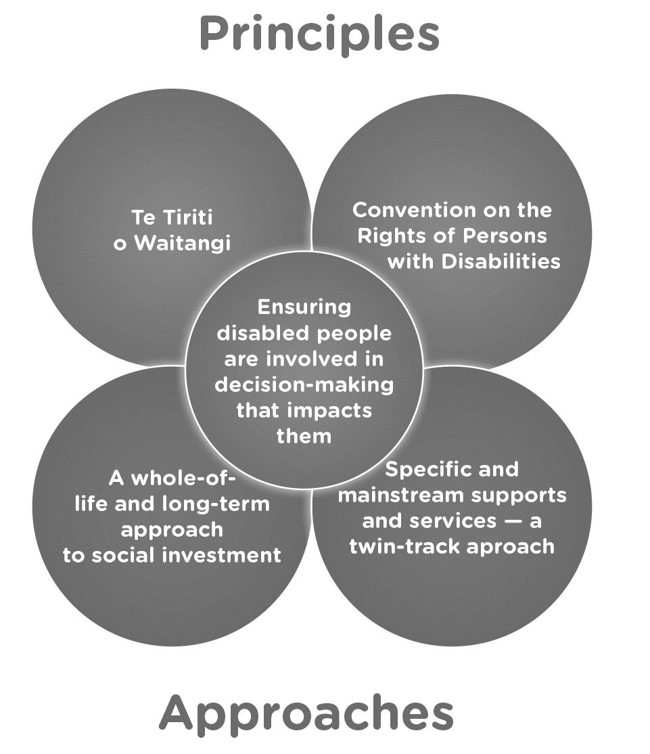
(Office for Disability Issues, 2016, p.16).

Phase Two: Close examination
The second reading involves seeking evidence of engagements with the element of Te Tiriti.

Preamble
Within the diversity section Māori are recognized as tangata whenua, as the Indigenous people, the first people of this land. The special relationship between Māori and the Crown is reinforced through a reference to Te Tiriti o Waitangi as our founding document. The Strategy emphasize the importance of a relationship between Māori and the Crown characterized by “…good faith, mutual respect and understanding and shared decision-making” (p. 18).

Kāwanatanga
There is a commitment in the Strategy to include whānau, hapū (sub-tribes), iwi (tribes) and Māori communities “at all levels of decision-making” (p. 18). The NZDS was developed through a significant consultation process involving face to face workshops on-line submissions and an expert reference group. It is not clear to what extent Māori engaged in these processes, but the reference group included the perspective of two Māori disabled people. We understand from an insider involved in the development of the Strategy that a bicultural co-governance model was proposed and rejected (Anon personal correspondence, 28 April 2020). In addition, the draft signed off by the expert reference group through a consensus process was later considerably changed by officials after subsequent consultation among Government agencies.

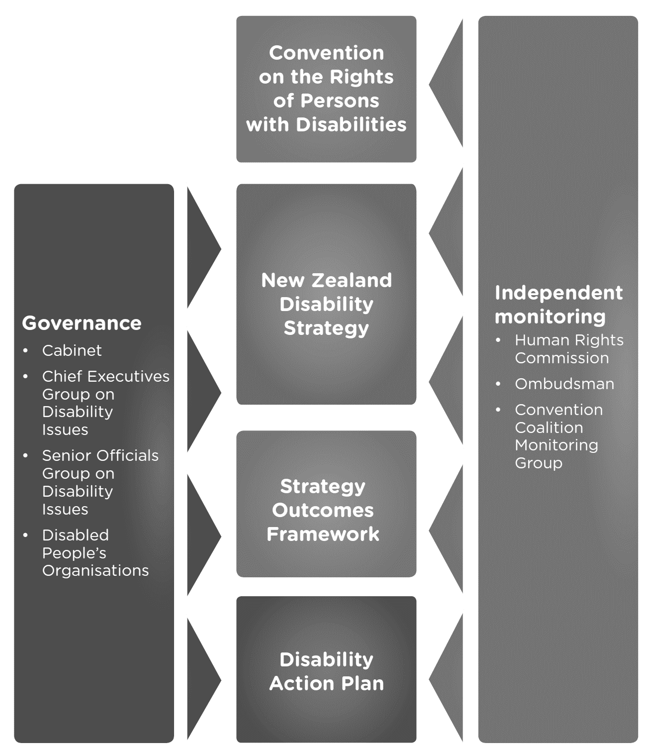
Figure 2
NZDS Governance & monitoring

(Office for Disability Issues, 2016, p.40).

Figure 2 shows the governance and monitoring schematic for the NZDS; which renders tāngata whaikaha, whānau, hapū and iwi voice invisible. It is unclear how Māori are involved in the Independent Monitoring Mechanism the government established to review the implementation of the NZDS. The Office of Disability Issues has planned ongoing consultation around updating the national disability action plan and associated outcomes framework. The Strategy states that the consultation process will consider the principles of Te Tiriti. Tāngata whaikaha or more broadly Māori are not however identified as stakeholders for achieving the vision of implementing the NZDS.

Rangatiratanga
The Strategy mentions Māori seeking self-determination but does not directly address the dynamics of rangatiratanga within the Te Tiriti partnership. Kaupapa Māori disability providers, who work from a Māori philosophical worldview delivering health and social services by Māori for tāngata whaikaha are invisible within the NZDS. The Strategy incorporates a handful of references to government reports and one non-governmental organization report. There is no evidence that engagement with the scholarly work of Māori academics as informed this Strategy.
The Strategy priorities eight key aspirational outcome areas to build a shared understanding of the future for disabled people. The need for a uniformed approach is strongly emphasized to: “…make sure that everyone has the same understanding about what the future should look like and that all actions are consistent with this” (p. 23).

Ōritetanga
The NZDS outlines a “twin-track approach” to health services where there are “mainstream” services and specific services for disabled people. Kaupapa Māori and/or iwi disability, health and social service providers are all invisible within the Strategy. The pursuit of equity is acknowledged in the Strategy without detail of how this might be achieved.

Wairuatanga
The importance of Māori values and world views is briefly identified within the Strategy. The need for culturally appropriate health services is stated as is the importance of being able to contribute to cultural activities. Rongoā Māori (Māori medicine) and wairua are not mentioned in the Strategy.

Phase Three: Determination
If te Tiriti o Waitangi was upheld within the NZDS, it would score good and excellent assessments in table one against the CTA indicators. The NZDS consistently scored poor and fair assessments. In relation to indicator one, the Strategy mentions the special relationship with Māori but this is not reflected elsewhere in the document. For Indicator two, there were two Māori on the expert reference group, but no further mechanism appeared to be in place to elevate Māori leadership. Research by Came, McCreanor, Haenga-Collins and Cornes (2019) suggests inequities in the health system also reproduced in advisory groups. There was a whakataukī included within the Strategy but limited or no engagement with Māori values, epistemologies, or approaches. Māori are listed as a special group in the diversity section of the Strategy but consideration to Māori aspirations is not visible. Wairua, rongoā and tikanga (cultural protocols) are not recognized within the Strategy.
Table 1
Assessment of NZDS against CTA indicators
Assessment of NZDS Against CTA Indicators
Indicators | Poor | Fair | Good | Excellent
1. Māori equal or lead partners in policy development
2. Mechanisms to ensure equitable Māori participation/ leadership
3. Evidence of inclusion of Māori values epistemologies, approaches and authority
4. Māori exercising their citizenship as Māori
5. Acknowledging importance wairua and rongoā

Discussion

Phase Four: Strengthening practice
Reviewing the NZDS, we identified four areas that we believe could be strengthened. These were: i) centering Māori world views, ii) addressing the determinants of Māori health, iii) embracing intersectionality and human rights and iv) deeper engagement with Te Tiriti o Waitangi responsibilities.

Centering Māori world views
Within the NZDS, the Office for Disability Issues (2016) recognized that:
Most Māori disabled people identify as Māori first. The importance of their cultural identify, which encompasses language, whānau, cultural principles, practices and linkages to the land through genealogy, is paramount to how they live their day to day lives in both Te Ao Māori [the Māori world] and Te Ao Pākehā [the settler world].
An initial review confirmed that the NZDS has privileged Te Ao Pākehā rather than Te Ao Māori. One way of centring tāngata whaikaha world views would have been to frame the strategy using Te Pae Mahutonga (Durie, 1999) or another Māori health model. With Te Pae, Durie uses the Southern Cross to represent the elements of a Māori health promotion approach to wellbeing. Most critical are the two pointers – that is ngā manukura (community leadership), and mana whakahaere (autonomy), which is about Māori control. The other elements include mauriora (cultural identity), waiora (physical environment), toiora (healthy lifestyles) and te oranga (participation in society). All elements need to be incorporated and addressed.
Tāngata whaikaha is a term gifted by a prominent elder Maaka Tibble to the disability community in 2015 (Opai, 2017). Tāngata whaikaha is a strength-based description to strive for enlightenment and enablement. It captures Tāngata whaikaha taking rangatiratanga (absolute control) over how they wish their impairments/disabilities to be described in Te Reo Māori (Māori language). The term tāngata whaikaha encapsulates all disabled people and also includes tāngata whaiora, a term that is used to mean a person who is subject of care, assessment and treatment in mental health. The Office for Disability Issues did not use this Māori term within the Strategy.
Māori and/or iwi health, disability and social service providers and services are an important expression of tino rangatiratanga (sovereignty) within Aotearoa. They are services developed from a Māori philosophical perspective by Māori for Māori. The twin-track approach outlined within the NZDS recognizes “mainstream” services and specific disability services but renders invisible the option of kaupapa Māori providers.
There is considerable evidence that kaupapa Māori services are effective in delivering quality holistic care to Māori whānau (Forrest et al., 2016; Gould et al., 2013; Te Puni Kōkiri, 2013). This effectiveness in part comes from the employment of Māori practitioners that are both clinically and culturally competent (Hunter, 2019; Wilson, 2018). Māori nurses for instance are often immersed in tikanga (Māori protocol), whakapapa (genealogy), and are fierce advocates for Māori whānau (Simon, 2006).

Determinants of Māori health
The Strategy failed to address the historical, cultural, political and social determinants of tāngata whaikaha health and well-being (Kiro, 2000; Robson, 2007). The inter-generational impact of the trauma of colonization on Māori whānau is well documented but rarely considered in public policy (Pihama et al., 2014). This historic legacy is compounded by contemporary manifestations of racism across the administration of the public sector (Came, 2014; Came et al., 2017). Within the health sector, racism can also be traced back to the quality and quantity of health care Māori whānau can access (Crengle et al., 2005; Harris et al., 2019).
Health inequities are fueled by the socio-economic circumstances in which people work, live and play (Marriott & Sim, 2014). The average Māori household income in 2013 was $22,500 (Statistics New Zealand, 2013), while the living wage in New Zealand was $46,500 (Living Wage Aotearoa New Zealand, 2017). The living wage is calculated to determine the real costs of essential family needs as well as energy, health, communication and education costs. These economic realities are different for Māori and non-Māori. Public policy needs to address the determinants of health and recognize the impact of the normalization of racism and privilege within settler colonialism.

Intersectionality and human rights
The NZDS would be strengthened by engagement with additional human rights instruments such as the Convention on the Rights of Indigenous Peoples (UN, 2007). There is strong evidence of systemic discrimination and disparities of outcomes disadvantaging Māori within the education and health sectors, the criminal justice system and elsewhere (Harris et al., 2019; MacDonald, 2019; McAllister et al., 2019; Workman, 2011). To achieve equitable access for all disabled people requires engagement with what Crenshaw (1991) calls intersectionality. Disabled people experience discrimination due to disability, but many also experience racism, sexism, homophobia and other forms of discrimination. All of these factors need nuanced consideration, especially racism, given it is importance as modifiable determinant of Indigenous health and wellbeing (Paradies, 2016).
Proportional universalism
Universal access to health services is widely accepted as part of the social contract in Western liberal social democracies. In the context of significant ethnic inequities in social and economic outcomes (Marriott & Sim, 2014), such as in New Zealand, the application of universal provision serves to maintain pre-existing inequities. Marmot (2010) maintains if a health service is committed to health equity, as claimed in the NZDS, it needs to engage with what he calls proportional universalism. That is “…actions must be universal but with a scale and intensity that is proportional to the level of disadvantage.”

Te Tiriti o Waitangi
Although the Strategy mentions Te Tiriti and emphasizes the special relationship between Māori and the Crown, this specialness is not reflected in the substance of the document. To uphold Te Tiriti, the NZDS needed to be much more explicit about how they proposed to engage with their te Tiriti responsibilities. It is not explicit how Māori have been involved in the development of the Strategy, or how they will be involved in implementation, monitoring and evaluation. It is unclear how this document advances tāngata whaikaha aspirations.
From a technical viewpoint, it is something of a polemic to refer to te Tiriti o Waitangi (the Māori text) which affirms Māori tino rangatiratanga (absolute sovereignty) and the Treaty principles interchangeably (Berghan et al., 2017). Scholars such as Durie (1998) have long maintained that Māori place greater emphasis on the actual words of te Tiriti rather than the Treaty principles because the definition of these has been left to the Crown acting on their own. It would therefore be more tika (correct) if the NZDS referred to the Articles of the Māori text of te Tiriti rather than the Crown-defined Treaty principles.
From the international experience in the field of disability among indigenous peoples, particularly those in anglophone colonial settings raised in the introduction, many of the issues with colonization, racism and other intersectional oppressions evident in the setting of Aotearoa apply. We can add to Stienstra’s (2018) view that indigenous, local, community perspectives are of critical importance to the constructive inclusion of indigenous disability, to argue that even a foundational document like Te Tiriti cannot prevent inequities unless the society is decolonised and transformed toward systems of natural justice for indigenous peoples. What Te Tiriti can do along with international human rights instruments such as the Declaration of the Rights of Indigenous Peoples (UN, 2007), is set in place alternative philosophies of society that allow the development and enactment of Indigenous-centered policy and practice for the elimination of this and other critical disparities.

Conclusion

Phase Five: Māori final word
It is sense of pōuritanga (sadness of heart) to review another health strategy centered in a western paradigm, tokenistic and hollow in its intent. It signals, another failed and lackluster opportunity to address and support Māori, who are overrepresented in disability statistics.
The uses of a whānau centered and well known whakatauakī, He aha te mea nui o te ao, must in principle be acknowledged as an attempt to weave a Māori worldview into the NZDS. It is an attempt to uphold the integrity and cultural important of people and whānau centred approaches. However, in my perspective, this whakatauakī has its own mana, mauri (life essence) and wairua (spiritual essence). Anyone using this whakatauakī must act with integrity, practice cultural authentic engagement, whānau centred approach, and a true commitment to Te Tiriti o Waitangi.
Unfortunately, the strategy does not actively demonstrate true commitment to the mana of the whakatauakī. It disappointingly does not implement any values of collectivism, whānau centred or whānau empowerment. There is little added value in the NZDS to understand the burden of disability for Māori, both from an individual and collective view. This should include essential dimensions of cultural appropriate health care, resourcing to support the life, work or play environments of tāngata whaikaha.
The CTA clearly highlights ways in which the strategy could be strengthened from a Māori worldview, at the center within the structure and content. How the NZDS engages with Māori as a collective of whānau, hapū and iwi, and/or as individuals, is unclear. Including only two perspectives of Māori disabled people on a reference group is inadequate. The NZDS fails to commit to tāngata whaikaha on many levels. This including failing to demonstrate a true or meaningful Te Tiriti o Waitangi relationship or partnership, bicultural governance, monitoring and decision making. This strategy has failed Māori and Tāngata Whaikaha.

References

Berghan, G., Came, H., Doole, C., Coupe, N., Fay, J., McCreanor, T., & Simpson, T. (2017). Te Tiriti-based practice in health promotion. STIR: Stop Institutional Racism.
Brewer, K. M., McCann, C. M., Harwood, M. L. N., & Worrall, L. E. (2015, 09 / 01 /). New Zealand speech-language therapists' perspectives on service provision for Maori with aphasia [Article]. Speech, Language and Hearing, 18(3), 140-147. https://doi.org/10.1179/2050572814Y.0000000060
Came, H. (2014). Sites of institutional racism in public health policy making in New Zealand. Social Science and Medicine, 106(0), 214-220. https://doi.org/10.1016/j.socscimed.2014.01.055
Came, H., Cornes, R., & McCreanor, T. (2018). Treaty of Waitangi in New Zealand public health policy 2006-2016 New Zealand Medical Journal, 131(1469), 32-27.
Came, H., Doole, C., McKenna, B., & McCreanor, T. (2017). Institutional racism in public health contracting: Findings of a nationwide survey from New Zealand. Social Science and Medicine, 199, 132-139. https://doi.org/10.1016/j.socscimed.2017.06.002
Came, H., Herbert, S., & McCreanor, T. (2019). Representations of Māori in colonial health policy in Aotearoa from 2006-2016: a barrier to the pursuit of health equity. Critical Public Health, 1-11. https://doi.org/10.1080/09581596.2019.1686461
Came, H., & Kidd, J. (2020, 2020/09/02/). A Critical te Tiriti o Waitangi analysis of the New Zealand Cancer Action Plan 2019-2029. Journal of Cancer Policy, 100252. https://doi.org/https://doi.org/10.1016/j.jcpo.2020.100252

Came, H., Kidd, J., & Goza, T. (2020, 2020/01/31/). A critical Tiriti analysis of the New Zealand Cancer Control Strategy. Journal of Cancer Policy, 100210. https://doi.org/10.1016/j.jcpo.2019.100210
Came, H., Kidd, J., Heke, D., & McCreanor, T. (2021). Te Tiriti o Waitangi compliance in regulated health practitioner competency documents in Aotearoa: A Critical Tiriti Analysis. New Zealand Medical Journal, 134(1535), 35-43.
Came, H., McCreanor, T., Haenga-Collins, M., & Cornes, R. (2019, 2019/01/02). Māori and Pasifika leaders’ experiences of government health advisory groups in New Zealand. Kōtuitui: New Zealand Journal of Social Sciences Online, 14(1), 126-135. https://doi.org/10.1080/1177083X.2018.1561477
Came, H., O'Sullivan, D., & McCreanor, T. (2020). Introducing Critical Tiriti Analysis through a retrospective review of the New Zealand Primary Health Care Strategy Ethnicities, 20(3), 434-456. https://doi.org/10.1177/1468796819896466
Crengle S, Lay-Yee R, Davis P, & J., P. (2005). A comparison of Māori and non-Māori patient visits to doctors: The national primary medical care survey Ministry of Health.
Crenshaw, K. (1991). Mapping the margins: Intersectionality, identity politics, and violence against women of color. Stanford Law Review, 43(6), 1241-1299.
Department of Economic and Social Affairs. (2009). State of the world's indigenous peoples. UN. http://www.converge.org.nz/pma/sowip09.pdf
Dew, A., Barton, R., Gilroy, J., Ryall, L., Lincoln, M., Jensen, H., Flood, V., Taylor, K., & McCrae, K. (2020, 12//). Importance of Land, family and culture for a good life: Remote Aboriginal people with disability and carers [Article]. Australian Journal of Social Issues (John Wiley & Sons, Inc. ), 55(4), 418-438. https://doi.org/10.1002/ajs4.96
DiGiacomo, M., Davidson, P. M., Abbott, P. A., Davison, J., Moore, L., & Thompson, S. C. (2011). Smoking Cessation in Indigenous Populations of Australia, New Zealand, Canada, and the United States: Elements of Effective Interventions. International Journal of Environmental Research and Public Health, 8(2), 388-410. https://www.mdpi.com/1660-4601/8/2/388
Durie. (1998). Whaiora: Māori health development (2nd ed.). Oxford University Press.
Durie, M. (1999, December). Te pae mahutonga: A model for Māori health promotion. Health Promotion Forum Newsletter, 49, 2-5. http://www.hauora.co.nz/resources/tepaemahutongatxtvers.pdf
Forrest, R., Taylor, L.-A., Roberts, J., Pearson, M., Foxall, D., & Scott-Chapman, S. (2016, 07//). PATU: Fighting fit, fighting fat! The Hinu Wero approach [Article]. AlterNative: An International Journal of Indigenous Peoples, 12(3), 282-297. https://doi.org/10.20507/AlterNative.2016.12.3.6
Gould, G., McEwen, A., Watters, T., Clough, A. R., & van der Zwan, R. (2013). Should anti-tobacco media messages be culturally targeted for Indigenous populations? A systematic review and narrative synthesis. Tobacco Control, 22(4), 1-10. https://doi.org/10.1136/tobaccocontrol-2012-050436
Goza, M., Came, H., & Emery-Whittington, I. (2021). A Critical Tiriti Analysis of the recruitment and performance review processes of public sector chief executives in Aotearoa. Australian and New Zealand Journal of Public Health, n/a(n/a). https://doi.org/https://doi.org/10.1111/1753-6405.13171

Harris, R. B., Cormack, D. M., & Stanley, J. (2019). Experience of racism and associations with unmet need and healthcare satisfaction: the 2011/12 adult New Zealand Health Survey [Article]. Australian & New Zealand Journal of Public Health, 43(1), 75-80. https://doi.org/10.1111/1753-6405.12835
Hickey, & Wilson. (2017). Whānau hauā: Reframing disability from an Indigenous perspective. Mai Journal, 6(1), 82-94. https://doi.org/10.20507/MAIJournal.2017.6.1.7
Hickey, H. (2006, 02//). Replacing medical and social models of disability by a communities-based model of equal access for people of differing abilities: A Māori perspective Huhana Hickey. He Puna Korero: Journal of Maori & Pacific Development, 7(1), 35. http://ezproxy.aut.ac.nz/login?url=http://search.ebscohost.com/login.aspx?direct=true&db=edo&AN=23056085&site=eds-live&scope=site
Hollinsworth, D. (2013, 2013/07/01). Decolonizing Indigenous disability in Australia. Disability & Society, 28(5), 601-615. https://doi.org/10.1080/09687599.2012.717879
Hunter, K. (2019). The significant cultural value of our Māori nursing workforce. Nursing Praxis in New Zealand, 35(3), 4-6. https://doi.org/10.36951/NgPxNZ.2019.009
Ineese-Nash, N. (2020, 09/26). Disability as a Colonial Construct: The Missing Discourse of Culture in Conceptualizations of Disabled Indigenous Children. Canadian Journal of Disability Studies, 9(3), 28-51. https://doi.org/10.15353/cjds.v9i3.645
Kidd, J., Came, H., Doole, C., & Rae, N. (2021). A critical analysis of te Tiriti o Waitangi application in primary health organisations in Aotearoa New Zealand: Findings from a nationwide survey. Health & Social Care in the Community, 30(1), e105-e112. https://doi.org/https://doi.org/10.1111/hsc.13417
Kiro, C. (2000). Kimihia mo te hauora Maori: Maori health policy and practice [Doctoral dissertation, Massey University]. Auckland, New Zealand.
Living Wage Aotearoa New Zealand. (2017). 2017 living wage rate: $20.20. Retrieved 14 February from https://d3n8a8pro7vhmx.cloudfront.net/nzlivingwage/pages/263/attachments/original/1487586293/The_Living_Wage_Rate_Announcement_2017_alternativev2.pdf?1487586293
MacDonald, L. (2019). Silencing and institutional racism in settler-colonial education Victoria University]. Wellington, New Zealand.
Marmot Review Team. (2010). Fair society, healthy lives: The Marmot review: strategic review of health inequalities in England post-2010 (The Marmot Review). Global Health Equity Group, Department of Epidemiology and Public Health, University College London.
Marriott, L., & Sim, D. (2014). Indicators of inequality for Māori and Pacific people [Working paper 09/2014]. Victoria University.
McAllister, T., Kidman, J., Rowley, O., & Theodore, R. (2019). Why isn’t my professor Māori? A snapshot of the academic workforce in New Zealand universities. Mai Journal, 8(2), 235-239. https://doi.org/10.20507/MAIJournal.2019.8.2.10

McGruer, N., Baldwin, J. N., Ruakere, B. T., & Larmer, P. J. (2019). Māori lived experience of osteoarthritis: a qualitative study guided by Kaupapa Māori principles. Journal of Primary Health Care, 11(2), 128-137. https://doi.org/10.1071/HC18079
O’Sullivan, D., Came, H., McCreanor, T., & Kidd, J. (2021). A critical review of the Cabinet Circular on Te Tiriti o Waitangi and the Treaty of Waitangi advice to ministers. Ethnicities, 21(6), 1093-1112. https://doi.org/10.1177/14687968211047902
Office for Disability Issues. (2016). New Zealand disability strategy 2016-2026.
Opai, K. (2017). Te Reo hāpai: A Māori language glossary for use in the mental health, addiction and disability sectors. Te Taura Whiri i te Reo Māori
Paradies, Y. (2016, 03//). Colonisation, racism and indigenous health [Article]. Journal of Population Research, 33(1), 83-96. https://doi.org/10.1007/s12546-016-9159-y
Pihama, L., Reynolds, P., Smith, C., Reid, J., Smith, L. T., & Te Nana, R. (2014, 07//). Postioning historical trauma theory within Aotearoa New Zealand [Article]. AlterNative: An International Journal of Indigenous Peoples, 10(3), 248-262. http://ezproxy.aut.ac.nz/login?url=http://search.ebscohost.com/login.aspx?direct=true&db=anh&AN=97821341&site=eds-live&scope=site
Rae, N., Came, H., Baker, M., & McCreanor, T. (2022). A Critical Tiriti Analysis of the Pae Ora (Healthy Futures) Bill. New Zealand Medical Journal, 135(1551), 106-111.
Ratima, K., & Ratima, M. (2007). Māori experiences of disability and disability support services. In B. Robson & R. Harris (Eds.), Hauora: Māori Standards of Health IV: A study of the years 2000-2005 (pp. 189-198). Te Rōpū Rangahau Hauora a Eru Pōmare, University of Otago.

Ratima, M. (1995). He anga whakamana: A framework for the delivery of disability support services for Māori. Massey University.
Robson, B. (2007). Economic determinants of Maori health and disparities. In M. Bargh (Ed.), Resistance: An indigenous response to neoliberalism (pp. 45-61). Huia.
Royal Commission on Social Policy. (1987). The Treaty of Waitangi and Social Policy [Discussion booklet number 1].
Simon, V. (2006, 09/01/). Characterising Maori nursing practice [Journal Article]. Contemporary Nurse: A Journal for the Australian Nursing Profession, 22(2), 203-213. https://doi.org/10.3316/informit.641111309885042
Smiler, K., & McKee, R. L. (2007, 01/01/). Perceptions of Māori Deaf Identity in New Zealand [research-article]. Journal of Deaf Studies and Deaf Education, 12(1), 93-111.
Statistics New Zealand. (2013). 2013 census quickstats about Māori.
Statistics New Zealand. (2014). Disability survey: 2013.
Statistics New Zealand. (2015). He hauā Māori: Findings from the 2013 Disability Survey. Statistics new Zealadn. Retrieved 24 October from https://www.stats.govt.nz/reports/he-haua-maori-findings-from-the-2013-disability-survey
Stienstra, D. (2018). Canadian Disability Policies in a World of Inequalities. Societies, 8(2), 36. https://www.mdpi.com/2075-4698/8/2/36

Te Puni Kōkiri. (2013). Ka mōhio, ka matau, ka ora: He ia kōrero: Measuring performance and effectiveness for Maori: Key themes from the literature.
UN. (2007). Declaration on the Rights of Indigenous Peoples. http://iwgia.synkron.com/graphics/Synkron-Library/Documents/InternationalProcesses/DraftDeclaration/07-09-13ResolutiontextDeclaration.pdf
UN. (2008). International Convention on the Rights of Persons with Disabilities.
Waitangi Tribunal. (2019). Hauora: Report on stage one of the health services and outcomes kaupapa inquiry.
Wilson, D. (2018, 05 / 01 /). Why do we need more Maori nurses? [Editorial]. Kai Tiaki Nursing New Zealand, 24(4), 2.
Workman, K. (2011). Māori over-representation in the criminal justice system does structural discrimination have anything to do with it?: A discussion paper. Rethinking Crime and Punishment. http://www.rethinking.org.nz/assets/Newsletter_PDF/Issue_105/01_Structural_Discrimination_in_the_CJS.pdf

A Critical Tiriti Analysis of the New Zealand Disability Strategy 2016-2026
by Heather Came https://rdsjournal.org/index.php/journal/article/view/1081 is licensed under a Creative Commons Attribution 4.0 International License. Based on a work at
https://rdsjournal.org.

