Research Articles and Essays
The Role of Teachers who are Deaf/Hard of Hearing in the Field of Deaf/Hard of Hearing Education
Holly Pedersen¹, Diane Gard², Monica Soukup³, Mary Huston,⁴
^{1, 2, 3, 4} Minot State University,
If you want to change the story, change the storytellers. – Oprah Winfrey
The student make-up in classrooms has changed, becoming increasingly more diverse across a number of factors. For example, in the United States, racial and ethnic diversity is highlighted by the U.S. Census Bureau who reported that in 2007, about 57% of elementary and middle school students were non-Hispanic white (Anderson, 2006). Ten years later that number had decreased to less than 50%. Numerous aspects of student diversity are evident in today’s schools including migrant status, socio-economic status, homelessness, English language learners and more. Not only must teachers become equipped to respond to the diverse characteristics of their students, the teaching profession recognizes the need for the make-up of teachers themselves to become more diverse and better reflect the population of students they serve. However, the gap between teacher diversity and student diversity remains large and widening (Boser, 2014).
This gap is also evident in the field of Special Education and calls to action for addressing it have appeared in the literature for more than 10 years (Nichols et al., 2008). For the current study, the following statistics related to students receiving special education in the U.S. are helpful: (a) Students ages 3-21 years receiving special education services make up about 14% of the total school-age population, (b) of these students, about 8.5% are also English Language Learners, (c) 17% are male and 9% are female, and (d) students who are DHH represent only about 1% of students receiving special education services in other disability categories (US Department of Education, 2018). While the majority of the literature on teacher diversity pertains to race and cultural/linguistic diversity, it is particularly important to remember a) that disability is a form of diversity, and b) Deaf and hard of hearing (DHH) students using a bilingual/bicultural communication approach, including American Sign Language (ASL), may also be considered culturally/linguistically diverse (Holcomb, 2013). It is logical then, that the make-up of Special Education teachers, including teachers of students who are DHH (TODHHs), should reflect the diversity characteristics of the students they serve. There is ample literature describing the population of students who are DHH as diverse. Ausbrooks et al., (2012) state, “Deaf Education has become a beautiful mosaic comprised of unique images of ethnicity, etiology, communication preference, and educational need” (p. 369). By contrast, a recent study including 365 TODHHs in the United States found that this group was 96% female, 92% white, 10% DHH, with a mean age of 44 (Luckner & Ayantoye, 2013). Clearly, these statistics illustrate the gap between the diversity characteristics of TODHHs and the students they serve.
Literature Review
Linguistic & Cultural Diversity in DHH Education
The majority (more than 90%) of children who are DHH are born to hearing parents (Shantie & Hoffmeister, 2000; Smith, 2001; Carty, 1994). Parents are faced with a myriad of new choices regarding technology and communication modality - the choice of learning a new language and culture, and whether or how to navigate between deaf and hearing worlds. The field of DHH education has a 200+ year history of controversy surrounding communication modality and cultural identity. This controversy continues today despite evidence that one method is superior for all children who are DHH (Sass-Lehrer, 2016).
Prior this century, the linguistic and cultural choices for children who were DHH were limited and often “black and white” – if you were audiologically profoundly deaf, it was likely you would attend a school for deaf children, use ASL, and identify with Deaf culture; if you were audiologically hard of hearing, it was likely you would use spoken language (possibly with support of English based sign systems) and identify with mainstream or hearing culture. The medical model of deafness was prevalent, meaning that hearing loss was viewed as something to be corrected rather than an identity. However, advances in technology including the implementation of universal newborn hearing screening, digital hearing aids, and cochlear implants has significantly impacted the field of DHH education. Before 1975, 80% of deaf students attended schools for the deaf, but today nearly 85% of students are in the general education classroom (Shaver et al., 2013). Also, the majority of students who are DHH now use listening and spoken language or listening and spoken language combined with some sign support (often referred to as total communication) as their primary means of communication (The NCHAM ebook, 2019; Sass-Lehrer, 2016; Gannon, 1981).
Language and culture are intertwined; language is how cultural norms are shared amongst the community (Hall, 1989; Holcomb, 2013). Immersion into the Deaf community is the best way to experience Deaf culture (Hall, 1989). The community helps with instruction in the areas of linguistic and cultural traditions, themes, signed storytelling, signed folklore, modeling, and identity development (Sutton-Sprence, 2010). Recently, some researchers have acknowledged that cultural identity amongst people who are DHH is now more fluid and that they often move between the Deaf and hearing communities depending on the various situations they may encounter (McIlroy & Storbeck, 2011; Kemmery & Compton, 2014).
Theoretical Framework
Two constructs provide support for the current study. James A. Banks is a contemporary author widely known for his work on multicultural theory in the field of education. Banks’ (1997) model proposed five aspects of multicultural education: content integration, knowledge construction, prejudice reduction, equity pedagogy, and empowering school structure. While a large body of literature discusses multicultural theory in the field of education, Cumming-McCann (2003) provides this succinct comment, “the primary goal of multicultural education is to promote the education and achievement of all students, particularly those who are traditionally dismissed and underserved in our education system” (p. 9). Clearly, this goal aligns with the intent of special education and with disability issues and the social model of disabilities commonly accepted today (Thomas, 2004); however, it is also important to note that some researchers strongly argue that the link between multicultural education and disability has not been well researched and the inclusion of Deaf culture in the discussion is lacking (Johnson & McIntosh, 2009; Storey, 2007).
Related to multicultural education is the developmental theory of self-concept. Discussed by well-known theorists Abraham Maslow and later Carl Rogers, self-concept is the general term that describes how a person perceives and evaluates themselves (McLeod, 2008). Self-concept theory supports the current study in the assumption that interaction with role-models who have similar characteristics to an individual motivates them to “see their potential” and develop a healthy or positive self-concept.
Multicultural Education. Multicultural education is an idea, an educational reform movement, and a process (Banks, 1997). Banks’ (1997) model, displayed in Figure 1, proposed five aspects of multicultural education: content integration, knowledge construction, prejudice reduction, equity pedagogy, and empowering school structure.

Figure 1
Banks’ Multicultural Education Model (Banks, 2009)
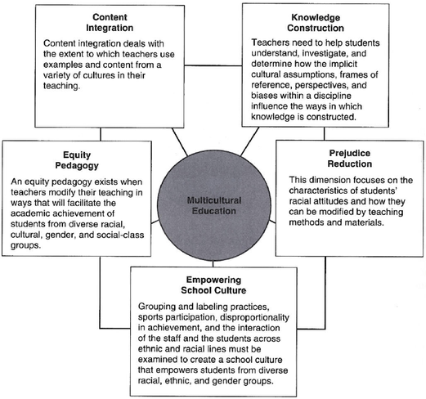
Banks’ model is conceptualized as a process that school systems will move through in increasing efforts to reach multicultural education. In the context of the current study, the dimensions of equity pedagogy and prejudice reduction are particularly important. The purpose of special education including the education of students who are DHH is to ensure these students receive access to the curriculum through free appropriate public education (Smith, 2001). Recent advances in technology have allowed for unprecedented opportunities for students who are DHH, and yet postsecondary outcomes for this population still lag behind their hearing peers (Garberoglio et al., 2016). Equity pedagogy and prejudice reduction focus on student outcomes and how teachers and teaching methods can influence them.
Self-Concept Development and Identity Formation. A major hurdle that children who are DHH who are born to hearing parents have to face is the prospect of finding and forming their identity while increasing their self-esteem (Desgeorges, 2003). Hearing parents pass on their knowledge the only way they know how: by telling their child stories of how they formed their identities through listening to the narratives around them; however, hearing parents’ experience is not the same as the experiences of their children will be (Cole & Flexer, 2016). The child who is DHH will face new and different challenges that will define who they are and they will need to find a role model that can lead them in this endeavor (Carty, 1994). According to Kemmery and Compton (2014), identity may be defined as “the distinctive characteristic belonging to any given individual and the formation of one’s identity may be affected by one’s identifications or lack of identifications with significant others.” The others noted could include caregivers, parents, siblings, or any other person who is a part of this individual’s life.
Another type of identification is the use of a cochlear implant or hearing aids, which drastically alters the experiences of the child who is DHH from that of a hearing child (Williams, 2009). The technology creates a visual identity marker which can make a difference in a child’s self-esteem, both good or bad. Perspectives of language, culture, daily routines, and communication are a few of the ways of how to ideally create the framework of identity development (Carty, 1994). Children need to be shown how to take what they know and mold it into self-identity and be proud of who they are, creating and fostering self-esteem. The TODHH may be one to encourage and direct a child in how to discover their identity (Hall, 1989). The teacher can point the way with introducing the child to other deaf and hard of hearing individuals (both child and adult), reading literature involving DHH characters, providing information to other teachers in how to guide and nurture the child’s journey to self-identity, and involving the family in Deaf culture immersion activities (Hall, 1989).
It is not uncommon for a child to choose to be part of both the Deaf and the hearing community (Vernon & Makowsky, 1969; Carty, 1994; Musengi & Dakwa, 2010). Another aspect is a fluid view of identity that would move them from one to the other of the four main types of Deaf identity: Deaf, deaf, bicultural/dual, and marginalized (Kemmery & Compton, 2014). The view that is chosen is based on factors such as roles, interactions, contexts or settings that the individual finds themselves in. The adults in this child’s life are an important influence on their identity by use of language choice, mode of instruction, and style of communication (Desgeorges, 2003).
Teachers with Disabilities
The number of teachers in pre K-12 education who have disabilities is not tracked; however, a number of sources provide rationale to suggest that this group is underrepresented in education as are other aspects of diversity amongst teachers (Anderson, 2006; Wills, 2007). There have been several studies examining various aspects of teachers who have disabilities. The majority of this work has been done with teachers who have learning disabilities. The potential benefits of hiring teachers with disabilities are numerous. Storey (2007) lists this practice as one way to combat ableism in schools. Riddick’s (2003) study of experienced, novice and preservice teachers with dyslexia found that these teachers had developed numerous coping strategies and that their own negative school experiences motivated them to become teachers who would provide a better experience for their students. Similar results were found by Ferri et al. (2005) and by Burns and Bell (2011) noting that being a positive role model for students with disabilities and having a great understanding of the challenges that these students may face was a motivating factor for teachers with disabilities. Teachers with disabilities have further opportunity to model ways that all students can view challenges as opportunities for growth (Stewart, 2010) and also to contribute to normalizing disability culture within schools. Finally, teachers with disabilities are in a unique position to examine the pedagogy of teaching students with disabilities (Anderson, 2006; Grenier et al., 2014).
Despite these benefits, teachers with disabilities may face barriers in their own profession. The Council for Exceptional Children (CEC) is a supporter of educators with disabilities as they believe first-hand, or personal experience is a strength offered by these educators (CEC, 2016). In CEC’s official policy statement, they acknowledge that teachers with disabilities may not disclose their disability for fear of discrimination or rejection and that appropriate accommodations to support the success of these teachers are not always in place. CEC’s policy calls for the provision of strategic supports for teachers with disabilities during recruitment, hiring, daily practice, and evaluation in order to gain the benefits that these teachers can offer to all students.
Teachers Who are DHH. The history of deaf education documents the use of teachers who were deaf themselves going back to its foundation in Paris in the 1700s (Roberson & Serwatka, 2000). When the first school for the deaf was established in 1817 in the US, the school exclusively used sign language and employed deaf teachers. However, the infamous Conference of Milan in 1880, which banned the use of sign language in deaf education, resulted in the loss of most deaf teachers in deaf education worldwide. While the large and highly controversial topic of communication modality in deaf education is acknowledged, it is discussed in this study only as it pertains to the linguistic diversity issue amongst students who are DHH.
Modern calls for teachers who are DHH to be represented in the education of students who are DHH are documented in the literature for more than 50 years (Vernon, 1970). Teachers who are DHH have the same goal as hearing teachers: teach students and help them to succeed (Thagard et al., 2011); however, concerns about whether or not the profession of teaching is truly inclusive discussed above are also echoed in the field of DHH education. In fact, the lack of diversity amongst TODHHs has been compared to apartheid (Simms et al., 2008). While this term is most often associated with the divide between whites and blacks in Africa, the term actually means “apartness” in the Afrikaans language, which Simms, et al. (2008) use to describe the marginalization of individuals who are DHH in the education system and offer increased teacher diversity in this field as a solution. Likewise, Andrews and Franklin (1997) highlighted the need for teachers who are DHH as well as those who are ethnically and culturally (in addition to Deaf culture) diverse. These authors also discussed the potential barriers faced by individuals who are DHH to even becoming teachers in the first place, including standardized testing bias and discrimination in post-secondary settings. It is interesting to note that these barriers were also present at this researcher’s own institution, where administration actively worked to keep teacher candidates out of the profession using the rationale that individuals who were DHH could not be effective teachers due to poor speech and language skills (Pedersen, personal communication March 6, 2020). However, one study disputes this notion, as Roberson and Serwatka (2000) found no difference in the achievement scores of students who were DHH that were taught by either TODHHs who were hearing or TODHHs who were DHH. Similarly, when it comes to the early language development of children who are DHH who are using ASL, Shantie and Hoffmeister (2000) argue that TODHHs who are DHH themselves are more effective as native language users than TODHHs who are hearing. Marlatt’s (2004) research concluded that, while there are differences in the ways that TODHHs who are DHH and TODHHs who are hearing teach, these two groups of teachers are more alike than different and the profession should focus on ways to collaborate. One study examining the perceptions of TODHH teaching teams that were comprised of both hearing and DHH teachers, identified positive aspects of such collaborative practices. Specifically, Jimenez-Sanchez & Antia (1999) found that it provided both hearing and DHH students with, “a model of interaction between D/HH and hearing individuals based on mutual respect, collaboration, and equal status. The team was providing a model of respect between individuals who use different languages” (p. 218).
While the research is thin, there does not appear to be any evidence that teachers who are DHH are less effective than those who are hearing, but rather that TODHHs who are DHH may possess specific skills that enhance the education of their students. These findings support the rationale that diversity in general can strengthen everyone’s experience.
The Current Study
The problem this study addresses is that the diversity characteristics of TODHHs do not reflect those of the students they serve; specifically, TODHHs who are DHH themselves. Barriers, such as language, culture, labels of disability, or lack of respect and support stand in the way of teachers with hearing loss either doing the best job they can or even becoming a teacher in the first place (Boser, 2014). Some research identifies possible barriers for individuals who are DHH in becoming teachers, but little input exists regarding the perceptions of TODHHs who are DHH themselves. This is significant because if efforts to increase the diversity characteristics of TODHHs are to be successful, we must consider the voices of these individuals in the conversation. Therefore, the purpose of this study was to explore the perceptions of TODHHs who are DHH themselves regarding the role, importance, and value of a TODHH who is DHH to the students they serve and to the field of DHH education.
Method
Design and Rationale
A cross-sectional electronic survey design was used for the current study. Survey designs are appropriate to describe both individual opinions at one point in time as well as to collectively search for trends amongst these individual opinions (Crewell, 2012). While survey designs may traditionally be viewed as tools for collecting quantitative data, this design has application for qualitative methods as well including interviews and focus groups because it allows the researcher access to a larger potential sample; this is particularly true when using electronic distribution methods (Creswell, 2012; Jansen, 2010). A narrative approach through the use of open-ended questions in the electronic survey, allowed researchers to explore the perceptions of TODHHs who are DHH themselves as there is limited available literature. Narrative approaches are best for capturing the experiences, values, feelings, perceptions, and goals of the people we want to know more about (Creswell, 1997).
Participants
Fifty teachers responded to the electronic survey and the average time for survey completion was 20 minutes. Participants identified their hearing status as 54% hard of hearing, 38% Deaf, 2% deaf, and 6% other (not specified). Most participants, 92%, were female and 8% were male. Represented age ranges for participants were 8% in their 20s, 25% in their 30s, 39% in their 40s, 18% in their 50s and 8% in their 60s. The professional preparation of these teachers was 60% with a Master’s degree, 24% with a Bachelor’s degree and 14% with a Doctorate degree (one participant skipped this question). Participants’ reported years of teaching experience in the field of DHH education is shown in Figure 2; indicating the majority of teachers in this study were experienced professionals.
Figure 2
Participants’ Years of Experience
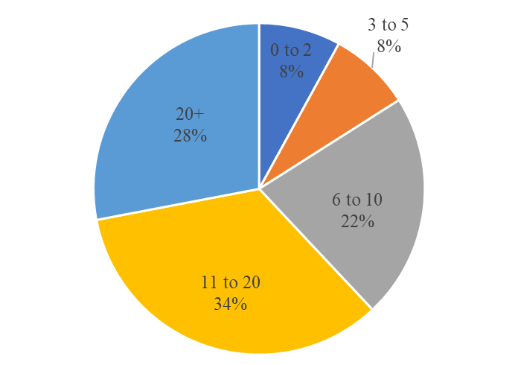
Aligning to national trends in the field, the majority of participants reported they were currently teaching in an itinerant role (68%), 22% were teaching in a self-contained program within a public school, and 8% were teaching at a school for the deaf (one participant skipped this question).
Instrument and Data Collection
Informed by the literature review for this study, an original survey instrument was developed containing both demographic questions and open-ended questions. When designing survey questions, it is important to (a) use different types of questions that may be personal or attitudinal, (b) ensure questions are clearly worded and applicable to all participants, and (c) pilot test the instrument (Creswell, 2012). The open-ended questions were piloted with five TODHHs who were DHH themselves and revisions to the survey were made based on this group’s feedback. The final survey instrument contained six demographic questions and eight open-ended questions. The survey was built using Microsoft Forms®. After obtaining approval from the researchers’ institutional review board for human subject research (Protocol #2110), the survey was distributed through social media channels consisting of groups for TODHHs. The researchers are members of these groups and had access to post the survey. The survey was open for a period of eight weeks, the repeat postings to the social media groups made four times during the survey period to ensure visibility to the population.
Data Analysis
After the survey was closed, raw data from Microsoft Forms® was exported into a spreadsheet for data analysis. Participant demographic data was analyzed using descriptive statistics and represented through percentages. An inductive approach to analyzing the qualitative data (participant responses to the open-ended questions) was taken. The written responses to the open-ended questions were coded by the researchers using a pattern matching strategy (Enns, 2017). Words and phrases that were consistent with the key constructs of each question were coded together. Through repeated readings of the raw data and the coded data, these groupings were refined into themes that could be described in the context of perceptions. In order to visually represent these themes, word clouds were created. A word cloud is a grouping of words and phrases representing a topic in which frequency and emphasis are shown through larger and bolder print; colors and other tools for visually representing the data may also be utilized (DePaolo & Wilkinson, 2017). Word clouds are useful to summarize qualitative data in an impactful and visual way.
Results
The five perception themes discovered during data analysis are presented below using the visual word clouds as well as salient participant quotes to describe the themes.
Recognizing and Valuing Diversity. Teachers were asked to indicate the education setting in which they preferred to teach students who are DHH. About 30% of teachers indicated itinerant models while about 26% indicated schools for the deaf or other self-contained settings. About 20% of teachers described inclusive settings within a public or private school that included resource room and pull-out services. Finally, about 12% of teachers stated they did not have a preference, but rather described they preferred settings that met the student’s needs. One participant said, “I prefer teaching in settings with clear and accessible communication.”, while another noted, “I like any situation that supports the student’s and family’s choice.”
Participants consistently noted they had lived experiences that could help them identify with their students and that serving as a role-model was important to them. “I can help my students realize I understand them and that we can work through challenges together”, one teacher said. The word cloud representing participant perceptions for valuing diversity is shown in Figure 3.
Figure 3
Recognizing and Valuing Diversity Word Cloud

As one participant noted,
Diversity is key! I think it’s incredibly important for students to have someone in their life they can relate to and have shared experiences with. I find myself interacting with students the way I wish I’d had a teacher who really understood.
In the same way, another TODHH said,
I think there is great value in students being taught by those who have the same characteristics as they do- the same challenges and who will pass down the knowledge gained by their experiences. Benefits include seeing others like themselves in successful and rewarding careers, functioning in the world, and meeting the same challenges.
However, participants in this study did not indicate students who are DHH exclusively need teachers who have the same characteristics as they have. One teacher observed, “The kids know I understand what they are experiencing. But I don’t have to have cancer to have empathy for someone who has cancer.”
Participants also expressed some motivators for becoming a TODHH that are common to all teachers including having a passion to help children learn and wanting to make a difference; however, TODHHs who are DHH themselves also noted they wanted to help students receive the same supports they had received as a student, or conversely, TODHHs wanted to be able to provide a supportive environment for their students that was not available to them.
Then Versus Now. The TODHHs who are DHH themselves in this study overwhelmingly noted the increased access that is available today than was their experience, as illustrated in Figure 4. One participant said,
Constantly fighting to hear and access sound (I grew up oral, no sign language); never knowing what was going on with peers around me, always left out; very little CC. This has not changed. What's changed is easier access to CC, texting for communicating is huge, great tech options for hearing or access to speech.
In the same manner, I remember getting my hearing tested by the nurse and her always giving me strange looks but never referring me. It wasn’t until my brother, who is 8 years younger than me, got diagnosed with hearing loss and then I went to get a physical for grad school that my hearing was ever screens by a professional. This was when I found out I probably had hearing loss. Looking back, I note how much trouble I had when I was little. Slight trouble with speech, reading, and other things, until I received more direct instruction. My anxiety was always high. Social situations were difficult. I think kids experience the same things today, especially those that have slipped through the cracks, like me, with mild-moderate hearing loss. However, I think things have changed because less kids are slipping through the cracks with the newborn hearing screenings, and those that do I feel receive prompt attention and direct instruction. It’s just more accepted and easily identified than it was 25 years ago.
Figure 4
Then vs. Now World Cloud
Participants also perceived that, while access and appreciation for diversity had improved for their students when compared to their own experiences, some of the same challenges remained and some new challenges have developed. For example,
SAME: Bullying. Isolation. (I saw when supporting mainstream students; I don't see nearly as much at the… school for the deaf where I currently teach, though it certainly still exists). Literacy and math struggles are ongoing. DIFFERENT: Greater focus on group work in mainstream settings (this is not a good thing). Children receiving early intervention earlier in life (this is a very good thing). Children moving more freely between ASL and English (this is a good thing).
Educational Philosophy. The diverse views related to communication methodology that are present within the field of DHH education were also reflected within this study’s sample of TODHHs that are DHH themselves. A few comments indicated a strong emotional philosophy toward exclusively oral or manual approaches including, “Bilingual, bilingual, and bilingual.”, “Every Deaf child should have access to ASL and English.” and also, “The hearing aids are the most important factor in children’s success in learning” and, “If they can learn to be oral they can become more independent functioning members of society. Not dependent upon an interpreter or writing notes.” However, the majority of participants perceived full access to language was the key and recognized that this could happen in a variety of ways; that one size did not fit all students as shown in Figure 5 below. As one participant noted, “Whatever the student needs to be successful they get - oral or sign support, technology or accommodations.”
Figure 5
Educational Philosophy
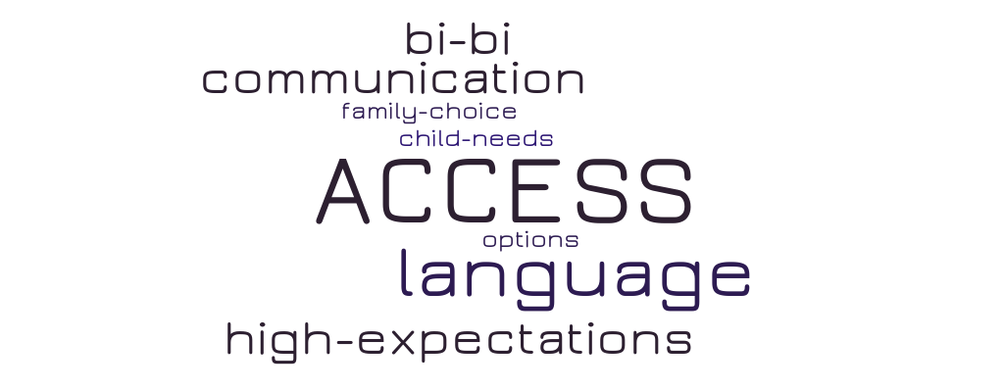
The concept of high expectations was expressed by participants and part of their educational philosophy, and related this to their personal experiences as an individual who is DHH:
I have high expectations so that they have high expectations. I feel it’s important they not use the hearing loss as a crutch but know they can do anything anyone else can do. That’s important to me. That was one of the hardest things for me growing up is that I could succeed as well as anyone else and I don’t want them to have doubts like I did.
Professional Relationships. The TODHHs who are DHH themselves in this study also perceived they had a role to play in having a positive influence with other professionals within the field of DHH education. One teacher stated they had, “Great collaboration and respect as an individual who has experience as a hard of hearing person.” Participants indicated their experiences as a professional within the field were mostly positive; however, there was still a need to self-advocate and raise awareness. For example, “I have good relationships with almost everyone I work with. That being said, I often have to confront biases about our DHH students and their needs. Communication with masks has been particularly challenging.” and, “Mutual respect between all parties. It took years to build that rapport but now people seek me out for advice and follow (most of) my recommendations.” One teacher noted,
I have been in my current role for 7 years. I took my employer to the (made a federal discrimination complaint) as they refused to make the necessary provisions I need to access calls. I won. It is now 7 years since this extremely stressful experience, and I couldn't be happier. A LOT has changed. It is a work in progress.
Further, many participants noted their professional relationships with their immediate team members was good, but that administration and other related personnel often did not understand the needs of individuals with hearing loss, as in, “I have a fantastic working relationship with SLPs, Audiologists, Interpreters, Paraeducators, and other TODHHs. I struggle with my administration quite a bit.” and,
I love the team I work with - I love that they are so understanding of using sign language immediately and never letting anyone feel left out. My administration unfortunately is not from a DHH background, so my team often relies on each other instead of administration for support and guidance.
The word cloud representation of this theme is displayed in Figure 6 below.
Figure 6
Professional Relationships Word Cloud
Future Directions
Interestingly, participants’ views of what is needed for a more positive future of the field of DHH education appears consistent with what all educators, regardless of their discipline, desire. As show in Figure 7, TODHHs in this study indicated more emphasis on student’s unique needs and to be provided with the resources to be able to successfully meet these needs.
Figure 7
The Future Word Cloud
Echoing what they described in their educational philosophies, TODHHs who are DHH themselves in this study commented on the need to move away from historical controversies (i.e., communication modalities) and focus on language and literacy outcomes. For example, “A fully comprehensive, standards-based curriculum aimed at bridging the literacy gaps for DHH students.” and,
I would like to see a more student-centered philosophy. Each child is unique in what they need and the child often knows best what that is. I would like to see children empowered to learn what is available and make their own choices. I would like to see Language Deprivation taken seriously.
Discussion
This exploratory study brings the voice of TODHHs who are DHH themselves to the conversation of increasing teaching diversity in the field of DHH education. In this study, being a role model for students who are DHH was very important to participants. The findings support Roberson & Serwatka’s (2000) assertion that a teacher who is DHH has gone through some of the same experiences as their students and are thus able to truly understand and have credibility with the student.
The longstanding challenges faced by teacher candidates who are DHH still requires attention. This begins with representation amongst the faculty (Parasnis & Fischer, 2005). There continues to be a need for not only recruitment efforts of teacher candidates who are DHH but also support for their retention. If we know that younger students who are DHH require linguistic and academic supports as well as mentoring, perhaps the evidence-based practices used with this group can be systematically employed in university to support retention and graduation of TODHHs who are DHH themselves. This study’s findings also indicated a need for both personnel preparation programs and prek-12 systems to “practice what we preach.” While the field of DHH education places value on efforts to develop cultural competence, appreciation for diversity, and an atmosphere of accessibility, this may not be happening with enough regularity in practice (Cannon & Luckner, 2016; Johnson & McIntosh, 2009).
It is also important to note how colleagues can learn from each other. When a teacher who is DHH is not available, schools may use what is necessary to close the gap, such as films, other media, biographies of famous people with disabilities, and other literature (Storey, 2007), but daily interaction with a fellow TODHH who is also DHH can lead to greater understanding. Banks (1997) describes implementation of his multicultural education model often progresses from things that are very easy to implement and have a lesser impact to things that are harder to implement but have a larger impact as shown in Figure 8.

Figure 8
Implementation of Multicultural Education
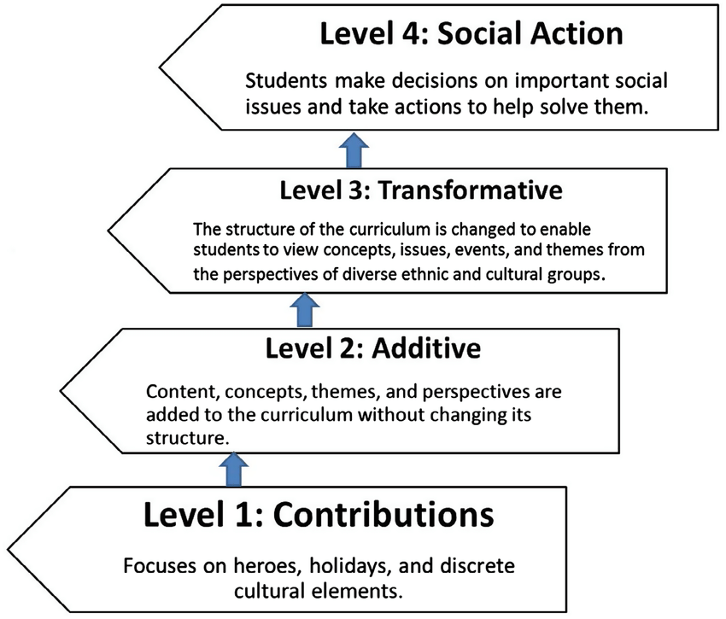
Within the context of multicultural education, Johnson & McIntosh (2009) remind us that in order for this greater understanding to take place, someone’s lived experience must be accepted as valid and worthy of value. Whenever possible, individuals who are DHH (including TODHHs) should be willing and invited members both in preservice and inservice arenas. As Martlatt (2004) recommended, finding common ground amongst DHH and hearing professionals can lead to improved outcomes for all.
Limitations and Recommendations for Future Research
The current study sought to explore the topic of diversity in DHH education by bringing the voice of TODHHs who are DHH themselves to the conversation, but there is still much more to be learned. This study gathered initial information of teacher perceptions. Additional research that contains the voices of these teachers is needed, including strategies that have been employed to address the challenges that were identified in this study. Personnel preparation programs and prek-12 education systems should carefully examine how they truly support cultural competence, multicultural education, and disability access. One recent case study of how a TODHH preparation program did this was done by Engler and Macgregor (2018) and could be used as a basis for future investigation.
Conclusion
Results of this study highlight the continued need for representation of diversity in schools including diversity amongst teachers. Access to positive role models is key to healthy self-concept development for all children, including children who are DHH. As noted by Johnson & McIntosh (2009), “an understanding of the shared and collective experiences and perspectives of the Disability community and the Deaf community may better inform educational policies, practices, and research that leads to improved educational outcomes for Disabled and Deaf youth” (pp. 76-77). Mainstream society is making some gains, recognizing this and taking appropriate steps, but there is more work to do. As illustrated in the candid snapshot of a child at Target® in Figure 9, one thing is clear, representation matters in the healthy growth and development of all children.
Figure 9
Representation
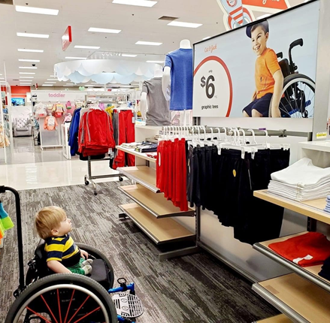
References
Anderson, R. C. (2006). Teaching (with) disability: Pedagogies of lived experience. Review of Education, Pedagogy, and Cultural Studies, 28(3-4), 367-379. https://doi.org/10.1080/10714410600873258
Andrews, J. F., & Franklin, T. C. (1997). Why hire deaf teachers? Retrieved from ERIC database https://files.eric.ed.gov/fulltext/ED425600.pdf
Ausbrooks, M., Baker, S., & Daugaard, J. (2012). Recruiting deaf and diverse teachers: Priorities of preservice teachers in deaf education. Journal of the American Deafness and Rehabilitation Associations, 46, 369-398. Retrieved from https://repository.wcsu.edu/jadara/vol46/iss1/4
Banks, J. A. (1997). Educating citizens in a multicultural society. Teachers College Press.
Banks, J. A. (2009). The Routledge international companion to multicultural education. Routledge.
Boser, U. (2014). Teacher diversity revisited: A new state-by-state analysis. Washington, DC: Center for American Progress.
Cannon, J. E., & Luckner, J. L. (2016). Increasing cultural and linguistic diversity in deaf education teacher preparation programs. American Annals of the Deaf, 161(1), 89–103. https://www.jstor.org/stable/26235253
Carty, B. (1994). The development of deaf identity. In C. J. Erting, R. C. Johnson, D. L. Smith, & B. D. Snider (Eds.), The Deaf Way: Perspectives from the International Conference on Deaf Culture (p. 43). Gallaudet University Press.
Cole, E. B. & Flexer, C. (2016). Children with hearing loss: Developing listening and talking, birth to six (3rd ed.). Plural Publishing.
Creswell, J. (2012). Educational research. Planning, conducting, and evaluating quantitative and qualitative research (4th Ed.). Pearson.
Creswell, J. (1997). Qualitative inquiry and research design: Choosing among 5 traditions. Sage.
Cumming-McCann, A. (2003). Multicultural education: Connecting theory to practice. Focus on Basics, 6(B), 9-12. Retrieved from http://www.ncsall.net/fileadmin/resources/fob/2003/fob_6b.pdf
Desgeorges, J. (2003). Family perceptions of early hearing, detection, and intervention systems: Listening to and learning from families. Mental Retardation and Developmental Disabilities Research Reviews, 9(2), 89-93. https://doi.org/10.1002/mrdd.10064
DePaolo, C. A., & Wilkinson, K. (2014). Get your head into the clouds: Using word clouds for analyzing qualitative assessment data. TechTrends, 58(3), 38-44. http://dx.doi.org/10.1007/s11528-014-0750-9
Engler, K. S., & Macgregor, C. J. (2018). Deaf education teacher preparation: A phenomenological case study of a graduate program with a comprehensive philosophy. American Annals of the Deaf, 162(5), 388–418. https://www.jstor.org/stable/26382401
Enns, C. (2017). Making the case for case studies in deaf education research. In S.W. Cawthon & C.L. Garberoglio (Eds.). Research in deaf education: Contexts, challenges, and considerations (pp. 203-224). Oxford University Press.
Ferri, B. A., Connor, D., Solis, S., Valle, J., & Volpitta, D. (2005). Teachers with LD: Ongoing negotiations with discourses of disability. Journal of Learning Disabilities, 38(1), 62–78. https://doi.org/10.1177/00222194050380010501
Gannon, J. R. (1981). Deaf heritage: A narrative history of Deaf America. National Association of the Deaf.
Garberoglio, C. L., Cawthon, S., & Bond, M. (2016). Deaf people and employment in the United States. Washington, DC: US Department of Education, Office of Special Education Programs, National Deaf Center on Postsecondary Outcomes.
Grenier, M. A., Horrell, A., & Genovese, B. (2014). Doing things my way: Teaching physical education with a disability. Adapted Physical Activity Quarterly, 31(4), 325-342. http://dx.doi.org/10.1123/apaq.2013-0089
Hall, S. A. (1989). " The Deaf Club is Like a Second Home": An ethnography of folklore communication in American Sign Language (Unpublished doctoral dissertation). University of Pennsylvania, Philadelphia, Pennsylvania.
Holcomb, T. K. (2013). Introduction to American deaf culture. Oxford University Press.
Jansen, H. (2010). The logic of qualitative survey research and its position in the field of social research methods. Forum Qualitative Sozialforschung/Forum: Qualitative Social Research,11(2). https://doi.org/10.17169/fqs-11.2.1450
Jimenez-Sanchez, C. & Antia, S. (1999). Team-teaching in an integrated classroom: Perceptions of deaf and hearing teachers. Journal of Deaf Studies and Deaf Education, 4(3), 215-224. https://doi.org/10.1093/deafed/4.3.215
Johnson, J. R., & Mcintosh, A. S. (2009). Toward a cultural perspective and understanding of the disability and deaf experience in special and multicultural education. Remedial and Special Education, 30(2), 67–83. https://doi.org/10.1177%2F0741932508324405
Kemmery, M. A., & Compton, M. V. (2014). Are you deaf or hard of hearing? Which do you go by: Perceptions of identity in families of students with hearing loss. The Volta Review, 114(2), 157–192. http://dx.doi.org/10.17955/tvr.114.2.748
Luckner, J. L., & Ayantoye, C. (2013). Itinerant teachers of students who are deaf or hard of hearing: Practices and preparation. Journal of Deaf Studies and Deaf Education, 18(3), 409-423. http://dx.doi.org/10.1093/deafed/ent015
Marlatt, E. A. (2004). Comparing practical knowledge storage of deaf and hearing teachers of students who are deaf or hard of hearing. American Annals of the Deaf, 148(5), 349-357. https://www.jstor.org/stable/26234626
McIlroy, G., & Storbeck, C. (2011). Development of deaf identity: An ethnographic study. Journal of Deaf Studies and Deaf Education, 16, 494–511. https://doi.org/10.1093/deafed/enr017
McLeod, S. A. (2008). Self concept. Retrieved from https://www.simplypsychology.org/self-concept.html
Musengi, M., & Dakwa, F. E. (2010). The language dilemma of the deaf child: An educator's viewpoint. NAWA Journal of Language & Communication, 4/5(1/2), 45-54. Retrieved from https://www.thefreelibrary.com/The+language+dilemma+of+the+deaf+child%3a+an+educator%27s+viewpoint.-a0300979658
Nichols, S. M. C., Bicard, S. C., Bicard, D. F., & Casey, L. B. (2008). A field at risk: The teacher shortage in special education. Phi Delta Kappan, 89(8), 597-600. https://doi.org/10.1177%2F003172170808900813
Parasnis, I., & Fischer, S. D. (2005). Perceptions of diverse educators regarding ethnic minority deaf college students, role models, and diversity. American Annals of the Deaf, 150(4), 343–349. https://doi.org/10.1353/aad.2005.0045
Riddick, B. (2003). Experiences of teachers and trainee teachers who are dyslexic. International Journal of Inclusive Education, 7(4), 389–402. https://doi.org/10.1080/1360311032000110945
Roberson, J. L., & Serwatka, T. S. (2000). Student perceptions and instructional effectiveness of deaf and hearing teachers. American Annals of the Deaf,145(3), 256-262. https://doi.org/10.1353/aad.2012.0066
Sass-Lehrer, M. (Ed.). (2016). Early intervention for deaf and hard of hearing infants, toddlers, and their families: Interdisciplinary perspectives. Oxford University Press.
Shantie, C., & Hoffmeister, R. J. (2000). Why schools for deaf children should hire deaf teachers: A preschool issue. Journal of Education,182(3), 42-53. https://www.jstor.org/stable/42744075
Shaver, D. M., Marschark, M., Newman, L., & Marder, C. (2013). Who is where? Characteristics of deaf and hard-of-hearing students in regular and special schools. Journal of Deaf Studies and Deaf Education, 19(2), 203-219. https://doi.org/10.1093/deafed/ent056
Simms, L., Rusher, M., Andrews, J. F., & Coryell, J. (2008). Apartheid in deaf education: Examining workforce diversity. American Annals of the Deaf,153(4), 384-395. http://dx.doi.org/10.1353/aad.0.0060
Smith, D.D. (2001). Introduction to special education: Teaching in an age of opportunity. Allyn and Bacon.
Stewart, M. (2010). Doubly vulnerable: The paradox of disability and teaching. English Journal, 100(2), 27-30. https://www.jstor.org/stable/i25790021
Storey, K. (2007). Combating ableism in schools. Preventing School Failure: Alternative Education for Children and Youth, 52(1), 56-58. http://dx.doi.org/10.3200/PSFL.52.1.56-58
Sutton-Sprence, R. (2010). The role of sign language narratives in developing identity for deaf children. Journal of Folklore Research, 47(3), 265-77. https://doi.org/10.2979/jfolkrese.2010.47.3.265
Thagard, E. K., Hilsmier, A. S., & Easterbrooks, S. R. (2011). Pragmatic language in deaf and hard of hearing students: Correlation with success in general education. American Annals of the Deaf, 155(5), 526-534. https://doi.org/10.1353/aad.2011.0008
The NCHAM ebook. (2019). Retrieved from www.infanthearing.org/ehdi-ebook/
Thomas, C. (2004). How is disability understood? An examination of sociological approaches. Disability & Society, 19, 570-583. https://doi.org/10.1080/0968759042000252506
U.S. Department of Education. (2018). IDEA section 618 data products: State level data files. Retrieved from https://www2.ed.gov/programs/osepidea/618-data/state-level-data-files/index.html#bcc
Vernon, M. & Makowsky, B. (1969). Deaf and minority group dynamics. Deaf American, 21, 3-6.
Vernon, M. (1970). The role of deaf teachers in the education of deaf students. Deaf American, July-August, 17-20.
Williams, C. B. (2009). No Limits: A practical guide for teaching deaf and hard of hearing students. Butte Publications.
Wills, D. (2007). The advantage of disadvantage: Teachers with disabilities are not a handicap. Retrieved from https://www.edutopia.org/disabled-teachers

The Role of Teachers who are Deaf/Hard of Hearing in the Field of Deaf/Hard of Hearing Education https://rdsjournal.org/index.php/journal/article/view/1076 is licensed under a Creative Commons Attribution 4.0 International License. Based on a work at
https://rdsjournal.org.

