Research Articles and Essays
A Universal Design Framework for Addressing Diversity, Equity, and Inclusion on Postsecondary Campuses
Sheryl Burgstahler,
DO-IT (Disabilities, Opportunities, Internetworking, and Technology) Team and the IT Accessibility Technology Team (ITAT),
University of Washington

Abstract
The pivot toward online courses and services as a result of the COVID-19 pandemic amplified weaknesses in an accommodation approach to making academic offerings accessible to students with disabilities. This article elaborates on how a universal design approach can more effectively reach diversity, equity, and inclusion goals with respect to students with disabilities.
Keywords: diversity, universal design, postsecondary education

Weaknesses in an accommodations approach to making campus offerings accessible to students with disabilities were illuminated as campuses moved postsecondary courses and services online at lightning speed as a result of the pandemic. Offices that provide accommodations have reported significant increases in requests for remediation of inaccessible curriculum materials, including digital documents, as well as other aspects of online delivery. Why do so many leaders in higher education consider it reasonable to marginalize one group of students by requiring that they provide documentation of their disabilities and make special requests from a designated office for an accommodation simply to have access to the basic materials provided to other students in courses? Why do so many courses use inaccessible materials and practices when there are established principles, guidelines, and evidence-based practices for designing accessible and inclusive courses as they are being created?
An accommodation process for addressing the inaccessible design of physical spaces, technology, courses, and services is deeply rooted in the culture of most postsecondary institutions. In this approach a professional identifies an individual’s functional “deficits” and prescribes adjustments that allow this person to engage in an offering that is not accessible to them as initially designed. The idea of an accommodation rests on the view that the difficulties people with disabilities experience are a direct result of their deficits rather than deficits in the product or environments to which they seek access. Besides marginalizing students with disabilities by requiring a segregated process for gaining access to what the institution routinely offers to other students, an accommodation approach often results in students receiving accessible course materials at a later time than other students. In addition, accommodations only benefit students who have documentation to validate their disabilities and choose to disclose them, even though this group has been estimated to be less than one third of the students with disabilities on campuses and other groups of students might benefit from the accommodations as well (e.g., English language learners who benefit from captions on videos). And, typically the work in developing an accommodation for one student does not in and of itself make a course or other campus offering more accessible to future students. Instead, faculty members continue to use inaccessible materials and apply inaccessible practices and rely on the accommodation process to meet the needs of students with disabilities who enroll in their courses in the future.
Accessibility efforts that primarily rely on accommodations in postsecondary institutions have been criticized for their focus on the perceived “deficit” of an individual with much less attention given to remediating deficits in the designs of courses and other offerings. Although most people recognize the need to provide some accommodations (e.g., sign language interpreters for students who are deaf), proponents of proactive, inclusive design practices suggest that institutions reflect on their role in creating systemic barriers and commit to eliminating or at least reducing them and on how accommodations for routine, predictable academic needs could be systematically eliminated by, for example, making the use of accessibly designed course materials a standard practice.

The UD Framework
Universal design (UD) has emerged as an approach for achieve equity in the design of a broad range of applications. UD requires that a wide range of abilities and other characteristics of potential users be considered when developing products and environments, rather than simply designing for the “average” person and relying on accommodations when a product or environment is not accessible to an individual.
Universal design has been identified as an appropriate design approach to embrace in higher education because it can be applied to all products and environments and results in making them beneficial to a broad audience (Burgstahler, 2020). The Centre for Excellence in Universal Design (n.d.) in Dublin does a good job of correcting some misconceptions about UD in its list of “10 things to know about UD.” Essentially, Centre assertions include the following:
  - UD is much more than just a new design trend.
  - UD strives to improve an original design concept by making it more inclusive.
  - UD benefits are not limited to older people and people with disabilities.
  - UD is not about “one size fits all.”
  - UD is not a synonym for compliance with accessible design standards.
  - UD should be integrated throughout the design process.
  - Universally designed products can have high aesthetic value.
  - A universally designed product is the goal; UD is the process.
  - UD does not aim to replace the design of products targeted at specific markets.
  - UD can be undertaken by any designer, not just by specialists.
The paragraphs that follow present a UD in Higher Education (UDHE) Framework that can be fleshed out into a toolkit for a campus seeking to address diversity, equity, and inclusion efforts that include issues related to disability. Note that much content was informed by a review of the literature and the experiences of collaborators in UDHE initiatives of the DO-IT Center (where, DO-IT stands for Disabilities, Opportunities, Internetworking, and Technology) at the University of Washington (UW, n.d.a).
UD can be applied to the whole campus, as presented in this article, but also to a campus unit, such as an academic department, informal science learning facility, or online learning program. As presented in Figure 1, once a scope is determined, remaining issues to address in fleshing out the framework require choices with respect to definition, principles, guidelines, practices, and process.
Figure 1
Components of the UDHE Framework
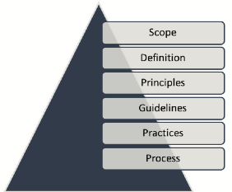

Definition, Principles, Guidelines
The term “universal design” was coined late in the twentieth century by Ronald Mace, an internationally recognized architect, product designer, educator, and wheelchair user. He helped to develop the Center for Universal Design (n.d.) which defined UD as “the design of products and environments to be usable by all people, to the greatest extent possible, without the need for adaptation or specialized design.” Mace’s approach to design challenged more traditional approaches that designed for a “typical” user; in his view all designs should contribute to a more inclusive world for everyone.

The Contribution of UD to the UDHE Principles and Guidelines
In the early years of the Internet, UD practices began to be applied to the design of hardware and software to ensure accessibility to individuals with disabilities, English language learners, and other groups. Principles for the UD of any product or environment include the following:
- Equitable use: The design is useful and marketable to people with diverse abilities.
- Flexibility in use: The design accommodates a wide range of individual preferences and abilities.
- Simple and intuitive use: Use of the design is easy to understand, regardless of the user’s experience, knowledge, language skills, or current concentration level.
- Perceptible information: The design communicates necessary information effectively to the user, regardless of ambient conditions or the user’s sensory abilities.
- Tolerance for error: The design minimizes hazards and the adverse consequences of accidental or unintended actions.
- Low physical effort: The design can be used efficiently, comfortably, and with a minimum of fatigue.
- Size and space for approach and use: Appropriate size and space is provided for approach, reach, manipulation, and use regardless of the user’s body size, posture, or mobility. (Story, Mueller, & Mace, 1998, pp. 34–35)
These principles, originally applied in designing architecture and commercial products, have been more recently used in the design of hardware and software, later to instruction, and even later to student services (Burgstahler, 2020). The result of this proactive process of UD is products and environment that are accessible to, usable by, and inclusive of a broad audience. With respect to a product or environment, “accessible” means that individuals with a variety of disabilities cab operate it as it was designed to be used, “usable” means everyone can effectively perform its functions, and “inclusive” means it has flexible features so that people with a wide variety of characteristics can use the same product.
The UD principles have stood the test of time. For example, Principle 5, “Tolerance for error,” can be used in the design of educational software—by providing feedback to guide students when they make a selection error—even though such software was only available years after the principle was established.

The Contribution of UDL to the UDHE Principles and Guidelines
UD-inspired frameworks have emerged to specifically address instructional applications. Each is based upon a common finding in educational research: that learners are highly variable with respect to their abilities, preferred learning modes, and responses to instruction. Applications of UD to create inclusive teaching and learning opportunities include Universal Design for Learning (UDL), Universal Design of Instruction (UDI), UID (Universal Instructional Design), UDT (Universal Design of Teaching), UCD (Universal Course Design), IDL (Inclusive Design for Learning). Several different approaches have been taken in adopting principles to underpin guidelines and practices for the design of curriculum and instruction. Some leaders in these efforts have simply applied the seven principles of UD and their respective; others edited or added additional principles to the UD list because they considered them necessary for making them more relevant to postsecondary instruction (Burgstahler, 2015).
The most common UD-inspired approach applied in K-12 settings underpins Universal Design for Learning (UDL). Developed by the Center for Applied Special Technology (CAST), UDL is increasingly applied in higher education. Applying the UDL principles, which have roots in cognitive neuroscience, leads to practices where instructors offer students multiple means of engagement, representation, and action and expression, as represented below.
- Engagement: For purposeful, motivated learners, stimulate interest and motivation for learning.
- Representation: For resourceful, knowledgeable learners, present information and content in different ways.
- Action and expression: For strategic, goal-directed learners, differentiate the ways that students can express what they know (Center for Applied Special Technology, 2018).

The Contribution of WCAG to the UDHE Principles and Guidelines
Many specific barriers to digital tools and materials faced by students with disabilities have well-documented solutions. These include those articulated by the Web Content Accessibility Guidelines (WCAG), originally published in 1999 by the World Wide Web Consortium (W3C) (2018). The Guidelines dictate that, to be universally designed, all content and user interface components of IT adhere to four guiding principles.
- Perceivable: Users must be able to perceive the content, regardless of the device or configuration they’re using.
- Operable: Users must be able to operate the controls, buttons, sliders, menus, etc., regardless of the device they’re using.
- Understandable: Users must be able to understand the content and interface; and
- Robust: Content must be coded in compliance with relevant coding standards in order to ensure its accurately and meaningfully interpreted by devices, browsers, and assistive technologies.
While principles that underpin WCAG were developed to apply to web-based technologies, their guidelines and success criteria can also be applied to digital media, software, and other technologies (W3C, 2013).
It is not necessary to memorize the three sets of principles for UDHE, but it is good to know that, for most applications, taking the following three actions will result in an educational product or environment that is accessible to, usable by, and inclusive of individuals with disabilities.
- Provide multiple ways for participants to learn and to demonstrate what they have learned.
- Provide multiple ways to engage.
- Ensure all technologies, facilities, services, resources, and strategies are accessible to individuals with a wide variety of disabilities.
Although the need is minimized with this approach, reasonable accommodations will in some cases be necessary to ensure full access and engagement for a particular student when the universally designed offering does not already do so. For example, a student with a learning disability engaging in a universally-designed online course may require extra time on examinations as determined by a disability services office.

Practices
The first widely adopted UD practice is the routine inclusion of curb cuts in sidewalks. This feature allows a person using a wheelchair to go from sidewalk to street level without negotiating a curb. Figure 2 is a sketch of picture that appeared with an article in the UW Daily student newspaper in 1970. The picture shows a student with a sign affixed to the back of his wheelchair: "Ramp the curbs. Keep me off the street." In 1970, many people thought this was an unreasonable goal for the UW’s hilly campus. They were wrong. And, those who benefit from the now common practice of including curb cuts when sidewalks are being created includes parents pushing baby strollers, delivery carts, and roller bags. And, as with other universal designs, adding this UD feature to a sidewalk does not deny people the choice to step to street level directly from the sidewalk.
Figure 2
A UW Student Posts a Sign on His Wheelchair That Reads "RAMP THE CURBS."
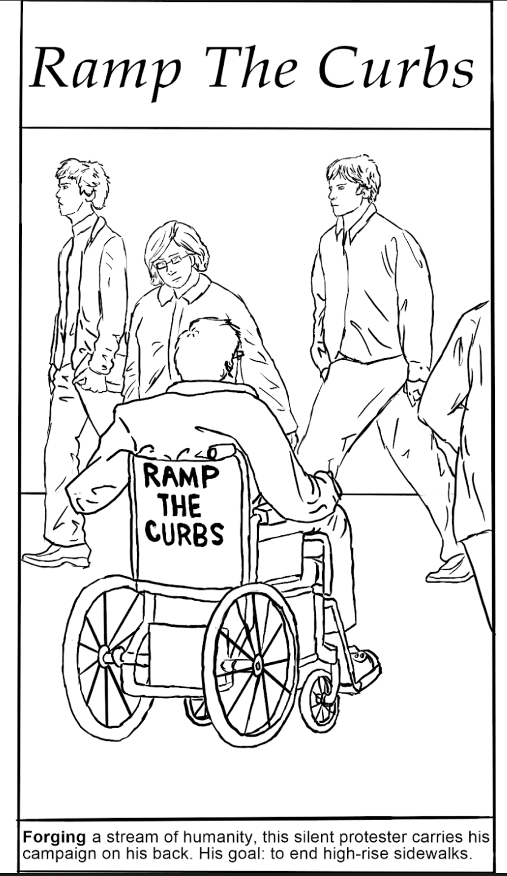
An illustration of how UD goes beyond “ADA compliance” can be found in the designs of a main entrance of a campus building. A typical design for an entrance that includes steps is to provide an alternative for those who cannot walk up the steps. This approach is accessible and usable, and usually “ADA compliant,” but it is not inclusive because people reach the entrance door in different ways. If I walked up to this building with someone who uses a wheelchair or walker I would likely use the steps to avoid the awkward situation of walking in front of or behind my companion on the ramp. In contrast, a wide, sloping ramp to the main entrance would allow us to approach and enter the building side by side, thus meeting all three characteristics of a space that is universally designed—it is accessible, usable and inclusive.
Combining the UD approach and the capabilities of digital technology allows a user to customize a product to make it almost unrecognizable with another user’s configuration. A universally designed smart phone, for example, gives users myriad choices (including text size, background color, speech output) for tailoring an environment to their unique preferences. Unfortunately, most technology developers today do not apply UD and continue to create products that are inaccessible to some potential users with disabilities.
Infusing UDHE into all aspects of higher education is an important step toward destigmatizing disability and ensuring equity for all groups. Evidence-based practices have been established for all three sets of principles included in the Framework. The list below provides examples in higher education for all fourteen principles (Burgstahler, 2020, p. 95).
  - UD 1: Equitable use: Career services: Job postings are in formats accessible to people with a great variety of abilities, disabilities, ages, racial/ethnic backgrounds, and technologies.
  - UD 2: Flexibility in use. A museum exhibit allows a visitor to choose to read or listen to descriptions of the contents of display cases.
  - UD 3: Simple and intuitive. Assessment in a course is conducted in a predictable, straightforward manner.
  - UD 4: Perceptible information. An emergency alarm system in a dormitory has visual, aural, and kinesthetic characteristics.
  - UD 5: Tolerance for error. Instructional software provides guidance when a student makes an inappropriate selection.
  - UD: Low physical effort. Curriculum software includes on-screen control buttons that are large enough for students with limited fine motor skills to select.
  - UD 7: Size and space for approach and use. In a science lab, an adjustable table and flexible work area is usable by students who are right- or left-handed and have a wide range of physical characteristics.
  - UDL 1: Multiple means of engagement. In a course, multiple examples ensure relevance to a diverse student group.
  - UDL 2: Multiple means of representation. Multiple forms of accessibly designed media are used to communicate what a student service offers.
  - UDL 3: Multiple means of action and expression. An assigned course project optimizes individual choice and autonomy.
  - WCAG 1: Perceivable. A person who is blind and using a screen reader can access the content in images on a school website because text descriptions are provided.
  - WCAG 2: Operable. A person who cannot operate a mouse can navigate all content and operate all functions of a learning management system (LMS) by using a keyboard alone.
  - WCAG 3: Understandable. Definitions are provided for unusual words, phrases, idioms, and abbreviations used in instructional materials.
  - WCAG 4: Robust. Application forms can be completed using a wide range of web browsers and assistive technologies.

Process
The following steps can be followed when applying UDHE. Note that this process suggests that the best designs for products and environments integrate both UDHE practices and best practices within the field of application. Putting captions on a movie of poor quality (a UDHE practice) will simply make a poor movie accessible to more people, including those who are deaf.
- Identify the application and best practices in the field. Specify the product or environment to which you wish to apply UDHE. Identify best practices within the field of the application (e.g., evidence-based teaching practices, technology standards, architectural design specifications).
- Consider the diverse characteristics of potential user: Describe diverse characteristics of potential users for which the application is designed—e.g., with respect to gender; age; ethnicity; race; native language; learning preferences; size; abilities to see, hear, walk, manipulate objects, read, speak—and the challenges they might encounter when attempting to engage with the product or environment.
- Integrate UDHE with best practices in the field: Integrate UDHE practices (underpinned by relevant UD, UDL, and WCAG principles) with best practices within the field of application to maximize the benefits of the application to individuals with a wide variety of characteristics.
- Plan for accommodations: Develop processes for the provision of accommodations for individuals for whom the design does not automatically provide access (e.g., with assistive technology or sign language interpreters). Make these processes known through signage, syllabi, publications, or websites.
- Evaluate: After implementing the product or environment, collect feedback from individuals with diverse characteristics who use it (e.g., through online surveys, focus groups). Make modifications based on the results. Return to step 3 if evidence from your evaluation suggests that improvements should be made to your design. (Burgstahler, 2020, pp. 47–48).

Example: Application of the UDHE Framework to Online Learning
We have witnessed with the explosion of online offerings due to the need for social distancing a corresponding increase in certain types of accommodations that could have been addressed by course designers and instructors as their courses were being developed. The UDHE Framework can be used as a guide for designing more accessible and inclusive fully online as well as hybrid courses in the future.
Faculty and designers can begin by anticipating that students interacting in online components of a course will have diverse characteristics—one may be blind and using audible output presented by a screen reader of digital content using synthesized speech); a
student with a learning disability such as dyslexia who uses text to speech technology to read aloud digital text while visually highlighting each word; a student with low vision who enlarges default fonts or uses screen magnification software; a student with fine motor impairments who uses assistive technology such as speech recognition, a head pointer, a mouth sticks, or eye-gaze tracking systems; a student in a noisy or noise-free environment or who is deaf or hard of hearing and depends on captions or transcripts to access audio content; and many students who use mobile smartphones, tablets, or other devices, which have a variety of screen sizes, as well as touch screens or other user interfaces. Although there is an interesting array of assistive technologies for people with disabilities, the good news for faculty and designers is that they do not need to be familiar with specific products in order to make simple decisions about online elements of a new or updated course in order to make it more accessible and inclusive of future students. For example, an assistive technology may emulate the keyboard, but not the mouse; this makes it important that technology used in a course can be operated with the keyboard alone. Assistive technology that reads aloud content for those who are blind or have learning disabilities cannot read words presented in an image (including scanned in PDFs); to be accessible to these students, the content needs to be presented in a text-based format. In addition, screen reader users who are blind benefit from alternative text to describe images and document and web content that is formatted using style features provided within the LMS or word processor and linked text that is descriptive.
With a deep understanding of these and other accessibility issues and an extensive literature review (see NWeLearn, in press), the author of this article, with input from collaborators in projects led by the DO-IT (Disabilities, Opportunities, Internetworking and Technology) Center created a list of 20 tips for helping faculty and designers get started in making online components of a course accessible to students with a wide range of disabilities. Always a work in progress, the list below includes some of the practices suggested in the current list (Burgstahler, 2021). The freely available document, 20 Tips for Teaching an Accessible Online Course also includes a reference to an online tutorial and other resources for implementation of the tips (e.g., UW, n.d.b). Following guidelines such as these reduces the need for accommodations of future students with some types of disabilities.
  - Use clear, consistent layouts and organization schemes to present content.
  - Use a text-based format and structure headings, lists, and tables using style and formatting features within your LMS and content creation software, such as Microsoft Word, and PowerPoint and Adobe InDesign and Acrobat; use built-in page layouts where applicable.
  - Use descriptive wording for hyperlink text (e.g., “student services website” rather than “click here”).
  - Avoid creating PDF documents. Post most instructor-created content within LMS content pages (i.e., in HTML) and, if a PDF is desired, link to it only as a secondary source of the information.
  - Provide concise text descriptions of content presented within images.
  - Use large, bold, sans serif fonts on uncluttered pages with plain backgrounds.
  - Use color combinations that are high contrast and can be distinguished by those who are colorblind.
  - Caption videos and transcribe audio content.
  - Don’t overburden students with learning to operate a large number of technology products unless they are related to the topic of the course; use asynchronous tools; make sure IT used requires the use of the keyboard alone and otherwise employs accessible design practices.
  - Recommend videos and written materials to students where they can gain technical skills needed for course participation.
  - Provide multiple ways for students to learn (e.g., use a combination of text, video, audio, and/or image; speak aloud all content presented on slides in synchronous presentations and then record them for later viewing).
  - Provide multiple ways to communicate and collaborate that are accessible to individuals with a variety of disabilities.
  - Provide multiple ways for students to demonstrate what they have learned (e.g., different types of test items, portfolios, presentations, single-topic discussions).
  - Address a wide range of language skills as you write content (e.g., use plain English, spell out acronyms, define terms, avoid or define jargon).
  - Make instructions and expectations clear for activities, projects, discussions and readings.
  - Make examples and assignments relevant to learners with a wide variety of interests and backgrounds.
  - Offer outlines and other scaffolding tools and share tips that might help students learn.
  - Provide adequate opportunities to practice.
  - Allow adequate time for activities, projects, and tests (e.g., give details of all project assignments at the beginning of the course).
  - Provide feedback on project parts and offer corrective opportunities.

A Model for an Inclusive Campus
Institutions can adapt and flesh out each aspect of the UDHE Framework—scope, definition, principles, guidelines, exemplary practices, process—to create a toolkit appropriate for applying UDHE to campus practices as a whole or to those in specific units. An institution, for example, might decide to use a different definition of UD or to choose a different set of principles to apply. The UD Framework can then be used to underpin an Inclusive Campus Model to guide diversity, equity and inclusion narrowly or broadly defined for a whole campus or specific organization. The Model was developed and applied within an IT unit charged with ensuring the procurement, development, and use of accessible IT campus-wide. The Model format is well known by faculty, researchers, administrators, and evaluators who use it to present the flow of a project being proposed for funding. Such a roadmap can lead to a more accessible and inclusive campus where UDHE is routinely applied. It embraces a vision for an inclusive campus; identifies campus values that support the desired shift; embraces the UDHE Framework to create a toolkit for achieving the desired change; identifies relevant current practices; identifies and implements modifications to existing practices or new ones that are more in line with the vision, values and adopted UDHE Framework; measures and analyzes outputs, outcomes, and impacts; and applies results to further improve practices to be more in line with the desired shift.
Figure 3 presents the Inclusive Campus Model that is underpinned by the UDHE Framework. When fleshed out with details, this flexible Model can be used as a tool to guide the creation of a roadmap for making a campus more inclusive.
Figure 3
An Inclusive Campus Model Underpinned by the UDHE Framework
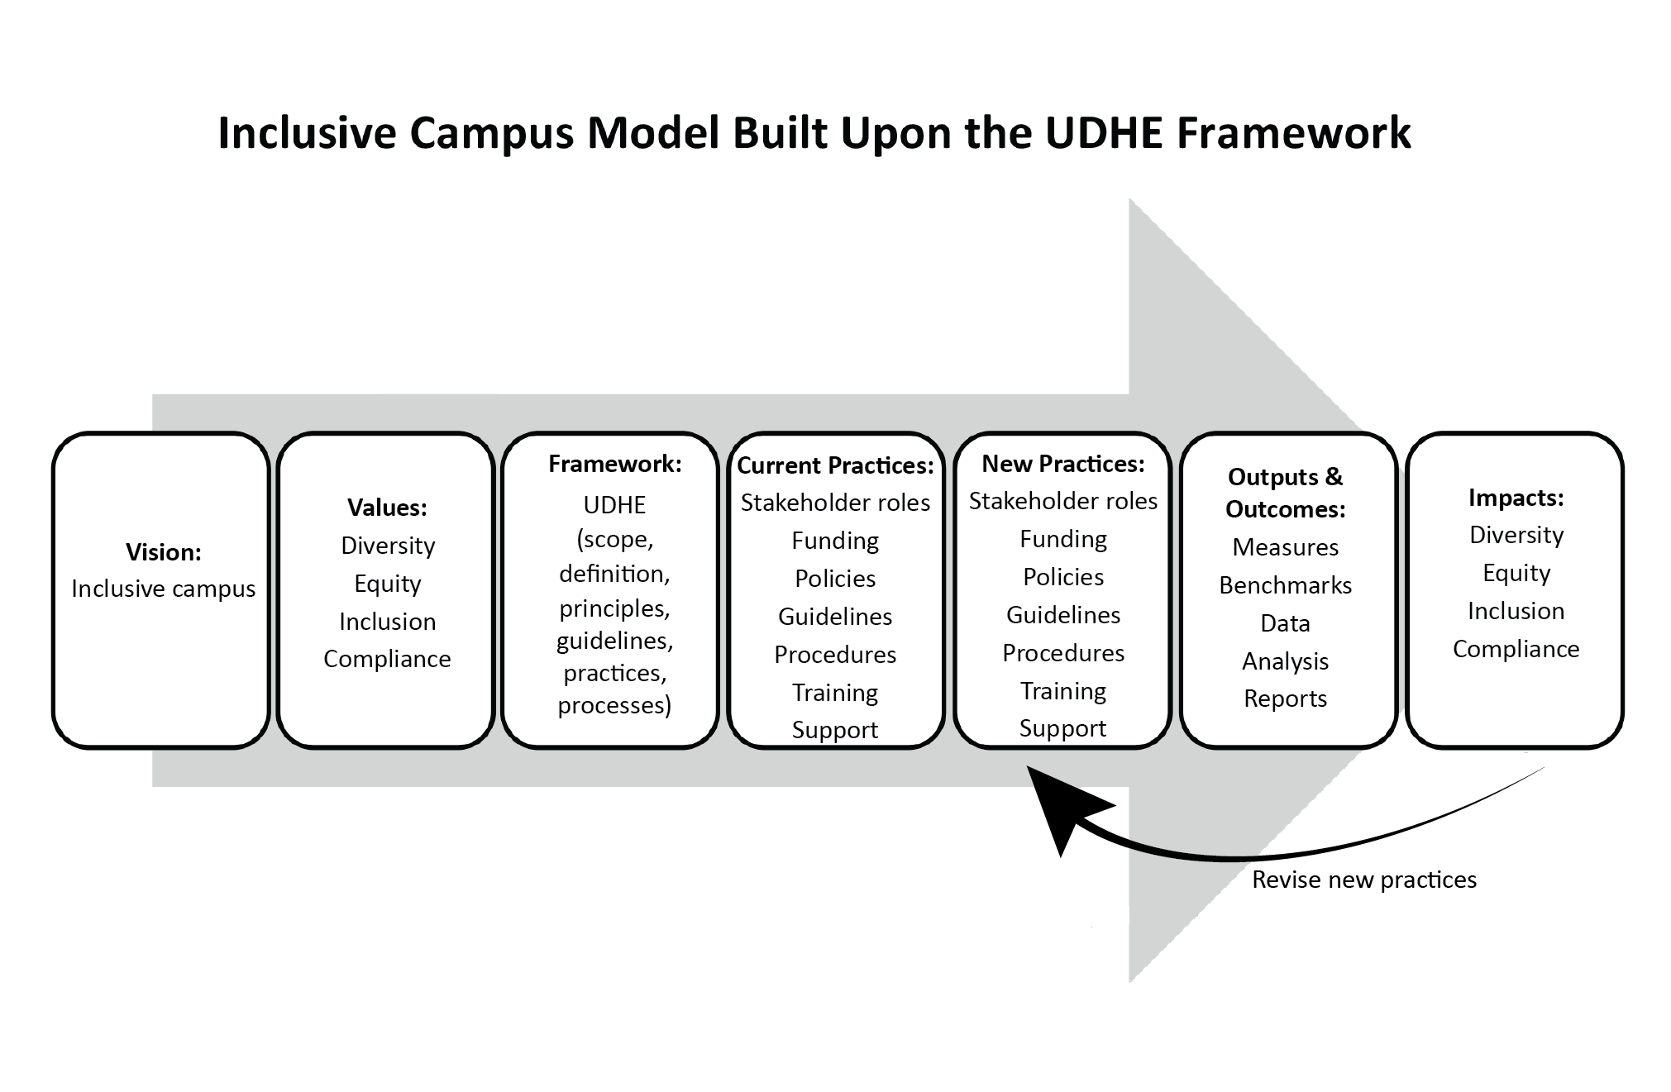
The adoption of the Inclusive Campus Model or similar one adapted for a campus identifies practices that can contribute to making a paradigm shift toward a broadly defined inclusive campus. “Paradigm,” in this context refers to “a theory or a group of ideas about how something should be done, made, or thought about” (Merriam-Webster’s Collegiate Dictionary, n.d.). A dominant paradigm is a system of thought in a society or organization that is widely held at a given time. For the group that has adopted the paradigm it provides an almost unconscious, internalized framework that affects the way they think things should work and often goes without question. Paradigm shifts—when the dominant system of thought changes—take a long time to develop. Some paradigm shifts are accomplished in the next generation if they become part of early education programs—which is what happened, at least in part, when recycling became common practice in many communities. A paradigm shift toward a UDHE approach challenges leaders to work toward constructing an institution in which everyone can fully participate. With the adoption of UDHE, when a product, environment, or social structure is found to be inaccessible to some students, leaders routinely explore changes that could be made to the product, environment, or social structure so that it contributes to the inclusion of all students.
An Inclusive Campus Model that is underpinned by the UDHE Framework can be adapted and fleshed out to create a roadmap for implementation of diversity, equity, and inclusion initiatives for the institution and specific campus units. The logic of this approach is revealed in the following short description of the efforts of a fictitious institution—FirstRateUniversity—that applies the Inclusive Campus Model.
Our FirstRateUniversity’s vision of an inclusive campus culture reflects our values that include diversity, equity, inclusion, as well as compliance with all relevant legislation and policies. Underpinning our model for change is the UDHE Framework, which we fleshed out into a toolkit tailored to our campus; we assigned stakeholder roles; secured funding; developed policies, guidelines and procedures; engaged in training tailored to stakeholder groups; created resources; and made structural changes. Throughout these activities, we updated old practices and created new ones that more closely align with our vision, values, and the UDHE Framework. We regularly measure outputs, outcomes, and impacts from these efforts and, from lessons learned, revise our practices to ensure continual project improvements. There is clear evidence that our efforts are gradually leading to a paradigm shift toward a more inclusive campus that better reflects our vision and values. (Burgstahler, 2020, p. 189)
To apply the Inclusive Campus Model or similar model tailored to your campus, create a working document and begin to flesh out key components of your model by answering questions similar to those listed below, which were designed for an informal science learning (ISL) program at a postsecondary institution.
  - Vision: What is our vision for an inclusive campus and ISL program?
  - Values: What campus values (e.g., diversity, equity, inclusion, compliance) are most relevant to making our campus and ISL program more inclusive?
  - Framework: What framework (e.g., the UDHE Framework along with principles, guidelines, practices, and processes) reflects our vision and values and can be fleshed out to helps us work toward making our campus more inclusive?
  - Current Practices: What are current practices in our ISL program with respect to stakeholder roles, funding, policies, guidelines, procedures, training, support, and other relevant issues?
  - New Practices: What existing practices for our ISL program should we modify and which new practices should we develop to be more consistent with our vision, values, and Framework?
  - Outputs and Outcomes: What measures should be identified, what benchmarks should be set, what data should be collected and analyzed, and what reports should be made?
  - Impact: What evidence suggests a positive impact of our UDHE efforts with respect to a more inclusive ISL program and campus that better reflects our vision and values?

Implications for Practice
Applying UDHE enhances the quality of campus offerings, but may impact the roles of faculty, staff, and disability service personnel when it comes to serving students with disabilities. In an accommodation approach, a student typically presents documentation to a disability service counselor who approves reasonable accommodations and tells faculty and staff members how to implement them. With a UDHE Framework, faculty, staff, and disability service personnel share responsibility for creating accessible, usable, and inclusive products and environments. For example, under the guidance of a UD Framework, disability service staff might continue to authorize and arrange for reasonable accommodation, but also be funded to consult with faculty and staff about UDHE practices relevant to their positions; faculty members would apply UDHE practices to their courses and implement reasonable accommodations determined by disability service staff; IT staff would work to ensure that IT procured, developed, and used at the institution is accessible to people with disabilities and consult on assistive technology and the accessible design of documents, videos, and other IT; and administrators of student service units would apply UDHE practices and implement reasonable accommodations determined by disability service staff.
A common inhibitor to the acceptance of UDHE is adherence to “the way we have always done things” (e.g., reactively providing accommodations for students with disabilities rather than employing proactive practices). A paradigm shift to the UDHE Framework may require no less than a different way of thinking about every campus offering in order to nudge a campus toward the ideal of UDHE. To implement UDHE campus-wide effectively, efforts should be made to engage units throughout the institution (e.g., faculty, physical plant, libraries, centers for teaching and learning, student services, IT units). Potential efforts include disseminating UDHE guidelines customized to specific audiences (e.g., webmasters, administrators, faculty), publishing articles on UD in campus periodicals, and delivering presentations on UDHE. All stakeholders should have access to training that is tailored to their specific application areas.

Conclusion
When it comes to human beings, variability is not the exception, it is the norm. Every field, every project, every initiative can benefit from the engagement of people with diverse expertise and experiences, including those with disabilities. In contrast to one size does not fit all, UD has a simple goal: to design flexible products and environments that are accessible to and usable by everyone and, when they are not, provide reasonable accommodations. On many campuses today, embracing UDHE requires a shift from a deficit to a social model of disability; from a view of disability as a deficit to a view of disability as a diversity characteristic; from considering inaccessibility as a problem caused by a person’s impairment to a problem that may be the result of design flaws in a product or environment; from a focus on the average person to a focus on individuals with diverse characteristics; and from a reactive accommodation approach to proactive design practices that minimize the need for accommodations. Multiple stakeholders have roles to play in making a campus more inclusive, but it takes strong leadership to draw them together and identify ways for everyone to receive the support they need in order to contribute. Looking through a UD lens can lead to making curriculum and instruction and other offerings better for everyone. When those of us who teach include UD topics in our curriculum, we can also contribute to a world that is more inclusive of everyone through the future careers of our students. Among the beneficiaries of this paradigm shift to UD are students who disclose their disabilities, those who have disabilities but do not disclose, students with various learning preferences and technological expertise, those whose native language is not English, people who are older than the average student, members of specific racial and ethnic groups, and everybody else!

References
Burgstahler, S. (in press). Creating online instruction that is accessible, usable, and inclusive. Northwest eLearning Journal.
Burgstahler, S. (2021). 20 for teaching an accessible online course. University of Washington. Retrieved from https://www.washington.edu/doit/20-tips-teaching-accessible-online-course
Burgstahler, S. (2020). Creating inclusive learning opportunities in higher education: A universal design toolkit. Harvard Education Press.
Burgstahler, S. (Ed). (2015). Universal design of instruction: From principles to practice. In S. Burgstahler (Ed.), Universal design in higher education: From principles to practice (pp. 31–64). Boston: Harvard Education Press.
Burgstahler, S., & Thompson, T. (Eds). (2019). Designing accessible cyberlearning: Current state and pathway forward. Seattle: University of Washington. Retrieved from https://www.washington.edu/doit/accessible-cyberlearning-community-report
Center for Universal Design. (n.d.). History of universal design. Retrieved from https://projects.ncsu.edu/design/cud/about_ud/udhistory.htm
The Centre for Excellence in Universal Design. (n.d.). 10 things to know about UD. Dublin: National Disability Authority. Retrieved from universaldesign.ie/what-is-universal-design/the-10-things-to-know-about-ud/10-things-to-know-about-ud.html
Gravel, J. W., Edwards, L. A., But timer, C. J., & Rose, D. H. (2015). Universal design for learning in postsecondary education: Reflections on principles and their application. In S. Burgstahler (Ed.), Universal design in higher education: From principles to practice (pp. 81–100). Harvard Education Press.
Merriam-Webster’s Collegiate Dictionary (11th ed.). (n.d.). Paradigm. In Merriam-Webster’s Collegiate Dictionary. Chicago: Encyclopedia Britannica Company. Retrieved from merriam-webster.com/dictionary/paradigm
Story, M. F., Mueller, J. L., & Mace, R. L. (1998). The principles of universal design and their application. In M. F. Story, M. L. Mueller, & R. L. Mace (Eds.), The universal design file: Designing for people of all ages and abilities (pp. 32–36). Center for Universal Design. Retrieved from http://www.ncsu.edu/ncsu/design/cud/pubs_p/docs/udffile/chap_3.pdf
University of Washington. (n.d.a). Disabilities, Opportunities, Internetworking, and Technology. Author. Retrieved from https://www.washington.edu/doit
University of Washington. (n.d.b). Accessible technology. Author. Retrieved from https://www.washington.edu/accessibility/
World Wide Web Consortium. (2018). Web content accessibility guidelines, 2.1. Retrieved from http://www.w3.org/TR/wcag21/
World Wide Web Consortium. (2013). Guidance on applying WCAG 2.0 to non-web information and communications technologies. Retrieved from https://www.w3.org/TR/wcag2ict/
Acknowledgment
Some of the content of this article is based on work supported by the National Science Foundation (grant numbers 1539179, 1834924, 1906147). Any opinions, findings, and conclusions or recommendations are those of the author and do not necessarily reflect the policy or views of the federal government. The Principles of Universal Design were conceived and developed by the Center for Universal Design at North Carolina State University. Use or application of the Principles in any form is separate and distinct from the Principles and does not constitute or imply acceptance or endorsement by the Center for Universal Design of the use or application.

A Universal Design Framework for Addressing Diversity, Equity, and Inclusion on Postsecondary Campuses https://rdsjournal.org/index.php/journal/article/view/1071 is licensed under a
Creative Commons Attribution 4.0 International License. Based on a work at
https://rdsjournal.org.

