Research Articles and Essays

**Audio description for 3-Dimensional (3D) virtual worlds**

Peter Leong1, Sarah Espinosa2, and Melissa Peterson,3  
1, 2, 3 Department of Learning Design & Technology, University of Hawaiʻi at Mānoa

**Abstract**

Three-dimensional (3D) virtual worlds have little to offer people with visual disabilities because the experience is largely visual in nature. This paper describes a project that seeks to develop best practices for creating audio description for 3D virtual worlds by creating and testing audio descriptions for the University of Hawaiʻi at Manoa College of Education’s OpenSim virtual campus as a proof of concept.

*Keywords*: audio description; 3D virtual worlds; virtual campus

A three-dimensional (3D) virtual world is a simulated 3D environment that can be accessed online through a computer. Instead of a flat two-dimensional (2D) website, 3D virtual worlds allow users to interact through animated avatars (digital representations), customizable objects, instant text and voice chat. The use of virtual worlds has been explored for purposes that include entertainment, socialization, education and commerce. A 3D virtual world that is the most widely used and popular is Second Life (SL), a platform created by Linden Lab.

Many institutions of higher education have established their own presence in SL in order to explore the possibilities of stimulating different forms of learning (Michels, 2008). A number of universities have introduced virtual representations of themselves in the form of virtual campuses for supporting a wide range of educational activities. A virtual campus provides learners with a special place as a framework for learning activities and a set of tools to benefit the educational process (Clark & Maher, 2001). Due to COVID-19 pandemic, many academic-related activities pivoted to an online delivery format and the need for a virtual campus is more evident now than ever.

The University of Hawaiʻi’s (UHM) College of Education Second Life (COE SL) virtual campus was launched on March 4, 2011. The COE SL virtual campus was built with the help and advice of the COE SL advisory board of nine members representing the college’s stakeholders. Following Prasolova-Førland et al.'s (2006) proposed six requirements for a 3D virtual campus representing a real university; the college made the decision to design the virtual campus to partially resemble the real campus while creating other new fictitious places to meet all the goals of the COE SL virtual campus.

The virtual campus features a replica of the Wist-Everly Hall complex (see Figure 1) which houses the faculty offices and the college’s Office of Student Academic Services, the Diamond Head Amphitheatre (see Figure 2), the Holomua Learning Area (see Figure 3), a tree house, the Hale Anuenue dormitory and a dockside coffee shop.

**Figure 1**   
*Façade of Wist –Everly Hall Complex*

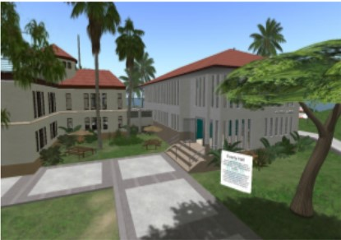

**Figure 2***Diamond Head Amphitheatre*

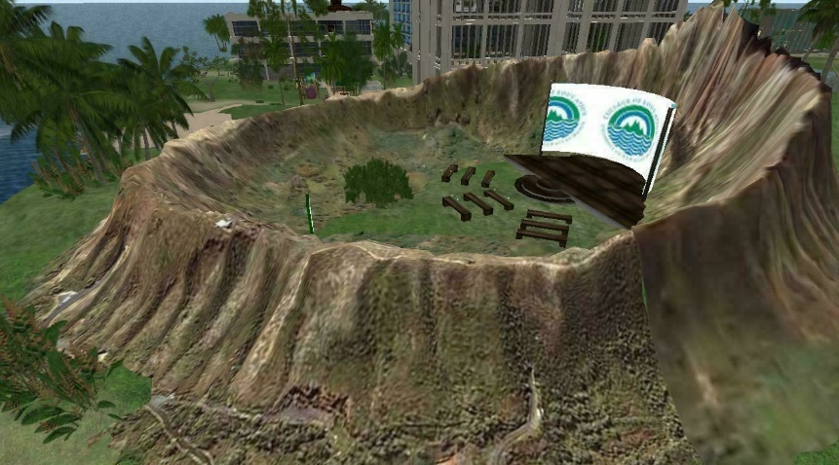

**Figure 3***Holomua Learning Area*

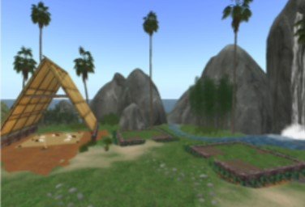

In 2018, the COE SL virtual campus was moved to OpenSim, a free and open-source software that allows anyone to create a 3D virtual world similar to SL. This paper describes a project that seeks to develop best practices for creating audio description for 3D virtual worlds, such as OpenSim, in order to provide access to students with visual disabilities and to enhance universal design for learning (UDL). Like other “assistive technology,” audio description is geared primarily toward people who are blind or visually impaired but many sighted people can benefit from“description’s concise, objective ‘translation’ of the key visual components of various art genres and social settings”(Snyder, 2014, p.46). The project created audio descriptions for the UHM COE OpenSim virtual campus as a proof of concept and will recruit students (visually impaired & sighted) to evaluate their satisfaction and effectiveness of the audio descriptions.

**Problem to be Addressed**

From an assistive technology standpoint, 3D virtual worlds have little to offer people with disabilities because the experience is largely visual in nature and user inputs often require extensive hand/eye coordination to precisely control an avatar's movements. Wood, Morris and Ussery (2009) identified numerous accessibility limitations of 3D virtual worlds to students with disabilities. Blind and visually impaired students face significant barriers to entry to 3D virtual worlds, specifically challenges on how they navigate and orient themselves within virtual spaces. Information in these virtual spaces is presented graphically rather than with textual equivalents. In particular, user generated content within 3D virtual worlds is not accessible to visually impaired users.

**Project Solution**

This project seeks to develop best practices for creating audio description for 3D virtual worlds for the purpose of providing access to the 3D virtual world of OpenSim for blind and visually impaired students by creating and testing the use of audio descriptions for the COE OpenSim virtual campus. Audio description:

involves the accessibility of the visual images of theater, television, movies, and other art forms for people who are blind, have low vision, or who are otherwise visually impaired. It is a narration service (provided at no additional charge to the patron) that attempts to describe what the sighted person takes for granted -- those images that a person who is blind or visually impaired formerly could only experience through the whispered asides from a sighted companion. (The Audio Description Project, n.d)

Virtual reality offers great potential for people with disabilities; however, it suffers from major accessibility issues (Phillips, 2020). While efforts have been made to devise best practices for creating audio descriptions for 360-degree videos (Herndon, 2020), to our knowledge, there has been no initiative to incorporate audio descriptions into 3D virtual worlds.

**Project Methods & Evaluation**

This project comprised two components. The first part involved creating audio descriptions for the UHM COE OpenSim virtual campus as a proof of concept. For this proof-of-concept stage of the project, the audio descriptions are integrated as audio streams within the Holomua Learning Area of our COE OpenSim virtual campus.

The second project component will involve formative evaluation of the audio description of the Holomua Learning Area. The formative evaluation will involve both qualitative and quantitative online methods. Data collected from both visually impaired and sighted students will be analyzed for similarities and differences.

**Design of audio description for the COE OpenSim virtual campus**

Two overarching principles guided the design of the audio descriptions for the COE OpenSim virtual campus:

1. To promote independence and agency
2. To thoroughly describe visual content without judgment about what is “important” or “most useful” (Conway, Oppegaard & Hayes, 2020)

Firstly, audio description was created to set the mood and provide an overview of the Holomua Learning Area. When an avatar arrives at the Holomua Learning Area, this overview audio description will automatically play in the parcel audio streaming. The Holomua Learning Area overview audio description reads:

Aloha and welcome to the University of Hawaiʻi at Mānoa's College of Education Open Simulator virtual space. You have arrived at the Holomua Learning Area. The Holomua Learning Area's natural landscape from an aerial 360-degree view: At 12 o'clock, the ocean can be seen at a short distance from the green grassy spaces bounding the Holomua Learning Area. From one o'clock to four o'clock, several mountains create a barrier between the Holomua Learning Area and the sea. The tallest of the mountains has a waterfall cascading into a small river that leads to the sea. Tall thin Lauhala palm trees are sprinkled around the perimeter close to the water's edge. At six o'clock, the island extends out with light and dark green grassy hills and palm trees. The ocean can be seen at a distance. Between seven o’clock and ten o'clock no ocean is visible. The rolling green hills bound the Holomua Learning Area from this direction. At 11 o'clock, Diamond Head, a volcanic tuff, cone looms in the distance. It is brown, rocky and without vegetation. The ridge line of the crater resembles the shape of a tuna's dorsal fin. From a 360-degree ground viewpoint of the Holomua Learning Area man-made constructions: At 12 o'clock, a large A-frame structure called the Hale stands as tall as its closest mountain. At one o'clock and three o'clock, two identical taro patches are enclosed by short, stone walls and dark green fronds. A rectangular thatched hut called the Bishop Hale is a short distance away at six o'clock. From a distance, a modern two-story cream building with a flat rooftop can be seen at eight o'clock. In the center of the Holomua Learning Area is a large cream sheer canopy. Two strands of hanging light bulbs stretch from either side of the canopy poles to the trunks of clumping palms above a stone path. The stone path leads to each of the buildings directly to the right of the path. From nine o'clock to eleven o'clock are several signposts. At nine o'clock, the signpost is a teleporter to a sandbox area. Next to the right of this, is a sign describing the Holomua Learning Area. To the right of this are two directional signs stacked on top of each other with blue arrows pointing in opposite directions. The top sign points to Diamond Head Amphitheater; the bottom sign points to Wist Hall. Each sign also functions as a teleporter. The final sign to the right is a stem signpost that links to the STEM^2 website at University of Hawaiʻi at Mānoa's College of Education.

Next, audio description was created for the main structure in the Holomua Learning Area – the A-frame hale (traditional Hawaiian hut). The audio description for the A-frame hale reads:

The dirt ground beneath the hale holds a blazing campfire with smoke billowing towards the sky. A tan woven mat (Lauhala mat) spanning the perimeter of the hale is several inches thick. On top of the mat, brown and cream floor pillows are scattered about. There are dark rocks on each corner of the mat weighing the mat down. The hale frame is wooden and sits atop a stone wall on its two sides. Five diagonal beams stretch out from the two walls and meet at the top from either side forming the "A" and are braced by three horizontal beams. The outside of the frame is covered in yellow palms. The palms overlap in four sections. A perpendicular wooden platform in the center of the hale is two thirds of the way up the intersection of the frame.

In addition to creating audio descriptions, to promote agency and independence, we devised structures and strategies that would aid blind and visually impaired users navigate independently within the Holomua Learning Area. We designed walking paths with semi-translucent barriers on either side of the path as well as a “thud” sound trigger to alert when an avatar ventures off the path. The path has various junction points and walking over a junction will trigger a voice prompt that tells users how to enter and exit to various locations. The audio description for the walking path and junction reads:

Your avatar arrives at the Holomua Learning Area and stands on top of an aloha mat that is on top of a stone path that leads to the various areas in the learning area. Semi-translucent barriers are on either side of the path and enable a sound trigger to occur if you venture off the path and go on again. If your avatar strays off the path, continue walking until you hear a thud sound indicating that the avatar has walked back onto the stone path. The path has various junction points and walking over the junction will trigger a voice response that tells you how to enter and exit to various locations. "You are either exiting the junction heading towards the hale, or you are entering the junction at 4 o’clock. The path to the Bishop Hale is at 12 o’clock, and the path to the Taro patch is at 8 o’clock." Continuing on towards the taro patch...Upon entering the taro patch, another voice will trigger to describe the area.

Finally, the audio description was created to describe the taro patch:

A green grassy square enclosed by a short stone wall on four sides. Two divided lines of tilled earth have three evenly spaced taro root chairs. A green stem and heart-shaped leaf bends slightly out from the speckled dirt. A white ball hovers over the leaf. Right clicking on the ball will allow the avatar to sit on it.

**Next Steps & Conclusion**

In the next phase of the project, we will conduct formative evaluation of the audio description of the Holomua Learning Area. We plan to recruit both visually impaired and sighted students to evaluate the effectiveness of and their satisfaction with the audio descriptions. Participants will spend about an hour navigating and evaluating the audio descriptions of the COE OpenSim virtual campus. Feedback from both groups of students will help us improve the quality and process of creating audio descriptions for 3D virtual worlds. The formative evaluation will involve both quantitative and qualitative online methods.

Students will complete an online satisfaction survey and participate in a usability study which will take place online using the Zoom web conferencing system. Unlike 2D web usability, usability testing of 3D virtual worlds involves “complex, multiple, interdependent layers that must be taken into consideration” (Espinosa and Leong, 2021, p. 131). The usability test will focus primarily on the COE OpenSim virtual campus simulation, setting aside the user interface of OpenSim which is currently not fully accessible. Participants’ avatars will be positioned at the landing point of the Holomua Learning Area from which the usability test will proceed. Data collected from both visually impaired and sighted students will be analyzed for similarities and differences.

The intent of this proof-of-concept project is to develop best practices for creating audio description for 3D virtual worlds by creating and testing audio descriptions for the Holomua Learning Area of the COE OpenSim virtual campus. We will revise the audio descriptions and prototype of our pathway navigation based on the results of our usability testing. We plan to seek further funding to develop more sophisticated technical implementations of audio descriptions in 3D virtual worlds.

**References**

Clark, S., & Maher, M. L. (2001). The Role of Place in Designing a Learner Centered Virtual Learning Environment. In *Proceedings of CAAD Futures 2001.* de Vries, B., van Leeuwen, J., & Achten, H. (eds.). Eindhoven, The Netherlands: Kluwer Academic Publishers. 187-200.

Conway, M., Oppegaard, B., & Hayes, T. (2020). Audio Description: Making Useful Maps for Blind and Visually Impaired People. *Technical Communication, 67*(2), 68-85.

Espinosa, S., & Leong, P. (2021). Complex, Multiple, Interdependent Layers (C-MIL): A Conceptual Model for Usability Studies in 3-Dimensional Virtual Worlds. In E. Romero-Hall (Ed.) *Research Methods in Learning Design & Technology* (pp. 126-145). New York: Routledge. [https://doi.org/10.4324/9780429260919](https://www.taylorfrancis.com/books/e/9780429260919)

Herndon, J. (2020, May 14). *Audio Descriptions for 360-Degree Video: Recap of Webinar*. Equal Entry. https://equalentry.com/audio-descriptions-for-360-degree-video-recap/.

Phillips, K. U. (2020, January 29). *Virtual Reality has an Accessibility Problem.* https://blogs.scientificamerican.com/voices/virtual-reality-has-an-accessibility-problem/.

Prasolova-Førland, E., Sourin, A. & Sourina, O. (2006). Cybercampuses: Design issues and future directions. *The Visual Computer,* *22*(12), 1015-1028.

Michels, P. (2008). Universities Use Second Life to Teach Complex Concepts. *Government Technology*. http://www.govtech.com/gt/252550

Smith, K. (2010). The use of virtual worlds among people with disabilities. *The Journal of Virtual Worlds and Education,1*(1), 63-89

The Audio Description Project (n.d). The Audio Description Project: An Initiative of the American Council of the Blind. https://acb.org/adp/ad.html

Wood, D., Morris, C. and Ussery J. (2009, July). *Accessibility Solutions for 3D Virtual Learning Environments*. Paper presentation at the IEEE Conference, Boston, Massachusetts.

Creative Commons CC:BY logo Audio description for 3-Dimensional (3D) virtual worlds <https://rdsjournal.org/index.php/journal/article/view/1068> is licensed under a [Creative Commons Attribution 4.0 International License](http://creativecommons.org/licenses/by/4.0/). Based on a work at<https://rdsjournal.org>.