Creative Works

Safe Dreamlike Portraits: Dreams During the Pandemic
Michaela Oteri

Michaela Oteri is a 30-year-old Disabled Digital Artist from Florida, USA. Her passion is depicting diverse bodies, specializing in her portraits of disabled people, for disabled people. She feels the need to emphasize that disabled bodies of all kinds are beautiful.
You can see more of Michaela's work on her website: www.ogrefairy.com She uses the handle "Ogrefairy" as a means of self-expression. Being overweight and disabled she always struggled to see herself as beautiful like a fairy, relating more to seeing herself as an ogre. So why not claim that as her own?

Figure 1
Portrait of Alice Wong
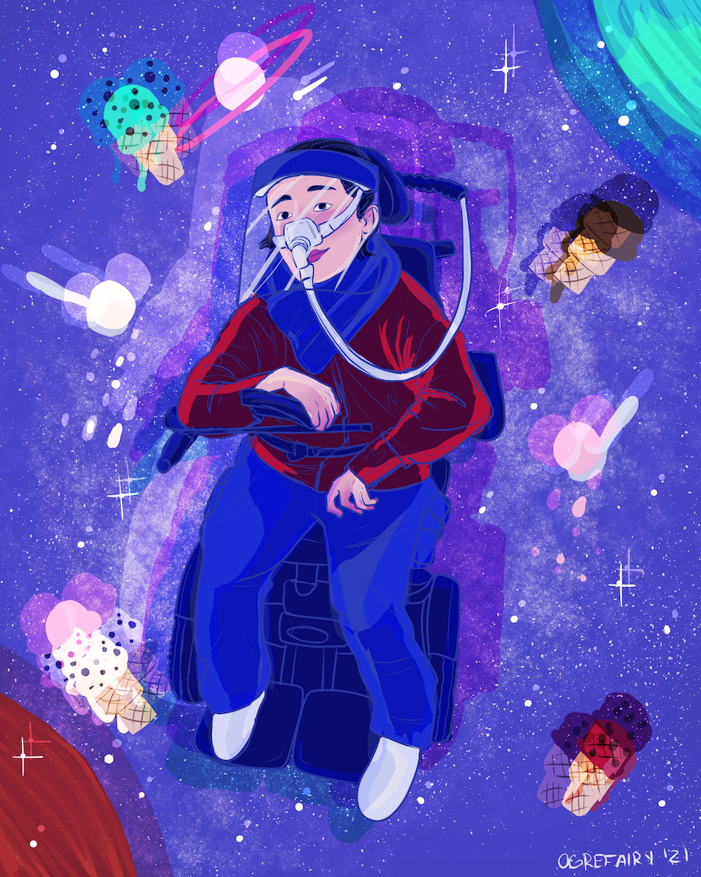
Note. Depicted here is Alice Wong, an amazing disability activist, author, podcaster, and more, wearing a face shield.

Figure 2
Michaela Oteri’s self-portrait

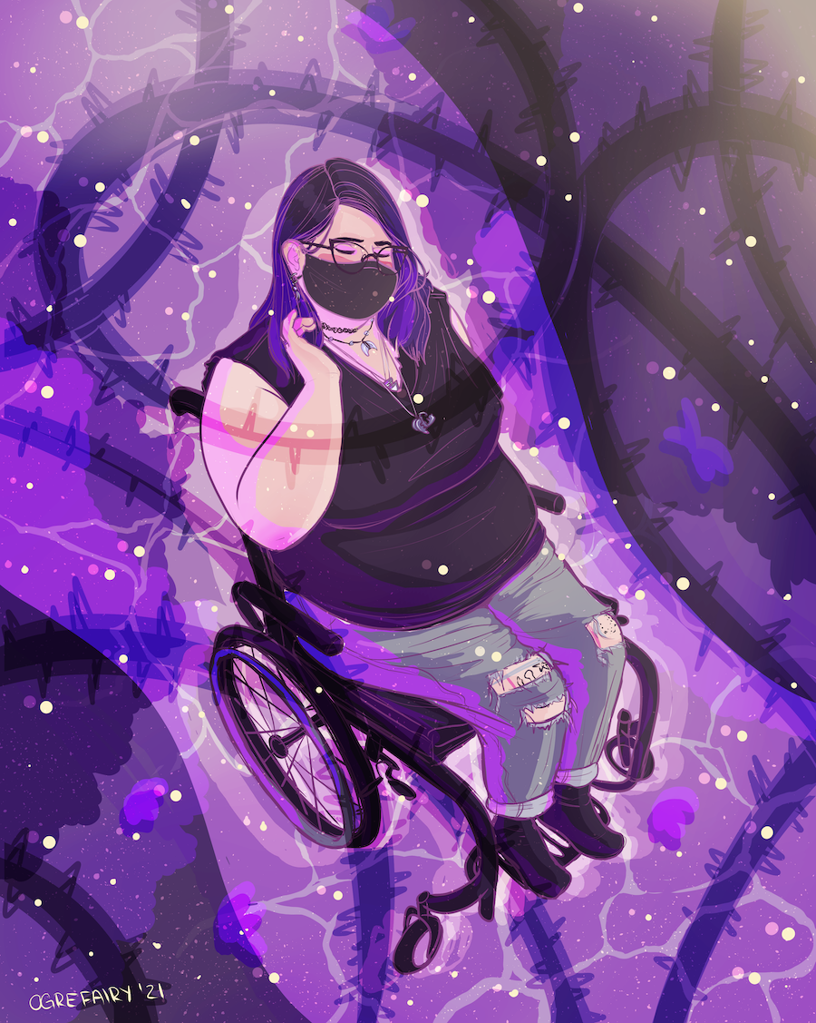

Note: Second is a self-portrait of Michaela herself in a face mask. Both are in a dreamlike style while also reflecting safety during the worldwide pandemic we are in the middle of facing.

Safe Dreamlike Portraits: Dreams During the Pandemic by Michaela Oteri https://rdsjournal.org/index.php/journal/article/view/1057 is licensed under a Creative Commons Attribution 4.0 International License. Based on a work at https://rdsjournal.org.

